Active Management of
Aircraft System Failures
Phase III

Progress Report

March 3, 2003

Prepared for:
NASA Langley Research Center
Under NASA Task Order #1003
Contract NAS1-00107, FCSR Program
Technical Officer: Tom Bundick

Prepared by:
Dr. Sonja Glavaski, Dr. George Papageorgiou, Dr. Michael Elgersma,
Dr. Michael Dorneich and Peter Lommel
Honeywell Laboratories
Minneapolis, MN 55418
sonja.glavaski@honeywell.com

Table of Contents

1. Introduction 4
2. Previous Work 6
3. Active Failure Management 7
3.1 Failure Detection 7
3.2 Failure Isolation 8
3.3 Control Recovery 8
4. Parameter Identification 10
4.1 Parameter ID Using Linearizations 11
4.2 Time Domain Identification 12
4.3 Updating the Parameter Matrix in the FDI Model and the Controller 14
5. Pilot Cueing 16
6. Control Reconfiguration 18
7. Simulation 19
7.1 Aircraft Model 19
7.2 Aircraft Parameter Initialization 21
7.3 Bias, Noise and Disturbance Models 23
7.3 Simulation Results 24
8. Future Work 28
9. Acknowledgements 29
References 30
APPENDIX 32
1. Introduction 33
1.1 Project Purpose 33
1.2 Project Scope 34
1.3 Definitions, acronyms, and abbreviations 36
2. Hardware Requirements 37
2.1 Modifications Needed to Existing Simulator 37
2.2 Visual System 37
2.3 Audio System 37
2.4 Video recording 37
2.5 Audio recording 37
2.6 Interfaces 37
2.7 Discussion of Operation of any Controls, Displays, or Equipment 37
2.7.1 Displays 37
2.7.2 Controls 38
2.8 Performance requirements 38
2.9 Procurements needed 38
2.10 Fabrications needed 38
2.11 Constraints or limitations 38
2.12 Assumptions or dependencies 38
3. Software Requirements 39
3.1 Simulation Software Only 39
3.1.1 Mathematical Representation 39
3.1.2 Computational Techniques Considerations 41
3.1.3 Display Specifications 42
3.1.4 Audio Specifications 42
3.1.5 Data Link Specifications 42
3.1.6 Interfaces 42
3.1.7 Data Recording 44
3.1.8 Graphical User Interface 44
3.1.9 Operational Scenario 44
3.1.10 Performance Requirements 44
3.1.11 Assumptions, Constraints and Dependencies 44
3.2 Common Software to Simulation and Flight 44
4. Simulation Facility Validation 45
5. Experiment Definition 46
6. Desired Schedules for Researcher Checkout and Production 47
Appendix A Failure Detection and Isolation (FDI), Pilot Cueing System (PCS), and Reconfigurable Control (CUPRSys) 48
A.1 Matlab Simulink Diagrams (Vectorized) 49
A.2 Matlab Functions 55
A.2.1 Matlab Functions 68
Appendix B Pilot Cueing System Requirements 69
B.1 Cueing System Functional Requirements 69
B.2 Primary Flight Display 71
B.3 Control Surface Display 72
B.4 Input Device 76
Appendix C Control Effector Failure/Damage/Icing Model 78

Introduction
The goal of the NASA Aviation Safety Program is to develop and demonstrate technologies that contribute to a reduction in the aviation fatal accident rate by a factor of 5 by year 2007. NASA Langley Research Center in Hampton, Virginia is leading the safety program that is a partnership that includes NASA, the Federal Aviation Administration (FAA), the aviation industry and the Department of Defense.
The Aviation Safety Program was created in response to a report from the White House Commission on Aviation Safety and Security. NASA responded by forming the Aviation Safety Investment Strategy Team (ASIST) with industry, government, and academia participation in defining aviation safety research needs.
The objectives of the Aviation Safety Program are twofold:
- Develop and demonstrate technologies that reduce aircraft accident rates; and
- Develop technologies that reduce aviation injuries and fatalities when accidents do occur.
Research and technology will address accidents involving hazardous weather, controlled flight into terrain, human-error-caused accidents and incidents, and mechanical or software malfunctions. The program will also develop and integrate information technologies needed to build a safer aviation system and provide information for the assessment of situations and trends that indicate unsafe conditions before they lead to accidents.
To achieve the proposed safety goals in the air travel, it will become necessary, among other measures, to actively deal with and recover from a large class of aircraft system failures [22]. In general terms the class of problems that need to be addressed are common among the different segments of the air transport market. However, there are sufficient differences in the vehicles and their equipment, operations, and commercialization to justify the study of different segments of the markets separately. We develop and analyze performance of an active failure management for control recovery system for the commuter and business aircraft. However, in the current phase (Phase III), we will demonstrate our technology in the B-757 simulation facility at NASA Langley Research Center.
Initially, in Phase II of our project, we focused on commuter aircraft for the regional airlines because commuter airline crashes are far more common than those for the commercial transports are. Reference [1] provides data on the circumstances and malfunctions associated with commuter airline crashes during the period 1983-1988. The study places the 118 crashes studied into 10 mutually exclusive categories. The largest numbers of cases mentioned in the study were due to mechanical failure during climb-out, cruise, and approach (20) and to loss of control on takeoff/landing (22). Although aircraft icing falls somewhat lower on the list above, we included it in out study because we believe it too is amenable to advanced control solutions. In Phase II, we have addressed detection, isolation, and accommodation of selected mechanical failures as well as aircraft icing. Such failures would be uncovered by failure detection and system parameter identification and dealt with using a combination of pilot cueing, and autopilot reconfiguration wherever feasible. We have also defined several candidate failure scenarios (e.g., aircraft icing, failures of control surface actuators, stuck or floating control surfaces, etc.) that are both common occurrences and amenable to improved control solutions. We developed autopilot reconfiguration algorithm to accommodate failures wherever possible and to provide pilot cueing to inform the pilot of autopilot reconfiguration. Performance was determined by simulations of failure detection and system parameter identification algorithms under the defined failure scenarios.
In this Phase III status report, we advance detection algorithm and an algorithm that allows the onboard identification of the parameters associated with a six-degree-of-freedom nonlinear model of an aircraft. The parameter identification uses time-domain signals, but the initial parameter estimates can also be obtained from linearizations of the nonlinear system about several operating points. For the time-domain parameter identification, we assume that we can measure all control inputs and states, and that the state derivatives can be computed from the state values (see later section). Noise at the input (e.g., wind gust) affects the measured state and the actual state in the same way, so it can act as additional excitation, which can actually help parameter estimation. Noise at the output (e.g., unmodeled dynamics) affects the measured state but not the actual state, so the output noise leads to errors in the parameter estimates. At this stage, we do not include any wind gusts in our simulation.

Previous Work
Standard results for linear least-squares problems can be found in References [10] and [11]. Reference [12] contains many standard results in linear system identification. References [3], [19], and [20] describe many of the techniques, which we use in this report. They describe both the parameter identification algorithms and their application to aircraft. They also describe various other algorithms and consider the trade off between using recursive least squares vs. using a batch algorithm on a moving window of data. They also discuss the issues associated with turning off the identification when insufficient excitation is present, and effects of damage occurs (parameters value jumps) somewhere inside a window of data.
Control surface effectiveness degradation due to icing has been extensively investigated in References [16], [17], [18] and [14]. Reference [13] describes parameter identification for on-flight detection of aircraft icing. Reference [6] describes previous work on parameter identification for systems with redundant actuators.
Reference [15] presents a general methodology for adaptive control using multiple models, switching and tuning. This method allows a controller to operate in multiple environments by recognizing which environment is currently in existence and servicing it appropriately. The concept of using multiple models for switching or tuning is not new in control theory. Multiple Kalman model filters were studied in the 1970’s.
In this report, we will present a practical application of active aircraft failure management system, whose adaptation is based on onboard aircraft aerodynamic parameter identification. This method allows for the pilot cueing strategies to deal with such failures, and for the control reconfiguration strategies to prevent a failed vehicle from entering an extreme flight condition whenever possible. Results of research conducted under this contract have been reported in References [4], [5], [7], [8] and [9].

Active Failure Management
System failures are detected and isolated using a hierarchy of techniques that is chosen to ensure minimal disruption of operations and to minimize the number of false alarms. Successive layers in the hierarchy are increasingly invasive. Higher layers will be invoked only when lower layers indicate a potential problem.
Figure 1 shows distributed architecture of our Active Failure Management system. Model based Fault Detection and Isolation (FDI) is executed in parallel on all control surface actuators, as well as on aircraft.
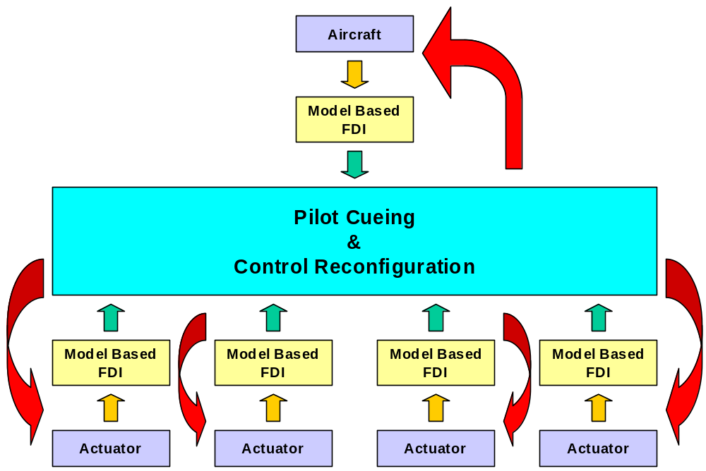

Figure 1. Active Failure Management Distributed Architecture

Failure Detection
Hardware-based failure monitors provide the first line of defense in failure detection. Commuter aircraft today have failure monitors covering various health aspects of the engine, hydraulics, auxiliary power, sensors, actuators, control surfaces, etc. These monitors are particularly useful for isolating simple problems: stuck actuator, surface hard covers, etc. But they are prone to common mode failures that set off multiple alarms simultaneously and contribute to pilot confusion. Many commuter aircraft also have sensors to detect icing, but these too are not always reliable. Thus, we will augment them with other methods.
Model-based failure detection algorithms provide the next line of defense and are based upon simple comparisons of true aircraft responses to those of an internal model. Parameters for this internal model will be determined using system identification or using linearization data. Failure detection defines the first layer in hierarchy. It operates full time and requires no external test signals.

Failure Isolation
Failure detection in our terminology indicates only a potential failure. We rely on the system parameter identification to both confirm that a failure has occurred and to isolate that failure to particular element. Reliable system identification requires the use of test signals to excite the system to be identified. Occasional pilot inputs and scheduled autopilot maneuvers do provide useful test signals for identification, but they are relatively infrequent during much of the flight. When the failure detection algorithm indicates a potential failure, it will usually be necessary to inject a test signal to confirm this possibility and isolate the failure. We use classical detection theory methods to strike an acceptable balance between false alarms (detecting a failure where none exists) and misses (not detecting a failure where one exists). Results will be presented later in this report.
To minimize the disruption to operations, we will first inject test signals into the null space of the inputs using redundant control surfaces such that these signals (ideally) cancel one another and thereby do not excite aircraft motion. This allows detection of failures among redundant control surfaces, where available, and is particularly useful for identifying changes in surface effectiveness. Where redundancy does not exist, we will use more general test signals that do excite aircraft motion. In general, test signals must be large enough so they won’t be dominated by sensor noise and disturbances (i.e., gust inputs). On the other hand, control inputs cannot be too large since injecting test signals into the null space of the inputs using redundant control surfaces could be hazardous in the presence of actual failures. This is because the null space is no longer what it was before the failure. These general test signals should produce relatively small accelerations and need only last for a few seconds and even then only when failure detection indicates a potential problem.

3.3 Control Recovery
To accommodate failures wherever possible, autopilot reconfiguration algorithms and pilot cueing strategy have to be developed. Pilot cueing is necessary to inform the pilot of the current situation, potential responses, and any autopilot reconfiguration. Control recovery will allow real-time in-flight updates to the aircraft autopilot in the face of confirmed and isolated failures. As such, it is a potential alternative primarily for newly designed aircraft or for retrofit aircraft that are scheduled for flight control upgrades. Improved pilot cueing is the more likely option for the older retrofit market. Nevertheless, autopilot reconfiguration will be considered and will likely play a critical role in failures for which control bandwidth exceeds pilot capabilities (e.g., yaw damper).
For some types of failures, reconfiguration may be as simple as replacing one failed control surface with another similar surface and possibly making minor gain adjustments (e.g., split surface, where one half fails). In other cases, it may require replacing a failed surface with dissimilar surfaces, which could require re-computing the entire control allocation matrix. In yet more extreme cases (e.g., loss of hydraulics), it may require augmenting traditional control inputs with very non-traditional ones. We refer to all of the mentioned strategies as control reconfiguration.

4. Parameter Identification
Given a nonlinear dynamical system represented by a system of ordinary differential equations, with states x and inputs u:
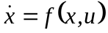
our goal is to identify unknown parameters in the function f. To simplify the identification process, we can make use of the fact that if f has certain smoothness properties, then f can be approximated arbitrarily well by a nominal value 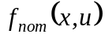, plus a linear combination of nonlinear basis functions 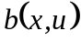, where the coefficients in the linear combination form the unknown parameter matrix H:
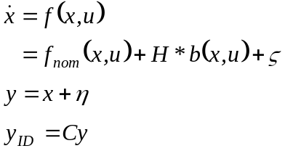 (1)
where
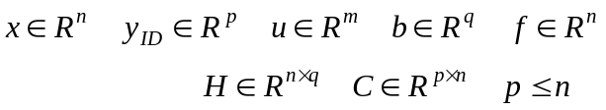 (2)
and and denote residual and measurement noise, respectively. All states are included in the measurement y since the nonlinear identification needs them to evaluate . The C matrix is used to select the combination of identification inputs, 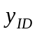 associated with the unknown force or moment coefficients in certain rows of H, as shown later.
If only some rows of 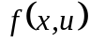 depend on unknown parameters; then, the parameter matrix H can be factored into a known matrix 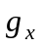 times a smaller unknown coefficient matrix 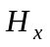.
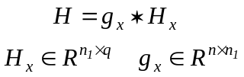 (3)
The size of  decreases as the number of basis-functions increases. As the number of basis functions increases, the number of columns of the coefficient matrices H and also increases. Knowledge of the physics of the problem allows the choice of a small number of nonlinear basis functions that still give adequately small residual. After the basis functions have been chosen, the value of the coefficient matrix H must be determined. This can be done using either of the following two methods:
- Using multiple linearizations,
- Using time domain data.
The first method is used to initialize the parameters when several linearizations are available. The second method is used to refine the parameters using flight data, and can also be used to update the parameters after a failure has occurred.
Both methods lead to a linear matrix equation for H of the form: 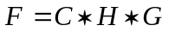, with solution: 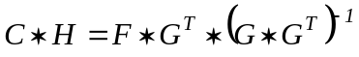. If the matrix C is chosen so that 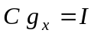, then 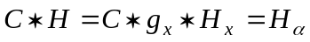, so 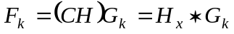 with solution: 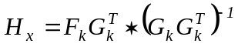. When the matrix 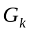 is not full column rank, then a matrix D can be used to select only the columns of G that matter.

4.1 Parameter ID Using Linearizations
Before using time-domain data to update the parameter matrix H, it is often possible to get initial parameter estimates from linearizations of the full nonlinear simulation represented by . Linearization of the original system, about trim point of i, gives: . Linearization of the parameterized approximation of the system (1) gives:
.
Setting the right-hand sides of the above linearizations equal to each other, gives two sets of linear equations for the constant matrix H:
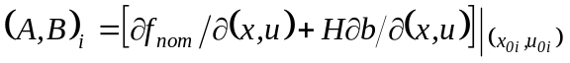
which can be combined to form: 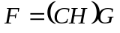, where 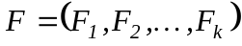 and 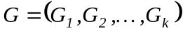 with entries given by:
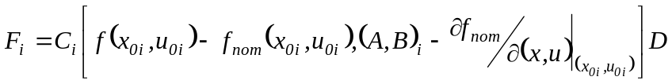
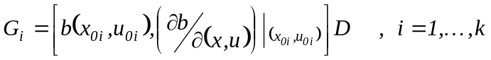
When the matrix 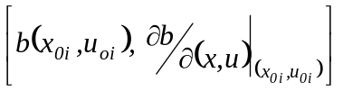 is not full column rank, then a matrix D can be used to select only the columns of that matter.

4.2 Time Domain Identification
After obtaining initial estimates for the parameter matrix H as described in the previous section, time-domain data can be used to refine the parameter estimates. Time-domain data can also be used to update the parameters after a failure has changed the values of the parameters.
For our aircraft model, we represent the aero forces and moments with the 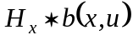 term, while all other terms of the dynamics may be put into . This is because minor failure of the aircraft can significantly change the aero coefficients, while having only a small effect on the mass and moment coefficients in and .
If the aero coefficients themselves are considered as nonlinear functions of the state, those nominal nonlinear functions could either be put into the function , or could be considered as a nominal nonlinear function plus a linear perturbation to be estimated.
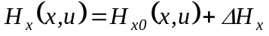
Noise on the states can cause the nominal nonlinear table lookup values and 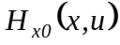 to be noisy; therefore, the states should be filtered before being used in those functions. It is assumed that x and u can be measured with sensors. Then, by comparing the differentiated value of the measured x with the computed values of and , the coefficient matrix can be computed.
The least-squares procedure for determining the parameter matrix acts to average out any high frequency noise introduced by differentiation of the noisy state. One concern is that the noise can cause biases in some cases, so any amplification of the noise due to differentiation of the state could increase the size of the bias. It has been shown in Reference [6] that if 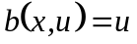, and there is no noise on u, then the least-square parameter solution will not be biased.
After acquiring k samples, let
The matrix 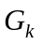is size 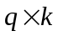 where 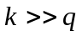, so we have an over-determined linear algebra problem to solve for .
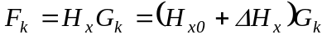
We may have some a-priori knowledge of what the value of the matrix should be. In this case, we can bias the computed answer to stay close to the preferred value 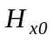.
The unweighted least-squares problem can be weighted with a 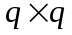 weighting matrix W to keep 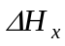 small. This can be done as follows:
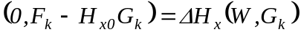
Let 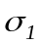 be the largest singular value of the 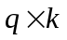 matrix . Then, a quantitative estimate on how much the size of 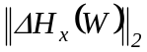 is reduced by the presence of the weighting matrix W is given by:
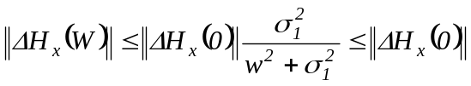
Define the inverse covariance matrix 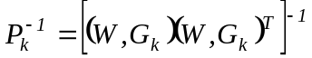 , so 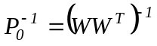 and define 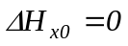.
The iterative update for the 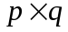 parameter matrix update is given by:
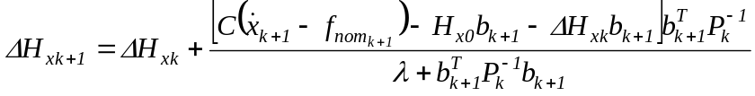
while the inverse covariance matrix update is:
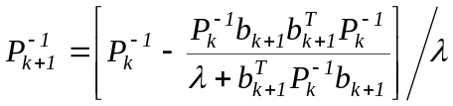
where 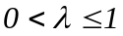 is a forgetting factor on the old data, which replaces data that is i samples old with 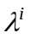 times that old data. Once we have a solution for 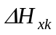, we can obtain 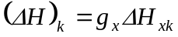.
In order to obtain a well-conditioned identification computation, it is necessary to have sufficient excitation, either from pilot maneuvers or external signal injection (e.g., sinusoids, square waves, or random noise). When there are redundant actuators, then signals can be injected into the kernel of 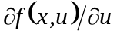 without affecting . This type of injection can be used to identify the additional terms in that are not identifiable from aircraft maneuvers alone.
The external signal generator is only turned on when the failure detection flag signal has exceeded some threshold size. This prevents excessive actuator wear, and avoids annoying the pilot. The pilot can see the surfaces moving when signals are being injected, and if the kernel is not accurately computed, the injected signals could have some affect on , which the pilot would feel. If the batch least-squares solution is used, this time interval is fixed; but with the iterative solution, the parameter identification can be turned off whenever the error has decreased below some threshold value.

4.3 Updating the Parameter Matrix in the FDI Model and the Controller
Recall that the parameter matrix is modeled as 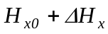, where is the current nominal value of the parameter matrix and represents the change of the parameter matrix with respect to due to new actuator loss-of-effectiveness and/or icing conditions. Also, recall that is estimated from aircraft sensor data using a recursive least-squares algorithm that keeps the size of small (refer to relevant section).
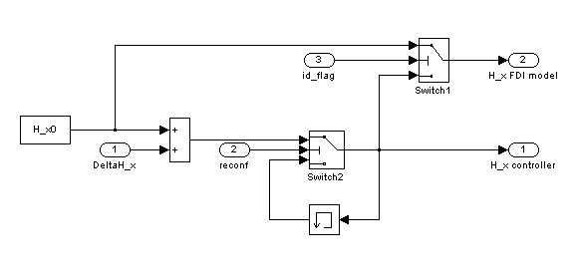

Figure 2. Logic Used to Update the Parameter Matrix in the FDI Model and the Controller
Figure 2 depicts the logic used to update the parameter matrix in the FDI model and the controller. The parameter matrix in the controller is updated to only when reconfigure occurs. A reconfigure occurs when the solution of the recursive least-squares algorithm converges, that is, the rate-of-change of the size of due to new actuator loss-of-effectiveness and/or icing conditions is smaller than a specified threshold. Note that when a reconfigure occurs, the signal reconf in Figure 2 is high for one instant.
The parameter matrix in the FDI model is updated to when a reconfigure occurs and is set to when the identification flag is high, that is, identification is always done about the same nominal value of the parameter matrix. The identification flag is high when a filtered version of the size of the error between the output of the model and the aircraft (the identification signal) exceeds a specified threshold.
If is a high fidelity estimate of the parameter matrix when no faults/ice are present and it is assumed that an aircraft at the start of its mission is not faulty/icy, then one can argue that the parameter matrix can always be modeled effectively using perturbations about . Therefore, it was decided not to set the parameter matrix in the FDI model to when the identification flag is high. Consequently, the size of the parameter matrix in the FDI model and the controller cannot grow continuously potentially leading to instability of our scheme and jeopardizing airworthiness certification.

5. Pilot Cueing
A preliminary design of a cueing system for a hierarchy of active flight management techniques is presented in this report. The automation in the system for active management of aircraft system failures, both active and passive, is responsible for detecting, isolating, and potentially compensating for upset conditions. It is vital that the pilots be aware of the automation as it manages faults. Thus, among the preliminary designs introduced in this report, a dedicated display is necessary to support the pilot’s awareness of the automation as it performs its tasks.
The full set of displays in the pilot cueing system is derived from a framework, [21], of information requirements. This framework of information requirements addresses situation awareness by explicitly representing the automation as an agent, which performs fault management tasks (detect, diagnose, prognose, and compensate) in the operational environment (environment, system, aircraft, or mission). Given a prioritization and categorization scheme, alerts are realized on multiple displays including aural alerts, visual cues and symbology on existing flight displays, dedicated messages, and finally a dedicated situation awareness display.
Figure 3 illustrates a conceptual design of a Control Upset Automation Situation Awareness (CUASA) display. There are three primary components:
- The primary flight control surface display, which depicts the control surface displacement within the scale of its (possible revised) limits.
- The control authority display, which conveys to the pilot what the new limits (placed on the control inputs by the automation’s reconfiguration) are on the three degrees of freedom: roll, pitch, and yaw.
- The message area, where dedicated messages alerting the pilot to automation-related tasks are presented.

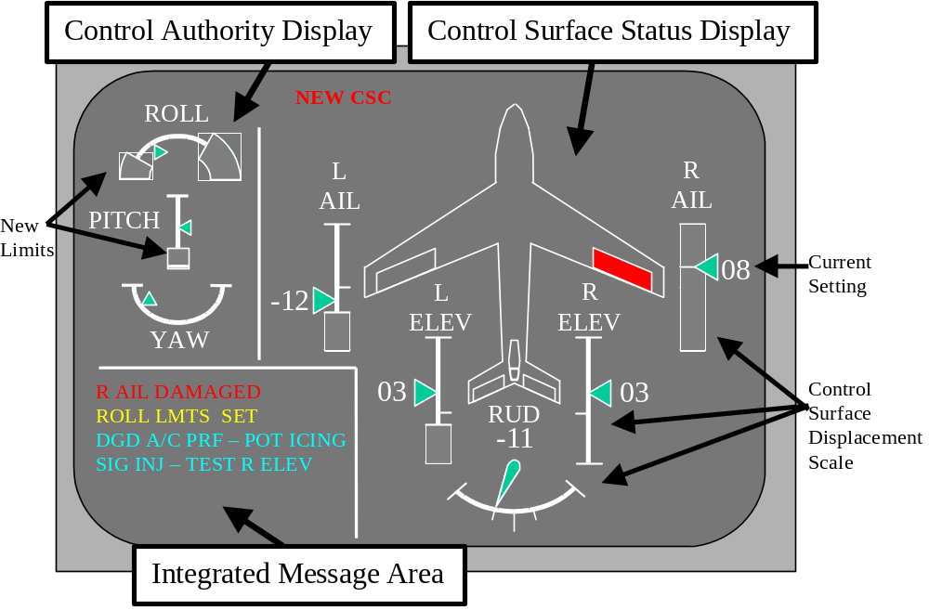
Figure 3. Integrated Message Area and Situation Awareness Display

6. Control Reconfiguration
The in-flight system parameter identification ultimately provides the potential for in-flight control law reconfiguration. We address robustness to identification errors by limiting the authorities of parameter corrections derived from the system identification.
The controller is parameterized with the coefficients in the matrix H, provided by the parameter identification algorithm. The controller starts out with the nominal value of the parameters, and is updated continuously with the current estimate of the parameter values. The dynamic inversion controller uses the plant model given in Section 7.1. Let
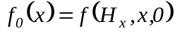 and 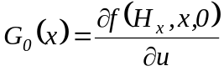
The desired dynamics are of the form:
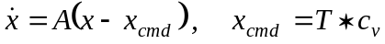
where 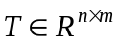and 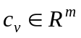 are the m external command inputs.
With 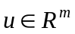, m outputs can be controlled with the m inputs. Let 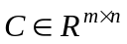 be a matrix that selects which combinations of the state will be controlled. Then, the portions of the desired dynamics that can be obtained are:
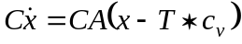
Setting the right hand side of this equal to the right hand side of:
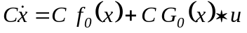
Gives:
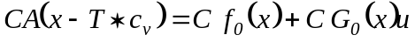
Solving for u gives the controller as a function of x and the external input 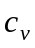:
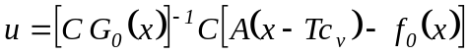

7. Simulation

Aircraft Model
Let v be the body-axis velocity, w be the body-axis angular rate, 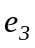 be a unit vector in the down direction (third column of the rotation matrix from inertial coordinates to body coordinates), and let h be the altitude. Let the inputs consist of a sub-vector of thrusts, 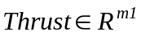 and a sub-vector of surface deflection 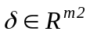. Let J be the moment of inertia matrix, mass be the mass, S the wing and 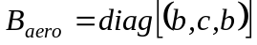 where b is the wingspan and c is the chord.
The corresponding nonlinear aircraft model’s states and input vectors are given by:
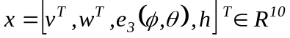
where 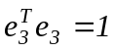 and ,
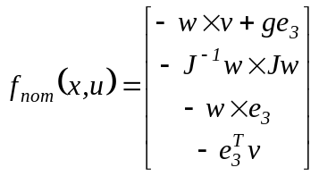
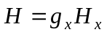 where
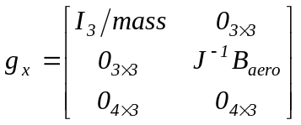
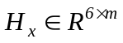 is a dimensionless coefficient matrix to be identified, and the basis functions have units of force.
The choice of basis functions for system parameter identification is driven by the fact that the parameters need to be identified very quickly. This does not give us time to move very far in the 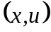 space, so we can only expect to identify a linear (plus bias) approximation of the model. We want to be able to identify the effectiveness of each actuator, so each component of u is a basis function. The only other parameters that are not well known (after failure) are the coefficients, which determine the aero forces and moments, which depend on 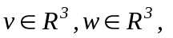and . The dependence of the aero forces and torques on 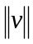 is well known, but their dependence on 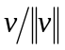, and w may be significantly altered when failure occurs.
If we choose
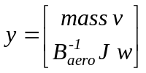
then
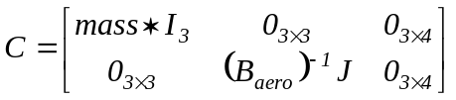
and we get 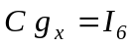.
To obtain aero forces and moments that are quadratic in speed, and dynamic derivatives that are bilinear in v and w, as well as input terms from thrust and surface deflections, the basis functions are chosen as:
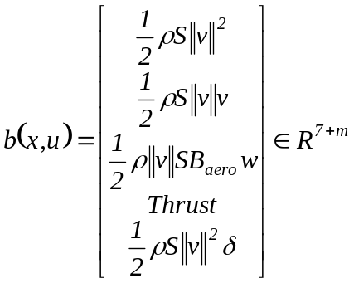
Let 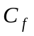 and 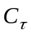 be the dimensionless aero-coefficients, which determine the forces and torques due to aerodynamics. Then, the coefficient matrix we need to identify is 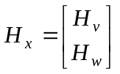 where:
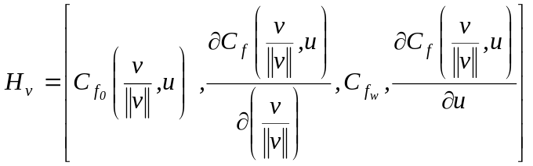
and
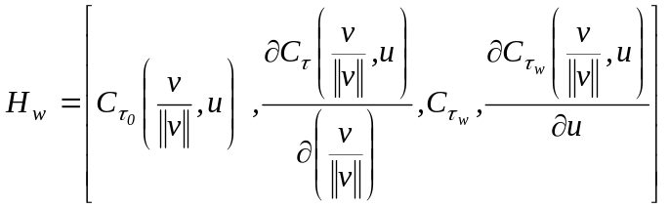
We have added elasticity to the aircraft model. We do this by multiplying the angular velocities by the following transfer function:
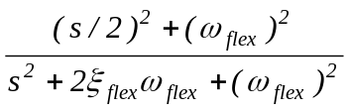
where the damping is 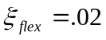 and the flex frequency is 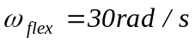. The estimator model does not include the flex mode; so at high frequency, there is always some model mismatch. However, the estimator is essentially averaging over a time window of several seconds, so the quality of the estimation is only very slightly eroded by the addition of this model of elasticity.

Aircraft Parameter Initialization
The only nonzero rows of H are the top 6 rows, so C will be chosen to select all or some of the top 6 rows. This means that only the top 6 rows of need to be computed, so if Euler angles are used instead of the part of the state, it will not matter. In order to compute H based on linearization data, we need to compute the partial derivative of and . To simplify the expressions, we will assume that we are trimming about a value of the state that has 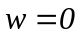.
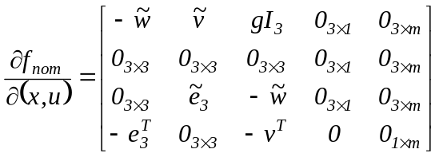
where is the 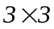 skew symmetric matrix formed from the element of v, such that 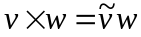. The 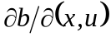 matrix is sparse, with the only non-trivial computations being:
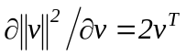
and
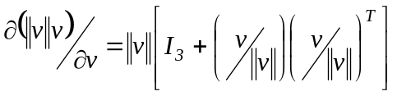
Actually,  depends on the state h, but the 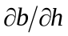 column of the above matrix will be eliminated anyway by the matrix D. We will choose typically:
which gives 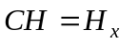or 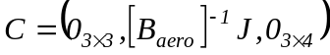, if we only want to identify the coefficients associated with the angular dynamics, in the bottom 3 rows of . For the above choice of basis functions, we will choose typically:
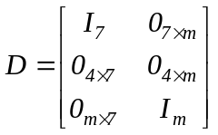
since the basis functions are only a function of the first 6 states 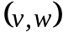, and all the m inputs.
For the first choice of C, we get (when 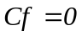 and ):
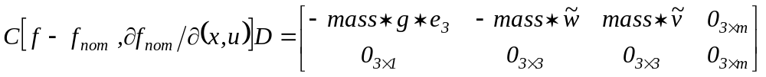
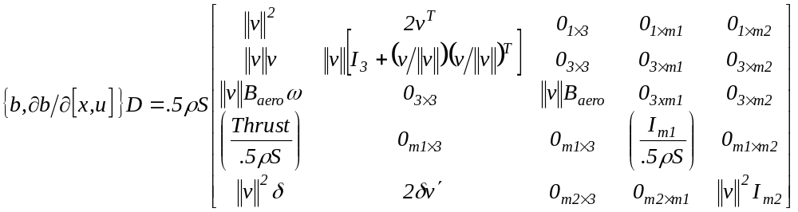
This 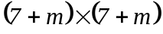 matrix is only rank 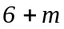, since its upper 4 rows are only rank 3. The left kernel of the matrix is 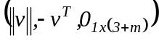. This is due to the fact that the first 4 basis functions are not independent at a single speed. To solve for CH in this quadratic model, we need at least two linearizations 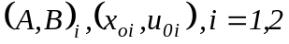. Let
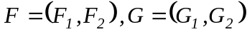
Then, the equation for CH is:
and 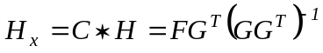.
The matrix 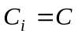 scales the first 6 rows and D selects the first 7 and last m columns of the functions, partial derivatives and 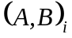.
The basis functions used above were nonlinear in to handle changes in dynamic pressure, but they only captured constant plus linear variation in the unit vector . To calibrate the coefficients in a larger matrix H that multiplies higher order terms in , we need to use either time-domain data that has large 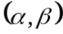 excursions, or use multiple linearizations about several points. When using several linearizations, we need to know the mass and moment-of-inertia matrix for each linearization. In this case, we can use a different 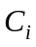 for each linearization:
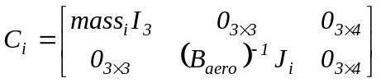
resulting in linear equations for rather than H, where 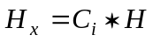. In the previous example, the basis functions that depended only on the velocity vector v, part of the state were: 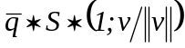, where 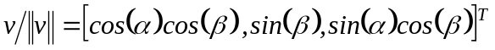, so we capture first-order terms in the unit vector . To capture the aero functions as arbitrary functions of , i.e., for anywhere on the unit sphere, we can use spherical harmonies (which are orthonormal if evaluated over the entire 2-sphere) as basis functions. Let 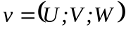. Spherical harmonics, truncated to second order, multiplied by 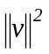, are:
Four linearizations should be used to calibrate the matrix H that multiplies these second-order terms. For example, linearize about
Note that if all linearizations are done about 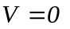(i.e., 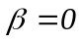), then the 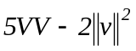 term can be dropped.

7.3 Bias, Noise and Disturbance Models
Two main gust model forms are widely accepted today: Von Karman and Dryden. The Dryden form is much simpler to use. The three components of gust (axial, lateral, and normal) have power spectra that are implemented using a linear dynamic filter for each direction. The resulting filters, 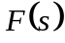, for each gust component are:
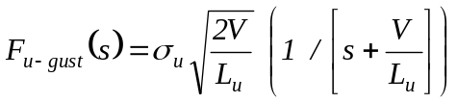
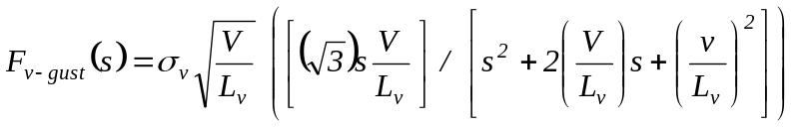
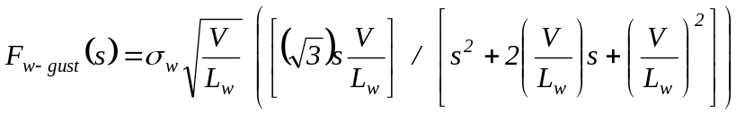
The scales 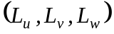 and intensities 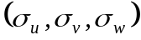 for various levels of gust can be found in MIL-STD-1797. Independent random number generators drive each of these filters to produce the desired turbulence model.

Simulation Results
In our previous report, we presented simulation results of our CUPR algorithm using a generic business jet model. In this section, we will present preliminary simulation results of our FDI algorithm using the B757 simulation model supplied by NASA.
Recall that FDI algorithm stores a copy of the aircraft model in the following form: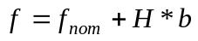, where 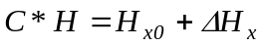(refer to relevant section). To enable reliable identification of actuator loss-of-effectiveness and ice, 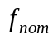 must be of sufficient accuracy so that the nominal value of the parameter matrix does not trigger the identification flag when the aircraft has no faults or ice. So, for example, if the lift-curve slope changes with angle-of-attack, then with the proposed basis functions (refer to relevant section) would have to capture this effect otherwise would trigger the identification flag resulting in a false alarm.
In an effort to improve the accuracy of , the aerodynamic forces and moments due to angle-of-attack and sideslip for 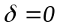, T = 0 and have been included into using look-up tables. Consequently, it is expected that the columns of corresponding to the basis functions 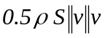are close to zero.
The nominal value of the parameter matrix can be initialized in two conceptually different ways (refer to relevant section):
- Using time-domain data from the real aircraft or its model with no faults/ice; or
- Using one or more linearizations of the aircraft model with no faults/ice.
The second method is a cheap and simple way for initializing . To date our approach has been to obtain an initial guess for the value of using the linearization method and then to fine-tune using time-domain data.

 | Default | Trim11 | Trim3
Weight (lbs) | 180,000 | 180,000 | 140,000
CG (%MAC) | 0.25 | 0.242 | 0.224
Altitude (ft) | 1,000 | 10,000 | 35,000
Flap Handle (deg) | 30 | 0 | 0
Mach | 0.2124 | 0.4 | 0.79
Landing Gear | Down | Up | Up
Alpha (deg) | 2.4413 | 4.6569 | 1.4531
Table 1. Details of the Three B757 Flight Conditions Used
The performance of the FDI algorithm has been evaluated with no faults/ice at the three flight conditions of the B757 described in Table 1. Figures 4-7 are representative of the performance of the FDI algorithm. The look-up tables added to were developed at flight condition Trim11 and therefore the performance of the FDI algorithm at Trim 11 (Figures 4 and 5) is very good; the identification signal is small signifying that the identification flag would remain low not triggering a false alarm. At flight condition Default though (Figures 6 and 7), the identification signal is large. This is because at Default the flaps are deployed and the landing gear is down, and currently the look-up tables do not account for flaps and the landing gear. Although not illustrated, the identification signal for Trim3 was also large due to compressibility effects; Trim3 is at March 0.79. Consequently, we are currently in the process of developing multi-dimensional look-up tables based on the above findings.
Unfortunately, it was not possible to test the FDI algorithm with faults because the B757 simulation model supplied by NASA does not enable simulation of actuator faults in the same way they have been implemented in our Phase II simulation setup. Further development is needed.

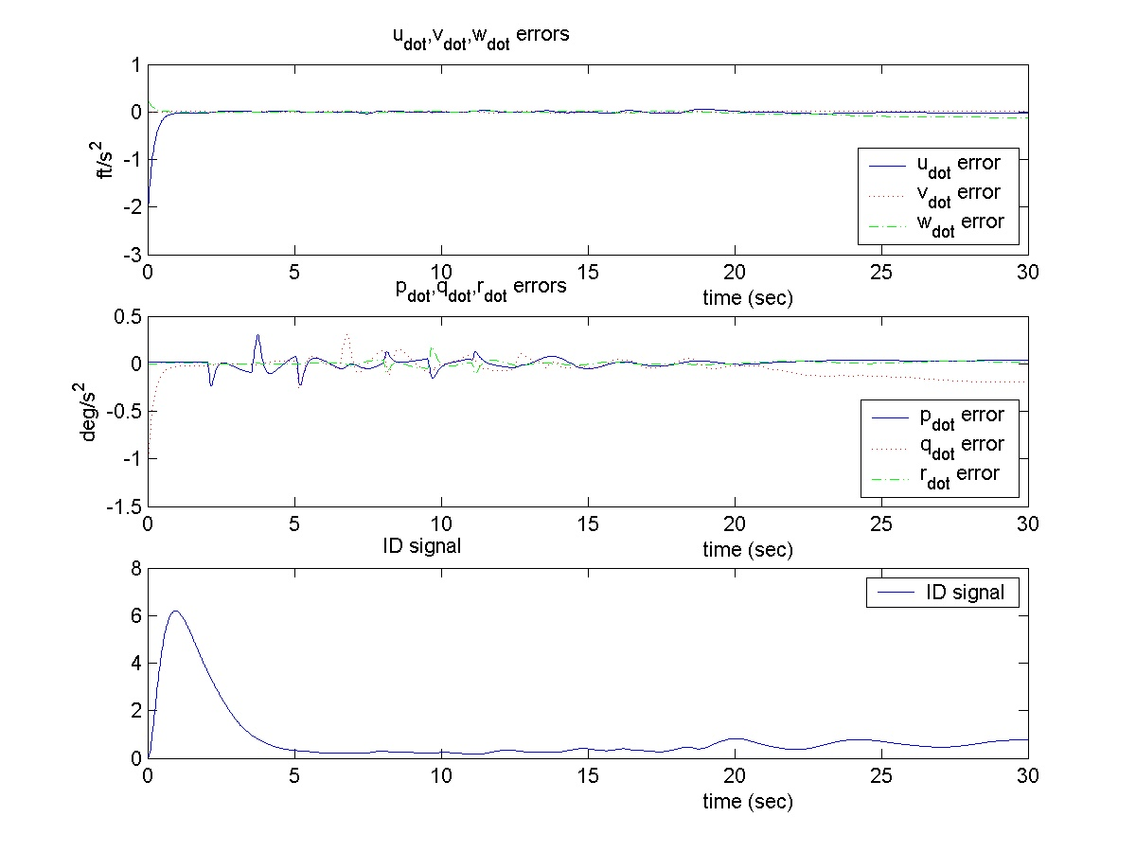
Figure 4. Acceleration Errors and Identification Signal at Flight Condition Trim11

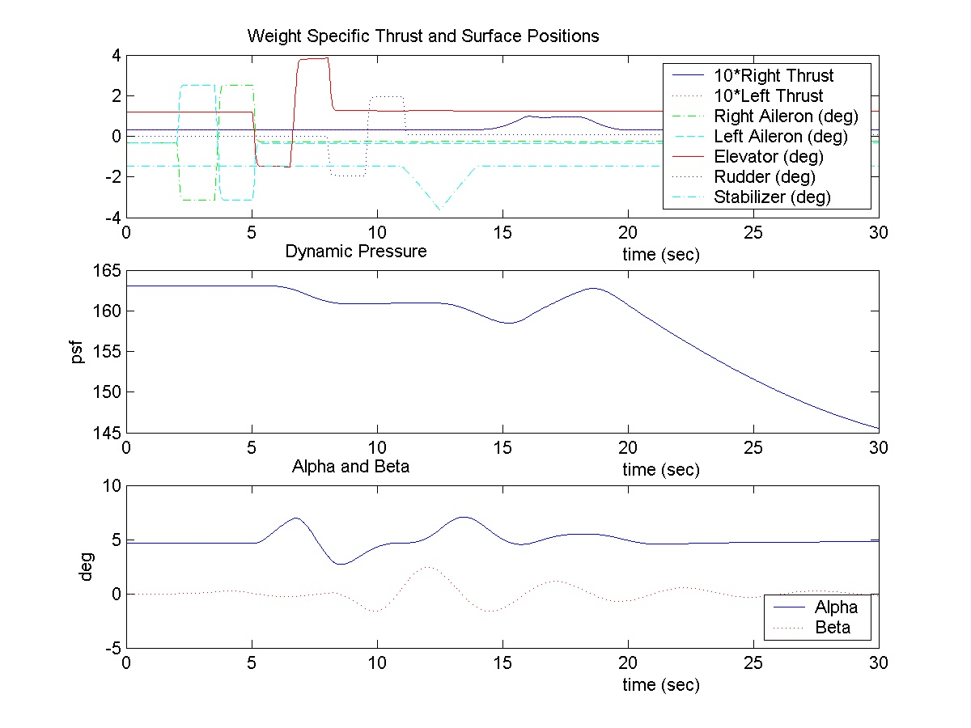
Figure 5. Details about Simulation at Flight Condition Trim11
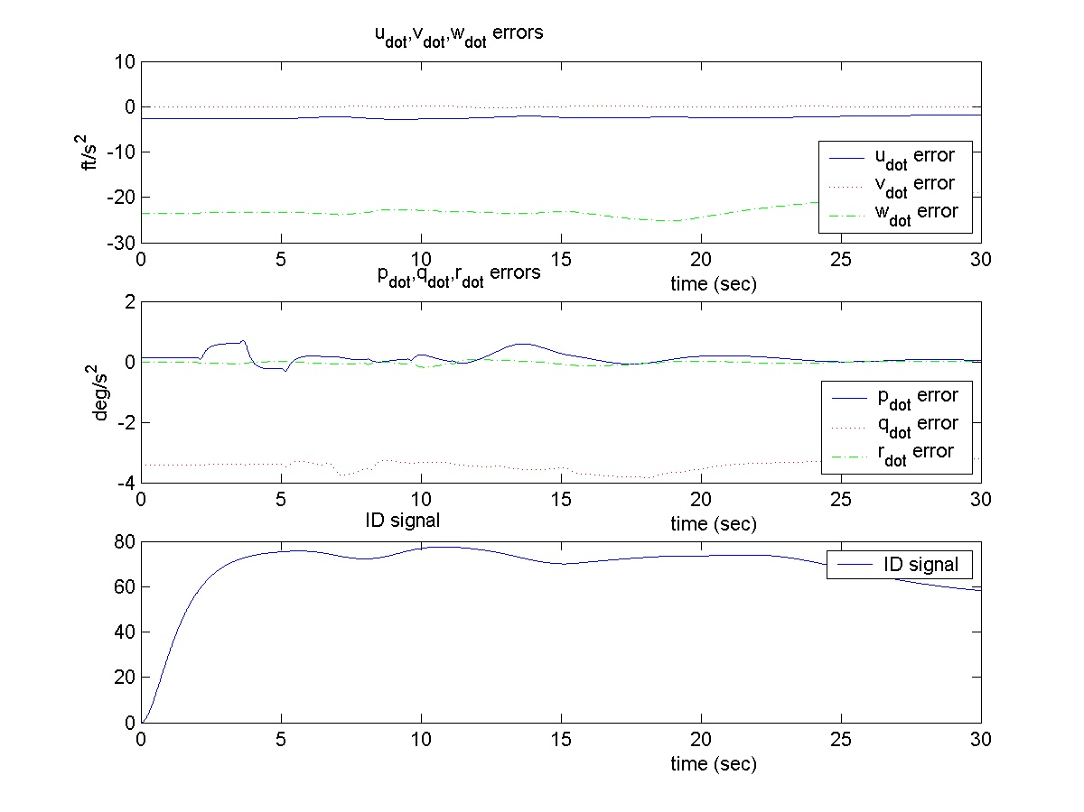
Figure 6. Acceleration Errors and Identification Signal at Flight Condition Trim3

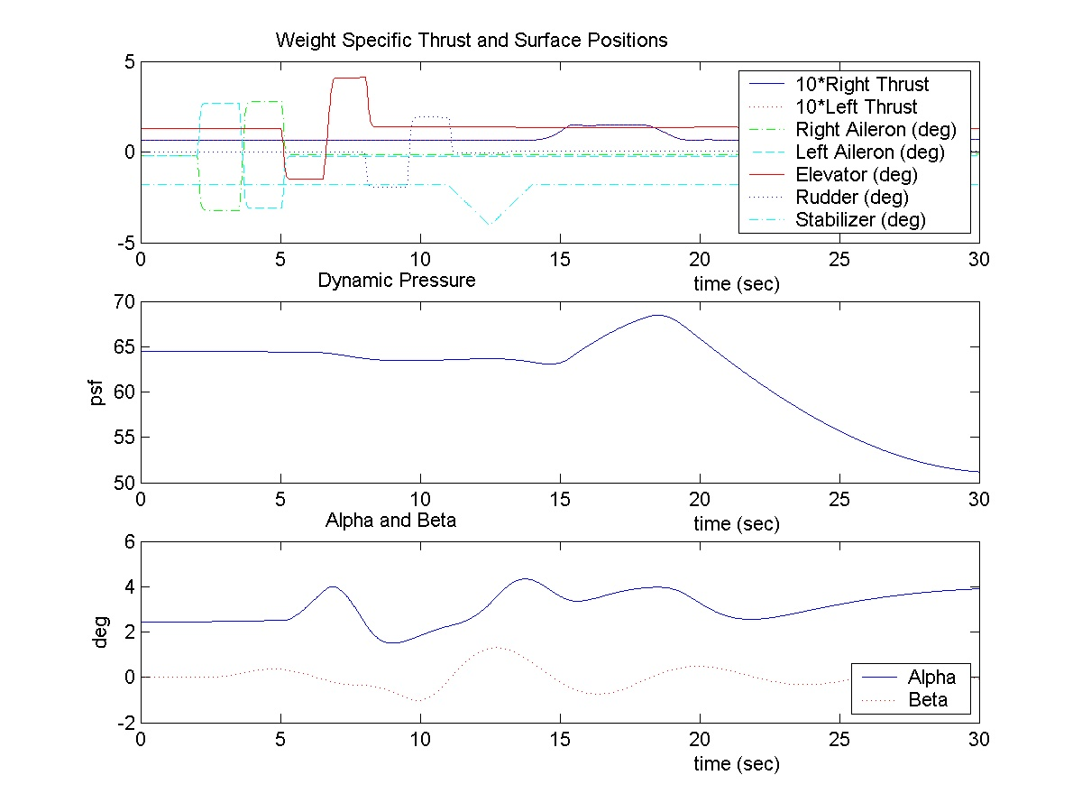
Figure 7. Details about Simulation at Flight Condition Trim3

8. Future Work
We are currently working towards the piloted simulations that are tentatively scheduled to take place in June 2003. To that end, we are working in the following directions:
- Investigating whether we can modify the B757 simulation model to enable simulation of actuator failures.
- Open loop evaluation of the performance of our FDI algorithm in the presence of faults and gusts.
- Finish adding the CUPR controller to the B757 simulation model.
- Closed-loop evaluation of the performance of our CUPR algorithm in the presence of faults and gusts.
5. Redesign the signal injection block.

9. Acknowledgements
Authors would like to thank Tom Bundick, Gus Taylor, Christine Belcastro, and Celeste Belcastro for many helpful discussions.

References
[1] S. Baker, M. Lamb, G. Li, and R. Dodd. Human Factors in Crashes of Commuter Airplanes. Aviation, Space, and Environmental Medicine, 1993.
[2] M. B. Bragg, W. R. Perkins, N. B. Sarter, T. Basar, P. G. Voulgaris, H. M. Gurbacki, J. W. Melody, and S. A. McCray. An Interdisciplinary Approach to In-flight Aircraft Icing Safety. AIAA Paper No. 98-0095, 1998.
[3] P. R. Chandler, M. Pachter, and M. Mears. System Identification for Adaptive and Reconfigurable Control. Journal of Guidance, Control, and Dynamics, 18:516-524, 1995.
[4] M. Elgersma, S. Glavaski, M. Dorneich, and P. Lommel. Failure Accommodating Aircraft Control. Proceedings of American Control Conference, 2002.
[5] M. Elgersma, S. Glavaski. Reconfigurable Control for Active Management of Aircraft System Failures. Proceedings of American Control Conference, 2001.
[6] M. Elgersma, D. Enns, S. Shald, and P. Voulgaris. Parameter Identification for Systems with Redundant Actuators. Proceedings of the AIAA Guidance Navigation and Control Conference, 1998.
[7] S. Glavaski, and M. Elgersma. Diagnostics for Active Management of Aircraft System Failures. Proceedings of the IEEE AerospaceConference, 2001.
[8] S. Glavaski, and M. Elgersma. Active Aircraft Fault Detection and Isolation. Proceedings of the AUTOTESTCON, 2001.
[9] S. Glavaski, M. Elgersma, M. Dorneich, and P. Lommel. Active Failure Management for Aircraft Control Recovery. Proceedings of the AIAA Guidance Navigation and Control Conference, 2002.
[10] G. H. Golub and C. F. Van Loan. Matrix Computations. Johns Hopkins University Press, 1996.
[11] S. Van Huffel and J. Vandewalle. The Total Least Squares Problem: Computational Aspects and Analysis. SIAM, 1991.
[12] L. Ljung. System Identification, Theory for the User. Prentice Hall, 1987.
[13] J. W. Melody, T. Basar, W. R. Perkins, and P. G. Voulgaris. Parameter Identification for In-Flight Detection of Aircraft Icing. Proceedings of the 14th IFAC World Congress, 1999.
[14] R. H. Miller and William R. Ribbens. Detection of the Loss of Elevator Effectiveness due to Aircraft Icing. AIAA Paper No. 99-0637, 1999.
[15] K. S. Narendra and J. Balakrishnan. Adaptive Control Using Multiple Models. IEEE Transactions on Automatic Control, 42:171-187, 1997.
[16] NTSB. Aircraft Accident Report, In-Flight Icing Encounter and Loss of Control Simmons Airlines, d.b.a. American Eagle Flight 4184, Avions de Transport (ATR) Model 72-212, N401AM, Roselawn, Indiana, October 31, 1994, Volume AAR-96/01, 1996.
[17] NTSB. Aircraft Accident Report, In-Flight Icing Encounter and Uncontrolled Collision with Terrain, Comair Flight 3272, Embraer EMB-120RT, N265CA, Monroe, Michigan, January 9, 1997, Volume AAR-98/04, 1998.
[18] T. P. Ratvasky and R. J. Ranaudo. Icing Effects on Aircraft Stability and Control Determined from Flight Data. Proceedings of the AIAA Conference, 1998.
[19] L. Smith, P.R. Chandler, and M. Pachter. Regularization for Real-Time Identification of Aircraft Parameters. Proceedings of the AIAA Guidance Navigation and Control Conference, 1997.
[20] D. G.Ward and R. Barron. A Self-Designing Receding Horizon Optimal Flight Controller. 1995.
[21] Michael C. Dorneich and William H. Rogers. Active Management of Aircraft System Failures: Pilot Cueing. Prepared for NASA Langley Research Center under Contract NCC-1-334, Milestone #5, Honeywell Technology Center, December 1, 2000.
[22] Christine M. Belcasto and Celeste M. Belcastro. Application of Failure Detection, Identification, and Accommodation Methods for Improved Aircraft Safety. Proceedings of the American Control Conference, 2001.

APPENDIX

Software Requirements for Research System

Version 2.6

1. Introduction

1.1 Project Purpose
Under NASA's Aviation Safety Program, the Control Upset Prevention and Recovery (CUPR) sub-element of the Single Aircraft Accident Prevention element is developing advanced control technologies to prevent and recover from loss of aircraft control under adverse conditions. Loss of vehicle control under adverse conditions (control upset) is a leading cause of numerous fatal accidents worldwide and can result from a variety of adverse conditions. These include aircraft system failures, entry into unusual or abnormal flight conditions which may exceed the normal operational envelope of the vehicle, aircraft pilot coupling, poor situational awareness, and harsh atmospheric conditions (e.g., weather, wake vortices, etc.). The development of advanced control technologies to prevent and recover from loss of vehicle control is of critical importance in reducing the current aircraft accident rate and in reducing the loss of human life.
Algorithms and techniques are being developed in-house by Honeywell Laboratories for the detection and isolation of aircraft system failures (FDI), for the estimation of the effectiveness of damaged effectors (PID), for control re-allocation to accommodate effector damage/failures, and for alerting and providing guidance to the crew. Development and initial evaluation of these algorithms and techniques will be done using a Matlab-based nonlinear 6-DoF simulation of the B-757. This Matlab simulation is being developed by GCB/DCB. The batch simulation evaluation will focus on performance of the FDI algorithms in terms of missed detection, false alarms, and correct isolation; the PID algorithms in terms of estimation errors and convergence properties; and the reconfigured controller to recover and control the aircraft following a failure.
The products of this development will be:
- A Failure Detection and Isolation and Pilot Cueing System (FDI&PCS), which will include the FDI, PID, and pilot-cueing functions, and
- An integrated Control Upset Prevention and Recovery System (CUPRSys), which will add a control re-allocation function to the FDI&PCS to form a complete reconfigurable flight control system with pilot cueing.
The FDI&PCS is suitable for use in providing guidance and status information to the crew in the event of a failure on an aircraft not equipped with a fly-by-wire control system. The CUPRSys can provide automatic failure detection, isolation, and accommodation on a fly-by-wire aircraft. The Controller in CUPRSys will replace the existing flight control system in the current B-757 simulation for this experiment. These systems, illustrated in Figure 1, will be designed using an aerodynamic and propulsion model of a B-757 airplane.

These systems will then be evaluated in a two-phase process in piloted simulation using the B-757 models and the RFD. In Phase I, the FDI&PCS and the CUPRSys will be evaluated without including the distributed actuator FDI subsystems, which may require a higher sample rate than the rest of the system. The actuator FDI subsystems will be added in Phase II. Evaluation scenarios will include simulated effector damage or failure and specified pilot tasks. Evaluation parameters will include many of those utilized in batch simulation. The evaluation will focus on the efficacy of the displays, the ability of the pilot to utilize the systems to recover and control the aircraft following an upset, and closed-loop handling qualities. Pilot comments and Cooper-Harper ratings will be collected.

1.2 Project Scope
The objective of this study is to evaluate and demonstrate in piloted simulation a reconfigurable flight control system for preventing and recovering from loss of aircraft control under adverse conditions.
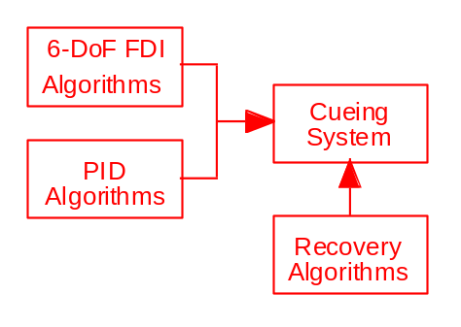
a) Phase I - FDI&PCS

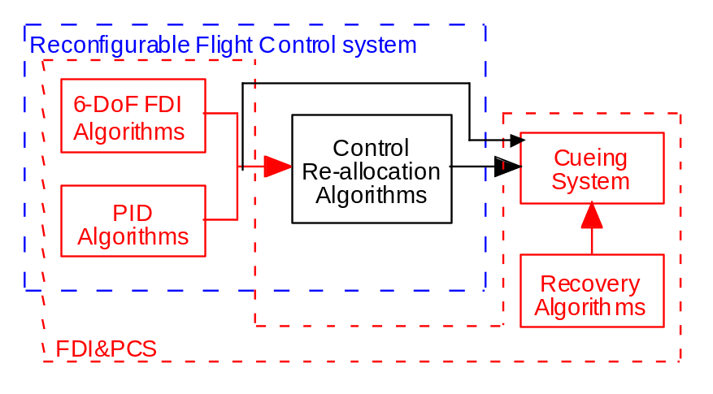
b) Phase I - CUPRSys
Figure 1. FDI&PCS and CUPRSys Block Diagrams

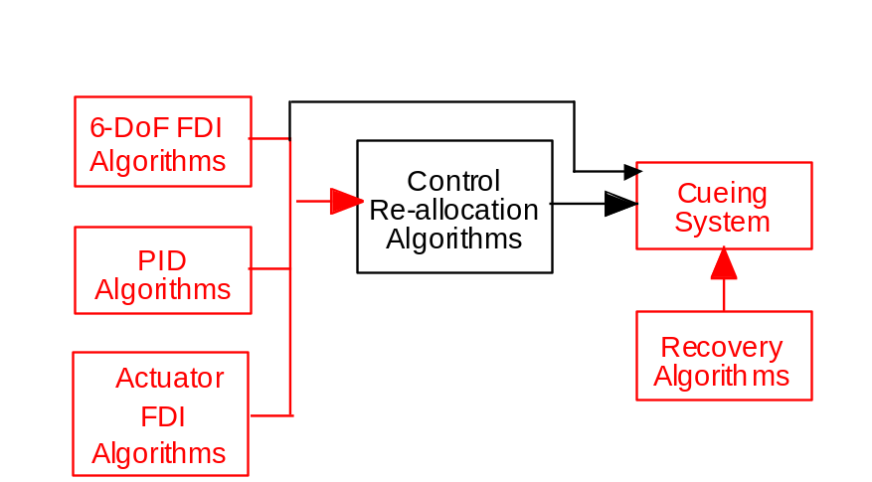
c) Phase II - CUPRSys
Figure 1 Concl’d.
This study will involve approximately twelve three-hour sessions in the RFD, in two phases using existing B-757 models with modifications. These modifications will include a new control law, new display formats, and new control actuator/surface failure/damage models. It is anticipated that the study will be completed in the first half of CY2002.

1.3 Definitions, acronyms, and abbreviations
CUPR Control Upset Prevention and Recovery
CUPRSys Control Upset Prevention and Recovery System
FD Failure Detection
FDI Failure Detection and Isolation
PID Parameter identification
FDI&PCS Failure Detection and Isolation and Pilot Cueing System
RFD Research Flight Deck

2. Hardware Requirements
This activity will require the RFD.

2.1 Modifications Needed to Existing Simulator
No known hardware modifications are required.

2.2 Visual System
No hardware modifications are required.

2.3 Audio System
(Environmental Sound and Special Equipment Sound or Alerting Systems)
No hardware modifications are required.

2.4 Video recording
No hardware modifications are required.

2.5 Audio recording
No hardware modifications are required.

2.6 Interfaces
(Definition of All Inputs and Outputs to and from Software and Hardware Instrumentation Controls, Displays, and the Like)
See Paragraph 3.1.6 for definition of CUPRSys input and output variables.

2.7 Discussion of Operation of any Controls, Displays, or Equipment

2.7.1 Displays
Use existing RFD displays for aircraft attitude, velocity, flight director, etc. with the exception of the PFD and/or MFD as follows:
A new display format for alerting the pilot to control effector/surface failure or damage will be evaluated. See Appendix B for description of this control damage display.

2.7.2 Controls
A means is required (such as a push-button or touch panel) that will allow the pilot to initiate control re-allocation when an effector failure/damage is detected and the pilot is cued by the Control Damage display. Call it the “Control Surface Controller” buttons; we will need two buttons [ORG CSC(B_ALLOC=0), NEW CSC(B_ALLOC=1)]. The “ORG CSC” button immediately reinstates the original control surface controller. The “NEW CSC” button implements the new control surface controller. Not pressing either button, when prompted, is de facto a defer action.
A means is required (such as a push-button or touch panel) that will allow the pilot to initiate computer-generated doublet commands to the ailerons, elevator, rudder, and stabilator when an effector failure/damage is detected and the pilot is cued by the control damage display. Call it the “ID Test” buttons; we will need three buttons [Yes(B_DOUB=1), No(B_DOUB=0), Defer(B_DOUB=0)]. “Yes/No” buttons give an immediate answer to the system. “Defer” keeps the question active (i.e., pilot will come back and press Yes or No at a later time).

2.8 Performance requirements
None

2.9 Procurements needed
None

2.10 Fabrications needed
None

2.11 Constraints or limitations
None noted.

2.12 Assumptions or dependencies
None noted.

3. Software Requirements

3.1 Simulation Software Only
The existing SDB B-757 simulation software will be the baseline software for this study. Required modifications to this baseline are described in this section including:
- A new reconfigurable flight control system to replace the existing control law,
- New formats for the pilot's PFD and MFD displays, and
- New failure/damage/icing models for the control actuators/surfaces consisting of the following at least option (a) below, possible options (b) and (c).
- Aileron/elevator/rudder damage: reduce the aileron, elevator, or rudder effectiveness in the 757-simulation model. This can be accomplished in several ways. For example, reduce the coefficient that determines how effective a particular surface is. This needs to be done during a flight, either at some preprogrammed time, or from the operator’s console. We need to be able to reduce the effectiveness of the aileron, elevator, or rudder by a given amount, e.g., 10%, 20%, 50%.
- Floating aileron (possibly elevator and rudder as well): allow the surfaces to be driven only by the hinge moments, with no servo or hydraulic moments.
- Modify the wing and control-surface coefficients to correspond to icing conditions, e.g.:
- CM_alpha reduced to 85% of nominal, and
- CM_de reduced to 85% of nominal at the same time.
These (icing) changes need to be applied gradually, over a period of 10 minutes for example.

3.1.1 Mathematical Representation

3.1.1.1 FDI&PCS

3.1.1.1.1 Algorithms
The mathematical models and algorithms of the FDI&PCS are represented as Matlab Simulink diagrams contained in Appendix A. Some Simulink blocks represent C-code or m-files, and this code is contained in Appendix A. Electronic files of the Simulink diagrams and of the code will be provided. An alternative approach would be to provide electronic files containing autocoded C-code versions of the algorithms. A list of variables with definition and units are also provided.

3.1.1.1.2 Display Formats
New display formats will be required for the pilot's PFD and MFD. These new formats will include information to alert the pilot about control effector failure or damage, flight envelope constraints, and control upset recovery guidance. These formats are illustrated in Appendix B.

3.1.1.1.3 Failure/Damage Models
The mathematical models of control actuator failure/surface damage/icing are represented as Matlab Simulink diagrams contained in Appendix C. Some Simulink blocks represent C-code or m-files, and this code is contained in Appendix C. A list of variables with definition and units are also provided. Failure models existing in the baseline B-757 simulation will also be used.

3.1.1.1.4 Modes of Operation
There are four modes of operation, determined by the four possible combinations of the two Boolean variable, B_DOUB and B_ALLOC, which the pilot sets using two pushbuttons. The FDI&PCS system always tries to detect and isolate faults. When a fault is detected, the system alerts the pilot and requests permission to inject doublets to help identify the fault. If the pilot gives permission (by pressing a button changing B_DOUB from 0 to 1), then doublets are injected; otherwise, the FDI&PCS system tries to identify the faults using the existing motion of the aircraft. After the fault has been identified, the FDI&PCS system asks the pilot for permission to reconfigure the controller. If the pilot gives permission (by pressing a button changing B_ALLOC from 0 to 1), then the controller uses the newly identified parameter values to adjust the controller gains and reallocate surface authority. If the pilot does not give the system permission to reallocate, then the original control gains are used, and the pilot can just compensate for the fault by manual control. To summarize, the four modes are as follows:

Monitor Mode (B_DOUB=0, B_ALLOC=0)
In the Monitor Mode, the FDI&PCS will detect and isolate control-effector failures and alert the pilot to these failures via the display. No doublets are injected in this mode, and control re-allocation is not available in this mode (the pilots can still compensate by manual control).
Monitor Mode with Signal Injection (B_DOUB=1, B_ALLOC=0)
In the Monitor Mode with Signal Injection, the FDI&PCS will detect effector failures, alert the pilot of the detected failure, and request permission to inject doublets to help in identifying the failures. When the failures are identified, they will be displayed to the pilot (the pilots can still compensate by the way they fly).
Manual Mode (B_DOUB=0, B_ALLOC=1)
In the Manual Mode, no doublets are injected, but if the FDI&PCS system succeeds in identifying the failure anyway, it uses the newly identified parameters to update the control gains and control effector allocation.
Manual Mode with Signal Injection (B_DOUB=1, B_ALLOC=1)
In the Manual Mode with Signal Injection, the pilot gives permission to inject, and when the FDI&PCS system succeeds in identifying the failure, the pilot gives permission to use the newly identified parameters to update the control gains and control effector allocation.

3.1.1.2 CUPRSys
The FDI&PCS described in Paragraph 3.1.1.1 will be a part of the CUPRSys.

3.1.1.2.1 Algorithms
Modifications and additions to the FDI&PCS to form the CUPRSys are represented as Matlab Simulink diagrams and code contained in Appendix A. Electronic files of the Simulink diagrams and of the code will be provided. An alternative approach would be to provide electronic files containing autocoded C-code versions of the algorithms. A list of variables with definition and units are also provided.

3.1.1.2.2 Display Formats
Display Formats − Modifications to the FDI&PCS display formats are illustrated in Appendix B. These new formats will include information to alert the pilot about control-effector re-allocation.

3.1.1.2.3 Failure/Damage Models
Same as Paragraph 3.1.1.1.3.

3.1.1.2.4 Modes of Operation
See Paragraph 3.1.1.1.4.

3.1.2 Computational Techniques Considerations
The FDI/PCS and CUPRSys code is implemented in Matlab/Simulink using a combination of continuous-time integrators (for various filters) and discrete delays (for the estimation of parameters). The discrete delays require that the simulation use a fixed time-step integration technique. The sample rate that we need for the 6dof FDI/PCS and CUPRSys code is 50 Hz.

3.1.3 Display Specifications
(Heads Down Displays, Heads Up Displays, and Image Generation for Out-the-Window Scenes)
Out-the-window scenes typical of enroute, approach, and landing flight conditions will be required.
Existing displays and formats will be used for all displays except the pilot's Multi-Function Display (MFD) and Primary Flight Display (PFD). New MFD formats designed to alert the pilot to control failures and upsets and to cue the pilot to failure/damage locations and icing conditions will be evaluated as part of this research. There are two possible messages on the PFD:
- To identify a control-surface error detection, and
- Severe icing detected. The pilot can then get more information in the Control Surface Display.

3.1.4 Audio Specifications
(Type and Frequency of Any Environmental or Equipment Sound or Alert Systems)
Aural cues to the pilot are described in Appendix B, Section B.3.

3.1.5 Data Link Specifications
(Communications Protocols, Data Message Formats, and Message Contents)
No data link requirements.

3.1.6 Interfaces
(Various Input and Output Specifications between Software/Software Components or Software/Hardware Components)

3.1.6.1 CUPRSys Inputs

N_{x} | g | x-acceleration (body-axis)
N_{y} | g | y-acceleration (body-axis)
N_{z} | g | z-acceleration (body-axis)
U | ft/sec | x-velocity (body-axis)
V | ft/sec | y-velocity (body-axis)
W | ft/sec | z-velocity (body-axis)
P | rad/sec | Roll Rate (body-axis)
Q | rad/sec | Pitch Rate (body-axis)
R | rad/sec | Yaw Rate (body-axis)
Φ | rad | Bank Angle
Θ | Rad | Pitch Angle
T_{L} | deg | Left Throttle Position
T_{R} | deg | Right Throttle Position
S_{LAT} | deg | Pilot’s Sidestick Longitudinal Position
S_{LON} | deg | Pilot’s Sidestick Lateral Position
R_{PED} | lb | Pilot’s Rudder Pedal Force
B_{ALLOC} | Boolean | Pilot Input to Initiate Control Re-allocation
B_{DOUB} | Boolean | Pilot Input to Initiate Control-doublet Inputs
del_a | deg | Aileron Deflection
del_e | deg | Elevator Deflection
del_r | deg | Rudder Deflection
del_s | deg | Stabilator Deflection
h | ft | Altitude
EPR |  | Currently Thrust is taken as an available input, in the future thrust will be obtained from applying an EPR vs. thrust look-up table to the input EPR.

3.1.6.2 CUPRSys Outputs

T_r | deg | Right Throttle Command
T_l | deg | Left Throttle Command
da | deg | Aileron Command
de | deg | Elevator Command
dr | deg | Rudder Command
ds | deg | Stabilator Command
R_{ALLOC} | Boolean | Request Pilot Permission to Initiate Control Re-allocation
R_{DOUB} | Boolean | Request Permission to Initiate Control Doublet Input
Flag | Boolean | Cue Pilot: Surface Damage Detected
roll_ind | No Units | Current Roll Control Authority
pitch_ind | No Units | Current Pitch Control Authority
yaw_ind | No Units | Current Yaw Control Authority
ail.effectiveness | No Units | max.roll Control Authority
elev.effectiveness | No Units | max.pitch Control Authority
rud.effectiveness | No Units | max.yaw Control Authority
del_a_norm | No Units | Normalized Aileron Deflection
del_e_norm | No Units | Normalized Elevator Deflection
del_r_norm | No Units | Normalized Rudder Deflection
del_a_lim_norm | No Units | Normalized Aileron Deflection Limit
del_e_lim_norm | No Units | Normalized Elevator Deflection Limit
del_r_lim_norm | No Units | Normalized Rudder Deflection Limit
ail_bool | Boolean | Damaged Aileron
elev_bool | Boolean | Damaged Elevator
rud_bool | Boolean | Damaged Rudder

3.1.7 Data Recording
Digital recording of aircraft state data and control law variables will be required. Strip chart display of critical variables will be required. Specific variables to be recorded and displayed on the strip chart will be supplied (selected from the simulink output vector, and the FDI parameter matrix, delta_H_est – See Simulink diagrams in Appendix A).

3.1.8 Graphical User Interface
None

3.1.9 Operational Scenario
In general, the scenarios will involve flight segments at various flight conditions with specified maneuvers and other tasks for the pilot. Many of these scenarios will include control-effector actuator failure or surface damage.

3.1.10 Performance Requirements
TBD

3.1.11 Assumptions, Constraints and Dependencies
TBD

3.2 Common Software to Simulation and Flight
Not applicable

4. Simulation Facility Validation
The simulation system will be validated through both quantitative and qualitative means. Quantitative evaluations will validate the FDI&PCS and CUPRSys and control effector failure/damage/icing models via comparison of selected time histories with similar time histories produced by the researcher using the DCB/GCB Simulink-based B-757 simulation. Analysis and engineering judgment by the researcher and SDB personnel will determine if the time histories agree within tolerance. Display formats will be validated by comparison of displays with predicted displays for various flight conditions and scenarios. Data recording parameters are listed in Section 3.1.6.2 and a matrix of runs for validation appears in the following section.

5. Experiment Definition
This study will provide an initial pilot's evaluation of reconfigurable-controls technologies and pilot cueing strategies for control-upset prevention and recovery for the Aviation Safety Program. Various control upset scenarios, including actuator failures, control surface damage, and surface icing, will be flown in simulation to obtain pilot-in-the-loop performance data and pilot comments and Cooper-Harper ratings. A matrix of runs defining flight conditions, failures and pilot tasks is as follows.

Control System⁽¹⁾ |  | Failure⁽⁴⁾ |  | Pilot Cueing Display | Reconfigure Controls? ⁽⁶⁾ |  | Inject ID Signal? ⁽⁶⁾
B-757⁽²⁾  (Manual) | CUPR⁽³⁾ | No | Yes |  | No | Yes | No | Yes
x |  | x |  | ⁽⁵⁾ | x⁽⁵⁾ |  | x⁽⁵⁾
x |  |  | x | ⁽⁵⁾ | x⁽⁵⁾ |  | x⁽⁵⁾
 | x | x |  | x |  |  | x
 | x | x |  | x |  |  |  | x
 | x |  | x | x | x |  | x
 | x |  | x | x | x |  |  | x
 | x |  | x | x |  | x | x
 | x |  | x | x |  | x |  | x

⁽¹⁾ The system to be used for each run is selected at the console by the operator.
⁽²⁾ Yaw damper turned ‘on’.
⁽³⁾ Yaw damper turned ‘off’.
⁽⁴⁾ Failure type and time to be used for each run is selected at the console by the operator.
⁽⁵⁾ Not available with B-757 system
⁽⁶⁾ Pilot activated via “CONTROL SURFACE RECOVERT SYSTEM” input device in Paragraph B.4.

6. Desired Schedules for Researcher Checkout and Production
This study is planned for November 1, 2002 through December 31, 2002. The desired researcher checkout initiation date is November 1, 2002.

Appendix A
Failure Detection and Isolation (FDI), Pilot Cueing System (PCS), and Reconfigurable Control (CUPRSys)

The FDI&PCS and the CUPRSys are under development. They consist of one system, with mode changes set by two Boolean variables, B_DOUB and B_ALLOC. The diagrams and code contained in this appendix are current as of the date of this document. Any changes to these diagrams and code will be provided as they become available, but these changes are expected to be minimal.
Electronic files containing the Simulink models depicted in this appendix and electronic files of the C-code (produced by compiling the diagrams) will be provided.

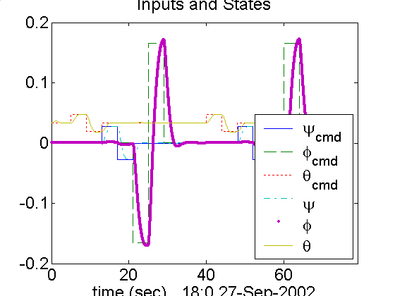

Figure 11

The above figure is the response of the Honeywell aircraft model with the improved controller.

A.1 Matlab Simulink Diagrams (Vectorized)
Top-Level System Diagram

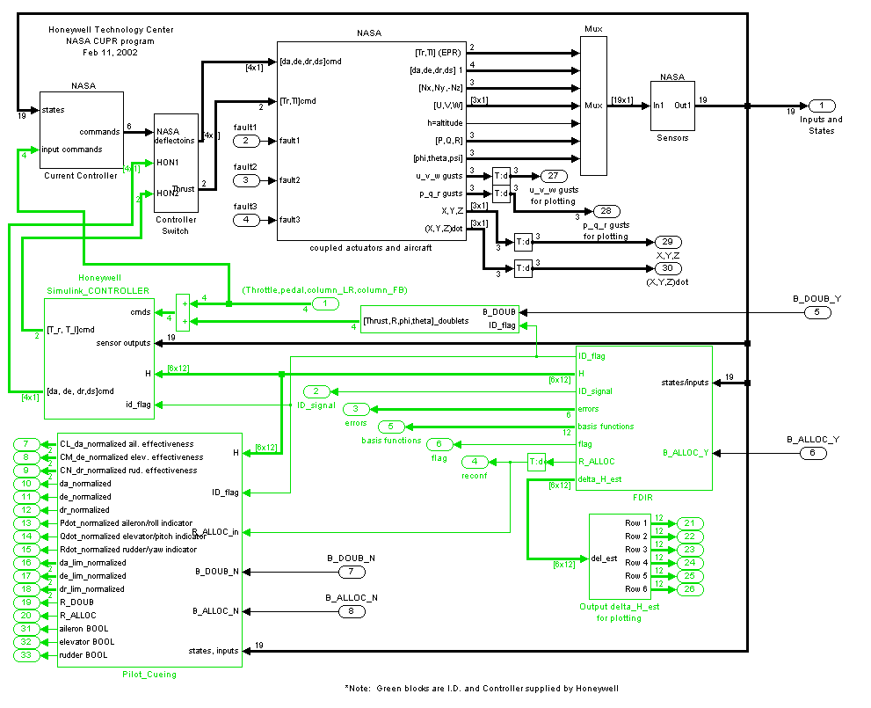
The following pages show the details of the sub-blocks of the above diagram.
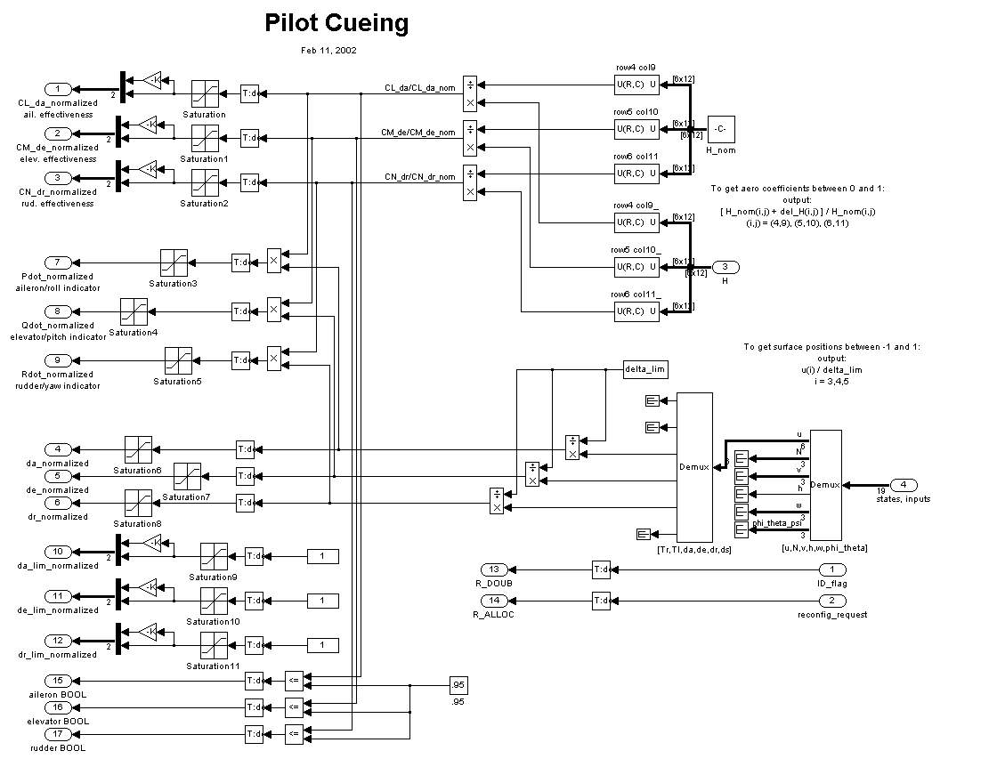

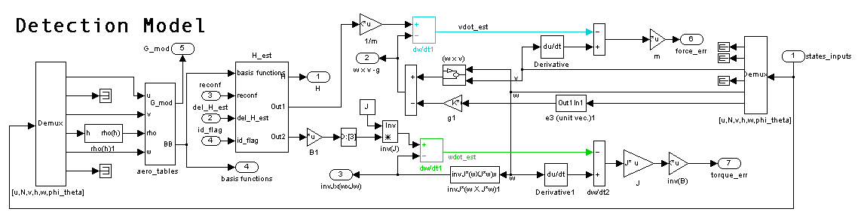

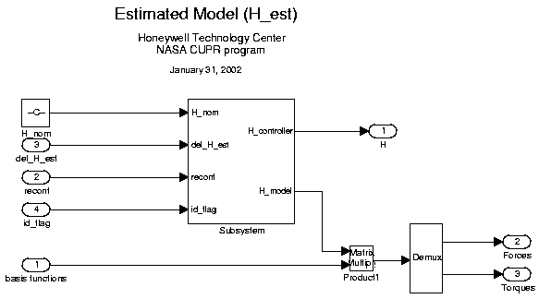

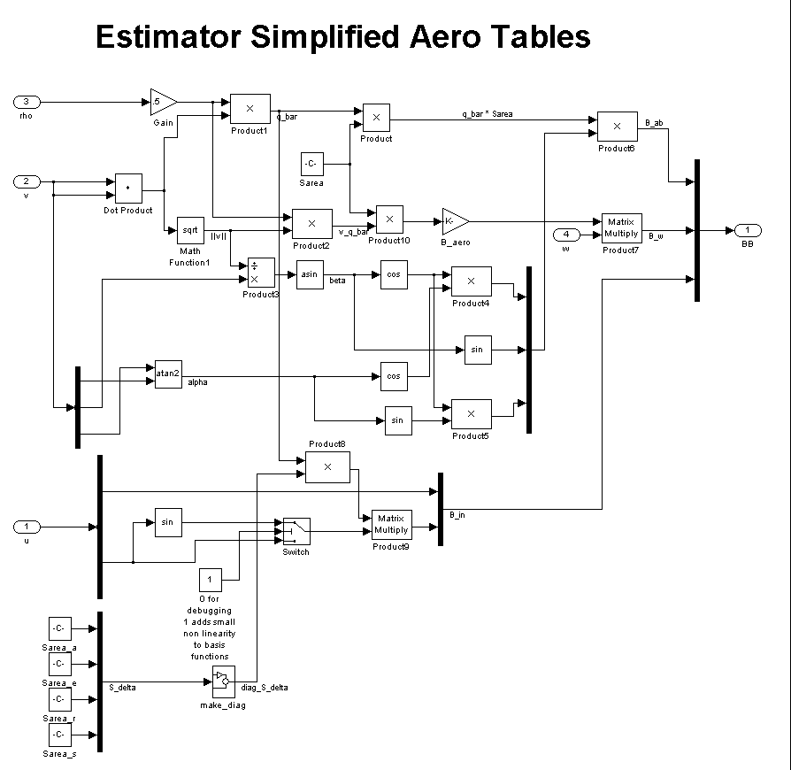

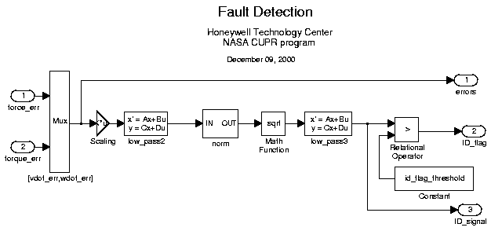

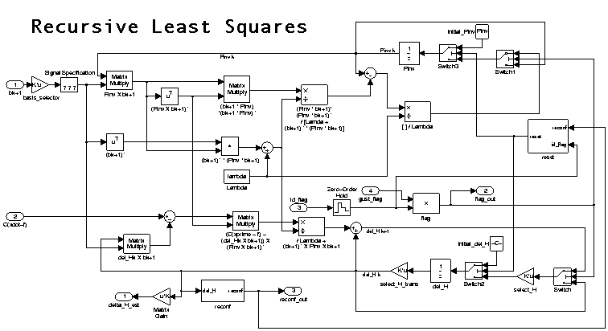

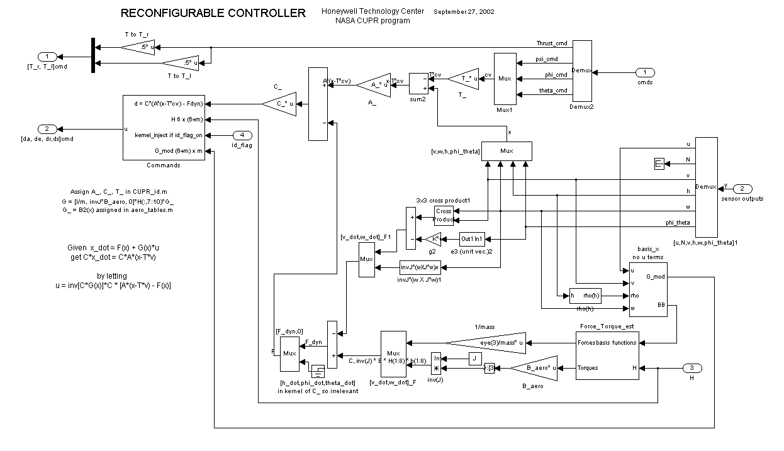

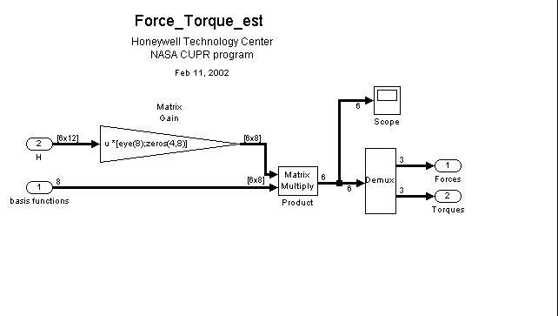

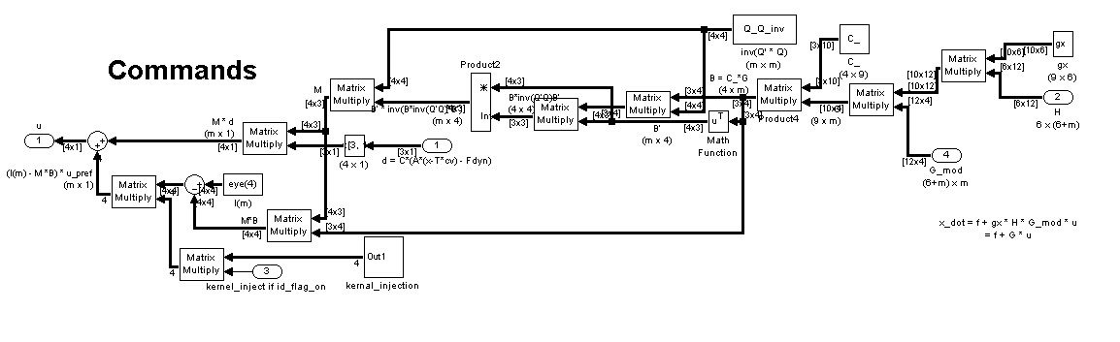

A.2 Matlab Functions
Main Program − CUPR_ID_subr.m to show initialization of variables.

%%%%%%%%%%%%%%%%%%%%%%%%%%%%%%%%%%%%%%%%%%%%%%%%
% CUPR_id_monti.m

% Version 3.1 Feb 07, 2002
%%%%%%%%%%%%%%%%%%%%%%%%%%%%%%%%%%%%%%%%%%%%%%%%
% Sonja Glavaski, Micheal Elgersma, Peter Lommel
% Honeywell
% NASA CUPR program (Tom Bundick)
%======================================================================
% UPDATE HISTORY:
% Version 2.0 Sep 11, 2000
% Added a parameterized controller. Sep 11, 2000
% Made trim computation optional. Sep 12, 2000
% Made R_cmd = f(V) in outer loop for coordinated flight Sep 22, 2000
% Inputs were (T,da,de,dr), now (U,R,phi,theta)_cmds Nov 28, 2000
% Now inputs can step at arbitrary times Nov 28, 2000
% Moved inverse operation from matlab block to subroutine Nov 29, 2000
% Fixed hinge moments. de(alpha), da(0), dr(-beta). Nov 29, 2000
% Added a barchart to display the parameter matrix, H Dec 04, 2000
% Reduced size of largest entries of H Dec 11, 2000
% Added "reconf" variable to turn reconfiguration on Dec 11, 2000
% Moved all plots to subroutine plot_test_results.m Dec 11, 2000
% Added user selected mode and fault # to plot filenames Dec 11, 2000
% Made separate error norms for each row of H matrix Dec 11, 2000
% Reduce Ts from .005 to .01, reduced a_act & filter bw Mar 20, 2001
% NOTE: 1/.01 = 100Hz for small aircraft, 40 Hz for 757? Mar 20, 2001

% Reduce Rcmd from 2 rad/sec to .2 rad/sec Apr 11, 2001

% Note: R and phi do not follow R_cmd and phi_cmd Apr 11, 2001
%
% initialized G_mod, gx and select_H, changed P to Pinv May 10, 2001
% changed x_initial to zeros(sizes(1) + sizes(2),1) May 10, 2001
% Rdot = -w_c*(R-Rcmd) May 11, 2001
% (s+10)/(s+1) in actuator control for hinge moments May 11, 2001
% initial_low_pass_1 = u_initial(1:4,1) May 11, 2001
% U_initial set in different place in code May 11, 2001
% input_magnitudes =[40,[.2, -.5, .025]*(580/v_fps(1))^2] May 11, 2001
% Added G_mod to global variables IN AERO_TABLES.M May 11, 2001
% Cleaned up controller/H_est diagram May 11, 2001
% Can successfully toggle nout between 3 and 6 May 14, 2001
% Removed -del_H*bk+1 from Hest in six_dof_3x3 May 14, 2001
% Deleted G_ and G_mod and removed from global variables May 15, 2001
% Allow 1 to 10 basis functions = n_basis May 29, 2001
% fault no. 4 is perturbing only da,de,dr coeff. May 29, 2001
% Put in thrust_rate_lim to limit min to max thrust time June 1, 2001
% Reduced thrust_time_scale to 4 sec June 1, 2001
% Open up limits on thrust, rate, and delta DURING TRIM June 1, 2001
% Changed speed of filters in Fault Detection Aug 1, 2001
% Updated noise values Aug 1, 2001
% 2 input_magnitudes *1 and *1/2 Aug 1, 2001
% 3 faults, added delta_H2, delta_H3 Aug 1, 2001
% 3 groups of input doublets Aug 1, 2001
% Added w_flex, zeta_flex and z_flex for elasticity Sept 6, 2001
% Changed aircraft to B-757 model
% H = inv(gx) * ([A_757,B_757] - F) * inv(G)
% Appended thrust inputs and changed surface inputs
% to radians in B_757 Jan 1, 2002
% Put in control allocation to allow for more inputs Jan 7, 2002
% Put weight matrix into control allocation Jan 14, 2002
% Automated outer loop gain on R_dot due to V Jan 17, 2002
% Added pilot cueing outputs Jan 22, 2002
% Modified sensor filter to accomodate additional inputs Jan 29, 2002
% Modified controller so thrusts are in F instead of G Feb 07, 2002

% Modified G to use B_aero instead of B_aero(1)*eye(3) Feb 07, 2002
% Added input doublets to simulink diagram and a
% switch(do_input_commands) to shut off commands
% generated in this .m file. Mar 07, 2002
% Control Psi instead of R Sep 26, 2002

% ------------------
% Note: To bypass actuators, connect the cable that bypasses the
% actuator blocks and move take-off point for states_inputs
% input to controller behind the low-pass filter.
% ------------------

% To do:

% H_nom is made in subroutine make_H,

% for debugging purposes we have temporarily modified it in this file

% H(1,10), H(1,12) and H(3,1) have been set to 0, and

% H(6,6) has been increased by a factor of approx. 10

% CHANGE B_aero(1)*eye to B_aero to match controller

%
% gx and G_mod should be made in 1 place (currently it is made
% seperately in make_H and controller)
%
% H_nom is currently a constant, in future make it a
% function of alpha by doing a least squares fit
% over all of the flight conditions
%
% I.D. the J matrix by adding basis fun(PQ,QR,PR,PP,QQ,RR)
%
% Change from discrete differentiator to non-causal filter
%
% Add ability to handle seperate left and right ailerons
%
% Note: Actuater models have stuck, floating, nominal switch
%-------------------------------------------------------
%
% This program sets up the variables for the aircraft FDIR simulation
%
% On December 13, 2000, 2pm, these files in
% /net/users/elgersma/NASA/Upset_Management/matlab/ID
% were the same as those in
% /net/users/elgersma/NASA/Upset_Management/matlab/deliverable_final
% which were sent to Tom Bundick at NASA LaRC on December 13, 2000.
%
% The aircraft model includes a nonlinear 6dof model, actutator dynamics, sensor
% dynamics, a parameterized controller, and FDIR for the 6dof model/controller.
%
% Detection:
% a) Feed the same inputs to the model and the physical plant
% b) compute a weighted norm of a lowpassed difference of the ouput vectors
% c) when the norm exceeds some threshold, an error is detected.
%
% Identification:
% c) while the norm exceeds some threshold, update a recursive parameter estimate
% d) ID; x_dot_model - x_dot_physical = dH*b(x,u) solve LSQ for dH
% where x_dot_model = f(x,u) + H0*b(x,u) and no model integrators are used
%
% Reconfiguration:
% e) The nonlinear controller is given as a function of the parameter matrix H
% f) After the ID steps/doublets are done, the controller uses H reconfigure.
%
% -----------------------------------------------------------------------------
%
% Another simulink model for the rudder, including FDI can be found in:
% /net/users/elgersma/NASA/Upset_Management/matlab/ID/monitor.
%
% The additional complexity with actuators comes from the fact that it has several modes:
% 1) Nominal operation
% 2) Stuck, with either delta=delta_limit or delta=delta_stuck
% 3) Floating, when the actuator toque is disconnected from the delta dynamics
% The position limits are dealt with by the mode switches, while the rate limits
% are implicitely enforced by the rate feedback and max torque.
%%%%%%%%%%%%%%%%%%%%%%%%%%%%%%%%%%%%%%%%%%%%%%%%%%%%%%%%%%%%%%%%%%%%%%%

global Sarea Sarea_a Sarea_e Sarea_r c_a c_e c_r rho_0 h_atmosphere H_nom B_aero delta_H delta_H_est Pinv lambda nout m C_ Q_Q_inv
clear Pinv_vec

% User input
%do_trim = input('Do you want to compute trim? 0(no), 1(yes) : ');
%fault_num=input('Which fault? 0(none) 1(Whole H matrix), 2(Icing), 3(Rudder), 4(pqr from da,de,dr), 5(pqr from all H) : ');

delta_H_change=0;
using_Monte_Carlo = 1; % 0 = no, 1 = yes, used to reduce time by not repeating trim.
min_change = 0;
if(delta_H_num==0)
delta_H_change=0.1;
elseif(delta_H_num==1)
delta_H_change=0;
min_change = 0;
elseif(delta_H_num==2)
delta_H_change=0.4;
min_change = .1;
elseif(delta_H_num==3)
delta_H_change=0.4;
min_change = .1;
else
delta_H_change=0.5;
end

Ts=0.01; % simulation sample time. Keep Ts*a_act < .6 to avoid aliasing, sample time can be increased when a/c model is replaced by B757 model

%%%%%%%%%%%%%%%%%%%%%%%%%%%%
% DETECTION initialization
%%%%%%%%%%%%%%%%%%%%%%%%%%%%
% Estimator detects fault if
% K_f*diag([1e-5 1e-5 1e-5 1 1 1])*[force_err;inv(B_aero)*torque_err] < id_flag_threshold
% id_flag_threshold=3;
K_f=0.03;
K_f_plot=5; % used in plot routines

%%%%%%%%%%%%%%%%%%%%%%%%
% Physical constants
%%%%%%%%%%%%%%%%%%%%%%%%

deg2rad=pi/180;
g = 32.2; % ft/s^2
% rho=rho_0*exp(-h/h_atmosphere) done in subroutines, h is a state
h_atmosphere=30000; % feet
rho_0 = .00237; % slug/ft^3

%%%%%%%%%%%%%%%%%%%%%%%%%%%%%%%%%%%%%%%%%%%
% Set aerodynamic areas and lengths
%%%%%%%%%%%%%%%%%%%%%%%%%%%%%%%%%%%%%%%%%%%

Sarea = 1951; % feet^2 % wing&body area

Sarea_a = 0.08*Sarea ; % aileron area
Sarea_e = 0.015*Sarea ; % elevator area
Sarea_r = 0.03*Sarea ; % rudder area
Sarea_s = 0.05*Sarea ; % stab. area

b = 124.52; % feet % wing span
c = 16.6417; % feet % wing chord
B_aero = diag([b,c,b]);

chord_scale=0.02; % aero surfaces are hinged approximately at their center
c_a = chord_scale*0.1*c;
c_e = chord_scale*0.07*c;
c_r = chord_scale*0.17*c;

%%%%%%%%%%%%%%%%%%%%%%%%%%%%%%
% Set up the mass properties
%%%%%%%%%%%%%%%%%%%%%%%%%%%%%%

J = [1219999, 0, 152999;
0, 5306344, 0;
152999, 0, 6349998]; % slug*ft^2
invJ = inv(J);
mass = 5625; % slugs

%%%%%%%%%%%%%%%%%%%%%%%%%%%%
% CONTROLLER initialization
%%%%%%%%%%%%%%%%%%%%%%%%%%%%

% Controller Design
% Have x_dot = f(x,Tr,Tl) + G(x)*u where u = [da,de,dr,ds]
% Get C_*x_dot = C_*A_*(x-T*cv) where cv are the controlled variables
% by setting u = inv(C_*G(x))*C_ * (A_*(x-T*cv) - f(x,Tr,Tl))

% CONTROL ALLOCATION ( when m=dim(u)>rows(C_)=3, ie redundant control surfaces)

% Let d = C_*(A_*(x-T*cv) - f(x)) d in R^3

% Let B = C_*G(x) B in R^{3-by-m2}

% Minimize ||Q_*(u-u_pref)||, subject to constraint: B*u=d

% Solution: Let M = inv(Q_'*Q_)*B'*inv(B*inv(Q_'*Q_)*B')

% then u = [M, I-M]*[d; u_pref]

% Note that when Q_=I and B is square, then M = inv(B) = inv(C_*G(x))
% x = [v,w,h,phi_theta]
% cv = [v(1), R, phi, theta]_cmd % outer loop makes R_cmd = f(v(2))
% G = H(:, columns associated with u)*G_ G_ from aero_tables.m
T_ = zeros(10,3); T_(10,1)=1; T_(8,2)=1; T_(9,3)=1;%
C_ = zeros(3,10); C_(1,4)=1; C_(2,5)=1; C_(3,6)=1;% u, P,Q,R
Q_ = diag([1,1,1,5]); %weighting matrix so surfaces are used before engines
Q_Q_inv = inv(Q_*Q_); %done here to save time during simulation due to repetition.
lam_c = .3/2; w_c = 3/2; % rad/sec
A_ = zeros(10,10);
A_(1,1) = -lam_c;
A_(4,4) = -2*.7*w_c;
A_(4,8) = -w_c*w_c;
A_(5,5) = -2*.7*w_c;
A_(5,9) = -w_c*w_c;
A_(6,6) = -2*.7*w_c;
A_(6,10) = -w_c*w_c;
A_(8,4) = 1;
A_(9,5) = 1;
A_(10,6) = 1;

% filter bandwidths (rad/s)
a_fil=40; % v_dot 20 rad/sec
b_fil=40; % w_dot 30 rad/sec
c_fil=3; % sensors_to_detection 10 rad/sec (do not filter sensors_to_control)
d_fil= 2; % command inputs d_fil was 2
f_fil=.75;
g_fil=.75;

B_ALLOC = 1;
B_DOUB = 0;

% Scale states so that none are huge, so trim routine works better

v_scale = diag([300,1,10]);% makes inv(v_scale)*[U,V,W] approximately size 1
inv_v_scale = inv(v_scale);

% form constant matrices

H_nom = zeros(6,12);

%%% from old model
H_nom = [-0.0030 0 0 0 0 0 0.9998 0.9998 0 0 0 0 ;
0 -0.7600 0 -0.0440 0 2.3000 0 0 0 0 1.0000 0 ;
0 0 -6.0000 0 -23.0000 0 0.0200 0.0200 0 -1.0000 0 -1.0000 ;
0 -0.1300 0 -1.4000 0 0.5500 0 0 -0.7020 0 0.0780 0 ;
0 0 -0.7300 0 -22.0000 0 0.0816 0.0816 0 -4.0816 0 -4.0816 ;
0 0.2700 0 -0.0220 0 -1.2000 0 0 0 0 -0.6240 0 ];

delta_H = zeros(size(H_nom));
delta_H2 = zeros(size(H_nom));
delta_H3 = zeros(size(H_nom));

n_basis = 12;
nout=6; % nout=3 we estimate only [p,q,r] coeff. nout=6 for [u,v,w,p,q,r] coeff

if(fault_num>3)
nout = 3;
n_basis = 5;
end

%%%%%%%%%%%%%%%%%%%%%%%%%%%%%%%%%%%%%%%%%%%%%%%%%
%%%% Making the basis selector
%%%%%%%%%%%%%%%%%%%%%%%%%%%%%%%%%%%%%%%%%%%%%%%%%

indices = zeros(n_basis,1);

if (fault_num==0) % no faults
indices = [1 2 3 4 5 6 7 8 9 10 11 12];
elseif (fault_num==1) % percent change to all of H
nout = 3;
indices = [1 2 3 4 5 6 7 8 9 10 11 12];
elseif(fault_num==2) % icing
indices = [1 2 3 4 5 6 7 8 9 10 11 12];
elseif(fault_num==3) % rudder
indices = [1 2 3 4 5 6 7 8 9 10 11 12];
elseif(fault_num==4) % perturb and id Pdot, Qdot, Rdot due to da, de, dr, ds
indices = [1 9 10 11 12];
elseif(fault_num==5) % perturb and id Pdot, Qdot, Rdot due to da
indices = [1 9 10 11 12];
elseif(fault_num==6) % perturb and id Pdot, Qdot, Rdot due to de
indices = [1 9 10 11 12];
elseif(fault_num==7) % perturb and id Pdot, Qdot, Rdot due to dr
indices = [1 9 10 11 12];
elseif(fault_num==8) % perturb and id Pdot, Qdot, Rdot due to ds
indices = [1 9 10 11 12];
elseif(fault_num==9) % perturbing all, id Pdot, Qdot, Rdot
indices = [1 9 10 11 12];
elseif(fault_num==10) % fault 4 w/ gradual fault.
indices = [1 9 10 11 12];
elseif(fault_num==11) % floating aileron
indices = [1 9 10 11 12];
end

basis_selector = zeros(n_basis,12);
for(indexer = 1:n_basis)
basis_selector(indexer,indices(indexer)) = 1;
end

%%%%%%%%%%%%%%%%%%%%%%%%%%%%
% ID initialization
%%%%%%%%%%%%%%%%%%%%%%%%%%%%

select_H = [zeros(nout,6-nout),eye(nout)]; % selects the last 'nout' rows of H.
lambda = 1; % forgetting factor in recursive ID. 0 <=lambda <= 1 1 for no forgetting
W = .01*eye(n_basis);
Pinv = inv(W*W');

%%%%%%%%%%%%%%%%%%%%%
% Draw Simulink diagram
%%%%%%%%%%%%%%%%%%%%%

%six_dof_3x3 % draws the simulink diagram

% Initialize the simulink diagram parameters
v_fps = [780; 0; 29]; % (ft/sec)
v_initial=inv(v_scale)*v_fps; % scaled so all states are about same size
w_initial = zeros(3,1); % angular rate vector
euler_initial = [0; 0.033; 0]; % phi, theta, psi (radians)
h_initial = 5000; % (ft)
rho=rho_0*exp(-h_initial/h_atmosphere);
q_bar_0 = .5*rho*v_fps'*v_fps;
Cd_0 = -H_nom(1,1); % adjust this based on A(1,1) from linear model
T_initial = (mass*g*sin(euler_initial(2)) + q_bar_0 * Sarea * Cd_0) / 2;
neg_Nz_initial = -1;
initial_low_pass1 = [w_initial(3); euler_initial(1:2)]; % cmds = [R,phi,theta]_cmd

E_initial = [cos(euler_initial(2))*cos(euler_initial(3)), cos(euler_initial(2))*sin(euler_initial(3)), -sin(euler_initial(2));
sin(euler_initial(1))*sin(euler_initial(2))*cos(euler_initial(3)) - cos(euler_initial(1))*sin(euler_initial(3)), sin(euler_initial(1))*sin(euler_initial(2))*sin(euler_initial(3)) + cos(euler_initial(1))*cos(euler_initial(3)), sin(euler_initial(1))*cos(euler_initial(2));
cos(euler_initial(1))*sin(euler_initial(2))*cos(euler_initial(3)) + sin(euler_initial(1))*sin(euler_initial(3)), cos(euler_initial(1))*sin(euler_initial(2))*sin(euler_initial(3)) - sin(euler_initial(1))*cos(euler_initial(3)), cos(euler_initial(1))*cos(euler_initial(2))];
E_initial_vec = [E_initial(:,1);E_initial(:,2);E_initial(:,3)];

xyzE_initial = [0;0;-h_initial];

%%%%%%%%%%%%%%%%%%%%%%%%%%%%%%%%%%%%%
% Set initial values for states and inputs
%%%%%%%%%%%%%%%%%%%%%%%%%%%%%%%%%%%%%

input_magnitudes =[0,0,0,0,1,1,1]; % this will be changed later, the next line will not work without it.
[sizes,x0,xstr]=six_dof_3x3([],[],[],0); % xstr is a string with state names
x_initial = zeros(sizes(1)+sizes(2),1);
y_initial = zeros(sizes(3),1);
u_initial = zeros(sizes(4),1);

% Initialize the commanded inputs
u_initial(1) = 2*T_initial;
u_initial(2:4,1) = initial_low_pass1;
u_initial(5,1) = 0; % fault
u_initial(6,1) = 0; % fault
u_initial(7,1) = 0; % fault
%u_initial(8,1) = 2; % aileron mode

% Determine the locations of the states (redo if diagram names change)
iT1=strmatch('six_dof_3x3/coupled actuators and aircraft/actuators/Engine_r/Int Thrust//scale',xstr,'exact');
iT2=strmatch('six_dof_3x3/coupled actuators and aircraft/actuators/Engine_l/Int Thrust//scale',xstr,'exact');
iv = strmatch('six_dof_3x3/coupled actuators and aircraft/Int v',xstr,'exact');
iw = strmatch('six_dof_3x3/coupled actuators and aircraft/Int w',xstr,'exact');
i_lp= strmatch('six_dof_3x3/low_pass',xstr,'exact');
i_lp1= strmatch('six_dof_3x3/low_pass1',xstr,'exact');
i_Pinv= strmatch('six_dof_3x3/Recursive_Least_Squares/Pinv',xstr,'exact');
i_del_H= strmatch('six_dof_3x3/Recursive_Least_Squares/del_H',xstr,'exact');
i_flex1= strmatch('six_dof_3x3/coupled actuators and aircraft/Wing flex/Integrator',xstr,'exact');
i_flex2= strmatch('six_dof_3x3/coupled actuators and aircraft/Wing flex/Integrator1',xstr,'exact');
i_flex3= strmatch('six_dof_3x3/coupled actuators and aircraft/Wing flex/Integrator2',xstr,'exact');
i_flex4= strmatch('six_dof_3x3/coupled actuators and aircraft/Wing flex/Integrator3',xstr,'exact');
i_flex5= strmatch('six_dof_3x3/coupled actuators and aircraft/Wing flex/Integrator4',xstr,'exact');
i_flex6= strmatch('six_dof_3x3/coupled actuators and aircraft/Wing flex/Integrator5',xstr,'exact');
i_E = strmatch('six_dof_3x3/coupled actuators and aircraft/Int_E',xstr,'exact');
i_xyz = strmatch('six_dof_3x3/coupled actuators and aircraft/Int_xyz',xstr,'exact');
i_errors1 = strmatch('six_dof_3x3/FAULT_DETECTION/low_pass2',xstr,'exact');
i_errors2 = strmatch('six_dof_3x3/FAULT_DETECTION/low_pass3',xstr,'exact');

%Initialize the detection filter states
for i_fil = 1:n_basis
Pinv_vec(n_basis*(i_fil-1)+1 : n_basis*i_fil , 1)= Pinv(:,i_fil);
end

x_initial(i_Pinv,1) = Pinv_vec;
x_initial(i_E,1) = E_initial_vec;
x_initial(i_xyz,1) = xyzE_initial;

x_initial(i_flex4,1) = .2; % Prevents singular matrix in trim.

% Initialize the thrust states
x_initial(iT1,1) = T_initial/thrust_scale; % Thrust/thrust_scale
x_initial(iT2,1) = T_initial/thrust_scale; % Thrust/thrust_scale

% Initialize the rigid-body state vector
x_initial(iv,1) = v_initial; % v = [U,V,W]
x_initial(iw,1) = w_initial; % w = [P,Q,R]

% Initialize the filter states
x_initial(i_lp,1)=[T_initial/thrust_scale; T_initial/thrust_scale; zeros(6,1); neg_Nz_initial; v_scale*v_initial;h_initial;zeros(4,1);euler_initial(2:3)];
%x_initial(i_lp1,1) = initial_low_pass1;

%%%%%%%%%%%%%%%%%%%%%%%%%%%%%%%%%%
% TRIM
%%%%%%%%%%%%%%%%%%%%%%%%%%%%%%%%%%

disp('%%%%% TRIM %%%%%')
cupr_options=foptions; % read the default options
%cupr_options(14)=5000; % max number of iterations in trim routine

IX=[iv(2),i_E',i_Pinv',i_del_H']; % discrete states held const. so that nout and detection filters don't effect trim.
% inputs 1 to 4 are the commanded values of four states [T,psi,phi,theta]
IU = [1 5 6 7]; % indices of inputs held constant during trim search (inputs 5:7 = faults, 8 = aileron mode)

IY = []; % indices of outputs that are held constant during trim search
DX = zeros(sizes(1),1); % derivitive (d/dt)*X(IDX) = DX(IDX) constant
IDX=[1:i_xyz(1)-1, i_xyz(3)+1:sizes(1)]'; % changed size, transposed
i_errors2+1:i_errors1(1)-1, i_errors1(6)+1:sizes(1)]'; % changed size, transposed

if(do_trim == 1)
delta_lim_temp = delta_lim;
rate_lim_temp = rate_lim;
thrust_max_temp = thrust_max;
thrust_min_temp = thrust_min;
thrust_rate_lim_temp = thrust_rate_lim;
K_noise=0; % turn off noise during trim computation
delta_lim = 1e9;
rate_lim = 1e9;
thrust_max = 1e9;
thrust_min = -1e9;
thrust_rate_lim = 1e9;
[x_tr,u_tr,y_tr,dx_tr,option_tr]= ...
trim('six_dof_3x3',x_initial,u_initial,y_initial,IX,IU,IY,DX,IDX,cupr_options);
delta_lim = delta_lim_temp;
rate_lim = rate_lim_temp;
thrust_max = thrust_max_temp;
thrust_min = thrust_min_temp;
thrust_rate_lim = thrust_rate_lim_temp;
K_noise=1; % turn noise back on again after trim is computed
x_tr_temp = x_tr;
u_tr_temp = u_tr;
y_tr_temp = y_tr;
else
if(using_Monte_Carlo==0)
x_tr = x_initial;
u_tr = u_initial;
y_tr = y_initial;
else
x_tr = x_tr_temp;
u_tr = u_tr_temp;
y_tr = y_tr_temp;
end
end

%%%%%%%%%%%%%%%%%%%%%%%
% Fault choice (Replace with Faults in aero coeff in 757 sim)
%%%%%%%%%%%%%%%%%%%%%%%

delta_mat = zeros(size(H_nom));
delta_mat2 = zeros(size(H_nom));
delta_mat3 = zeros(size(H_nom));

if (fault_num==0) % no faults
delta_H = delta_mat.*H_nom;
delta_H2 = delta_mat.*H_nom;
delta_H3 = delta_mat.*H_nom;
elseif (fault_num==1) % percent change to all of H
%delta_mat = -(min_change+delta_H_change*rand(6,12));
delta_mat(4:6,:) = -(min_change+delta_H_change*rand(3,12));
%delta_H = delta_mat.*H_nom;
delta_H(4:6,:) = delta_mat(4:6,:).*H_nom(4:6,:);
%delta_mat2 = -(min_change+delta_H_change*rand(6,12));
delta_mat2(4:6,:) = -(min_change+delta_H_change*rand(3,12));
%delta_H2 = delta_mat2.*H_nom;
delta_H2(4:6,:) = delta_mat2(4:6,:).*H_nom(4:6,:);
%delta_mat3 = -(min_change+delta_H_change*rand(6,12));
delta_mat3(4:6,:) = -(min_change+delta_H_change*rand(3,12));
%delta_H3 = delta_mat3.*H_nom;
delta_H3(4:6,:) = delta_mat3(4:6,:).*H_nom(4:6,:);
elseif(fault_num==2) % icing
delta_mat(5,3) = .85;
delta_mat(5,10) = .85;
delta_H(5,3) = delta_mat(5,3)*H_nom(5,3); % UIUC percentage change in CM_alpha
delta_H(5,10) = delta_mat(5,10)*H_nom(5,10); % UIUC percentage change in CM_de
delta_H2 = delta_H;
delta_H3 = delta_H;
elseif(fault_num==3) % rudder
delta_mat(6,11) = -(min_change+delta_H_change*rand);
delta_H(6,11) = delta_mat(6,11)*H_nom(6,11); % CN_dr
delta_mat2(6,11) = -(min_change+delta_H_change*rand);
delta_H2(6,11) = delta_mat2(6,11)*H_nom(6,11); % CN_dr
delta_mat3(6,11) = -(min_change+delta_H_change*rand);
delta_H3(6,11) = delta_mat3(6,11)*H_nom(6,11); % CN_dr
elseif(fault_num==4) % perturb and id Pdot, Qdot, Rdot due to da, de, dr, ds
delta_mat(4:6,9:12) = -(min_change+delta_H_change*rand(3,4)); %-(delta_H_change/2 + (delta_H_change/2)*rand(3,3));
delta_H(4:6,9:12) = delta_mat(4:6,9:12).*H_nom(4:6,9:12);
delta_mat2(4:6,9:12) = -(min_change+delta_H_change*rand(3,4));
delta_H2(4:6,9:12) = delta_mat2(4:6,9:12).*H_nom(4:6,9:12);
delta_mat3(4:6,9:12) = -(min_change+delta_H_change*rand(3,4));
delta_H3(4:6,9:12) = delta_mat3(4:6,9:12).*H_nom(4:6,9:12);
elseif(fault_num==5) % perturb and id Pdot, Qdot, Rdot due to da
%delta_mat(4:6,9) = -(min_change+delta_H_change*rand(3,1));
delta_mat(4:6,9) = -(min_change+delta_H_change*ones(3,1));
delta_H(4:6,9) = delta_mat(4:6,9).*H_nom(4:6,9);
delta_mat2(4:6,9) = -(min_change+delta_H_change*rand(3,1));
delta_H2(4:6,9) = delta_mat2(4:6,9).*H_nom(4:6,9);
delta_mat3(4:6,9) = -(min_change+delta_H_change*rand(3,1));
delta_H3(4:6,9) = delta_mat3(4:6,9).*H_nom(4:6,9);
elseif(fault_num==6) % perturb and id Pdot, Qdot, Rdot due to de
delta_mat(4:6,10) = -(min_change+delta_H_change*ones(3,1));%*rand(3,1));
delta_H(4:6,10) = delta_mat(4:6,10).*H_nom(4:6,10);
delta_mat2(4:6,10) = -(min_change+delta_H_change*rand(3,1));
delta_H2(4:6,10) = delta_mat2(4:6,10).*H_nom(4:6,10);
delta_mat3(4:6,10) = -(min_change+delta_H_change*rand(3,1));
delta_H3(4:6,10) = delta_mat3(4:6,10).*H_nom(4:6,10);
elseif(fault_num==7) % perturb and id Pdot, Qdot, Rdot due to dr
delta_mat(4:6,11) = -(min_change+delta_H_change*ones(3,1));%rand(3,1));
delta_H(4:6,11) = delta_mat(4:6,11).*H_nom(4:6,11);
delta_mat2(4:6,11) = -(min_change+delta_H_change*rand(3,1));
delta_H2(4:6,11) = delta_mat2(4:6,11).*H_nom(4:6,11);
delta_mat3(4:6,11) = -(min_change+delta_H_change*rand(3,1));
delta_H3(4:6,11) = delta_mat3(4:6,11).*H_nom(4:6,11);
elseif(fault_num==8) % perturb and id Pdot, Qdot, Rdot due to ds
delta_mat(4:6,12) = -(min_change+delta_H_change*rand(3,1));
delta_H(4:6,12) = delta_mat(4:6,12).*H_nom(4:6,12);
delta_mat2(4:6,12) = -(min_change+delta_H_change*rand(3,1));
delta_H2(4:6,12) = delta_mat2(4:6,12).*H_nom(4:6,12);
delta_mat3(4:6,12) = -(min_change+delta_H_change*rand(3,1));
delta_H3(4:6,12) = delta_mat3(4:6,12).*H_nom(4:6,12);
elseif(fault_num==9) % perturbing all, id Pdot, Qdot, Rdot
delta_mat = -(min_change+delta_H_change*rand(6,12));
delta_H = delta_mat.*H_nom;
delta_mat2 = -(min_change+delta_H_change*rand(6,12));
delta_H2 = delta_mat2.*H_nom;
delta_mat3 = -(min_change+delta_H_change*rand(6,12));
delta_H3 = delta_mat3.*H_nom;
elseif(fault_num==10) % fault 4, gradual fault.
delta_mat(4:6,9:12) = -(min_change+delta_H_change*rand(3,4));
delta_H(4:6,9:12) = delta_mat(4:6,9:12).*H_nom(4:6,9:12);
elseif(fault_num==11) % floating aileron
delta_H(4:6,9) = -H_nom(4:6,9);
delta_H2(4:6,9) = -H_nom(4:6,9);
delta_H3(4:6,9) = -H_nom(4:6,9);
else
disp('Nonexisting fault chosen! ')
end

%%%%%%%%%%%%%%%%%%%%%%%%%%%%%%%%%%%%%%%%%%%%%%%%%%%%%%%%%%%%%%%%%%%%%%%
% ID maneuver consists of steps or doublets in each input.
% This maneuver approximately decouples the [x(t1), ..., x(tk);
% u(t1), ..., u(tk)];
%%%%%%%%%%%%%%%%%%%%%%%%%%%%%%%%%%%%%%%%%%%%%%%%%%%%%%%%%%%%%%%%%%%%%%%

Tf = 75; % (sec) final time
Ti = 0; % (sec) initial time
Tfault = 2; % (sec) Time at which fault occurs
if(fault_num < 10)
rand_fault = randperm(25);
Tfault2 = 2 + rand_fault(1); % (sec) Time at which second fault occurs
Tfault2 = min(Tf-2*Ts,Tfault2);
rand_fault = randperm(30);
Tfault3 = Tfault2 + rand_fault(1); % (sec) Time at which second fault occurs
Tfault3 = min(Tf-Ts,Tfault3);
else
Tfault2 = Tf - 2*Ts;
Tfault3 = Tf - Ts;
end

% temporary to give 1 fault only %
Tfault2 = Tf - 2*Ts;
Tfault3 = Tf - Ts;

Tt = [ 5 9 13 40 44 48 75 79 83]; % (sec) times for theta doublet [start, middle, stop, start2, middle2, stop2]
Tpsi = [ 13.1 17 21 48.1 52 56 83.1 87 91]; % (sec) times for R doublet [start, middle, stop, start2, middle2, stop2]
Tp = [ 21.1 25 29 56.1 60 64 91.1 95 99]; % (sec) times for phi doublet [start, middle, stop, start2, middle2, stop2]
TT = [29.1 35 64.1 70 99.1 105]; % (sec) times for thrust step [start, stop, start2, stop2]

% Make input step/doublets for [U_cmd, R_cmd, Phi_cmd, Theta_cmd, fault]
u1 = [zeros(1,floor((TT(1) - Ti)/Ts)) ones(1,floor((TT(2) -TT(1))/Ts)) zeros(1,floor((TT(3) -TT(2))/Ts)) ones(1,floor((TT(4) -TT(3))/Ts)) zeros(1,floor((TT(5) -TT(4))/Ts)) ones(1,floor((TT(6) -TT(5))/Ts)) zeros(1,floor((Tf- TT(4))/Ts)) 0];
%u2 = [zeros(1,floor((TR(1) - Ti)/Ts)) ones(1,floor((TR(2) -TR(1))/Ts)) -ones(1,floor((TR(3) -TR(2))/Ts)) zeros(1,floor((TR(4) -TR(3))/Ts)) ones(1,floor((TR(5) -TR(4))/Ts)) -ones(1,floor((TR(6) -TR(5))/Ts)) zeros(1,floor((TR(7) -TR(6))/Ts)) ones(1,floor((TR(8) -TR(7))/Ts)) -ones(1,floor((TR(9) -TR(8))/Ts)) zeros(1,floor((Tf- TR(9))/Ts)) 0];
u2 = [zeros(1,floor((Tpsi(1) - Ti)/Ts)) ones(1,floor((Tpsi(2) -Tpsi(1))/Ts)) -ones(1,floor((Tpsi(3) -Tpsi(2))/Ts)) zeros(1,floor((Tpsi(4) -Tpsi(3))/Ts)) ones(1,floor((Tpsi(5) -Tpsi(4))/Ts)) -ones(1,floor((Tpsi(6) -Tpsi(5))/Ts)) zeros(1,floor((Tpsi(7) -Tpsi(6))/Ts)) ones(1,floor((Tpsi(8) -Tpsi(7))/Ts)) -ones(1,floor((Tpsi(9) -Tpsi(8))/Ts)) zeros(1,floor((Tf- Tpsi(9))/Ts)) 0];
u3 = [zeros(1,floor((Tp(1) - Ti)/Ts)) ones(1,floor((Tp(2) -Tp(1))/Ts)) -ones(1,floor((Tp(3) -Tp(2))/Ts)) zeros(1,floor((Tp(4) -Tp(3))/Ts)) ones(1,floor((Tp(5) -Tp(4))/Ts)) -ones(1,floor((Tp(6) -Tp(5))/Ts)) zeros(1,floor((Tp(7) -Tp(6))/Ts)) ones(1,floor((Tp(8) -Tp(7))/Ts)) -ones(1,floor((Tp(9) -Tp(8))/Ts)) zeros(1,floor((Tf- Tp(9))/Ts)) 0];
u4 = [zeros(1,floor((Tt(1) - Ti)/Ts)) ones(1,floor((Tt(2) -Tt(1))/Ts)) -ones(1,floor((Tt(3) -Tt(2))/Ts)) zeros(1,floor((Tt(4) -Tt(3))/Ts)) ones(1,floor((Tt(5) -Tt(4))/Ts)) -ones(1,floor((Tt(6) -Tt(5))/Ts)) zeros(1,floor((Tt(7) -Tt(6))/Ts)) ones(1,floor((Tt(8) -Tt(7))/Ts)) -ones(1,floor((Tt(9) -Tt(8))/Ts)) zeros(1,floor((Tf- Tt(9))/Ts)) 0];
fault= [zeros(1,floor((Tfault -Ti)/Ts)) ones(1,floor((Tfault2 - Tfault )/Ts)) zeros(1,floor((Tf - Tfault2) / Ts)) 0];
fault2= [zeros(1,floor((Tfault2 -Ti)/Ts)) ones(1,floor((Tfault3 - Tfault2 )/Ts)) zeros(1,floor((Tf - Tfault3) / Ts)) 0];
fault3= [zeros(1,floor((Tfault3 -Ti)/Ts)) ones(1,floor((Tf - Tfault3 )/Ts)) 0];
aileron_mode= 2*ones(1,length(u1));

if(fault_num==10)
fault_length = 40; %seconds
fault_step = 1 / (fault_length / Ts);
fault= [zeros(1,floor((Tfault -Ti)/Ts)) [0:fault_step:1] ones(1,floor((Tf - Tfault - fault_length)/Ts)) 1];
fault2= [zeros(1,floor((Tf - Ti)/Ts)) 0];
fault3= [zeros(1,floor((Tf - Ti)/Ts)) 0];
end

if(fault_num == 11)
aileron_mode= [2*ones(1,floor((Tfault - Ti)/Ts)) ones(1,floor((Tf - Tfault)/Ts))];
end
if(fault_num == 12)
aileron_mode= [2*ones(1,floor((Tfault - Ti)/Ts)) ones(1,floor((Tf - Tfault)/Ts))];
end

tt = [Ti:Ts:Tf]'; % make time vector for simulation

% Chop off the few mismatched points to make all lengths the same
leng_=min([length(u1),length(u2),length(u3),length(u4),length(fault),length(fault2),length(fault3),length(tt)]);
u1 = u1(1:leng_);
u2 = u2(1:leng_);
u3 = u3(1:leng_);
u4 = u4(1:leng_);
fault = fault(1:leng_);
fault2 = fault2(1:leng_);
fault3 = fault3(1:leng_);
tt = tt(1:leng_);
aileron_mode = aileron_mode(1:leng_);

if(command_mag==0)
input_magnitudes =[.05*mass*g,[.025, -.15, .0125]*(580/v_fps(1))^2, 1, 1, 1];%[Thrust_cmd (lbs), psi_cmd (rad/s), Phi_cmd (rad), Theta_cmd (rad), fault, fault2] * ½

else
input_magnitudes =[.10*mass*g,[.05, -.3, .025]*(580/v_fps(1))^2, 1, 1, 1];%[Thrust_cmd (lbs), psi_cmd (rad/s), Phi_cmd (rad), Theta_cmd (rad), fault, fault2]
end

step_tt_vector = diag(input_magnitudes)*[u1;u2;u3;u4;fault;fault2;fault3];%;reconf]; % combine magnitudes and step/doublet waveforms
trim_tt = ones(length(tt),1)*u_tr(1:7)'; % trim value of inputs

do_input_commands = 1;
if(do_input_commands == 0)
step_tt_vector(1:4,:) = zeros(4,length(step_tt_vector));
end
u_sim = [tt (step_tt_vector'+trim_tt)]; % trim + incremental

%%%%%%%%%%%%%%%%%%%%%%%%%%%%%%%%%%%%%
% SIMULATION
%%%%%%%%%%%%%%%%%%%%%%%%%%%%%%%%%%%%%

disp('%%%%% TEST SIMULATION %%%%%')

sim_option=simset('InitialState',x_tr,'FixedStep',Ts,'Solver','ode5'); [t_sim,x_sim,y_sim]=sim('six_dof_3x3',[tt(1),tt(length(tt))],sim_option,u_sim);
%%%%%%%%%%%%%%%%%%%%%%%%%%%%%%%%%%%%%

A.2.1 Matlab Functions
TBD

Appendix B
Pilot Cueing System Requirements

The pilot cueing system consists of displays on the pilot's Multi-Function Display and Primary Flight Display plus aural alerts. Existing displays and formats will be used for all other displays. As part of this research, aural alerting strategies, and new MFD and PFD formats will be evaluated. The aural alerts are designed to get the pilot's attention and direct this attention to the proper display. The MFD displays are designed:
- To alert the pilot to:
- Control actuator failures
- Control surface damage
- Control and lifting surface icing
- To cue the pilot to:
- Location of failure/damage
- Performance degradation due to failures, damage, and icing
- Control re-allocation
- Envelope restrictions
The PFD displays are designed to provide guidance cues to the pilot to assist in recovering the airplane from control upsets including those due to:
- Control element failures and damage
- Icing
- Turbulence and wake vortices

B.1 Cueing System Functional Requirements
Cueing system functional requirements are shown in Figure B1, and cue categorization is depicted in Figure B2. These figures illustrate the general conception of the CUPR cueing system, a subset of which will be implemented for this experiment. Specific displays to be implemented are detailed in Sections B.2 to B.4.

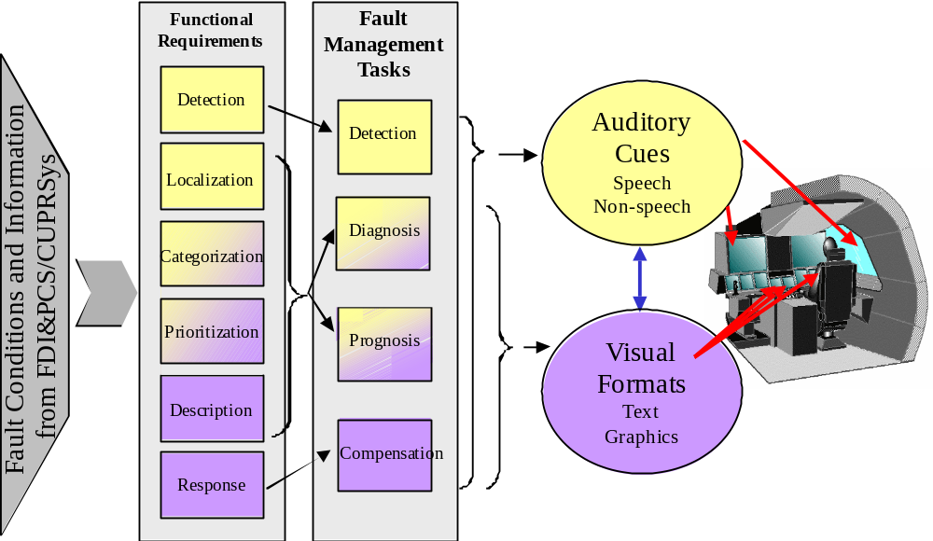

Figure B1. Cueing System Functional Requirements.
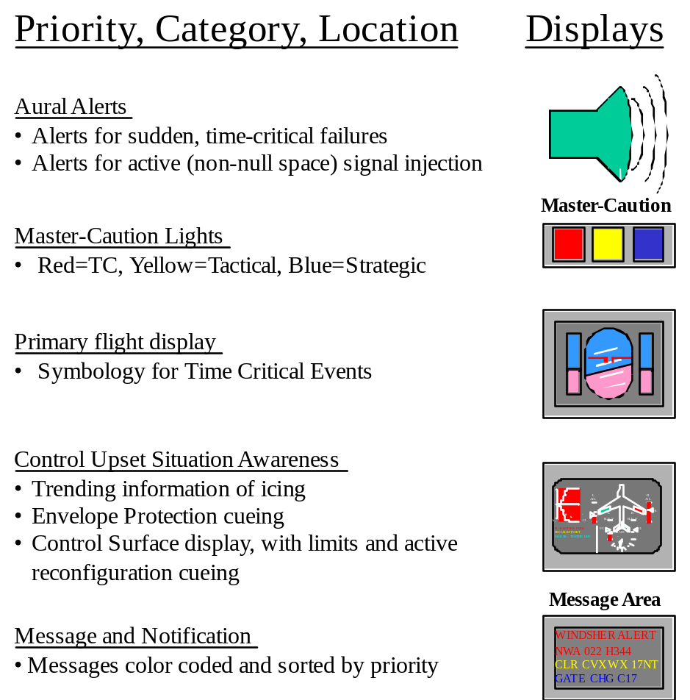

Figure B2. Categorization of Cues.

B.2 Primary Flight Display
The primary flight display will have one addition. Over the airplane symbol, a message in red will flash to alert the pilot of detected control surface damage or of severe icing. The message will be accompanied by a voice alert to alert the pilot that the CUPRSys has detected control surface damage or severe icing. Only time-critical alerts have a message appear on the PFD. Time critical alert messages appear both on the PFD and the Message Area, but only one aural alert sounds. It is the same alert, it’s just displayed in multiple areas. The pilot will be trained, upon hearing this alert, to call up the Control Surface Display (CSD) on the MFD. The rest of the pilot interaction will take place with the CSD. Table B1 details the specifications for the symbology placed on the PFD, and the accompanying aural alert.

Table B1. Display element specifications for the PFD

Display Element | Specification
Message on the PFD | CONTROL SURFACE DAMAGE DETECTED
Abbreviation | CTRL SRFC DMG
Color | Red
Location | Above fixed airplane wing symbols on ADI
Aural Alert Type | Voice
Aural Alert Text | “Control Surface Damage Detected”
Aural Alert Presentation | Test repeated twice, wait five seconds, start again
Aural Alert Inhibition | Press red master caution button to inhibit alert.
Message on the PFD | SEVER ICING DETECTED
Abbreviation | SVR ICG DET
Color | Red
Location | Above fixed airplane wing symbols on ADI
Aural Alert Type | Voice
Aural Alert Text | “Severe Icing Detected”
Aural Alert Presentation | Test repeated twice, wait five seconds, start again

B.3 Control Surface Display
The display formats are under development, but a concept for the MFD is shown in Figure B3.
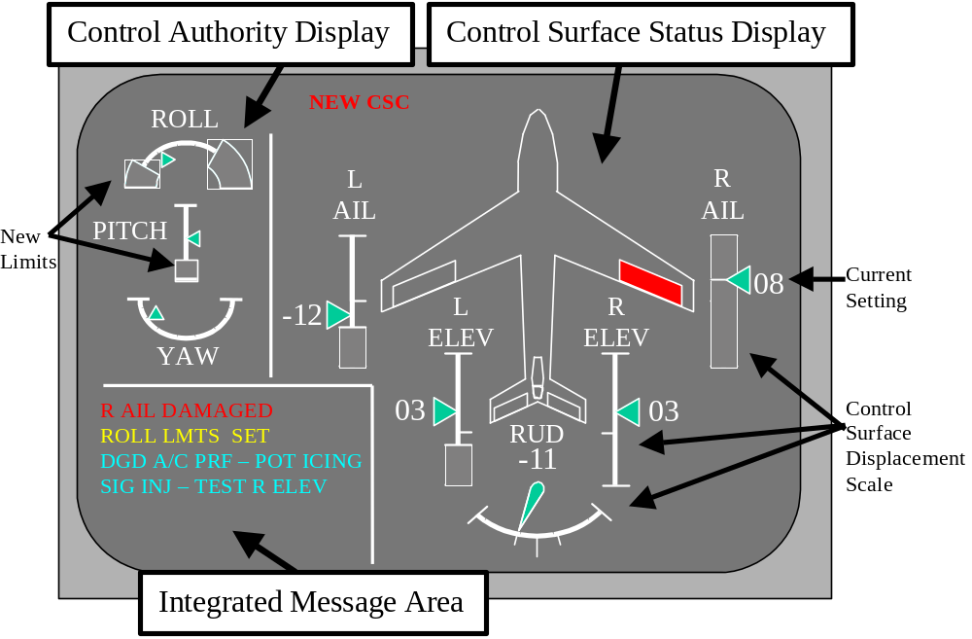

Figure B3. Control Surface Display.

The Control Surface Status Display − This display depicts the control surface displacement within the scale of its limits. The current setting is marked with the green bug. The limits are the extent of the scale for each control surface. When a new limit is set, the white crossing bar is reset and the “forbidden” area along the scale is marked in red. Notice in Figure B3, the right aileron is “stuck” as both, the lower limit and upper limit have met at the point where the surface is stuck (8 degrees). Thus, the whole scale is marked off in shaded red, and depicting the fact that there is no room for that control surface to move.
The Control Authority Display − In future implementations of CUPR, the automation may be able to put new limits (hard or soft) on the inputs pilots can give, in order to maintain the flight within a safe operating envelope after the control surfaces have been damaged. This display conveys to the pilot what the new limits are on along the three degrees of freedom: roll, pitch, and yaw. Additionally, the display through the green arrow bugs conveys the current settings of the inputs.
Input Requirements for the Display − The display in Figure B3 requires input to drive the display elements described above. Table B2 lists the display elements and the range of inputs required driving the particular display element.

Table B2. Input Formats for Display Elements

Display Element | Input Format
Roll | (0 < left limit < 1, 0 < right limit < 1, -1 < indicator position < 1)  left_limit=right_limit = CL_da_normalized  indicator_position = Pdot_normalized
Pitch | (0 < left limit < 1, 0 < right limit < 1, -1 < indicator position < 1)  left_limit=right_limit = CM_de_normalized  indicator_position = Qdot_normalized
Yaw | (0 < left limit < 1, 0 < right limit < 1, -1 < indicator position < 1)  left_limit=right_limit = CN_dr_normalized  indicator_position = Rdot_normalized
L Ail | (0 < left limit < 1, 0 < right limit < 1, -1 < indicator position < 1)  left_limit=right_limit = da_lim_normalized  indicator_position = da_normalized
R Ail | (0 < left limit < 1, 0 < right limit < 1, -1 < indicator position < 1)  left_limit=right_limit = da_lim_normalized  indicator_position = da_normalized
L Elev | (0 < left limit < 1, 0 < right limit < 1, -1 < indicator position < 1)  left_limit=right_limit = de_lim_normalized  indicator_position = de_normalized
R Elev | (0 < left limit < 1, 0 < right limit < 1, -1 < indicator position < 1)  left_limit=right_limit = de_lim_normalized  indicator_position = de_normalized
Rud | (0 < left limit < 1, 0 < right limit < 1, -1 < indicator position < 1)  left_limit=right_limit = dr_lim_normalized  indicator_position = dr_normalized
R Ail Control Surface | Boolean: red or background color
L Ail Control Surface | Boolean: red or background color
R Elev Control Surface | Boolean: red or background color
L Elev Control Surface | Boolean: red or background color
Rudder Control Surface | Boolean: red or background color
“NEW CSC” indicator message | Boolean: red (if surfaces have been reallocated) or  Background color (i.e. not showing)

Gauge Display Element − A display element has two endpoints and an indicator of present position for a particular variable (roll, pitch, yaw, right and left ailerons, right and left elevators, and the rudder). The range of the display element is –1 to 1.
Left Limit − The range of the left limit is –1 to 0 (i.e., the left half of the display element). Thus, when inputting a left limit, the screen will show a red “exclusion zone” starting at the left end of the display in the amount of the left limit. For example, a left limit of −0.8 will cause a red exclusion zone from –1 to −0.8 (20% of the left half of the zone, see the ROLL display element in Figure B3).
Right Limit − The range of the display element is –1 to 1. The range of the right limit is 0 to 1 (i.e., the right half of the display element). Thus, when inputting a right limit, the screen will show a red “exclusion zone” starting at the right end of the display in the amount of the right limit. For example, a right limit of 0.4 will cause a red exclusion zone from 0.4 to 1 (60% of the right half of the zone, see the ROLL display element in Figure B3).
Indicator position − Each display element has an indictor depicting the current setting. The range of the indicator is the range of the display element: −1 to 1.
Control Surface Display Elements − Color indicates a problem. Lack of color indicates no known problems.
Message Area − Messages that appear in the Message Area (in the bottom left of Figure B3) are sorted by priority, with the most critical rising to the top of the display. Messages can be color coded by priority: time-critical messages are red, tactical messages are yellow, and strategic messages are cyan. Table B3 lists some anticipated messages to be used in this simulation. Note that the messages in Table B3 can be shortened if space limitations require.
At present, we will use the message format illustrated in Table B3 (without specific numerical content like “8 degrees”). In the future, as we have more information available about the fault, it would be nice to include fault-specific information in the message (e.g., “R AIL STUCK 8 DEG”). Ideally, we would have messages with variable field, even though they would not be used for this iteration. It’s a matter of extra work now vs. extra rework later.
The Message Area should have scrollbar or button to access all messages. In fact, messages should disappear when the alert has been resolved.
Aural Alerts − A chime should sound when a priority = Tactical (yellow) alert (message) is displayed on the screen. When a priority = Time-critical (red) alert (message) is displayed, a voice alert should “speak” the alert twice, and repeat every five seconds until the pilot acknowledges by the master-caution button, thereby inhibiting the aural portion of the alert.

Table B3. Messages

Message | Description | Priority | CUPRSys Trigger
CONTROL SURFACE DAMAGE DETECTED | CUPRSys detects an error, but it is unidentified. | Red | R_DOUB
OK SIGNAL INJECTION, DURATION 15 SEC? | CUPRSys will ask pilot for permission to commence signal injection, with duration x sec. | Yellow | R_DOUB
R AIL DAMAGED | Right Aileron has been damaged. | Yellow | Monitor for changes in allowable range > 5%
L AIL DAMAGED | Left Aileron has been damaged. | Yellow | Monitor for changes in allowable range > 5%.
R ELEV DAMAGED | Right elevator has been damaged. | Yellow | Monitor for changes in allowable range > 5%.
L ELEV DAMAGED | Left elevator has been damaged. | Yellow | Monitor for changes in allowable range > 5%.
RUD DAMAGED | rudder has been damaged. | Yellow | Monitor for changes in allowable range > 5%.
OK TO RECONFIGURE CONTROL SURFACES? | CUPRSys has determined a new set of gains, asks pilot for permission to implement. | Yellow | R_ALLOC
MOD ICING DETECTED | CUPRSys detect icing | Yellow | D_ICING
SVR ICING DETECTED | CUPRSys detects sever icing | Red | D_ICING
CONTROL SURFACE RE-ALLOCATION COMPLETE | CUPRSys has re-allocated the control surfaces. | Yellow | Slave to “Yes” button of input device, B_ALLOC

Multi-Function Display Issues – We would create an EICAS page that reflects Figure B3 but placed physically on a different monitor, or we could use an existing EICAS display page and modify it to look something like Figure B3.

B.4 Input Device
The Control Surface Display (CSD) asks the pilot two types of questions:
- Should CUPRSys go ahead and use signal injection to try to determine the identity of the damaged control surface?
- Should CUPRSys implement the new control and re-allocate the surface to compensate for the damaged surface(s)?
For the experiment, we will need a way to allow pilots to answer the question. Figure B4 illustrates a potential design of an input device. Actual implementation will depend on the particulars of the experimental laboratory facilities. Possible implementations include an actual hardware box, a software display on a touch-screen monitor, or reallocation of existing-hardware switches. Actual implementation details are still to be determined.

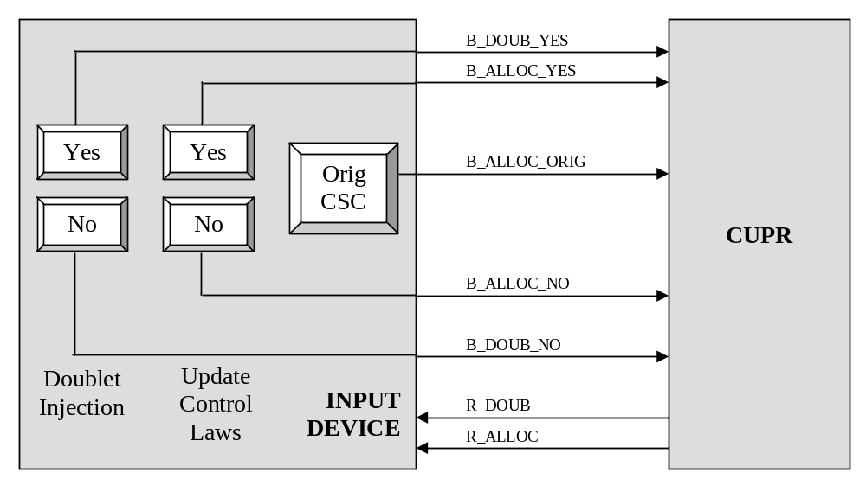

Figure B4. Conceptual Design of an Input Device for the CUPRSys

No matter how the input device is implemented, it must have the following functionality, detailed in Table B4.

Table B4. Input Element Specification

Input Element | Specification
ID Test: “Yes” | After pilot has been queried, pressing this button allows CUPRSys to commence signal injection identification techniques, by setting B_DOUB=1.
ID Test: “No” | After pilot has been queried, pressing this button tells CUPRSys that permission to commence signal injection identification techniques is refused, by setting B_DOUB=0.
ID Test: “Defer” | After pilot has been queried, pressing this button tells CUPRSys that the pilot has acknowledged receipt of the query, but will allow or disallow signal injection at a later time (i.e., the question remains “active”, and the pilot will press “yes” or “no” at some time in the future).
FCS: “ORG CSC” | Original control surface controller. Pressing this button, at any time, tells CUPRSys to return to the original flight control system model (i.e., the original controller), by setting B_ALLOC=0
FCS: “NEW CSC” | New control surface controller. After pilot has been queried, pressing this button tells CUPRSys to implement the new control and re-allocate flight surfaces, by setting B_ALLOC=1.

Appendix C
Control Effector Failure/Damage/Icing Model
List of Variables
TBD

