**Demographic Factors Impacting Income**

Subhabrata Ganguli, Matt Purkeypile, Aryaz Zomorodi

University of San Diego

**Abstract**

An examination of US Census data to determine if there are demographic factors that influence income. Data was selected from the UC Irvine Machine Learning Repository, which has been utilized for multiple studies.

**Demographic Factors Impacting Income**

Wealth has a profound impact on one’s life. It dictates living in poverty to jet-setting around the globe, and everything in between. For most, the primary driver of wealth is their income. (Obviously, there are other drivers such as wealth through inheritance.) This paper aims to examine what demographic factors influence wealth.

Within the United States, the US Census Bureau is an excellent source of demographic information. As they state (*About the Bureau*, 2023), “The Census Bureau's mission is to serve as the nation's leading provider of quality data about its people and economy.” Therefore, we used data from the Bureau to see if we could determine what demographic factors influence income, using a variety of models.

**Data Selection**

The selection of the data set focused on a set that would be relatively easy to understand, which would allow us to focus on the analysis and models- not understanding the underlying data itself. We also wanted a data source that was cited by other studies, as evidence of its use and to have other academic resources to consult.

The data for this project consists of adult data taken from a relatively clean pull of census data, known as “census income” (Becker & Kohavi, n.d.). Highlights of the data set, as described at the source:

* Description: Predict whether income exceeds $50K/yr based on census data.
* Number of variables: 14
* Size of data set: 48,842 (32,561 main set, 16,281 test set)
* Missing data: yes
* Dataset Characteristics: Multivariate
* Subject Area: Social Science
* Associated Tasks: Classification
* Feature Type: Categorical, Integer

With this dataset, we then moved forward to see if we could determine which demographic factors would influence income.

**Data Cleaning and Preparation**

As previously stated, a relatively clean data set was intentionally selected. Data cleaning and preparation itself can be an entire project - and was not the focus of this exercise.

As an example, United States Security and Exchange Commission (SEC) form 13-F was submitted and published as plain text up until about a decade ago (US Securities and Exchange Commission, 2023). These filings essentially contain a list of holdings made by investment managers. This presented consumers of the data with significant challenges being in plain text, as no formats had to be adhered to. In these plain text forms, holdings were identified by their CUSIP- which is a 9-digit identifier. These are broken into 3 parts, with the 9th digit being a check digit (*What Is a CUSIP Number, and How Do I Find a Stock or Bond CUSIP?*, n.d.). While it sounds simple enough, there are challenges in just identifying the CUSIP in the text:

* The CUSIP may be broken into the three parts: “XXXXXX YY Z”
* Distinguishing the CUSIP from a 8 or 9 digit word: “XXXXXXYYZ” vs “ABCDEFGHI”.
* The check digit could give some confidence on a CUSIP versus other text, but was not always included.
* The CUSIP could be broke across multiple lines:  
  XXXXXX  
  YY  
  Z
* …and many other variations

As mentioned, the data set we selected was relatively clean and that selection was intentional. Missing values in the data set were represented by “?”, and we first replaced those with “not a number” (NaN). We were then able to complete our cleanup by removing rows that had those NaN values. This left us with a completely clean data set to analyze.

**Exploratory Data Analysis**

We originally envisioned that the project would be centered around how income factored into education. More specifically, we wanted to see how education factored into hourly income. This was to account for variations in hours worked. For example, maybe a small business owner works long hours to keep the business going. On the other hand, maybe that business was up in running and required minimal oversight- leading to low hours. Another possibility we considered was a low-income person not being fully employed and working part-time. Hence, looking at the hourly income instead of just the income to account for these variations. Therefore, the original title of this paper was “Education Versus Hourly Income”.

As we did our initial data analysis, it became clear that more factored into income besides education alone. In hindsight, this shouldn’t have been a surprise. This can be seen by some of the exploratory data analysis we did, as outlined in the following figures.

**Figure 1**

*Income by education*

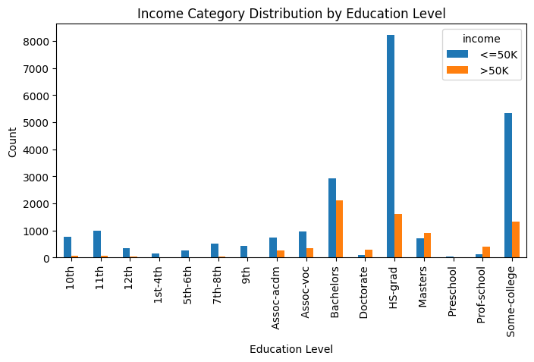

**Figure 2**

*Income by race*

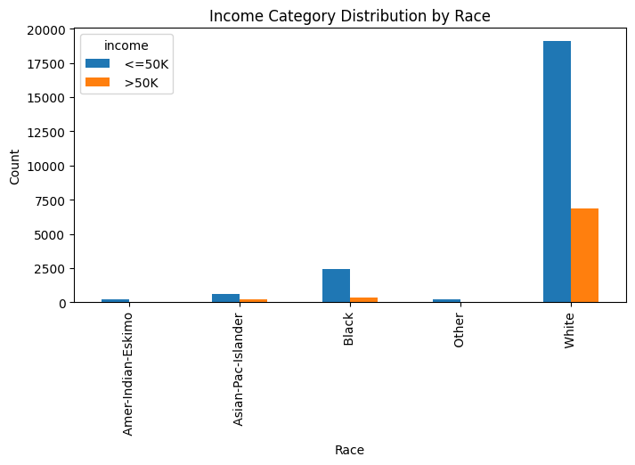

**Figure 3**

*Income by occupation*

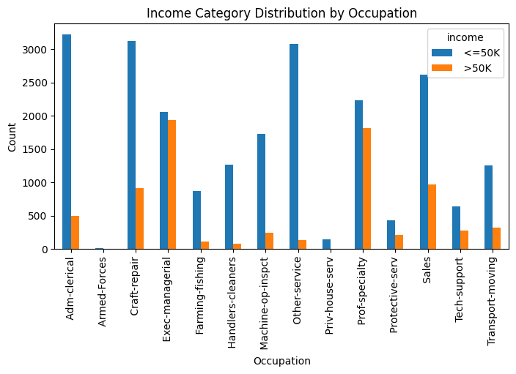

**Figure 4**

*Income by age category*

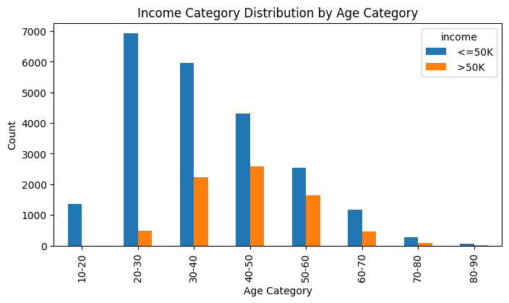

**Figure 5**

*Income by age, stacked*

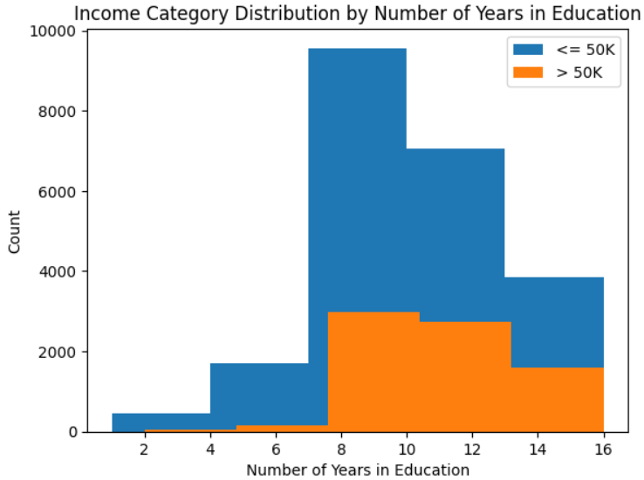

Consequently, the paper was renamed from “Education versus Hourly Income” to “Demographic Factors Impacting Income”. We believe the expanded scope of this title more accurately reflects the work uncovered during this exploratory data analysis.

**Model Selection**

The team selected 5 classifiers for analyzing the data. The rationale behind selecting five was that it struck a good balance between letting us compare various approaches, without being overwhelmed. Only selecting one or two is not a large enough sample size for a good comparison. On the other hand, there are diminishing returns when looking at too many approaches. Thus, we selected the following:

* The first classifier selected was the support vector machine classifier (*Scikit-Learn SVM Tutorial With Python (Support Vector Machines)*, n.d.):
  + Performs classification by constructing hyperplanes in multidimensional space.
  + Based on the concept of decision planes that define decision boundaries.
  + Employs an iterative training algorithm, which is used to minimize an error function and is implemented using a kernel.
* For our second choice we selected logistic regression (Kanade, 2022):
  + Supervised machine learning algorithm that accomplishes binary classification tasks by predicting the probability of an outcome, event, or observation.
  + Analyzes the relationship between one or more independent variables and classifies data into discrete classes.
* The third classifier selected was the decision tree classifier (*1.10. Decision Trees — Scikit-Learn 1.4.1 Documentation*, n.d.):
  + Supervised learning method used for classification and regression
  + Creates a model that predicts the value of a target variable by learning simple decision rules inferred from the data features.
  + A tree can be seen as a piecewise constant approximation
* As the fourth one we choose a random forest classifier (Donges, n.d.):
  + Supervised learning method where the “forest” it builds is an ensemble of decision trees.
  + Usually trained with the “bagging method”.
  + The general idea of the bagging method which is a combination of learning models increases the overall result.
  + Builds multiple decision trees and merges them to get a more accurate and stable prediction.
* Finally, the gradient boosting classifier was our fifth choice (*Gradient Boosting: A Step-By-Step Guide*, n.d.):
  + The algorithm starts by building a decision stump and then assigning equal weights to all the data points.
  + Increases the weights for all the points that are misclassified and lowers the weight for those that are easy to classify or are correctly classified.
  + A new decision stump is made for these weighted data points.

The following figures illustrate each of these and are cited from the same references as the above bullets.

**Figure 6**

*Support vector (Scikit-Learn SVM Tutorial With Python (Support Vector Machines), n.d.).*

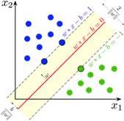

**Figure 7**

*Logic regression (Kanade, 2022)*

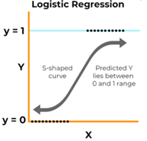

**Figure 8**

*Decision Tree, from (1.10. Decision Trees — Scikit-Learn 1.4.1 Documentation, n.d.).*

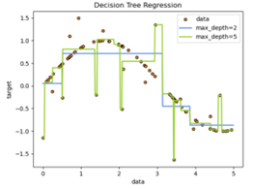

**Figure 9**

*Random forest (Donges, n.d.).*

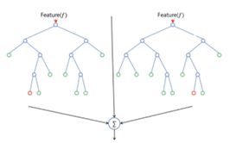

**Figure 10**

*Gradient boosting classifier* (*Gradient Boosting: A Step-By-Step Guide*, n.d.).

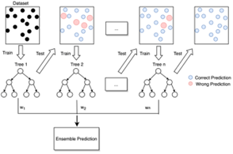

As previously mentioned, there was a choice of 14 variables in the data set to examine. Examining each of them would be a bit overwhelming. Therefore, we narrowed the set down to the variables we thought would have a significant influence on income. As a result, we considered the following features of the data for our analysis:

* Education
* Race
* Occupation
* Age Category (age divided into bins of 10)
* Education Number (number of years spent in education)

The data was split into two parts: one for training, and another for testing. 80% of the dataset was used for training, while the remaining 20% was used for testing. We broke each of these sets further into two subsets: x and y. We then proceeded to run the models, and the results and analysis are presented in the following section.

**Model Analysis**

The five models were then run on the data. The following are the results of our analysis for each of the five classifiers.

**Table 1**

*Supported Vector Machine Results*

precision recall f1-score support

<=50K 0.82 0.93 0.87 4503

>50K 0.65 0.38 0.48 1530

accuracy 0.79 6033

macro avg 0.73 0.66 0.68 6033

weighted avg 0.77 0.79 0.77 6033

**Table 2**

*Logic Regression Results*

precision recall f1-score support

<=50K 0.82 0.93 0.87 4503

>50K 0.66 0.40 0.50 1530

accuracy 0.80 6033

macro avg 0.74 0.67 0.69 6033

weighted avg 0.78 0.80 0.78 6033

**Table 3**

*Decision Tree Results*

precision recall f1-score support

<=50K 0.82 0.92 0.87 4503

>50K 0.64 0.41 0.50 1530

accuracy 0.79 6033

macro avg 0.73 0.67 0.69 6033

weighted avg 0.78 0.79 0.78 6033

**Table 4**

*Random Forest Results*

precision recall f1-score support

<=50K 0.82 0.91 0.87 4503

>50K 0.63 0.43 0.51 1530

accuracy 0.79 6033

macro avg 0.73 0.67 0.69 6033

weighted avg 0.78 0.79 0.78 6033

**Table 5**

*Gradient Boosting Machines Results*

precision recall f1-score support

<=50K 0.82 0.92 0.87 4503

>50K 0.65 0.42 0.51 1530

accuracy 0.80 6033

macro avg 0.74 0.67 0.69 6033

weighted avg 0.78 0.80 0.78 6033

This was the most shocking part of the exercise: there wasn’t a dramatic difference between the five models. This could be because these demographic factors all had a somewhat similar impact on income? In that case, it could be that these models were just different takes on the same slice of “truth”.

**Conclusion and Recommendations**

All of our models had similar results, so an area for future research would be to dig deeper into why that is. Perhaps different combinations of the demographic factors could lead to different results? Another area to dig deeper into is the data selection itself. Is the sample we used truly random? If it is not, then the results could be skewed. One way to examine this would be to select other sets from the same period and see if our analysis stands true still- as opposed to splitting the dataset into training and testing data as we did.

Another interesting area for future work would be to examine these factors over time. For example, has education played more of a role in determining income as the United States transformed from a largely agrarian society through the industrial revolution, and finally into the information revolution we’re in today? One could naturally hypothesize yes, that education does play more of a role now. However, society as a whole has become wealthier over time- so maybe this isn’t true.

Our exercise of looking at demographic factors influencing income was certainly an interesting one. We were able to determine several factors that influenced income, although not at an extremely high predictive rate.

**References**

*About the Bureau*. (2023, August 2). U.S. Census Bureau. Retrieved February 17, 2024, from https://www.census.gov/about.html

Becker, B., & Kohavi, R. (n.d.). *Census Income*. Retrieved February 13, 2024, from https://archive.ics.uci.edu/dataset/2/adult

Donges, N. (n.d.). *What Is Random Forest? A Complete Guide*. Built In. Retrieved February 21, 2024, from https://builtin.com/data-science/random-forest-algorithm

*Gradient Boosting: A Step-by-Step Guide*. (n.d.). Analytics Vidhya. Retrieved February 21, 2024, from https://www.analyticsvidhya.com/blog/2021/09/gradient-boosting-algorithm-a-complete-guide-for-beginners/

Kanade, V. (2022, April 18). *Logistic Regression: Equation, Assumptions, Types, and Best Practices*. Spiceworks. Retrieved February 21, 2024, from https://www.spiceworks.com/tech/artificial-intelligence/articles/what-is-logistic-regression/

*1.10. Decision Trees — scikit-learn 1.4.1 documentation*. (n.d.). Scikit-learn. Retrieved February 21, 2024, from https://scikit-learn.org/stable/modules/tree.html

*Scikit-learn SVM Tutorial with Python (Support Vector Machines)*. (n.d.). DataCamp. Retrieved February 21, 2024, from https://www.datacamp.com/tutorial/svm-classification-scikit-learn-python

US Securities and Exchange Commision. (2023, May 25). *Frequently Asked Questions About Form 13F*. Retrieved February 13, 2024, from https://www.sec.gov/divisions/investment/13ffaq

*What Is a CUSIP Number, and How Do I Find a Stock or Bond CUSIP?* (n.d.). Investopedia. Retrieved February 13, 2024, from <https://www.investopedia.com/terms/c/cusipnumber.asp>

**Appendix A: Code and Output**

**Appendix A: Code and Output**

Some of this is covered in the preceding text. This is dump of our notebook, including the output. For easier to read formatting, please see the readme: <https://github.com/suvoganguli/FinalProject/blob/main/README.md>

1 Adult dataset

Final_Project

February 20, 2024

For the Final Project, we will do statistical analysis on the Census Income dataset available at the UC Irvine Machine Learning Repository.

Here is the information on the dataset: - Dataset Characteristics: Multivariate - Subject Area: Social Science - Associated Tasks: Classification - Feature Type: Categorical, Integer - No. of Instances: 48842 - No. of Features: 14

# import libraries

import pandas as pd  
from matplotlib import gridspec  
import math  
import matplotlib.pyplot as plt  
import random  
import numpy as np  
import seaborn as sns  
from sklearn.model_selection import train_test_split  
from scipy import stats  
from sklearn.svm import SVC  
from sklearn.preprocessing import OneHotEncoder  
from sklearn.compose import ColumnTransformer  
from sklearn.pipeline import Pipeline  
from sklearn.metrics import accuracy_score, classification_report from sklearn.linear_model import LogisticRegression  
from sklearn.metrics import classification_report

# columns of interest

column_names = [

'age',

'workclass',

'fnlwgt',

'education',

'education-num',

'marital-status',

'occupation',

[3]:

1

'relationship',

'race',

'sex',

'capital-gain',

'capital-loss',

'hours-per-week',

'native-country',

'income',

]

# read data

df = pd.read_csv('adult/adult.data', names=column_names)

# get smaller chunk of data if desired

do_split = False if do_split:

df_shuffled = df.sample(frac=1,random_state = 51)

result = np.array_split(df_shuffled, 50)

data = result[0]

n = data.shape[0]

data.index = range(0,n) else:

data = df

# data cleanup

# initial data shape

print(data.shape)

# replace missing values

data.replace("?", np.NaN, inplace=True) data.replace(" ?", np.NaN, inplace=True)

# data preprocessing  
# drop rows with missing values data.dropna(inplace=True)

# final data shape

print(data.shape)

[4]:

(32561, 15)

(30162, 15)

[5]:

# get information about the size of the dataset

data.head()

2

age

1. 0  39
2. 1  50
3. 2  38

3 53

workclass fnlwgt education education-num \

4

0 1 2 3 4

0 1 2 3 4

28

Private

338409

State-gov

Self-emp-not-inc

Private

77516

Bachelors 13

Bachelors 13

HS-grad 9

11th 7

Bachelors 13

marital-status

Never-married

Married-civ-spouse

Divorced

Married-civ-spouse

Married-civ-spouse

occupation

Adm-clerical

Exec-managerial

Handlers-cleaners

Handlers-cleaners

Prof-specialty

relationship

Not-in-family

Husband

Not-in-family

Husband

Wife

race

White Male

White Male

White Male

Black Male

Black Female

83311

215646

Private 234721

capital-gain capital-loss hours-per-week native-country income

2174 0

0 0

0 0

0 0

0 0

40 United-States

13 United-States

40 United-States

40 United-States

40 Cuba

<=50K

<=50K

<=50K

<=50K

<=50K

sex \

[5]:

# Plotting function for discrete variables

import math

def discrete_plots(df, columns, num_cols): n_plots = len(columns)  
n_cols = num_cols  
n_rows = int(math.ceil(n_plots/n_cols)) gs = gridspec.GridSpec(n_rows, n_cols) fig = plt.figure(figsize=(8,100))

for i in range(n_plots):  
ax = fig.add_subplot(gs[i])  
if df.dtypes[columns[i]] != 'int64':

df[columns[i]].value_counts().sort_index().plot(kind='bar', ax=ax) else:

df[columns[i]].hist(ax=ax, grid=False) ax.set_xlabel(columns[i])

fig.tight_layout()

fig.supylabel('Count')

plt.show()

discrete_plots(data,column_names,1)

[6]:

3



4

1.1 Features affecting income level

We consider the following features which can potentially affect the income level.

1. Education  
2. Race  
3. Occupation  
4. Age Category (age divided into bins of 10) 5. Number of years in education

The corresponding barplots are shown below.

# Group the data by education level and income category

education_income_counts = data.groupby(['education', 'income']).size().unstack() # Grouped bar plot

education_income_counts.plot(kind='bar', stacked=False, figsize=(8, 4))

# Add labels and title

plt.title('Income Category Distribution by Education Level')

plt.xlabel('Education Level')

plt.ylabel('Count')

[7]:

page5image43905280

[7]: Text(0, 0.5, 'Count')

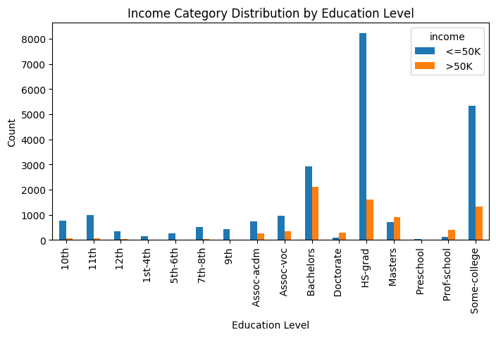

5

# Group the data by race and income category

race_income_counts = data.groupby(['race', 'income']).size().unstack() # Grouped bar plot

race_income_counts.plot(kind='bar', stacked=False, figsize=(8, 4))

# Add labels and title

plt.title('Income Category Distribution by Race')

plt.xlabel('Race')

plt.ylabel('Count')

[8]:

page6image43328592

[8]: Text(0, 0.5, 'Count')

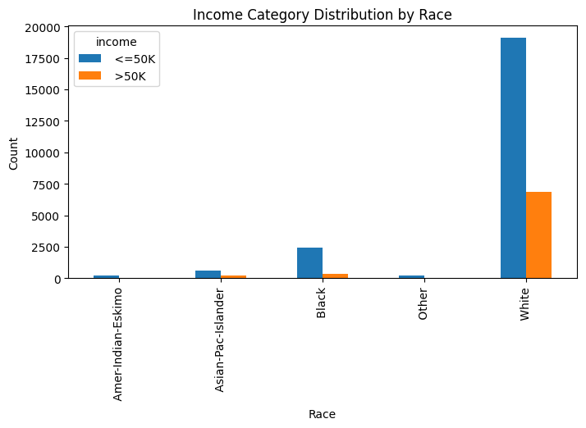

# Group the data by occupation and income category

occupation_income_counts = data.groupby(['occupation', 'income']).size(). ↪unstack()

# Grouped bar plot

[9]:

6

occupation_income_counts.plot(kind='bar', stacked=False, figsize=(8, 4))

# Add labels and title

plt.title('Income Category Distribution by Occupation')

plt.xlabel('Occupation')

plt.ylabel('Count')

page7image43304032

[9]: Text(0, 0.5, 'Count')

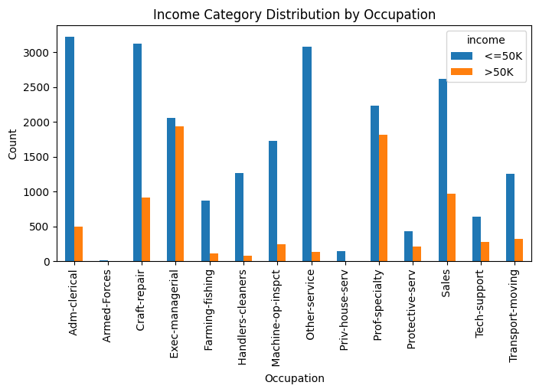

# converting age to categorical data

print('Min age = ', np.min(data['age']))

print('Max age = ', np.max(data['age']))

bins = [10,20,30,40,50,60,70,80,90]

labels = ['10-20','20-30','30-40','40-50','50-60','60-70','70-80','80-90']

data['age_category'] = pd.cut(data['age'], bins=bins, labels=labels,␣ ↪right=False)

data.head()

[10]:

7

Minage= 17 Maxage= 90

[10]:

age

1. 0  39
2. 1  50
3. 2  38

3 53

workclass fnlwgt education education-num \

4

0 1 2 3 4

28

Private

338409

State-gov

Self-emp-not-inc

Private

77516

Bachelors 13

Bachelors 13

HS-grad 9

11th 7

Bachelors 13

marital-status

Never-married

Married-civ-spouse

Divorced

Married-civ-spouse

Married-civ-spouse

occupation

Adm-clerical

Exec-managerial

Handlers-cleaners

Handlers-cleaners

Prof-specialty

relationship

Not-in-family

Husband

Not-in-family

Husband

Wife

race

White Male

White Male

White Male

Black Male

Black Female

83311

215646

Private 234721

capital-gain capital-loss hours-per-week native-country income \

0 2174 0

1 0 0

2 0 0

3 0 0

4 0 0

age_category

0 30-40

1 50-60

2 30-40

3 50-60

4 20-30

40 United-States

13 United-States

40 United-States

40 United-States

40 Cuba

<=50K

<=50K

<=50K

<=50K

<=50K

sex \

# Group the data by age and income category

age_income_counts = data.groupby(['age_category', 'income'], observed=False). ↪size().unstack()

# Grouped bar plot

age_income_counts.plot(kind='bar', stacked=False, figsize=(8, 4))

# Add labels and title

plt.title('Income Category Distribution by Age Category')

plt.xlabel('Age Category')

plt.ylabel('Count')

[11]:

page8image43297504

[11]: Text(0, 0.5, 'Count')

8

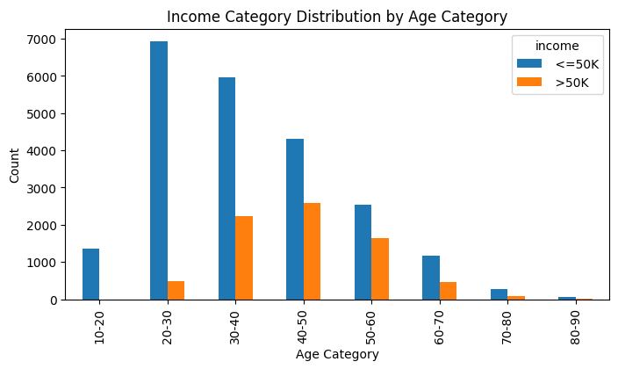

grouped_data = {}  
for category, values in zip(data['income'], data['education-num']):

grouped_data.setdefault(category, []).append(values)

# Plotting histogram for each category

plt.figure()  
for category, values in grouped_data.items():

plt.hist(values, bins=5, label=category)

# Add labels and title

plt.title('Income Category Distribution by Number of Years in Education')

plt.legend(['<= 50K','> 50K'])

plt.xlabel('Number of Years in Education')

plt.ylabel('Count')

[12]:

page9image43557744

[12]: Text(0, 0.5, 'Count')

9

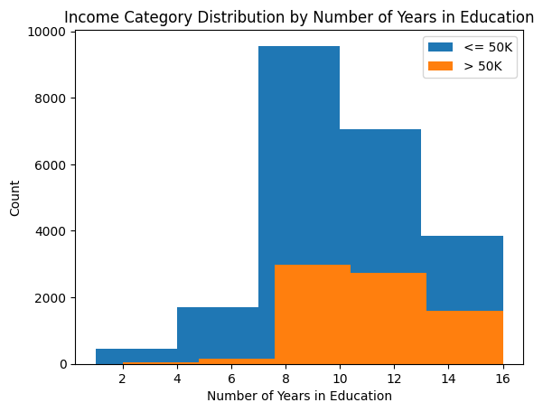

2 Value Counts

The code below shows the value counts for each of the independent variables we have considered above for the statistical analysis.

# income counts

income_counts = data['income'].value_counts()  
# sorting income count by descending order  
income_counts_sorted = income_counts.sort_values(ascending=False) # display the sorted income levels and their counts print(income_counts_sorted)

# ---------------

# education counts

education_counts = data['education'].value_counts()  
# sorting education count by descending order  
education_counts_sorted = education_counts.sort_values(ascending=False) # display the sorted education levels and their counts print(education_counts_sorted)

[21]:

10

# ---------------

# race counts

race_counts = data['race'].value_counts()  
# sorting race count by descending order  
race_counts_sorted = race_counts.sort_values(ascending=False) # display the sorted race and their counts print(race_counts_sorted)

# ---------------

# occupation counts

occupation_counts = data['occupation'].value_counts()  
# sorting occupation count by descending order  
occupation_counts_sorted = occupation_counts.sort_values(ascending=False) # display the sorted occupation and their counts print(occupation_counts_sorted)

# ---------------

# age category counts

age_counts = data['age_category'].value_counts()  
# sorting occupation count by descending order age_counts_sorted = age_counts.sort_values(ascending=False) # display the sorted occupation and their counts print(age_counts_sorted)

income

<=50K 22654

>50K 7508

Name: count, dtype: int64

education

HS-grad 9840

Some-college 6678

Bachelors 5044

Masters 1627

Assoc-voc 1307

11th 1048

Assoc-acdm 1008

10th 820

7th-8th 557

Prof-school 542

9th 455

12th 377

Doctorate 375

5th-6th 288

1st-4th 151

11

[36]:

Preschool 45

Name: count, dtype: int64

race

White

Black

Asian-Pac-Islander

Amer-Indian-Eskimo

Other

25933

2817

895

286

231

Name: count, dtype: int64

occupation

Prof-specialty 4038

Craft-repair 4030

Exec-managerial 3992

Adm-clerical 3721

Sales 3584

Other-service 3212

Machine-op-inspct 1966

Transport-moving 1572

Handlers-cleaners 1350

Farming-fishing 989

Tech-support 912

Protective-serv 644

Priv-house-serv 143

Armed-Forces

Name: count, dtype: int64

age_category

30-40 8211

20-30 7415

40-50 6900

50-60 4185

60-70 1634

10-20 1369

70-80 357

80-90 56

Name: count, dtype: int64

9

3 Correlation Analysis

In this section, we perform a correlation analysis between the potential independent variables we considered above and the dependent variable. After the analysis, we have decided that we will excluding the ‘race’ variable since the correlation is very small.

# import library

from scipy.stats import chi2_contingency

def cramers_v(x, y):  
confusion_matrix = pd.crosstab(x, y)

12

chi2 = chi2_contingency(confusion_matrix)[0]

n = confusion_matrix.sum().sum()

phi2 = chi2 / n

r, k = confusion_matrix.shape

phi2corr = max(0, phi2 - ((k-1)*(r-1))/(n-1))  
rcorr = r - ((r-1)**2)/(n-1)  
kcorr = k - ((k-1)**2)/(n-1)  
return np.sqrt(phi2corr / min((kcorr-1), (rcorr-1)))

correlation_education = cramers_v(data['education'], data['income']) print(f"Correlation with Education: {correlation_education:.4f}")

correlation_race = cramers_v(data['race'], data['income']) print(f"Correlation with Race: {correlation_race:.4f}")

correlation_occupation = cramers_v(data['occupation'], data['income']) print(f"Correlation with Occupation: {correlation_occupation:.4f}")

correlation_age_category = cramers_v(data['age_category'], data['income']) print(f"Correlation with Age Category: {correlation_age_category:.3f}")

correlation_education_num = cramers_v(data['education-num'], data['income'])

print(f"Correlation with Number of Years in Education:␣

↪{correlation_education_num:.4f}")

Correlation with Education: 0.3667

Correlation with Race: 0.0998

Correlation with Occupation: 0.3490

Correlation with Age Category: 0.308

Correlation with Number of Years in Education: 0.3667

4 Machine learning:

We have used the following five classifiers for our analysis: - Support Vector Machine Classifier - Logistic Regression - Decision Tree Classifier - Random Forest Classifier - Gradient Boosting Classifier

Our final list of independent variables are as follows:

1. Education  
2. Occupation  
3. Age Category (age divided into bins of 10)  
4. Education Number (number of years spent in education)

We split the dataset into 80% for train and 20% for test. The training data consists of X_train and y_train, and the test data consists of X_test and y_test.

After training the classifiers using X_train and Y_train, we test it using X_test and y_test. 13

[23]:

The classification report for each classifier are printed as the end of each code cell. All of the classifiers have very similar performance.

# SVC Classifier

# Get X and y

X = pd.get_dummies(data[['education', 'occupation', 'age_category',␣ ↪'education-num']])

y = data['income']

# Split data into training and testing sets

np.random.seed(123)

X_train, X_test, y_train, y_test = train_test_split(X, y, test_size=0.2,␣

↪random_state=42)  
svc = SVC(random_state=42)

svc.fit(X_train, y_train) # Predict

y_pred = svc.predict(X_test)

# Classification report

report = classification_report(y_test, y_pred)

print(report)

precision

<=50K 0.82

>50K 0.65

accuracy

macro avg 0.73

weighted avg 0.78

recall f1-score support

0.93 0.87 4503

0.39 0.49 1530

0.79 6033

0.66 0.68 6033

0.79 0.77 6033

# Logistic Regression

logistic = LogisticRegression(random_state=42, max_iter = 10000)

logistic.fit(X_train, y_train)

# Predict

y_pred = logistic.predict(X_test)

# Classification report

report = classification_report(y_test, y_pred)

print(report)

[24]:

precision

recall f1-score support

14

[26]:

<=50K >50K

accuracy

macro avg

weighted avg

0.82 0.93

0.66 0.39

0.74 0.66

0.78 0.79

0.87 4503

0.49 1530

0.79 6033

0.68 6033

0.78 6033

# import library

from sklearn.tree import DecisionTreeClassifier

# Initializing and training the Decision Tree Classifier

dt_classifier = DecisionTreeClassifier(random_state=42)

dt_classifier.fit(X_train, y_train)

# Making predictions

y_pred = dt_classifier.predict(X_test)

# Evaluating the model

# accuracy = accuracy_score(y_test, y_pred)

# print(f'Decision Tree Classifier Accuracy: {accuracy}')

# Classification report

report = classification_report(y_test, y_pred)

print(report)

[25]:

<=50K >50K

accuracy

macro avg

weighted avg

precision recall

0.82 0.93

0.65 0.41

0.74 0.67

0.78 0.79

f1-score support

0.87 4503

0.50 1530

0.79 6033

0.69 6033

0.78 6033

# Random Forest Classifier

from sklearn.ensemble import RandomForestClassifier

# Initializing and training the Random Forest Classifier

rf_classifier = RandomForestClassifier(n_estimators=100, random_state=42)

rf_classifier.fit(X_train, y_train)

# Making predictions

y_pred = rf_classifier.predict(X_test) # Evaluating the model

15

# accuracy_rf = accuracy_score(y_test, y_pred_rf)

# print(f'Random Forest Classifier Accuracy: {accuracy_rf}')

# Classification report

report = classification_report(y_test, y_pred)

print(report)

<=50K >50K

accuracy

macro avg

weighted avg

precision recall

0.82 0.92

0.65 0.41

0.73 0.67

0.78 0.79

f1-score support

0.87 4503

0.50 1530

0.79 6033

0.68 6033

0.78 6033

# Gradient Boosting Machines Classifer

from sklearn.ensemble import GradientBoostingClassifier

# Initializing and training the GBM Classifier

gbm_classifier = GradientBoostingClassifier(n_estimators=100, learning_rate=0. ↪1, random_state=42)

gbm_classifier.fit(X_train, y_train) # Making predictions

y_pred = gbm_classifier.predict(X_test)

# Evaluating the model

# accuracy_gbm = accuracy_score(y_test, y_pred_gbm)

# print(f'Gradient Boosting Machines Classifier Accuracy: {accuracy_gbm}')

# Classification report

report = classification_report(y_test, y_pred)

print(report)

[27]:

page16image43747856

[ ]:

<=50K >50K

accuracy

macro avg

weighted avg

precision recall

0.83 0.92

0.64 0.43

0.74 0.67

0.78 0.79

f1-score support

0.87 4503

0.51 1530

0.79 6033

0.69 6033

0.78 6033

16

**Appendix B: Source Code**

Source code can be found on github at <https://github.com/suvoganguli/FinalProject>.