Researcher’s Guide to Flight Control Law Implementation in AirSTAR

POC: Austin Murch (Austin.M.Murch@nasa.gov) 757-864-8292

This document is intended to provide a brief summary of the AirSTAR Flight Control System (FCS) and give you, the researcher, a guide to follow that will greatly ease implementation of you control law into the AirSTAR FCS.

The AirSTAR FCS separates flight control laws (FCLs) into 3 distinct Modes: Mode 1 is a reversionary, stick-to-surface control law, Mode 2 is the baseline FCL, and Mode 3 is reserved for research FCLs. Your control law will be implemented in Mode 3. The AirSTAR FCS uses a two-step/two-switch process to engage Mode 2 & 3. First, a switch is thrown that “arms” the Mode, but it does not have control of the aircraft until a second switch is pressed which “engages” the Mode.

Mode 3 is capable of housing multiple research FCLs, each with different structure or command schemes. This is accomplished by placing each research FCL in an Enabled Subsystem block. An FCL is selected and Mode 3 is then armed. The selected FCL will begin to run, but will NOT have control of the airplane until Mode 3 is engaged! This is very important as you need to make sure any integrators are not started until Mode 3 is engaged (see #3 below).

For more detail on the AirSTAR FCS and flight software refer to:

Murch, A. M., “A Flight Control System Architecture for the NASA AirSTAR Flight Test Infrastructure,” AIAA-2008-6990, AIAA Guidance, Navigation, and Control Conference and Exhibit, Honolulu, HI, 2008

Murch, A. M., Cox, D. E., Cunningham, K., “Software Considerations for Subscale Flight Testing of Experimental Control Laws,” AIAA-2009-2054, AIAA Infotech@Aerospace, Seattle, WA, 2009

To minimize the time required to integrate your FCL into the AirSTAR FCS, follow these guidelines:

- Place all of your FCL in a Subsystem block.
  - All of your inputs should be done at the top level of your FCL Subsystem (see Fig. 1). In other words, don’t take a bus signal and route it to the lowest level subsystem before picking out the signal you want. Be sure to have an input called “Engage” (or something similar) - this input will be connected to the Mode 3 Engage signal. It’s a good idea to put the units you are using in the Inport block name (e.g. “alpha (deg)”).
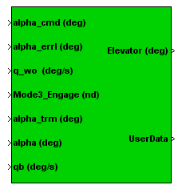
Figure 1: Example of a control law contained in a subsystem with all necessary inputs and outputs present at the top level.

  - You should have essentially two types of outputs: control surface commands and data storage.

    - Specify if the control surface commands are standalone or should be summed with the baseline controller commands. Again, it’s a good idea to put the units you are using in the Outport block name (e.g. “elevator (deg)”).
    - For data storage, you should use a Mux block to combine all of the signals you want stored (maximum 100 signals, must be all scalars, “double” datatype) into a single vector that is output at the top level of your FCL Subsystem. In addition to being stored at 200Hz, these signals are also broadcast in real-time over the MOS network during flight at 60Hz.

  - If you need to set variables prior to run/compile time, put them in an m-file script. Mask your FCL Subsystem (right click on the Subsystem and select “Mask Subsystem…”). The Mask Editor will appear. Click the Initialization tab, and call your m-file script in the Initialization commands (see Fig. 2). The variables in your script will be loaded into your FCL Subsystem’s workspace, NOT the base workspace. All of the blocks/subsystems beneath the mask will have access to the variables that are set in the m-file. Utilizing a masked subsystem avoids any variable naming conflicts between your variables and the AirSTAR variables. Your variables will have priority over any other variables that exist in the AirSTAR FCS.
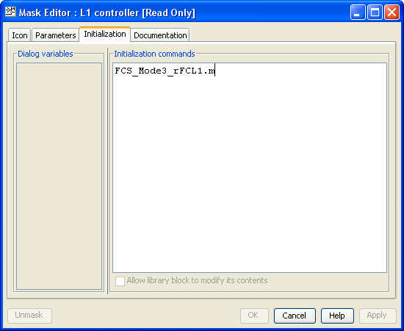
Figure 2: Example of an m-file script being called in the Initialization tab of a subsystem mask. The m-file script contains variables needed by the control law.

- We recommend using Embedded MATLAB Function blocks to implement equations rather than using blocks and wires. Make sure you restrict your function usage to the supported functions, which can be found in the “Embedded MATLAB” section of the MATLAB/Simulink Help browser.

- If you have integrators in your control law, you’ll need to do the following:
  - Set the “external reset” option to “either” (see Fig 3.). This port should be connected to the Engage signal input from the top level of your FCL subsystem. The purpose is to reset the state of the integrator to the initial condition (internal or external) when Mode 3 is engaged or disengaged.
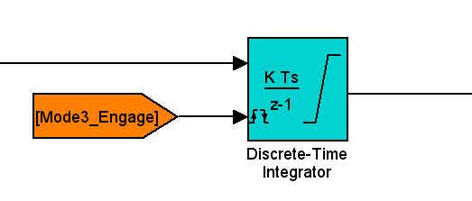
Figure 3: Example of a limited discrete-time integrator block with “External Reset” set to “either”. The initial condition of this integrator is set internally.

  - Make sure you set the initial condition of each integrator properly. The initial output of your FCL should match the current control surface commands so there are no transients. If you are augmenting the baseline FCL (i.e. Mode 2), the initial commands from Mode 2 will match the current control surface commands and the initial tracking error is zero, so the initial output of your FCL should be zero.
  - Make sure you have some kind of limiting applied to your integrators to prevent wind-up. Saturation blocks will be placed downstream of your FCL to enforce control surface command limits.
  - Discrete or Continuous integrators can be used, but since the control law will ultimately be run in discrete time, we STRONGLY recommend using discrete integrators so you know exactly what your control law will do on the real-time system.

- The update rate of the flight software is approximately 600Hz. The exact time step is available in the software in a variable called “Timestep”, and is set to 0.0016667 seconds. If you need the time step in your control law, you can either use this variable (but do NOT set this variable in your initialization scripts), or you can create a parameter in the subsystem Mask with your own naming convention, and set this variable to “Timestep”.

- If you use tags (Goto/From blocks), be sure to set the Tag Visibility parameter to “Local” or “Scoped” (not “Global”). This will avoid naming conflicts with existing tags in the AirSTAR FCS. You can get the same utility of Global tags by using a Scoped tag. Place a Goto Tag Visibility block at the top level of your FCS Subsystem- all subsystems underneath this will be able to see the Scoped tag.

- The Mode3_Engage signal is boolean datatype. If you use this signal in a mathematical sense (e.g. multiply another signal), you must convert the Mode3_Engage signal to the appropriate datatype.

- No special characters can be used in block names (e.g. double quotes). While this does not cause Simulink errors, it will cause an error in the compiled code. Use only letters, numbers, and spaces.

- Specify how much time your FCL needs to initialize (e.g. for filters to settle out, etc.) before being engaged.

- Provide a check case so the AirSTAR team can make sure your FCL is working correctly. This is important as minor modifications may be required to properly integrate your FCL in to the AirSTAR FCS.

- Bring a list of parameters you may want to tune. Using a program called Control Desk, the AirSTAR team can quickly modify some parameters in your control law (e.g. gain values) without recompiling. The AirSTAR team will need to know the full pathname to the block that contains the parameter you want to change. Only scalar parameters can be changed.

Some technical details of the AirSTAR flight control computer:
Mfg: dSPACE
AutoCoder: MathWork’s Real-Time Workshop
Time step: 0.0016667 seconds
Integration routine: 1st order Euler
Telemetry Tx/Rx: 200Hz (various update rates for sensors)
UDP broadcast: 60Hz
Data storage: 200Hz
Measured latency of telemetry system: ~21ms

