Contents

2 Introduction 3

1.1 Purpose 3

2.1 1.2 Scope 3

2.1.1 1.2.1 Use case Model 3

2.2 1.3 Definitions, Acronyms and Abbreviations 3

2.3 1.4 Glossary 3

2 Overall Description 4

2.1 Current Solution 4

2.4 Project perspective 5

2.2 Project Functions 5

2.2.1 Supported Functions 5

2.2.2 Unsupported functions 5

2.3 User Profiles 6

2.4 Use Cases 6

2.5 Specific Requirement 7

2.5 Functionality 8

2.6 Main Features 8

2.6.1 Users 8

2.6.2 User role 9

2.6.3 User Role wise Permission level 9

2.6.4 Storing user and User role 9

2.6.5 User role management 10

2.7 User Profile 10

2.7.1 User profile 10

2.7.2 System Login and Logout 11

2.8 Manage Project List 12

2.8.1 Show list of project 12

2.8.2 Store Project Information 12

2.8.3 Filtering Project 12

2.8.4 Searching Project 13

2.8.5 Creating Project 13

2.8.6 Selecting Project 14

2.8.7 Edite Project Configuration 14

2.8.8 Delete Project 14

2.8.9 Manage Project Leader 15

2.9 Manage Current Project 15

2.9.1 Make active Project 15

2.9.2 Project as an root entity 16

2.10 Manage Issue 17

2.10.1 Changing State of issue 17

2.10.2 Comment on issue 17

2.10.3 Add helper link to a issue 18

2.10.4 Update issue 18

3 Use Cases 19

3.1 Add Project 19

3.2 Create Issue 19

3.3 Create Board 20

3.4 Configure Project 21

3.5 Assign Project Lead 21

3.6 Create Team 22

3.7 Generate Report 22

3.8 Assign Developers to An Issue 23

3.9 View Notification 24

3.10 View Issue 24

3.11 Filter issues 25

3.12 Change state of Issue 26

4 Er Diagram 27

# Introduction

## Purpose

This document outlines the Project Management System's Software Requirements Specification (SRS) (PMS). This document is for describing the system's scope, the software's functional and non-functional requirements, design limitations, system interfaces, and others related to a SRS document.

## 1.2 Scope

The Project Management System addresses the management of software project development. It implements a framework of agile methodology and provide some extra functionality for smooth software development workflow management. It offers the structure for allocating and controlling resources so that they accomplish all work necessary to complete a software project within specified scope, timing, and defined restrictions.

The system is solely applicable to the administration of software projects, and it is a tool that aids in decision-making rather than making decisions itself.

This SRS describes only required functionality of PMS, not the functionality of external systems like data storage, change management or version control systems.

### 1.2.1 Use case Model

The Use-case model is defined as a model which is used to show how users interact with the system in order to solve a problem. As such, the use case model defines the user's objective, the interactions between the system and the user, and the system's behavior required to meet these objectives. The use cases of the system will be describe in upcoming section.

## 1.3 Definitions, Acronyms and Abbreviations

The following table explains the terms and abbreviations used in the document.

|  |  |
| --- | --- |
| Term | Explanations |
| PMS | Project Management System. |
| GUI | Graphical User Interface |
| DBMS | Database Management System |
| CMS | Change Management System |
|  |  |
|  |  |

## 1.4 Glossary

|  |  |
| --- | --- |
| Word | Explanation |
| Project Management | The main aspect of this document. Represent the entire solution. |
| Host System | The main part of the system that resides on the server and where the business logic runs. Maintains physical connections to all external systems (data storage system, version control and change management systems) |
| Client System | The part of the system that runs on the user PC. Provide GUI and required system functionality. Maintains physical connection to the host system |
| Project Team Leader | The person who has the overall responsibility for the successful planning and execution of any project. Project Team Leader leads the team of developers. |
| Manager/ Project Owner | The person who has the overall responsibility for the project portfolio |
| Project Team Member | One of the developers who does not have responsibility for the project. The project team member has responsibility for carrying out the task assigned to him or her. |
| User | Any person who uses the system and is registered within the system. It means that he or she has the user login. |
| User Profile | Preferences of the registered user of the system that are saved within the system |
| Report | A defined view on the project that contains the specified project attributes tasks and resources and provides information about project status. |
| Authorized user | The user who has logged into the system and has a right to perform some operation. The system “knows” the identity of the user and permission that are granted to this user. |
| Authenticated user | The user who has logged into the system. The system “knows” the identity of the user. |

# Overall Description

## Current Solution

I current time software development industry mostly use agile methodology and for managing the tasks in different sprints towards multiple team and person there exist multiple solution in the market. As for the moment every team leader is using a specific software product or no software at all, for maintaining the project schedule, to organize the tasks of the project and to physically store the all project data.

## Project perspective

The main perspective of the project is to develop a simple workflow management system where I will use simple functionality for managing workflow towards multiple team or individual team member. There will have several types of user role in the system for differentiating available feature in the system.

Fig 1: Project Management System Perspective

Project Management System

Personal and Group Messaging

Use and User Role Management

Resource Management

Project Management

Bug state tracking

Report Generation

Task Management

Project Portfolio Management

## Project Functions

### Supported Functions

The project functions:

* Provide a framework for project management
* Supports multiple project
* Support distributed development
* Support workflow management
* Support Scrum framework of agile methodology in project
* Support sprint wise task management in scrum frameworks project
* Allows to create dependencies between tasks
* Provide user role management
* Provide report generation
* Support messaging feature between users
* Provide user and user role management

### Unsupported functions

The project management system:

* does not provide code management or code storage,
* does not provide version control,
* does not provide Employee time scheduling
* does not provide employee management,
* does not provide work time accounting and payroll.

## User Profiles

The system is intended to be used by various users. We can divide all users into three profiles, each with own responsibility and role in the PMS:

|  |  |
| --- | --- |
| User | Functions and Responsibility |
| Project Owner | Responsible for the batch of the projects and controls overall development flow. Assigns projects to the project team leader and controls fulfilment of the project team leader’s tasks. |
| Project Team Leader | Responsible for a particular project. Leads a project team of developers. Assigns tasks to project team members and controls their fulfilment. Reports to the project Owner. |
| Project Team Member/ Developer | Responsible for a particular task or part of a task. Reports to the Project Team Leader. |

## Use Cases

Use Case model defines the users of the system (actors) and specifies the activities performed by a particular type of user. The use case model is decomposed into functional areas and each functional area comprises use cases. Each use case describes how the system shall be used by the actors to achieve a specific business goal or function. The use cases do not capture non-functional requirements of the system. In writing use cases we use only minimal level of details: a brief use case. It consists of a few sentences summarizing the use case. It is not intended to specify the PMS requirements in term of the defined use cases. The use cases server only for decomposing the whole system into functional areas. The use cases description of the system is given in chapter 3 of this document.

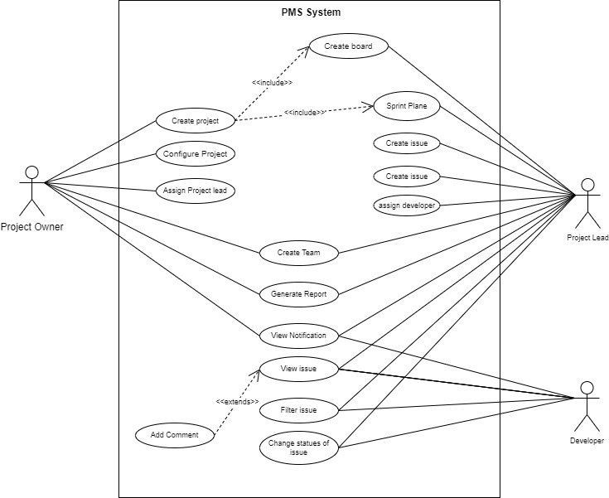

Use Care Diagram

## Specific Requirement

All software needs, both functional and non-functional, are listed in this section. According to the use case model, the functional needs are categorized.

|  |  |
| --- | --- |
| Requirements Id | Identifies each need in every PMS document in a unique way. |
| Title | Defines the functional group the requirement belongs to. Gives the  requirement a symbolic name |
| Description | It is definition of the requirement and here details should be place here. |
| Priority | Defines the order in which requirements should be implemented. Priorities are designated (highest to lowest) “1”, “2”, and “3” … Requirements of priority 1 must be implemented in the first productive system release. The requirements of priority 2 and lower are subject of special releaseagreement, which is out of scope of this document |
| Source | In a real-time SRS it refers to the source, what the requirement originates from. |
| Risk | Specifies risk of not implementing the requirement. It shows how the particular requirement is critical to the system. There are following risk’s levels and associated impact to the system if the requirement is not implemented or implemented incorrectly:   * Critical (C) – will break the main functionality of the system. The system can not be used if this requirement is not implemented * High (H) – will impact the main functionality of the system. Some function of the system could be inaccessible, but the system can be generally used. * Medium (M) – will impact some system’s features, but not the main functionality. System can be used with some limitation * Low (L) – the system can be used without limitation, but with some workarounds. |
| References | Gives link to the related use cases or requirements |

Fig: Properties of the requirements

## Functionality

This section describes the main functional requirements of the Project Management System. The requirements are structured by functionality area and correspond in general the user case model, defined in Use Case diagrams document. Each requirement, if applicable, has the reference to the equivalent use case.

## Main Features

### Users

|  |  |
| --- | --- |
| Requirement Id | R1.01.1 |
| Title | Users |
| Group | Main Functionality\Users |
| Description | The system shall support the concept of user. Every user of the system has a username and a password. The username must be unique. In addition, every user has a set of properties: Full Name, Full Business Title (Company Name, Position), E-Mail Address, Phone, Working Address. Each user is uniquely identified by its username within the system |
| Priority | High |
| Source |  |
| Risk |  |
| Reference |  |

### User role

|  |  |
| --- | --- |
| Requirement Id | R1.01.2 |
| Title | User Role |
| Group | Main Functionality\Users Roles |
| Description | The system shall support the concept of **user roles**. The role will vary project to project. So an user will be able to play multiple role by multiple project but one role will have specific feature than other. The system feature will be enable and disable based on user role. One project will have one owner , one or more assignee/project manager and one or more assigned user. |
| Priority | High |
| Source |  |
| Risk |  |
| Reference |  |

### User Role wise Permission level

|  |  |
| --- | --- |
| User Role | Is Allowed To |
| Project Owner | Browse project list, Create/Delete/View/Update project, Assign/Re-assign a resource to the project . Create/Delete/View/Update Board. |
| Team Leader | Create/Delete/View/Update task and sprint, Assign/Re-assign a resource to the task, associated to him. |
| Team Member | View Task and can change the state of their assigned Tasks. |

Fig: User Roles

### Storing user and User role

|  |  |
| --- | --- |
| Requirement Id | R1.01.3 |
| Title | Storing Users and Users Roles |
| Group | Main Functionality\User Roles\Storage |
| Description | The system must permanently maintain the list of all users (together with all of their permitted properties), the list of all user roles, and any relationships between users and user roles. The system must have storage capacity.  at least five user roles and 200 users, respectively. |
| Priority | High |
| Source |  |
| Risk |  |
| Reference | Security Requirements, Performance Requirement, Number of user |

### User role management

|  |  |
| --- | --- |
| **Requirement Id** | R1.01.4 |
| **Title** | User Role Management |
| **Group** | Main Functionality\User Roles\Manage |
| **Description** | The system shall provide the feature of managing user role. Project Owner will be able to manage user role to the project. |
| **Priority** | High |
| **Source** |  |
| **Risk** |  |
| **Reference** |  |

## User Profile

### User profile

|  |  |
| --- | --- |
| Requirement Id | R1.02.01 |
| Title | User Profile |
| Group | Main Functionality\User Profile |
| Description | The system shall provide the concept of User Profile. The user profile contains  the user-specific configurable parameters of the system. The user profile is  associated with one and only one user that is registered in the system (has a user  name and a password) |
| Priority | High |
| Source |  |
| Risk |  |
| Reference |  |

|  |  |
| --- | --- |
| Requirement Id | R1.02.02 |
| Title | User Profile Edite |
| Group | Main Functionality\User Profile\Edit |
| Description | The system shall provide the concept of User Profile. The user profile contains  the user-specific configurable parameters of the system. The user profile is  associated with one and only one user that is registered in the system (has a user  name and a password) |
| Priority | High |
| Source |  |
| Risk |  |
| Reference |  |

### System Login and Logout

|  |  |
| --- | --- |
| Requirement Id | R1.03.02 |
| Title | System Login |
| Group | Main Functionality\System Login |
| Description | Any user who wants to use the system his/her have to login the system first. The user need to log in the system by specifying exact username and password. There is no limit of login tries. After a successful login, the system will link the user to their roles and set the GUI's appearance to match their profiles. After logging in, the user becomes an authorized and authenticated user. |
| Priority | High |
| Source |  |
| Risk |  |
| Reference |  |

|  |  |
| --- | --- |
| Requirement Id | R1.03.01 |
| Title | System Logout |
| Group | Main Functionality\System Logout |
| Description | Any Logged in user can logout the system. After logout client used browser can’t access his/her profile associated functionalities without login in the system again by providing credential. |
| Priority | High |
| Source |  |
| Risk |  |
| Reference |  |

## Manage Project List

### Show list of project

|  |  |
| --- | --- |
| Requirement Id | R1.04.01 |
| Title | Show List of Projects |
| Group | Main Functionality\Show project List |
| Description | The system will organize have functionality to show list of assigned and created project by them. List of project should be able to shown by their minimal properties Name, Description, Owner, and Creation Date. Every project is associated through the property Owner with one and only one user. The projects where the user is not performing any role, these project will not be shown to them. |
| Priority | High |
| Source |  |
| Risk |  |
| Reference |  |

### Store Project Information

|  |  |
| --- | --- |
| Requirement Id | R1.04.02 |
| Title | Store Project information |
| Group | Main Functionality\Project\Storage |
| Description | Every project will have access to permanent storage to store its all necessary information in server permanent file storage and database |
| Priority | High |
| Source |  |
| Risk |  |
| Reference |  |

### Filtering Project

|  |  |
| --- | --- |
| Requirement Id | R1.04.03 |
| Title | Filtering Project |
| Group | Main Functionality\Project\Filter |
| Description | List of project can be filter by its owner, created date, created by user himself/ herself. The projects where the user is not performing any role, these project will not be shown to them. |
| Priority | Medium |
| Source |  |
| Risk |  |
| Reference |  |

### Searching Project

|  |  |
| --- | --- |
| Requirement Id | R1.04.03 |
| Title | Searching Project |
| Group | Main Functionality\Project\Search |
| Description | List of project can be search its name |
| Priority | Medium |
| Source |  |
| Risk |  |
| Reference |  |

### Creating Project

|  |  |
| --- | --- |
| Requirement Id | R1.04.04 |
| Title | Creating Project |
| Group | Main Functionality\Project\Create |
| Description | Any user can create project who are registered to the system. A user who create a project by default he is the project owner. At the time of creating a project users have to give unique project name compare to his created project. A unique project key will be automatically generated by the system, however user can modify the project key but the condition is project key has to be unique within the whole system. List of other project properties like project type, Project Lead, Default Assignee fields has to fill for creating a project |
| Priority | High |
| Source |  |
| Risk |  |
| Reference |  |

### Selecting Project

|  |  |
| --- | --- |
| Requirement Id | R1.04.05 |
| Title | Select Project |
| Group | Main Functionality\Project\Select |
| Description | From list of project a user can be able to select a project. After selecting a project the system GUI will detect the project as selected project and based the selected project information GUI will be render to the user. |
| Priority | High |
| Source |  |
| Risk |  |
| Reference |  |

### Edite Project Configuration

|  |  |
| --- | --- |
| Requirement Id | R1.04.05 |
| Title | Edite Project configuration |
| Group | Main Functionality\Project\Edit |
| Description | The projects which the user is in owner role these project configuration can be editable by the user. Other role users are not permitted to edit project configuration. Project configuration editable properties will be project name, project key, Project Lead , default assignee. |
| Priority | High |
| Source |  |
| Risk |  |
| Reference |  |

### Delete Project

|  |  |
| --- | --- |
| Requirement Id | R1.04.06 |
| Title | Delete Project |
| Group | Main Functionality\Project\Delete |
| Description | Only project owner will be able to delete the project. Deleting a project will also delete the project from other users who are not owner of the project but had dependency to the project. |
| Priority | High |
| Source |  |
| Risk |  |
| Reference |  |

### Manage Project Leader

|  |  |
| --- | --- |
| Requirement Id | R1.04.07 |
| Title | Manage Project Leader |
| Group | Main Functionality\Mange Project Leader |
| Description | Under the condition that the user has permission “edit project”, the user must be able to assign or re-assign any of available users to the Project Leader property of the project. The user can be associated with any number of projects, but project can be associated only with one user. |
| Priority | High |
| Source |  |
| Risk |  |
| Reference |  |

## Manage Current Project

### Make active Project

|  |  |
| --- | --- |
| Requirement Id | R1.05.01 |
| Title | Make active Project |
| Group | Main Functionality\Project\Current Project |
| Description | The system will be able to detect current project after selecting a project from project list |
| Priority | High |
| Source |  |
| Risk |  |
| Reference |  |

### Project as an root entity

|  |  |
| --- | --- |
| Requirement Id | R1.05.02 |
| Title | Project as an root entity |
| Group | Main Functionality\Project\Project |
| Description | The System shall provide the concept of projects. The project will have one or more board. Each board will have one or more sprints. Each sprint will have start and end date. And every sprint will have one or more issues. An issue will have one or more properties associated with them. |
| Priority | High |
| Source |  |
| Risk |  |
| Reference |  |

|  |  |
| --- | --- |
| Requirement Id | R1.05.02 |
| Title | Create Board |
| Group | Main Functionality\Project\Create Board |
| Description | The project Leader of the project will be able to create one or more board. |
| Priority | High |
| Source |  |
| Risk |  |
| Reference |  |

|  |  |
| --- | --- |
| Requirement Id | R1.05.03 |
| Title | Project view as a member of the projects |
| Group | Main Functionality\Project\Only view |
| Description | As a assigned member of the project a user can view assigned project but the user won’t have edit permission of the project configuration |
| Priority | High |
| Source |  |
| Risk |  |
| Reference |  |

|  |  |
| --- | --- |
| Requirement Id | R1.05.04 |
| Title | Reporting |
| Group | Main Functionality\Project\Reporting |
| Description | The system shall provide the authorized user with permission “create report” the ability to create a various reports on the project. Available report type will vary from user to user. |
| Priority | High |
| Source |  |
| Risk |  |
| Reference |  |

## Manage Issue

### Changing State of issue

|  |  |
| --- | --- |
| Requirement Id | R1.05.05 |
| Title | Changing State of issue |
| Group | Main Functionality\Manage Issue\issue state |
| Description | Project lead and assigned member will be able to change the state of issue. The state of issue are To do, In progress, To review, Done |
| Priority | High |
| Source |  |
| Risk |  |
| Reference |  |

### Comment on issue

|  |  |
| --- | --- |
| Requirement Id | R1.05.06 |
| Title | Comment on Issue |
| Group | Main Functionality\Manage Issue\issue |
| Description | User will be able to add comment to issues. The user who are assigned to the issue, project lead and owner of the project will be able to comment on the issue |
| Priority | Medium |
| Source |  |
| Risk |  |
| Reference |  |

### Add helper link to a issue

|  |  |
| --- | --- |
| Requirement Id | R1.05.07 |
| Title | Add helper link to the issue |
| Group | Main Functionality\Manage Issue\Add helper link |
| Description | Any authorized user associated with the project will be able to add link on the issue. |
| Priority | Low |
| Source |  |
| Risk |  |
| Reference |  |

### Update issue

|  |  |
| --- | --- |
| Requirement Id | R1.05.08 |
| Title | Update Issue |
| Group | Main Functionality\Manage Issue\Update |
| Description | Project Lead Will be able to update properties of issue Like issue title, issue description, Add issue Link, Update File Link. |
| Priority | Low |
| Source |  |
| Risk |  |
| Reference |  |

|  |  |
| --- | --- |
| Requirement Id | R1.05.08 |
| Title | Assign developer to an issue |
| Group | Main Functionality\Manage Issue\Update |
| Description | Project Lead Will be able to update properties of issue Like issue title, issue description, Add issue Link, Update File Link. |
| Priority | Low |
| Source |  |
| Risk |  |
| Reference |  |

# Use Cases

In software and systems engineering, a use case is a list of action or event steps, typically defining the interactions between a role and a system, to achieve a goal while software requirements specification (SRS) is a document that captures complete description about how the system is expected to perform. PMS for agile team use cases description are given below.

## Add Project

|  |  |  |
| --- | --- | --- |
| **Use Case 1** | Add Project | |
| **Goal** | Any registered user create project | |
| **Preconditions** | User have to sign in their account | |
| **Success End Condition** | User successfully create project | |
| **Fail End Condition** | User can’t successfully create the project | |
| **Primary Actor:**  **Secondary Actor:** | Any registered user of the system | |
| **Trigger** | Click on create project button | |
| **Main Success Flow** | **Steps** | **Action** |
| 1. | User will provide input for following field   * Project Name * Project Key * Project Category * Project default board Name * Project Assignee/ Lead * Default Assignee |
| 2 | User will click on create button |
| 3 | User go to created project dashboard |
|  |  |
| **Alternative Success Flows** | **Step** | **Action** |
| 1 |  |
| **Quality Requirements** | **Step** | **Action** |
| 1 |  |
| 2 |  |

## Create Issue

|  |  |  |
| --- | --- | --- |
| **Use Case 1** | Create Issue | |
| **Goal** | User create issue to a project sprint | |
| **Preconditions** | User have a selected project. | |
| **Success End Condition** | User will be able to create board | |
| **Fail End Condition** | User can’t successfully create issue | |
| **Primary Actor:**  **Secondary Actor:** | Project Lead | |
| **Trigger** | Click on Create issue button | |
| **Main Success Flow** | **Steps** | **Action** |
| 1. | User will provide input for following field   * Issue title * Issue sprint * Issue type * Labels * priority |
| 2 | Click on create button |
| 3 | Created issue will be added to chose sprint |
|  |  |
| **Alternative Success Flows** | **Step** | **Action** |
| 1 |  |
| **Quality Requirements** | **Step** | **Action** |
| 1 |  |
| 2 |  |

## Create Board

|  |  |  |
| --- | --- | --- |
| **Use Case 1** | Create Board | |
| **Goal** | User create board for container of multiple sprint | |
| **Preconditions** | User have a selected project. | |
| **Success End Condition** | User will be able to create board | |
| **Fail End Condition** | User can’t successfully create the board | |
| **Primary Actor:**  **Secondary Actor:** | Project Lead, Project owner | |
| **Trigger** | Click on Create issue button | |
| **Main Success Flow** | **Steps** | **Action** |
| 1. | User will provide input for following field   * Board Name * Board Type |
| 2 | Click on create button |
| 3 | Created board added to under the selected project |
|  |  |
| **Alternative Success Flows** | **Step** | **Action** |
| 1 |  |
| **Quality Requirements** | **Step** | **Action** |
| 1 |  |
| 2 |  |

## Configure Project

|  |  |  |
| --- | --- | --- |
| **Use Case 4** | Configure Project | |
| **Goal** | User edit/update project configuration according to user need | |
| **Preconditions** | User select target project to configure | |
| **Success End Condition** | User able to change project configuration | |
| **Fail End Condition** | User can’t successfully change project configuration | |
| **Primary Actor:**  **Secondary Actor:** | Project owner | |
| **Trigger** | Click on target configure project button | |
| **Main Success Flow** | **Steps** | **Action** |
| 1. | User will provide change configuration which his/her need from the following field   * Project Name * Project Key * Project Lead * Default Assignee |
| 2 | Click on save button |
| 3 | Configuration will be saved and user will be redirected to list of projects page |
|  |  |
| **Alternative Success Flows** | **Step** | **Action** |
| 1 |  |
| **Quality Requirements** | **Step** | **Action** |
| 1 |  |
| 2 |  |

## Assign Project Lead

|  |  |  |
| --- | --- | --- |
| **Use Case** | Assign Project Lead | |
| **Goal** | User will be able to assign project lead under a project | |
| **Preconditions** | User select target project to configure | |
| **Success End Condition** | User able to change selected project ‘Project Lead’. | |
| **Fail End Condition** | User can’t successfully change project lead | |
| **Primary Actor:**  **Secondary Actor:** | Project owner | |
| **Trigger** | Click on target configure project button | |
| **Main Success Flow** | **Steps** | **Action** |
| 1. | From list of configure input User will select project lead input |
| 2 | User type user name of project lead which he/she want to assign. |
| 3 | Click on ‘save’ button |
|  |  |
| **Alternative Success Flows** | **Step** | **Action** |
| 1 |  |
| **Quality Requirements** | **Step** | **Action** |
| 1 |  |
| 2 |  |

## Create Team

|  |  |  |
| --- | --- | --- |
| **Use Case** | Create Team | |
| **Goal** | User will be able to Create team | |
| **Preconditions** | 1. User open his/her profile 2. User select a project | |
| **Success End Condition** | User send create team request to peoples | |
| **Fail End Condition** | User can’t successfully send create team request to peoples | |
| **Primary Actor:**  **Secondary Actor:** | Project Lead, Project owner | |
| **Trigger** | Click on create Team button | |
| **Main Success Flow** | **Steps** | **Action** |
| 1. | Enter team Name |
| 2 | Add peoples in Invite people to your team field |
| 3 | Click on ‘Create team’ button |
|  |  |
| **Alternative Success Flows** | **Step** | **Action** |
| 1 |  |
| **Quality Requirements** | **Step** | **Action** |
| 1 |  |
| 2 |  |

## Generate Report

|  |  |  |
| --- | --- | --- |
| **Use Case** | Generate Report | |
| **Goal** | User will be able to generate report | |
| **Preconditions** | 1. User select project from which he/she want to generate report | |
| **Success End Condition** | User download required project report | |
| **Fail End Condition** | User can’t successfully send create team request to peoples | |
| **Primary Actor:**  **Secondary Actor:** | Project Lead, Project owner | |
| **Trigger** | Click on generate Report button | |
| **Main Success Flow** | **Steps** | **Action** |
| 1. | User Chose required report |
| 2 | Click on ‘generate’ button |
| 3 | Required report download will be started |
|  |  |
| **Alternative Success Flows** | **Step** | **Action** |
| 1 |  |
| **Quality Requirements** | **Step** | **Action** |
| 1 |  |
| 2 |  |

## Assign Developers to An Issue

|  |  |  |
| --- | --- | --- |
| **Use Case** | Assign Developer to an issue | |
| **Goal** | Project lead will be able to assign developer to an issue | |
| **Preconditions** | 1. User select a project 2. User go to backlog page | |
| **Success End Condition** | User download required project report | |
| **Fail End Condition** | User can’t successfully send create team request to peoples | |
| **Primary Actor:**  **Secondary Actor:** | Project Lead | |
| **Trigger** | Click on a issue | |
| **Main Success Flow** | **Steps** | **Action** |
| 1. | User will click on issue |
| 2 | From list of issue configuration click on assign member |
| 3 | Input one or more developer to an issue |
|  |  |
| **Alternative Success Flows** | **Step** | **Action** |
| 1 |  |
| **Quality Requirements** | **Step** | **Action** |
| 1 |  |
| 2 |  |

## View Notification

|  |  |  |
| --- | --- | --- |
| **Use Case** | View Notification | |
| **Goal** | Use will show their notification | |
| **Preconditions** | User has logged in the system | |
| **Success End Condition** | User successfully show their notification. | |
| **Fail End Condition** | Use can’t successfully show their notification | |
| **Primary Actor:**  **Secondary Actor:** | Project Lead, Project owner, Developers | |
| **Trigger** | Click on notification icon | |
| **Main Success Flow** | **Steps** | **Action** |
| 1. | User will show a spinner |
| 2 | User will show at most 8 recent notification in a modal |
|  |  |
|  |  |
| **Alternative Success Flows** | **Step** | **Action** |
| 1 | User show a spinner |
| 2 | User will show at most 8 recent notification in a modal |
| 3 | User click on show all notification |
| 4 | User will redirected to all notification page |
| **Quality Requirements** | **Step** | **Action** |
| 1 |  |
| 2 |  |

## View Issue

|  |  |  |
| --- | --- | --- |
| **Use Case** | View issue | |
| **Goal** | User will view issue | |
| **Preconditions** | 1. User is logged in the system 2. User is connected to a project 3. User click on My Work | |
| **Success End Condition** | User will successfully view issue. | |
| **Fail End Condition** | User will show message ‘You have no issue to show’ | |
| **Primary Actor:**  **Secondary Actor:** | Developer, Project Lead | |
| **Trigger** | User click on assigned to me | |
| **Main Success Flow** | **Steps** | **Action** |
| 1. | User will see spinner |
| 2 | User will see list of recent assigned issue which is assigned to him/her |
|  |  |
|  |  |
| **Alternative Success Flows** | **Step** | **Action** |
| 1 |  |
| **Quality Requirements** | **Step** | **Action** |
| 1 |  |
| 2 |  |

## Filter issues

|  |  |  |
| --- | --- | --- |
| **Use Case 11** | Filter issue | |
| **Goal** | User will be able to filer issue | |
| **Preconditions** | 1. User is in all issues page | |
| **Success End Condition** | User will be able to filter issue | |
| **Fail End Condition** | User will be shown ‘no issues to show’. | |
| **Primary Actor:**  **Secondary Actor:** | Project Owner, Project lead, developer | |
| **Trigger** | Only My issue, recently updated | |
| **Main Success Flow** | **Steps** | **Action** |
| 1. | User will click on any one filter option button |
| 2 | If user click on only my issue he/she will be shown only issues which they are related with. |
| 3 | User will successfully shown filtered issues. |
|  |  |
| **Alternative Success Flows** | **Step** | **Action** |
| 1 |  |
| **Quality Requirements** | **Step** | **Action** |
| 1 |  |
| 2 |  |

## Change state of Issue

|  |  |  |
| --- | --- | --- |
| **Use Case** | Change state of issue | |
| **Goal** | The state of an issue will be change | |
| **Preconditions** | 1. User is assigned to the issue 2. User is in sprint dashboard | |
| **Success End Condition** | User change the state of an | |
| **Fail End Condition** | User can’t successfully send create team request to peoples | |
| **Primary Actor:**  **Secondary Actor:** | Developers | |
| **Trigger** | Dragging the issue card one state to another state region | |
| **Main Success Flow** | **Steps** | **Action** |
| 1. | User dragged the issue where he/she want to changed the state of an issue |
| 2 | Dragged over the issue on a issue state container like To do, In progress , Done. |
| 3 | Dragged issue card html element will be replaced to the replace container. |
| 4 | Issue state will be change in the database as well. |
|  |  |
| **Alternative Success Flows** | **Step** | **Action** |
| 1 |  |
| **Quality Requirements** | **Step** | **Action** |
| 1 |  |
| 2 |  |

# Er Diagram

**ER Model** stands for Entity Relationship Model is a high-level conceptual data model diagram. ER model helps to systematically analyze data requirements to produce a well-designed database. The ER Model represents real-world entities and the relationships between them. Creating an ER Model in DBMS is considered as a best practice before implementing your database.

Er Model helps us to analyze data requirements systematically to produce a well-designed database. So, it is considered a best practice to complete ER modeling before implementing database.

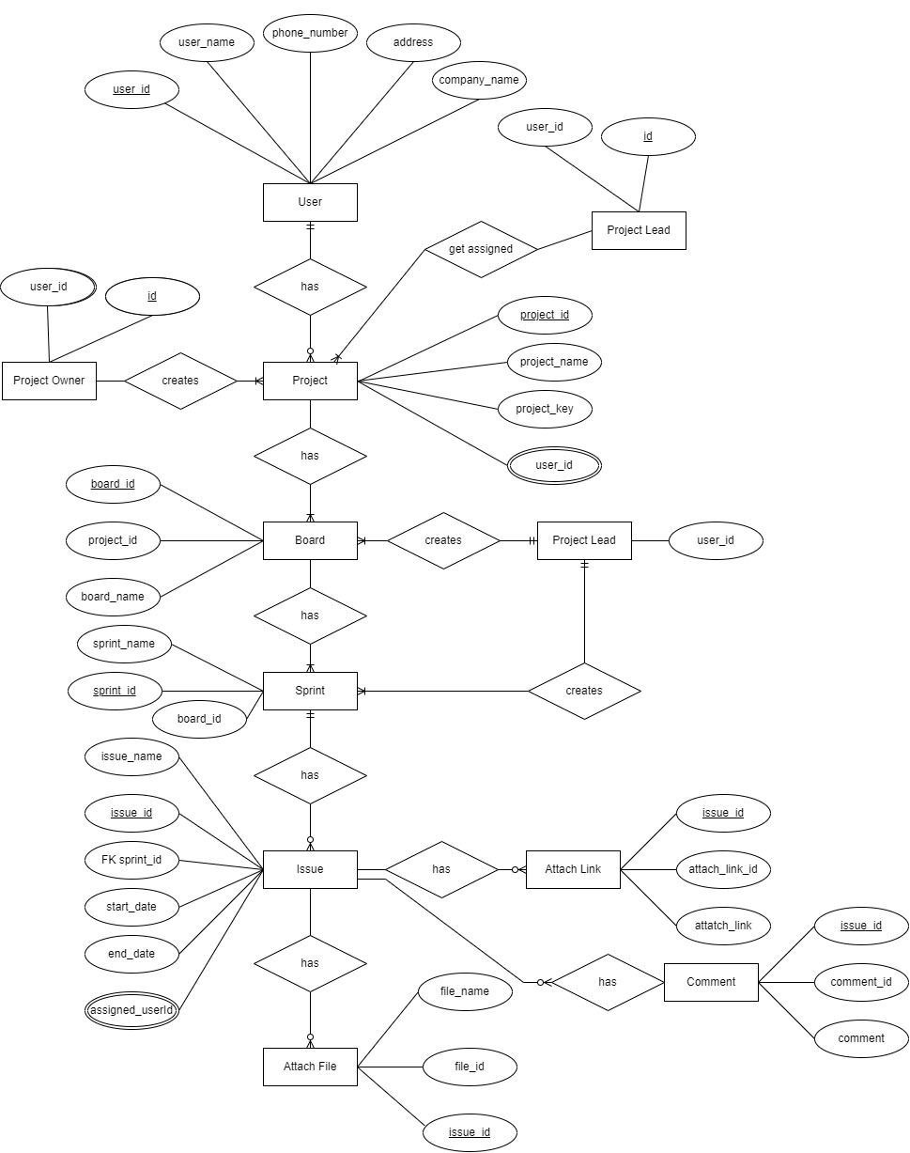

ER Diagram of project management system for agile team