On Effective Sharing of User Generated Content
Shubhajit Saha  IDC, IIT Bombay  Mumbai, India  shubhajit@iitb.ac.in | Goutam Paul  Department of CSE  Jadavpur University  Kolkata, India  goutam.paul@ieee.org

ABSTRACT
¹The work of this author was done in part during his visit at RWTH Aachen,
Germany as an Alexander von Humboldt Fellow.

Permission to make digital or hard copies of all or part of this work for personal or classroom use is granted without fee provided that copies are not made or distributed for profit or commercial advantage and that copies
bear this notice and the full citation on the first page. To copy otherwise, or republish, to post on servers or to redistribute to lists, requires prior specific permission and/or a fee.
APCHI
Copyright 2013 ACM 978-1-XXXX-XXXX-X/XX/XX...$10.00.
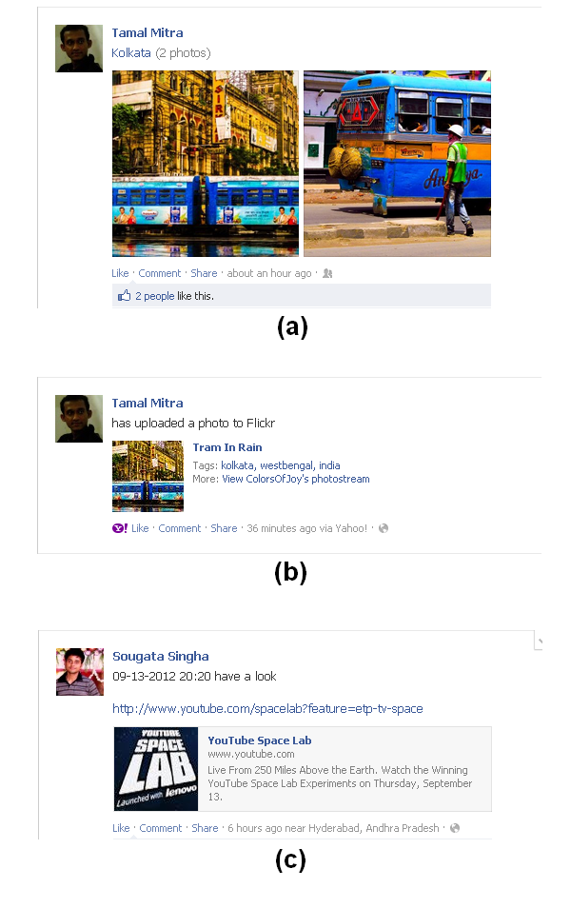
Sharing of content is an important part of growing social networking culture. We examine the effectiveness of shared user-generated content (UGC) on social networking sites (SNSs). We divide the shared content into two categories: direct share, where the content is created in SNS and indirect share, where the UGC is created in other websites/web-services. In particular, we study how the limited information and visibility of the post affect the popularity and longevity of the content on the basis of social activities such as likes, shares and comments. The findings indicate that indirect share is less popular and short lived as compared to direct share. The study suggests that there is a need to design social networking feature that supports integration of UGC form other popular web-services.

Author Keywords
Sharing, social networking sites, user generated content, web-services.

ACM Classification Keywords
H.5.m. Information interfaces and presentation (e.g., HCI): Miscellaneous.

General Terms
Human Factors

INTRODUCTION
Today internet is full of prominent web-services like photo sharing, video sharing, blogs, micro-blogs, messenger and social networks, and a large amount of user-generated content (UGC) is created everyday on these sites [10]. A user signs up for multiple services and generates contents on them. When the user creates content s/he shares it to social networking site (SNS) to notify his/her network about the content. The notification is shared explicitly by the user or by the website where the UGC was created. The posts on SNSs related to UGC are generally composed of elements from the content and sometimes appended with a link to the original content (see Figure 1a, c; 2a). We divided the posts of UGC into two categories: (1) direct share, where the content is crated on SNS itself (see Figure 1a) and (2) indirect share, where the content is created on external websites/web services (e.g., Flickr, Instagram, YouTube, etc.) (see Figure 1b, c). The effectiveness of sharing a content posted in social network is based on its popularity and longevity.
Figure 1 Indirect and Direct shared content on SNS
Most previous studies have looked at the UGC for its quality, privacy and visualization. We focus on sharing of UGC and its limits caused due to limited information and visibility. Sharing content on SNSs have changed the way we think and even reshape the way people take collective action [5].
In this paper, we examine the direct and indirect shares on SNSs. The results identify the difference in popularity and longevity between direct and indirect shares. The indirect shares of UGC have a smaller life span. Also it fails to establish much popularity on the SNSs because of limited information and visibility of data to non-members. Lastly, we discuss how these finding provide implication for designing specific features on SNS for integrating UGC created over other web-services, which enable user to create a mass approach toward its content.
Figure 2 Indirect shared content on (a) Twitter and (b) Facebook

Sharing User-Generated Content
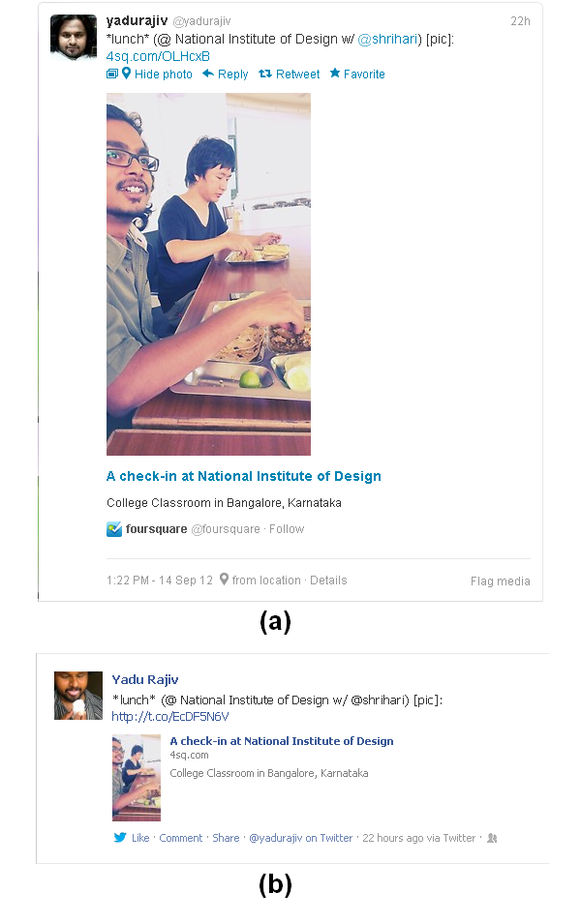
UGC is defined as “the work that is published in some context, be it on a publicly accessible website or on a page on a social networking site only accessible to a select group of people”, or a work such that “a certain amount of creative effort was put into creating the work or adapting existing works to construct a new one” and something “generally created outside of professional routines and practices” [13]. Three universal motivation of sharing UGC are identity management, knowledge management, and social connection [8]. Much of the previous research related to UGC and SNSs has examined different perspectives. A study by Fisher showed how user data visualization can help make privacy issues more visible within a social media space [7]. Lussier et al. studied consumption of UGC and showed that similar consumption patterns imply a higher tendency of people to choose friends similar to themselves [11]. Moris et al. explored that Twitter which is now used to distribute substantive content such as breaking news, has increased the importance of assessing the credibility of content [12]. Here we consider how UGC loses its importance when shared through other web services.

User-Generated Content on Social Networking Site
The elements on “information interface” influence the user judgments [12]. The presentation of the post on SNS sometimes differs when the UGC is created on it and when created on other media-sharing sites. When the content is created on other web-services the user uses web-apps or explicitly posts an update on SNS. These posts are generally associated with a link to the content where it is created and SNS like Facebook fetches media from the link and add a thumbnails or video with some text, like header and domain name, to the post and make it visually rich (see Figure 2b, 1a, b). The visual appearance of the post containing an external link or sharing UGC created on other site is distinctively different from one created on it, Figure 1a and 1b shows Facebook updates when a photo album is created on Facebook and when the same album is uploaded on other media-sharing website respectively. Twitter also analyzes link and embeds media and text element to the post (see Figure 2a) and it even allows user to add an image to the post [14]. People generally use web-apps in SNS to connect to other SNSs. So that when user shares update in one it automatically updates all another, which may sometimes turns out to be useless, for instance in Twitter people uses special symbols like hash “#” and at “@” [15] which is not recognized when posted to Facebook (see Figure 2b).
The presentation factor has an implication for the way people might respond to a post in SNSs, especially on Facebook which is heavily media driven as compared to Twitter. Therefore, the following hypotheses are formed:
H1. Indirect shared content is less popular than direct shared content.
The popularity of the content can be measured as an aggregation of (1) number of people shares/repost the article, (2) number of people likes it or mark it as favorite, and (3) number of comments.
H2. Indirect shared content is short lived as compared to direct shared contents in SNSs.
The news feed or the home page shows the updates of the friends or group the user is subscribed to. When a user posts an update, it becomes visible to his/her entire network or a group of people s/he selected to share with. The update keeps on sinking in the list of news feed but activities like share, comment and likes brings it up again. Prior research showed that these contents have a very short popular period [10].
 | Direct Share | Indirect Share
Average number of comments per post | 13.00 | 2.28
Average number of likes and share per post | 34.92 | 5.48
Average responses per post | 47.92 | 7.76
Table 1 Response to User’s Post/Updates
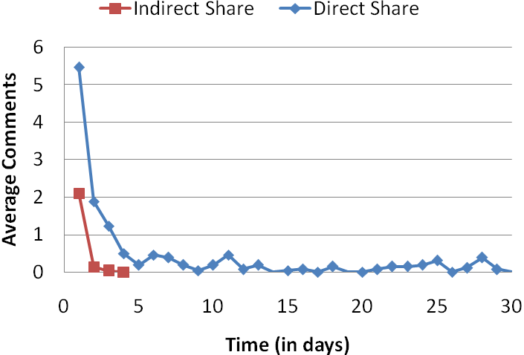
Figure 3 Response to User’s Post with Time

We perform a deeper analysis and find interesting patterns that differ between direct and indirect shares. When a user creates content in SNSs like uploading a photo or video, it gets associated to its profile and it can be found in the respective section of his profile page. But when the user creates the content in a media sharing website and s/he updates his/her network in SNSs with a post containing a link to the content, the update sinks in his/her profile with time as other posts comes in. As new posts comes in the life span of the content decreases as compared to the content generated in SNSs that can always be found on the respective section of the profile page. Facebook’s Timeline [6] hides some of the unresponsive posts form the user’s wall without his/her consent, which even shortens the life cycle of the post. We propose that it is more likely that UGC created on SNSs (direct share) will have a larger life cycle as compared to indirect ones.

Method

Participants
The study is based on the data collected from Facebook. We studied the response to post by different users. The posts were published with an access level of public. We sampled 100 different posts containing user-generated content (UGC) from the social networking site and 100 posts containing content from other media-sharing site. Among the 89 randomly chosen participants form our network, the average number of friends for each participants were 688 (ranging from 191 to 2759). The samples considered for the study were at least a month old and its response behavior for the immediate 30 days from the time of creation was noted. No more than 3 samples were taken from a single participant. The study consisted of measuring the activity in the post by counting number of comments, share and likes. The activity on the post also consists of the activity on the individual contents.

Data Analysis and Results
Since we have two categories of data, one for direct share and the other for indirect, we performed one-sided two-sample equal variance T-tests at 5% significance level. We worked with two data-sets. The first set contains 3 values for each of direct and indirect shares corresponding to average comments, average likes and average activities per post over a period of 30 days (see Table 1) for our first hypothesis. H1 is supported by a P-value of 0.0301, suggesting that the indirect shared content is less popular. The second set contains day-by-day records of average number of posts from day 1 to day 30 for direct and indirect shares (see Figure 3) for our second hypothesis. The test supporting H2 had a P-value of 0.0398, H2 predicts that indirect shared content have a shorter life cycle as compared to direct ones.

Discussion
The study examined the popularity and longevity of UGC shared on SNS compared to other media-sharing site. Our result suggests that the UGC shared on SNSs receives better response. Moreover when sharing from SNSs, UGC has a greater life cycle as compared to one sharing from other sites.
Lampe et al. [9] shows that “get information” and “provide information” as two dimensions of purposive value, which is one of the motivations set for participation in online communities [4]. The result suggests that “get information” dimension is not completely satisfied in case of content shared through other sites, where the user has completed the criteria of “provide information”. The average response to UGC shared through SNS (47.92) was very high as compared to response when shared through other site (7.79). The results also echo the popularity of the share over time; none of the indirect shared UGC lasted for more than immediate four days from the time of creation (see Figure 3) whereas some of the content on SNSs lasted for more than 30 days and most of them had activities all along. Deuker and Albers found that understanding which factors determine users’ perception and valuation of SNS content appears to be one of the most complex questions in the field of information filtering and social media to date [3].
Consumption activities are the most common activities in social networking services [1]. User sings up for multiple services for the consumption from peer, individual and/or group in other SNSs. Social network “aggregation” can be the solution to the inconsistency of awareness and longevity of UGC where content from multiple services is fetched and interwoven into one consistent user interface (UI) [2]. “Aggregation” of social networks in mobile devices has been studied for a long time. System as such which notify the user of the latest updates nearly in real time and combine content from multiple services. Commercial examples of such aggregators include Vodafone 360, Motorola’s Motoblur, Windows 7 People Hub and HTC’s friend stream. A social network “aggregator” for a web where users can connect multiple online profile, media-sharing sites, SNSs and other web-services to create a seamless experience for the peer or people in their network and remove the barrier of using multiple profiles and fragmented UGC.
There are also limitations to our study. First, the participants were mostly selected from our own social network. Second, the data found was very limited like the effectiveness of post over time was measured only by the count of comments because no date stamp was provided by Facebook for likes or share of the post. The samples considered were of wide range of variety which can have an effect on the popularity of the post. In future research, we plan to examine a wide range of data and analyze the effect of different categories and themes of content and also consider factors such as the size of the users network, the gender, age and social/professional backgrounds of the users, the day of the week and the time of day that the initial post was made, the time between this post and the next one on the users profile, and the topic of the post. We even plan to study the behavior of social network “aggregators” for web for sharing of UGC.

Conclusion
We are interested in how people respond to user’s UGC when shared on SNSs. This finding will help the community to get a vivid view of awareness and longevity of UGC on SNSs given that the major part of the research has been carried out on Facebook. Moreover, the finding could have an implication for SNS design for integrating UGC created outside of it. Example of a simple platform that allows users to integrate different media-sharing sites, SNSs, online identities and relevant external links to create a personalized page about them is About.me (www.about.me). About.me is uniquely characterized by one page user profiles, each with a large and often artistic background image and abbreviated biography. Integration of online identities and media-sharing web services can be incorporated into SNSs like Facebook to create a better awareness of the UGC.

REFERENCES
- Cui, Y. Facilitating Consumption of Online Social Networking Services on Mobile Devices. In Proc. UbiComp’11, September 17–21, 2011, Beijing, China.
- Cui, Y., Honkala, M., Pihkala, K., Kinnunen, K., and Grassel, G. Linked Internet UI: A mobile user interface optimized for social networking. In Proc. Mobile HCI ’10, ACM (2010), 45–54.
- Deuker, A., Albers, A. Who cares? Content sharing on social networking sites: a grounded theory study. In Proc. 16th Pacific Asia Conference on Information Systems (PACIS) 2012, July 11-15, 2012, Ho Chi Minh city, Vietnam.
- Dholakia, U.M., Bagozzi, R.P. and Pearo, L.K. A social influence model of consumer participation in network- and small-group-based virtual communities. International Journal of Research in Marketing, 21 (3). 241-263.
- Doerr, B., Fouz, M. and Tobias Friedrich, T. Why Rumors Spread Fast in Social Networks. In Proc. Communications of the ACM, Volume 55 Issue 6(70-75), June 2012. NY, USA.
- Facebook blog, Timeline: Now Available Worldwide, http://blog.facebook.com/blog.php?post=1015040848896213, December 15, 2011.
- Fisher, D. Social Media Visualization & Privacy. In Proc. CSCW 2011, March 19–23, 2011, Hangzhou, China.
- Grannell, C. The Psychology of User-Generated Content. www.marketingmag.com.au, marketing September 2009.
- Lampe, C., Wash, R., Velasquez, A., Ozkaya, E. Motivations to Participate in Online Communities. In Proc. CHI 2010, April 10–15, 2010, Atlanta, Georgia, USA.
- Li, G., Wang, M., Feng, J., Xu, L., Ramamurthy, B., Li, W., and Guan, X. Understanding User Generated Content Characteristics: A Hot-Event Perspective.
- Lussier, J.T.,Raeder, T. and Chawla, N.V. User Generated Content Consumption and Social Networking in Knowledge-Sharing OSNs. In Proc. SBP'10 (228-237). Springer-Verlag Berlin, Heidelberg.
- Morris, M.R., Counts, S., Roseway1, A., Hoff, A. and Schwarz, J. Tweeting is Believing? Understanding Microblog Credibility Perceptions. In Proc. CSCW 2012, February 11–15, 2012, Seattle, Washington, USA.
- Moriarty, G.L. Psychology 2.0: Harnessing Social Networking, User-Generated Content, and Crowdsourcing. In. Journal of Psychological Issues in Organizational Culture, Volume 1, Number 2, 2010.
- Twitter blog, Share a photo via text message. http://blog.twitter.com/2011/09/share-photo-via-text-message.html. September 21, 2011.
- Twitter basics, https://support.twitter.com/groups/31-twitter-basics#topic_109.

Twitter [https://twitter.com/], popular micro-blogging service generates 340 million tweets (140 character status messages) per day as of March 2012.
Facebook [https://facebook.com/] is a social networking site and has more than 955 million users as of June, 2012.

