**HTML project: Latitude Vs.**

Suvrangshu Ghosh

Url: <https://suvrangshu.github.io/HTML_homework/>

Main landing page (index.html)

To generate this data I have generated my own data and also tested using the supplied csv file.

This web has total of seven responsive pages:

1. Landing page – Index.html
2. Compare.html
3. Data.html
4. Latitude_vs_cloud_detail.html
5. Latitude_vs_humidity_detail.html
6. Latitude_vs_temp_detail.html
7. Latitude_vs_wind_detail.html

This is the first landing page: Latitude works as a home page button, it will take you back to home page.

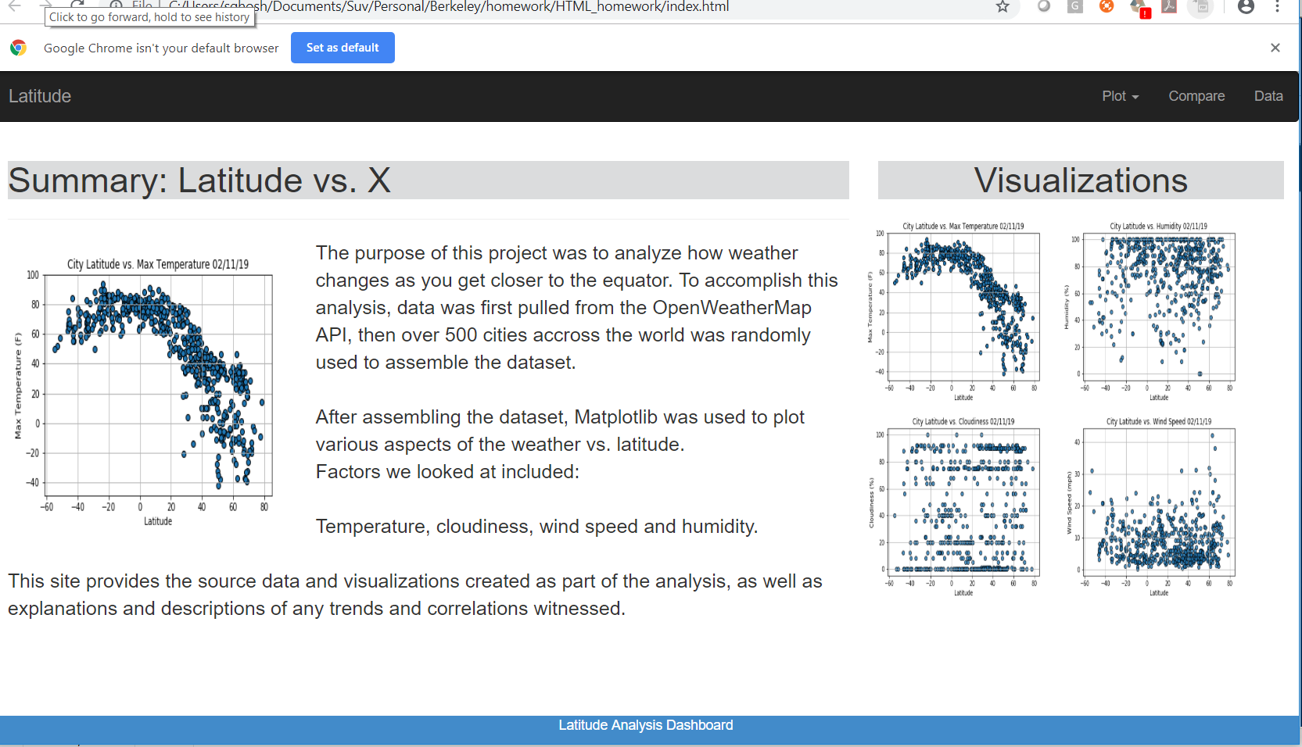

Landing page – Index.html – in small window (background color changes along with menu text and graphic alignments.

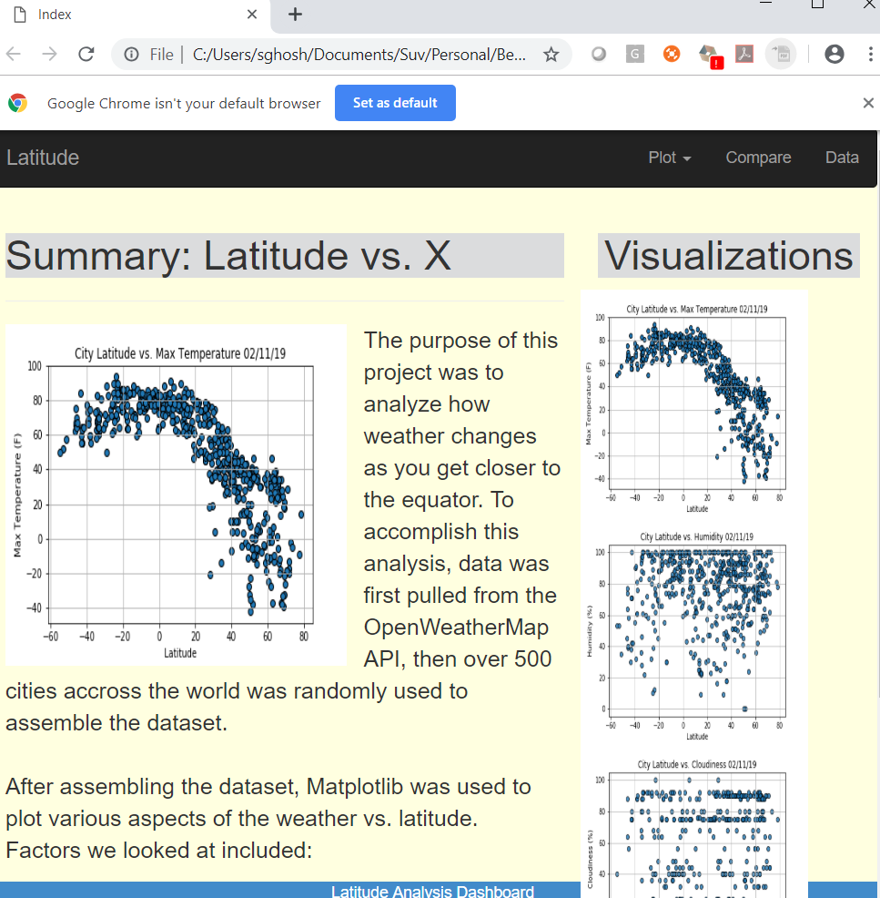

Smaller window:

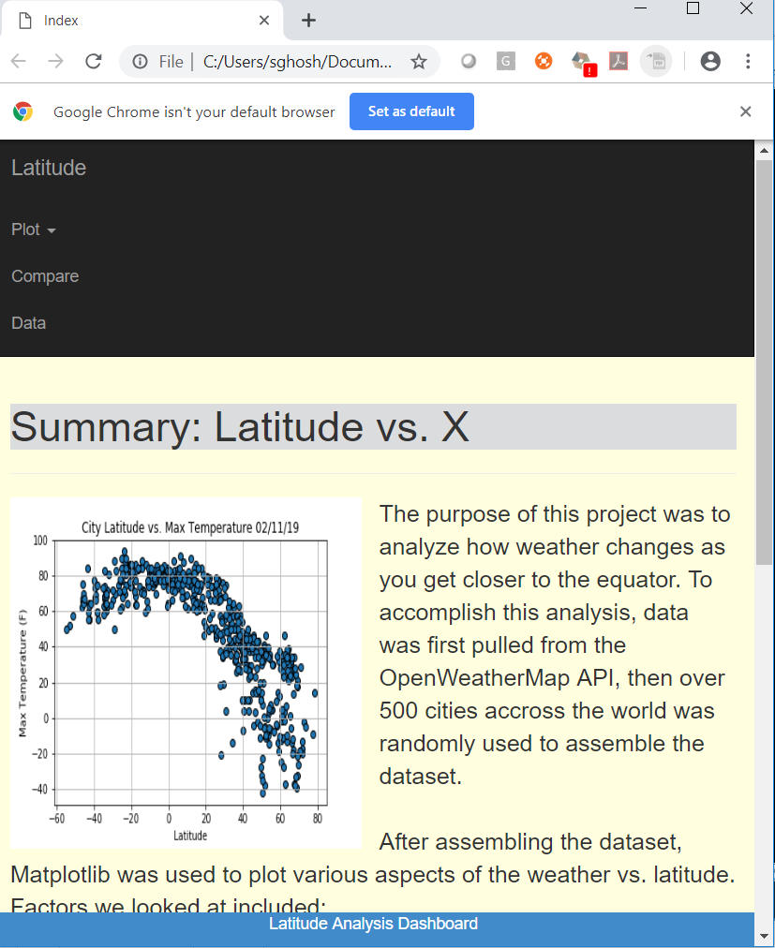

Visualization area, every image is clickable, when clicked opens a detailed page

Detail page –

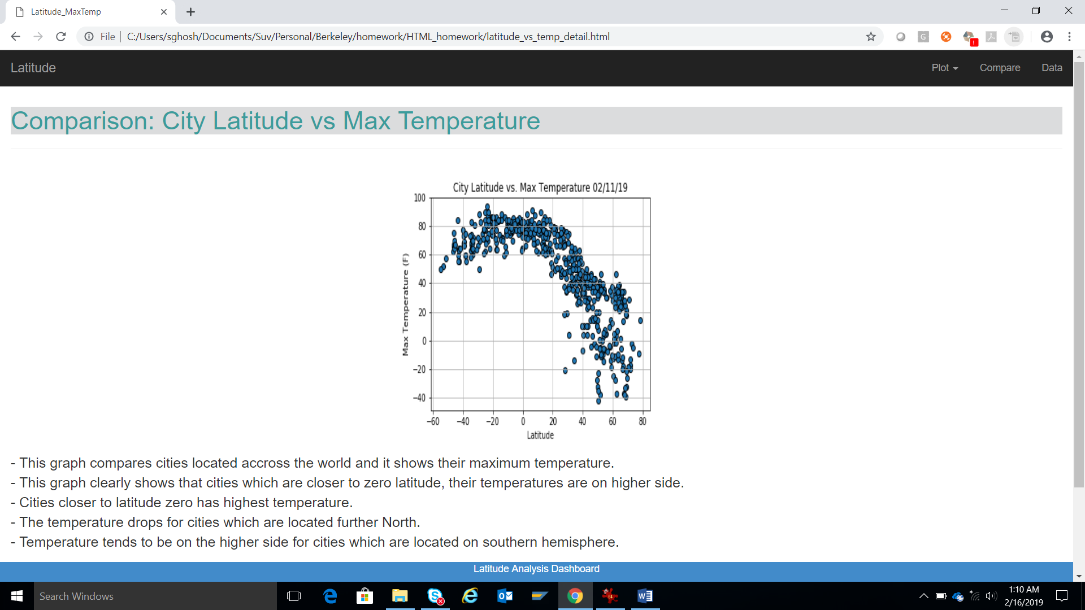

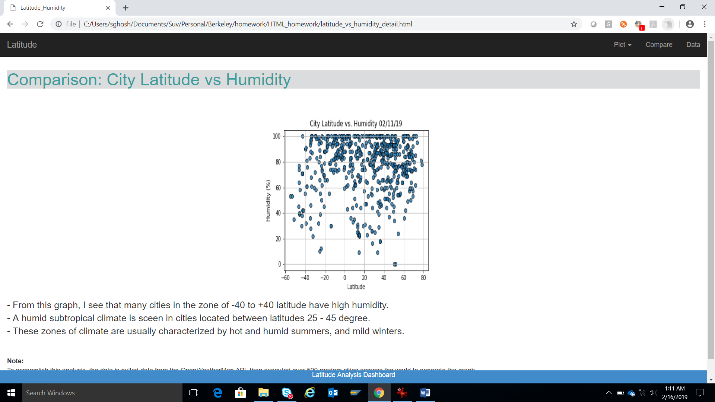

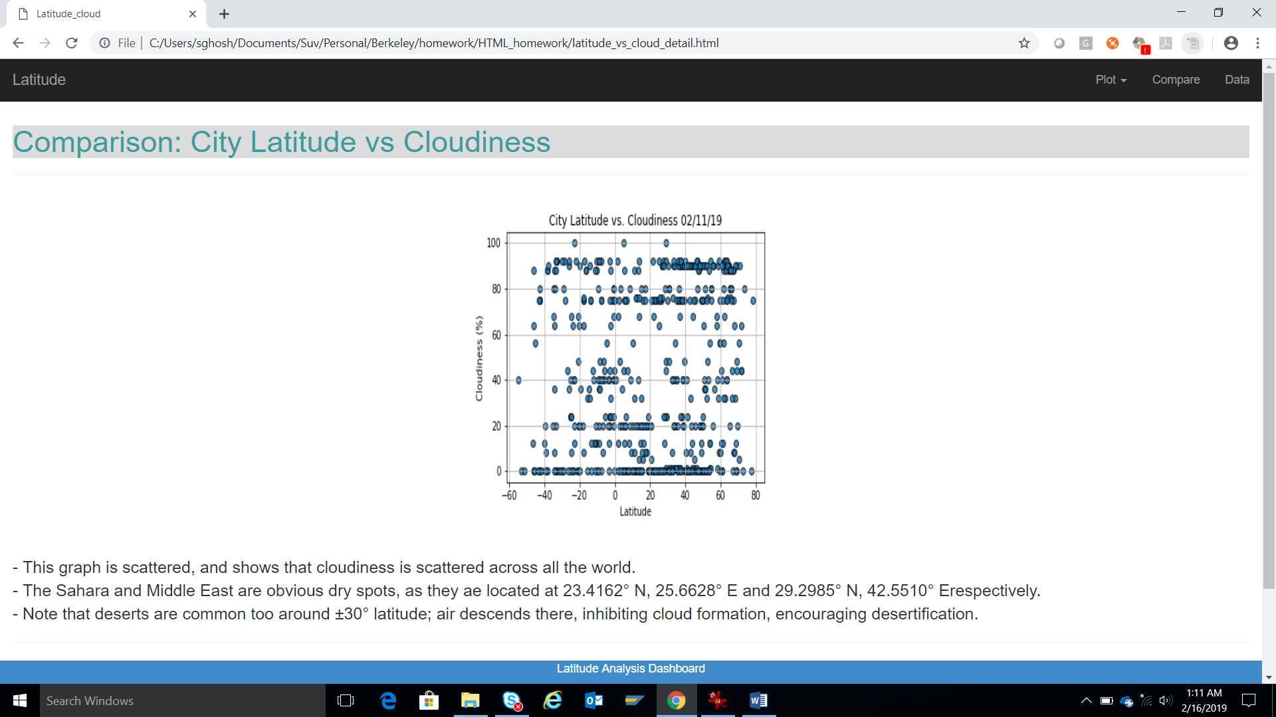

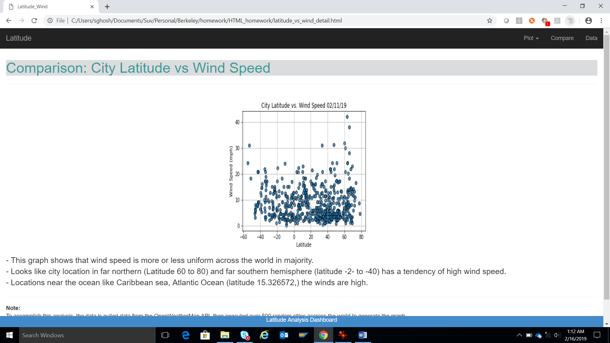

Responsive Detail page when window is made smaller, it adjusts and color changes:

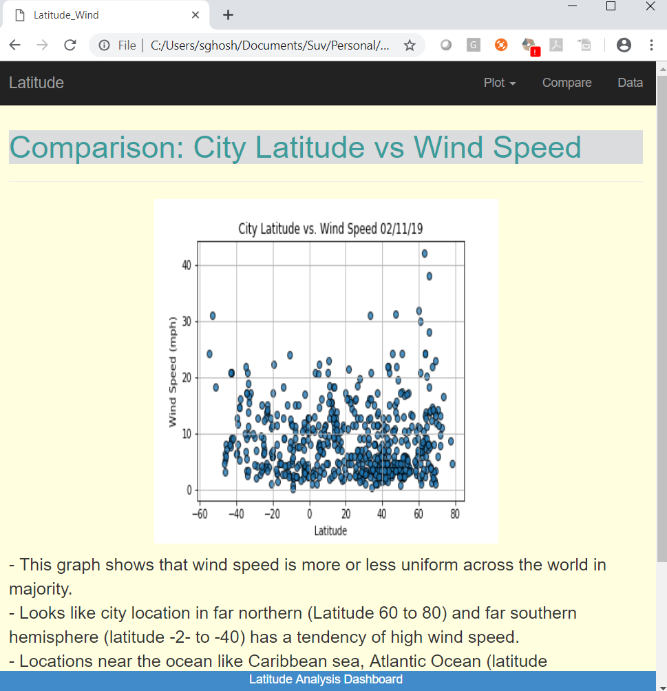

Screen capture of menu

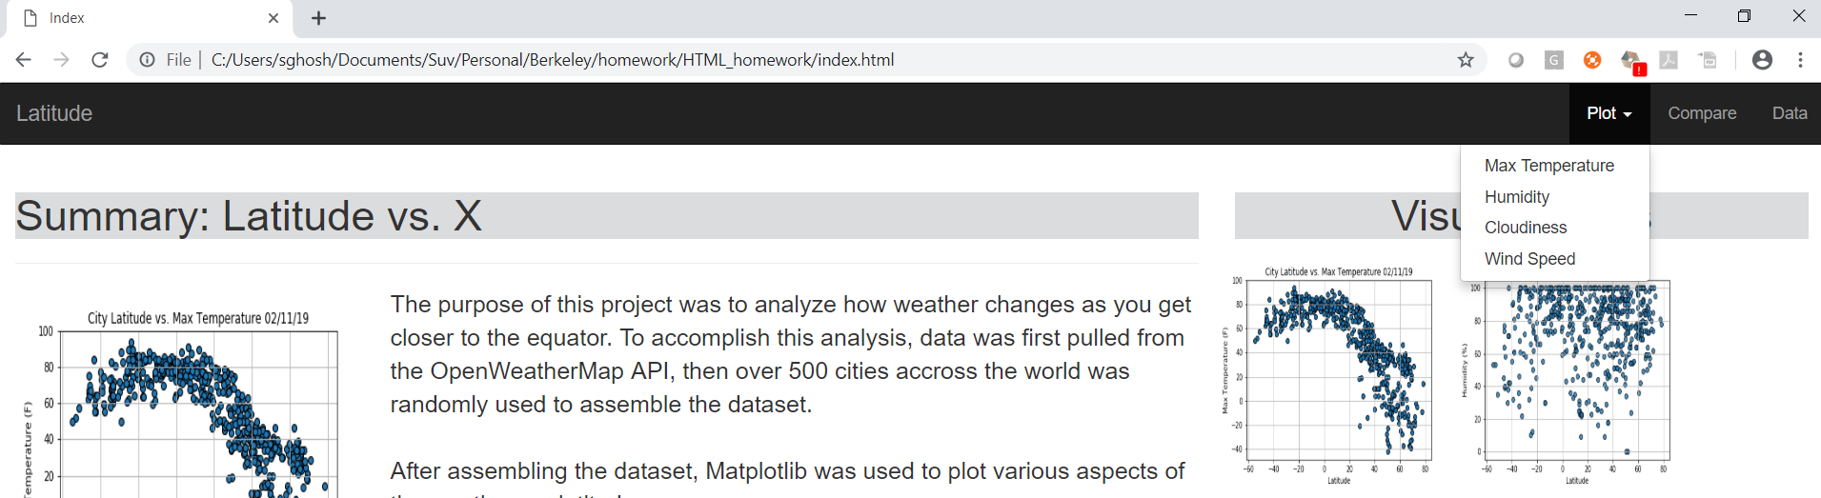

Compare page, showing all clickable graphs:

Latitude Vs: Temp , Vs Humidity, Vs Cloud, Vs Wind Speed

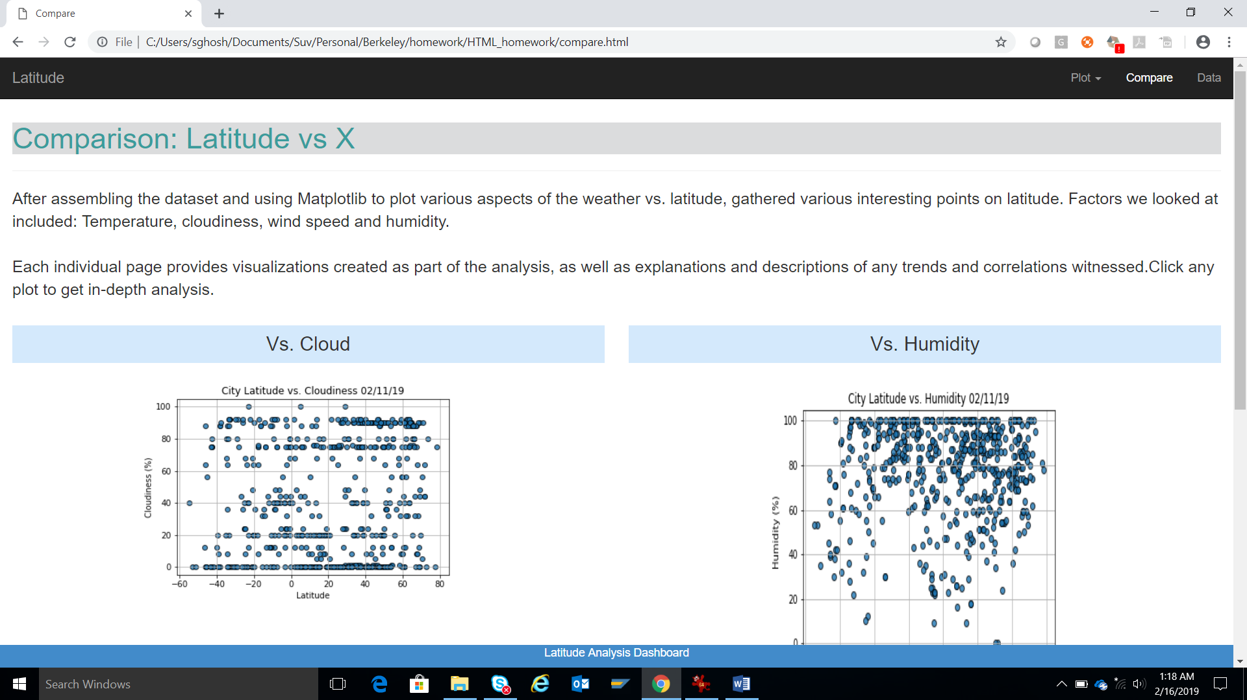

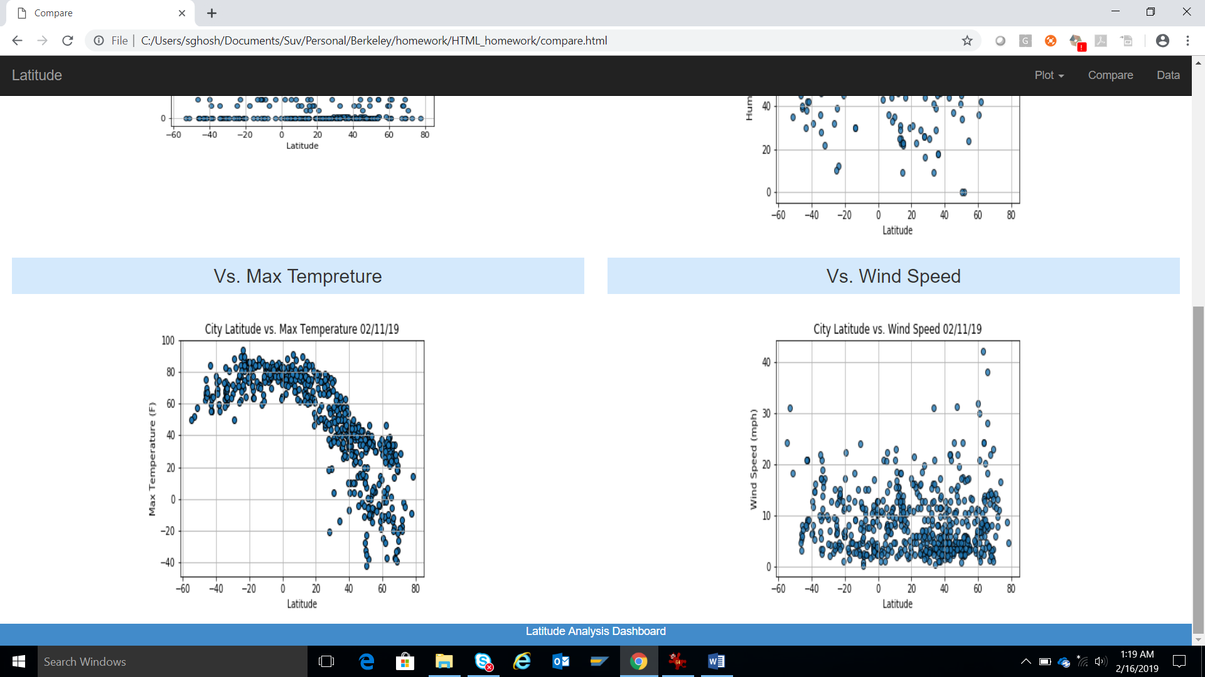

Data screen, showing table bootstrap enabled:

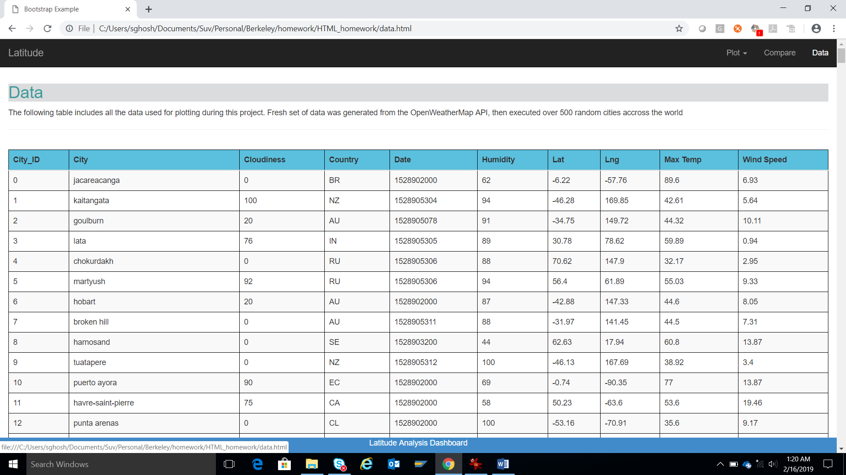

Data screen in smaller window, color changed:

