First screen (landing page):

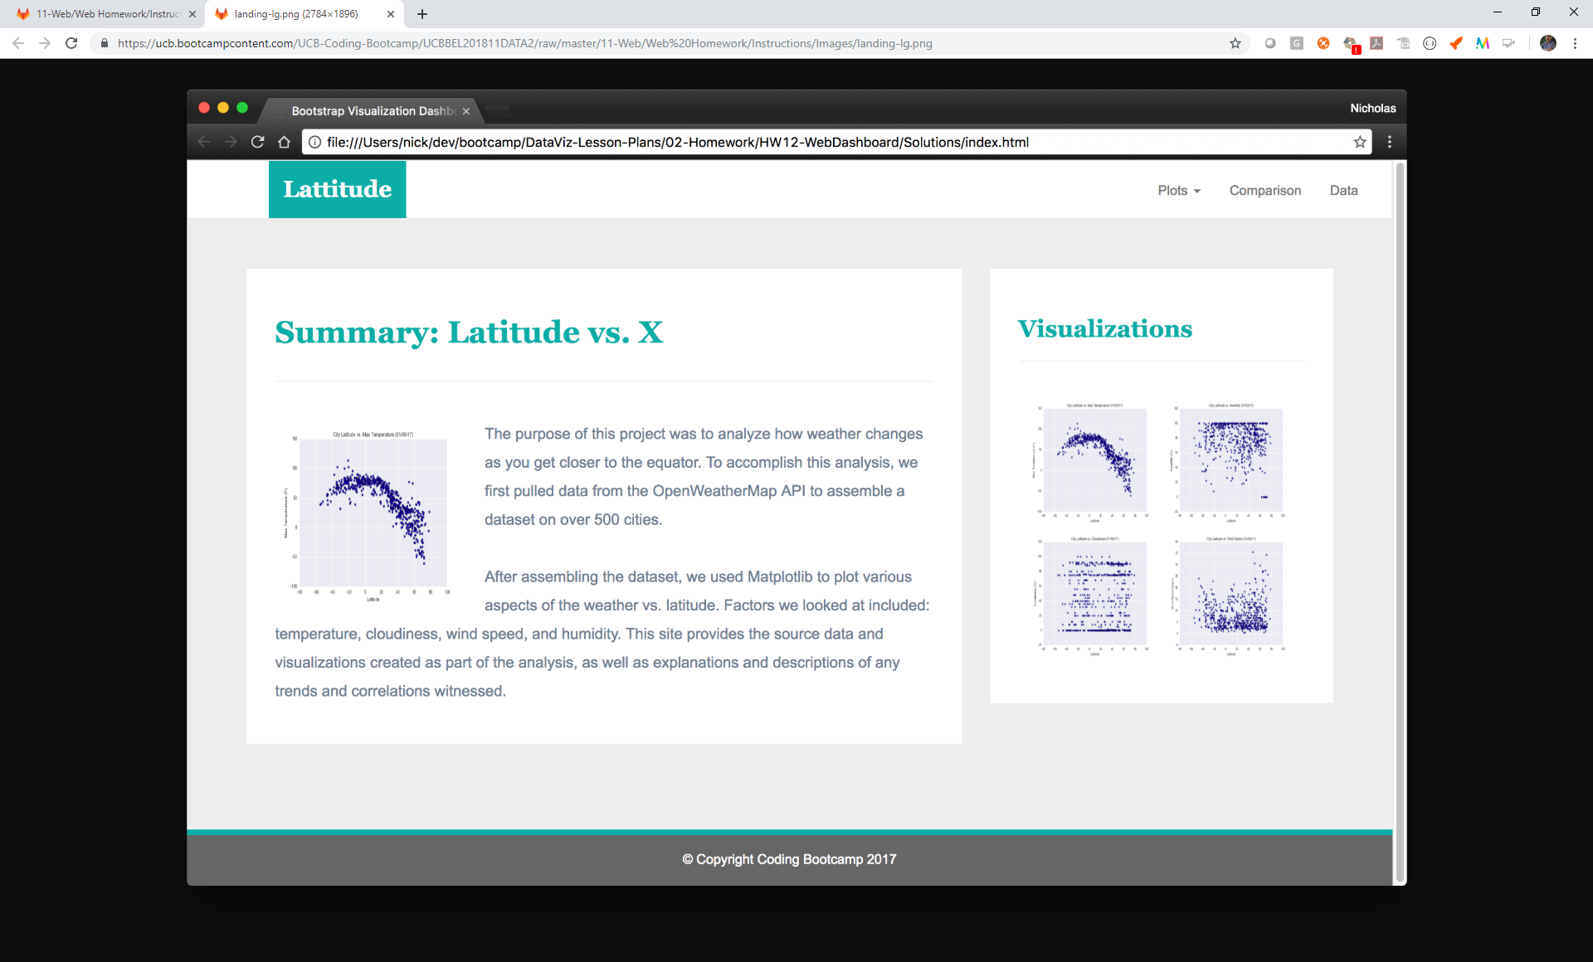

Top part should always be present.

If click on latitude, should take to landing page

