**Climate App- Flask**

***By: Suvrangshu Ghosh***

I have created the second part of the flask in two ways: **Easy Way**, **Tedious Way**.

But first execute code suv.py at command line:

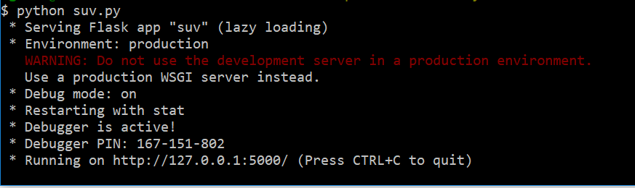

**Easy Way:**

I created a html file called ClimateApp.html.

From the folder, please right click and select open with Chrome

You will get this screen:

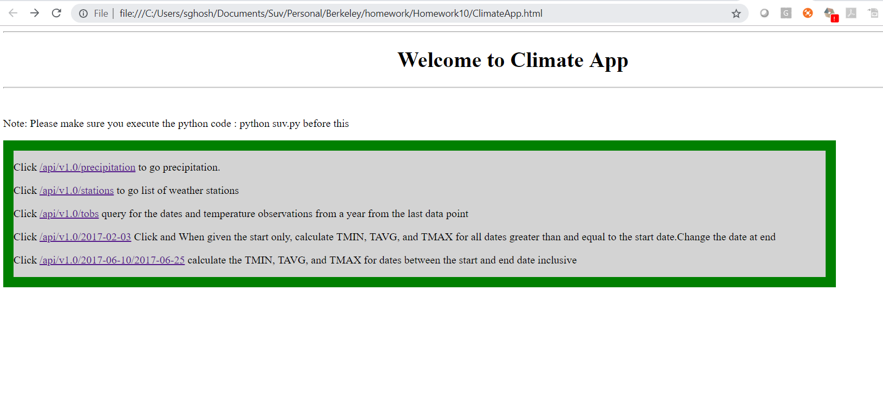

Click on each hyper links to see the results, back 🡨 to go back to selection screen

**Tedious way:**

You can execute the suv.py as - python suv.py and then test the selections:

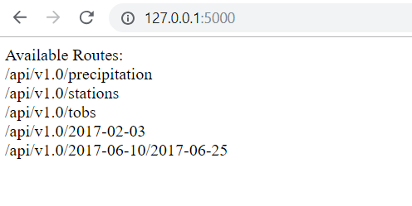

You can input a Start date and End date

You can input a Start date

Copy each selection and paste next to the url like shown below:

<http://127.0.0.1:5000/api/v1.0/precipitation>