|  |  |
| --- | --- |
| **Investment** | **Trading** |
| 1. Long term | Short term |
| 1. Buy | Buy |
| 1. One year | Days/months |
| 1. Hold | Sell |
|  |  |
| **Fundamental analysis is basis of investment** | **Technical analysis is basis of trading** |
| 1. Growth potential | 1. Trend |
| 1. Top management | 2. Support & Resistance |
| 1. Balance sheet/Profit & loss | 3. Chart Pattern |
|  | 4. Candlestick Pattern |
|  |  |
| 1. Fixed period | 1. Frequent profit or sometimes losses also |
| 1. Delayed return | 2. Multiple times opportunity of trading |
|  | For profitable trading you need to know technical analysis |
|  |  |
| Less risky | Risky but can be minimize if you have risk management skills |
| Less hectic | Hectic |
| Freedom | **Should know** a) Techniques b) Strategy c) Trading Psychology |
|  |  |
| Benefits of Bonus/Dividend | Miss the perks |

**Priority Chart:**

Priority No. 1 – Unavoidable expenses

…

…

Last priority – Least important Expense

*"Be fearful when others are Greedy and be greedy when others are fearful" –* ***Warren Buffet.***

**Technical Analysis**: Required for forming strategy

1. **Chart**: Chart patterns
2. **Candlestick**: Candlestick patterns
3. **Support/Resistance**:
4. **Trend/Trendline**
5. **Indicators**: Moving Average (EMA, Bollinger Bands, etc.)

Oscillators (RSI, MACD etc.)

Timeframe

Entry, Exit, Risk:Reward, Stop loss

Tools: Fibonacci Extension, Fibonacci Retracement etc.

Theories: Dow theory, Elliot Wave Theory etc.

**Benefits of Trading in Stock Market:**

1. Easy to start with low capital
2. Side income without leaving your job
3. Recession free and no saturation (no matter how many participants no liquidity)
4. Long term investment
5. Useful in international stock market

**Technical analysis:**

Analysis of the market by using techniques of present and past and predict for future.

1. **Charts** shows the movement of price of stocks/share of certain company in the past
2. **Candlesticks:**

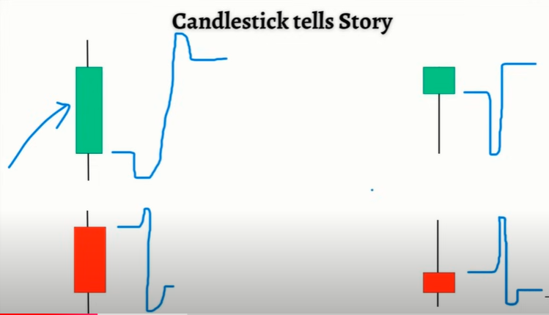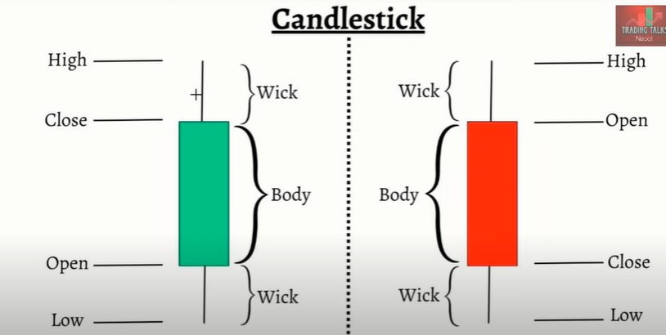Consists of green candle (Bullish Candle) and red candle (Bearish Candle).

Also shows who is more active, buyer or seller.

1. **Trends:**
2. **Uptrends**
3. **Downtrends**
4. 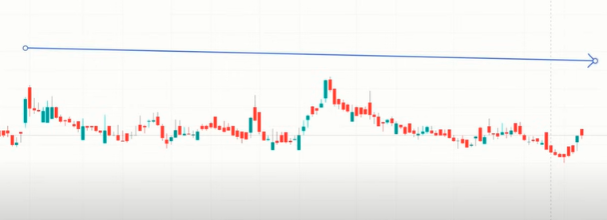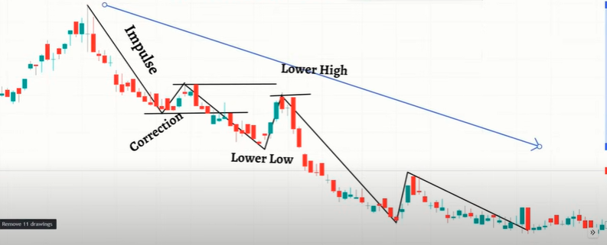**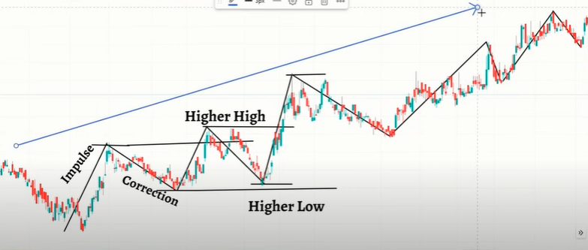Sideways**
5. **Support/Resistance:**

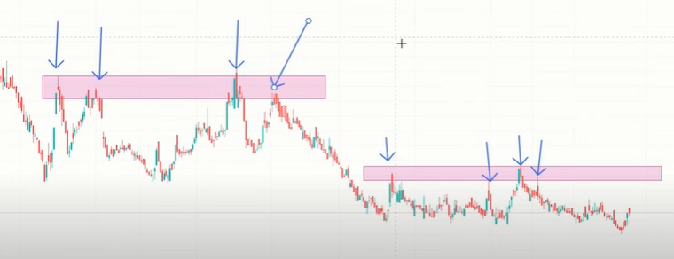 **Resistance:**

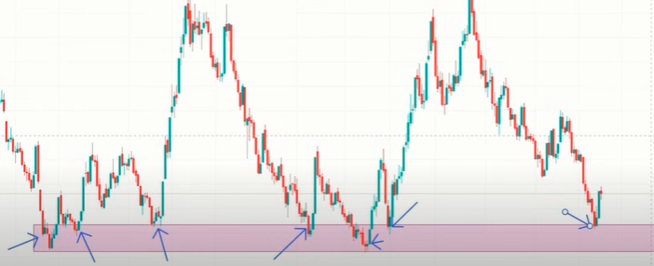**Support:**

1. **Indicators:**

Confluence add garna use garne tool ho.

Gives clarity of price.

1. **EMA (Exponential Moving Average):** Past ko certain numbers of candles ko close price lai average garera euta direction hamro chart maa plot garxa as a line.

* 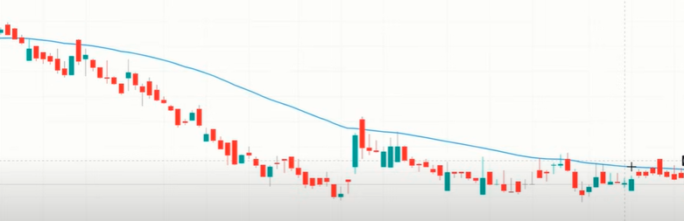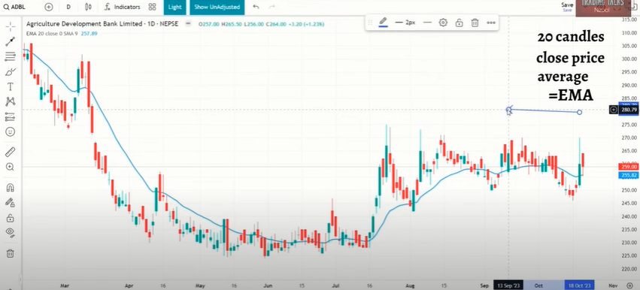Used for trend identification

Downtrends

Uptrends

* 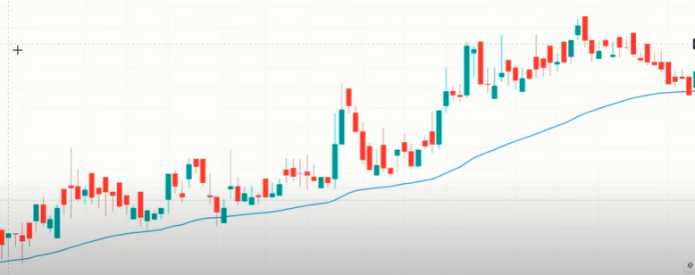Acts as support and resistance also.

1. 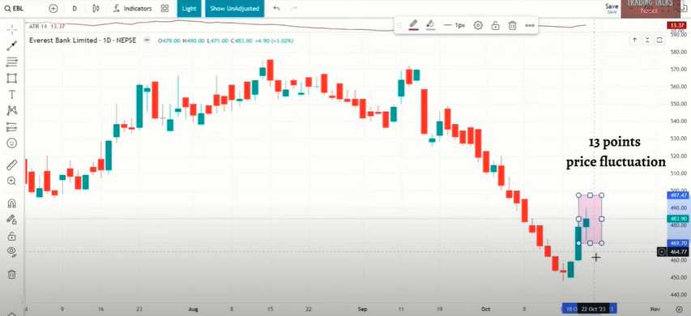**ATR (Average True Range):**  Past ko certain number of candles maa price kati mathi/kati tala move vayo vanera denote garxa.
2. RSI
3. Bollinger Band
4. MACD
5. Double Bottom chart pattern (Reversal pattern)