API Manual

1. HRMS data query

Method: POST

URL: <http://cptsvs531:1000/middleware/oracle/hrms>

Headers: {

Content-Type: application/json

}

Body

|  |  |  |  |
| --- | --- | --- | --- |
| Name | Type | Description | Required |
| command | String | The SQL query to HRMS database | True |

Response

|  |  |  |
| --- | --- | --- |
| Name | Type | Description |
| success | bool | The status of api process |
| data | Array of object | Row json data on SQL process |

1. Send e-mail with none-auth server used for application need to send e-mail

Method: POST

URL: <http://cptsvs531:1000/middleware/email/sendmail>

Headers: {

Content-Type: multipart/form-data

}

Body

|  |  |  |  |
| --- | --- | --- | --- |
| Name | Type | Description | Required |
| from | String | Email source  Example: <systemname>@mail.canon | True |
| to | String | Email send to…  **Can have multiple email with append this key to form data.** | True |
| subject | String | The subject of email | False |
| text | String | The message will append in email | False |
| attachment | files | Files attachment inside email | False |
| cc | String | Email cc to…  **Can have multiple email with append this key to form data.** | False |
| bcc | String | Email bcc to…  **Can have multiple email with append this key to form data.** | False |

1. Get all department list in company

Method: GET

URL: <http://cptsvs531:1000/middleware/oracle/departments>

Response

|  |  |  |
| --- | --- | --- |
| **Name** | **Type** | **Description** |
| DEPT_CODE | String | Department code |
| DEPT_NAME | String | Department full name |
| DEPT_ABB_NAME | String | Department short name |
| DIV_NAME_WC | String | Division short name |

1. Sing in with LDAP (login use username and password PC)

Method: POST

URL: http://cptsvs531:5000/api-ldap-auth/authentication/ldap

Headers: {

Content-Type: application/json

}

Body

|  |  |  |  |
| --- | --- | --- | --- |
| **Name** | **Type** | **Description** | **Required** |
| username | String | Employee no  Example: 013817 | True |
| password | String | Password PC login | True |

Response

|  |  |  |
| --- | --- | --- |
| **Name** | **Type** | **Description** |
| empNo | String | The employee no log in. |
| fname | String | The first name user login |
| lname | String | The last name userlogin |
| dept | String | User’s department short name |
| div | String | User’s division short name |
| band | String | User’s band J |
| deptCode | String | User’s department code |
| deptName | String | User’s department full name |

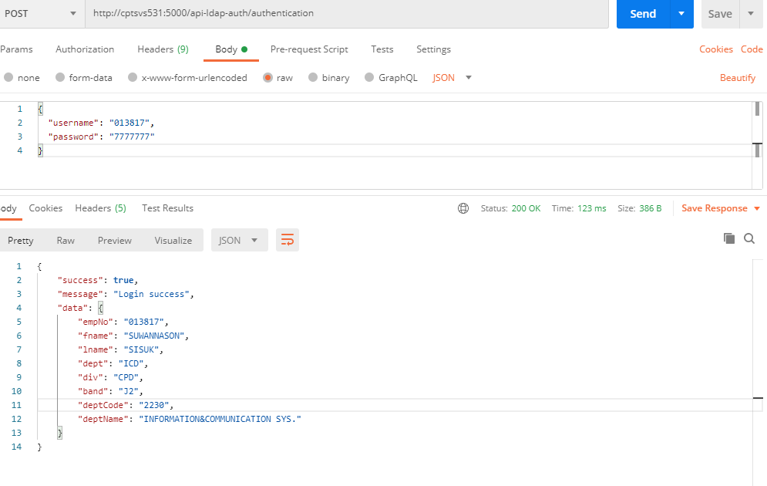Example

1. Get profile from LDAP using empNo

Method: GET

URL: [http://cptsvs531:5000/api-ldap-auth/authentication/profile?empNo={EMP_NO}](http://cptsvs531:5000/api-ldap-auth/authentication/profile?empNo=%7bEMP_NO%7d)

Query string

|  |  |  |
| --- | --- | --- |
| Name | Type | Description |
| empNo | String | Employee no of company |

Response

|  |  |  |
| --- | --- | --- |
| Name | Type | Description |
| email | String | The user’s email |
| name | String | The user’s name |
| department | String | The user’s department |
|  |  |  |

