**Docker**

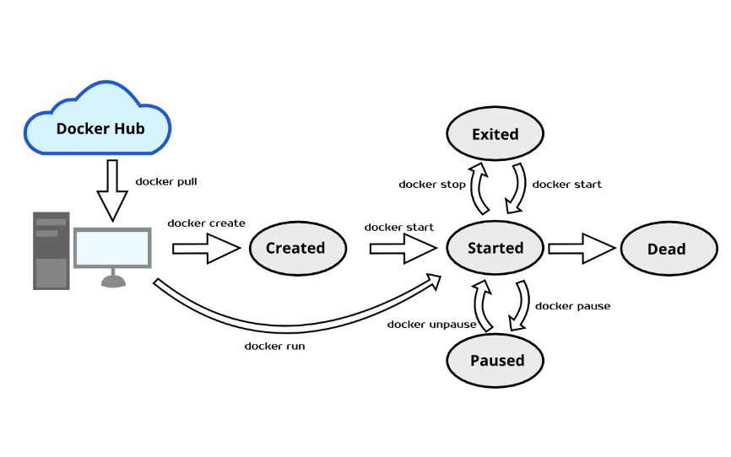

* Pull the image from Docker Hub to local computer user docker pull <IMAGE>

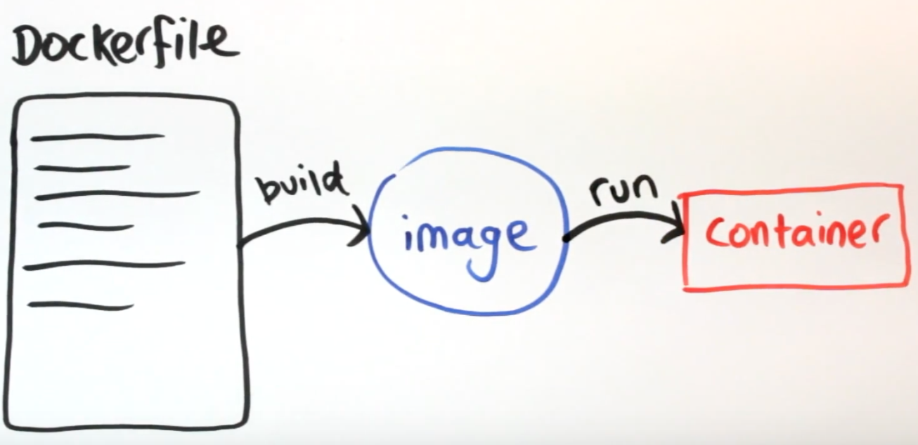

* Docker file will store in project directory this file will configure the image be run **container**. This file will set the image to use in this project, work directory, port, and command to **build** project to docker **images**.
* When have images or build success can run the container with already image on container. The **container** will started with configure **Dockerfile** if not fail.
  + **Example fail case** 
    - Host’s port already used <change port **Dockerfile** to build and start container again.
    - Pulled image not support your project.
    - Have some error build command in **Dockerfile**.
    - Your project have error code or program error

<Test run your project without docker>

**Docker compose**

Continue from **Dockerfile** docker-compose can use to run multi docker container it’s write with .yml syntax

Attribute in **docker-compose.yml**

* Version - network - volume - service

Cans see the sub attribute in document **docs.docker.com**

**Example command step:**

Create project and Dockerfile

docker build –t <tag/name> . 🡺 Build to path of Dockerfile

docker run -p 8001:4000 --name <container name> -d <Image>

Run with command step per on container without docker-compose

Then can use docker-compose to create multi container with once time command.

docker exec -it <container name> /bin/sh 🡺 remote to container with shell.

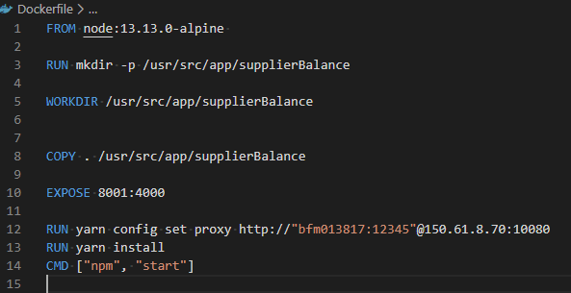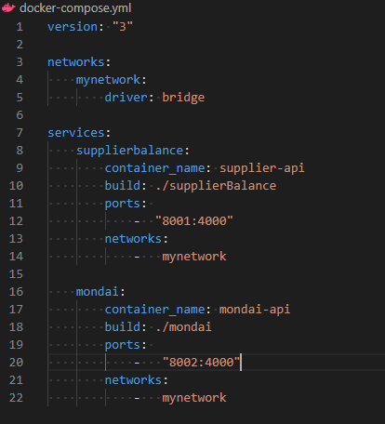

Figure 2 docker-compose call into path to Dockerfile

Figure 1 Dockerfile in project directory.