1. 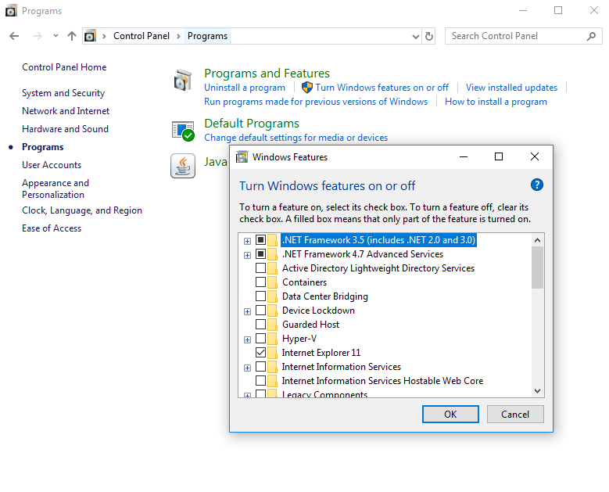Enable .net Framework on windows with this feature.
2. Download and install dotnet cli

<https://dotnet.microsoft.com/download/dotnet-core/3.1>

And test dotnet cli is worked?

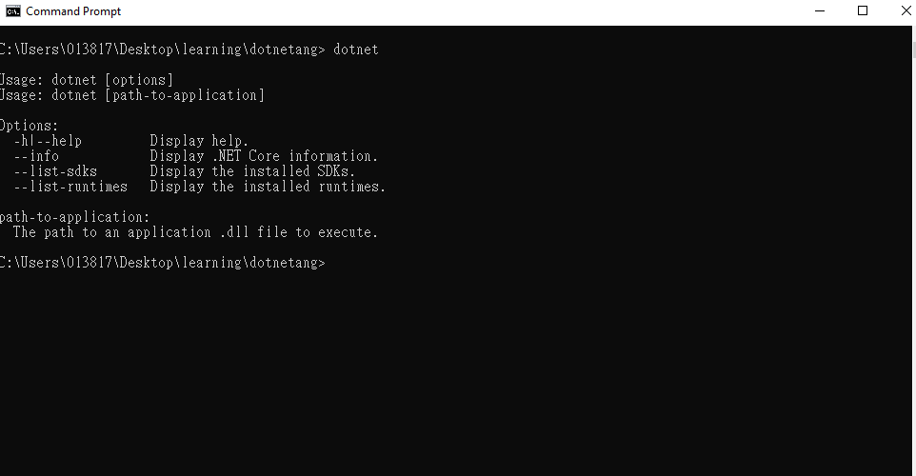

1. Create project with command “dotnet new <short Name>”

: console

Name reference command can show with command “dotnet new”

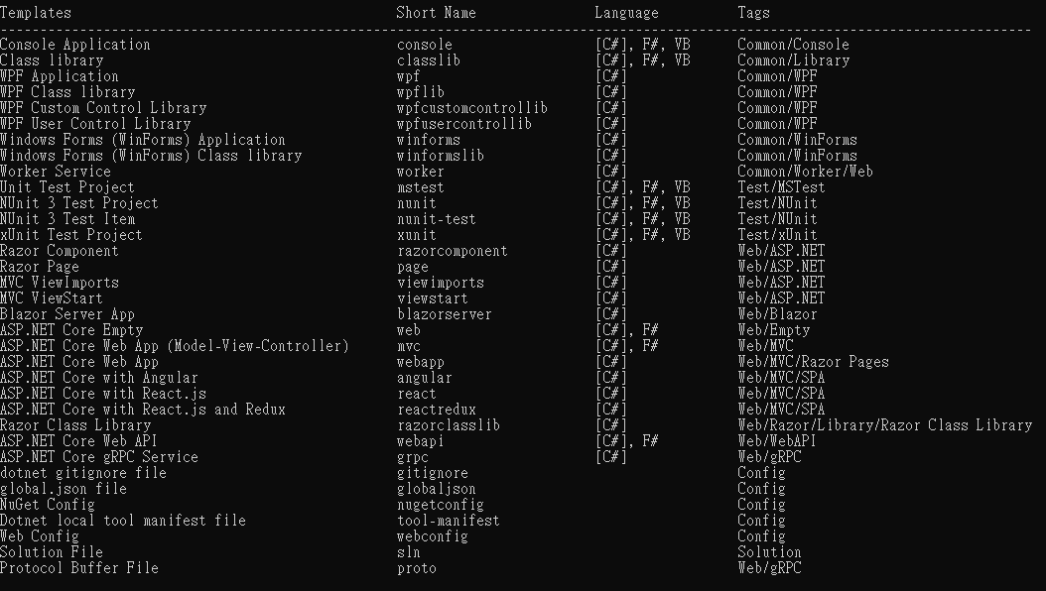

Example: dotnet new mvc