**React get started**

Pre – requirement

* Node.js cli >= 8.10
* Package manager Yarn Or npm
* React script command (npm install –g react-scripts)

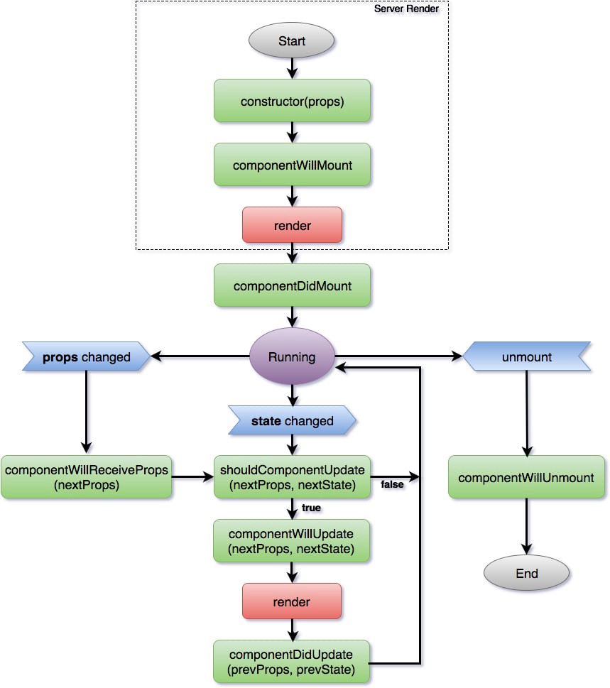

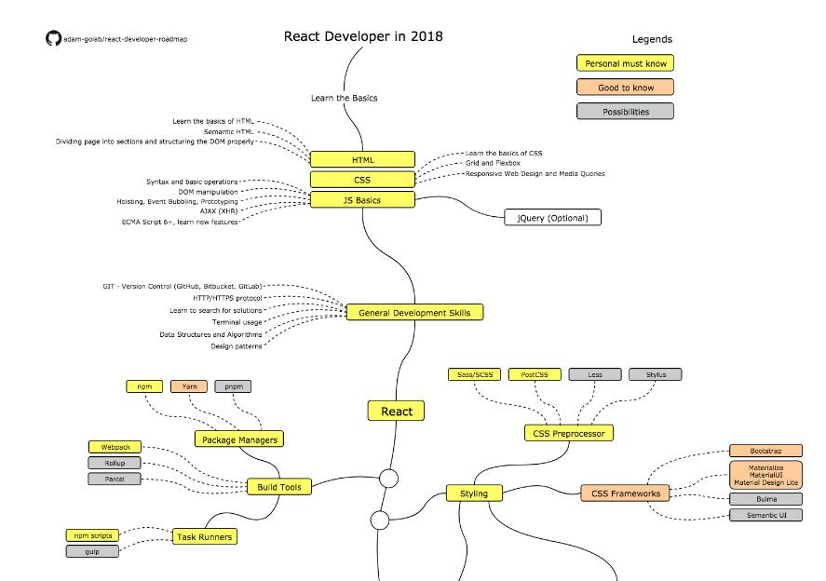

Before start

Default life cycle of react function.

1. npx create-react-app <APP_NAME> --use-npm
2. cd my-app
3. npm start

Web start at: <http://localhost:3000>

Use package “react-app-polyfill” to set react can run in IE browser.

* <https://www.npmjs.com/package/react-app-polyfill>