**SUPERSET ID : 6375627**

**WEEK 1 DESIGN PRINCIPLES AND PATTERNS**

**Exercise 1: Implementing the Singleton Pattern**

**Java Code:**

**Logger.java**

package Singleton;

public class Logger {

private static Logger *instance*;

private Logger() {

System.***out***.println("Logger instance created.");

}

public static Logger getInstance() {

if (*instance* == null) {

*instance* = new Logger();

}

return *instance*;

}

public void log(String message) {

System.***out***.println("Log message: " + message);

}

}

**Main.java**

package Singleton;

public class Main {

public static void main(String[] args) {

Logger l1 = Logger.*getInstance*();

l1.log("log message 1");

Logger l2 = Logger.*getInstance*();

l2.log("log message 2");

if (l1 == l2) {

System.***out***.println("Both logger instances are the same. Singleton confirmed.");

} else {

System.***out***.println("Different instances. Singleton failed.");

}

}

}

**Output:**

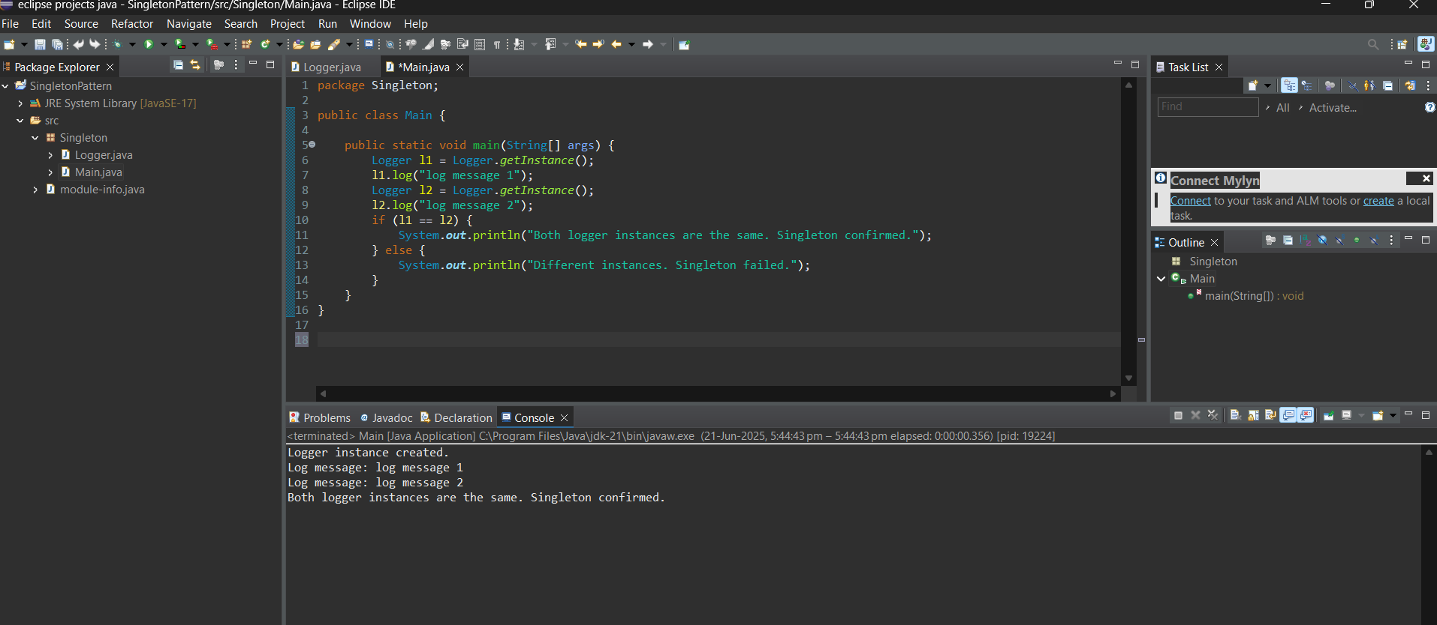

**Exercise 2: Implementing the Factory Method Pattern**

**Java code:**

**DocFile.java (Interface)**

package factorypattern;

public interface DocFile {

void open();

}

**WordFile.java**

package factorypattern;

public class WordFile implements DocFile {

@Override

public void open() {

System.out.println("Word file opened.");

}

}

**PdfFile.java**

package factorypattern;

public class PdfFile implements DocFile {

@Override

public void open() {

System.out.println("PDF file opened.");

}

}

**ExcelFile.java**

package factorypattern;

public class ExcelFile implements DocFile {

@Override

public void open() {

System.out.println("Excel file opened.");

}

}

**FileFactory.java (Abstract Factory)**

package factorypattern;

public abstract class FileFactory {

public abstract DocFile createFile();

}

**WordFileFactory.java**

package factorypattern;

public class WordFileFactory extends FileFactory {

@Override

public DocFile createFile() {

return new WordFile();

}

}

**PdfFileFactory.java**

package factorypattern;

public class PdfFileFactory extends FileFactory {

@Override

public DocFile createFile() {

return new PdfFile();

}

}

**ExcelFileFactory.java**

package factorypattern;

public class ExcelFileFactory extends FileFactory {

@Override

public DocFile createFile() {

return new ExcelFile();

}

}

**AppLauncher.java**

package factorypattern;

public class AppLauncher {

public static void main(String[] args) {

FileFactory wordGen = new WordFileFactory();

DocFile wordDoc = wordGen.createFile();

wordDoc.open();

FileFactory pdfGen = new PdfFileFactory();

DocFile pdfDoc = pdfGen.createFile();

pdfDoc.open();

FileFactory excelGen = new ExcelFileFactory();

DocFile excelDoc = excelGen.createFile();

excelDoc.open();

}

}

**Output:**

