WEEK-7

REACT

9. REACTJS-HOL CODE:

# IndianPlayers.js

import React from 'react';

const IndianPlayers = () => { const oddPlayers = ["Rohit", "Gill", "Pant", "Hardik", "Shami"]; const evenPlayers = ["Kohli", "Rahul", "Jadeja", "Kuldeep", "Bumrah", "Shreyas"]; const [odd1, odd2, ...restOdd] = oddPlayers; const [even1, even2, ...restEven] = evenPlayers; const T20players = ["Rohit", "Gill", "Hardik"]; const RanjiTrophyPlayers = ["Shaw", "Sarfaraz", "Jaiswal"]; const merged = [...T20players, ...RanjiTrophyPlayers];

return (

<div>

<h2>Odd Team Players (Destructuring)</h2>

<p>First Two: {odd1}, {odd2}</p>

<p>Rest: {restOdd.join(', ')}</p>

<h2>Even Team Players (Destructuring)</h2>

<p>First Two: {even1}, {even2}</p>

<p>Rest: {restEven.join(', ')}</p>

<h2>Merged Players (Spread)</h2>

<p>{merged.join(', ')}</p>

</div>

);

};

export default IndianPlayers;

# ListofPlayers.js

import React from 'react';

const ListofPlayers = () => { const players = [

{ name: "Rohit", score: 85 },

{ name: "Kohli", score: 95 },

{ name: "Gill", score: 45 },

{ name: "Rahul", score: 67 },

{ name: "Pant", score: 88 },

{ name: "Hardik", score: 50 },

{ name: "Jadeja", score: 72 },

{ name: "Shreyas", score: 63 },

{ name: "Bumrah", score: 78 },

{ name: "Kuldeep", score: 60 },

{ name: "Shami", score: 90 },

];

// Filter players with score < 70 using arrow function const below70 = players.filter(player => player.score < 70);

return (

<div>

<h2>All Players (using map)</h2>

{players.map((p, index) => (

<p key={index}>{p.name} - {p.score}</p>

))}

<h2>Players with Score Below 70 (using arrow function)</h2>

{below70.map((p, index) => (

<p key={index}>{p.name} - {p.score}</p>

))}

</div>

);

};

export default ListofPlayers;

# EvenPlayers.js

function EvenPlayers(players) {

return (

<ul>

{players.filter((_, i) => i % 2 !== 0).map((p, i) => (

<li key={i}>

{i === 0 && "Second"}{i === 1 && "Fourth"}{i === 2 && "Sixth"} : {p}

</li>

))}

</ul>

);

}

export default EvenPlayers;

# OddPlayers.js

function OddPlayers(players) {

return (

<ul>

{players.filter((_, i) => i % 2 === 0).map((p, i) => (

<li key={i}>

{i === 0 && "First"}{i === 2 && "Third"}{i === 4 && "Fifth"} : {p}

</li>

))}

</ul>

);

}

export default OddPlayers;

# Scorebelow70.js

// src/components/Scorebelow70.js import React from 'react';

const Scorebelow70 = ({ players }) => { const filtered = players.filter(player => player.score < 70);

return (

<div>

{filtered.map((player, index) => (

<p key={index}>{player.name} - {player.score}</p>

))}

</div>

);

};

export default Scorebelow70;

# ListofIndianPlayers.js

import React from 'react';

const ListofIndianPlayers = ({ IndianPlayers }) => { return (

<ul>

{IndianPlayers.map((player, i) => (

<li key={i}>{player}</li>

))}

</ul>

);

};

export default ListofIndianPlayers;

# App.js

import React from 'react'; import ListofPlayers from './Components/ListofPlayers'; import Scorebelow70 from './Components/Scorebelow70'; import OddPlayers from './Components/OddPlayers'; import EvenPlayers from './Components/EvenPlayers'; import ListofIndianPlayers from './Components/ListofIndianPlayers';

function App() { const flag = true; const players = [

{ name: "Rohit", score: 85 },

{ name: "Kohli", score: 95 },

{ name: "Gill", score: 45 },

{ name: "Pant", score: 88 },

{ name: "Hardik", score: 50 },

];

const IndianTeam = ["Sachin1", "Dhoni2", "Virat3", "Rohit4", "Yuvaraj5", "Raina6"];

const IndianPlayers = ["Mr. First Player", "Mr. Second Player", "Mr. Third Player", "Mr. Fourth Player", "Mr. Fifth Player", "Mr. Sixth Player"];

if (flag === true) { return (

<div>

<h1>List of Players</h1>

<ListofPlayers players={players} />

<hr />

<h1>List of Players having Scores Less than 70</h1>

<Scorebelow70 players={players} />

</div>

);

} else { return ( <div>

<div>

<h1>Indian Team</h1>

<h1>Odd Players</h1>

{OddPlayers(IndianTeam)}

<hr />

<h1>Even Players</h1>

{EvenPlayers(IndianTeam)}

</div>

<hr />

<div>

<h1>List of Indian Players Merged:</h1>

<ListofIndianPlayers IndianPlayers={IndianPlayers} />

</div>

</div>

);

}

}

export default App;

OUTPUT:

When flag=true

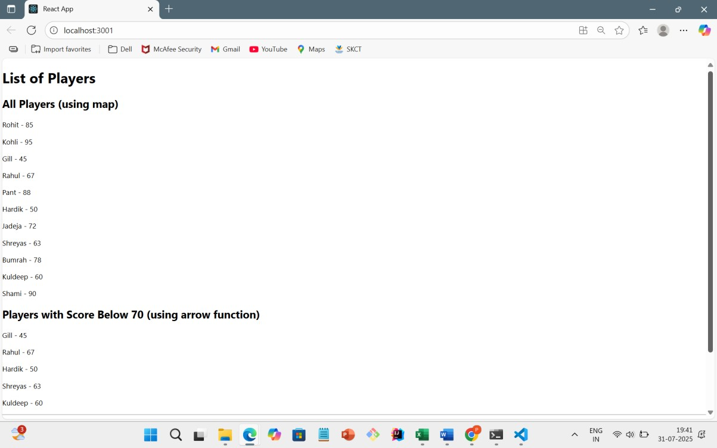

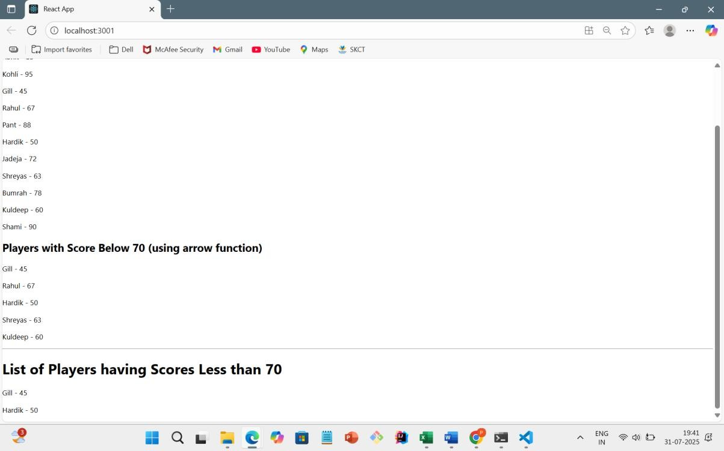

When flag=false

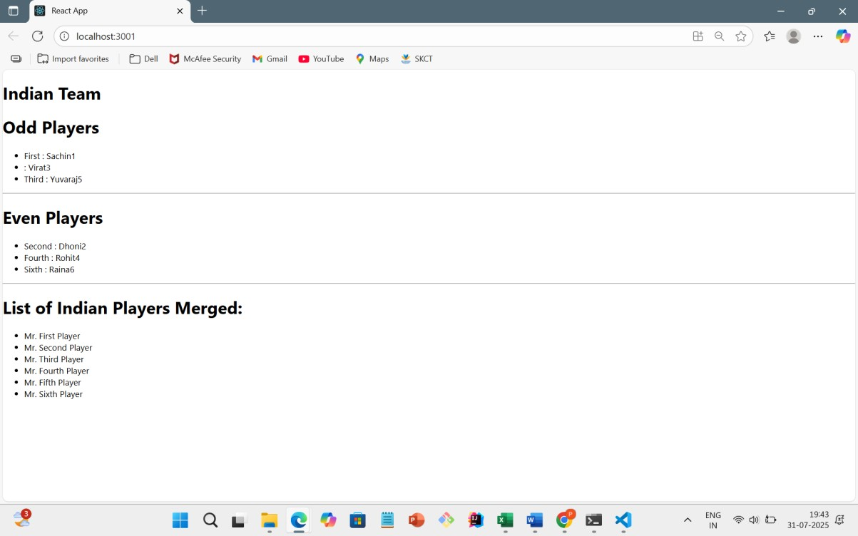

10.REACTJS-HOL CODE: App.js

import React from 'react';

function App() {

const office = { name: "Executive Suite", rent: 55000,

address: "Tower 5, TechPark, Mumbai"

};

const officeList = [

{

name: "Premium Office", rent: 75000, address: "Cyber City, Gurugram"

},

{

name: "Budget Workspace",

rent: 45000, address: "StartHub, Pune"

},

{

name: "Luxury Space", rent: 90000, address: "Infinity Tower, Bangalore"

}

];

const getRentStyle = (rent) => {

return { color: rent > 60000 ? 'green' : 'red', fontWeight: 'bold'

};

};

return ( <div style={{ display: 'flex', justifyContent: 'center', alignItems: 'center', minHeight: '100vh', backgroundColor: '#f9f9f9', fontFamily: 'Arial'

}}

>

<div style={{ width: '90%', maxWidth: '600px', textAlign: 'center' }}> <h1>Office Space Rental Listings</h1>

<img

src="https://img.freepik.com/premium-photo/modern-corporate-architecture-can-beseen-cityscape-office-buildings_410516-276.jpg"

alt="Office Space" width="100%" style={{ borderRadius: '10px', marginBottom: '20px' }}

/>

<h2>Featured Office:</h2>

<p><strong>Name:</strong> {office.name}</p>

<p><strong>Rent:</strong> <span

style={getRentStyle(office.rent)}>{office.rent}</span></p>

<p><strong>Address:</strong> {office.address}</p>

<hr />

<h2> Available Offices:</h2>

{officeList.map((item, index) => (

<div key={index} style={{ marginBottom: '20px' }}>

<p><strong>Name:</strong> {item.name}</p>

<p><strong>Rent:</strong> <span

style={getRentStyle(item.rent)}>{item.rent}</span></p>

<p><strong>Address:</strong> {item.address}</p>

<hr />

</div>

))}

</div>

</div>

);

}

export default App;

OUTPUT:

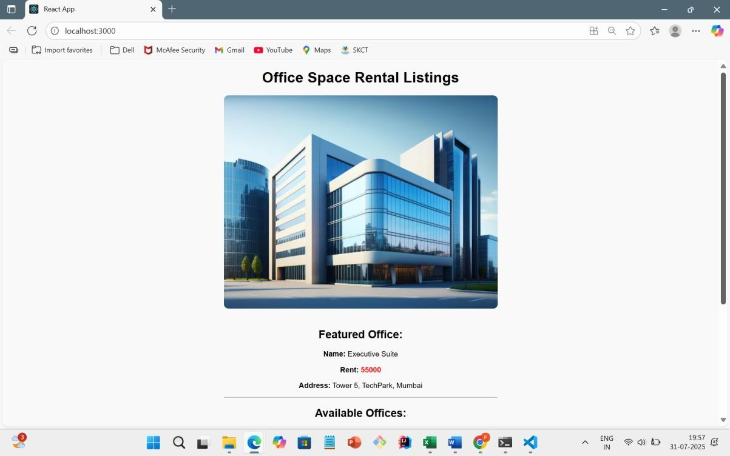

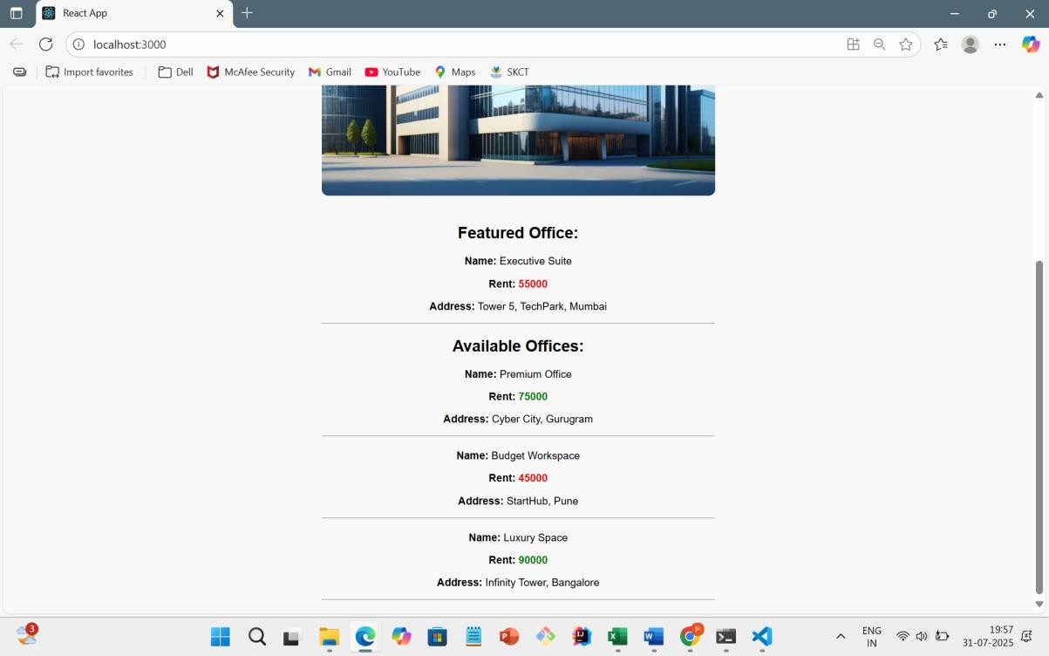

11.REACTJS-HOL CODE:

# CurrencyConvertor.js

import React, { Component } from 'react';

class CurrencyConvertor extends Component {

constructor() { super(); this.state = { rupees: '', euro: ''

};

}

handleChange = (event) => {

this.setState({ rupees: event.target.value });

};

handleSubmit = () => { const rate = 0.011; // Conversion rate const converted = (this.state.rupees * rate).toFixed(2); this.setState({ euro: converted });

// Show popup message after conversion alert(`Converting ₹${this.state.rupees} to €${converted}`);

};

render() { return (

<div>

<h2> Currency Converter</h2>

<input

type="number" placeholder="Enter Rupees" value={this.state.rupees} onChange={this.handleChange}

/>

&nbsp;

<button onClick={this.handleSubmit}>Convert</button>

{this.state.euro && (

<p>Converted Value: <strong>€ {this.state.euro}</strong></p>

)}

</div>

);

}

}

export default CurrencyConvertor;

# App.js

import React, { Component } from 'react'; import CurrencyConvertor from './CurrencyConvertor';

class App extends Component {

constructor() { super(); this.state = { count: 0

};

}

// a. Increment counter increment = () => { this.setState({ count: this.state.count + 1 }, () => { this.sayHello(); // b. call second method

});

};

// b. Say Hello message sayHello = () => { alert("Hello! This is a static message."); };

// Decrement counter decrement = () => { this.setState({ count: this.state.count - 1 });

};

// Say welcome with an argument sayWelcome = (message) => {

alert(message);

};

// Synthetic event handler handleSyntheticClick = (event) => { alert("I was clicked"); console.log("Synthetic Event object:", event);

};

render() { return (

<div style={{ textAlign: 'center', padding: '30px', fontFamily: 'Arial' }}>

<h1>React Event Examples</h1>

{/* Counter Section */}

<h2>Counter: {this.state.count}</h2>

<button onClick={this.increment}>Increment</button>&nbsp;

<button onClick={this.decrement}>Decrement</button>

<hr />

{/* Welcome Button */}

<button onClick={() => this.sayWelcome("Welcome to React Event Lab!")}>

Say Welcome

</button>

<hr />

{/* Synthetic Event Button */}

<button onClick={this.handleSyntheticClick}>

Synthetic Event (onPress)

</button>

<hr />

{/* Currency Converter */}

<CurrencyConvertor />

</div>

);

}

}

export default App;

OUTPUT:

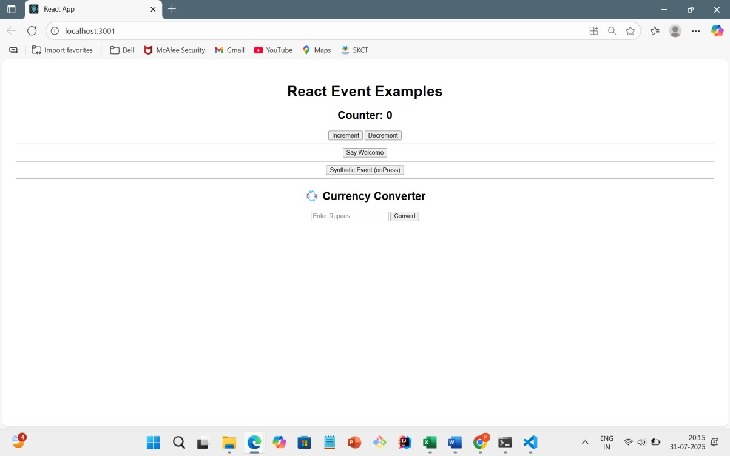

# While Clicking Increment

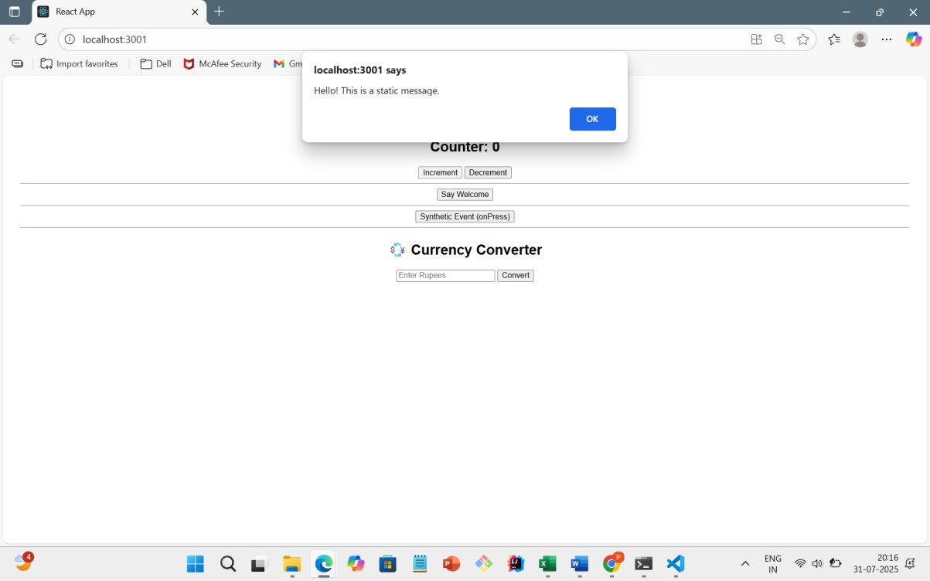

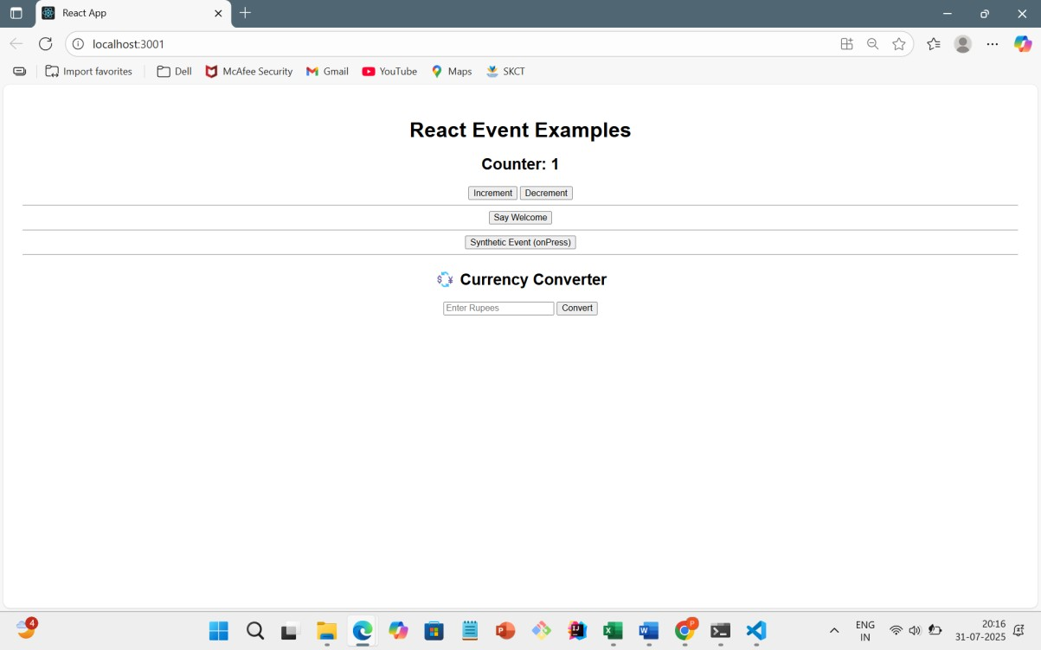

# While Clicking Say Welcome

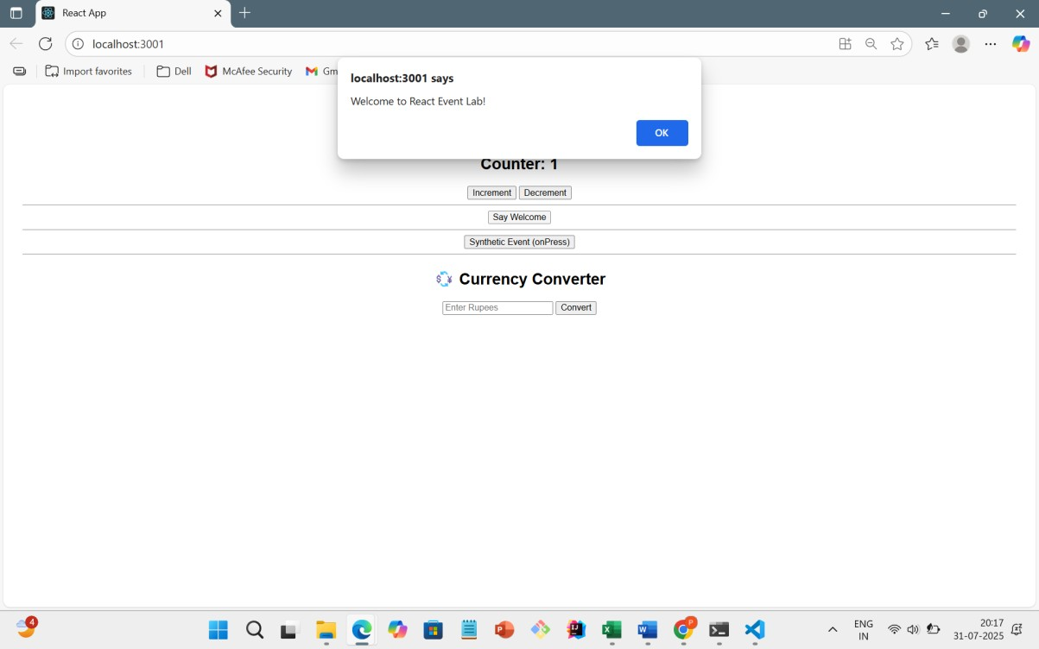

# While Clicking Synthetic Event

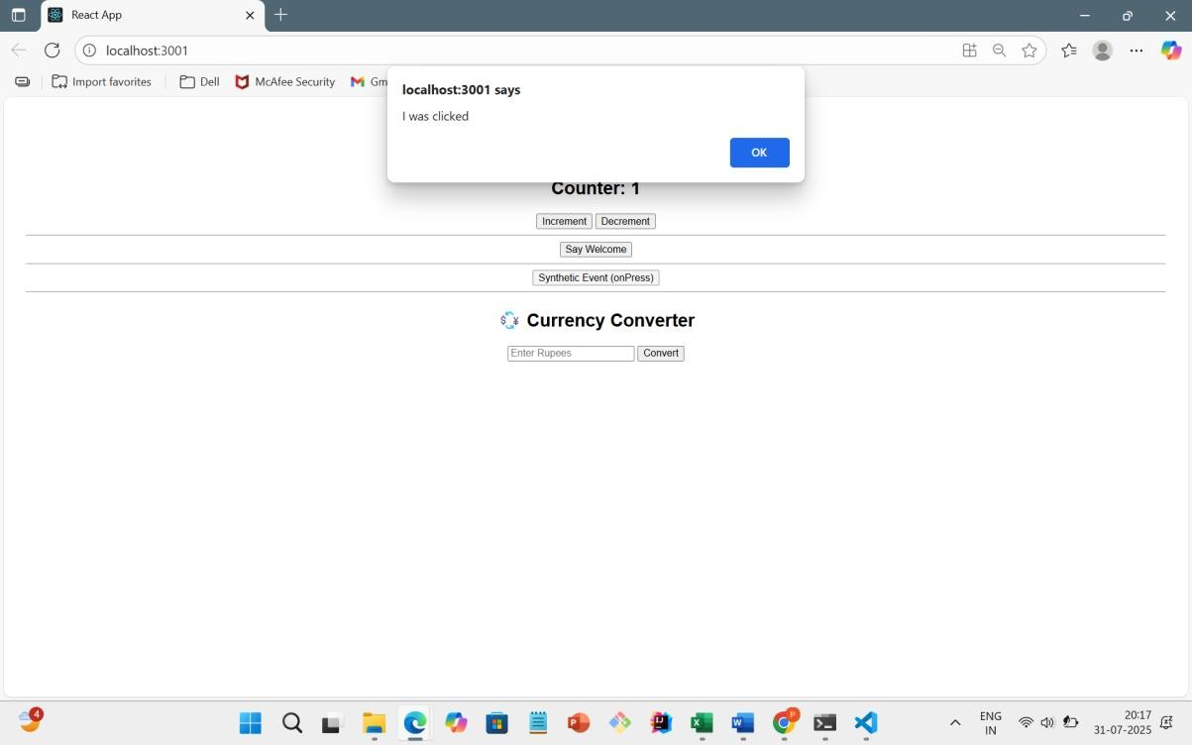

# Currency Converter

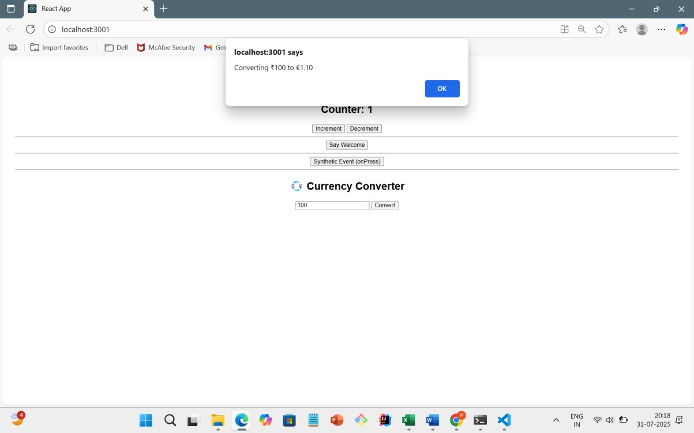

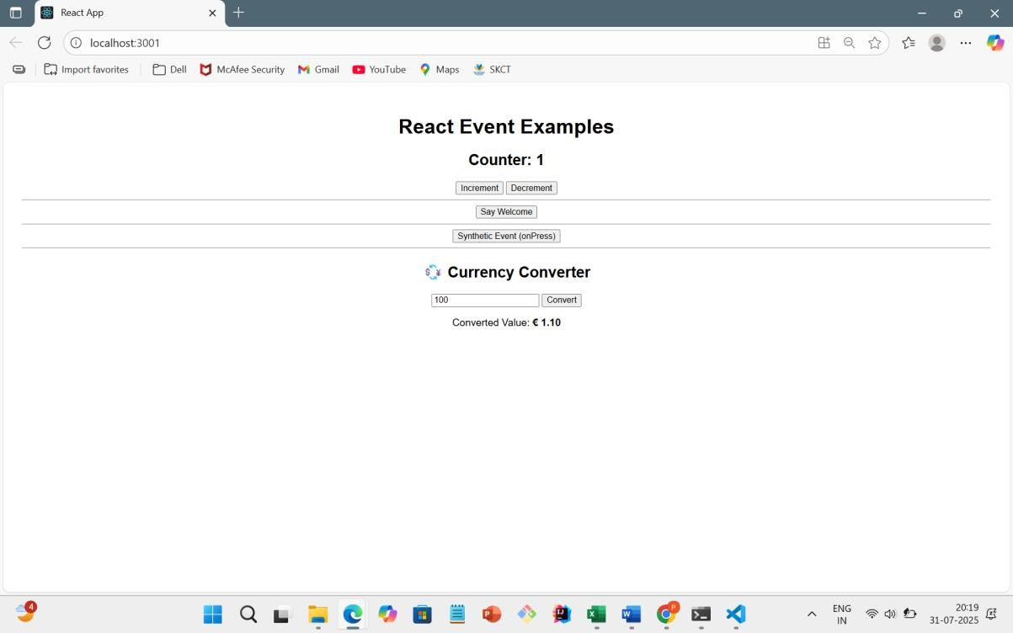

12.REACTJS-HOL

# CODE: App.js

import React, { useState } from 'react';

// Guest Page Component function GuestPage() {

return (

<div>

<h2> Welcome Guest!</h2>

<p>You can browse available flights below:</p>

<ul>

<li>Flight 1: Chennai to Mumbai - 9:00 AM</li>

<li>Flight 2: Delhi to Bangalore - 1:00 PM</li>

<li>Flight 3: Hyderabad to Kolkata - 6:30 PM</li>

</ul>

</div>

);

}

// User Page Component function UserPage() {

return (

<div>

<h2> Welcome, User!</h2>

<p>You are now logged in. You can book your flight below:</p>

<button> Book Ticket</button>

</div>

);

}

// Main App function App() { const [isLoggedIn, setIsLoggedIn] = useState(false);

// Toggle Login Status const handleLogin = () => setIsLoggedIn(true); const handleLogout = () => setIsLoggedIn(false);

// Choose what to render based on login state

let content; if (isLoggedIn) { content = <UserPage />;

} else {

content = <GuestPage />;

}

return (

<div style={{ textAlign: 'center', fontFamily: 'Arial', padding: '20px' }}>

<h1>Ticket Booking App</h1>

{/* Login/Logout Buttons */}

{isLoggedIn ? (

<button onClick={handleLogout}> Logout</button>

) : (

<button onClick={handleLogin}> Login</button>

)}

<hr />

{/* Conditional Content */}

{content}

</div>

);

}

export default App;

OUTPUT:

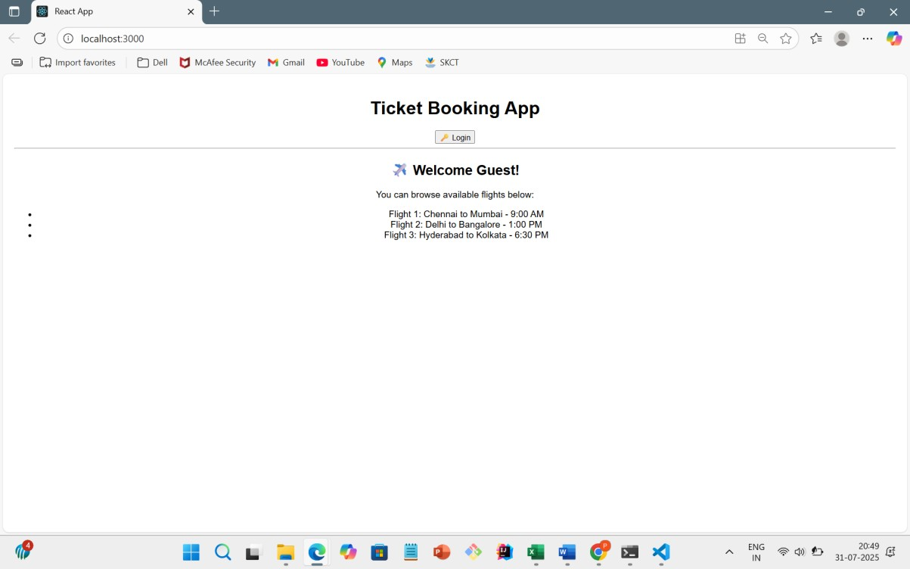

# ON CLICKING LOGIN

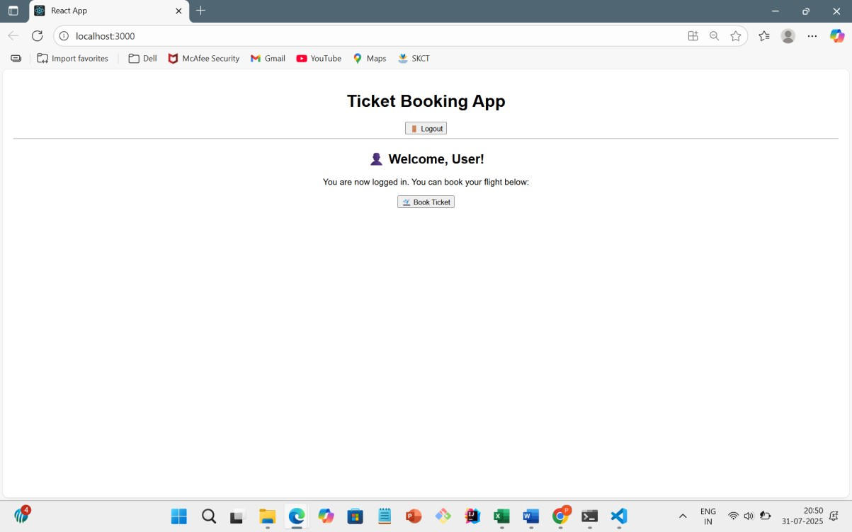

13.REACTJS-HOL

# CODE: App.js

import React, { useState } from 'react'; import BookDetails from './components/BookDetails'; import BlogDetails from './components/BlogDetails'; import CourseDetails from './components/CourseDetails';

function App() { const [activeComponent, setActiveComponent] = useState('book');

// 1. Element variable approach let content;

if (activeComponent === 'book') { content = <BookDetails />;

} else if (activeComponent === 'blog') { content = <BlogDetails />;

} else if (activeComponent === 'course') { content = <CourseDetails />;

}

// 2. Inline if rendering + ternary for title const title = activeComponent === 'book'

? "Book Section"

: activeComponent === 'blog'

? "Blog Section"

: "Course Section";

return (

<div style={{ textAlign: 'center', fontFamily: 'Arial', padding: '20px' }}>

<h1>Blogger App - {title}</h1>

{/* Buttons to switch components */}

<button onClick={() => setActiveComponent('book')}> Books</button>&nbsp;

<button onClick={() => setActiveComponent('blog')}> Blogs</button>&nbsp;

<button onClick={() => setActiveComponent('course')}> Courses</button>

<hr />

{/* Render selected component */}

{content}

</div>

);

}

export default App;

OUTPUT:

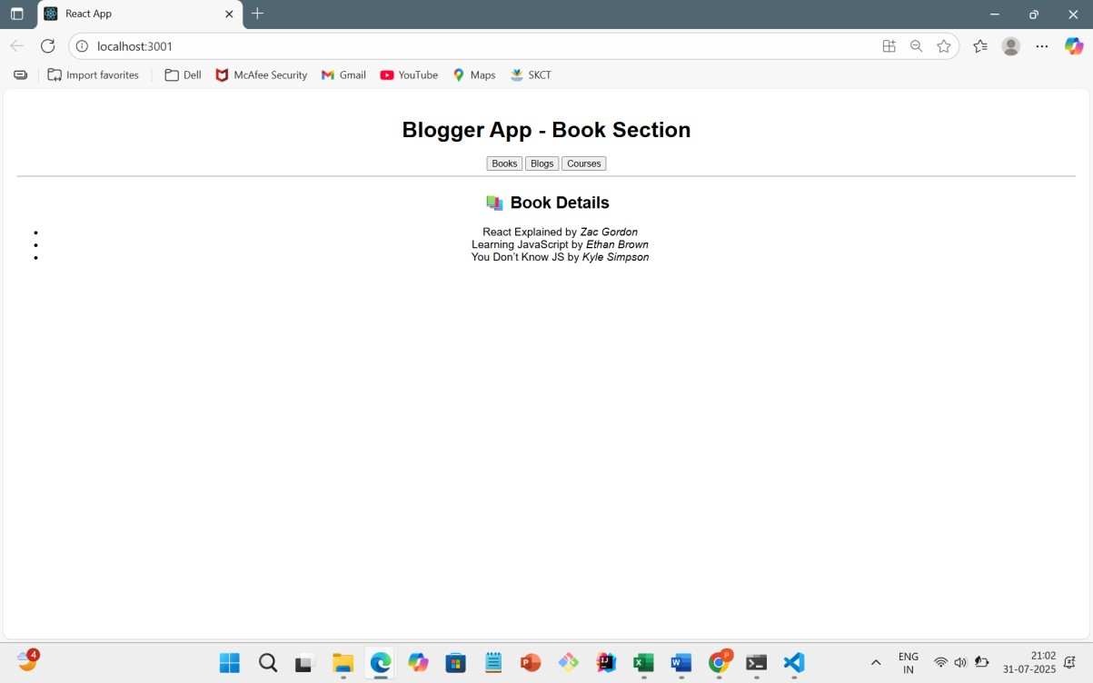

# ON CLICKING BLOGS

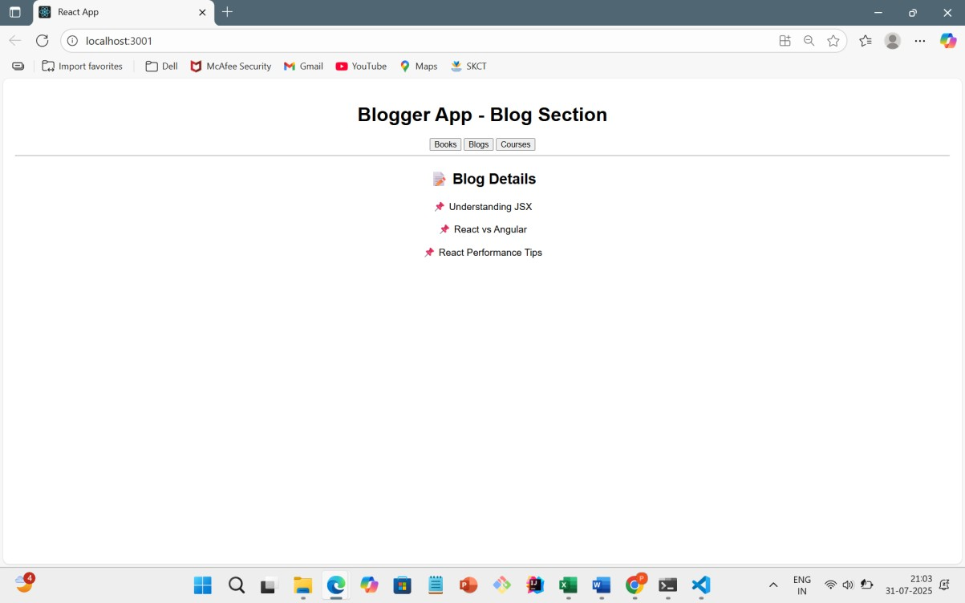

# ON CLICKING COURSES

