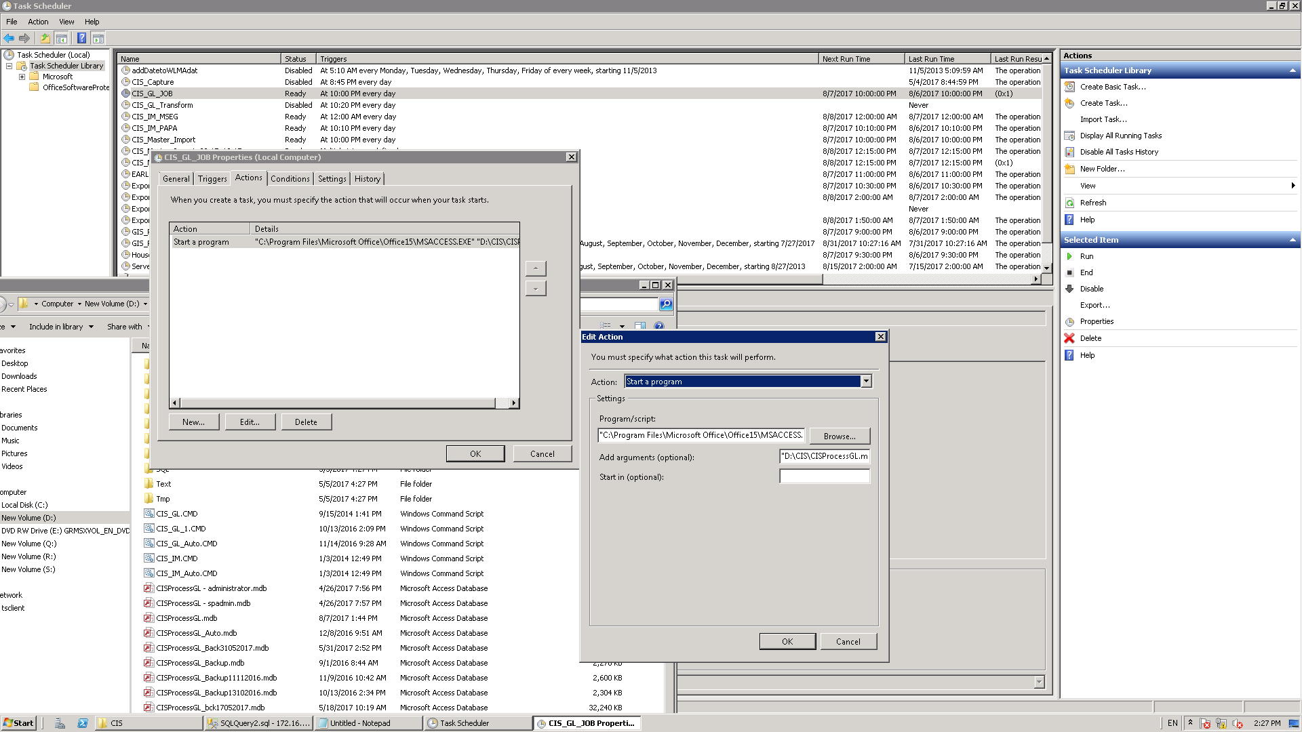

"C:\Program Files\Microsoft Office\Office15\MSACCESS.EXE"