**Post Material Document:** MIGO Goods Receipt

1. Input Material

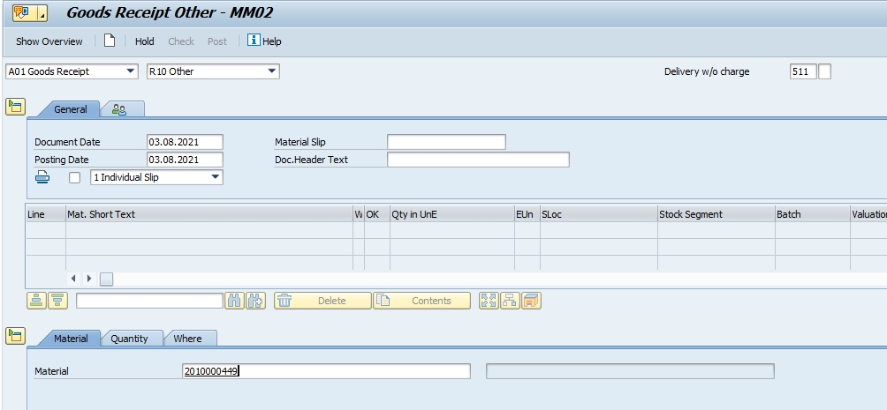

1. Input Tab Quantity

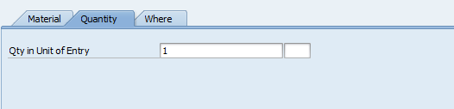

1. Input Tab Where then enter

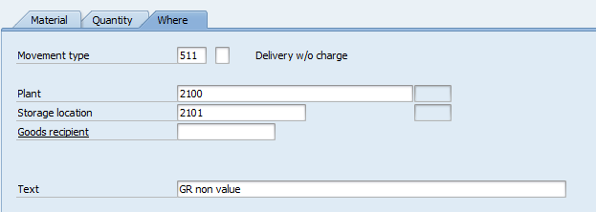

1. Input Vendor

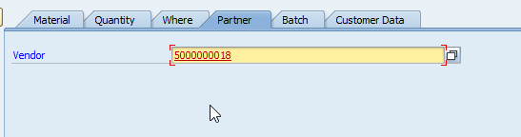

1. Input Batch

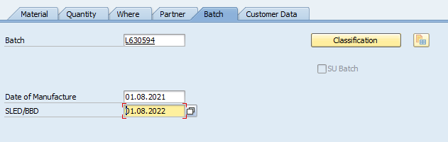

1. Click Next Item button

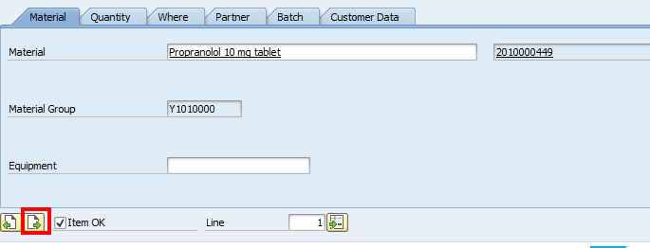

1. Input the same value of every tab as first item then POST

**Display Document: MIGO > Display**

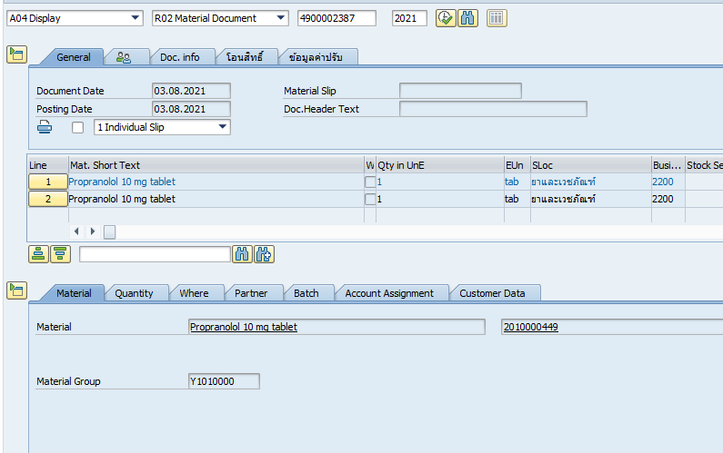

Display FI Document

