Test in QAS-900 system

Sales Order 3001273410

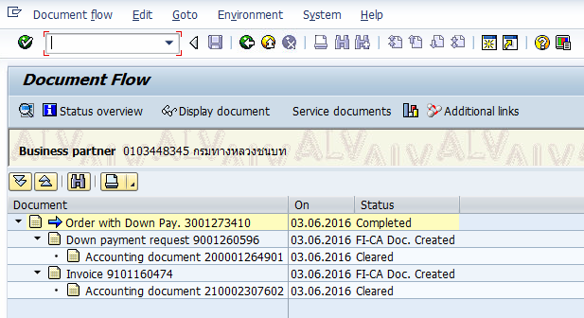

FICA doc DW 200001264901 (stat item for down payment request)

Payment made for down payment FICA doc 655007957736

Final invoice FICA doc NV#1 210002307602

Final invoice FICA doc NV#2 210002307603 (Cleared open item)

After complete all posting then verify result in Tax table DFKKREP06 with trigger doc (AUBEL) = 655007957736, 210002307603

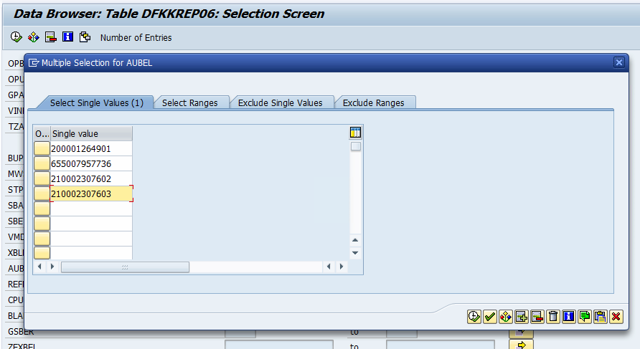

Result show that tax amount in table DFKKREP06 and DFKKOP is not consist (DFKKREP06 = 684.63, DFKKOP = 684.62)

