**ERD-300**

Test FULL Payment

Invoice

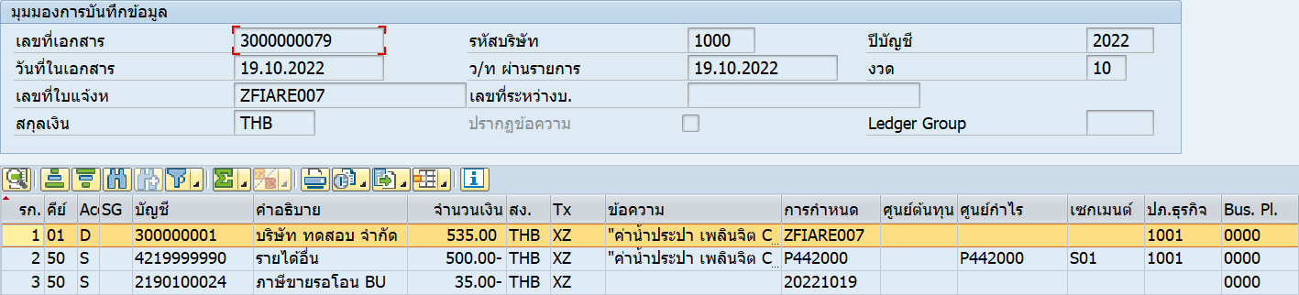

Full payment

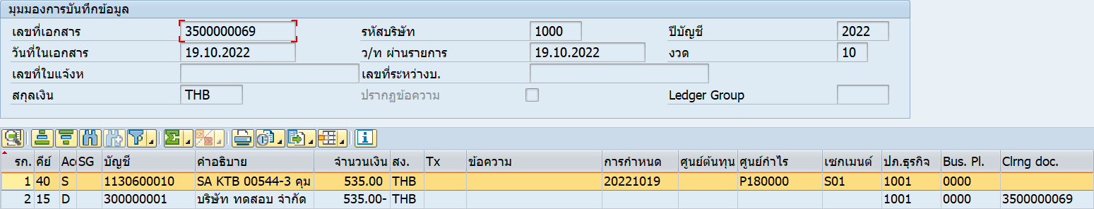

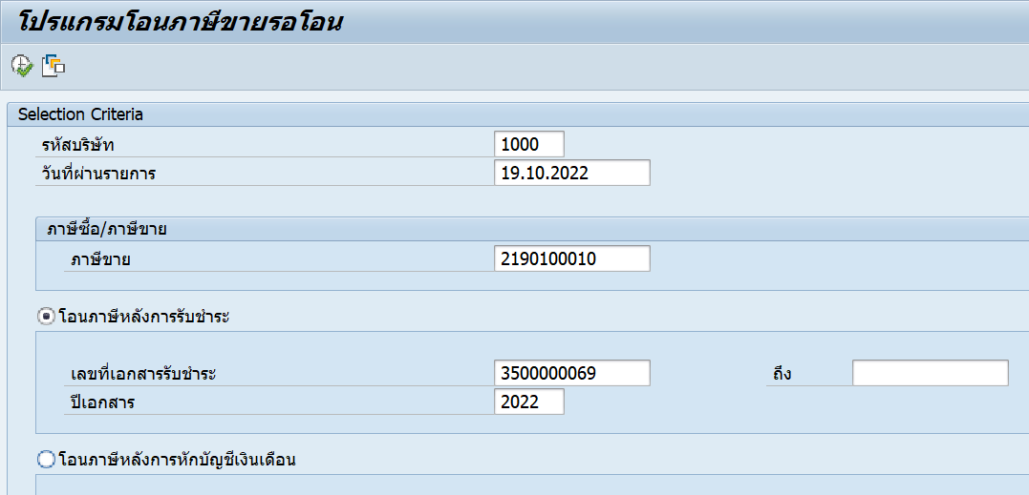

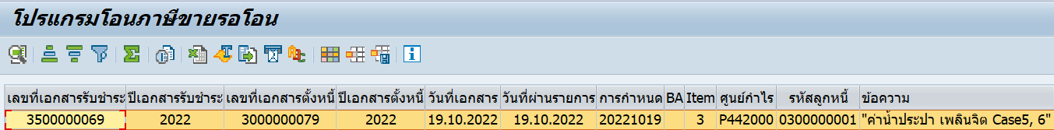



1 payment : 2 invoice

Invoice

3000000081/2022

3000000082/2022

Payment

3500000071/2022

