**ERQ-410**

Test FULL Payment

Invoice

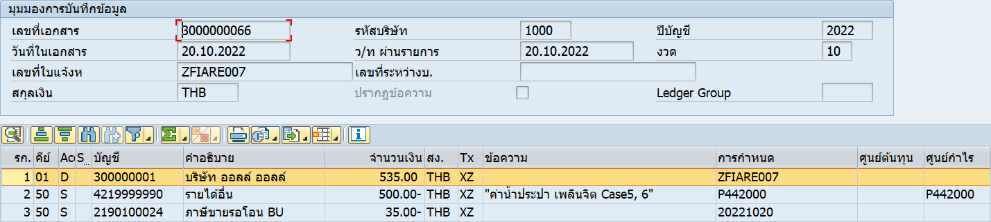

Full payment

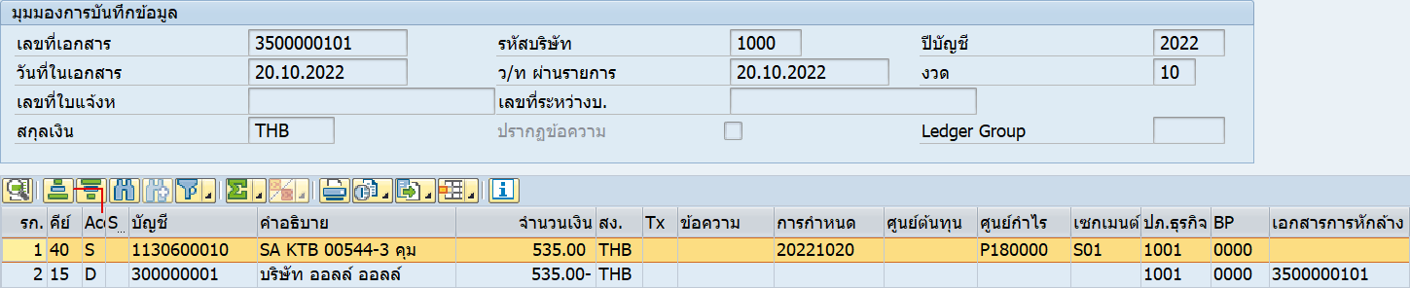

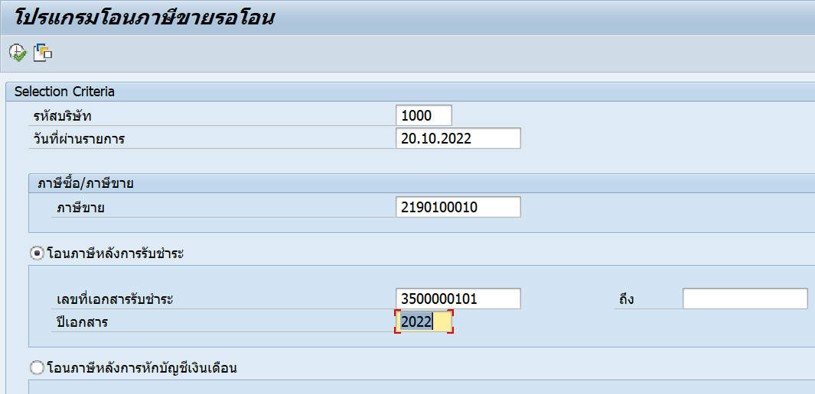

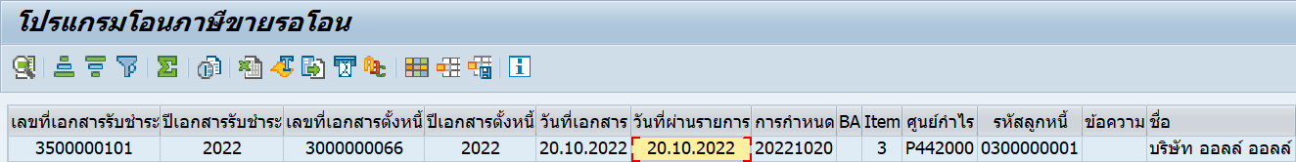



1 payment : 2 invoice

Invoice

3000000067/2022

3000000068/2022

Payment

3500000102/2022

