Office Management System.

GROUP NO :- GROUP 01

MEMBERS :- 1.Suwendra Gunawardhana
2.Ayodhya Manewa.
3.Sarangika Ethugala.
4.Nadeeshani Kaushalya.
5.Matheews Sathurshan.
6.Sangaranathan Sangalral
7.Nivethana Shanmugarathnam

SUPERVISOR : - Dr.E.Y.A.Chales

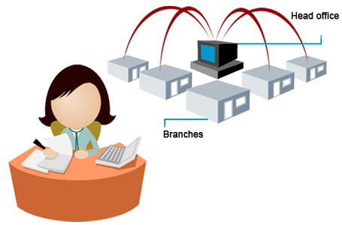
MENTORS:- Miss Nirthika R.
Miss T.Bamini

Executive summary

The purpose of this document is to present a detailed description of a Office Management System. Office is an important section of a business.The term business implies office work. The dictionary meaning of office is “a place for the
transaction of business, the room or department, where the clerical work is done,”
or we can say, “a place where business is carried on,” or it is, “a place where all sorts of
activities of organization are dealt with,” Office is the center of an organization.
So this project will explain the purpose and features of the system, the interfaces of the system will do, the constraints under which it must operate and how the system will react to external stimuli.
This document is intended for the developers of the system. Also this “Office Management system” has some specific details about the employees. Office management system is a technique of planning,organizing,coordinating and controlling office activities with a view to achieve business objectives and is concerned with efficient and effective performance of the office work. The main aim of this project is to attain following goals, better organized system, shorter and more efficient paper work and record keeping and improve the work postures of employees.” In this we studied about various departments of an office, there working and techniques by which improve the working conditions and office layout for minimize the office cost.In addition this office management comprises a number of vital functions, including time management, organizing our paperwork and workspace, managing multiple projects simultaneously, and being in control of all your job responsibilities. Accordingly our project Office management may be defined as the manipulation and control of men, methods, machines and materials to achieve the best possible results of the highest possible quality with the expenditure of the least possible effort and expenses in the shortest practicable time and in a manner acceptable to Top management.”
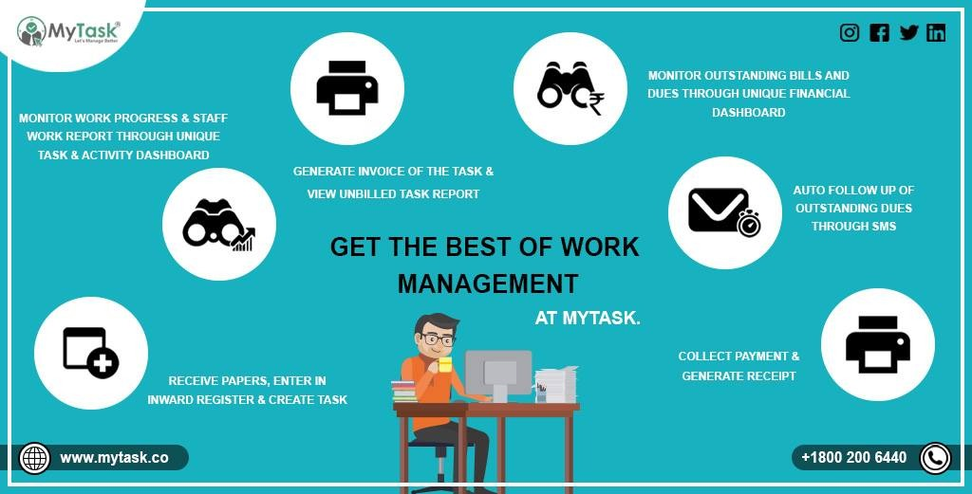

Acknowledgement

In making our project a successful one many parties helped us in different ways.Specially the supervisor of our group Dr.Chales supplied us the necessary guidance by showing the mistakes we did and by pointing out what should we do next and how the work to be shared with group members.Also our head of the department Dr.Ramanan gave us the correct motivation and how to dedicate in order to meet the deadlines. Our Mentors Miss Bamini and Miss Nirthika also gave us advices of how to create the necessary structures that help to succeed the work. What was most important was the dedication of group members and our friends who also showed us our erros in certain instances.
So as a group we all are very much thankful you all who helped us in different ways.!


Contribution of each member and Software Details


Suwendra Gunawardhana
- Database design.
- Complete all the backend part coding and modify the interface.
- Hosting.( http://www.rmsolution.tk/office1p/)
- Validation
- Modify the member’s work and finalize the project.
- Collect sample data and testing
- Complete the documentation and report

Ayodhya Manewa
- Assets,project ,policy parts coding
- Complete the documentation and report
- Testing.
- UI designing
- Web page creation of company policies
- Collection of sample data from clients

Sarangika Ethugala
- Leave,promotion,expenses part interface design
- Documentation and report
- Testing
- Collection of sample data from clients

Nadeeshani Kaushalya.
- Database design
- Awards,clients part interface design.
- Collection of sample data from clients

Matheews Sathurshan.
- Employee part interface design.
Sangaranathan Sangalral
- Employee part interface design.
Nivethana Shanmugarathnam

- Employee part database design.

Software details

01).Laravel freamwork 5.2

02).php 7.2.6

03).mysql

04).HTML5,CSS,Bootstrap

License

The Laravel framework is open-sourced software licensed

Comments from Supervisor

The supervisor Dr.Chales gave us the guidance to be shifted into the next step as soon as we go with monthly diaries.From his comments we understood the mistakes we did what we should further develope the system in as efficient way.



Table of Contents

- Objective of the project

- Problem statement

- Proposed solution

- System overview

- Diagrams

- Main components and their classes and GUI

- More information

Diagrams

Entity relationship diagram

Use-case diagram
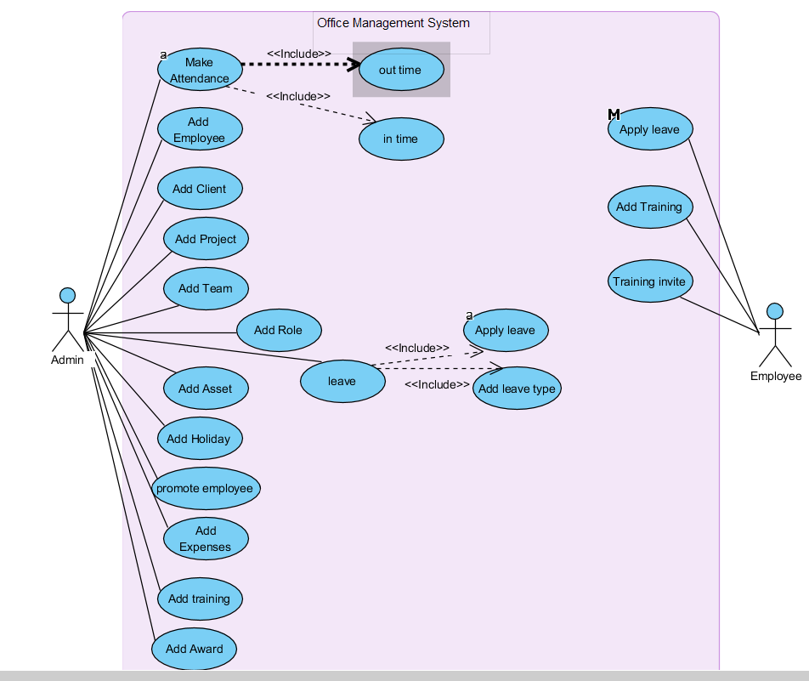

Sequence and class diagrams

Behavioural digrams
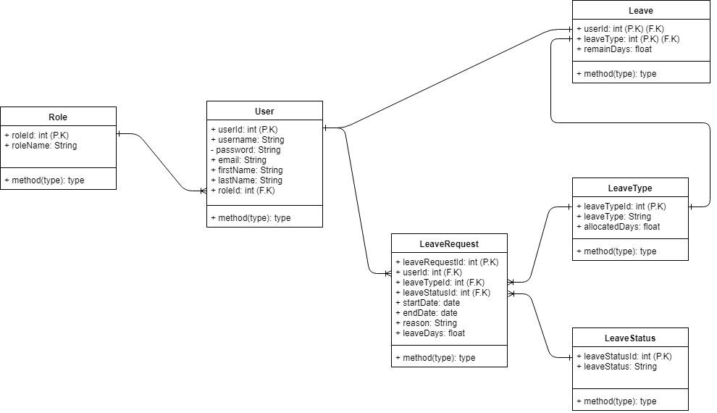

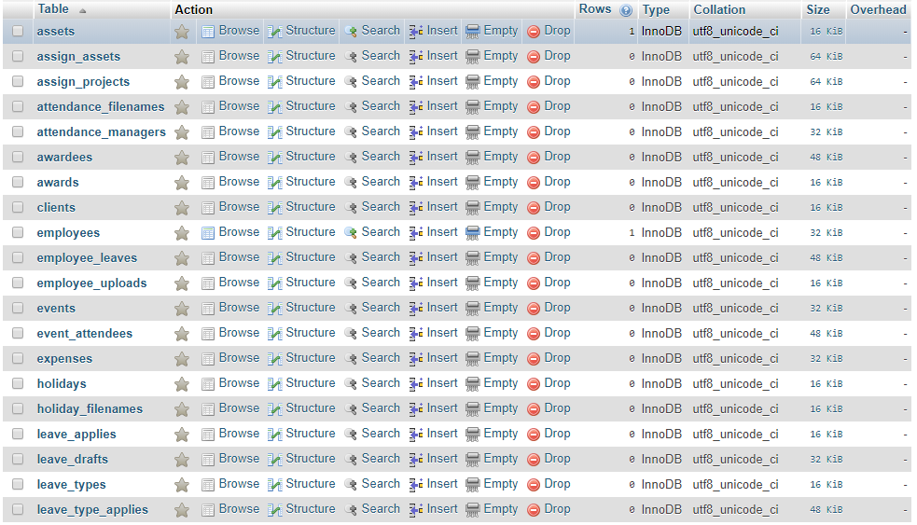
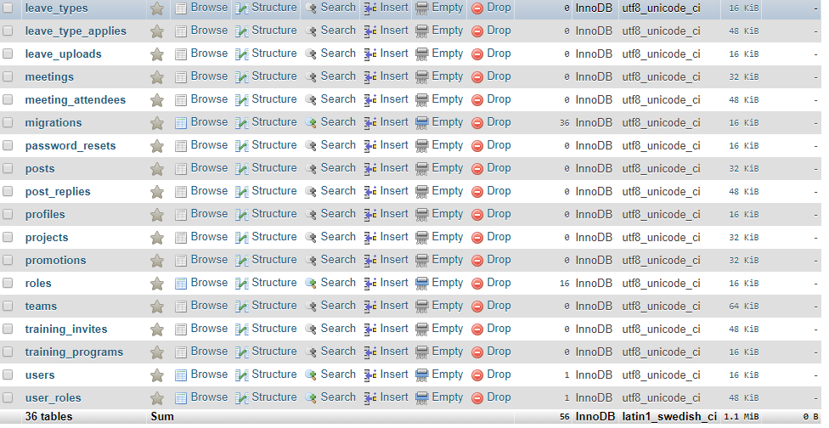
List of Tables

Developer
Report

of the project

“OFFICE MANAGEMENT SYSTEM”
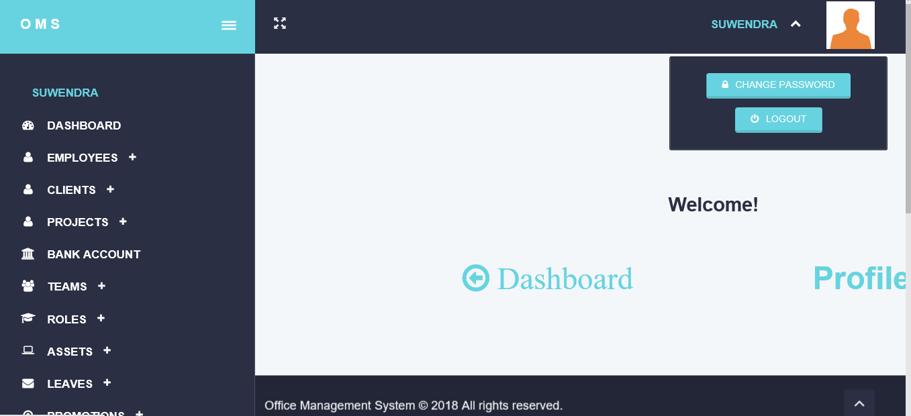
Introduction

• Objective of the project

The objevtive of this document is to present a detailed description of the Office Management System .It will explain the purpose and features of the system, the interfaces of the system will do, the constraints under which it must operate and how the system will react to external stimuli. This document is intended for developers of the system…

• Problem Statement

This report’s documentation goes through the whole process of both application
program and database development. It also comprises the development tools have been
utilized for these purposes..

• Proposed Solution

This system should consist of an application program, on one hand, and a database
(repository of data) on the other. The program should perform the basic operations
upon the database as retrieving, inserting, updating and deleting data. Any additional
functionality is a goal of a further module development.
It is a kind of strategy to start the development from designing and constructing the
database, as this structure will determine the further structure of the application
program.
The logical database model (tables, their content and the relationships between
them) should respond to the given task and cover the basic requirements.
The Interface of the program should be user-friendly, and the program should be as
easy for use as it is possible.
Both controls and forms should logically and functionally be related within the
program and fully respond to the structure of the database.
Another problem is establishing the connections with the database, every time, when
a query is needed to be performed upon it.
At the beginning,
1. Exploring the available development environments and techniques.
2. Database Analyzing.
3. Database design and Implementation.
4. Program’s Structure Analyzing.
5. GUI (Graphical User Interface) constructing.
6. Bringing all the stuff together (controls data binding and functions
implementation).
7. Tests

• System Overview

The Overall Description section of this document gives an overview of the functionality of the product. It describes the informal requirements and is used to establish a context for the technical requirements specification..
Also Requirements Specification section, of this document is written primarily for the developers and describes in technical terms the details of the functionality of the product.
Both sections of the document describe the same software product in its entirety, but are intended for different audiences and thus use different language.This contains a detailed description of the programming environments used for developing the system and the
implementation of the operations performed upon the database.

Testing

Testing involves,component testing where individual components are tested independently.Here the components may be functions or objects or coherent groupings of these entities.
It also involves system testing where Testing of the system as a whole. Testing of emergent properties is particularly important.

Accodingly in our project we,
Tested the front-end as a initial step and built it successfully without errors. Did the back end testing initially by running the each window with it's functions.
Finally run the system as complete system and entered some dummy data to check whether the system achieve it's user goals.

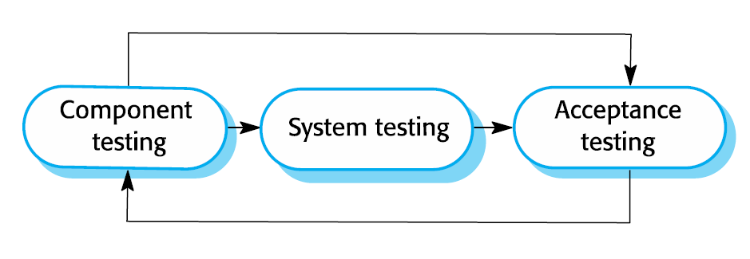
Main components and their classes and GUI

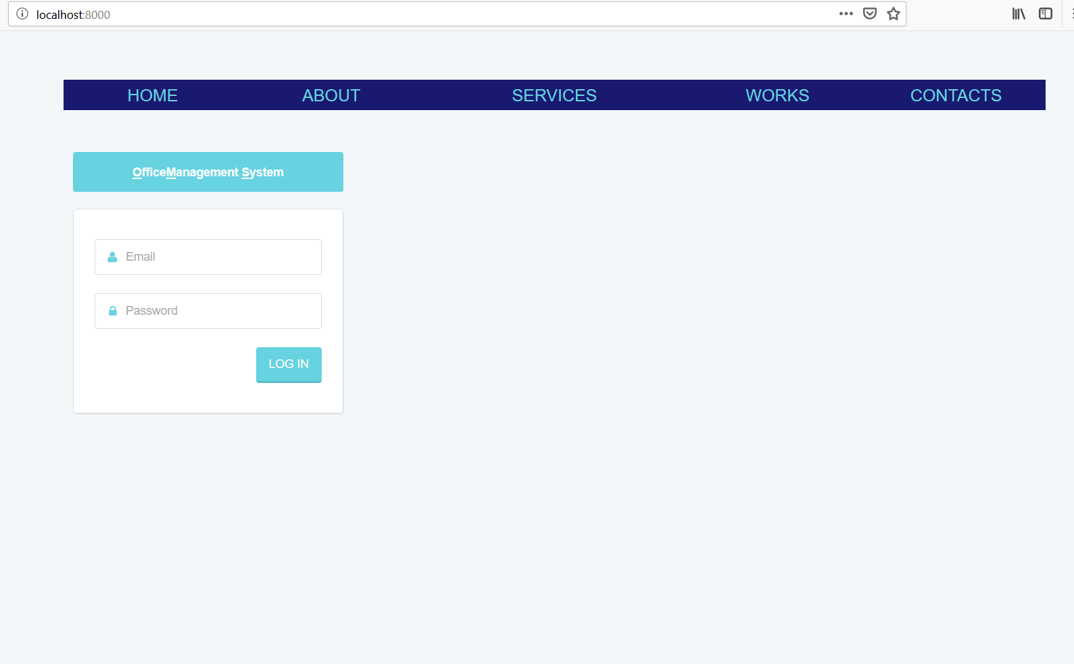

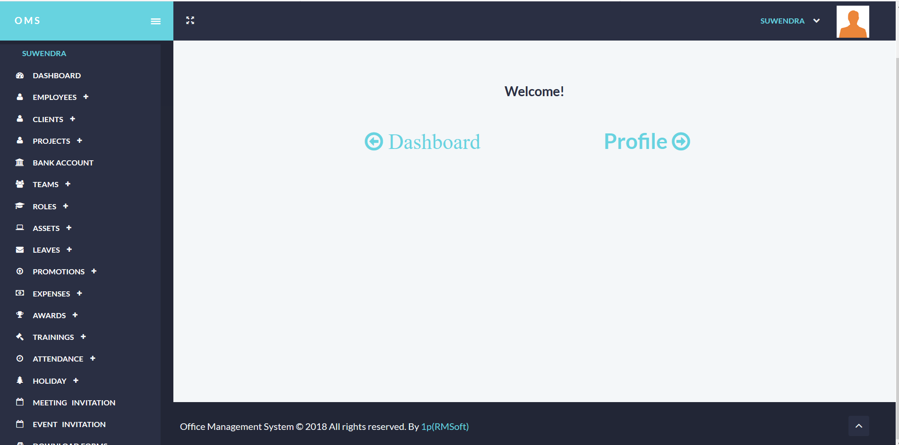

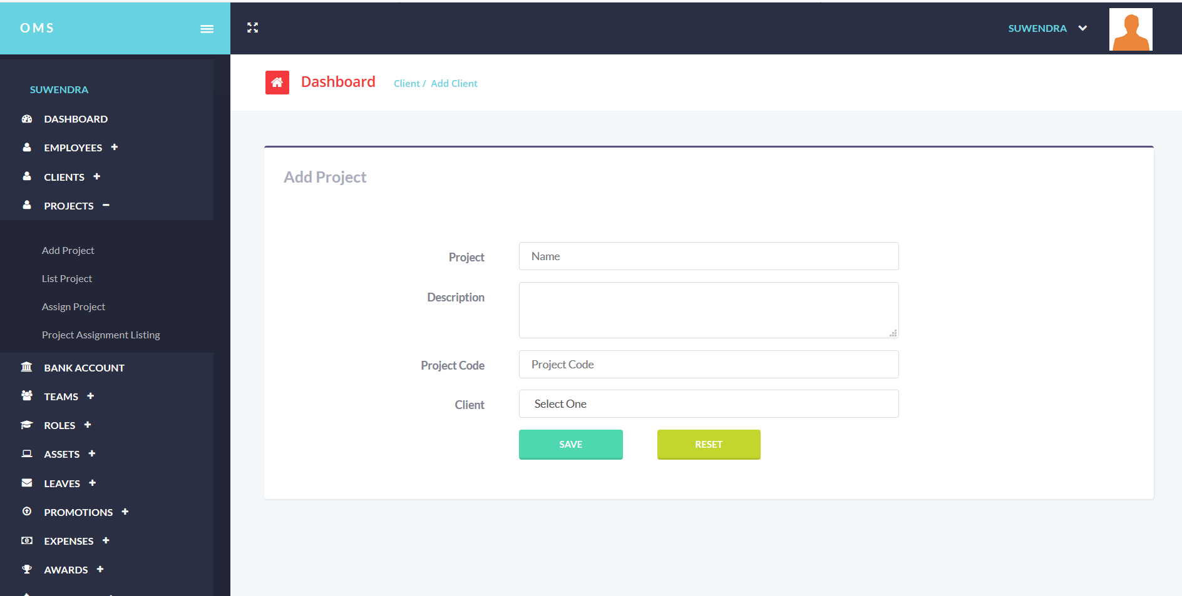

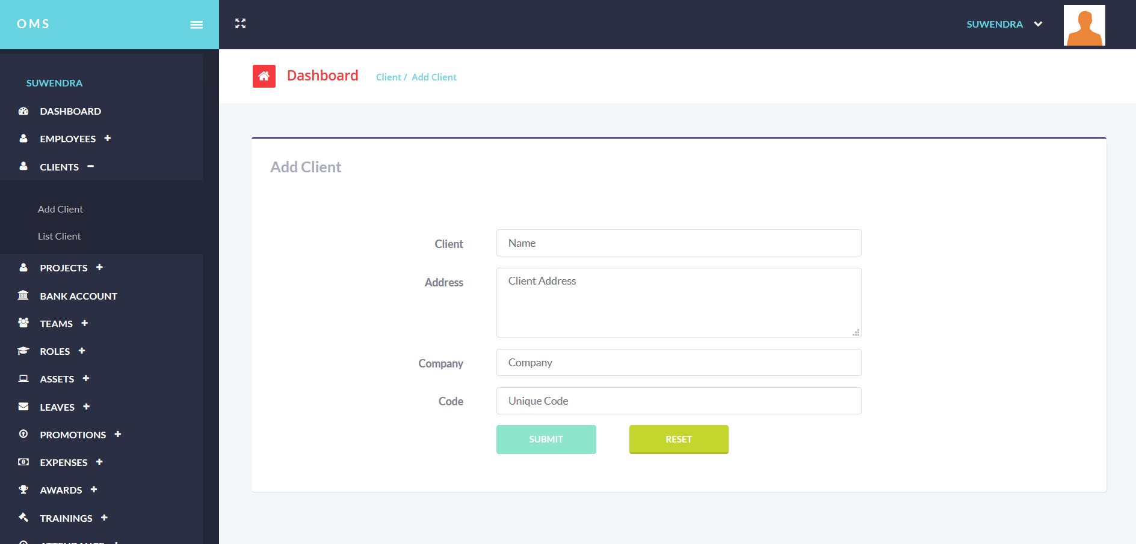

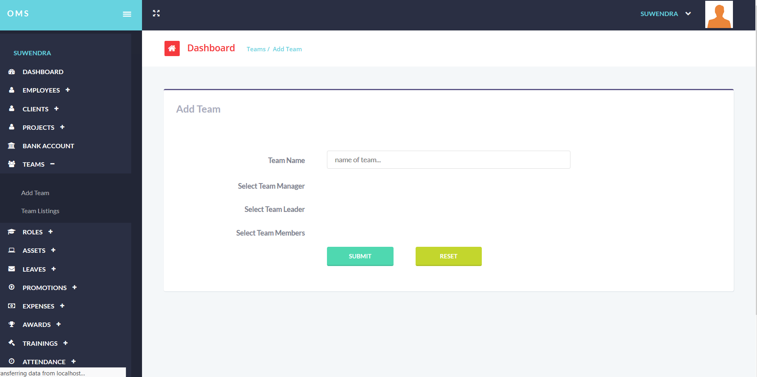

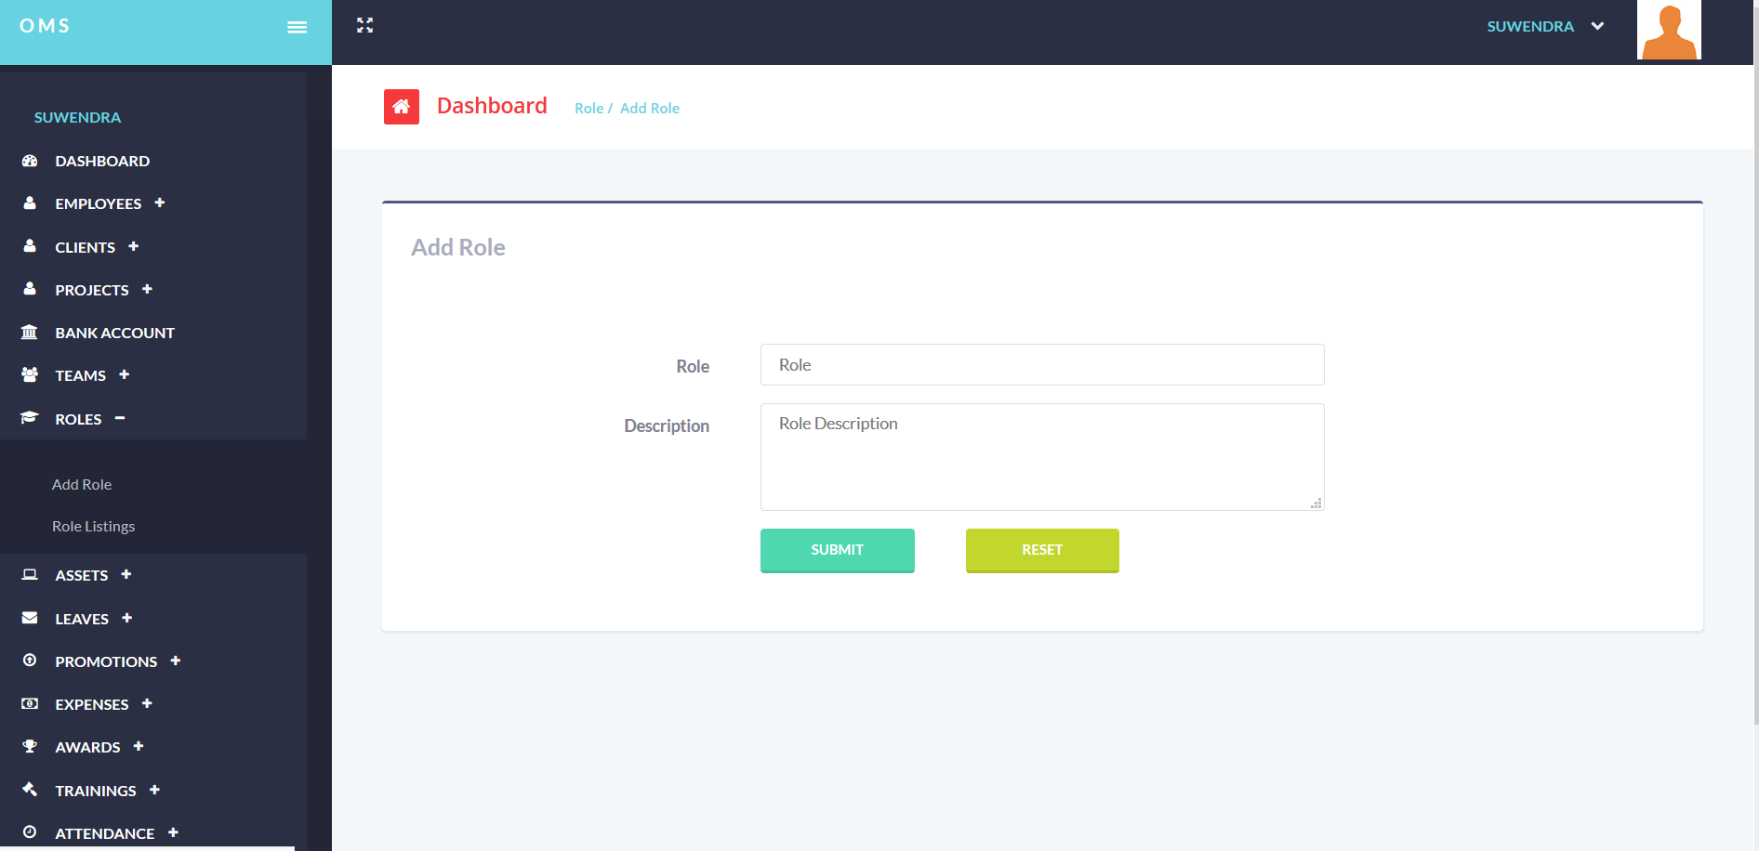

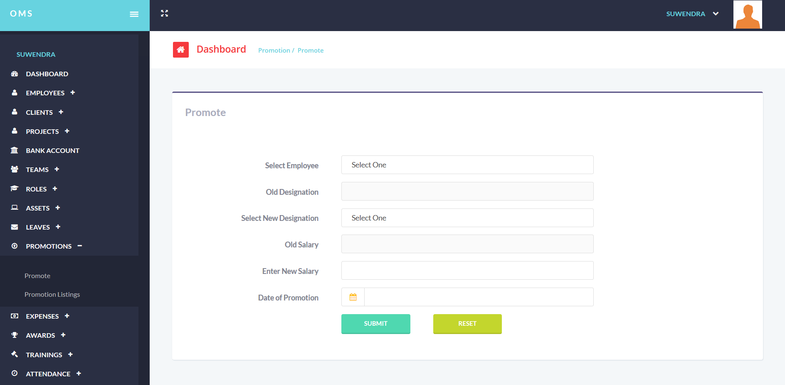

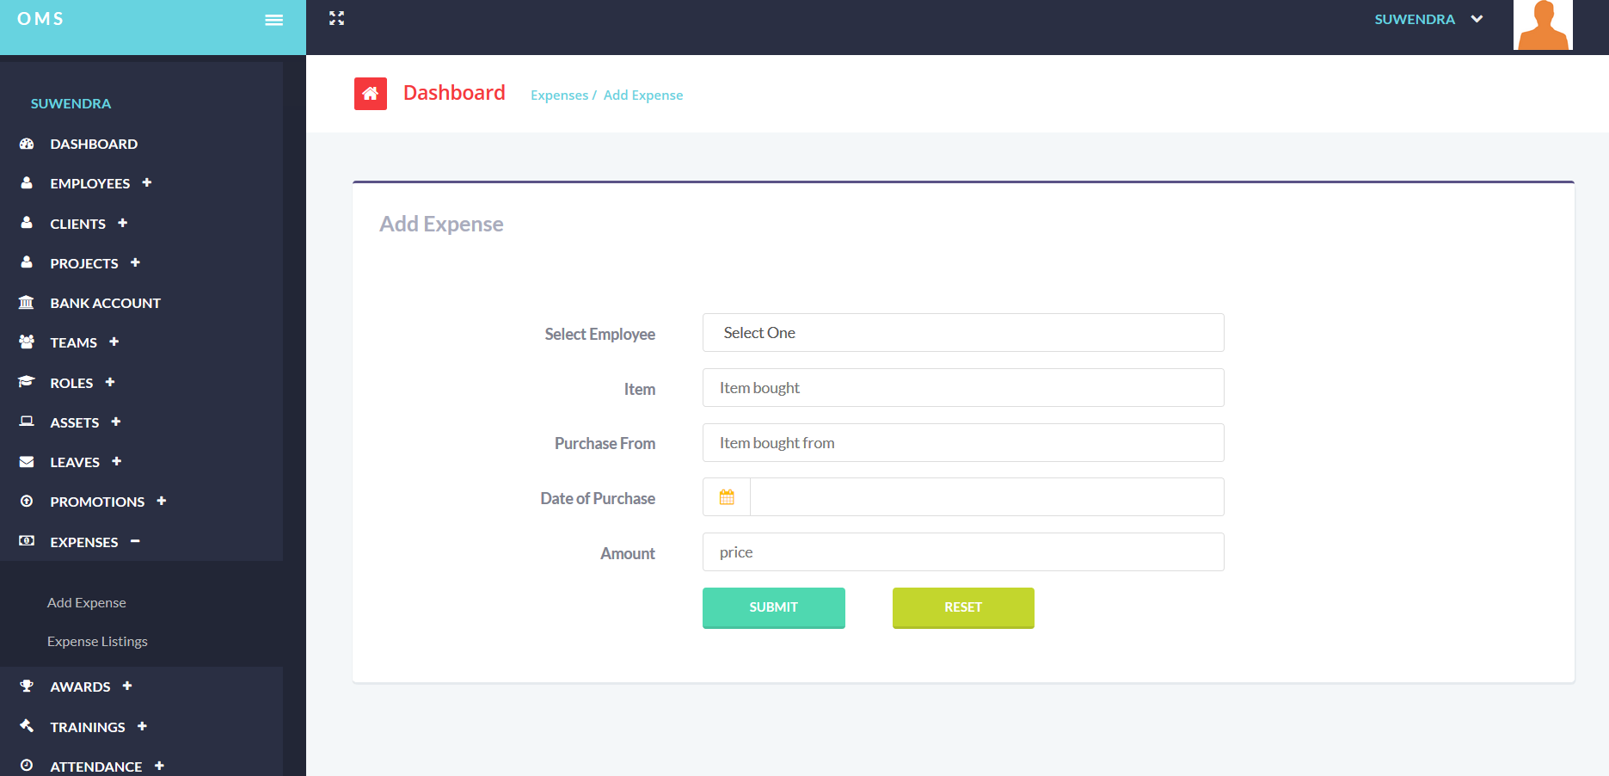

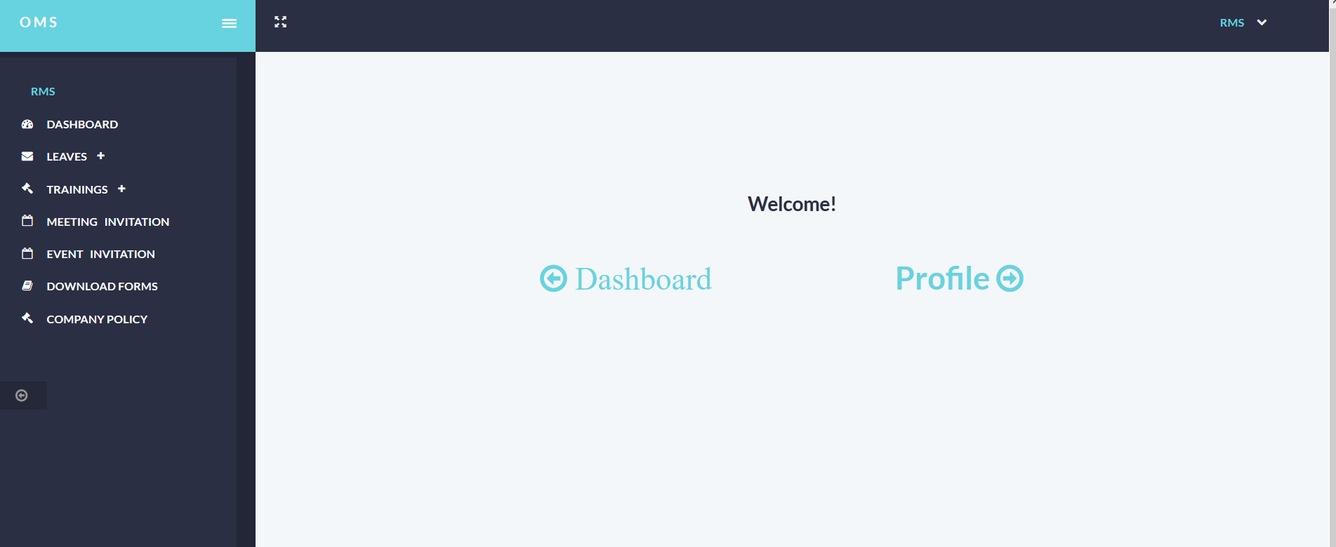

Discussion and Conclusion

Through the system it collects the details of employees of the office and the system users and analyses them according to the client requirement. The system provide facility to enter,edit and remove the data and viewing according to the actor's privileges. This will be a support to the user for managing the information of his workplace.
The system is useful for managers and employees in the office on achieving the major roles that they play such as retrieving the attendance details,financial statements,get leave facilities.
Functions of Administrator includes:
- Marking attendance of employees
- Assigning tasks to employees
- Viewing reports of employees
- Broadcasting notice to everyone
- Managing users
- Edit profile
Functions of Employee
- Viewing attendance records of own
- Viewing task records of own
- Taking leave
- Reporting complaints to the administrators
- Edit profile
Also the constraints are limitations imposed on the project such as the limitation of cost,schedule or resources and you have to work within the boundaries restricted by these constraints which are defined and identified at the beginning of the project.

More Information

Github id= https://github.com/suwendrarms/3rd-year-project-1p
Reference= All the branches in this repository and http://www.rmsolution.tk/office1p/

