Group Details

GROUP NO :- GROUP 01

Name Reg No

MEMBERS :- 1.Suwendra Gunawardhana 2015/sp/040
2.Ayodhya Manewa 2015/sp/084
3.Sarangika Ethugala 2015/sp/225
4.Nadeeshani Kaushalya
5.Matheews Sathurshan.
6.Sangaranathan Sangalral
7.Nivethana Shanmugarathnam

Software Details

Name version Licence

Laravel 5.2 Open-sourced
Bootstrap
CSS

How to install Laravel

Step 1 – Install LAMP
To start with Laravel, we first need to set up a running LAMP server. If you have already running LAMP stack skip this step else use followings commands to set up the lamp on Ubuntu system.
Install PHP 7
sudo apt-get install python-software-properties
sudo add-apt-repository ppa:ondrej/php
sudo apt-get update
sudo apt-get install -y php7.2 php7.2-mcrypt php7.2-gd php7.2-mbstring php7.2-xml
Install Apache2
sudo apt-get install apache2 libapache2-mod-php7.2
Install MySQL
sudo apt-get install mysql-server php7.2-mysql

Step 2 – Install Composer
The composer is required for installing Laravel dependencies. So use below commands to download and use as a command in our system.
curl -sS https://getcomposer.org/installer | php
sudo mv composer.phar /usr/local/bin/composer
sudo chmod +x /usr/local/bin/composer

Step 3 – Install Laravel
Download the latest version of Laravel from the official git repository. Use the below command to clone the master branch of the Laravel from GitHub.
cd /var/www
git clone https://github.com/laravel/laravel.git
Navigate to Laravel code directory and use composer to install all dependencies required for Laravel framework.
cd /var/www/laravel
sudo composer install
The dependencies installation may take some time as per your network speed. After successfully installing all dependencies, set the proper permissions on all files.
chown -R www-data.www-data /var/www/laravel
chmod -R 755 /var/www/laravel
chmod -R 777 /var/www/laravel/storage

Step 4 – Setup Encryption Key
Now, rename the .evn.example file to .env in projects main directory. This will use to setup application environment for the project.
mv .env.example .env
Now generate base64 random number encryption key, which used by the Illuminate encrypter service.
php artisan key:generate

Application key [base64:HFdS7c9rhDp+AeHu7kc2OLBPuxHqq2BQ/1gfFWEpoAk=] set successfully.
Edit the .env configuration file and update the required settings. Also, make sure APP_KEY is properly set as generated in above command.
vi .env
APP_NAME=Laravel
APP_ENV=local
APP_KEY=base64:HFdS7c9rhDp+AeHu7kc2OLBPuxHqq2BQ/1gfFWEpoAk=
APP_DEBUG=true
APP_URL=http://localhost

Step 5 – Create Database for Laravel
You may also require creating a database for your Laravel application. Login to your MySQL server and create MySQL database and user.

mysql> CREATE DATABASE laravel; mysql> GRANT ALL ON laravel.* to 'laravel'@'localhost' IDENTIFIED BY 'secret_password'; mysql> FLUSH PRIVILEGES; mysql> quit
1  2  3  4 | mysql> CREATE DATABASE laravel;  mysql> GRANT ALL ON laravel.* to 'laravel'@'localhost' IDENTIFIED BY 'secret_password';  mysql> FLUSH PRIVILEGES;  mysql> quit

Now edit the .env file and update database settings.
DB_CONNECTION=mysql
DB_HOST=127.0.0.1
DB_PORT=3306
DB_DATABASE=laravel
DB_USERNAME=laravel
DB_PASSWORD=secret_password

Step 6 – Apache Configuration
Edit Apache default virtual host configuration file 000-default.conf and update DocumentRoot to Laravel public directory as below:
vim /etc/apache2/sites-enabled/000-default.conf
also add some more configuration.
<VirtualHost *:80>

ServerAdmin webmaster@localhost
DocumentRoot /var/www/laravel/public

<Directory />
Options FollowSymLinks
AllowOverride None
</Directory>
<Directory /var/www/laravel>
AllowOverride All
</Directory>

ErrorLog ${APACHE_LOG_DIR}/error.log
CustomLog ${APACHE_LOG_DIR}/access.log combined

</VirtualHost>
Reload Apache configuration changes by restarting service using below command
sudo service apache2 restart

Step 7 – Access Laravel Application
You have successfully configured Laravel 5 PHP framework on your system. Access Laravel application in your favorite web browser
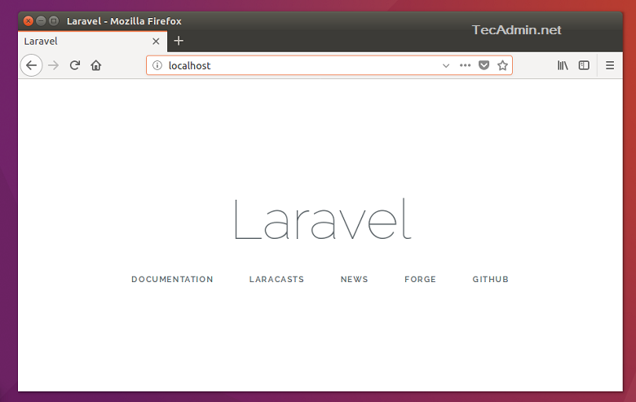

Let’s start building an awesome application using Laravel 5 PHP Framework.

Executive summary

An office manager is responsible for monitoring and reviewing system, usually focusing on specific outcomes such as improved timescale, turnover, outcome, sales, etc.They may supervise or manage a team of administrators ,allocating roles, recruiting and training and issuing assignments and projects.

Customers

smartshirt Lanka (pvt).ltd - Katunayake
Enet solution - Kelaniya
Chalk and chauser - Anuradhapura
LB finance - Trincomalee

user
Report

of the project

“OFFICE MANAGEMENT SYSTEM”
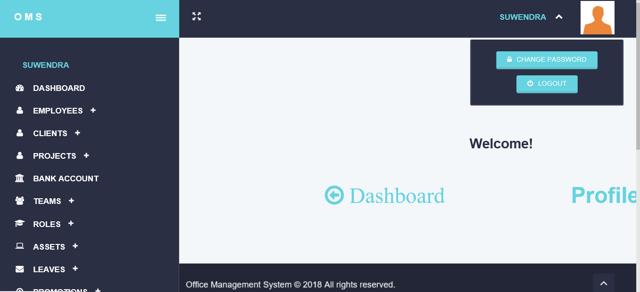

Introduction

• Objective of the project

The objevtive of this document is to present a detailed description of the Office Management System .It will explain the purpose and features of the system, the interfaces of the system will do, the constraints under which it must operate and how the system will react to external stimuli. This document is intended for developers of the system…

• Problem Statement

This report’s documentation goes through the whole process of both application
program and database development. It also comprises the development tools have been
utilized for these purposes..

• Proposed Solution

This system should consist of an application program, on one hand, and a database
(repository of data) on the other. The program should perform the basic operations
upon the database as retrieving, inserting, updating and deleting data. Any additional
functionality is a goal of a further module development.
It is a kind of strategy to start the development from designing and constructing the
database, as this structure will determine the further structure of the application
program.
The logical database model (tables, their content and the relationships between
them) should respond to the given task and cover the basic requirements.
The Interface of the program should be user-friendly, and the program should be as
easy for use as it is possible.
Both controls and forms should logically and functionally be related within the
program and fully respond to the structure of the database.
Another problem is establishing the connections with the database, every time, when
a query is needed to be performed upon it.
At the beginning,
1. Exploring the available development environments and techniques.
2. Database Analyzing.
3. Database design and Implementation.
4. Program’s Structure Analyzing.
5. GUI (Graphical User Interface) constructing.
6. Bringing all the stuff together (controls data binding and functions
implementation).
7. Tests

