Doctor-Patient Medical App
Software Requirements Specification
One Unified Mobile App for Patient, Doctor, Reception, Nurse and Admin
Mobile: React Native + TypeScript | Backend: Node.js

Document Title | Doctor-Patient Medical App - SRS
Version | 2.2 - Unified App + Modern UI + RBAC + Full Master Catalogue
Date | 2026-05-07
Prepared For | Stakeholders, Engineering, Design, Compliance
Phase 1 Theme | Modern, vibrant, colorful 'new-world' UI
Status | Final Draft for Review

1. Executive Summary
This document defines the full software requirements for a real-world, multi-actor Doctor-Patient Medical App delivered as ONE unified mobile application that adapts its experience based on the signed-in user's role - Patient, Doctor, Reception, Nurse, or Admin. A single install, a single brand, a single codebase: every actor uses the same app and is presented with a role-tailored home, navigation set, and feature list. Phase 1 emphasizes a modern, vibrant, 'new-world' visual identity with gradient accents, glassmorphism cards, smooth motion design, dark and light themes, and an adaptive role-color system. The mobile app is built with React Native + TypeScript, the backend services run on Node.js, and the data layer uses PostgreSQL with Redis. Every feature in this document is mapped to a real-world benefit derived from the system design, so engineering, design, business, and compliance teams can validate value at every interaction.

1.1 Outcomes Targeted
- One unified mobile app for every role - lower training cost, single brand presence.
- A modern, colorful, motion-rich UI that feels premium on day one.
- Faster, safer patient care across emergency and routine flows.
- Reduced documentation overhead for clinical staff.
- Standardized data and clear governance for administrators.
- Connected workflow between Reception, Nursing, and Doctor roles.
- Real-time visibility, audit, and KPI tracking for facility owners.
- Accessible, multilingual, dark/light theme experience for all users.

2. Purpose and Vision
The system replaces fragmented paper records, parallel WhatsApp/SMS communication, and standalone clinic software with a single connected platform. Every actor uses a role-specific interface, but they all operate against the same patient record - eliminating duplicate work, lost information, and unsafe handoffs.

2.1 Vision Statement
Build a healthcare operating layer where the patient's data follows the patient - securely, instantly, and with full audit - across every touchpoint inside and outside the clinic.

2.2 Strategic Goals
Goal | How the System Delivers It
Continuity of care | Single longitudinal record with QR-based instant lookup.
Patient safety | Allergy / interaction alerts, decision support, audit logs.
Operational efficiency | Reception queue, nurse triage, doctor consult - one digital flow.
Compliance readiness | RBAC, consent capture, immutable audit, encryption at rest and in transit.
Inclusivity | Multilingual UI (Sinhala, Tamil, English), low-bandwidth offline mode.

3. Scope

3.1 In Scope - One Unified Mobile App
The product is delivered as a SINGLE cross-platform mobile application (iOS and Android, phone and tablet) built with React Native + TypeScript. After login, the app detects the user's role and renders a role-specific home, navigation, color accent, and feature set. Admin gets a responsive web companion in addition to the mobile experience. All five roles share the same authentication, design system, and offline behavior - only what is on screen changes by role.
- ONE unified mobile app (React Native + TypeScript) for Patient, Doctor, Reception, Nurse, and Admin roles - iOS and Android.
- Role-aware adaptive UI: navigation, dashboard widgets, accent color, and feature switches change automatically per role.
- Modern, colorful, motion-rich Phase-1 design language (gradient palette, glassmorphism cards, dark/light themes).
- Admin responsive web companion (React + TypeScript) for desktop-heavy management tasks.
- Node.js backend services with REST APIs, JWT auth, and OpenAPI contracts.
- PostgreSQL data store + Redis cache + Object storage for files.
- QR token issuance, scanning, and consent enforcement.
- Appointment, visit, prescription, refill, and telemedicine flows.
- Reporting, KPI dashboards, audit logs, RBAC.
- Notifications via FCM, SMS, and email with rich-media push.
- In-app AI Health Assistant (chat) and voice-to-text clinical notes.
- Wearable / Apple Health / Google Fit ingestion for patient role.

3.2 Out of Scope (Phase 1)
- Insurance claim adjudication beyond eligibility check.
- Native desktop applications (Admin web is responsive only).
- Hardware procurement (kiosks, BP cuffs, glucose meters).
- National-level interoperability bus (planned for Phase 3).
- Separate per-role apps - explicitly replaced by the unified app strategy.

4. Technology Stack
Layer | Technology | Reason / Real-World Benefit
Mobile UI | React Native 0.74+ with TypeScript | Single codebase for iOS and Android, type safety reduces production defects, large hiring pool.
Mobile state | Redux Toolkit / Zustand + React Query | Predictable state, automatic cache + retries for unstable clinic networks.
Mobile UI kit | React Native Paper / NativeBase | Accessible Material components, faster delivery, theming for branding.
Mobile QR | react-native-vision-camera + ML Kit | Reliable scanning even in low light at reception or bedside.
Push | Firebase Cloud Messaging + APNs | Free, reliable patient and staff notifications.
Backend runtime | Node.js 20 LTS | Non-blocking I/O ideal for many concurrent requests; same language as mobile reduces context switching.
Backend framework | NestJS or Express + TypeScript | Strong typing, DI, OpenAPI generation; structured for medical-grade auditing.
Database | PostgreSQL 16 | ACID transactions, JSONB for flexible clinical data, mature replication.
Cache / Queue | Redis 7 | Sub-millisecond cache for QR tokens and queue management.
Search | OpenSearch / Postgres tsvector | Fast patient lookup by name, phone, NIC.
Object storage | S3-compatible (AWS S3 / MinIO) | Stores PDFs, lab images, patient documents at scale.
Auth | JWT + OAuth 2.0 + TOTP 2FA | Industry-standard, supports SSO with hospital identity providers.
Observability | OpenTelemetry, Prometheus, Grafana, Loki | Detect outages and SLA breaches in seconds.
CI/CD | GitHub Actions + Docker + Kubernetes | Repeatable deploys, blue/green releases, easy rollback.
Secrets | HashiCorp Vault / AWS Secrets Manager | Compliance-grade secret rotation.

5. System Actors and Real-World Value

5.1 Patient
End user receiving care. Owns their medical identity and consent.
Capability (System Design) | Real-World Benefit
Generates a QR for instant authorized data sharing | Skips re-explaining history at every clinic visit.
Receives medication, follow-up, and lab reminders | Higher adherence and fewer relapses.
Requests prescription refill in-app | Avoids unnecessary clinic visits and travel cost.
Sees consent and access history | Builds trust by knowing exactly who saw their data and when.

5.2 Reception
First touchpoint at the facility. Manages check-in, queue, and billing.
Capability (System Design) | Real-World Benefit
Scans the patient QR to check in | Eliminates manual form-filling and wrong-patient errors.
Sees real-time doctor availability and queue length | Sets correct expectations and reduces walk-away rate.
Verifies insurance eligibility on the fly | Avoids billing disputes after the visit.
Issues digital receipts and discharge | Creates a clean paper trail for audit and tax.

5.3 Nurse
Clinical assistant who triages, records vitals, prepares the patient, and administers treatments.
Capability (System Design) | Real-World Benefit
Captures vitals on tablet linked to the visit record | No transcription error from paper to chart.
Performs triage and assigns severity | Doctor sees the most urgent cases first.
Administers and tracks medication / IV / vaccinations | Each dose is timestamped and audited.
Coordinates lab orders and sample collection | Reduces lost samples and result delays.

5.4 Doctor
Licensed clinician performing diagnosis, prescription, and treatment planning.
Capability (System Design) | Real-World Benefit
Scans the patient QR to open full history | Saves consultation time, especially in emergencies.
Sees AI risk alerts (drug interaction, abnormal trend) | Safer prescriptions and earlier intervention.
Issues e-prescription routed to in-house or partner pharmacy | Eliminates illegible handwriting and pharmacy callbacks.
Conducts telemedicine with structured notes | Expands patient reach without extra clinic space.

5.5 Admin
Facility administrator managing users, masters, compliance, and reporting.
Capability (System Design) | Real-World Benefit
Maintains masters for diseases, medications, treatments | Standardized data improves analytics and billing.
Configures RBAC and consent policies | Limits insider risk and supports audits.
Reviews audit logs and KPI dashboards | Data-driven decisions on staffing and quality.
Runs backup, retention, and DR drills | Protects facility from data loss and ransomware.

6. Use Case Diagram
The diagram below summarizes the full set of use cases across all five actors. Each ellipse represents a use case implemented as one or more API endpoints in the Node.js backend, with a corresponding screen in the unified React Native mobile app's role shell.
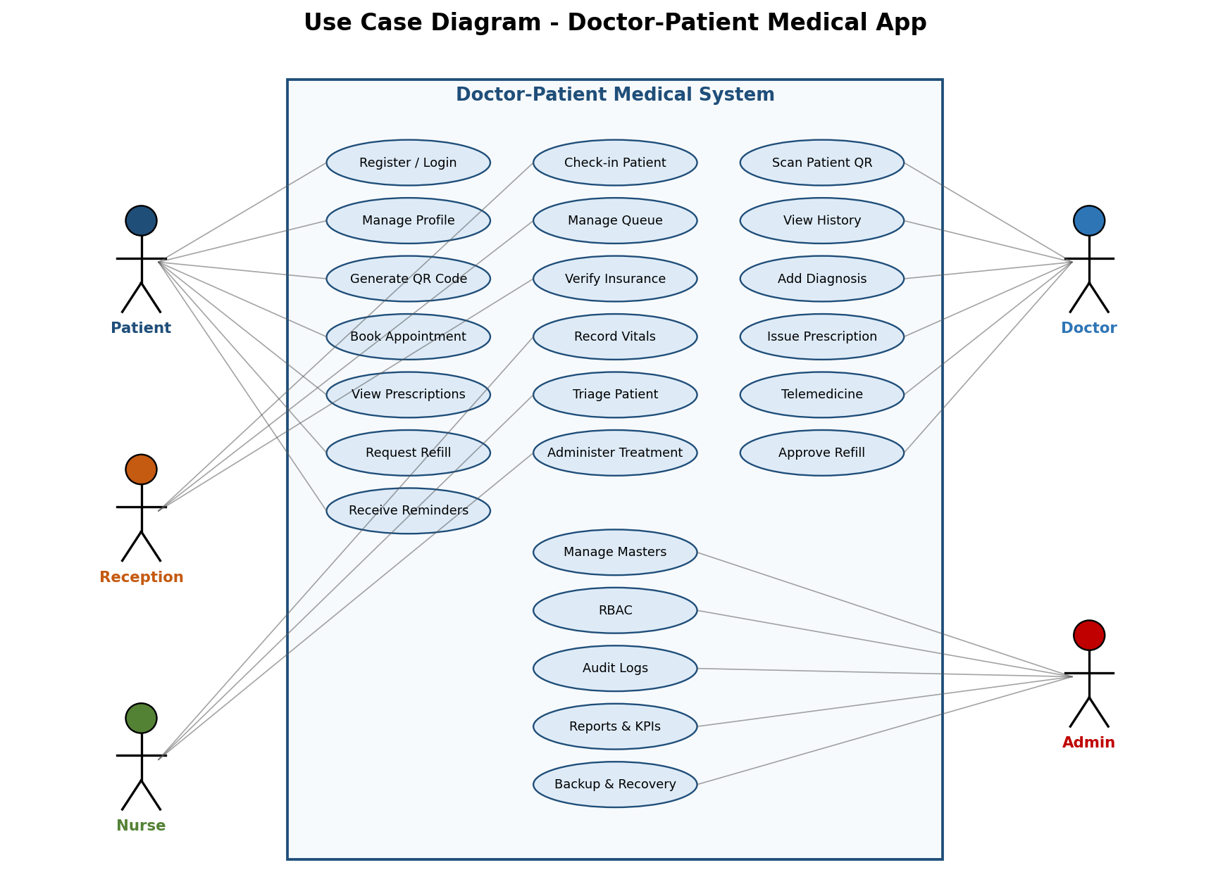
Figure 6.1 - Consolidated Use Case Diagram

7. System Architecture
The system is a layered, service-oriented architecture. The unified mobile app (with all five role shells) is a pure client that communicates over HTTPS to a Node.js API gateway. Each service in the application layer is independently deployable and owns its own data domain. Cross-cutting concerns (auth, audit, observability) are centralized.
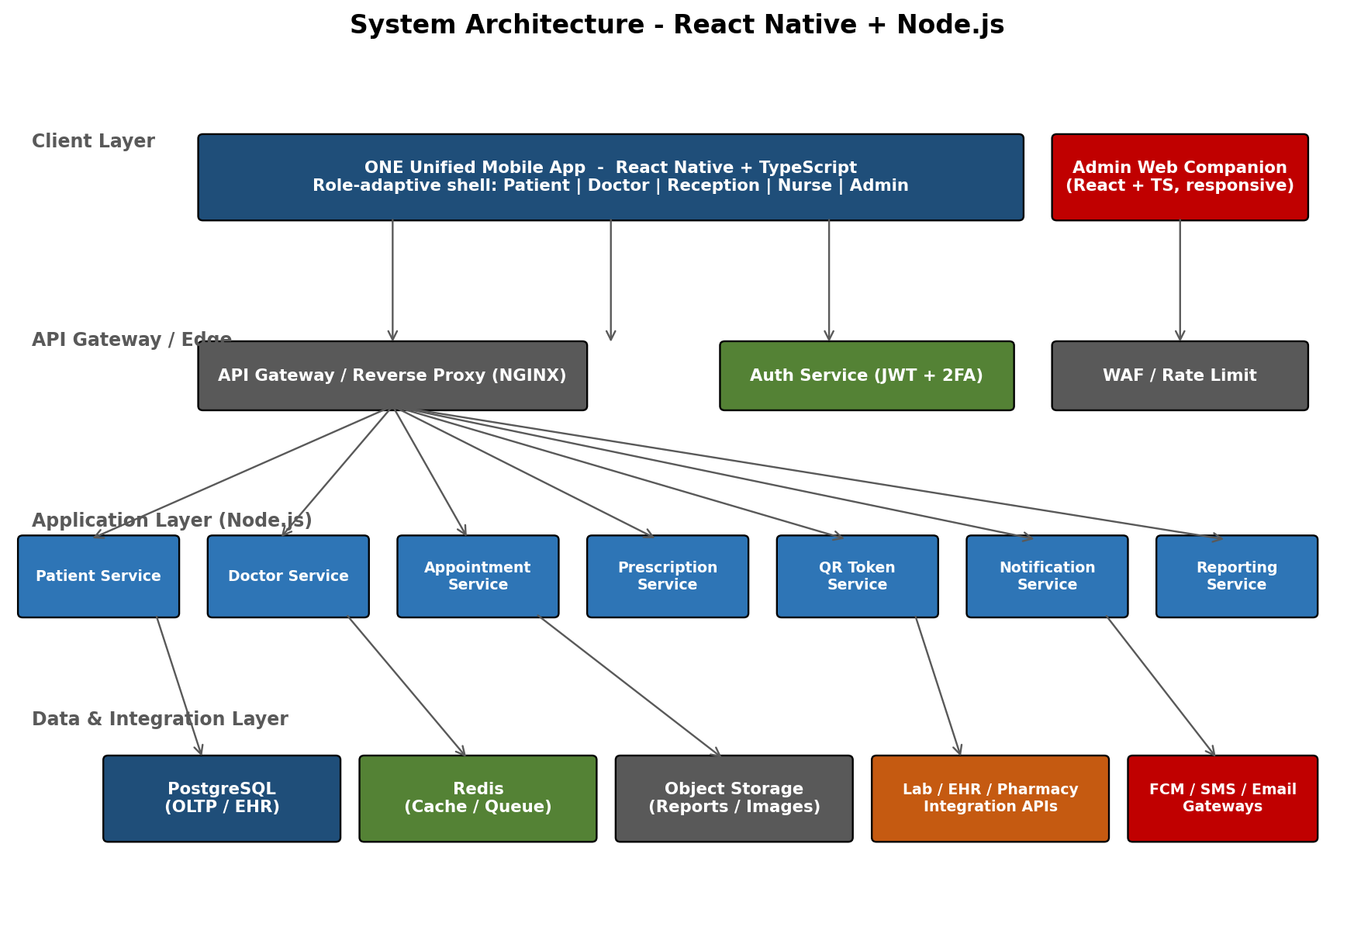
Figure 7.1 - System Architecture

7.1 Architectural Principles
- API-first: every screen calls a documented, versioned REST API.
- Stateless services behind a load balancer for horizontal scaling.
- Event-driven for audit and notifications - never blocking the request path.
- Defense in depth: WAF, gateway auth, service auth, DB-level row policies.
- Zero-trust between services: mTLS within the cluster.

8. Unified Mobile App Architecture (React Native + TypeScript)
There is ONE mobile application binary, published to the Play Store and App Store under a single brand. After authentication, the app reads the user's role from the JWT and dynamically loads a 'role shell' - a combination of navigation tree, dashboard widgets, accent color, and feature flags. All shells share the same design system, the same API client, and the same offline / sync layer, so engineering effort scales linearly with features rather than with roles.
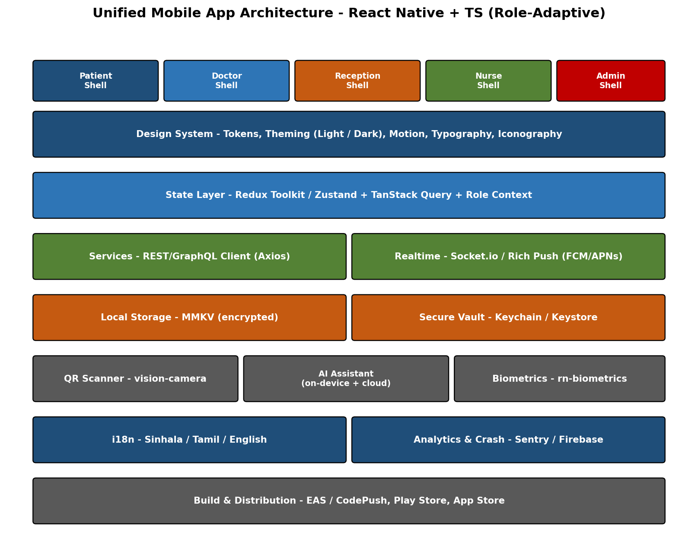
Figure 8.1 - Unified Mobile App Architecture (Role-Adaptive)

8.1 Why One App Instead of Four
Concern | Per-Role Apps (Old Plan) | Unified App (This Plan)
App store presence | 4-5 listings to maintain | 1 listing, 1 brand, simpler discovery
Install friction for staff | Reception/nurse install separate apps | Same app the patient already trusts
Feature parity | Drift across apps over time | Single codebase guarantees consistent UX
Build / release pipeline | 4 pipelines, 4 release notes | 1 pipeline, role flags toggle features
Cross-role demos | Multiple devices needed | Switch role inside the app for demos / training
Onboarding cost | Each role learns a new app | Familiar shell - only the role panel differs

8.2 Folder Structure (Single App, Role Shells)
/app
/src
/shells
/patient - patient role navigation + screens
/doctor - doctor role navigation + screens
/reception - reception role navigation + screens
/nurse - nurse role navigation + screens
/admin - admin role navigation + screens
/design-system - tokens, theme, components, motion
/api-client - typed REST client + TanStack Query hooks
/features - cross-role features (auth, QR, chat, AI assistant)
/types - shared TS interfaces
/i18n - locales (si / ta / en)
/utils - validators, formatters, QR helpers
/role-router - resolves role from JWT, mounts the right shell

8.3 Key Mobile Capabilities
Capability | Library | Real-World Benefit
Navigation | React Navigation v6 | Native feel, deep links from notifications.
UI primitives | Tamagui / RN Paper + custom design tokens | Modern, themable, performant cross-platform components.
Motion | Reanimated 3 + Moti + Lottie | Smooth 60-fps micro-interactions and onboarding animations.
Forms | React Hook Form + Zod | Type-safe, low-rerender forms for fast triage entry.
Data fetching | TanStack Query | Auto-retry on flaky clinic Wi-Fi, optimistic UI.
Secure storage | react-native-keychain + MMKV (encrypted) | Encrypted storage of tokens and offline records.
QR scan | react-native-vision-camera | Hardware-accelerated, decodes in poor light.
Offline | TanStack Query persist + sync queue | Works during outage, syncs when online.
Biometrics | react-native-biometrics | Faster, safer login than PIN at busy reception.
Telemedicine | react-native-webrtc / Twilio Video | HD video consults across mobile networks.
AI Assistant | OpenAI / on-device small model + STT | Conversational triage and clinical-note dictation.
Theming | Theme tokens + system dark mode | Light, dark, and high-contrast themes by user choice.

8.4 Role Resolution Flow
- User authenticates -> backend issues JWT containing role and scopes.
- Mobile reads role -> mounts the matching shell from /shells/<role>.
- Theme accent color is set from a per-role token (Patient blue, Doctor teal, Reception amber, Nurse green, Admin violet).
- Feature flags hide / show shared features (telemedicine, refills, queue board, masters).
- On role switch (multi-role staff) the app re-mounts only the shell - no re-login required.

8A. Phase 1 - Modern, Colorful 'New-World' UI/UX Design
Phase 1 is not just a functional MVP - it ships with a deliberately modern, vibrant, motion-rich visual identity that makes the product feel premium from the first launch. The design language is the same across all five role shells; only the accent gradient and feature set change. This section is the source of truth for designers and engineers building the first release.

8A.1 Design Principles
- Bold but calm - vibrant gradients on a generous neutral canvas, never overwhelming.
- Motion with meaning - every transition explains what happened or where the user is going.
- One screen, one job - hero action is always obvious within 1 second.
- Glance-first - dashboards are scannable in 3 seconds; details are one tap away.
- Inclusive by default - WCAG 2.1 AA contrast, large tap targets, reduced-motion option.
- Adaptive - same component reads as Patient, Doctor, Reception, Nurse, or Admin via tokens.
- Feels native - respects iOS and Android platform gestures and typography.

8A.2 Color System (Role-Adaptive Gradients)
The color system is built on token pairs - a 'from' and a 'to' for the primary gradient, plus a deep ink for text and a soft surface for cards. Each role gets its own gradient identity so a glance at the screen tells you which hat the user is wearing.
Role | Gradient (From -> To) | Personality
Patient | Indigo #6366F1 -> Sky #38BDF8 | Calm, trustworthy, friendly.
Doctor | Teal #0D9488 -> Emerald #10B981 | Clinical, focused, decisive.
Reception | Amber #F59E0B -> Pink #F472B6 | Welcoming, warm, energetic.
Nurse | Mint #34D399 -> Lime #A3E635 | Caring, fresh, gentle.
Admin | Violet #8B5CF6 -> Fuchsia #D946EF | Authoritative, powerful, premium.
System Neutrals | Ink #0F172A / Surface #F8FAFC | High-contrast text and clean cards.
Status - Success | #10B981 | Positive confirmations.
Status - Warning | #F59E0B | Soft caution alerts.
Status - Critical | #EF4444 | Urgent / blocking alerts.

8A.3 Typography
Token | Font / Size / Weight | Use
display.xl | Manrope / Inter, 32 pt, 700 | Welcome screens, big numeric KPIs.
display.l | Manrope / Inter, 26 pt, 700 | Dashboard greetings, hero cards.
title.l | Inter, 20 pt, 600 | Screen titles.
title.m | Inter, 17 pt, 600 | Card headers, section titles.
body | Inter, 15 pt, 400 | Default body text.
body.bold | Inter, 15 pt, 600 | Emphasis inline.
caption | Inter, 12 pt, 500 | Helper text, timestamps.
mono | JetBrains Mono, 13 pt, 500 | QR token strings, IDs, audit codes.

8A.4 Layout, Cards, and Surfaces
- Card radius: 20 px outer, 14 px inner. Soft elevation shadow at 12 % opacity.
- Glassmorphism: 14 px blur on translucent cards over gradient hero backgrounds.
- Spacing scale: 4 / 8 / 12 / 16 / 24 / 32 / 48 - no arbitrary values.
- Hero header: 220 px tall with role gradient + greeting + smart action button.
- Bottom tab bar: 5 tabs max with a centered floating action button (FAB) for the role's primary action.
- Empty states: friendly illustration + one-line message + one CTA.
- Skeleton loaders for every list and card - never a blank screen.

8A.5 Iconography and Imagery
- Icon set: Lucide / Phosphor (duotone) at 24 px standard, 20 px in dense lists.
- Illustrations: clean, flat-with-soft-gradient style - friendly and inclusive across genders, ages, and abilities.
- Avatars: gradient-ring around photo or initials when no photo.
- Charts: rounded line charts with gradient fill (Victory Native or react-native-svg).

8A.6 Motion, Haptics, and Sound
- Default motion duration 220 ms with iOS spring easing.
- Page transitions: shared-element transitions for QR card and patient avatar.
- Lottie micro-animations on success states (check-in done, prescription sent).
- Haptic feedback (light) on toggles, (success) on confirmations, (warning) on alerts.
- Optional notification sounds chosen for clinical calm - never alarming.
- Reduced-motion mode honors the OS setting and disables non-essential animation.

8A.7 Theming - Light, Dark, and Auto
- Three themes: Light, Dark, and System (Auto).
- Dark theme keeps role gradients but uses a #0B1220 surface and softer accents.
- High-contrast variant available for accessibility (AA -> AAA contrast).
- All colors flow from tokens - never hex codes inside components.

8A.8 Role Home Dashboard Anatomy
Role | Hero Greeting | Primary Action | Top Widgets
Patient | Hi <Name>, take care today. | Show My QR (FAB) | Next appointment, Active medications, Health goals, Wearable trend, Tips.
Doctor | Good <morning>, Dr. <Name>. | Scan Patient QR (FAB) | Today's queue, Critical alerts, Pending refills, Telemedicine slots, KPI snapshot.
Reception | Welcome, <Name>. | Check-in by QR (FAB) | Live queue, Doctor availability, Insurance pending, Walk-in counter.
Nurse | Hi <Name>, ready to triage. | Capture Vitals (FAB) | Triage queue, Medication due, Lab samples, Vaccination batches.
Admin | Welcome, <Name>. | Open Reports (FAB) | Facility KPIs, RBAC alerts, Audit anomalies, System health, Master data updates.

8A.9 Onboarding and First-Run Experience
- 3-screen Lottie-driven welcome explaining QR, role, and privacy.
- One-tap login with biometric or OTP - no passwords by default for patients.
- Personalization: pick language (Sinhala / Tamil / English), theme, and notification preferences.
- Permission requests are explained with friendly copy - never raw OS dialogs first.
- Empty-state coach marks fade out after the first successful action.

8A.10 Accessibility and Inclusivity
- Minimum 4.5:1 text contrast; 3:1 for large text and UI affordances.
- Screen reader labels on every interactive element.
- Dynamic Type support up to 200 percent without layout breakage.
- Colorblind-safe palette tested for protanopia, deuteranopia, tritanopia.
- All flows operable with one hand on phones up to 6.7 inch displays.
- Multilingual UI with right-to-left readiness for future locales.

8A.11 Phase 1 Screen Inventory (per Role)
These are the screens that ship in Phase 1. Each is delivered with light and dark theme variants, role gradient applied, and motion / haptics wired up.
Role | Phase 1 Screens
Patient | Onboarding, Login, Home Dashboard, My QR, Appointments, Prescriptions, Medication Reminders, AI Health Assistant, Profile + Consent, Notifications.
Doctor | Login (2FA), Home Dashboard, Today's Queue, Patient Record (post QR scan), Add Diagnosis, Issue e-Prescription, Telemedicine Console, Profile.
Reception | Login, Home Dashboard, Check-in (QR scanner), Live Queue Board, Insurance Verify, Walk-in Register, Profile.
Nurse | Login, Home Dashboard, Triage Queue, Capture Vitals, Administer Medication (scan QR + barcode), Lab Sample Tracker, Profile.
Admin | Login (2FA), Home Dashboard, User & Role Management, Master Data, Audit Log Viewer, KPI Reports, System Health, Settings.

9. Backend Architecture (Node.js)
The backend is implemented as modular Node.js services using NestJS or Express with TypeScript. Each service exposes a versioned REST API, validated with Zod / class-validator, and documented via OpenAPI. Heavy or asynchronous work (notifications, audit, integrations) is handled through queues to keep request latency low.
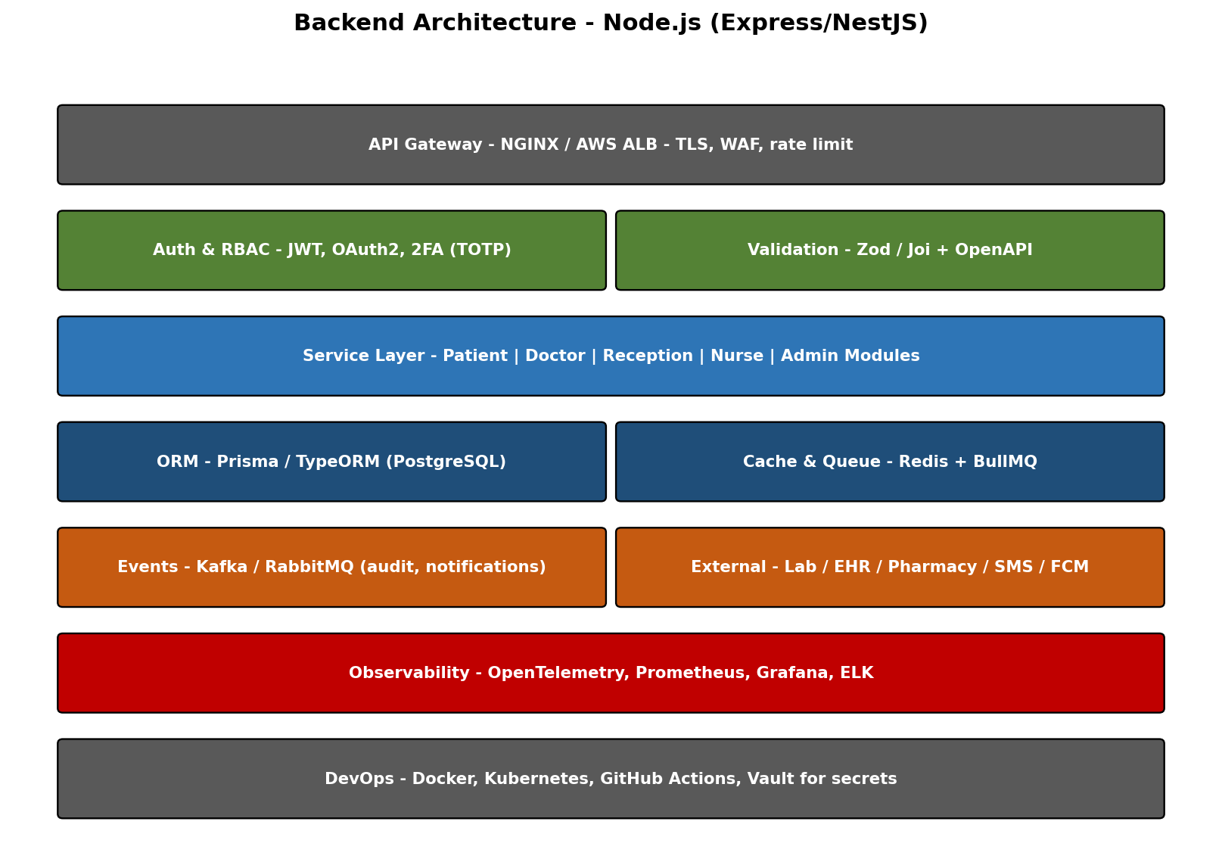
Figure 9.1 - Backend Architecture

9.1 Service Catalogue
Service | Responsibility | Data Domain
Auth Service | Login, MFA, JWT issue/refresh, password reset, account lockout, login attempts. | users, sessions, refresh_tokens, password_history, password_reset_tokens, login_attempts, account_lockouts, mfa_methods
Identity & Access Service | Roles, permissions, role-permission mapping, user-role assignment, user overrides, RBAC effective-permission resolution and cache. | roles, permissions, permission_groups, role_permissions, user_roles, user_permissions, role_hierarchy
Organization Service | Multi-tenant org / branch / department / specialization / room / bed / shift / holiday management. | organizations, branches, departments, specializations, rooms, beds, shifts, holidays, working_hours
Patient Service | Patient profile, allergies, consent. | patient_profile, consent_record
Doctor Service | Doctor profile, schedule, license verification. | doctor_profile, doctor_specializations
Staff Service | Reception and Nurse profiles, shift assignment. | staff_profile, staff_shifts
Appointment Service | Booking, rescheduling, queue. | appointment, visit
Clinical Service | Diagnosis, history, treatment plan. | patient_history, treatment
Prescription Service | e-Rx, refill workflow. | prescription
QR Token Service | Token issuance and verification. | qr_mapping
Notification Service | Multi-channel send (email, SMS, push, in-app), templates, preferences, delivery audit. | notification_templates, notification_preferences, notification_logs, user_devices
File Service | Upload, virus scan, signed-URL access, access logging. | files, file_access_logs
Billing Service | Service catalog, invoices, payments, refunds, insurance eligibility. | service_catalog, price_lists, invoices, invoice_items, payments, payment_methods, refunds, insurance_providers, patient_insurances
Chat Service | End-to-end encrypted messages between patient and care team. | chat_threads, chat_thread_members, messages, message_receipts
Configuration Service | System config, feature flags, languages, translations. | system_config, feature_flags, languages, translations
Master Data Service | All clinical / reference / operational masters; inline add, approval workflow, versioning, deprecation, bulk import from standard catalogues (ICD, SNOMED, LOINC, ATC, CPT). | All ~50 master tables in 12B + master_data_requests, master_data_request_reviews, master_data_change_log, master_data_pending_links, master_governance_rules
Reporting Service | KPIs, dashboards, scheduled exports. | Read replicas / OLAP
Audit Service | Immutable activity log, user activity feed, file access logs. | audit_log, activity_logs, file_access_logs
Integration Service | Lab, EHR, pharmacy adapters; outbound webhooks; API keys. | api_keys, webhooks, webhook_deliveries, integration_credentials
Observability Service | Error and request logs (separate from audit). | error_logs, api_request_logs

9.2 API Design Conventions
- Base path /api/v1 with strict semver-style breaking changes.
- All write endpoints require Idempotency-Key header.
- Errors return RFC 7807 problem+json shape.
- Pagination via cursor (not offset) for clinical history.
- Every request carries a correlation_id propagated through logs.

10. Detailed Use Cases by Actor
Each use case below is described with the trigger, main flow, system design notes, and the real-world benefit produced. Benefits are stated from the perspective of the end user and the facility, not just the technical capability.

10.1 Patient Registration and Login
Primary Actor | Patient
Trigger | Patient installs the app and creates an account.
Main Flow | Phone OTP -> identity capture (NIC / passport) -> biometric enrollment -> account active.
System Design Note | Auth Service issues short-lived JWT (15 min) + refresh token (7 days). NIC stored encrypted; biometric template stays on device.
Real-World Benefit | Trusted patient identity from day one. Prevents impersonation in pharmacy or insurance flows.

10.2 Generate Patient QR Code
Primary Actor | Patient
Trigger | Patient taps 'Show QR' before or during a visit.
Main Flow | App requests a token from QR Service -> backend signs JWT with TTL (default 60s) -> displayed as QR.
System Design Note | Token stored only in Redis; never reused; can be revoked by patient. Consent scope embedded in token claims.
Real-World Benefit | No paper file needed. Faster triage, especially in emergencies and crowded OPDs.

10.3 Book Appointment
Primary Actor | Patient
Trigger | Patient picks a doctor or specialty.
Main Flow | Browse available slots -> select -> confirm -> push notification with visit code.
System Design Note | Slot held in Redis for 90 seconds during checkout; persisted to PostgreSQL on confirm.
Real-World Benefit | Lower no-show rate. Patient sees true availability instead of calling reception.

10.4 Request Prescription Refill
Primary Actor | Patient
Trigger | Patient with active chronic prescription opens 'My Medications'.
Main Flow | Tap 'Request refill' -> doctor reviews on Doctor App -> approves or modifies -> sent to chosen pharmacy.
System Design Note | Refill workflow is event-driven; doctor approval recorded in Audit_Log; pharmacy receives signed eRx.
Real-World Benefit | No clinic visit needed for routine refills. Continuous treatment for chronic patients.

10.5 Patient Check-in by Reception
Primary Actor | Reception
Trigger | Patient walks up with a QR.
Main Flow | Receptionist scans QR on tablet -> patient identified -> assigned to doctor queue -> printed token (optional).
System Design Note | Reception app uses vision-camera; check-in writes a Visit row with checked_in_by = receptionist_id.
Real-World Benefit | Zero typing at the desk - shorter line, fewer wrong-patient errors.

10.6 Manage Live Queue
Primary Actor | Reception
Trigger | Reception monitors patients waiting for each doctor.
Main Flow | View queue board -> reorder, mark no-show, escalate emergency.
System Design Note | Backend pushes queue updates via WebSocket; reorder triggers audit event.
Real-World Benefit | Reception, doctors, and patients all see the same queue - reduces complaints and confusion.

10.7 Verify Insurance / Discount Eligibility
Primary Actor | Reception
Trigger | Reception confirms patient is eligible.
Main Flow | Enter membership ID -> Integration Service calls insurer API -> result displayed.
System Design Note | Result cached for the visit; reused at billing time to avoid double calls.
Real-World Benefit | Patient knows out-of-pocket amount before consultation - higher trust and fewer disputes.

10.8 Triage and Vitals Capture
Primary Actor | Nurse
Trigger | Nurse calls patient before doctor consultation.
Main Flow | Open visit -> capture BP, pulse, temperature, weight -> assign severity (1 to 5).
System Design Note | Vitals stored as JSONB in Visit row; triage severity updates queue priority in real time.
Real-World Benefit | Doctor sees urgency at a glance - critical patients reach the doctor faster.

10.9 Administer Medication / Treatment
Primary Actor | Nurse
Trigger | Doctor orders an injection or IV.
Main Flow | Order appears on Nurse App -> nurse scans patient QR + medication barcode -> administers -> marks complete.
System Design Note | Two-factor verification (patient QR + medication barcode) before status update; audited per dose.
Real-World Benefit | Five-rights medication safety enforced by software, not memory.

10.10 Lab Order and Sample Tracking
Primary Actor | Nurse
Trigger | Doctor orders a blood test.
Main Flow | Order routed to Nurse App -> sample collected -> barcode label printed -> sample handed to lab -> result returns to patient record.
System Design Note | Integration Service polls / receives result via HL7 / FHIR adapter; result auto-attached to Visit.
Real-World Benefit | No lost samples and no manual result entry - faster diagnosis turnaround.

10.11 Doctor Login with 2FA
Primary Actor | Doctor
Trigger | Doctor opens app at start of shift.
Main Flow | Email / phone -> password -> TOTP 2FA -> biometric on subsequent sessions.
System Design Note | Auth Service enforces step-up auth before sensitive actions (delete record, override allergy alert).
Real-World Benefit | Strong protection against stolen credentials - critical for medico-legal accountability.

10.12 Scan Patient QR and Open Record
Primary Actor | Doctor
Trigger | Doctor starts a consultation.
Main Flow | Scan QR -> backend validates token -> consent enforced -> full patient summary opens.
System Design Note | Doctor never sees data the patient hasn't consented to share. Access is logged before screen renders.
Real-World Benefit | Five seconds to complete history vs five minutes of paper hunting.

10.13 Add Diagnosis with Decision Support
Primary Actor | Doctor
Trigger | Doctor records findings.
Main Flow | Search ICD-10 / SNOMED -> attach to visit -> system shows interaction warnings if relevant.
System Design Note | Disease_Master indexed for prefix search; alerts run server-side using rule engine + ML risk model.
Real-World Benefit | Fewer missed contraindications; safer prescriptions - especially for elderly polypharmacy patients.

10.14 Issue e-Prescription
Primary Actor | Doctor
Trigger | Doctor finalizes treatment plan.
Main Flow | Pick medication from master -> set dosage / frequency / duration -> sign -> push to pharmacy.
System Design Note | Each Rx digitally signed with doctor's key; status flow draft -> active -> dispensed -> completed.
Real-World Benefit | No handwriting errors and no pharmacy phone-backs - faster dispensing for the patient.

10.15 Telemedicine Consultation
Primary Actor | Doctor
Trigger | Patient books an online slot.
Main Flow | Doctor joins video call -> structured notes panel side-by-side -> ends with prescription / follow-up.
System Design Note | WebRTC channel with TURN fallback; recording optional and consent-gated; notes saved to Visit.
Real-World Benefit | Brings specialists to remote patients without travel cost or risk.

10.16 Manage Master Data
Primary Actor | Admin
Trigger | Admin updates a master (e.g. new vaccine).
Main Flow | Open admin portal -> Masters -> add / edit / deprecate -> approve.
System Design Note | All master changes are versioned; deprecated records remain for historical reads.
Real-World Benefit | Standardized data across teams improves analytics, billing, and reporting accuracy.

10.17 Configure RBAC
Primary Actor | Admin
Trigger | Admin onboards a new staff role.
Main Flow | Define role -> attach permissions -> assign to users.
System Design Note | RBAC matrix stored centrally; service layer enforces via decorators / middleware.
Real-World Benefit | Least-privilege by default - reduces insider risk and audit findings.

10.18 Audit Review and Forensics
Primary Actor | Admin
Trigger | Compliance officer investigates an access alert.
Main Flow | Filter Audit_Log by actor / target / timeframe -> export evidence package.
System Design Note | Audit log is append-only; periodically signed and archived to immutable storage.
Real-World Benefit | Faster, defensible response to medico-legal or regulatory queries.

10.19 Backup and Disaster Recovery Drill
Primary Actor | Admin
Trigger | Quarterly DR drill.
Main Flow | Run scripted failover -> validate RPO / RTO -> sign off report.
System Design Note | Automated PITR on PostgreSQL; cross-region replica; runbooks in repo.
Real-World Benefit | Facility can prove operational resilience to insurers and regulators.

11. End-to-End Workflows

11.1 In-Clinic Patient Visit Workflow
This is the most common path: patient walks in, gets seen, leaves with a prescription. The four staff actors hand off through the system - never through paper.
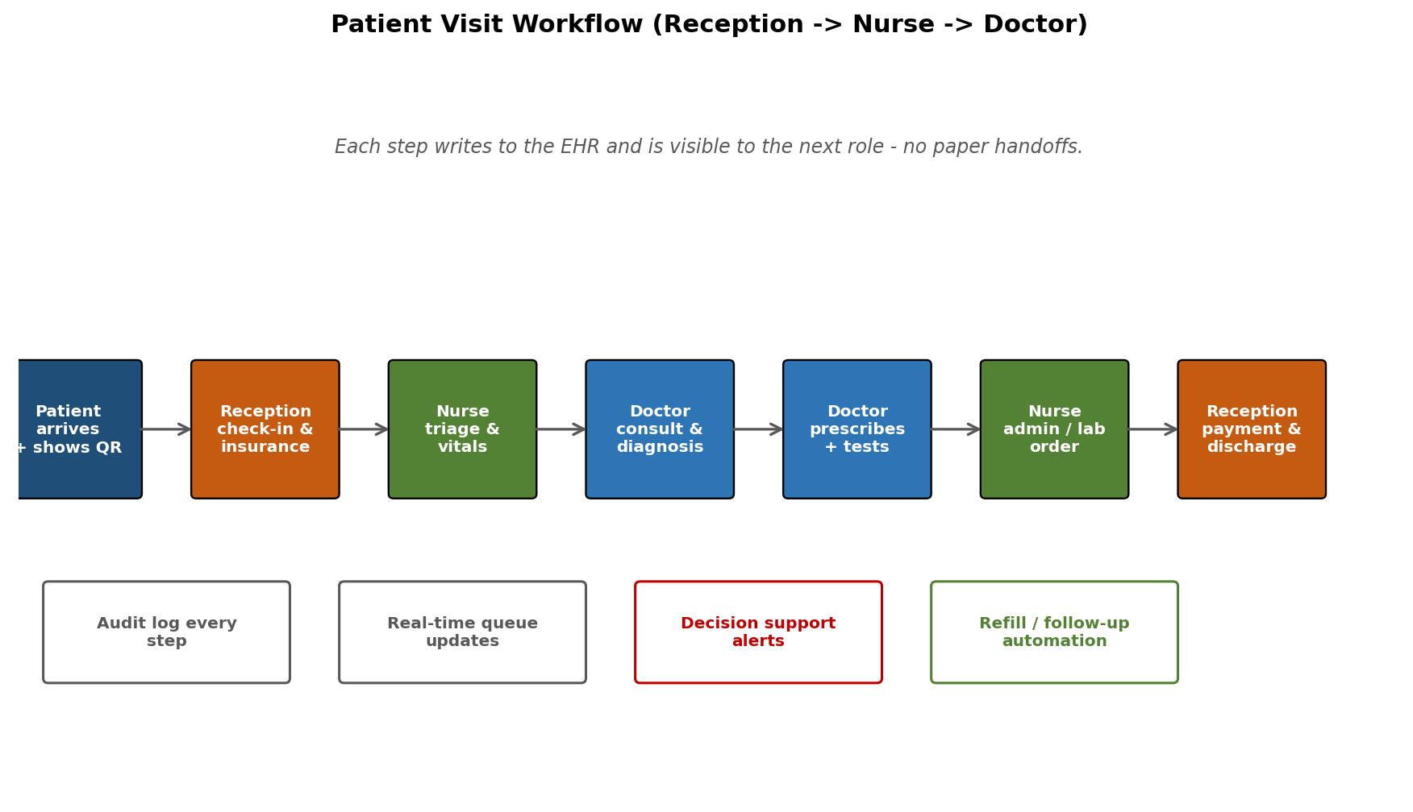
Figure 11.1 - In-Clinic Patient Visit Workflow

11.2 QR Scan Sequence (Doctor Access)
QR-based access is the highest-trust action in the system. The sequence below shows how the patient grants access, the doctor consumes it, and the audit trail captures every step.
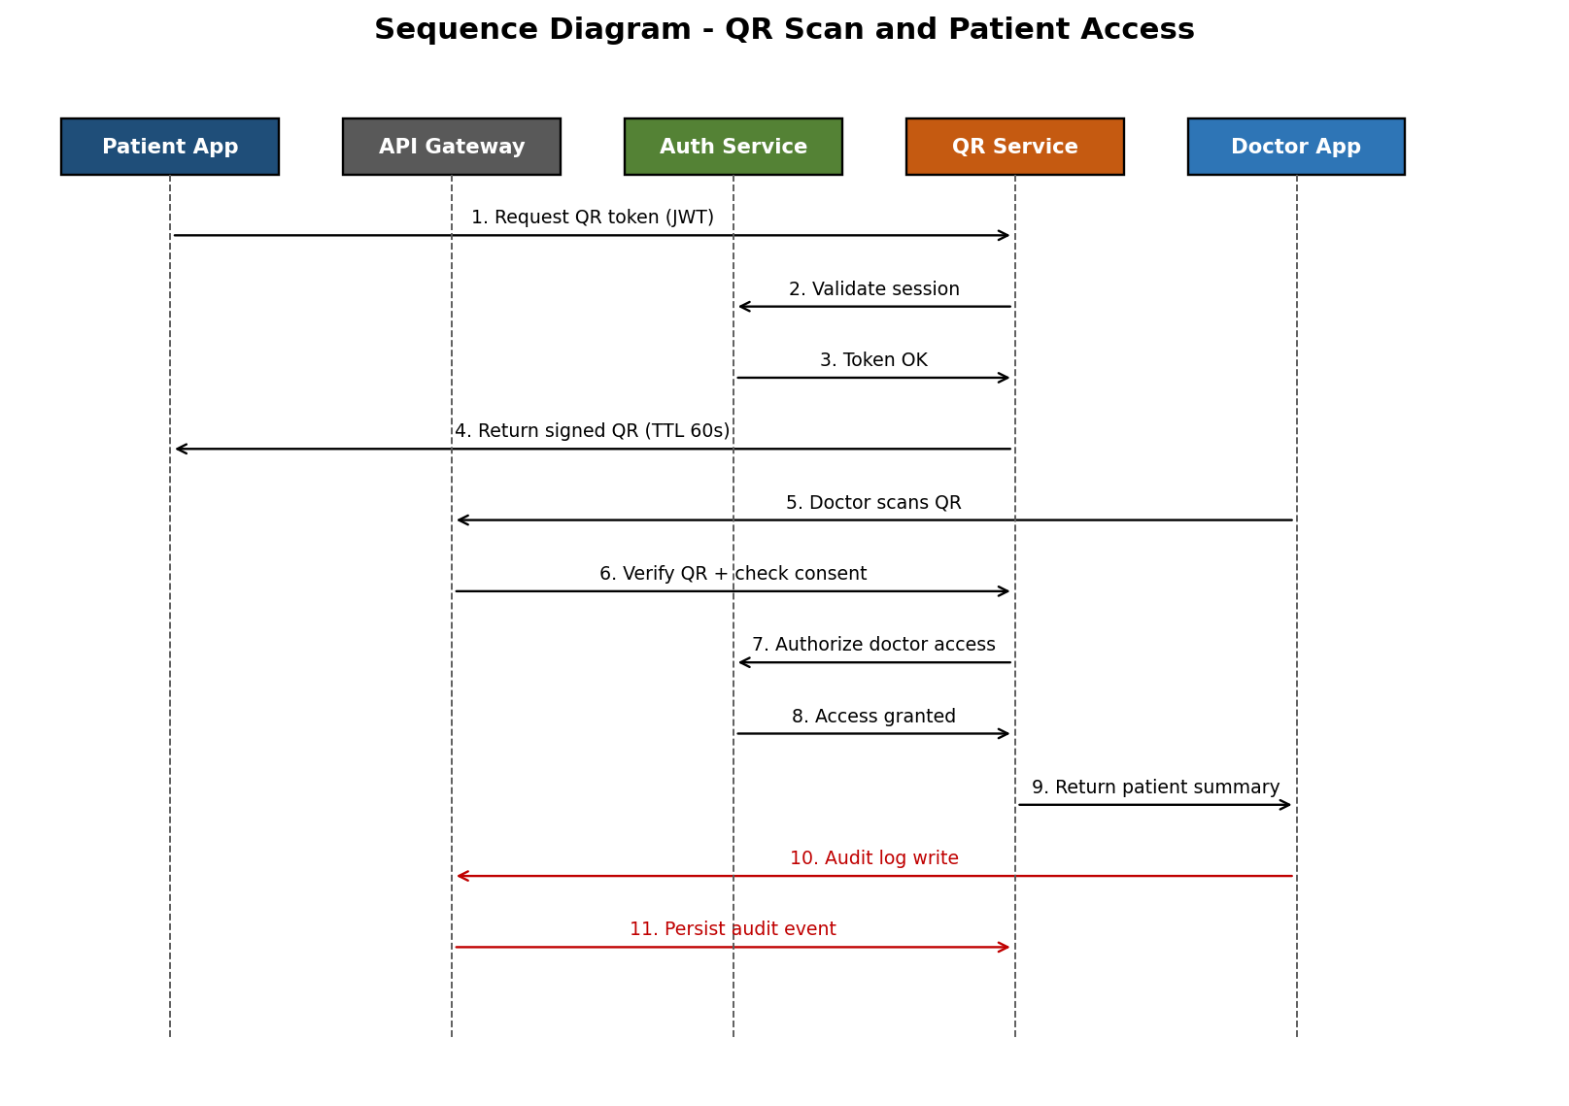
Figure 11.2 - QR Scan Sequence

12. Data Model
All clinical data uses normalized relational tables with referential integrity. Flexible fields (vitals snapshots, structured notes) are stored as JSONB with schema validation at the API layer. Master data tables follow consistent versioning conventions.
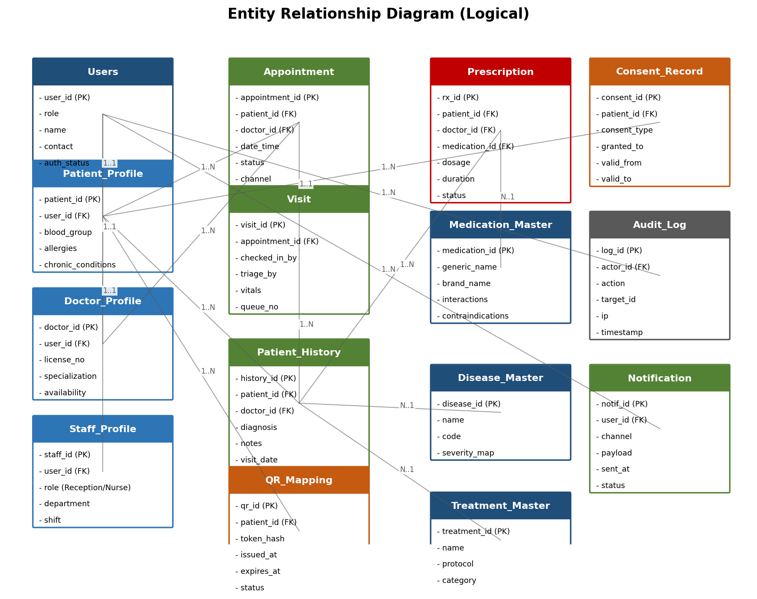
Figure 12.1 - Entity Relationship Diagram (Logical)

12.1 Core Tables
Table | Purpose | Key Columns
Users | All login-capable identities | user_id, role, name, contact, auth_status
Patient_Profile | Patient demographics and clinical basics | patient_id, user_id, blood_group, allergies, chronic_conditions
Doctor_Profile | Licensed doctor information | doctor_id, user_id, license_no, specialization, availability
Staff_Profile | Reception and Nurse staff details | staff_id, user_id, role, department, shift
Appointment | Slot bookings | appointment_id, patient_id, doctor_id, date_time, status, channel
Visit | Actual visit instance and queue context | visit_id, appointment_id, checked_in_by, triage_by, vitals, queue_no
Patient_History | Diagnoses and notes per visit | history_id, patient_id, doctor_id, diagnosis, notes, visit_date
Prescription | Medications issued | rx_id, patient_id, doctor_id, medication_id, dosage, frequency, duration, status
Disease_Master | ICD-coded diseases | disease_id, name, code, severity_map
Medication_Master | Drug catalog | medication_id, generic_name, brand_name, interactions, contraindications
Treatment_Master | Standard protocols | treatment_id, name, protocol, category
QR_Mapping | QR token lifecycle | qr_id, patient_id, token_hash, issued_at, expires_at, status
Consent_Record | Patient consent grants | consent_id, patient_id, consent_type, granted_to, valid_from, valid_to
Audit_Log | Immutable activity log | log_id, actor_id, action, target_id, ip, timestamp
Notification | Outbound notification history | notif_id, user_id, channel, payload, sent_at, status

12A. Identity, RBAC, and Standard Enterprise Tables
This section closes the gaps that are typically taken for granted in real enterprise systems but easy to overlook in a clinical-first SRS: a first-class Role / Permission model, multi-clinic / branch hierarchy, session and MFA management, devices, billing, chat, files, feature flags, API keys, and standard audit columns. Every table below ships in Phase 1 and is referenced directly by the unified mobile app's role-resolution and the backend's authorization layer.

12A.1 RBAC Core - Roles, Permissions, Assignments
Roles are NOT hard-coded. They live in the database so an Admin can create new roles, edit permissions, and assign them to users without a deployment. The five built-in roles (Patient, Doctor, Reception, Nurse, Admin) are seeded as is_system = true and protected from deletion.
Table | Purpose | Key Columns
roles | All roles in the system (built-in + custom). | role_id (PK), code, name, description, is_system, organization_id (FK, nullable for system roles), is_active, + standard audit columns
permissions | Granular system actions, defined as MODULE.ACTION codes. | permission_id (PK), code (e.g. PATIENT.VIEW, RX.CREATE, AUDIT.EXPORT), module, action, description, is_system, group_id (FK)
permission_groups | Logical grouping of permissions for UI (Patient Mgmt, Clinical, Billing, Admin). | group_id (PK), name, description, sort_order
role_permissions | Many-to-many: which permissions a role grants. | id (PK), role_id (FK), permission_id (FK), granted_by (FK users), granted_at, UNIQUE(role_id, permission_id)
user_roles | Assignment of roles to users (a user can hold multiple roles - e.g. Doctor + Admin). | id (PK), user_id (FK), role_id (FK), organization_id (FK), branch_id (FK, nullable), assigned_by (FK), assigned_at, valid_from, valid_to, is_active
user_permissions | Per-user GRANT or DENY override (highest precedence). | id (PK), user_id (FK), permission_id (FK), effect (GRANT/DENY), reason, granted_by (FK), valid_from, valid_to
role_hierarchy | Optional inheritance (e.g. SeniorDoctor inherits from Doctor). | parent_role_id (FK), child_role_id (FK), PRIMARY KEY(parent, child)

12A.2 Sample Permission Codes
Permission codes follow the convention MODULE.ACTION. The list below is illustrative; the full Phase-1 permission seed has approximately 120 codes.
Module | Sample Permission Codes
PATIENT | PATIENT.VIEW, PATIENT.CREATE, PATIENT.UPDATE, PATIENT.DELETE, PATIENT.EXPORT, PATIENT.MERGE
APPOINTMENT | APPOINTMENT.VIEW, APPOINTMENT.CREATE, APPOINTMENT.RESCHEDULE, APPOINTMENT.CANCEL, APPOINTMENT.OVERRIDE_SLOT
CLINICAL | VITALS.CAPTURE, DIAGNOSIS.ADD, DIAGNOSIS.AMEND, HISTORY.VIEW, HISTORY.EXPORT, TRIAGE.SET_SEVERITY
PRESCRIPTION | RX.CREATE, RX.SIGN, RX.CANCEL, RX.REFILL_APPROVE, RX.OVERRIDE_INTERACTION_ALERT
QR | QR.GENERATE, QR.SCAN, QR.REVOKE
BILLING | INVOICE.VIEW, INVOICE.CREATE, INVOICE.VOID, PAYMENT.RECORD, PAYMENT.REFUND, DISCOUNT.APPLY
ADMIN | USER.MANAGE, ROLE.MANAGE, PERMISSION.MANAGE, MASTER.MANAGE, FEATURE_FLAG.MANAGE
AUDIT | AUDIT.VIEW, AUDIT.EXPORT, AUDIT.SEARCH
REPORTING | REPORT.VIEW, REPORT.EXPORT, REPORT.SCHEDULE
SYSTEM | CONFIG.READ, CONFIG.WRITE, BACKUP.RUN, INTEGRATION.MANAGE

12A.3 Default Role -> Permission Matrix (Seed)
Role | Permission Highlights
Patient | PATIENT.VIEW (self), QR.GENERATE, APPOINTMENT.CREATE/CANCEL (self), RX.VIEW (self), RX.REFILL_REQUEST, INVOICE.VIEW (self), CHAT.SEND_TO_CARE_TEAM
Doctor | PATIENT.VIEW (consented), QR.SCAN, HISTORY.VIEW, DIAGNOSIS.ADD/AMEND, RX.CREATE/SIGN/CANCEL, RX.REFILL_APPROVE, TELE.CONSULT, REPORT.VIEW (own)
Reception | PATIENT.CREATE/UPDATE (basic), QR.SCAN, APPOINTMENT.CREATE/RESCHEDULE/CANCEL, INVOICE.CREATE, PAYMENT.RECORD, INSURANCE.VERIFY
Nurse | QR.SCAN, VITALS.CAPTURE, TRIAGE.SET_SEVERITY, MEDICATION.ADMINISTER, LAB_SAMPLE.COLLECT, HISTORY.VIEW (active visit)
Admin | Full USER/ROLE/PERMISSION/MASTER/FEATURE_FLAG/CONFIG.MANAGE, AUDIT.VIEW/EXPORT, REPORT.* , BACKUP.RUN, INTEGRATION.MANAGE

12A.4 Effective Permission Resolution Algorithm
- 1. Default = DENY for every permission code.
- 2. Resolve all active rows in user_roles (where now BETWEEN valid_from AND valid_to AND is_active = true).
- 3. UNION all role_permissions for those roles (apply role_hierarchy if present).
- 4. Apply user_permissions overrides last - GRANT or DENY, highest precedence.
- 5. Enforce organization_id / branch_id scope from JWT (multi-tenant isolation).
- 6. Cache the resolved permission set in Redis keyed by user_id + org_id, TTL 5 minutes.
- 7. Invalidate cache on any change to user_roles, role_permissions, or user_permissions.
- 8. Defense in depth: PostgreSQL row-level security (RLS) policies enforce organization_id at the database level so a stolen JWT cannot cross-tenant.

12A.5 Authentication and Session Tables
Table | Purpose | Key Columns
users | All login-capable identities (extended from earlier). | user_id (PK), email, phone, nic_hash, password_hash, status, mfa_enabled, last_login_at, failed_attempts, locked_until, email_verified_at, phone_verified_at, organization_id (FK), + audit cols
sessions | Active logged-in sessions per device. | session_id (PK), user_id (FK), device_id (FK), ip, user_agent, refresh_token_hash, issued_at, last_activity_at, expires_at, revoked_at, revoked_reason
refresh_tokens | Long-lived refresh tokens (rotated on use). | id (PK), user_id (FK), token_hash, parent_token_id (FK, for rotation chain), expires_at, used_at, revoked_at
password_history | Prevents reuse of last N passwords. | id (PK), user_id (FK), password_hash, changed_at
password_reset_tokens | Forgot-password flow. | id (PK), user_id (FK), token_hash, expires_at, used_at, requested_ip
email_verification_tokens | Email confirmation flow. | id (PK), user_id (FK), token_hash, expires_at, used_at
login_attempts | Every login attempt (success or fail) for forensics. | id (PK), user_id (FK, nullable), email_or_phone, ip, user_agent, success, failure_reason, attempted_at
account_lockouts | Brute-force / suspicious activity lockouts. | id (PK), user_id (FK), locked_at, locked_until, locked_by_system, reason, unlocked_at, unlocked_by
mfa_methods | Per-user MFA configurations. | id (PK), user_id (FK), method_type (TOTP/SMS/EMAIL/BIOMETRIC), secret_encrypted, backup_codes_encrypted, is_primary, verified_at, last_used_at
oauth_accounts | Linked external identity providers (future). | id (PK), user_id (FK), provider, provider_user_id, access_token_encrypted, refresh_token_encrypted, linked_at

12A.6 Organization, Branch, and Clinical Hierarchy
Even a single-clinic launch should be modeled as a multi-tenant schema from day one. It costs nothing extra and makes future expansion to a chain of clinics or a hospital group a configuration change instead of a re-platform.
Table | Purpose | Key Columns
organizations | Top-level tenant - hospital group, clinic chain, single facility. | organization_id (PK), name, code, type, license_no, address, phone, email, settings_json, status, + audit
branches | Physical clinic / branch under an organization. | branch_id (PK), organization_id (FK), name, code, address, phone, working_hours_json, timezone, is_active
departments | Departments within a branch (OPD, Pharmacy, Lab, Radiology). | department_id (PK), branch_id (FK), name, code, head_user_id (FK), is_active
specializations | Doctor specializations master (Cardiology, Pediatrics, etc.). | specialization_id (PK), name, code, description, is_active
doctor_specializations | Many-to-many: doctor <-> specialization. | doctor_id (FK), specialization_id (FK), is_primary, certified_on
rooms | Consultation rooms, OT, wards. | room_id (PK), branch_id (FK), name, room_type (OPD/OT/WARD/LAB), capacity, status
beds | Individual beds (for inpatient flows). | bed_id (PK), room_id (FK), bed_no, status (FREE/OCCUPIED/MAINTENANCE), occupied_by (FK patients), since
shifts | Standard shift definitions. | shift_id (PK), branch_id (FK), name, start_time, end_time, days_of_week_bitmap, is_active
staff_shifts | Assignment of staff to shifts. | id (PK), user_id (FK), shift_id (FK), date, status, swapped_with (FK)
holidays | Branch holiday calendar. | id (PK), branch_id (FK), date, name, type, is_full_day
working_hours | Per-doctor weekly availability template. | id (PK), user_id (FK), branch_id (FK), day_of_week, start_time, end_time, slot_minutes, is_active

12A.7 Devices, Notifications, and Templates
Table | Purpose | Key Columns
user_devices | Each device a user logs in from (used for push and security). | device_id (PK), user_id (FK), platform (iOS/Android/Web), device_model, os_version, app_version, fcm_token, apns_token, last_seen_at, is_trusted, is_active
notification_templates | Reusable templates per channel and locale. | template_id (PK), code, channel (PUSH/SMS/EMAIL/IN_APP), locale, subject, body, variables_json, is_active, version
notification_preferences | Per-user opt-in/out by category and channel. | id (PK), user_id (FK), category (APPOINTMENT/RX/MARKETING/SECURITY), channel, is_enabled, quiet_hours_start, quiet_hours_end
notification_logs | Outbound notification audit trail (extends existing Notification table). | log_id (PK), template_id (FK), user_id (FK), channel, status, attempted_at, delivered_at, error, provider_message_id

12A.8 Files, Configuration, and Feature Flags
Table | Purpose | Key Columns
files | Generic attachment table for prescriptions, lab reports, profile photos. | file_id (PK), owner_type, owner_id, file_name, mime_type, size_bytes, storage_path, hash_sha256, virus_scan_status, uploaded_by (FK), + audit
file_access_logs | Who opened / downloaded which file (PHI compliance). | id (PK), file_id (FK), user_id (FK), action (VIEW/DOWNLOAD/DELETE), ip, accessed_at
system_config | Global key/value configuration without redeploys. | key (PK), value, value_type, description, is_secret, updated_by (FK), updated_at
feature_flags | Toggle features per role / user / percentage. | id (PK), code, description, is_enabled, target_roles (jsonb), target_users (jsonb), percentage_rollout, expires_at, updated_by
languages | Supported languages. | language_id (PK), code (si/ta/en), name, is_rtl, is_active
translations | Localization strings stored centrally (overrides bundle). | id (PK), namespace, key, locale, value, updated_by, UNIQUE(namespace, key, locale)

12A.9 Billing - Service Catalog, Invoices, Payments
Table | Purpose | Key Columns
service_catalog | All chargeable services / consultations / tests. | service_id (PK), code, name, category, base_price, tax_rate, currency, is_active
price_lists | Branch- or insurer-specific price overrides. | id (PK), service_id (FK), branch_id (FK, nullable), insurer_id (FK, nullable), price, valid_from, valid_to
invoices | Patient invoices per visit / appointment. | invoice_id (PK), invoice_no (unique per branch+year), patient_id (FK), visit_id (FK), branch_id (FK), subtotal, tax_amount, discount_amount, total, currency, status (DRAFT/ISSUED/PAID/VOIDED), issued_at, due_date, + audit
invoice_items | Line items on an invoice. | id (PK), invoice_id (FK), service_id (FK), description, quantity, unit_price, tax_rate, line_total, ordered_by (FK)
payments | Inbound payments (cash, card, insurance, wallet). | payment_id (PK), invoice_id (FK), method_id (FK), amount, currency, transaction_ref, gateway, gateway_response_json, status, paid_at, received_by (FK)
payment_methods | Configured payment methods. | method_id (PK), code (CASH/CARD/INSURANCE/WALLET/BANK), name, is_active, settings_json
refunds | Refund records linked to a payment. | refund_id (PK), payment_id (FK), amount, reason, approved_by (FK), refunded_at, status
insurance_providers | Insurer master. | insurer_id (PK), name, code, api_endpoint, contact, is_active
patient_insurances | Linked insurance policies per patient. | id (PK), patient_id (FK), insurer_id (FK), policy_no, valid_from, valid_to, coverage_limit, status

12A.10 In-App Communications (Patient <-> Care Team)
Table | Purpose | Key Columns
chat_threads | A conversation - 1:1, group, or visit-scoped. | thread_id (PK), type (DIRECT/GROUP/VISIT), subject, visit_id (FK, nullable), created_by (FK), last_message_at, is_archived
chat_thread_members | Membership of a thread. | thread_id (FK), user_id (FK), role_in_thread, joined_at, last_read_at, muted_until, PRIMARY KEY(thread_id, user_id)
messages | Messages within a thread (E2EE payload). | message_id (PK), thread_id (FK), sender_id (FK), content_encrypted, message_type (TEXT/IMAGE/FILE/SYSTEM), attachment_id (FK), created_at, edited_at, deleted_at
message_receipts | Per-recipient delivery / read receipts. | id (PK), message_id (FK), user_id (FK), delivered_at, read_at

12A.11 API Integration, Webhooks, and System Logs
Table | Purpose | Key Columns
api_keys | Machine-to-machine API keys for external partners (lab, pharmacy). | api_key_id (PK), name, key_hash, scope_permissions (jsonb), allowed_ips, expires_at, last_used_at, created_by (FK), is_active
webhooks | Outbound webhooks subscribed by partners. | webhook_id (PK), name, target_url, events (jsonb), secret_hash, is_active, last_triggered_at, last_status, retry_policy_json
webhook_deliveries | Per-call delivery log for retries and forensics. | id (PK), webhook_id (FK), event, payload_hash, http_status, attempt_no, sent_at, response_body_truncated
integration_credentials | Encrypted credentials for outbound system calls (FHIR/HL7/SMS/SMTP). | id (PK), system_name, type, credentials_encrypted, expires_at, last_rotated_at, status
error_logs | Application error log (separate from audit). | id (PK), level, service, request_id, user_id (FK, nullable), message, stack_trace, context_json, created_at
api_request_logs | Sampled / full request log for SLO and forensics. | id (PK), method, path, user_id (FK), status, duration_ms, ip, user_agent, request_id, created_at
activity_logs | User-visible activity feed (e.g. 'You shared QR with Dr X'). | id (PK), user_id (FK), category, summary, target_type, target_id, created_at

12A.12 Standard Audit Columns and Soft Delete
Every business table in the schema includes the following columns. They are added by a base migration and enforced by a lint check in CI so no table goes to production without them.
Column | Type | Purpose
id | UUID v4 | Globally unique primary key. No auto-increment IDs in clinical tables.
created_at | timestamptz | Record creation time.
created_by | UUID FK users | Who created the record.
updated_at | timestamptz | Last modification time (auto-updated).
updated_by | UUID FK users | Who last modified the record.
deleted_at | timestamptz NULL | Soft delete marker - rows never physically removed except by retention job.
deleted_by | UUID FK users NULL | Who soft-deleted the record.
version | int | Optimistic locking - increments on every update.
organization_id | UUID FK organizations | Multi-tenant isolation key (where applicable).
branch_id | UUID FK branches | Branch scope (where applicable).

12A.13 RBAC Admin UI (in the Unified App's Admin Shell)
- Role list: search, create, edit, deactivate. System roles are read-only.
- Role detail: permission tree grouped by module, with Select All / Clear per group.
- User search: filter by role, branch, status; bulk role assignment.
- User detail: list of effective permissions (resolved), source of each (role vs override), valid-from / valid-to.
- Audit panel: every change to a role, permission, or user assignment is logged with who / when / before / after.
- Permission impact preview: when changing a role, show how many users gain or lose which permissions.

12A.14 Threat-Model Notes Specific to RBAC
Threat | Mitigation
Privilege escalation via direct DB write | All writes through services; DB role for app has no GRANT on RBAC tables; row-level security per organization.
Forgotten time-bound role | user_roles.valid_to enforced; nightly job reports roles expiring in 7 days.
Insider granting self extra permissions | ROLE.MANAGE / PERMISSION.MANAGE require step-up MFA + 2-person approval for production tier.
Stale cached permissions after role change | Cache invalidation on role / permission / user_role mutation; TTL ceiling 5 minutes.
Cross-tenant data leak via JWT replay | RLS policy on every clinical table keyed to organization_id from JWT claim, verified at DB.

12B. Master Data Catalogue and 'Missing Master' Workflow
A real clinic depends on dozens of master tables - clinical (drugs, diseases, lab tests), reference (countries, blood groups, document types), and operational (insurers, suppliers, manufacturers). On day one some of these will be incomplete. A doctor will reach for a brand-new medication or a rare disease that is not yet seeded - and care must NOT stop. This section catalogues the full master set and defines the approval workflow that lets clinical staff capture care immediately while admins curate the master in the background.

12B.1 Clinical Masters (Drugs, Diseases, Tests, Procedures)
Master Table | Purpose | Key Columns
disease_master | ICD-10 / SNOMED-CT coded diseases (existing - extended). | disease_id (PK), code (ICD/SNOMED), name, name_si, name_ta, category, severity_map, synonyms_jsonb, is_active, is_pending_review, version, + audit
symptom_master | Patient-reportable symptoms. | symptom_id (PK), name, name_si, name_ta, body_part_id (FK), severity_scale, synonyms_jsonb, is_active
body_part_master | Anatomical reference for symptoms / imaging. | body_part_id (PK), name, parent_id (FK, hierarchical), code
medication_master | Drugs (existing - extended). | medication_id (PK), generic_name, brand_name, manufacturer_id (FK), atc_code, dosage_form_id (FK), strength, unit, route_id (FK), interactions_jsonb, contraindications_jsonb, side_effects_jsonb, is_controlled, schedule_class, name_si, name_ta, synonyms_jsonb, is_active, is_pending_review, version
dosage_form_master | Tablet, Capsule, Syrup, Injection, Drops, Ointment, Patch, Inhaler. | dosage_form_id (PK), code, name, default_unit
route_master | Oral, IV, IM, SC, Topical, Inhalation, Sublingual, Rectal, etc. | route_id (PK), code, name, description
frequency_master | OD, BD, TDS, QID, SOS, HS, Q4H, etc. | frequency_id (PK), code, name, expanded (Latin), times_per_day, interval_hours
drug_category_master | Antibiotic, Analgesic, Antihypertensive, etc. (ATC tree). | category_id (PK), code, name, parent_id (FK), level
drug_interaction_master | Known drug-drug interactions. | interaction_id (PK), drug_a_id (FK), drug_b_id (FK), severity (MINOR/MODERATE/MAJOR/CONTRAINDICATED), mechanism, recommendation, evidence_level, source
drug_allergy_master | Cross-reaction map between drugs and allergens. | id (PK), medication_id (FK), allergen_id (FK), reaction_type, severity
drug_disease_contraindication_master | Drug should not be given when patient has X disease. | id (PK), medication_id (FK), disease_id (FK), severity, recommendation
allergen_master | Food, drug, environmental allergens. | allergen_id (PK), name, name_si, name_ta, type (DRUG/FOOD/ENV), code, is_active
lab_test_master | Individual lab tests (CBC, FBS, HbA1c, LFT, RFT, TSH, etc.). | test_id (PK), code (LOINC), name, name_si, name_ta, category, sample_type, container_type, normal_range_jsonb (by age/gender), unit, turnaround_hours, base_price, is_active
lab_panel_master | Bundles of tests (Liver Panel, Lipid Profile). | panel_id (PK), code, name, included_tests (jsonb of test_ids), is_active
imaging_procedure_master | X-Ray, CT, MRI, USG, ECG, Echo, Mammography, etc. | procedure_id (PK), code (CPT), name, modality, body_part_id (FK), prep_instructions, base_price
vaccine_master | BCG, Polio, MMR, COVID, HPV, Influenza, etc. | vaccine_id (PK), code, name, manufacturer_id (FK), schedule_jsonb (age + interval), route_id (FK), dose_volume, is_active
vitals_range_master | Normal ranges for BP, pulse, SpO2, BMI by age and gender. | id (PK), vital_type, gender, age_min, age_max, normal_min, normal_max, critical_min, critical_max, unit
treatment_master | Standard treatment protocols (existing - extended). | treatment_id (PK), name, protocol_jsonb, category, applicable_diseases (jsonb of disease_ids), name_si, name_ta, version
manufacturer_master | Drug / device manufacturers. | manufacturer_id (PK), name, country_id (FK), license_no, is_active
brand_master | Brand names mapped to generic medication. | brand_id (PK), name, generic_medication_id (FK), manufacturer_id (FK), is_active

12B.2 Reference / Demographic Masters
Master Table | Purpose / Sample Values
country_master | ISO country list with calling code, currency. Seeded ISO-3166.
state_master / province_master | States / provinces under each country.
city_master / district_master | Cities / districts under each state.
postal_code_master | Postal codes (optional, by district).
currency_master | ISO currencies with symbol and decimals.
blood_group_master | A+, A-, B+, B-, AB+, AB-, O+, O-, Unknown.
gender_master | Male, Female, Other, Prefer-not-to-say.
marital_status_master | Single, Married, Divorced, Widowed, Separated.
religion_master | Buddhist, Hindu, Christian, Islamic, Other.
ethnicity_master | Sinhalese, Tamil, Muslim, Burgher, Other (configurable per country).
occupation_master | WHO ISCO-08 occupations or local list.
education_level_master | Below-OL, OL, AL, Diploma, Degree, Postgrad.
relationship_master | Father, Mother, Spouse, Son, Daughter, Sibling, Guardian, Other.
document_type_master | NIC, Passport, Driving License, Birth Certificate.
title_master | Mr, Mrs, Ms, Dr, Prof, Rev.
language_master | Languages list (already in 12A.8).
timezone_master | IANA timezones for branches and patients.

12B.3 Operational / Administrative Masters
Master Table | Purpose
specialization_master | Doctor specialties (already in 12A.6).
department_master | OPD, Pharmacy, Lab, Radiology, Cardiology (already in 12A.6).
room_type_master | OPD-Room, OT, ICU, General Ward, Private, Semi-Private.
bed_type_master | General, Semi-Private, Private, ICU, NICU, PICU.
ward_master | Named wards within the branch.
equipment_master | Medical devices (BP cuff, ECG, ventilator) for traceability.
equipment_category_master | Diagnostic, Monitoring, Therapeutic, Surgical.
supplier_master | Drug / consumable suppliers.
inventory_item_master | Stock-keeping items (drugs, consumables).
uom_master | Units of measure: tablet, ml, mg, IU, drops, vial, ampoule.
tax_master | Tax types and rates (VAT, NBT, SSCL).
discount_type_master | Senior, Staff, Charity, Promotional, Insurance.
payment_method_master | Cash, Card, Insurance, Wallet, Bank Transfer (already in 12A.9).
appointment_status_master | Booked, Confirmed, Checked-In, In-Consultation, Completed, Cancelled, No-Show.
cancellation_reason_master | Patient request, Doctor unavailable, Emergency, System.
no_show_reason_master | Forgot, Traffic, Health, Resolved at home, Other.
referral_reason_master | Specialist opinion, Diagnostic, Treatment, Second opinion.
notification_category_master | Appointment, Medication, Lab Result, Refill, Marketing, Security.
kpi_target_master | KPI codes with target values per branch.

12B.4 Multilingual, Synonyms, and Versioning on Every Master
- Every master row carries name_si and name_ta in addition to English.
- synonyms_jsonb on clinical masters captures common misspellings, brand-vs-generic, and local names (e.g. 'Crocin' -> Paracetamol).
- Search uses synonyms + Postgres trigram + tsvector to be tolerant of typos.
- Every master has a version column - changes never overwrite history; superseded rows are kept and joined for historical reads.
- is_active flips items off without deletion. is_pending_review flags items added inline by clinicians but not yet curated.
- deprecated_at + replacement_id enables retiring items while pointing existing references to the canonical replacement.

12B.5 The 'Missing Master' Problem - Why It Matters
Real example: a doctor wants to prescribe a brand-new antibiotic that the supplier brought in last week. It is not in medication_master yet. If the system blocks the prescription, the doctor falls back to paper and the patient loses the digital trail. If the system silently accepts free text, analytics break and refill workflows fail. The correct answer is a 'capture now, curate later' workflow: the clinician saves what they need with a pending placeholder, the admin queue lights up, and references are resolved automatically once approved.

12B.6 Master Data Request & Approval Workflow Tables
Table | Purpose | Key Columns
master_data_requests | One pending change to ANY master table (add / edit / deprecate). | request_id (PK), master_table, action (CREATE/UPDATE/DEPRECATE), payload_jsonb, source_module (where the user was when they raised it), linked_target_type, linked_target_id (e.g. prescription_id that depends on it), requested_by (FK), requested_at, status (DRAFT/SUBMITTED/UNDER_REVIEW/APPROVED/REJECTED/NEEDS_REVISION), priority (LOW/NORMAL/URGENT)
master_data_request_reviews | Reviewer history per request (multi-step approval). | id (PK), request_id (FK), reviewer_id (FK), step_no, decision, comments, decided_at
master_data_change_log | Versioned diff log of every approved change. | id (PK), master_table, master_row_id, action, before_jsonb, after_jsonb, changed_by, changed_at, request_id (FK)
master_data_pending_links | Bridge table - real records that point at a pending master row. | id (PK), master_table, pending_master_id, dependent_table, dependent_row_id, created_at, resolved_at
master_governance_rules | Per-master rules on who can request, who must approve, auto-approve thresholds. | id (PK), master_table, can_request_roles (jsonb), required_approver_roles (jsonb), auto_approve_if_jsonb, sla_hours

12B.7 Inline 'Add Missing Master' UX Flow
Wherever a user picks from a master (medication, disease, lab test, allergen, etc.), the picker exposes a '+ Add new' affordance. Selecting it opens a slim form pre-filled with what the user already typed. The user finishes the prescription / order WITHOUT waiting for approval. Behind the scenes:
- 1. The new master row is inserted with is_pending_review = true.
- 2. A master_data_requests row is created and routed to the appropriate admin queue (governed by master_governance_rules).
- 3. The dependent record (e.g. prescription) saves a real FK to the pending master row, and a master_data_pending_links row records the dependency.
- 4. The patient and the doctor see a small 'Pending master review' badge - care continues normally.
- 5. When admin approves, the pending row flips to is_pending_review = false; if admin edits the canonical name, dependent records inherit automatically because they reference by ID.
- 6. If admin rejects, the pending row is deprecated, the dependent record is flagged for clinician follow-up with a one-tap 'Replace with...' picker.
- 7. SLA timers (e.g. 24h for medications) escalate stale requests to a senior admin.

12B.8 Auto-Approve and Quick-Approve Rules
- Adding a new BRAND that maps to an existing generic_medication_id auto-approves with audit (low-risk addition).
- Adding a new MANUFACTURER auto-approves but flags for monthly review.
- Adding / editing a DRUG INTERACTION never auto-approves - always requires senior pharmacy / clinical lead.
- Adding a new ICD / SNOMED code auto-approves if the code matches the official catalogue (validated at request time).
- Free-text 'Other' is allowed for symptoms and complaints - no master row created; flagged for periodic mining.

12B.9 Bulk Import from Standard Catalogues
Catalogue | Used For | Update Cadence
ICD-10 / ICD-11 | disease_master | Annually + as WHO publishes.
SNOMED-CT | disease_master, symptom_master | Quarterly.
LOINC | lab_test_master | Quarterly.
ATC (WHO) | drug_category_master, medication_master | Annually.
CPT / HCPCS | imaging_procedure_master, service_catalog | Annually.
RxNorm / national drug index | medication_master, brand_master | Monthly where available.
ISO-3166 / ISO-4217 | country_master, currency_master | On change (rare).
- Imports run through the same master_data_requests pipeline so every change is auditable.
- Diff preview shows admins what's new, what's changed, and what's deprecated before applying.
- Imports are reversible via master_data_change_log replay.

12B.10 Master Search and 'Smart Pick' UX
- Server-side search uses pg_trgm + tsvector + synonyms_jsonb for typo tolerance.
- Recently-used items per doctor are cached and shown first.
- Brand <-> generic toggle on the medication picker.
- Voice-to-pick: doctor speaks the drug name; STT + fuzzy match suggests top 3.
- Barcode scan auto-resolves medication and dose from manufacturer-encoded GS1.

12B.11 Real-World Scenarios - Missing Master Handling

12B.11.1 Doctor prescribes a medication that is not yet in the master
Situation | A new antibiotic 'Zentilex 500mg' arrived from a supplier today; medication_master has no row yet.
What the user does | On the prescription screen, types 'Zentilex' -> sees 'No match. + Add new medication'. Taps '+ Add' -> slim form pre-fills name, generic, manufacturer, dose, route. Submits and continues prescribing.
What the system does | Inserts medication_master row with is_pending_review = true. Creates master_data_requests row routed to Pharmacy Lead. Saves prescription with the new medication_id and a master_data_pending_links row. Pharmacist gets push + queue badge.
Outcome | Patient gets the prescription in seconds. Pharmacy lead approves within SLA; if they rename it, the prescription row inherits the corrected name automatically.

12B.11.2 Doctor diagnoses a rare disease that is not in disease_master
Situation | Pediatric patient with a rare congenital condition that the seed catalogue missed.
What the user does | On diagnosis, searches the name and ICD code -> nothing found. Picks 'Other / Add new' -> enters provisional name + ICD-10 code -> attaches notes.
What the system does | Validates the ICD code against the bundled ICD reference. If valid, auto-approves (rule from 12B.8). If invalid, routes to Clinical Lead.
Outcome | Clinical history records a concrete disease_id (no free text). Analytics / reporting stays accurate.

12B.11.3 Patient reports an unknown allergen during triage
Situation | Patient says 'I'm allergic to a yellow dye in some sweets' - allergen_master has only common allergens.
What the user does | Nurse types in allergen field -> chooses 'Add new allergen' -> selects type FOOD, severity MODERATE, free-text description.
What the system does | allergen_master row created (pending). Patient_Profile.allergies updated with new allergen_id. Admin queue gets the request.
Outcome | Drug-allergy alerts can already be wired up to this allergen later when admin links it to specific medications.

12B.11.4 Drug interaction not flagged but doctor knows about it
Situation | Doctor sees no warning when prescribing Drug X + Drug Y, but knows from a recent journal that they interact.
What the user does | Taps 'Report missing interaction' on the prescribing screen. Selects the two drugs, severity, mechanism, source link.
What the system does | Creates a master_data_requests entry for drug_interaction_master with HIGH priority. Senior clinical reviewer is paged.
Outcome | Once approved, the rule is live for every subsequent prescription system-wide - one report protects every patient.

12B.11.5 Brand name not in master but generic exists
Situation | Doctor wants to prescribe 'Glycomet' (a brand of Metformin); brand_master has no row but medication_master has Metformin.
What the user does | Searches 'Glycomet' -> sees 'Did you mean Metformin?' suggestion. Confirms or chooses '+ Add Glycomet as brand of Metformin'.
What the system does | brand_master row added; auto-approved (12B.8 rule for brand-to-existing-generic).
Outcome | Future searches for 'Glycomet' resolve instantly. Pharmacy fulfilment uses the canonical generic.

12B.11.6 Lab test not in lab_test_master yet (new assay)
Situation | Doctor orders a new specialty test the lab just enabled.
What the user does | On lab order screen, types name -> 'Add new test' -> fills sample type, container, normal range, unit.
What the system does | Creates a pending lab_test_master entry; lab order saves with the new test_id; routed to Lab Manager for review.
Outcome | Sample collection labels generate immediately. Admin curates the canonical normal range later without losing this order.

12B.11.7 Vaccine campaign uses a brand-new vaccine code
Situation | A new flu strain vaccine arrived for an annual campaign; vaccine_master is missing the row.
What the user does | Nurse / admin uses bulk-import of vaccine batch sheet; system pre-fills schedule and manufacturer.
What the system does | All rows go through master_data_requests; admin batch-approves; nurse can administer and barcode-track.
Outcome | Doses are tracked from day one of the campaign with no paper backlog.

12B.11.8 Doctor records dosage outside normal range
Situation | Pediatric oncology dosing exceeds the normal-range master for paracetamol.
What the user does | System warns 'Dose exceeds master range for age 7'. Doctor selects 'Override with reason' and types justification.
What the system does | Prescription is saved with override_flag = true and justification text; audit log captures it.
Outcome | Patient gets correct individualized care; pharmacy double-checks; admin sees overrides in a weekly KPI.

12B.11.9 Admin retires an obsolete medication
Situation | Manufacturer recalled a brand; admin needs to deprecate it without breaking historical records.
What the user does | Admin opens medication_master row -> Deprecate -> selects replacement_id (the safer brand).
What the system does | deprecated_at set; new prescriptions cannot use it; existing prescriptions still resolve and display the old name with a 'Deprecated' badge.
Outcome | Compliance is maintained, history is intact, future prescribing is safe.

12B.11.10 Nurse needs a unit of measure not in uom_master
Situation | Imported drug is dosed in 'puff' (inhaler) and uom_master only has tablet / ml / mg.
What the user does | On dose entry, taps '+ Add unit' -> name 'puff', symbol 'puff', allowed for INHALER dosage form.
What the system does | uom_master pending row added; auto-approved (low risk, scope-limited to dosage form).
Outcome | Inhaler dosing is recorded accurately and auditable.

12B.12 Use Cases - Admin Master Management

12B.12.1 Review Pending Master Data Requests
Primary Actor | Admin / Domain Lead
Trigger | A new request arrives in the master queue (badge on Admin shell home).
Main Flow | Open queue -> filter by master_table / priority -> open request -> see proposed payload, who requested, linked dependent records -> approve / edit / reject / ask for revision.
System Design Note | master_data_requests transitions through master_data_request_reviews. On approve, dependent_table FKs auto-resolve; on reject, dependents are flagged with a one-tap fix UI.
Real-World Benefit | Curated, consistent master data without blocking clinical work.

12B.12.2 Add Master Item Directly (Admin)
Primary Actor | Admin / Domain Lead
Trigger | Admin proactively adds a missing master row.
Main Flow | Open Master -> + New -> fill form -> save (auto-approved as admin) -> optionally bulk-link existing 'pending' rows to this canonical row.
System Design Note | Skips the request workflow but still writes master_data_change_log for audit.
Real-World Benefit | Fast onboarding of new catalogues during go-live.

12B.12.3 Bulk Import from Standard Catalogue
Primary Actor | Admin
Trigger | WHO publishes new ICD revision; admin uploads CSV / FHIR bundle.
Main Flow | Choose master -> upload -> diff preview (added / changed / deprecated) -> approve -> apply.
System Design Note | Each diff row becomes a master_data_requests row in a single batch; transactional apply with rollback support.
Real-World Benefit | Catalogue stays current with international standards without manual data entry.

12B.12.4 Configure Master Governance Rules
Primary Actor | Admin / Compliance
Trigger | New compliance rule: drug interactions need 2 reviewers.
Main Flow | Open Master Governance -> select drug_interaction_master -> set required_approver_roles = [PHARMACY_LEAD, CLINICAL_LEAD] -> save.
System Design Note | master_governance_rules row updated; new requests honor the rule immediately.
Real-World Benefit | Auditable, configurable governance without code changes.

12B.12.5 Recover from a Bad Master Edit
Primary Actor | Admin
Trigger | Someone accidentally renamed a medication.
Main Flow | Open master row -> History tab -> see versioned diffs -> Revert.
System Design Note | master_data_change_log replay restores prior state; new entry recorded.
Real-World Benefit | Mistakes are reversible - master data is always recoverable.

12B.13 KPIs for Master Data Health
KPI | Why It Matters
Pending master requests by age | Highlights backlogs that slow clinicians.
Auto-approve hit rate | High = good seed catalogue; low = governance is too tight.
Free-text 'Other' usage rate | Identifies new master items to add upstream.
Master deprecation activity | Tracks catalogue hygiene.
Override rate (dose / interaction) | Flags safety review or master quality issues.
SLA breach rate on master requests | Drives staffing of admin / clinical leads.

13. Modern Features and Real-World Value
Feature | Underlying Design | Real-World Benefit
End-to-end encryption (E2EE) | TLS 1.3 in transit; AES-256 at rest; field-level encryption for PHI columns. | Health data is protected even if a backup or network is breached.
Multi-factor authentication | TOTP for staff; biometric for patients; step-up auth for sensitive actions. | Stops account takeover, the most common breach vector.
AI clinical risk alerts | Server-side rule engine + ML model trained on de-identified history. | Catches drug interactions and abnormal trends before they harm the patient.
Wearable integration | BLE bridge in the patient app; daily metrics synced to Visit timeline. | Doctors see continuous data, not just the moment of the visit.
EHR / Lab / Pharmacy interop | FHIR / HL7 adapters via Integration Service. | Less manual entry; fewer transcription errors.
Voice-to-text clinical notes | On-device STT for short notes; cloud STT for full dictation with consent. | Cuts doctor documentation time by 30 to 50 percent.
Multilingual UI (Sinhala / Tamil / English) | i18n keys, locale-aware date / number formatting. | Better adoption in mixed-language clinics; respects patient inclusion.
Offline-first QR flow | Cached signed QR + delta sync; conflict resolution per record. | App stays usable during clinic Wi-Fi outages and ambulance transit.
Real-time queue board | WebSocket broadcast; subscription per role view. | Reception and patients see live wait times - reduces complaints.
Telemedicine with structured notes | WebRTC + structured notes panel + post-call summary. | Specialists can see more patients per day without travel.
AI Health Assistant (in-app chat) | LLM-powered assistant guided by medical guardrails; reads patient context. | Patients get instant safe guidance; doctors get summarized history on demand.
AR pill identifier | Camera + on-device ML to identify pills from shape / imprint. | Patients double-check medication and avoid mix-ups at home.
NFC tap-to-share QR | QR fallback uses NFC where available. | Even faster, contactless check-in for repeat patients.
Family / dependents account | Linked profiles under one patient, scoped consent. | Parents manage children and elders without juggling logins.
Health goals and gamification | Steps, hydration, medication-adherence streaks with friendly badges. | Sustained engagement, better chronic care outcomes.
Smart notifications | Rich push with quick actions (confirm appointment, snooze refill). | Higher action rate, fewer missed appointments.
Dark mode and adaptive themes | Light / Dark / Auto with role-tinted gradients. | Comfortable use day or night - especially for night-shift staff.
Glassmorphism and motion design | Reanimated 3 + Lottie + shared-element transitions. | Premium feel that builds patient trust on first launch.
Apple Health / Google Fit sync | HealthKit / Health Connect adapters for vitals and activity. | Out-of-clinic data flows straight into the visit timeline.
Digital health card / wallet pass | Apple Wallet and Google Wallet pass with rotating QR. | One-tap lock-screen check-in - even with the app closed.
In-app secure chat | End-to-end encrypted patient <-> doctor messaging tied to a visit. | Reduces back-and-forth phone calls and misinformation.
Smart search across record | Full-text + semantic search over the patient's history. | Doctors find the relevant note in seconds, not minutes.

14. Real-World Scenarios with Multi-Role Benefit

14.1 Scenario A - Walk-in Emergency
Flow:
Patient/paramedic arrives unconscious -> reception scans QR -> nurse captures vitals (auto-flagged critical) -> doctor immediately sees allergies, current medications, last lab -> issues urgent prescription -> nurse administers and timestamps each dose.
Real-World Benefits:
- Patient: faster, safer emergency care - even without speaking.
- Reception: no time spent on registration during a critical event.
- Nurse: dose history is captured automatically; nothing missed in chaos.
- Doctor: full clinical context within seconds.
- Admin: complete audit trail for medico-legal review.

14.2 Scenario B - Chronic Disease Follow-up
Flow:
Diabetic patient logs glucose at home -> trend visible in Doctor App -> doctor adjusts insulin dosage -> refill auto-routed to pharmacy -> patient receives reminder to pick up.
Real-World Benefits:
- Patient: avoids unnecessary clinic visit; gets continuous care.
- Doctor: data-driven decisions instead of single-snapshot guessing.
- Reception: lighter footfall, more capacity for new patients.
- Admin: population-level dashboards for chronic care quality.

14.3 Scenario C - Multi-Doctor Collaboration
Flow:
Primary doctor refers patient to a cardiologist -> with patient consent the cardiologist sees the same record -> notes added by both are merged in one timeline -> nurse sees the combined plan.
Real-World Benefits:
- Patient: no repeat tests, no re-telling the story.
- Doctors: cleaner handoff, fewer coordination errors.
- Nurse: single combined plan for safe execution.
- Admin: better care-coordination KPIs.

14.4 Scenario D - Telemedicine for Rural Patient
Flow:
Rural patient books a video slot -> doctor consults via WebRTC -> structured notes -> e-prescription routed to nearest partner pharmacy -> patient picks up locally.
Real-World Benefits:
- Patient: avoids long, expensive travel for routine care.
- Doctor: serves more patients per day.
- Pharmacy partner: digital prescription removes verification overhead.
- Admin: expands service catchment without new physical clinics.

14.5 Scenario E - Vaccination Drive Coordinated by Reception and Nurse
Flow:
Reception checks in many patients in parallel -> nurses scan QR before each shot -> stock and dose tracked per nurse -> per-batch reports auto-generated.
Real-World Benefits:
- Patient: no waiting line confusion, correct vaccine matched to record.
- Reception: handles high volume without paperwork backlog.
- Nurse: safe administration with two-factor barcode check.
- Admin: real-time stock visibility and reportable per-batch data.

15. Non-Functional Requirements
Category | Requirement | Target
Performance | Mobile screen first paint | < 2 seconds on mid-range Android
Performance | API p95 latency for read endpoints | < 200 ms
Scalability | Concurrent users | 10,000 with horizontal scaling
Availability | Production uptime | 99.9 percent monthly
Reliability | Data loss objective (RPO) | < 5 minutes
Reliability | Recovery time objective (RTO) | < 30 minutes
Security | Auth | JWT + 2FA for staff, biometric for patients
Security | Data at rest | AES-256 with KMS-managed keys
Security | Data in transit | TLS 1.3 only
Privacy | Consent | Explicit, time-bound, revocable
Compliance | Standards | GDPR-aligned, HIPAA-aligned, ISO 27001 ready
Accessibility | Standard | WCAG 2.1 AA on web; RN a11y guidelines on mobile
Localization | Languages | Sinhala, Tamil, English at launch
Maintainability | Code | TypeScript everywhere, 80%+ unit coverage on services
Observability | SLO breach alert | < 60 seconds via on-call

16. Security, Compliance and Governance

16.1 Controls
- Role-based access control (RBAC) enforced at API and DB row level.
- Time-bound QR tokens (default 60 seconds) with revocation support.
- All sensitive fields encrypted at rest with KMS-rotated keys.
- All traffic over TLS 1.3 with HSTS and certificate pinning on mobile.
- Consent capture with legally valid timestamp and signed receipt.
- Append-only audit log with periodic cryptographic checksum.
- Backup with point-in-time recovery and quarterly DR drill.
- Data retention and deletion policy enforced by background jobs.
- Secrets in HashiCorp Vault / AWS Secrets Manager - no env files in repo.
- Static and dependency scanning on every PR; SBOM published per release.

16.2 Threat Model Highlights
Threat | Mitigation
Stolen doctor phone | Biometric unlock + remote token revocation + short JWT lifetime.
Malicious QR scan | Token tied to patient + consent scope; one-time use; TTL 60s.
Insider data exfiltration | RBAC, audit log, anomaly detection on bulk reads.
Lost lab reports | Server-side virus scan, hash verification on attach.
DDoS on public APIs | WAF + rate limit + autoscaling + circuit breaker.
Ransomware on DB | Immutable, off-site, encrypted backups + tested restore runbook.

17. KPI Framework
Category | KPI | Why It Matters
Clinical | Medication adherence rate | Indicates real treatment effectiveness and patient outcomes.
Clinical | 30-day readmission rate | Lower is better; reflects diagnosis and discharge quality.
Clinical | Follow-up completion rate | Detects gaps in chronic care.
Operational | Average consultation time | Balance between care quality and throughput.
Operational | Average wait time at reception | Direct patient experience metric.
Operational | QR scan success rate | Confirms hardware, lighting, and process effectiveness.
Operational | Appointment no-show rate | Lower is better; reminders and re-confirmation drive this.
Operational | Nurse triage accuracy | Correct severity assignment vs final diagnosis.
Security | Unauthorized access attempts blocked | Confirms perimeter health.
Security | Mean time to revoke a compromised token | Critical for incident response.
User | Patient NPS / satisfaction score | Tracks loyalty and brand.
User | Doctor documentation time per visit | Voice notes and templates should drive this down.

18. Implementation Roadmap
Phase | Scope | Outcome
Phase 1 - Unified App + Modern UI (0-4 months) | ONE unified mobile app with role-adaptive shells (Patient, Doctor, Reception, Nurse, Admin). Full Phase-1 modern design system: gradient role themes, dark/light, glassmorphism, motion. Auth + 2FA, QR flow, Reception check-in, Nurse vitals, Doctor consult, e-Prescription, Appointments, AI Health Assistant (basic), Audit, Admin masters and responsive web companion. | Premium, paperless, single-app clinic with a modern brand-grade UI.
Phase 2 - Operations (4-7 months) | Refill workflow, pharmacy integration, lab integration, live queue board, telemedicine with structured notes, KPI dashboards, advanced RBAC, family / dependents accounts, digital health card / wallet pass. | Connected facility with cross-role coordination.
Phase 3 - Intelligence (7-12 months) | AI clinical risk alerts, wearable / Apple Health / Google Fit sync, AR pill identifier, multilingual rollout, insurance integration, population analytics, FHIR interoperability, voice-first clinical notes. | Smart, integrated, regional-ready platform.

19. Appendix

19.1 Glossary
Term | Definition
EHR | Electronic Health Record.
eRx | Electronic prescription.
RBAC | Role-Based Access Control.
RPO / RTO | Recovery Point / Time Objective.
SLO | Service Level Objective.
FHIR / HL7 | Healthcare interoperability standards.
TOTP | Time-based One-Time Password (e.g., Google Authenticator).
WebRTC | Browser-based real-time communication standard.

19.2 Document Control
Version | Date | Author | Change
1.0 | 2026-05-07 | Engineering | Initial full requirements with Reception and Nurse roles.
2.0 | 2026-05-07 | Engineering + Design | Consolidated to ONE unified mobile app with role-adaptive shells. Added Section 8A 'Modern UI/UX Design Language' for Phase 1 with gradient role colors, glassmorphism, dark/light themes, motion. Added new modern features (AI Health Assistant, AR pill ID, NFC, wallet pass, family accounts, gamification, in-app chat). Updated roadmap to lead with the unified app + modern UI in Phase 1.
2.1 | 2026-05-07 | Engineering | Added Section 12A - Identity, RBAC and Standard Enterprise Tables: first-class roles, permissions, role_permissions, user_roles, user_permissions; auth/session/MFA/login-attempts/lockouts/password-history; organization/branch/department/specialization/room/bed/shift/holiday; user_devices, notification_templates, notification_preferences; files, system_config, feature_flags, languages, translations; service_catalog, invoices, payments, refunds, insurance; chat threads/messages/receipts; api_keys, webhooks, integration_credentials, error_logs, api_request_logs, activity_logs. Documented effective-permission resolution algorithm, standard audit columns / soft-delete convention, RBAC threat model, and admin RBAC UI. Service catalogue (9.1) extended to match.
2.2 | 2026-05-07 | Engineering + Clinical | Added Section 12B - Full Master Data Catalogue and 'Missing Master' workflow. Catalogued ~50 master tables across clinical (drugs, diseases, symptoms, allergens, lab tests, lab panels, imaging, vaccines, dosage forms, routes, frequencies, drug categories, drug interactions, drug-allergy and drug-disease contraindications, vitals ranges, treatments, manufacturers, brands), reference (countries, states, cities, blood groups, genders, religions, ethnicities, occupations, education, relationships, document types, titles, timezones), and operational (room/bed/ward/equipment/supplier/inventory/uom/tax/discount/payment/appointment-status/cancellation-reason/no-show/referral-reason/notification-category/kpi-target). Defined master_data_requests, master_data_request_reviews, master_data_change_log, master_data_pending_links, master_governance_rules. Documented inline '+ Add new master' UX, auto-approve rules, bulk import from ICD/SNOMED/LOINC/ATC/CPT, multilingual + synonyms + versioning + deprecation, and 10 real-world missing-master scenarios (new drug, rare disease, unknown allergen, missing interaction, brand vs generic, new lab test, new vaccine, dose override, retire obsolete, custom UOM). Added 5 admin master use cases and master-data health KPIs.

19.3 Diagrams Index
- Figure 6.1 - Use Case Diagram
- Figure 7.1 - System Architecture (unified mobile app + admin web)
- Figure 8.1 - Unified Mobile App Architecture - Role Adaptive (RN + TS)
- Figure 9.1 - Backend Architecture (Node.js)
- Figure 11.1 - In-Clinic Patient Visit Workflow
- Figure 11.2 - QR Scan Sequence
- Figure 12.1 - Entity Relationship Diagram

- End of Document -

