1. Purpose:
This modules implements DataSet Creation Using Python 2.7.
2.Module Location:
1_DataSet_Creation/Code
3. Approaches:
3.1-Get Feeds from NEWS Websites.
Tool Used:
a)FeedParser
b)BeautifulSoup
Code Location:
1_DataSet_Creation/Code
Program file name:
parse_feeds.py
input:
No Input required.
Output:
1_DataSet_Creation/Data/Parse_Feeds_Files
Process to Execute:
a)use command python parse_feeds.py
3.2-Copy Data from OSINT lab
Tool Used:
a)MySQLdb
Code Location:
1_DataSet_Creation/Code
Program file name:
get_data.py
extract_all_files.py
input:
No Input required.
Output:
a)a table named NEWS in Database comtainig Articles and its features.
b) 1_DataSet_Creation/Data/All_Articles
Process to Execute:
a)Install SQL Database(remember the credentials you used while setting up database)
b)create a database named TESTDB.
c)open get_data.py and enter credential to access Database.
d)now, in terminal execute command get_data.py
e)To get the Database files in .txt format use ‘python extract_all_files.py’.
f)this will create .txt files in 1_DataSet_Creation/Data/All_Articles .
4. Software and Tools Requirement:
python 2.7,MySQLdb
(to install MySQLdb use pip install pymysql)

5. Process:
Before the mid term evaluation we worked on Feed Parser approach but after evaluation as instucted by instructor we used second approach.
a)Install MySQL:

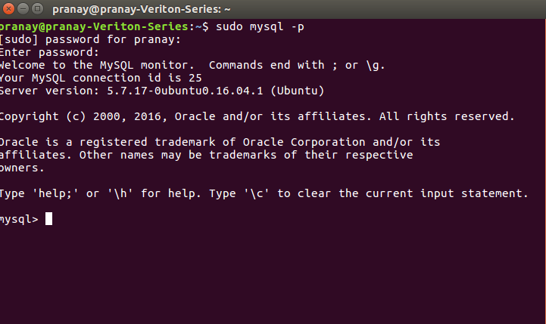
After installing you will get a screen like this

b)Create Databse using Create Databse TESTDB; command
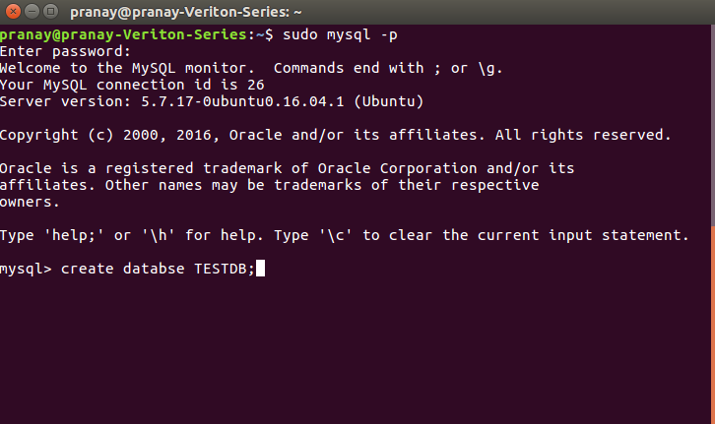
c)open get_data.py and enter credential to access Database.

db_local = MySQLdb.connect("127.0.0.1","YOUR USERNAME","YOUR PASSWORD","TESTDB");

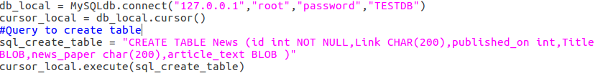
d)in terminal execute command get_data.py

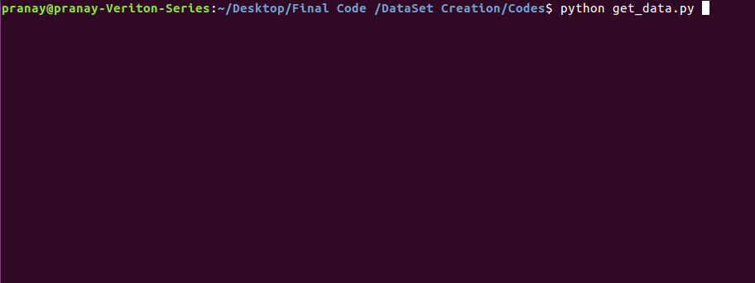
wait till you get

Now the database is ready.It has a table named News
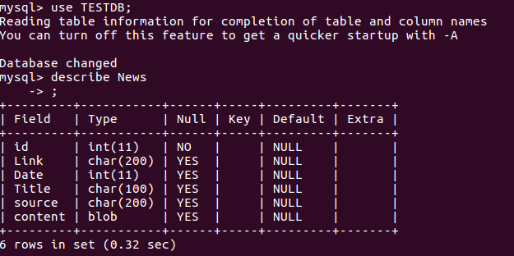
Next part is to create .txt files using this database.

e) We extarcted data from DB to store in files (for simple processing). Please use ‘python extract_all_files.py’.
Simply Run this command python extract_all_files.py

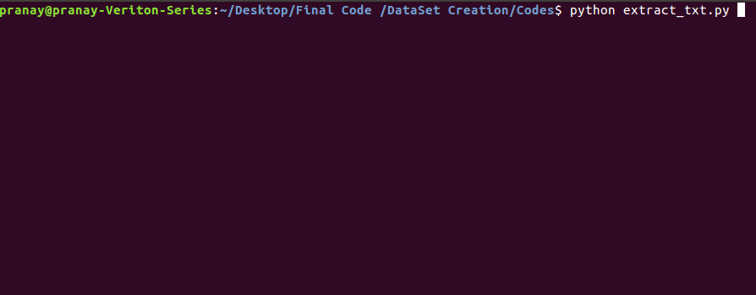

Format of data store in files is:

Location: 1_DataSet_Creation/Data/All_Articles

<Article_Published_Date in yyyymmdd format>
<Article_Title>
<Article_Published_Date in dd-mm-yyyy format>
<Article_Content>

Example

20170117
Turkey: Istanbul nightclub attacker who killed 39 caught in police raid
17-1-2017
Turkish police on Monday captured the s...

