EX NO: 1A | FACTORIAL
DATE:

AIM:
To write a R program to find the factorial of a number with all possibilities.
PROCEDURE:
Step-1: Open the R studio and type the program.
Step-2: Enter the input number.
Step-3: Assign f=1.
Step-4: Give the condition for factorial.
Step-5: Print the output.
CODING:
num = as.integer(readline(prompt="Enter a number: "))
factorial = 1
if(num< 0) {
print("Sorry, factorial does not exist for negative numbers")
} else if(num == 0) {
print("The factorial of 0 is 1")
} else {
for(i in 1:num) {
factorial = factorial * i
}
print(paste("The factorial of", num ,"is",factorial))
1
}
OUTPUT:
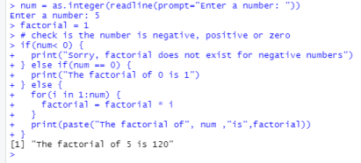2

EX NO: 1B | ARITHMETIC OPERATIONS USING FUNCTIONS
DATE:

AIM:
To write a R program to perform Arithmetic operations using functions with choices.
PROCEDURE:
Step-1: Open R studio.
Step-2: Type the arithmetic operation program.
Step-3: Select the operation.
Step-4: Enter the first number.
Step-5: Enter the second number.
Step-6: Run the program.
CODING:
add<- function(x, y) {
return(x + y)
}
subtract<- function(x, y) {
return(x - y)
}
multiply<- function(x, y) {
return(x * y)
}
divide<- function(x, y) {
3
return(x / y)
}
# take input from the user
print("Select operation.")
print("1.Add")
print("2.Subtract")
print("3.Multiply")
print("4.Divide")
choice = as.integer(readline(prompt="Enter choice[1/2/3/4]: "))
num1 = as.integer(readline(prompt="Enter first number: "))
num2 = as.integer(readline(prompt="Enter second number: "))
operator<- switch(choice,"+","-","*","/")
result<- switch(choice, add(num1, num2), subtract(num1, num2), multiply(num1, num2), divide(num1, num2))
print(paste(num1, operator, num2, "=", result))
OUTPUT:
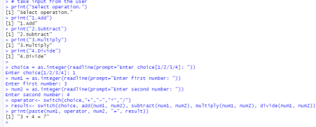4

EX NO: 1C | FIBONACCI SERIES
DATE:

AIM:
To write a R program to perform Fibonacci series for a given number.
PRODECURE:
Step-1: Open R studio
Step-2: Assign Fibonacci <- numeric(10).
Step-3: Give the for condition for Fibonacci series.
Step-4: print the Fibonacci number.
Step-5: Run the program.
CODING:
nterms = as.integer(readline(prompt="How many terms? "))
# first two terms
n1 = 0
n2 = 1
count = 2
# check if the number of terms is valid
if(nterms<= 0) {
print("Please enter a positive integer")
} else {
if(nterms == 1) {
print("Fibonacci sequence:")
print(n1)
} else {
5
print("Fibonacci sequence:") print(n1)
print(n2)
while(count <nterms) { nth = n1 + n2
print(nth)
# update values
n1 = n2
n2 = nth
count = count + 1
}}}
6
OUTPUT:
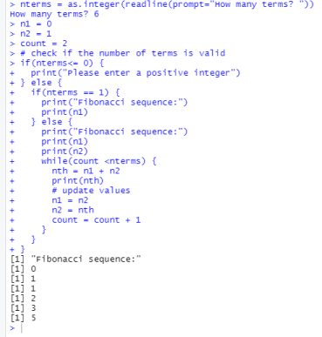7

EX NO: 1D | EMPLOYEE PAYROLL
DATE:

AIM:
To Write a R program to perform employee payroll with neat display
PROCEDURE:
STEP 1: Open R studio environment.
STEP 2: File------> New File -------> R script
STEP 3: Type the respective r script in the R studio followed by step 2
STEP 4: Assign the employee payroll details.
STEP 5: Save and run the output
CODING:
Employee_Id<-as.integer(readline(prompt=”Enter Employee Id:”))
Employee_Id<-as.character(readline(prompt=”Employee name:”))
Basic_pay<-as.integer(readline(prompt=”Enter Basic pay:”))
HRA <-as.integer(readline(prompt=”Enter HRA”))
CCA <- as.integer(readline(prompt=”Enter CCA”))
print(“Deductions”)
PF<- as.integer(readline(prompt=”Enter providend fund:”))
PT<- as.integer(readline(prompt=”Enter professional tax:”))
GP <-as.integer(Basic_pay+HRA+CCA)
Deduct<-as.integer(PF+PT)
NP <-as.integer(GP-Deduct)
print(“Employee pay roll”)
print(“---------------“)
8
print(paste(“Employee Id:”,Employee_Id))
print(paste(“Employee Name:”,Employee_name))
print(“\t”)
print(“Allowance”)
print(“---------------“)
print(paste(“Basic pay is”,Basic_pay))
print(paste(“House rent Allowance is”,HRA))
print(paste(“conveyance Allowance is”,CCA))
print(“Deduction”)
print(“---------------“)
print(paste(“Providendfund”,PF))
print(paste(“Professional tax”,PT))
print(paste(“Gross pay”,GP))
print(paste(“Net pay”,NP))
OUTPUT:
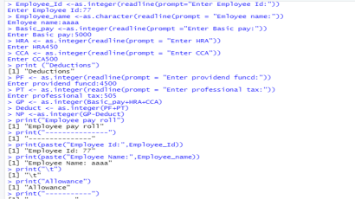9
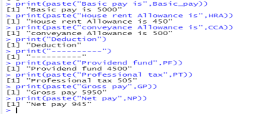10

EX NO: 1E | STUDENT GRADESHEET
DATE:

AIM:
To Write a R program to perform Students grade sheet with internal and external mark display.
PROCEDURE:
STEP 1:Open R studio environment.
STEP 2:File------> New File -------> R script
STEP 3:Type the respective r script in the R studio followed by step 2
STEP 4:Assign the Students grade sheet with internal and external mark display. STEP 5:Save and run the output
CODING:
Print(“personal Info”)
Print(--------------)
Roll no=as.integer(readline(prompt=”Enter the Roll no”))
name=as.character(readline(prompt=”Enter name”))
print(“Internal marks”)
int1=as.integer(readline(prompt=”Enter the DBMS mark ”))
int2=as.integer(readline(prompt=”Enter software testing mark ”))
int3=as.integer(readline(prompt=”Enter the MOS mark ”))
int4=as.integer(readline(prompt=”Enter the Cryptography mark ”))
print(“External marks”)
external1=as.integer(readline(prompt=”Enter DBMS external”))
external2=as.integer(readline(prompt=”Enter software testing external”))
11
external3=as.integer(readline(prompt=”Enter MOS external”)) external4=as.integer(readline(prompt=”Enter Cryptography external”)) m1<-(int1 &external1 )
m2<-(int2 &external2 )
m3<-(int3 &external3 )
m4<-(int4 &external4 )
print(“Grade sheet”)
print(paste(“Roll no:”,Rollno))
print(paste(“Name:”,name))
print(paste(“DBMS:”,m1))
print(paste(“software testing:”,m2))
print(paste(“mos:”,m3))
print(paste(“cryptography:”,m4))
print(paste(“Total mark”,m1+m2+m3+m4))
x<-print(paste(“Average mark”,m1+m2+m3+m4)/4)) if(x>90)
{
print(“o grade”)
}else if (x>80)
{
print(“A grade”)
}else if (x<70)
{
print(“B grade”)
}else
12
{
print(“C grade”)
}
OUTPUT:
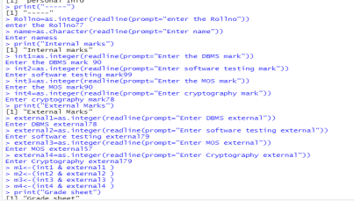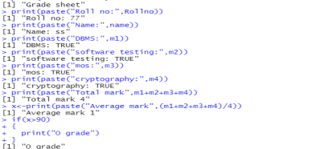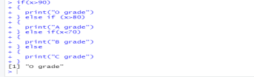
13
EX NO: 2A | LIST CREATION
DATE:

AIM:
To write a R program to create a list containing strings, numbers, vectors and logical values.
PROCEDURE:
Step1: Open R studio and type the program.
Step2: Create a list containing strings, numbers, vectors and logical values. Step3: Print the list using print function.
Step4: Save and Run R program in R studio.
CODING:
list_data = list("Python", "PHP", c(5, 7, 9, 11), TRUE, 125.17, 75.83)
print("Data of the list:")
print(list_data)
14
OUTPUT:
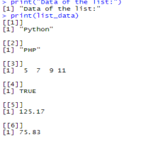
15
EX NO: 2B | ADD AN ELEMENT AT THE END OF LIST
DATE:

AIM:
To create a list containing a vector, a matrix and a list and add the new element at the end of the list.
PROCEDURE:
Step1:Open R studio and type the program.
Step2:Assign and print the lists which consists of vector, a matrix and a list and add the new element at the end of the list.
Step3:Save and run the output.
CODING:
list_data <- list(c("Red","Green","Black"), matrix(c(1,3,5,7,9,11), nrow = 2), list("Python", "PHP", "Java"))
print("List:")
print(list_data)
print("Add a new element at the end of the list:")
list_data[4] = "R programming"
print("New list:")
print(list_data)
16
OUTPUT:
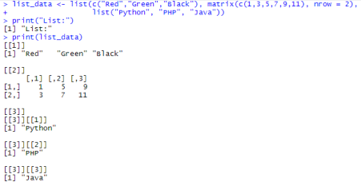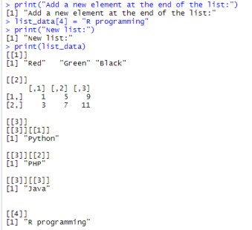
17
EX NO: 2C | CONVERT A GIVEN LIST INTO VECTOR
DATE:

AIM:
To write a R program to convert a given list to vector.
PROCEDURE:
Step1: Open R studio and type the program.
Step2: File->new file->R script
Step3: Create a list and print the original lists.
Step4: Convert the lists to vector, print that two vectors.
Step5: Print the new vectors and output will be displayed.
CODING:
n1 = list(1,2,3)
c1 = list(4,5,6)
print("Original lists:")
print(n1)
print(c1)
print("Convert the lists to vectors:")
v1 = unlist(n1)
v2 = unlist(c1)
print(v1)
print(v2)
print("Add two vectors:")
v = v1 + v2
18
print("New vector:")
print(v)
OUTPUT:
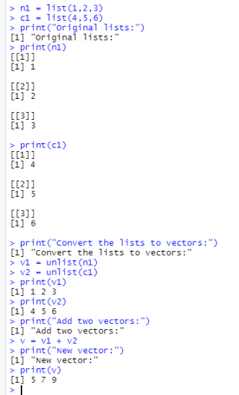19

EX NO: 2D | MERGE TWO GIVEN LISTS INTO ONE LIST
DATE:

AIM:
To write a R program to merge two given lists into one list.
PROCEDURE:
Step 1: Assign variables n1, c1 with a list of two different types.
Step 2: Print the original lists.
Step 3: Merge the two lists by calling the combine function as c(n1, n2) Step 4: Assign merged lists into the variable mlist.
Step 5: Print the merged list mlist.
CODING:
n1 = list(1,2,3)
c1 = list("Red", "Green", "Black")
print("Original lists:")
print(n1)
print(c1)
print("Merge the said lists:")
mlist = c(n1, c1)
print("New merged list:")
print(mlist)
20
OUTPUT:
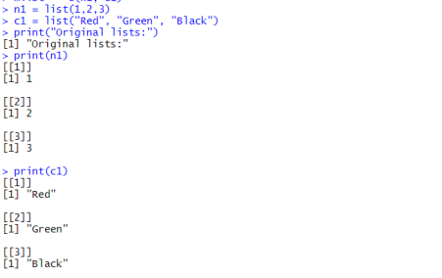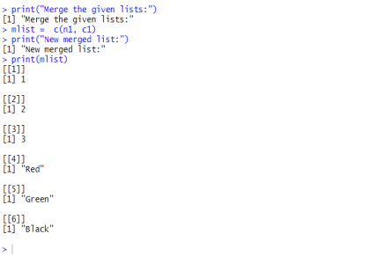
21
EX NO: 3A | CREATE A VECTOR OF LENGTH
DATE:

AIM:
To write a R program to create a vector of length 10
PROCEDURE:
Step1: Open R studio and type the program.
Step2: Create a vector containing value of length 10.
Step3: Print numeric type, data type, length, complex, logical, character using the vector Step4: Save and Run R program in R studio.
PROGRAM CODING:
x = vector("numeric", 10)
print("Numeric Type:")
print(x)
print("Data Type:")
print(typeof(x))
print("Length of vector")
print(length(x))
c = vector("complex", 10)
print("Complex Type:")
print(c)
l = vector("logical", 10)
print("Logical Type:")
print(l)
chr = vector("character", 10)
print("Character Type:")
print(chr)
22
OUTPUT:
23

EX NO:3B | ARITHMETIC OPERATION OF TWO VECTORS OF INTEGERS TYPE AND LENGTH
DATE:

AIM:
To write R program using Arithmetic Operation of two vectors of Integer Type and length 5.
PROCEDURE:
Step1:Open R studio and type the program.
Step2:Create two vector of integer type and its length 5
Step3: Write arithmetic operations like addition, subtraction, multiplication, division, modulus using two vectors
Step 4:Save and Run R program in R studio.
PROGRAM CODING:
x = c(10, 20, 30,40,50)
y = c(20, 10, 40,45,12)
print("Original Vectors:")
print(x)
print(y)
print("After adding two Vectors:")
z = x + y
print(z)
print("After subtracting two Vectors:")
z = x -y
print(z)
24
print("After multiplying two Vectors:")
z = x * y
print(z)
print("After dividing two Vectors:")
z = x / y
print(z)
OUTPUT:
25

EX NO:3C | FIND THE MINIMUM AND THE MAXIMUM OF A VECTOR, ASCENDING AND DESCENDING ORDER
DATE:

AIM:
To write a R program to find the minimum and the maximum of a vector, ascending and descending order.
PROCEDURE:
Step1: Open R studio and type the program.
Step2: File->new file->R script
Step3: Create a vector.
Step4:Use maximum, minimum, ascending and descending operations in the vector. Step5:Save and run the program
PROGRAM CODING:
x =c(10, 20, 30, 25, 9, 26) #min & max
print("Original Vectors:")
print(x)
print("Maximum value of the above Vector:")
print(max(x))
print("Minimum value of the above Vector:")
print(min(x))
print("Sort in ascending order:") #ascending & descending
print(sort(x))
print("Sort in descending order:")
print(sort(x, decreasing=TRUE))
26
OUTPUT:
27

EX NO:3D | REVERSE THE ORDER OF GIVEN VECTOR
DATE:

AIM:
To write a R program to reverse the order of given vector
PROCEDURE:
Step 1:Open R studio and type the program.
Step 2:Create a vectors in numeric and string
Step 3: Reverse the vector using reverse operation
Step 4:Save and run the R program
PROGRAM CODING:
v = c(0, 10, 10, 10, 20, 30, 40, 40, 40, 50, 60) #using numbers
print("Original vector-1:")
print(v)
rv = rev(v)
print("The said vector in reverse order:")
print(rv)
# create vector with names
vec = c("sai", "karthi", "anu","radha", "vani", "charan")
print("Original vector-1:")
print(vec)
rv = rev(vec)
print("The said vector in reverse order:")
print(rv)
28
OUTPUT:
29

EX NO:3E | CONCATENATE A VECTOR
DATE:

AIM:
To write a R program to concatenate the given vector
PROCEDURE:
Step 1: Open R studio and type the program.
Step 2:Create a vectors in numeric and string
Step 3: Reverse the vector using reverse operation
Step 4: Save and run the R program
PROGRAM CODING:
a = c("A","B","C")
print(a)
x = paste(a, collapse = "")
print("Concatenation of the said string:")
print(x)
OUTPUT:
30
EX NO:3F | COMBINES TWO GIVEN VECTORS BY COLUMNS, ROWS
DATE:

AIM:
To write a R program to combine two given vectors by columns and rows
PROCEDURE:
Step 1: Open R studio and type the program.
Step 2:Create a two vectors and print the original vector
Step 3: Combine the two vector by Column and by rows.
Step 4: Save and run the R program
PROGRAM CODING:
v1 = c(1,3,5,7,9)
v2 = c(2,4,6,8,10)
print("Original vectors:")
print(v1)
print(v2)
print("Combines the said two vectors by columns:")
result = cbind(v1,v2)
print(result)
print("Combines the said two vectors by rows:")
result = rbind(v1,v2)
print(result)
31
OUTPUT:
32

EX NO:3G | ACCESS THE LAST VALUE IN A GIVEN VECTOR
DATE:

AIM:
To write a R program to access the last value in a given vector.
PROCEDURE:
Step 1: Open R studio and type the program.
Step 2:Create a vectors and print original vector
Step 3:Access the last value of the vector using tail keyword.
Step 4: Save and run the R program
PROGRAM CODING:
x = c(10, 20, 30, 20, 20, 25, 9, 26)
print("Original Vectors:")
print(x)
print("Access the last value of the said vector:")
print(tail(x, n=1))
OUTPUT:
33
EX NO:3H | ARITHMETIC OPERATIONS OF TWO VECTORS
DATE:

AIM:
To write a R program using arithmetic operations of two vectors.
PROCEDURE:
Step1: Open R studio and type the program.
Step2:Create two vector.
Step3: Write arithmetic operations like addition, subtraction, multiplication, division, modulus using two vectors
Step 4: Save and Run R program in R studio.
PROGRAM CODING:
x = c(12,56,21,23,26,32,14,17)
y = c(45,10,32,14,17,13,15,26)
print("Original Vectors:")
print(x)
print(y)
print("After adding two Vectors:")
z = x + y
print(z)
print("After subtracting two Vectors:")
z = x -y
print(z)
print("After multiplying two Vectors:")
z = x * y
print(z)
print("After dividing two Vectors:")
z = x / y
print(z)
34
OUTPUT:
35
EX NO:3I | ARITHMETIC OPERATIONS OF TWO VECTORS USING FUNCTIONS
DATE:

AIM:
To write a R program using arithmetic operations of two vectors.
PROCEDURE:
Step1: Open R studio and type the program.
Step2:Create a function.
Step3: In that function write arithmetic operations like addition, subtraction, multiplication, division,modulus using two vectors
Step 4:Get vector from user
Step 4: Save and Run R program in R studio.
PROGRAM CODING:
add<- function(x, y) {
return(x + y)
}
subtract<- function(x, y) {
return(x - y)
}
multiply<- function(x, y) {
return(x * y)
}
divide<- function(x, y) {
return(x / y)
}
36
# take input from the user
print("Select operation.")
print("1.Add")
print("2.Subtract")
print("3.Multiply")
print("4.Divide")
choice = as.integer(readline(prompt="Enter choice[1/2/3/4]: "))
num1 = as.integer(readline(prompt="Enter first number: "))
num2 = as.integer(readline(prompt="Enter second number: "))
operator<- switch(choice,"+","-","*","/")
result<- switch(choice, add(num1, num2), subtract(num1, num2), multiply(num1, num2), divide(num1, num2))
print(paste(num1, operator, num2, "=", result))
OUTPUT:
37

EX NO: 4A | CREATE A DATA FRAME FROM FOUR GIVEN VECTORS
DATE:

AIM
To write a R program to create a data frame from four given vectors.
PROCEDURE
Step 1: Open R studio environment.
Step 2: File -> new file -> R script.
Step 3: Type the respective R script in the R studio followed by step 2.
Step 4:A data frame is used for storing data tables. It is a list of vectors of equal length. Df=datafram is used to data displayed in a format as a table.
Step 5: Then run the code, output will be displayed successfully.
CODING
name = c('Ana', 'Diana', 'Katherine', 'John', 'Monika', 'Michael', 'Matthew', 'Laura', 'Kevin', 'Jonas')
score = c(12.5, 9, 16.5, 12, 9, 20, 14.5, 13.5, 8, 19)
attempts = c(1, 3, 2, 3, 2, 3, 1, 1, 2, 1)
qualify = c('yes', 'no', 'yes', 'no', 'no', 'yes', 'yes', 'no', 'no', 'yes')
print("Original data frame:")
print(name)
print(score)
print(attempts)
print(qualify)
df = data.frame(name, score, attempts, qualify)
print(df)
38
OUTPUT
39

EX NO : 4B | STRUCTURE OF A GIVEN DATA FRAME
DATE :

AIM
To Write a R program to get the structure of a given data frame.
PROCEDURE
Step 1: Open R studio environment.
Step 2: File -> new file -> R script.
Step 3: Type the respective R script in the R studio followed by step 2.
Step 4:str() function in R Language is used for compactly displaying the internal structure ofa R object
Step 5: Then run the code, output will be displayed successfully.
CODING
exam_data = data.frame(name = c('Anastasia', 'Dima', 'Katherine', 'James', 'Emily', 'Michael', 'Matthew', 'Laura', 'Kevin', 'Jonas'),
score = c(12.5, 9, 16.5, 12, 9, 20, 14.5, 13.5, 8, 19),
attempts = c(1, 3, 2, 3, 2, 3, 1, 1, 2, 1),
qualify = c('yes', 'no', 'yes', 'no', 'no', 'yes', 'yes', 'no', 'no', 'yes'))
print("Original dataframe:")
print(exam_data)
print("Structure of the said data frame:")
print(str(exam_data))
40
OUTPUT
41

EXNO: 4C | STATISTICAL SUMMARY AND NATURE OF THE DATA
DATE :

AIM
To write a R program to get the statistical summary and nature of the data of a given data.
PROCEDURE
Step 1: Assign variables with vector values.
Step 2: First print original vector values.
Step 3: Print the statistical summary of a given data frame as summary(exam_data) Step 4: Print the final data frame.
CODING
exam_data = data.frame(
name = c('Jaya', 'Vicky', 'Ganesh', 'Priya', 'Keerthi', 'Karthi', 'Meena', 'Lakshmi', 'Luna', 'Jino'), score = c(12.5, 9, 16.5, 12, 9, 20, 14.5, 13.5, 8, 19),
attempts = c(1, 3, 2, 3, 2, 3, 1, 1, 2, 1),
qualify = c('yes', 'no', 'yes', 'no', 'no', 'yes', 'yes', 'no', 'no', 'yes'))
print("Original dataframe:")
print(exam_data)
print("Statistical summary and nature of the data of the said dataframe:") print(summary(exam_data))
42
OUTPUT
43

EXNO:4D | EXTRACT SPECIFIC COLUMN FROM A DATA FRAME USING COLUMN NAME.
DATE:

AIM:
To Write a R program to extract specific column from a data frame using column name.
PROCEDURE:
STEP 1: Open R studio and type the program.
STEP 2: File->new file->R script
STEP 3: create a data frame.
STEP 4: Extract a specific column by specifying column name.
STEP 5: Output will be displayed.
CODING
emp.data <- data.frame(
emp_id = c (1:5),
emp_name = c("vini","swetha","sumi","vidhya","srinithi"),
salary = c(623.3,515.2,611.0,729.0,843.25),
start_date = as.Date(c("2020-05-01", "2021-08-23", "2022-11-10", "2021-05-11", "2020-03-27")),
stringsAsFactors = FALSE)
print(emp.data)
result <- data.frame(emp.data$emp_name,emp.data$salary)
print(result)
result1 <- emp.data[1:2,]
print(result1)
44
OUTPUT
45

EX NO : 4E | EXTRACT ROWS
DATE :

AIM
To write a r program to extract first two rows from a given data frame
PROCEDURE
STEP 1 : Open R studio environment.
STEP 2 : File->New File ->R script.
STEP 3 : Create a data frame and it will print the original vector values. STEP 4 : Extract the first two rows from a given data frame as E[1:2,]
STEP 5 : Then run the console panel the output will be displayed.
CODING
E = data.frame(
N = c('Nithya', 'Mooga', 'Priyanka', 'Tharuneya', 'Aishwarya'),
S = c(10, 9.5, 12.2, 11, 8),
A = c(2, 1, 2, 4, 1),
Q = c('yes', 'no', 'yes', 'no', 'no'))
print("Original dataframe:")
print(E)
print("Extract first two rows:")
result = E[1:2,]
print(result)
46
OUTPUT
47

EX NO : 4F | EXTRACT SPECIFIC ROWS AND COLUMNS
DATE :

AIM
To write a R program to extract first 3rd and 5th rows with 1st and 3rd columns from a given data frame.
PROCEDURE
STEP 1 : Open R studio environment.
STEP 2 : File->New File ->R script.
STEP 3 : Create a data frame and it will print the original vector values.
STEP 4 : Extract the 3rd and 5th rows with 1st and 3rd columns from a given data frame as E[c(3,5),c(1,3)]
STEP 5 : Then run the console panel the output will be displayed.
CODING
E = data.frame( N = c('Nithya', 'Mooga', 'Priyanka', 'Tharuneya', 'Aishwarya'), S = c(10, 9.5, 12.2, 11, 8),
A = c(2, 1, 2, 4, 1),
Q = c('yes', 'no', 'yes', 'no', 'no'))
print("Original dataframe:")
print(E)
print("Extract 3rd and 5th rows with 1st and 3rd columns :")
result = E[c(3,5),c(1,3)]
print(result)
48
OUTPUT
49

EXNO:4G | ADD A NEW COLUMN
DATE:

AIM
To write a program to add a new column in a given data frame.
PROCEDURE
STEP1: Open R studio and type the program.
STEP2: Add a new column in the data frame.
STEP3: Print the added column.
STEP4: Save and run R program in R studio.
CODING
exam_data = data.frame(name = c('Aishu', 'Mooga', 'Nithya', 'Priya', 'Srinithi', 'Sumitha', 'Tharuneya', 'Vidhya', 'Vinitha'),score = c(12.5, 9, 16.5, 12, 9, 20, 14.5, 13.5, 8),
attempts = c(1, 1, 2, 1, 2, 1, 1, 1, 2),
qualify = c('yes', 'no', 'yes', 'yes', 'no', 'yes', 'yes', 'no', 'no'))
print("Original dataframe:")
print(exam_data)
print("New data frame after adding the 'country' column:")
exam_data$country=c("USA","USA","USA","USA","USA","USA","USA", "USA","USA")
print(exam_data)
50
OUTPUT
51

EXNO:4H | ADD A NEW ROW
DATE:

AIM
To write a program to add a new row in a given data frame.
PROCEDURE
STEP1: Open R studio and type the program.
STEP2: Add a new row in the data frame.
STEP3: Print the added column.
STEP4: Save and run R program in R studio.
CODING
exam_data = data.frame(name = c('Aishu', 'Mooga', 'Nithya', 'Priya', 'Srinithi', 'Sumitha', 'Tharuneya', 'Vidhya', 'Vinitha'),
score = c(12.5, 9, 16.5, 12, 9, 20, 14.5, 13.5, 8),
attempts = c(1, 1, 2, 1, 2, 1, 1, 1, 2),
qualify = c('yes', 'no', 'yes', 'yes', 'no', 'yes', 'yes', 'no', 'no'))
print("Original dataframe:")
print(exam_data)
new_exam_data = data.frame(
name = c('Robert', 'Sophia'),
score = c(10.5, 9),
attempts = c(1, 3),
qualify = c('yes', 'no'))
exam_data = rbind(exam_data, new_exam_data)
print("After adding new row(s) to data frame:")
print(exam_data)
52
OUTPUT
53
EX NO : 4I | PROGRAM TO DROP COLUMNS BY NAME FOR GIVEN DATA FRAME
DATE:

AIM
To write a R program to drop columns by name for given data frame.
PROCEDURE
Step 1: Open R studio environment.
Step 2: File->new file->R script
Step 3: Type the respective R script in the R studio.
Step 4: Create a data frame exam_data and display the original dataframe.
Step 5: In the next step select only the subset of the dataframe based on name and qualify attribute.
PROGRAM
exam_data = data.frame(
name = c('Anitha', 'Deva', 'lakshmi', 'seetha', 'radha', 'Keerthi', 'ashwini', 'Laura', 'Kevin', 'Jonas'),
score = c(12.5, 9, 16.5, 12, 9, 20, 14.5, 13.5, 8, 19),
attempts = c(1, 3, 2, 3, 2, 3, 1, 1, 2, 1),
qualify = c('yes', 'no', 'yes', 'no', 'no', 'yes', 'yes', 'no', 'no', 'yes'))
print("Original dataframe:")
print(exam_data)
exam_data = subset(exam_data, select = -c(name, qualify))
print(exam_data)
54
OUTPUT
55

EX NO: 4J | PROGRAM TO DROP ROWS BY NAME FOR GIVEN DATA FRAME
Date:

AIM
To write a R program to drop rows by name for given data frame.
PROCEDURE
Step 1: Open R studio environment.
Step 2: File->new file->R script
Step 3: Type the respective R script in the R studio.
Step 4: Create a data frame exam_data and display the original dataframe.
Step 5: In the next step select only the subset of the dataframe based on name and qualify attribute.
PROGRAM
exam_data = data.frame( name = c('A', 'd', 'E', 'M', 'L', 'K', 'J'),
score = c(12.5, 9, 16.5, 12, 9, 20, 14.5),
attempts = c(1, 3, 2, 3, 2, 3, 1),
qualify = c('yes', 'no', 'yes', 'no', 'no', 'yes', 'yes'))
print("Original dataframe:")
print(exam_data)
exam_data <- exam_data[-c(2, 4, 6), ]
print(exam_data)
56
OUTPUT:
57

EX NO: 4K | SORTING A DATAFRAME BY MULTIPLE COLUMNS
DATE:

AIM
To write a R program to sort a given data frame by multiple columns.
PROCEDURE
Step1: Open R studio and type the program.
Step2: Create data frame
Step3: Choose any more number of values more than one which includes name, score, attempts and qualify.
Step4: Pass those columns as the parameter in the sorting functions.
Step5: Display result.
CODING
exam_data = data.frame(
name = c('sri', 'Dima', 'Katherine'),
score = c(12.5, 9, 16.5),
attempts = c(1, 3, 2),
qualify = c('yes', 'no', 'yes'))
print("Original dataframe:")
print(exam_data)
print("dataframe after sorting 'name' and 'score' columns:")
exam_data = exam_data[with(exam_data, order(name, score)), ]
print(exam_data)
58
OUTPUT
59

EX NO:4L | CHANGING A COLUMN NAME OF A DATA FRAME
DATE:

AIM
To write a R program to change a column name of a data frame.
PROCEDURE
Step 1: Open R studio and type the program.
Step 2: Create data frame „exam_data‟ which have name, score, attemps, qualify Step 3: Change column-name 'name' to 'student_name'
Step 4: Display result
.
CODING
exam_data = data.frame(
name = c('Anastasia', 'Dima', 'Katherine', 'James', 'Emily', 'Michael', 'Matthew', 'Laura', 'Kevin', 'Jonas'),
score = c(12.5, 9, 16.5, 12, 9, 20, 14.5, 13.5, 8, 19),
attempts = c(1, NA, 2, NA, 2, NA, 1, NA, 2, 1),
qualify = c('yes', 'no', 'yes', 'no', 'no', 'yes', 'yes', 'no', 'no', 'yes'))
print("Original dataframe:")
print(exam_data)
print("Change column-name 'name' to 'student_name' of the said dataframe:") colnames(exam_data)[which(names(exam_data) == "name")] = "student_name" print(exam_data)
60
OUTPUT
61
EX NO:4M | CHANGE MORE THAN ONE COLUMN IN DATAFRAME
DATE:

AIM
To write a R program to change more than one column name of a given data frame
PROCEDURE
Step 1: Assign the dataframe with the specific column name using the variable c. Step 2: First print the original dataframe using the dataframe name.
Step 3: Change the column names usingcolnames(emp.data)[3:4] <- c("Col3","Col4") Step 4: Print the updated dataframe
CODING
emp.data<data.frame(emp_id=c(1:5),
emp_name=c("Samantha","Saipallavi","Mooga","Priyanka","Nithya"),
salary=c(978.24,804.92,923.43,682.95,902.54),
start_date=as.Date(c("2000-08-19","2000-08-27","2000-11-26","2001-05-08","2002-08- 26")),
stringsAsFactors=FALSE)
print("Original dataframe:")
print(emp.data)
colnames(emp.data)[3:4] <- c("Col3","Col4")
print("Updated Dataframe:")
print(emp.data)
62
OUTPUT
63

EX NO:4N | EXTRACT RANDOM ROWS
DATE:

AIM
To write a R program to extract some random rows from a dataframe
PROCEDURE
Step 1: Assign the data frame with the specific column name using the variable c. Step 2: First print the original dataframe using the dataframe name
Step 3 : Select random rows by emp.data[sample(Which(emp.data$salary>900)2),] Step 4: Print the Final dataframe.
CODING
emp.data<data.frame(emp_id=c(1:5),
emp_name=c("Samantha","Saipallavi","Mooga","Priyanka","Nithya"),
salary=c(978.24,804.92,923.43,682.95,902.54),
start_date=as.Date(c("2000-08-19","2000-08-27","2000-11-26","2001-05-08","2002-08- 26")),
stringsAsFactors=FALSE)
print(emp.data)
print("2samples")
emp.data[ sample(which(emp.data$salary>900),2), ]
64
OUTPUT
65

EX NO:4O | COMPARE TWO DATA FRAMES
DATE:

AIM
To write a R program to compare two data frames to find the rows in first data frame that are not present in second data frame.
PROCEDURE
Step 1: Open R studio and type the program.
Step 2: Create data frame and assign variables(df_1,df_2) with data frames. Step 3: Compare the two data frames by calling setdiff(df_1,df_2)
Step 4: Print the final data frame.
CODING
df_1 = data.frame(
"item" = c("item1", "item2", "item3"),
"Jan_sale" = c(12, 14, 12),
"Feb_sale" = c(11, 12, 15),
"Mar_sale" = c(12, 14, 15))
df_2 = data.frame(
"item" = c("item1", "item2", "item3"),
"Jan_sale" = c(12, 14, 12),
"Feb_sale" = c(11, 12, 15),
"Mar_sale" = c(12, 15, 18))
print("Original Dataframes:")
print(df_90)
print(df_91)
print("Row(s) in first data frame that are not present in second data frame:") print(setdiff(df_90,df_91))
66
OUTPUT
67

EX NO:4P | CONVERSION TO DATAFRAME
DATE:

AIM:
To write a R program for conversion to dataframe.
PROCEDURE:
Step1: Open R studio and type the program.
Step2: Create a dataframe for exam data
Step3: Print the original data
Step4: Print the dataframe rows to alist.
Step5: Save and Run R program in R studio.
PROGRAM CODING:
exam_data = data.frame(
name = c('Anastasia', 'Dima', 'Katherine', 'James', 'Emily'),
score = c(12.5, 9, 16.5, 12, 9),
attempts = c(1, 3, 2, 3, 2),
qualify = c('yes', 'no', 'yes', 'no', 'no')
)
print("Original dataframe:")
print(exam_data)
new_list = split(exam_data, seq(nrow(exam_data)))
print("dataframe rows to a list:")
print(new_list)
68
OUTPUT:
69
EX NO:4Q | EMPLOYEE DETAILS
DATE:

AIM:
To write a R program to create a dataframe from your given employee details
PROCEDURE :
Step-1: Open R studio.
Step-2: Type the employee id and name using dataframe.
Step-3: Declare gender, designation, Basicpay,HRA,PF details.
Step-4: Calculate netpay amd grosspay.
Step-5:Print the details.
CODING:
Employees = data.frame(Name=c("Anastasia S","Dima R","Katherine S", "JAMES A","LAURA MARTIN"),
Gender=c("M","M","F","F","M"),
Age=c(23,22,25,26,32),
Designation=c("Clerk","Manager","Exective","CEO","ASSISTANT"), Basicpay=c(12000,10000,20000,11000,13400),
HRA=c(1000,2341,1290,3312,1099),
DA= c(1200,1000,2000,1100,2012),
TA= c(1031,1231,1421,1220,1241),
PF=c(1200,1200,1200,1200,1200)
)
Employees$NP <- Employees$Basicpay + Employees$HRA + Employees$DA + Employees$TA
Employees$GP <- Employees$NP - Employees$PF
print("Details of the employees:")
70
print(Employees)
OUTPUT:
71
EX.NO:5A | CREATING,MODIFICATION,ACCESSING MATRIX ELEMENTS AND ADDITION & DELETION THE ROWS AND COLUMNS
DATE:

AIM :
To create a matrix, modifying a matrix and accessing an matrix elements and addition and deletion of the rows and columns using R program.
PROCEDURE :
Step 1: To create a matrix which have 4 rows and 3 columns.
Step 2: Accessing the matrix
Step 3: Modifying the matrix
Step 4 : Adding the rows
Step 5 : Adding the columns
Step 6 : Deletion of rows
Step 7 : Deletion of columns
CODING :
# Defining the column and row names.
row_names = c("row1", "row2", "row3", "row4")
col_names = c("col1", "col2", "col3")
#Creating matrix
R <- matrix(c(5:16), nrow = 4, byrow = TRUE, dimnames = list(row_names, col_names)) print(R)
#Accessing element present on 3rd row and 2nd column
print(R[3,2])
#Accessing element present in 3rd row
print(R[3,])
72
#Accessing element present in 2nd column
print(R[,2])
#Modification of the matrix
#Assigning value 20 to the element at 3d row and 2nd column
R[3,2]<-20
print(R)
#Adding row
rbind(R,c(17,18,19))
#Adding column
cbind(R,c(17,18,19,20))
#transpose of the matrix using the t() function:
t(R)
#Modifying the dimension of the matrix using the dim() function dim(R)<-c(1,12)
print(R)
row_names = c("row1", "row2", "row3", "row4")
col_names = c("col1", "col2", "col3","col4")
R <- matrix(c(1:16), nrow = 4,ncol=4, byrow = FALSE, dimnames = list(row_names, col_names))
print(R)
# Remove specific rows
new_R <- R[-c(2, 3), ]
print(new_R)
# Remove range of rows
new_R <- R[-c(1:2), ]
print(new_R)
# Remove specific cols
73
new_R <- R[,-c(2) ]
print(new_R)
# Remove range of cols
new_R <- R[,-c(1:2) ]
print(new_R)
OUTPUT:
74
75
EX NO:5B | MATRIX INTO LIST
DATE:

AIM:
To write a program to convert a given matrix to a list in R programming.
PROCEDURE:
Step1: Open R studio and type the program.
Step 2: Create the matrix which contains 3 rows and 4 columns
Step 3: Print the original matrix
Step 4: Convert the matrix into the list and print the result.
CODING:
matrix1 <- matrix(c(3, 9, -1, 4, 2, 6, -7, 12, -5, 17, 5, 8), nrow = 3, ncol = 4) print(matrix1)
print("Original matrix:")
print(matrix1)
list1 = split(matrix1, rep(1:ncol(matrix1), each = nrow(matrix1)))
print("list from the said matrix:")
print(list1)
OUTPUT:
76
EX NO:5C | MERGE TWO MATRIX INTO SINGLE MATRIX
DATE:

AIM:
To write a program to merge two given matrix into a single matrix in R programming.
PROCEDURE:
Step1: Open R studio and type the program.
Step 2: Create two matrices named as A and B
Step 3: Print the created two matrices
Step 4: Combine the two matrices using the function cbind() and print the result
CODING:
A = matrix(c(1, 2), nrow = 2, ncol = 2)
# Creating 2nd Matrix
B = matrix(c(3, 4, 5), nrow = 2, ncol = 3)
# Original Matrices
print(A)
print(B)
# Combining matrices
print (cbind(A, B))
OUTPUT:
77

EX NO: 5D | MATRIX ARITHMETIC OPERATIONS USING FUNCTIONS
DATE:

AIM:
To Write a R program to create the matrix using function
a. Add b. Subtract c. Multiplication d. division.
PROCEDURE:
STEP 1: Open R studio environment.
STEP 2: File------> New File -------> R script
STEP 3: Type the respective r script in the R studio followed by step 2
STEP 4: Assign and create the matrix using function add, subtract, multiply, divide. STEP 5: Save and run the output
CODING:
data<- c(1, 2, 3, 0, 1, 2, 0, 0, 1)
x <-matrix(data, nrow =3, ncol = 3)
data<- c(0, 1, 1, 1, 0, 3, 1, 3, 3)
y<-matrix(data, nrow =3, ncol = 3)
add<- function(x, y) {
return(x + y)
}
subtract<- function(x,y) {
return(x - y)
}
multiply<- function(x,y) {
return(x * y)
}
divide<- function(x, y) {
78
return(x / y)
}
print(“Select operation.”)
print(“1.Add”)
print(“2.Subtract”)
print(“3.Multiply”)
print(“4.Divide”)
choice = as.integer(readline(prompt=”Enter choice[1/2/3/4]:”)) result<- switch(choice, add(x,y), subtract(x,y), multiply(x,y), divide(x,y)) m <- as.matrix(result)
print(m)
79
OUTPUT:
80

