Home
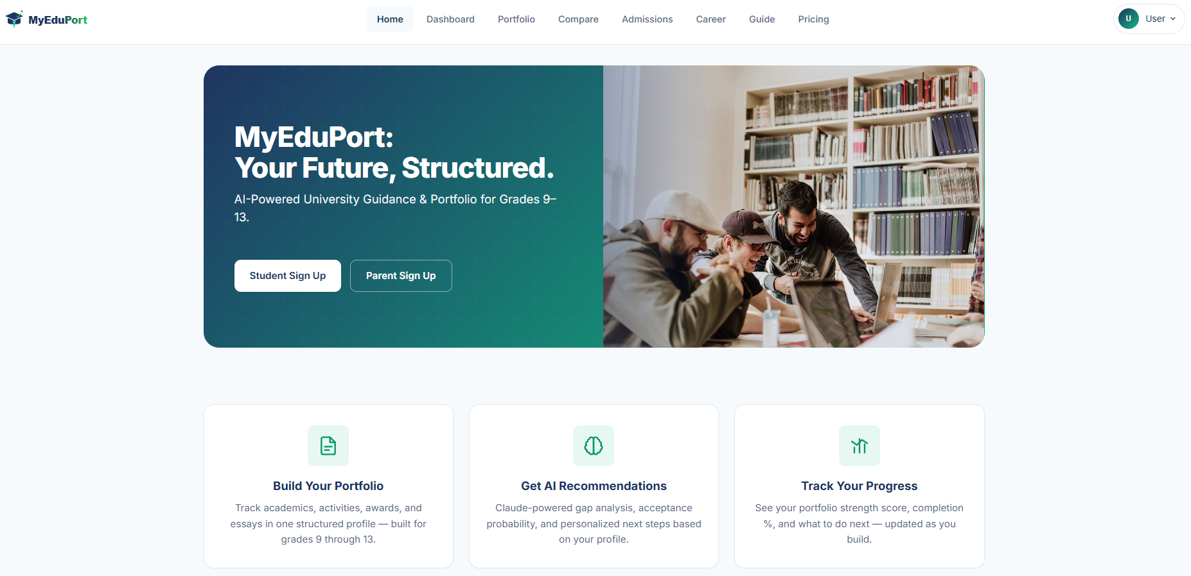

- Change logo

Dashboard
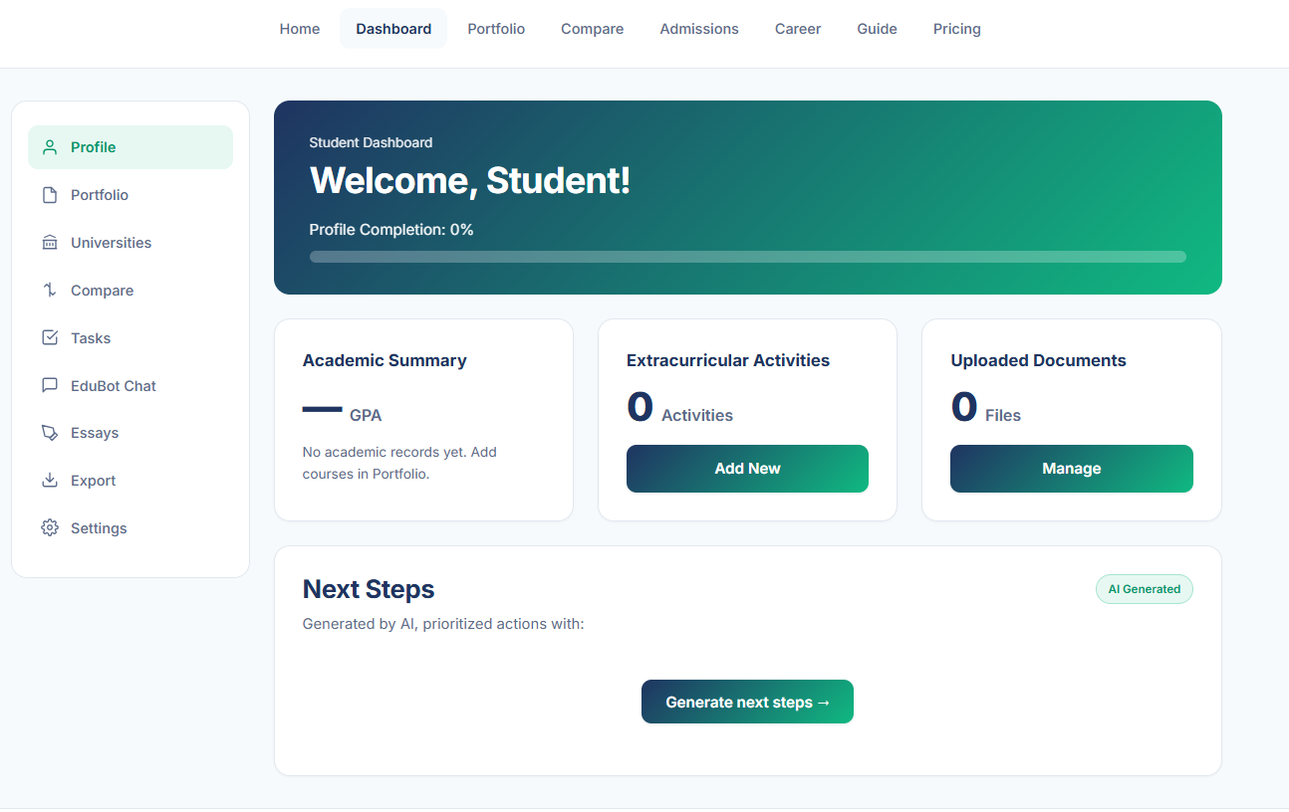
- Add Overall Portfolio Score (AI)
- Add Aacceptance Predictions (AI)
- Change Profile Completion to be Portfolio Completion.
- Add Important Date
- Add timeline of application
- Change GPA -> Score
- Change number of activities -> Score
- Change number of uploaded documents -> Score

Portfolio -> 01 Personal
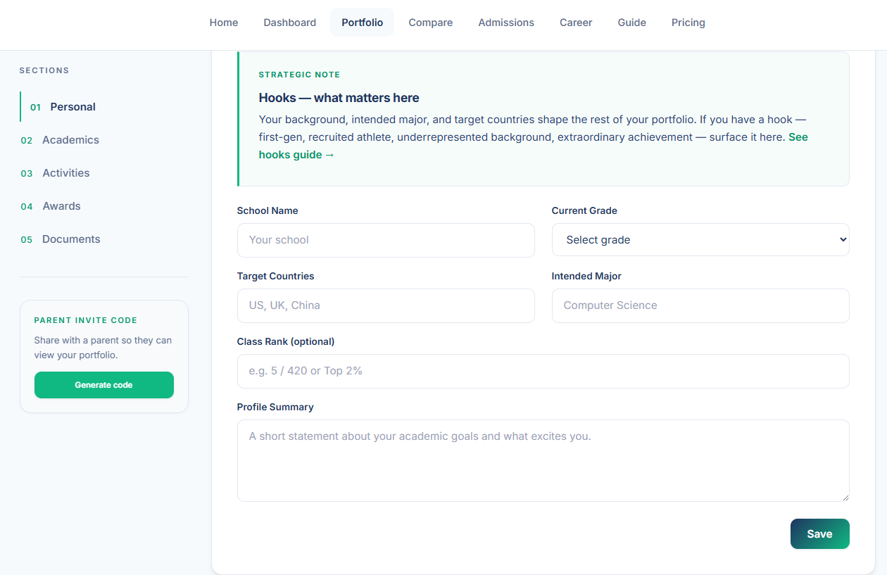
- Change “Current Grade” to be “Current Grade/Year”, Dropdown to be “Grade 9/Year 10 … “
- Change Target Country to be dropdown.
- Add 3 Intended Majors.
- Add Personal Character Test (to be created).
- Add Career Test (to be created).
- Short statement from 200 to 500 words.

Portfolio -> 02 Academics
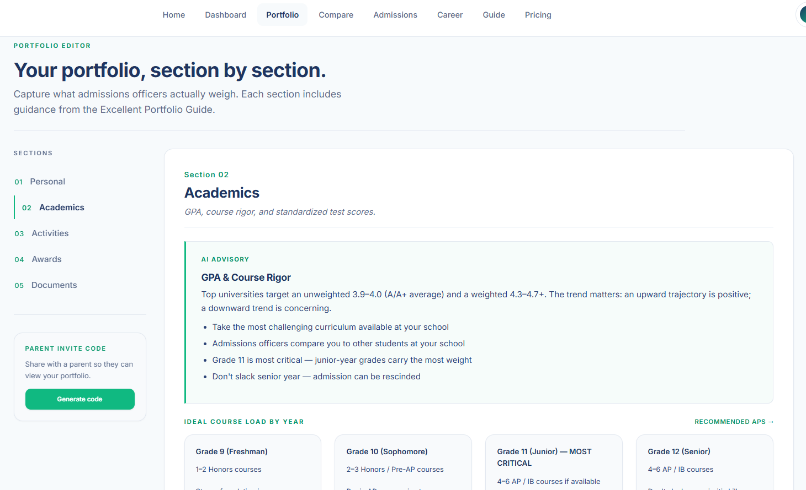

Change to be this.

Section I
Grade 6 / Year 7
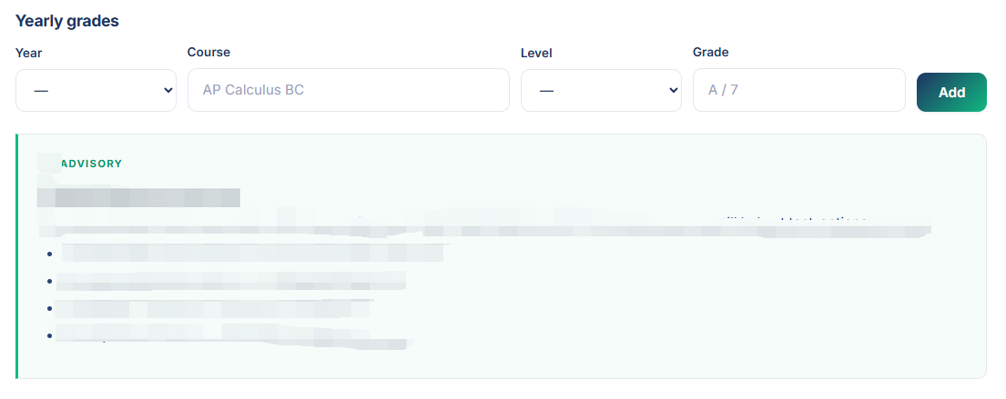

.
.
.

Grade 12 / Year 13
- Each year academic result
- ADVISORY (AI) on each year
- Add academic score (AI)

Section II : Standard Tests
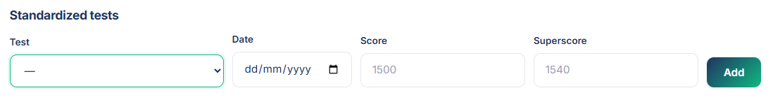
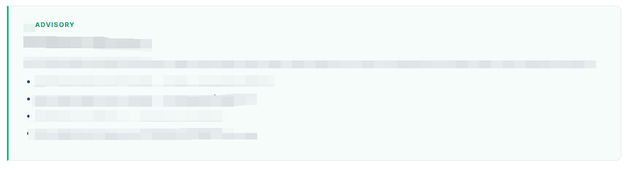
- ADVISORY (AI)
- Recommended tests (AI)

Portfolio -> 03 Extracurricular Activities
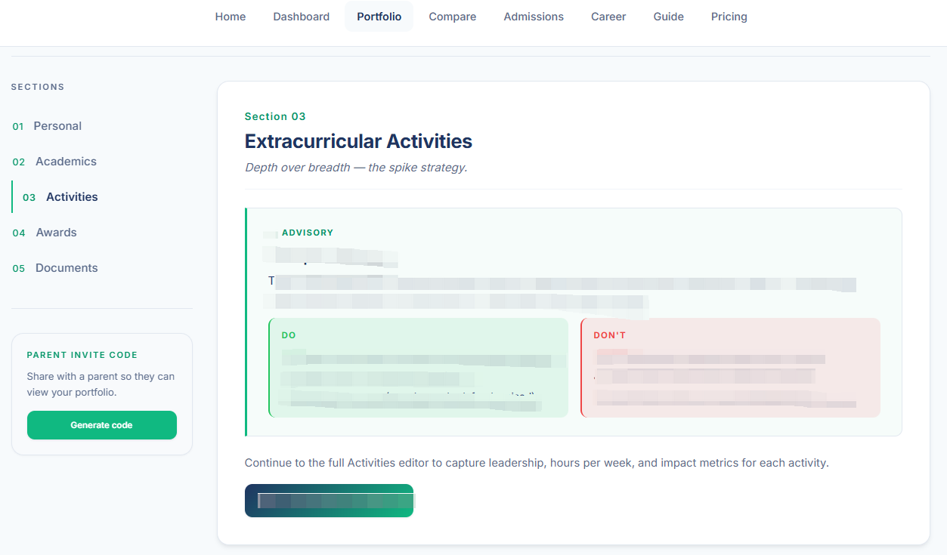
- Change Activities -> Extracurricular Activities
- Change Spike Strategy -> Extracurricular Strategy (AI)
- Add recommended Extracurricular Activities (AI)
- Add Topic and summary of added Activities
- Add score of Extracurricular Activities (AI)
- Add “Add Extracurricular Activity” -> Extracurricular Activity Editor

Portfolio -> 03 Extracurricular Activities Editor

Portfolio -> 04 Awards

Portfolio -> 05 Documents

Section I : Essay
- Topic and summary of added essays (up to 5 essays)
- Essay Editor (AI)
- Overall score (AI)

Essay Editor
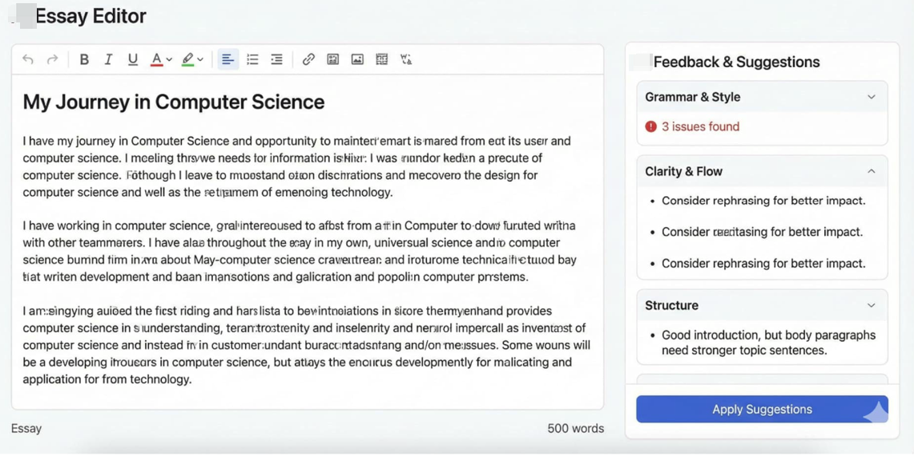
- Add score (AI)
- Add Feedback and Suggestions (AI)
- Edit and Apply
- Add draft/revise/final

Section II : Recommendation Letter
- Add Recommendation Letter Advisory (AI)
- Add Feedback and Suggestions (AI)
- Add Timeline

Section III : Additional Documents
- Add Additional Document Advisory (AI)
- Add Feedback and Suggestions (AI)
- Add Timeline

Portfolio -> 06 (Export) – Find another wording
- Create Templates

Pricing plan
