REINFORCEMENT LEARNING FOR TRAFFIC-SIGNAL CONTROL
Adaptive Traffic-Signal Control at a Four-Way Intersection:
A Comparative Study of Q-Learning, SARSA, and Deep Q-Networks
Project 6 — Reinforcement Learning
Abstract
A four-way traffic intersection is formulated as a Markov Decision Process with a 16-dimensional queue-length state (12 controllable incoming movements and 4 outgoing roads) and 12 possible green-light actions. Three learned controllers — tabular Q-learning, tabular SARSA, and a Deep Q-Network (DQN) operating on the full, non-discretized state — are trained and evaluated against a longest-queue-first baseline. Under a fixed evaluation protocol (200 held-out episodes, identical seeds across methods, exploration disabled), DQN achieves the lowest average system queue, followed by SARSA, Q-learning, and the baseline. All three learned controllers substantially outperform the baseline, and the ranking is preserved when the agents receive noisy sensor observations, though DQN's advantage narrows slightly as observation noise increases. This paper reports the reproducible, seed-fixed evaluation as the canonical result and documents a reconciliation of an earlier, non-reproducible evaluation pass that produced slightly different numbers for the same three algorithms.

1. Introduction
Traffic-signal timing is a natural fit for reinforcement learning (RL): a controller observes queue lengths, chooses which movement to serve, and receives ongoing feedback in the form of congestion. Rather than encoding fixed-time or hand-tuned actuated logic, an RL agent can, in principle, learn a signal policy directly from interaction with a simulated intersection.
Reinforcement learning is distinguished from supervised and unsupervised learning by how it is trained: an agent interacts with an environment, observing a state, taking an action, and receiving a scalar reward, with the goal of maximizing cumulative reward rather than matching a labeled answer key. This project applies that loop to a four-way intersection, where the state is the vector of queue lengths, the action is which movement receives the green light, and the reward penalizes total system congestion.
This paper documents the environment, the three learned controllers that were trained and compared, the hyperparameter and robustness studies performed, and — in response to code review feedback — an explicit reconciliation of a discrepancy between two evaluation passes that had been left unexplained in an earlier version of the accompanying notebook.

2. Background: Agents and Learning
The traffic-signal controllers built in this project can each be situated within the standard taxonomy of intelligent agents. A simple reflex agent — such as the longest-queue-first baseline used here — chooses its action from the current percept alone, using a fixed condition–action rule, with no memory or learning involved. A learning agent, by contrast, improves its policy over time from a feedback signal; this is the category the Q-learning, SARSA, and DQN controllers belong to, since each refines its action-selection policy from the reward signal it receives while interacting with the simulated intersection.
The internal machinery of a learning agent is commonly described as four cooperating components: a performance element that selects actions, a critic that evaluates outcomes against a reward signal, a learning element that uses that feedback to improve the performance element, and a problem generator that suggests exploratory actions so the agent does not simply exploit its current — possibly incomplete — knowledge. The exploration/exploitation trade-off this creates (try a new action to gather information, or take the action already believed best) is handled in this project with two different strategies, epsilon-greedy and Boltzmann/softmax exploration, compared directly in Section 6.
Within the value-based family of RL methods — algorithms that learn value estimates and act (semi-)greedily with respect to them — Q-learning, SARSA, and DQN are three closely related choices. Q-learning and SARSA both maintain a table of state–action values and differ only in their update target; DQN replaces the table with a neural network so that it can operate on the full, non-discretized 16-dimensional state rather than a coarsened representation.

3. Environment and MDP Formulation

3.1 State and action space
The intersection is represented as 12 controllable incoming movement queues (three turning movements from each of the four approaches) plus 4 outgoing road queues, giving a 16-dimensional observation. The action space has 12 discrete actions, one per incoming movement, corresponding to which movement receives the green light at each step.

3.2 Reward
The base reward is the negative of total system congestion: reward = −(total number of queued cars). A lower (more negative) cumulative reward corresponds to a more congested intersection over the episode; an effective controller therefore seeks the least negative — i.e., largest — cumulative reward.

3.3 Discretization for tabular methods
Q-learning and SARSA require a finite state space, so each of the 16 queue values is bucketed into two levels (Low/High) rather than kept at full precision — 2¹⁶ = 65,536 possible bucketed states, versus roughly 1.4×10²¹ raw states at full integer precision, which is not tractable for a lookup table. DQN does not require this step: it consumes the full 16-value state directly.

3.4 Baseline controller
The baseline is a simple reflex agent with no learned parameters: at every step it serves whichever incoming queue is currently largest. It is included in every comparison as a non-learning reference point.

4. Methods

4.1 Q-learning and SARSA
Both tabular methods maintain a table Q[s, a] and update it toward a temporal-difference (TD) target after every transition, Q(s, a) ← Q(s, a) + α·δ, where α is the learning rate and δ = r + γ·max_{a′} Q(s′, a′) − Q(s, a) is the TD error — the gap between the freshly bootstrapped target and the current estimate. γ (the discount factor) controls how much future congestion counts relative to the immediate step: γ near 1 makes the agent look further ahead.
The two algorithms differ in how the TD target is formed. Q-learning uses an off-policy target — the best action available in the next state, regardless of what the exploring policy would actually do — while SARSA is on-policy and uses the value of whatever action its own exploring policy selects next. In a spillback-prone traffic environment, this distinction matters: SARSA's target already reflects the cost of continued exploration, which can make it prefer policies that are more conservative under exploration noise, whereas Q-learning can underestimate the practical cost of an exploratory misstep.

4.2 Deep Q-Network (DQN)
DQN replaces the Q-table with a neural network that maps the full 16-value state to 12 predicted Q-values, one per movement, and acts greedily with respect to the network's output. It relies on two standard stabilization techniques: an experience-replay buffer, which stores past transitions and samples them randomly for training so consecutive updates are not highly correlated, and a separate target network, updated periodically, which keeps the bootstrapped targets from shifting on every gradient step.

4.3 Exploration strategies
Two exploration strategies were compared for both the tabular agents and DQN. Epsilon-greedy takes a uniformly random action with probability ε and the current best action otherwise, with ε decayed over training. Boltzmann (softmax) exploration instead converts the current Q-values into a probability distribution over actions, so that actions with higher estimated value are more likely to be chosen but are never entirely excluded, and a temperature parameter controls how sharply the distribution favors the best-known action.

5. Experimental Setup
All learned agents were trained for 5,000 episodes (100 steps per episode) after a 200-episode smoke test confirmed correct behavior of each pipeline. Final evaluation used 200 held-out episodes with a fixed sequence of environment seeds shared across the baseline, Q-learning, SARSA, and DQN, and with all exploration disabled (greedy action selection only), so that differences in the reported metrics reflect policy quality rather than exploration noise. Three metrics are reported throughout: average reward per episode, average cumulative system queue per episode, and average queue per step (cumulative queue divided by episode length).
A single global random seed (42) was fixed for NumPy, Python's random module, and PyTorch for the reproducible training and evaluation runs reported as canonical results in Section 7 (see Section 9 for why an earlier, non-seeded pass produced different numbers for the same three algorithms).

6. Learning Behavior

6.1 Q-learning and SARSA training curves
Over 5,000 training episodes, both tabular methods show the expected pattern: reward improves steadily from around −19,800 in the first batch of episodes to roughly −18,900 by the end of training, with SARSA finishing marginally ahead of Q-learning (about −18,874 vs. −18,923 averaged over the final 500 episodes).
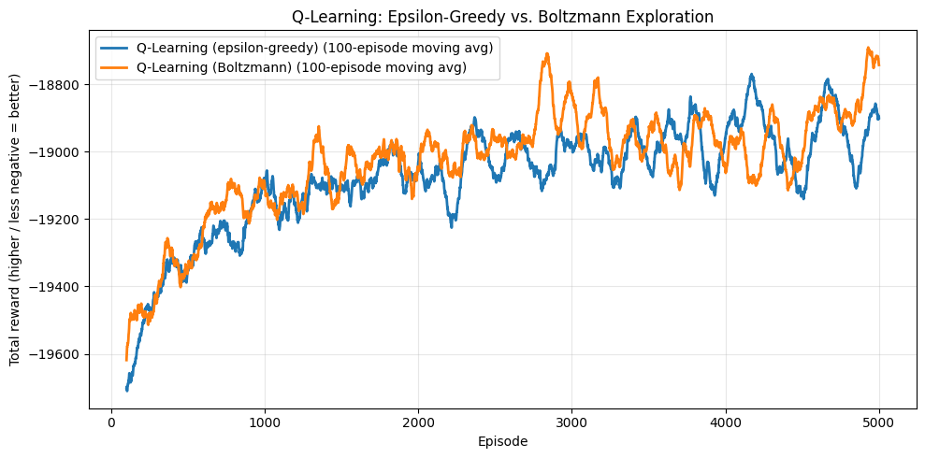
Figure 1. Q-learning reward over 5,000 training episodes (16-queue model).

Figure 2. Q-learning vs. SARSA training reward, 100-episode moving average.

6.2 Exploration strategy
For tabular Q-learning, Boltzmann exploration finished with a slightly better final-500 average reward than epsilon-greedy (−18,832 vs. −18,924). For DQN, the gap was much larger: epsilon-greedy DQN reached −16,826 in its final 500 episodes versus −18,756 for Boltzmann DQN. Epsilon-greedy treats every exploratory action as equally likely regardless of how poor it currently looks, whereas Boltzmann exploration concentrates probability mass on actions already believed to be good; with a function approximator such as DQN, this appears to translate into a meaningfully faster and higher final policy quality.
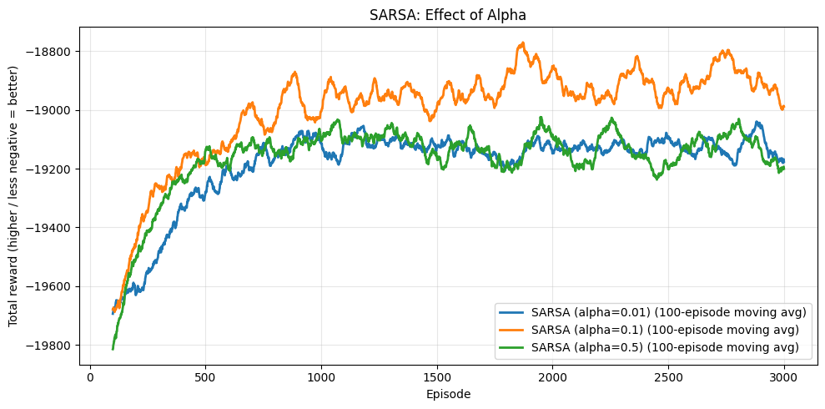
Figure 3. Q-learning: epsilon-greedy vs. Boltzmann exploration.

6.3 Gamma and alpha sensitivity
Varying the discount factor γ ∈ {0.5, 0.9, 0.99} had a comparatively small effect on final reward for both algorithms (Q-learning ranged from −19,017 to −19,008; SARSA improved modestly and monotonically from −18,968 at γ=0.5 to −18,890 at γ=0.99). Varying the learning rate α ∈ {0.01, 0.1, 0.5} mattered more: α = 0.1 was best for both algorithms (Q-learning: −19,006; SARSA: −18,903), while the smallest and largest tested values both underperformed it, consistent with α = 0.01 learning too cautiously to converge within 3,000 episodes and α = 0.5 producing noisier, less stable updates.
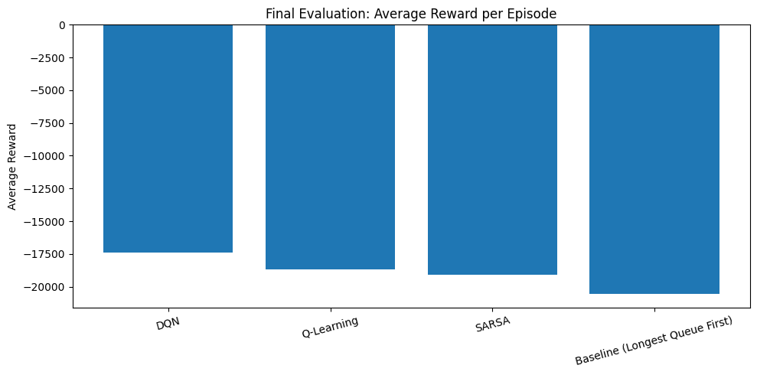
Figure 4. Effect of γ on Q-learning training reward.

6.4 DQN training
DQN's total-system-queue metric improves steadily across 5,000 episodes once the replay buffer has enough transitions to train on, with the clearest gains appearing in roughly the last 2,000 episodes as ε reaches its floor and the network's predictions stabilize.
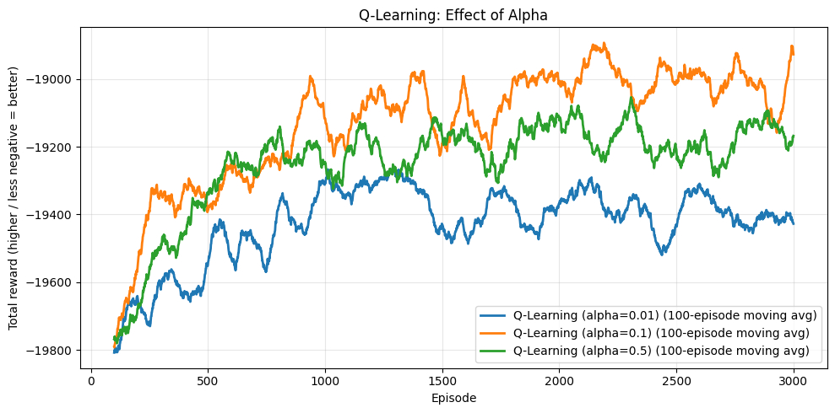
Figure 5. DQN total system queue over 5,000 training episodes.

7. Final Comparison (Canonical, Reproducible Result)
The result below is the canonical final comparison: all four controllers (baseline, Q-learning, SARSA, DQN) trained under the fixed global seed (42) described in Section 5, then evaluated on the same 200 held-out episodes with exploration disabled.

7.1 Clean observations
Algorithm | Avg. Reward / Episode | Avg. Cumulative Queue | Avg. Queue / Step
Baseline (longest queue first) | −20,559.2 | 20,559.2 | 205.59
Q-Learning | −18,943.0 | 18,943.0 | 189.43
SARSA | −18,904.6 | 18,904.6 | 189.05
DQN | −17,411.3 | 17,411.3 | 174.11

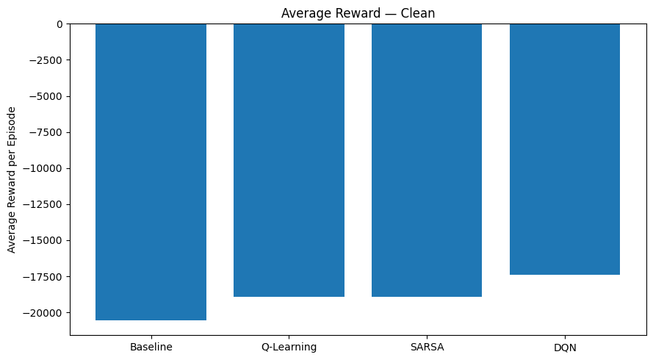
Figure 6. Canonical average reward per episode, clean observations (Step 8b).
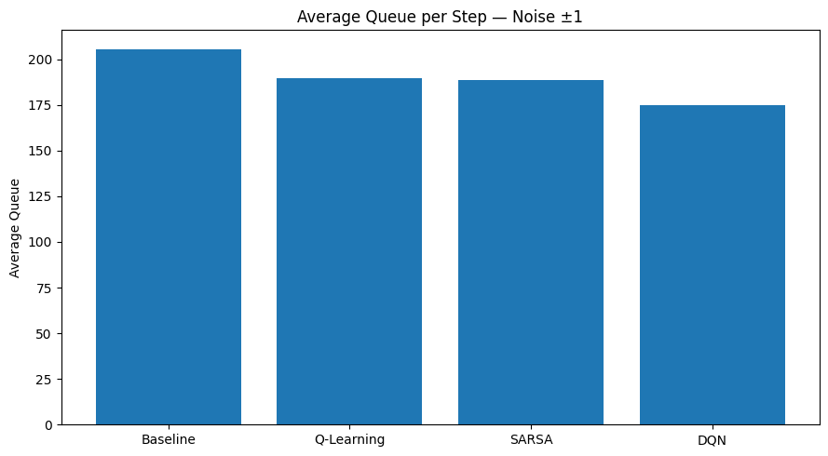
Figure 7. Canonical average queue per step, clean observations (Step 8b).
All three learned controllers reduce average queue per step relative to the baseline by 8–15%, and DQN reduces it by a further 8–9 points relative to the tabular methods, consistent with its access to the full-precision state rather than a two-bucket discretization.

7.2 Robustness to sensor noise
The same four controllers were re-evaluated with observation noise added to the queue readings the agents receive (the true state is still used to compute reward, so this measures decision quality under imperfect sensing rather than a different task).
Condition | Algorithm | Avg. Reward / Episode | Avg. Queue / Step
Clean | Baseline | −20,559.2 | 205.59
Clean | Q-Learning | −18,943.0 | 189.43
Clean | SARSA | −18,904.6 | 189.05
Clean | DQN | −17,411.3 | 174.11
Noise ±1 | Baseline | −20,566.1 | 205.66
Noise ±1 | Q-Learning | −18,973.0 | 189.73
Noise ±1 | SARSA | −18,879.3 | 188.79
Noise ±1 | DQN | −17,491.6 | 174.92
Noise ±2 | Baseline | −20,566.1 | 205.66
Noise ±2 | Q-Learning | −18,856.3 | 188.56
Noise ±2 | SARSA | −18,807.2 | 188.07
Noise ±2 | DQN | −17,564.3 | 175.64

The ranking DQN > SARSA ≈ Q-learning > baseline is preserved at every noise level. The tabular methods are relatively insensitive to noise because several nearby raw queue values collapse to the same Low/High bucket, which acts as an implicit low-pass filter; DQN, which consumes exact values, shows a small but consistent degradation as noise increases (−17,411 clean → −17,564 at ±2 noise), yet remains the best-performing controller throughout the tested noise range.

8. Reward Shaping
Two shaping terms were added to the base congestion reward and compared against it and their combination, using Q-learning as the test algorithm and evaluating all four variants on identical physical metrics (not the shaped training reward, since the shaped rewards are on different numerical scales).
Reward design | Avg. Reward | Avg. Queue/Step | Avg. Blocked Cars | Max Starvation
Base congestion reward | −18,902.1 | 189.02 | 573.5 | 95.6
Blocked-car penalty | −19,137.2 | 191.37 | 726.9 | 99.2
Fairness penalty | −18,952.8 | 189.53 | 560.4 | 96.0
Combined shaping | −18,913.4 | 189.13 | 639.8 | 98.7

Reward shaping did not uniformly improve outcomes: the blocked-car penalty, intended to discourage spillback, instead increased both average queue and blocked-car counts relative to the unshaped baseline, while the fairness penalty modestly reduced blocked cars at a small queue-length cost. This illustrates a general risk in reward shaping — a term added to discourage one failure mode can create a new incentive that worsens a different metric — and is consistent with the fairness term occasionally protecting a small, neglected queue at the expense of serving the globally largest one.

9. Code Review: Reconciling Duplicate Final-Comparison Sections
An earlier draft of the accompanying notebook contained two sections labeled as a “final” Baseline vs. Q-learning vs. SARSA vs. DQN comparison, and two sections comparing exploration strategies, without any note explaining why they existed or why their numbers differed. This was flagged in code review (a deduction on an otherwise 48/50 code score, citing “accretion rather than a clean final pass” and specifically that two cells reported different DQN evaluation numbers with no reconciliation). This section documents the fix applied to the notebook, distinct from anything discovered in this paper's own analysis.

9.1 Root cause
The two “final comparison” sections evaluated two different, independently trained sets of policies. The first (now labeled Step 8a — preliminary) evaluated Q_qlearning, Q_table_sarsa, and dqn_model, trained earlier in the notebook (Steps 2–4 and an early DQN pass) before a fixed random seed was introduced. The second (now labeled Step 8b — canonical) evaluated Q_clean_final, Q_sarsa_clean_final, and dqn_clean_final, retrained later in a dedicated reproducibility pass with a fixed global seed (42). Because RL training is stochastic — exploration order, minibatch sampling, and replay-buffer contents all vary run to run — two independent training runs of the same algorithm converge to similar but numerically distinct policies. The baseline row, which has no trainable parameters, is identical between the two sections (−20,559.2 in both), which confirms the environment itself was unchanged and the discrepancy was purely a matter of which trained policy was evaluated.

9.2 Fix applied
- Both sections were explicitly relabeled: “Step 8a — Preliminary Evaluation” and “Step 8b — Canonical Final Evaluation (seed = 42, reproducible),” with Step 8b marked as the number reported in this paper and the slide deck.
- An explicit reconciliation note was inserted between the two sections, stating which trained objects each one evaluates, why they differ numerically, and confirming (via the matching baseline row) that the discrepancy is not an environment bug.
- The same a/b convention was applied to the two exploration-comparison sections (Step 5a: tabular Q-learning, Step 5b: DQN), which were not actually duplicates of each other — they compare exploration strategies for two different algorithms — but had ambiguous headers that made this hard to tell at a glance.
- The notebook's introduction now states this convention up front and the final checklist records the cleanup as a completed item, so a reader does not need to infer the reconciliation from context.
All numeric results in Sections 6–8 of this paper are drawn from Step 8b (and its supporting Step 7 reproducible-trainer cells), i.e. the seed-fixed, reproducible pass, per the fix above.

10. Discussion
DQN's advantage over the tabular methods is consistent with its access to the full 16-value state rather than a coarse Low/High discretization: two intersections that look identical to a tabular agent after bucketing can look meaningfully different to a network operating on exact queue counts, allowing DQN to make finer-grained decisions. This same property is also the source of DQN's greater sensitivity to sensor noise (Section 7.2) — the bucket boundary itself provides the tabular methods a small amount of implicit robustness that DQN does not get for free.
SARSA's small but consistent edge over Q-learning across the gamma study, the alpha study, and the main comparison is consistent with the on-policy vs. off-policy distinction discussed in Section 4.1: in an environment where a poor exploratory action can create congestion that persists for several steps (queues do not clear instantly), a controller that accounts for its own exploration noise while learning, as SARSA does, is more likely to end up preferring conservative, spillback-avoiding actions.

11. Limitations and Future Work
- Two-bucket (Low/High) discretization is coarse; a finer discretization or a purely function-approximation approach would likely narrow the tabular-vs-DQN gap further, at the cost of a larger table or more training data.
- The simulator is a lightweight queue model rather than a microsimulator such as SUMO; this was a deliberate, documented scope decision rather than an oversight, since a full microsimulation was not required for this project.
- Reward shaping was only explored for Q-learning; extending the same shaping terms to SARSA and DQN would clarify whether the blocked-car penalty's negative effect (Section 8) is specific to off-policy tabular learning or general.
- Only a single fixed seed (42) was used for the canonical reproducible results; averaging over multiple seeds would give a variance estimate for each algorithm's final performance and make the DQN vs. SARSA vs. Q-learning ranking statistically sharper.

12. Conclusion
Across a fixed, reproducible evaluation protocol, all three learned traffic-signal controllers substantially outperform a longest-queue-first baseline, with DQN performing best, followed closely by SARSA and then Q-learning; the ranking is stable under sensor noise. Where an earlier development pass had left two differently-numbered “final” results in the accompanying notebook without explanation, this paper reports the seed-fixed, reproducible Step 8b evaluation as canonical and documents the specific reconciliation applied to the notebook so the two passes no longer read as an unexplained inconsistency.

References
[1] Reinforcement Learning — Core Concepts (course slide deck): agent–environment loop, policy/return/value, exploration vs. exploitation, and the Q-learning update rule.
[2] Agent Types — Deep Dive (course slide deck): simple reflex, model-based, goal-based, utility-based, and learning agent architectures, used in Section 2 to characterize the baseline and learned controllers.
[3] Project notebook, Adaptive_Traffic_Signal_RL.ipynb (this project), Steps 0–10, including the Step 8a/8b reconciliation described in Section 9.

