第二题程序：#include <iostream>
using namespace std;
main()
{
int n=100;
for(n=100;n<=200;n++)
{
if((n%3!=0)&&(n%7!=0))
cout<<n<<"\t";
}
}
程序运行结果截图：
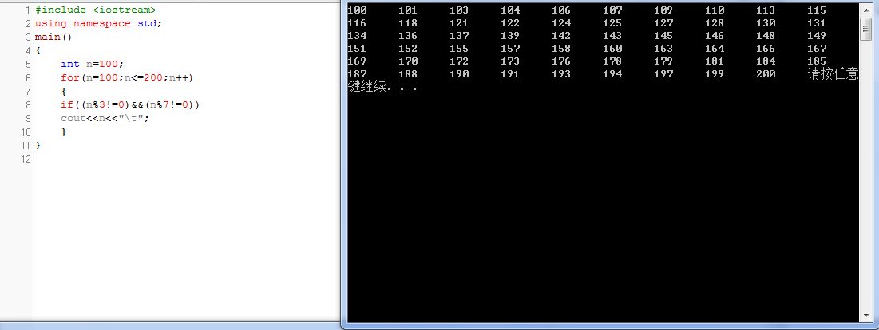
第五题程序：#include <iostream>
using namespace std;
main()
{char n;
cout<<"正序是：";
for( n='A';n<='Z';n++)
cout<<n<<"\t";
cout<<"\n";
cout<<"逆序是:";
for(n='Z';n>='A';n--)
cout<<n<<"\t";
return 0;
}
程序运行结果截图：
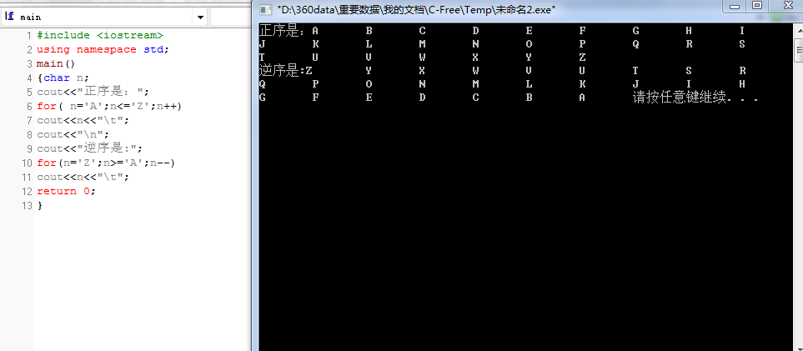
第十一题程序：#include <iostream>
using namespace std;
main()
{
float x;
int y;
float d;
cout<<x<<"重量为:";
cin>>x;
cout<<d<<"距离为:";
cin>>d;
if(x>60)
{ y=15+(int)(d/1000);
cout<<y<<"邮资为:";}
else if(x>45)
{y=14+(int)(d/1000);
cout<<y<<"邮资为:";}
else if(x>30)
{y=12;
cout<<y<<"邮资为:";}
else if (x>15)
{y=9;
cout<<y<<"邮资为:";}
else
{ y=5;
cout<<y<<"邮资为:";}
}
程序运行结果截图：
