3179 week9 homework

Xiaoyu Sun

32950683

studio 24

Joe Liu

The URL: <https://github.com/suxyu/3179-a2/tree/main>

hw9.json is the map json file

The screen shot:

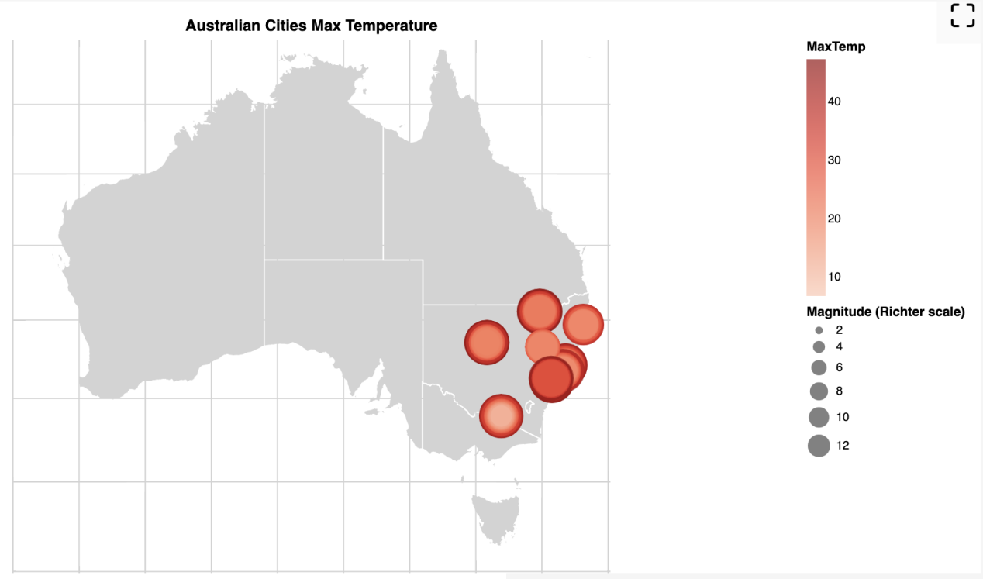

-the domain of my visualization is the Australian weather in different cities

-The visualized data set:

data source:

<https://www.kaggle.com/datasets/rever3nd/weather-data>

<https://www.kaggle.com/datasets/shamilnabi/weather-australia-geo-coordinates>

The first one contains city name and its weather data. The second one contains the city names and their latitude and longitude data. I wrote a python code to merge the two csv.

The weather data contains temperature, rainfall,evaporation, etc data w.r.t. date

-Justification for map idiom: Since all my data are only points on the map. It is reasonable to use circle mark to represent each data. I also used size and color to represent the magnitude.

In addition, since temperatures are pretty similar, I used “pow” scale type to better distinguish the difference.