create database crdb;

use crdb;

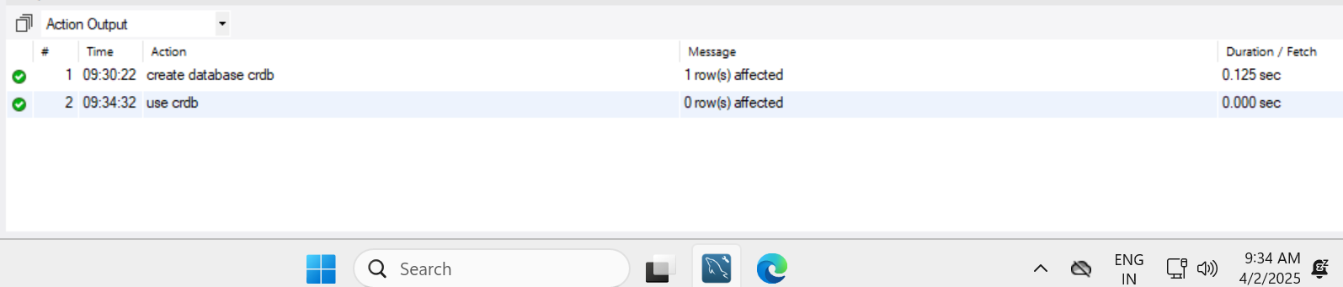

create table vehicle(

vehicle_id int primary key,

make varchar(20),

model varchar(20),

yearr year,

dailyrate double,

available int,

pass_cap int,

eng_cap double);

create table customer(

customer_id int primary key,

f_name varchar(20),

l_name varchar(20),

email varchar(30),

ph_no varchar(10));

create table lease(

lease_id int primary key,

vehicle_id int,

customer_id int,

startDate date,

endDate date,

leasetype varchar(10));

create table payment(

payment_id int primary key,

lease_id int,

pay_date date,

amount double);

show tables;

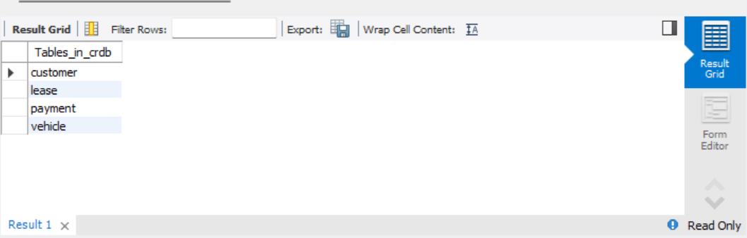

insert into vehicle values (1 , "Toyota", "Camry" , "2022" , 50.00 , 1 , 4 , 1450 ),

(2 , "Honda" , "Civic" , "2023" , 45.00 , 1 , 7 , 1500),

(3 , "Ford" , "Focus" , "2022" , 48.00 , 0 , 4 , 1400),

(4 , "Nissan" ,"Altima" , "2023" , 52.00 , 1 , 7 , 1200),

(5 , "Chevrolet" , "Malibu" , "2022" , 47.00 , 1 , 4 , 1800),

(6 , "Hyundai" , "Sonata" , "2023" , 49.00 , 0 , 7 , 1400),

(7 , "BMW" , "3 Series" , "2023", 60.00 , 1 , 7 , 2499),

(8 , "Mercedes" , "C-Class" , "2022" , 58.00 , 1 , 8 , 2599),

(9 , "Audi" , "A4" , "2022" , 55.00 , 0 , 4 , 2500),

(10 , "Lexus" , "ES" , "2023" , 54.00 , 1 , 4 , 2500);

select * from vehicle;

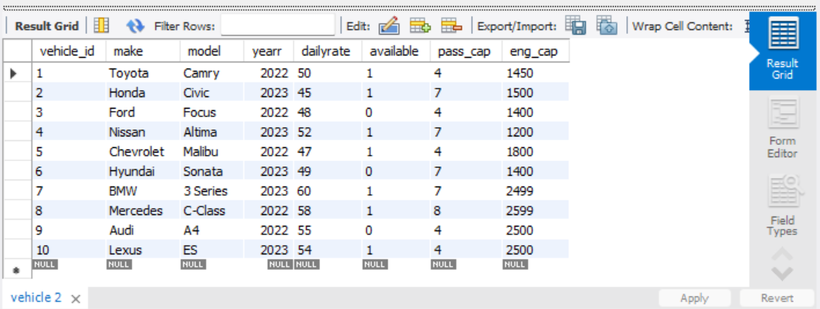insert into lease values (1 , 1 , 1 , "2023-01-01" , "2023-01-05" , "Daily"),

(2 , 2 , 2, "2023-02-15" , "2023-02-28" , "Monthly"),

(3 , 3 , 3 , "2023-03-10" , "2023-03-15" , "Daily"),

(4 , 4 , 4 , "2023-04-20" , "2023-04-30" , "Monthly"),

(5 , 5 , 5 , "2023-05-05" , "2023-05-10" , "Daily"),

(6 , 4 , 3 , "2023-06-15" , "2023-06-30" , "Monthly"),

(7 , 7 , 7 , "2021-07-01" , "2023-07-10" , "Daily"),

(8 , 8 , 8 , "2023-08-12" , "2023-08-15" , "Monthly"),

(9 , 3 , 3 , "2023-09-07" , "2023-09-10" , "Daily"),

(10 , 10 , 10 , "2023-10-10" , "20-10-31" , "Monthly");

select * from lease;

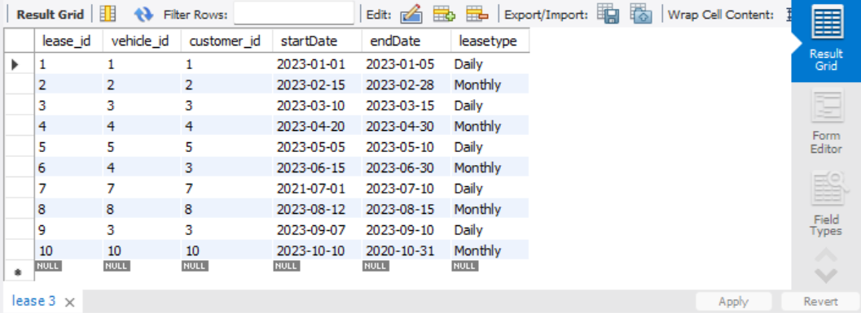

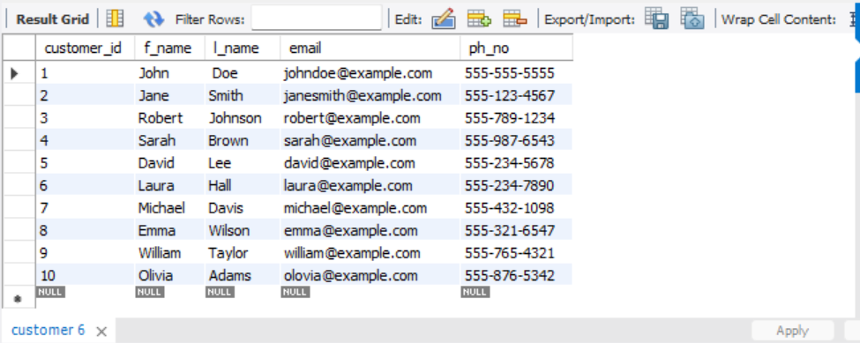insert into customer values (1 , "John" , " Doe " , "johndoe@example.com" ,'555-555-5555'),

(2 , "Jane", "Smith" , "janesmith@example.com" , '555-123-4567'),

(3 , "Robert" , "Johnson" , "robert@example.com" , "555-789-1234"),

(4 , "Sarah" , "Brown" , "sarah@example.com" , '555-987-6543'),

(5 , "David", "Lee" , "david@example.com" , '555-234-5678'),

(6 , "Laura", "Hall" , "laura@example.com" , '555-234-7890'),

(7 , "Michael" , "Davis" , "michael@example.com" , '555-432-1098'),

(8 , "Emma" , "Wilson" , "emma@example.com" , '555-321-6547'),

(9 , "William" , "Taylor" , "william@example.com" ,'555-765-4321'),

(10 , "Olivia" , "Adams" , "olovia@example.com" , '555-876-5342');

select * from customer;

insert into payment values (1 , 1 , "2023-01-03" ,200.00),

(2, 2 ,"2023-01-20",900.00),

(3,3,"2023-03-12",75.00),

(4,4,"2023-04-25",900),

(5,5,"2023-05-07",60.00),

(6,6,"2023-06-18",1200.00),

(7,7,"2023-07-03",40.00),

(8,8,"2023-08-14",1100.00),

(9,9,"2023-09-09",80.00),

(10,10,"2023-10-25",1500.00);

select * from payment;

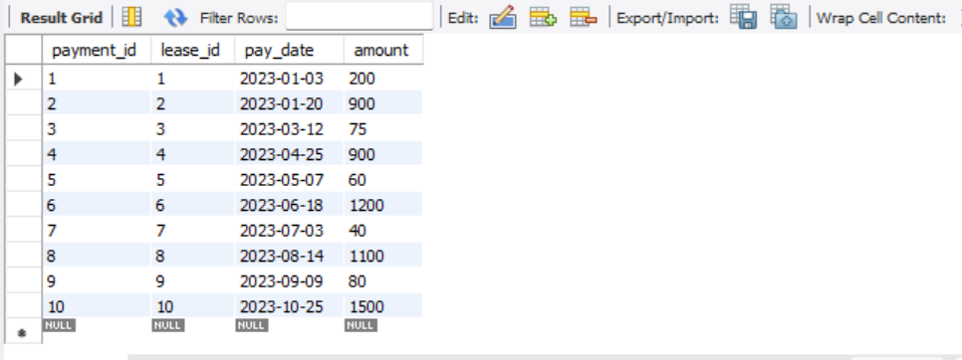

1. update vehicle set dailyrate = 68 where make = 'Mercedes';

 select * from vehicles;



1. Delete from payment where lease_id = (select lease_id from lease where customer_id=2);

Delete from lease where customer_id=2;

Delete from customer where customer_id =2;

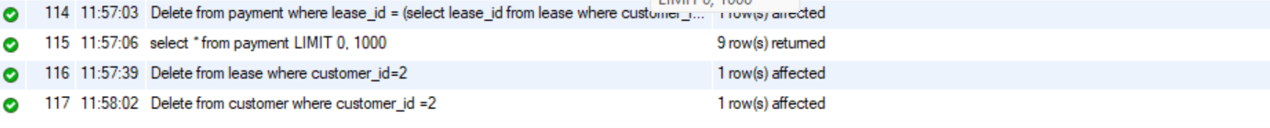

1. alter table payment change pay_date transactiondate date;

 select * from payment;

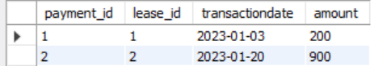

1. select * from customer where [email='laura@example.com](mailto:email='laura@example.com)';

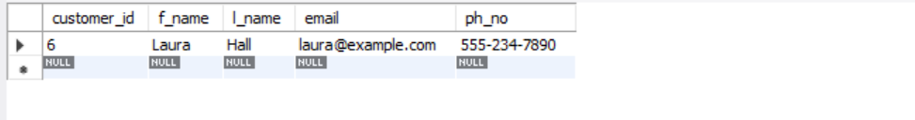

1. select * from lease where customer_id = 5;

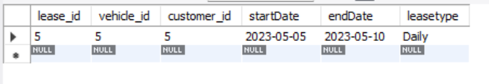

1. select c.f_name, c.l_name, p.payment_id, p.amount from payment p join lease l on p.lease_id=l.lease_id join customer c on l.customer_id=c.customer_id where c.ph_no = '555-789-1234' group by p.payment_id;

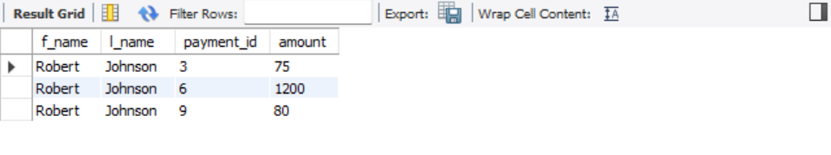

1. select avg(dailyRate) as Avg_Rate from vehicle where available > 0;



1. select vehicle_id, make, model from vehicle

where dailyRate = (select max(dailyRate) from vehicle);

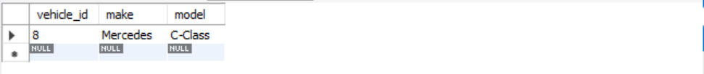

1. select c.f_name, c.l_name,l.lease_id,v.vehicle_id, v.make, v.model,v.dailyRate from vehicle v join lease l on l.vehicle_id = v.vehicle_id join customer c on c.customer_id = l.customer_id where c.f_name= 'Robert' and c.l_name='Johnson';

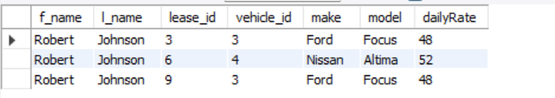

1. select * from lease where endDate=(select max(endDate) from lease); 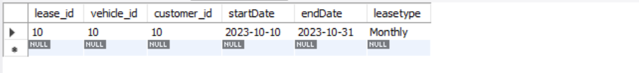
2. select * from payment where year(transactiondate) = 2023;

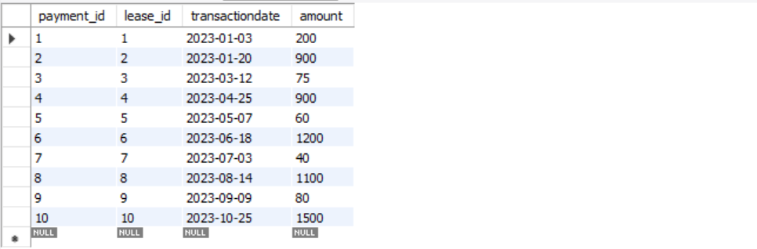

1. select * from customer

where customer_id not in ( select distinct(customer_id) from lease);

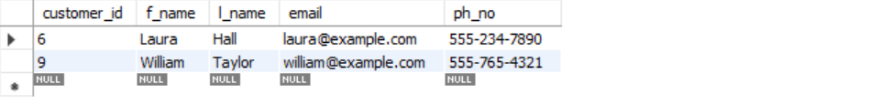

1. select v.*, sum(p.amount) as totalAmount from vehicle v join lease l on v.vehicle_id=l.vehicle_id join payment p on l.lease_id=p.lease_id group by v.vehicle_id ,v.make;

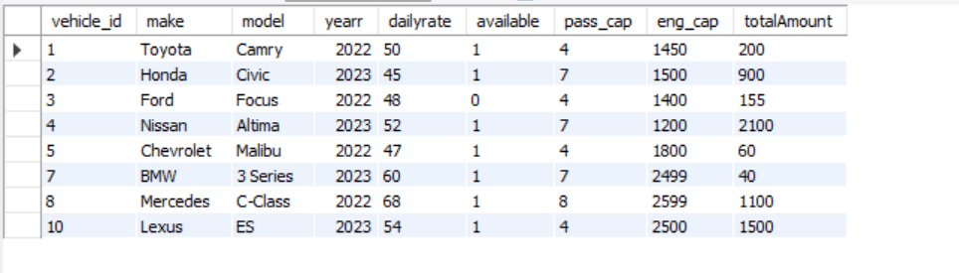

1. select c.*, sum(p.amount) as TotalPayment from customer c join lease l on l.customer_id=c.customer_id join payment p on p.lease_id=l.lease_id group by c.customer_id;

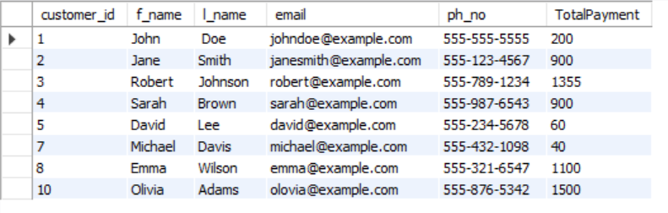

1. select l.lease_id, v.* from vehicle v join lease l on v.vehicle_id=l.vehicle_id;

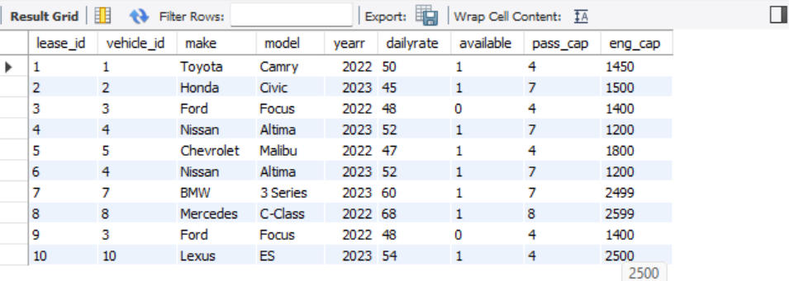

1. select l.lease_id, c.*,v.* from lease l join vehicle v on v.vehicle_id = l.vehicle_id join customer c on c.customer_id = l.customer_id where enddate> curdate();

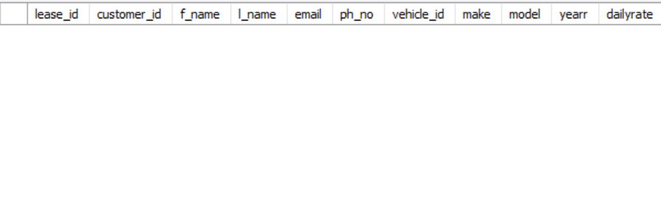

1. select c.*, sum(p.amount) as TotalPayment from customer c join lease l on l.customer_id=c.customer_id join payment p on p.lease_id=l.lease_id group by c.customer_id order by sum(p.amount) desc limit 1;

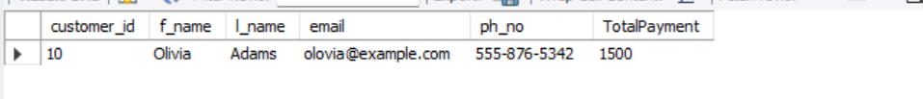

1. select c.*, l.* from lease l right join vehicle c on c.vehicle_id=l.vehicle_id where endDate >= curdate();

