# ITEC3150-Final-Exam-Project

ADVANCE PROGRAMMING FEATURES: Generic Class/Method, GUI, and Threads

INSTRUCTIONS

1. Run Driver.java
2. Fill in General Information then click Next

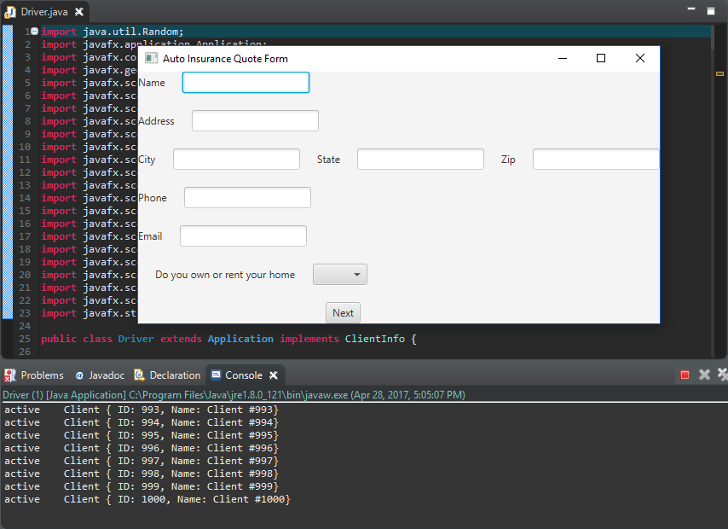

1. Fill in Vehicle Information then click Next

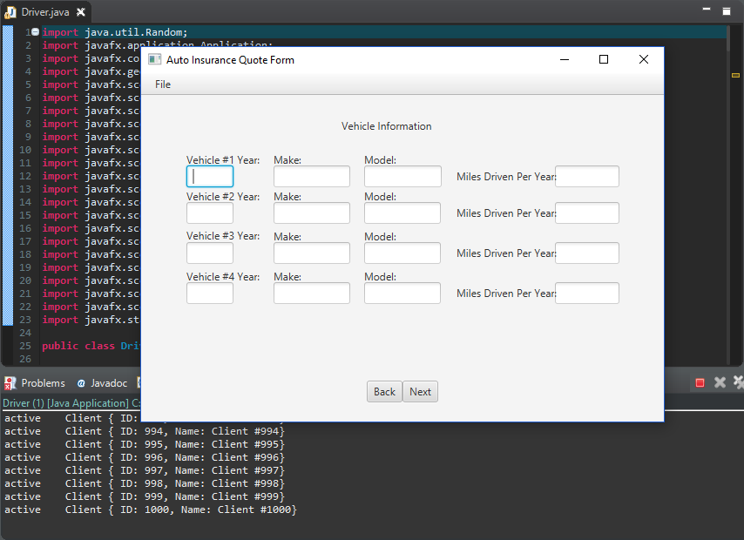

1. Fill in Driver Information then when done, click Submit.

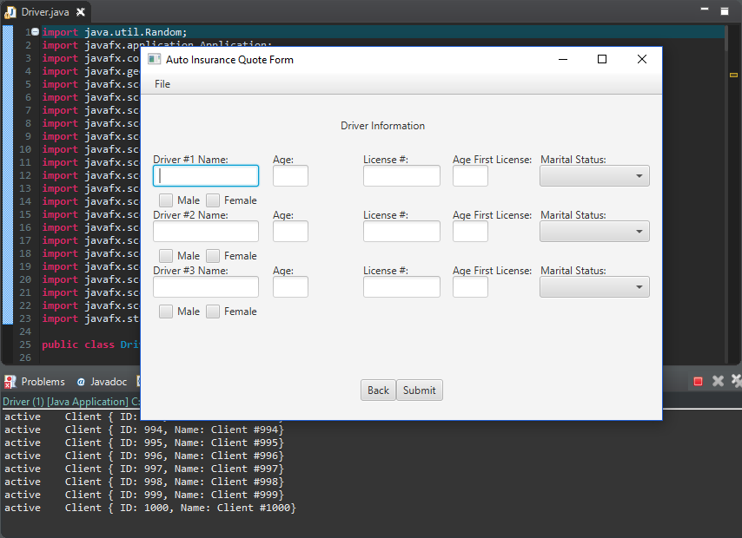

1. Quotes will be generated displaying total monthly, 6 month, and annually term.

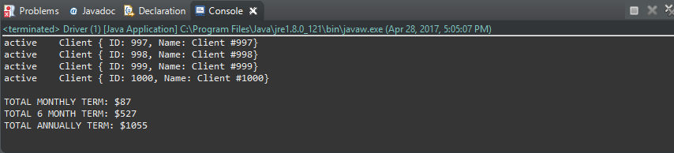

UML DIAGRAM

