Developing an environmental monitoring system is a complex and multifaceted project that typically involves several key components

**Project Introduction**

* Provide an overview of the project's objectives.
* Explain the significance of environmental monitoring.

**Project Goals and Objectives**

* Define specific goals and measurable objectives.
* Explain what you intend to achieve with the monitoring system.

**Environmental Parameters**

* Identify the environmental parameters you plan to monitor (e.g., air quality, water quality, temperature, humidity, etc.).
* Explain why these parameters are important.

**Sensor Selection**

* Describe the types of sensors you'll use for data collection.
* Justify your sensor choices based on accuracy, cost, and applicability.

**Data Collection and Communication**

* Explain how the data will be collected from the sensors.
* Describe the communication protocols (e.g., IoT, wireless, wired) that will be used.

**Data Processing and Storage**

* Detail the methods for processing and storing the collected data.
* Mention any algorithms or data processing techniques you plan to implement.

**Data Visualization**

* Discuss how the environmental data will be visualized for users.
* Consider graphs, charts, dashboards, or other visualization tools.

**Power Supply**

* Explain how the system will be powered (e.g., batteries, solar panels, mains power).
* Address power management and energy efficiency.

**Environmental Impact Assessment**

* Consider the ecological impact of your monitoring system.
* Describe any measures you'll take to minimize its environmental footprint.

**Budget and Resources**

* Provide an estimated budget for Part 1.
* List the resources (hardware, software, personnel) required.

**Timeline**

* Define deadlines for each phase of development.
* Create a project timeline with milestones for Part 1.

**Risks and Mitigation**

* Identify potential risks to the project's success.
* Explain how you plan to mitigate these risks.

**Regulatory Compliance**

* Discuss any legal and regulatory requirements for environmental monitoring.
* Ensure compliance with local, national, and international regulations.

**Conclusion**

* Summarize the key points of Part 1.
* Provide a transition to the next phase of the project.

Keep in mind that Part 1 is usually focused on the planning and initial setup of the project. Subsequent parts will delve into implementation, testing, and data analysis.

Circuit Diagram

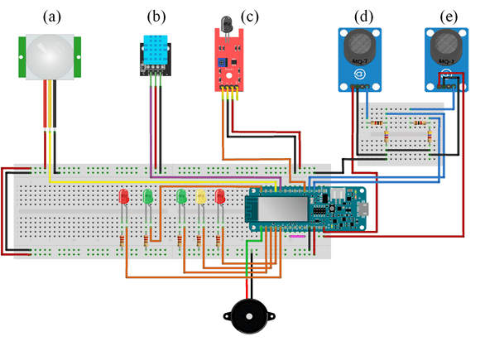

Flow chart

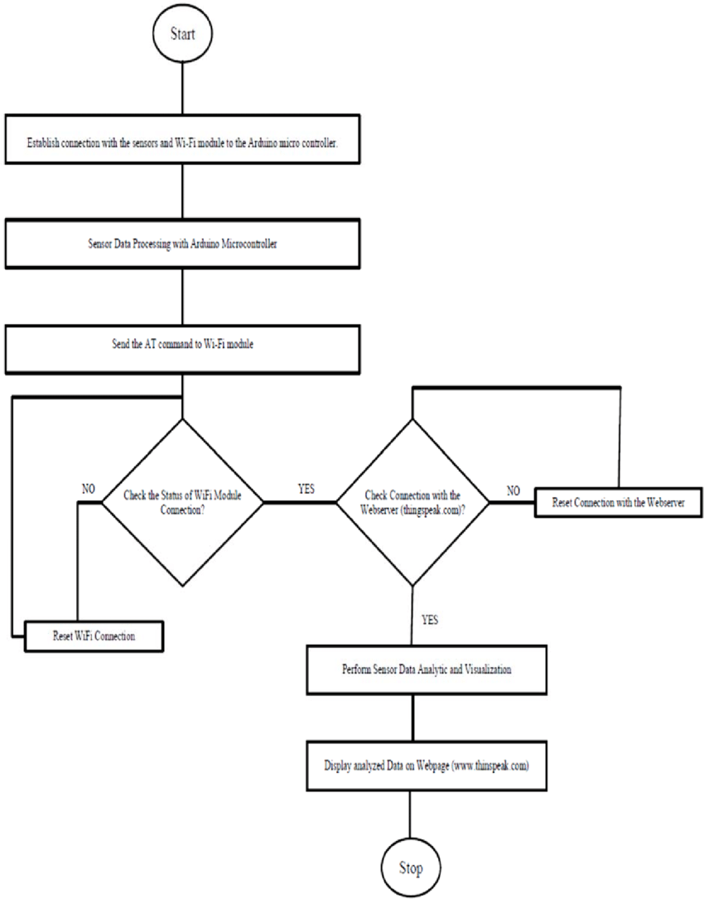

Python Coding

import serial

# Define the serial port and baud rate

ser = serial.Serial('COM3', 9600) # Replace 'COM3' with your Arduino's serial port

try:

    while True:

        # Read data from the Arduino

        data = ser.readline().decode('utf-8').strip() # Decode and remove trailing newline

        # Print the received data

        print(data)

except KeyboardInterrupt:

    # Handle user interruption

    print("Monitoring stopped.")