Student Grade Management System
A PROJECT REPORT
Submitted by
Sr No | Name | Registration No
1 | Shraddha Suyal

in partial fulfillment for the award of the degree
of
BACHELOR OF TECHNOLOGY
School of Computer Science and Engineering
August 2026

TABLE OF CONTENTS
Sr No | Topic | Page
1 | Abstract | 3
2 | Introduction | 4
3 | Problem Statement | 5
4 | Objectives | 6
5 | Scope | 7
6 | System Design & Analysis | 8
7 | Technologies Used | 9
8 | Architect Diagram | 10
9 | Module Description | 11
10 | Implementation | 11
11 | Code Snippets | 12-13
12 | Screenshot of Web Pages | 14-16
13 | Testing | 17
14 | Result | 18
15 | Output Screenshot | 18
16 | Conclusion | 19
17 | Future Work | 19
18 | References | 20

ABSTRACT
The Student Grade Management System is a web-based academic dashboard developed to simplify the process of recording student details, entering subject marks, and generating instant grade-based performance summaries. The system allows a teacher or coordinator to register students with roll numbers, assign marks for Mathematics, Science, and English, and automatically compute each student's average score, grade, and pass or fail status. It also highlights class-level analytics such as total students, topper details, and class average so that the overall performance picture is available at a glance.
The project is built using HTML5, CSS3, JavaScript, and a lightweight Node.js static server for local execution. Browser local storage is used to preserve records between sessions, while the JavaScript application logic handles validation, grade mapping, and dynamic dashboard rendering in real time. The result is a simple, responsive, and practical classroom utility that demonstrates how front-end web technologies can be used to digitize routine academic record management tasks.

INTRODUCTION
Managing student performance manually through paper registers or spreadsheets can be time-consuming, repetitive, and error-prone. Teachers often need to maintain lists of students, enter marks for multiple subjects, calculate averages, assign grades, identify toppers, and review class-level performance. When these tasks are handled manually, even small arithmetic mistakes or missing entries can affect the accuracy of the final report.
The Student Grade Management System addresses this challenge by offering a focused academic dashboard that combines student registration, marks entry, and performance reporting in a single interface. The application is designed for quick everyday use, with clear forms, automatic calculations, and a live data table that updates instantly whenever a new student is added or marks are modified.
From a technical perspective, the project demonstrates a clean front-end architecture in which HTML defines the structure, CSS provides the dashboard styling, and JavaScript coordinates all validation, calculations, state updates, and persistence. A small Node.js server is used to serve the static files locally during execution and testing.

PROBLEM STATEMENT
In many academic settings, student records are still maintained using disconnected tools such as notebooks, spreadsheets, or multiple paper files. This makes the process of registering students, recording subject-wise marks, and producing quick performance summaries inefficient. Repeated manual calculations of average marks and grade categories also increase the chance of mistakes and consume time that could otherwise be used for teaching or student support.
The Student Grade Management System is designed to solve this problem by providing a single digital interface for entering student information and marks while automatically generating averages, letter grades, pass or fail status, topper information, and class-level statistics. The project reduces repetitive work, improves data clarity, and demonstrates a structured approach to small-scale academic record management through a browser-based dashboard.

OBJECTIVES
- To register students with essential academic identifiers such as student name and roll number.
- To provide a subject-wise marks entry interface for Mathematics, Science, and English.
- To calculate average marks automatically and map them to grade categories without manual intervention.
- To display pass or fail status immediately after marks are updated.
- To present summary indicators such as total students, topper, and class average in a dashboard format.
- To preserve student records in the browser so that the application remains useful across sessions.

SCOPE
The scope of the Student Grade Management System is centered on small to medium classroom use where a teacher, mentor, or coordinator needs a quick and reliable method to maintain student performance data. The current version supports student registration, subject-wise marks entry for three subjects, automatic average calculation, grade assignment, pass or fail determination, and live performance reporting through a responsive dashboard.
The application is intentionally lightweight and easy to deploy because it does not depend on a database server or external APIs. Its current implementation is best suited for local use, classroom demonstrations, and introductory academic management scenarios. Future enhancements can extend the project toward multi-subject support, exportable reports, authentication, cloud-backed storage, attendance integration, and richer analytics such as subject trends and student comparisons.

SYSTEM DESIGN & ANALYSIS
The Student Grade Management System follows a simple client-side architecture in which the browser hosts the full user interface and application logic, while a minimal Node.js server delivers the static project files. The application interface is divided into four major visual blocks: a hero header, a student registration panel, a marks entry panel, and a reporting area containing summary cards and the performance table.
The system workflow begins when the user enters student details through the registration form. After validation checks for empty fields and duplicate roll numbers, the student record is added to the in-memory student array and stored in browser local storage. Once a student is available in the list, the marks module allows subject scores to be assigned. JavaScript then calculates the average score, determines the grade through conditional rules, and updates the pass or fail status before the interface is re-rendered.
The reporting area continuously reflects the latest state of the data. It shows the total number of students, identifies the topper by sorting student averages, calculates the class average, and lists all student records in a tabular view. This design keeps the application responsive and easy to understand, while also making the codebase suitable for learning core front-end development patterns such as form handling, DOM updates, data validation, and local persistence.

TECHNOLOGIES USED
The project uses a compact set of front-end and Node.js technologies. Each technology contributes a specific responsibility to the interface, interaction logic, or local execution environment.
Technology | Purpose
HTML5 | Provides the semantic structure for forms, summary cards, and the performance table.
CSS3 | Creates the dashboard layout, gradients, cards, responsive grid, and visual styling.
JavaScript (ES6) | Handles validation, state updates, grade calculation, rendering, and user feedback messages.
Browser Local Storage | Preserves student records and marks between page reloads on the same device.
Node.js | Runs the local static server used to preview and test the application in the browser.
HTTP, FS, and Path Modules | Serve project files safely and map requests to the correct assets in server.js.
DOM APIs and crypto.randomUUID() | Support dynamic table rendering, form handling, and stable student identifiers.

ARCHITECT DIAGRAM
Figure 1 illustrates the high-level architecture of the Student Grade Management System and the relationship between the user, browser interface, grading logic, persistent browser storage, and the Node.js static server.
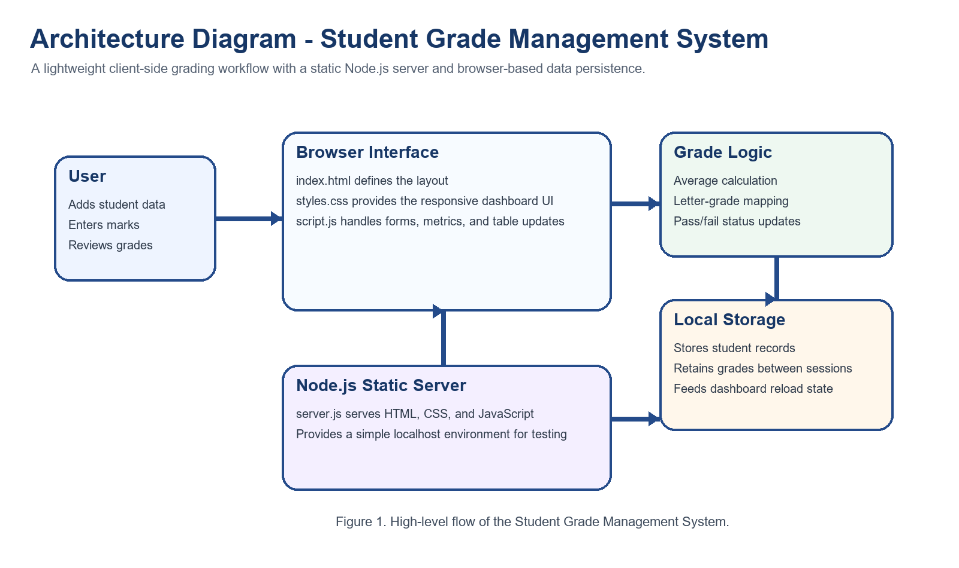
Figure 1. Architecture diagram of the Student Grade Management System.

MODULE DESCRIPTION
- Student Registration Module: captures the student name and roll number, validates required fields, and prevents duplicate roll entries.
- Marks Entry Module: allows the user to select a registered student and enter marks for Mathematics, Science, and English.
- Grade Evaluation Module: calculates the average score, assigns the grade band, and updates the pass or fail status.
- Summary Dashboard Module: computes the total number of students, topper information, and class average.
- Performance Report Module: renders a table view of every student record with subject scores and final outcome details.
IMPLEMENTATION
The implementation is organized into four project files. The `index.html` file structures the dashboard and form controls. The `styles.css` file defines the dark themed layout, responsive grid behavior, and reusable card treatments. The `script.js` file contains the complete application logic for form submission, validation, grade calculation, summary generation, local storage persistence, and dynamic table rendering.
The `server.js` file provides a lightweight Node.js HTTP server so that the project can be executed consistently through `http://127.0.0.1:8000/`. It resolves requests safely, determines the correct MIME type, and serves the static assets required by the dashboard. This separation keeps the project easy to understand while still reflecting a practical web development workflow.

CODE SNIPPETS
Snippet 1. Grade mapping and metrics update logic
function calculateGrade(average) {
if (average >= 90) return "A+";
if (average >= 80) return "A";
if (average >= 70) return "B";
if (average >= 60) return "C";
if (average >= 50) return "D";
return "F";
}
function updateStudentMetrics(student) {
const average = calculateAverage(student.marks);
student.average = Number(average.toFixed(1));
student.grade = calculateGrade(student.average);
student.status = student.average >= 40 ? "Pass" : "Fail";
}
Snippet 2. Student registration workflow
studentForm.onsubmit = function (event) {
event.preventDefault();
const name = document.getElementById("studentName").value.trim();
const rollNumber = document.getElementById("rollNumber").value.trim();
if (!name || !rollNumber) {
showMessage(studentMessage, "Please enter both student name and roll number.", true);
return;
}
const existingRoll = students.some((student) => student.rollNumber === rollNumber);
if (existingRoll) {
showMessage(studentMessage, "A student with this roll number already exists.", true);
return;
}
};

CODE SNIPPETS
Snippet 3. Dynamic table rendering
function renderStudents() {
studentTableBody.innerHTML = "";
studentSelect.innerHTML = '<option value="">Choose a student</option>';
students.forEach((student) => {
const row = document.createElement("tr");
row.innerHTML = `
<td>${student.name}</td>
<td>${student.rollNumber}</td>
<td>${student.marks.math}</td>
<td>${student.marks.science}</td>
<td>${student.marks.english}</td>
<td>${student.average.toFixed(1)}</td>
<td>${student.grade}</td>
<td class="${student.status === "Pass" ? "status-pass" : "status-fail"}">${student.status}</td>
`;
studentTableBody.appendChild(row);
});
}
Snippet 4. Static Node.js file server
const server = http.createServer((req, res) => {
const requestUrl = new URL(req.url, 'http://127.0.0.1');
const pathname = requestUrl.pathname === '/' ? '/index.html' : requestUrl.pathname;
const safePath = path.normalize(pathname).replace(/^([a-zA-Z]:[\\/])?/, '');
const filePath = path.join(rootDir, safePath);
if (!filePath.startsWith(rootDir)) {
res.writeHead(403, { 'Content-Type': 'text/plain; charset=utf-8' });
res.end('Forbidden');
return;
}
});

SCREENSHOTS OF WEB PAGES
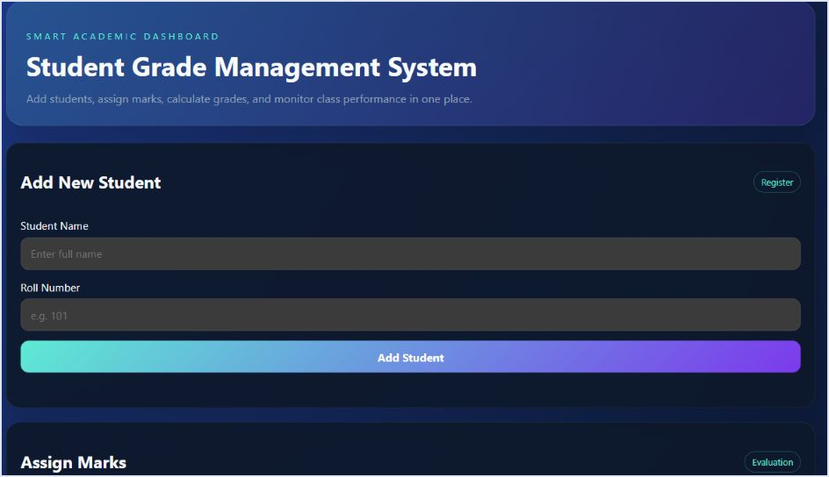
1. Home page overview of the academic dashboard.
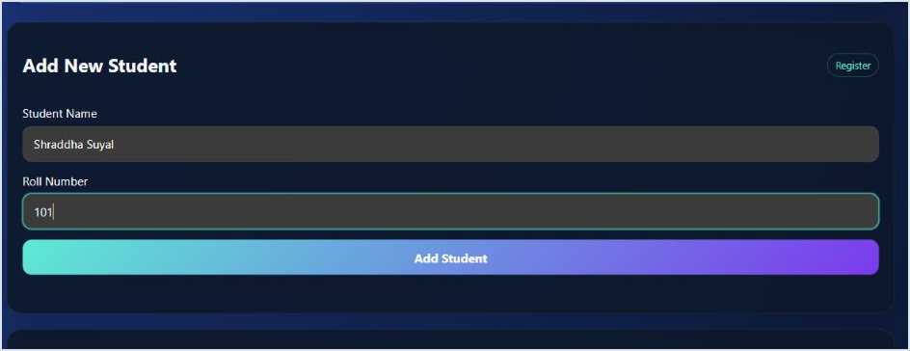
2. Student registration panel with name and roll number inputs.

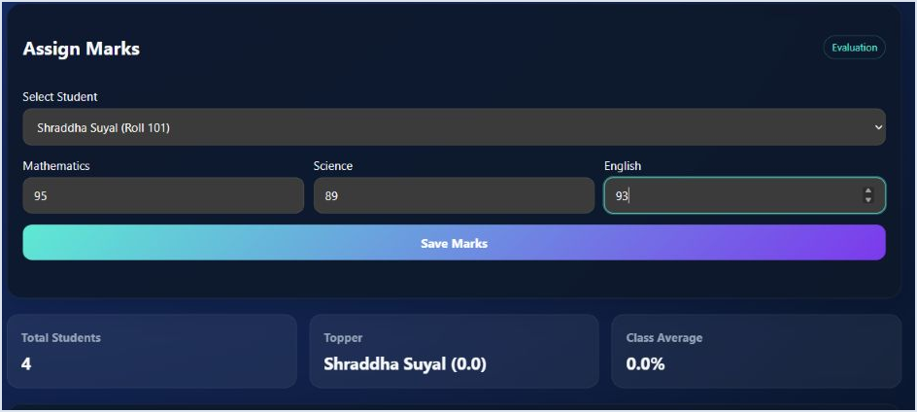
3. Marks assignment module showing subject-wise entry fields.
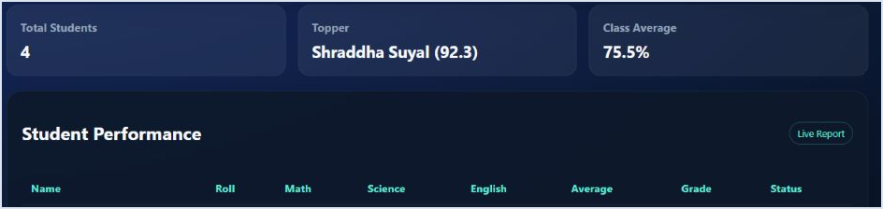
4. Summary cards highlighting total students, topper, and class average.

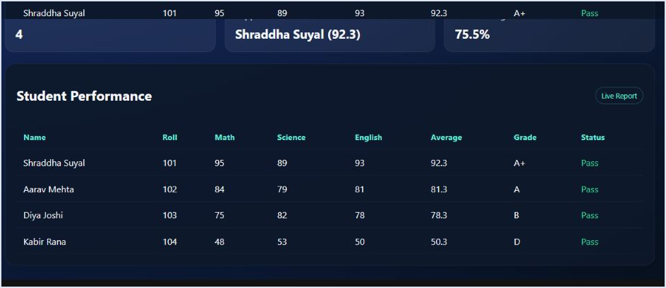
5. Student performance table displaying grades and final status.

TESTING
Functional testing was performed on the primary modules of the Student Grade Management System to confirm that the input flow, calculations, and output panels behave as expected.
Test Case | Expected Result | Status
Student registration | A new student record is created with valid name and roll number. | Passed
Duplicate roll validation | Duplicate roll numbers are rejected with an error message. | Passed
Marks entry | The selected student's marks are stored successfully. | Passed
Average calculation | Average score is calculated to one decimal place. | Passed
Grade generation | The correct grade is assigned according to the defined score bands. | Passed
Pass or fail status | Student status updates automatically after marks are saved. | Passed
Summary cards | Topper and class average values refresh after each update. | Passed
Responsive layout | The dashboard remains usable across smaller screen widths. | Passed

RESULT
The Student Grade Management System was successfully developed and tested as a responsive classroom dashboard. The application correctly supports student registration, subject-wise marks entry, average calculation, grade assignment, and live performance reporting. The final interface presents both student-level and class-level insights in a clear format, which improves the speed and reliability of basic academic record management.
OUTPUT SCREENSHOT

Final dashboard summary after completing student and marks entry.

CONCLUSION
The Student Grade Management System demonstrates how a focused web application can simplify an everyday academic task. By combining student registration, marks management, grade computation, summary analytics, and a live reporting table in one interface, the project reduces manual work and improves the clarity of classroom performance tracking.
The project also reflects core front-end development concepts such as structured HTML, responsive CSS, DOM manipulation, validation, local persistence, and modular JavaScript logic. Its clean architecture makes it suitable both as a practical classroom utility and as a learning project for web development fundamentals.
FUTURE WORK
- Support additional subjects and customizable grading schemes.
- Add edit and delete actions for existing student records.
- Export the final report to PDF, CSV, or printable mark sheets.
- Integrate authentication and role-based access for teachers and administrators.
- Connect the application to a database for multi-device access and long-term record storage.

REFERENCES
1. MDN Web Docs. HTML basics. Available at: https://developer.mozilla.org/en-US/docs/Learn/HTML/Introduction_to_HTML
2. MDN Web Docs. CSS first steps. Available at: https://developer.mozilla.org/en-US/docs/Learn/CSS/First_steps
3. MDN Web Docs. JavaScript guide. Available at: https://developer.mozilla.org/en-US/docs/Web/JavaScript/Guide
4. MDN Web Docs. Web Storage API. Available at: https://developer.mozilla.org/en-US/docs/Web/API/Web_Storage_API
5. MDN Web Docs. Crypto.randomUUID(). Available at: https://developer.mozilla.org/en-US/docs/Web/API/Crypto/randomUUID
6. Node.js Documentation. HTTP module. Available at: https://nodejs.org/api/http.html
7. Node.js Documentation. File system module. Available at: https://nodejs.org/api/fs.html
8. Node.js Documentation. Path module. Available at: https://nodejs.org/api/path.html

