**How to Make a Peanut Butter and Jelly (PB&J) Sandwich**

**Step 1 Collect and check your ingredients and tools**

To make a PB&J sandwich, you will want the following ingredients and tools:

* A jar of peanut butter (crunchy or creamy)
* A jar of jam or jelly (strawberry or other flavors)
* At least two slices of bread (white or whole wheat)
* A cleaned teaspoon
* A cleaned knife
* A cleaned plate
* A roll of paper towel

**Ingredients**

* Peanut butter: There are lots of kinds of peanut butter. Creamy peanut butter gives more smooth taste, and crunchy peanut butter gives more creative taste. If you are seeking healthier ingredients, organic or low-sugar peanut butter would be a better choice. Just find your perfect match. Notice, do not add peanut butter if you have an allergy to peanuts.
* Jam/Jelly: Strawberry jelly is the most typical kind of jam/jelly we use for PB&J sandwich, but be adventurous if you want some other different flavors! Low-sugar, honey-added, and organic jam/jelly would be a better choice for those people who want healthier ingredients. Avoid choosing any jam/jelly that contains allergic ingredients to you.
* Bread: The most commonly used bread for PB&J sandwich is white bread or whole wheat bread. If you are looking to be healthy, whole wheat bread is definitely the first choice for you. If the bread is not pre-sliced, you will want to slice the bread to one-inch width or thickness. If you have a gluten allergy, try gluten-free bread.

**Tools**

* Teaspoon: A teaspoon is used for scooping peanut butter and jam/jelly.
* Knife: A knife is used for putting and spreading peanut butter and jam/jelly to your bread. At the end, it will be used for cutting the sandwich.
* Plate: A plate is for placing your bread, and the sandwich at the end.
* Paper towel: A roll of paper towel is used for cleaning your teaspoon and knife between the steps of spreading peanut butter and putting jam/jelly.

**Step 2 Toast your bread**

If you want your sandwich to be a little bit crunchy, you may want to toast your bread before putting peanut butter and jam/jelly.

* Open the oven door.
* Take two slices of bread and put them to your oven and close the oven door. Toast the bread with 360 ℉ for 2 minutes.
* Put a piece of paper towel on the cooking bench.
* After 2 minutes that the bread was toasted, open the oven door and be careful of the heat. Take these two slices of toasted bread on the piece of paper towel.

(If you don’t want your bread toasted, please skip this step and jump to step 3.)

**Step 3 Spread peanut butter evenly on your bread**

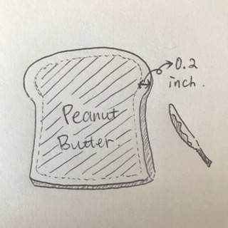

* Put a plate on your cooking bench.
* Take a slice of bread (either the toasted one on the paper towel or from a new pack) and put it in the middle of the plate.
* Open the container of peanut butter, and scoop two teaspoons of peanut butter on the bread. Close the container of peanut butter.
* Use a knife to spread the peanut butter evenly on the slice of bread. Avoid spreading the peanut butter to the very edge of the bread (leave about 0.2-inch-wide edge on the bread), as the peanut butter may get everywhere before you eat it.
* Move the slice of bread covered with peanut butter to the left side of the plate.

**Step 4 Clean your teaspoon and knife**

In order not to mix the jam/jelly with the peanut butter, you may want to clean your teaspoon and knife before putting jam/jelly. You can either rinse them with running water and dry them with a piece of paper towel or just swipe them directly with a piece of paper towel. Be careful, do not clean the knife with your hands directly as it may hurt your hands.

**Step 5 Spread jam/jelly evenly on your bread**

* Take another slice of bread (either the toasted one on the paper towel or from a new pack) and put it on the right side of the plate. Make sure those two slices of bread do not overlap together at all.
* Open the container of the jam/jelly, and scoop one teaspoon of jam/jelly on the slice of bread (the best ration of peanut butter to jam/jelly is 2:1).
* As the same as step 3, use the knife to spread the peanut butter evenly on the bread and avoid spreading it to the very edge of the bread (leave about 0.2-inch-wide edge on the bread).

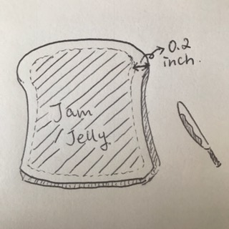

**Step 6 Press the two slices of bread together**

Now you have two slices of bread, one is peanut butter-covered on your left-hand side, and one is jelly-covered on your right-hand side.

* Take the peanut butter-covered slice with your left hand and jelly-covered slice with your right hand at the same time, place them together as jelly-side to peanut butter-side.
* Rotate your wrist slightly until the two slices until the two pieces of bread are aligned, then press gently. This is the best way of avoiding peanut butter and jam/jelly gets everywhere, and also matching up perfect shape-wise.
* Put the sandwich back to the plate.

**Step 7 Clean your knife**

In order not to make a messy sandwich, you will want to clean your knife again before cutting your sandwich in the next step. Simply follow step 4 and jump to step 8.

**Step 8 Cut the sandwich**

Almost done! Now is to cut your sandwich.

* Cut the sandwich with the knife diagonally from one corner to another. This gives you the classical shape of a PB&J sandwich.
* You can also cut the sandwich from the middle to divide it to two rectangles.
* Otherwise, try something different!

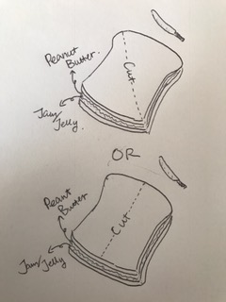

**Step 9 Enjoy your sandwich**

Congratulations! You should now be holding your first ready-to-eat PB&J sandwich! Enjoy your fresh-home-made sandwich!

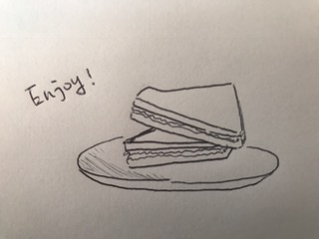

**Word Count:** 965

**Citation**

wikiHow. How to Make a Peanut Butter and Jelly Sandwich. Retrieved October 24, 2016, from <http://www.wikihow.com/Make-a-Peanut-Butter-and-Jelly-Sandwich>

Sanders, R. 16 Ways To Make A Better PB&J. Retrieved October 24, 2016, from <https://www.buzzfeed.com/rachelysanders/better-peanut-butter-jelly-sandwich-hacks?utm_term=.rf63vRWwB#.paQ97oOXz>

Kzavoral. How To Make the Perfect Peanut Butter and Jelly Sandwich. Retrieved October 24, 2016, from <http://www.instructables.com/id/How-To-Make-a-Perfect-Peanut-Butter-and-Jelly-Sand/>