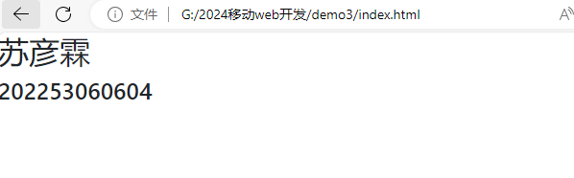

<!DOCTYPE html>

<html>

    <head>

        <meta name="viewport" content="width=device.width,initial-scale=1.0,shrink-to-fit=no">

        <link rel="stylesheet" href="bootstrap/css/bootstrap.min.css">

        <script src="bootstrap/js/jquery-3.5.1.slim.min.js"/>

        <script src="bootstrap/js/bootstrap.min.js"></script>

    </head>

    <body>

        <div class="">

            <h2>苏彦霖</h2>

            <h4>202253060604</h4>

        </div>

    </body>

</html>

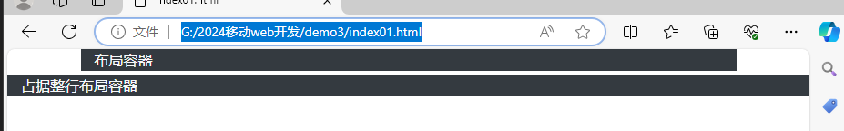

<!DOCTYPE html>

<html>

    <head>

        <meta name="viewport" content="width=device.width,initial-scale=1.0,shrink-to-fit=no">

        <link rel="stylesheet" href="bootstrap/css/bootstrap.min.css">

    </head>

    <body>

        <div class="container bg-dark text-light mb-1">布局容器</div>

        <div class="container-fluid bg-dark text-light mb-1">占据整行布局容器</div>

    </body>

</html>