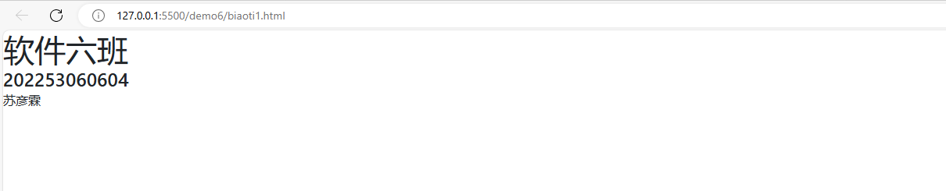

<!DOCTYPE html>

<html>

    <head>

    <link rel="stylesheet" href="bootstrap-4.6.0-dist/css/bootstrap.min.css">

    </style>

    </head>

    <body>

        <span class="h1">软件六班</span><br>

        <span class="h4">202253060604</span><br>

        <span class="h6">苏彦霖</span>

    </body>

</html>

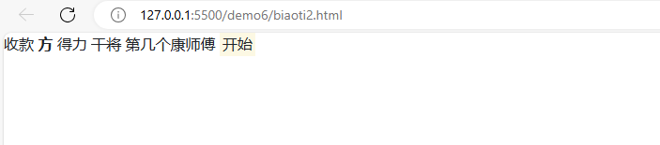<!DOCTYPE html>

<html>

    <head>

        <link rel="stylesheet" href="bootstrap-4.6.0-dist/css/bootstrap.min.css">

    </head>

    <body>

        收款

        <b>方</b>

        得力

        <del>干将</del>

        第几个康师傅

        <span class="mark">开始</span>

    </body>

</html>

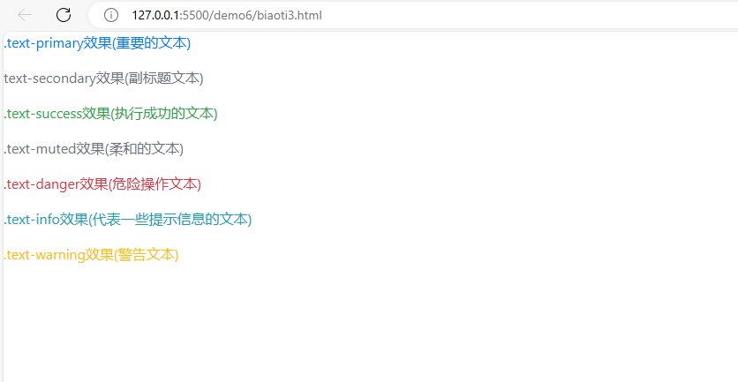

<!DOCTYPE html>

<html>

    <head>

        <link rel="stylesheet" href="bootstrap-4.6.0-dist/css/bootstrap.min.css">

    </head>

    <body>

        <p class="text-primary">.text-primary效果(重要的文本)</p>

        <p class="text-secondary">text-secondary效果(副标题文本)</p>

        <p class="text-success">.text-success效果(执行成功的文本)</p>

        <p class="text-muted">.text-muted效果(柔和的文本)</p>

        <p class="text-danger">.text-danger效果(危险操作文本)</p>

        <p class="text-info">.text-info效果(代表一些提示信息的文本)</p>

        <p class="text-warning">.text-warning效果(警告文本)</p>

    </body>

</html>

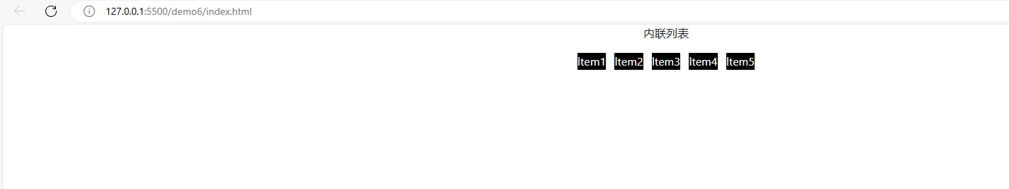

<!DOCTYPE html>

<html>

    <head>

        <link rel="stylesheet" href="bootstrap-4.6.0-dist/css/bootstrap.min.css">

        <style>

            li {background-color: black;color: #fff;}

        </style>

    </head>

    <body>

        <p class="text-center">内联列表</p>

        <ul class="list-inline text-center">

            <li class="list-inline-item">ltem1</li>

            <li class="list-inline-item">ltem2</li>

            <li class="list-inline-item">ltem3</li>

            <li class="list-inline-item">ltem4</li>

            <li class="list-inline-item">ltem5</li>

        </ul>

    </body>

</html>