Feature Engineering and Analysis in Automotive Pricing

1. Executive Summary & Objective
This report performs comprehensive feature engineering on a 500-record automotive pricing dataset. The primary goal is to derive high-value engineered features from raw variables (vehicle age, mileage, brand, price) to enhance predictive modeling capability and uncover deeper economic drivers behind vehicle depreciation.

2. Feature Engineering Rationale & Definitions
Four new features were designed and extracted from the raw dataset:
1. Price per Mile (Price / Mileage): Captures monetary residual value relative to usage.
2. Mileage per Year (Mileage / Age): Measures driver usage intensity.
3. Depreciation Rate (%/Year): Standardizes value loss over time relative to brand base MSRP.
4. Vehicle Segment Categorization: Segmented cars into 'Luxury', 'Nearly New', and 'Economy' tiers with one-hot encoding.

3. Correlation Analysis & Visual Findings

Figure 1: Vehicle Price vs. Age Segmented by Vehicle Class
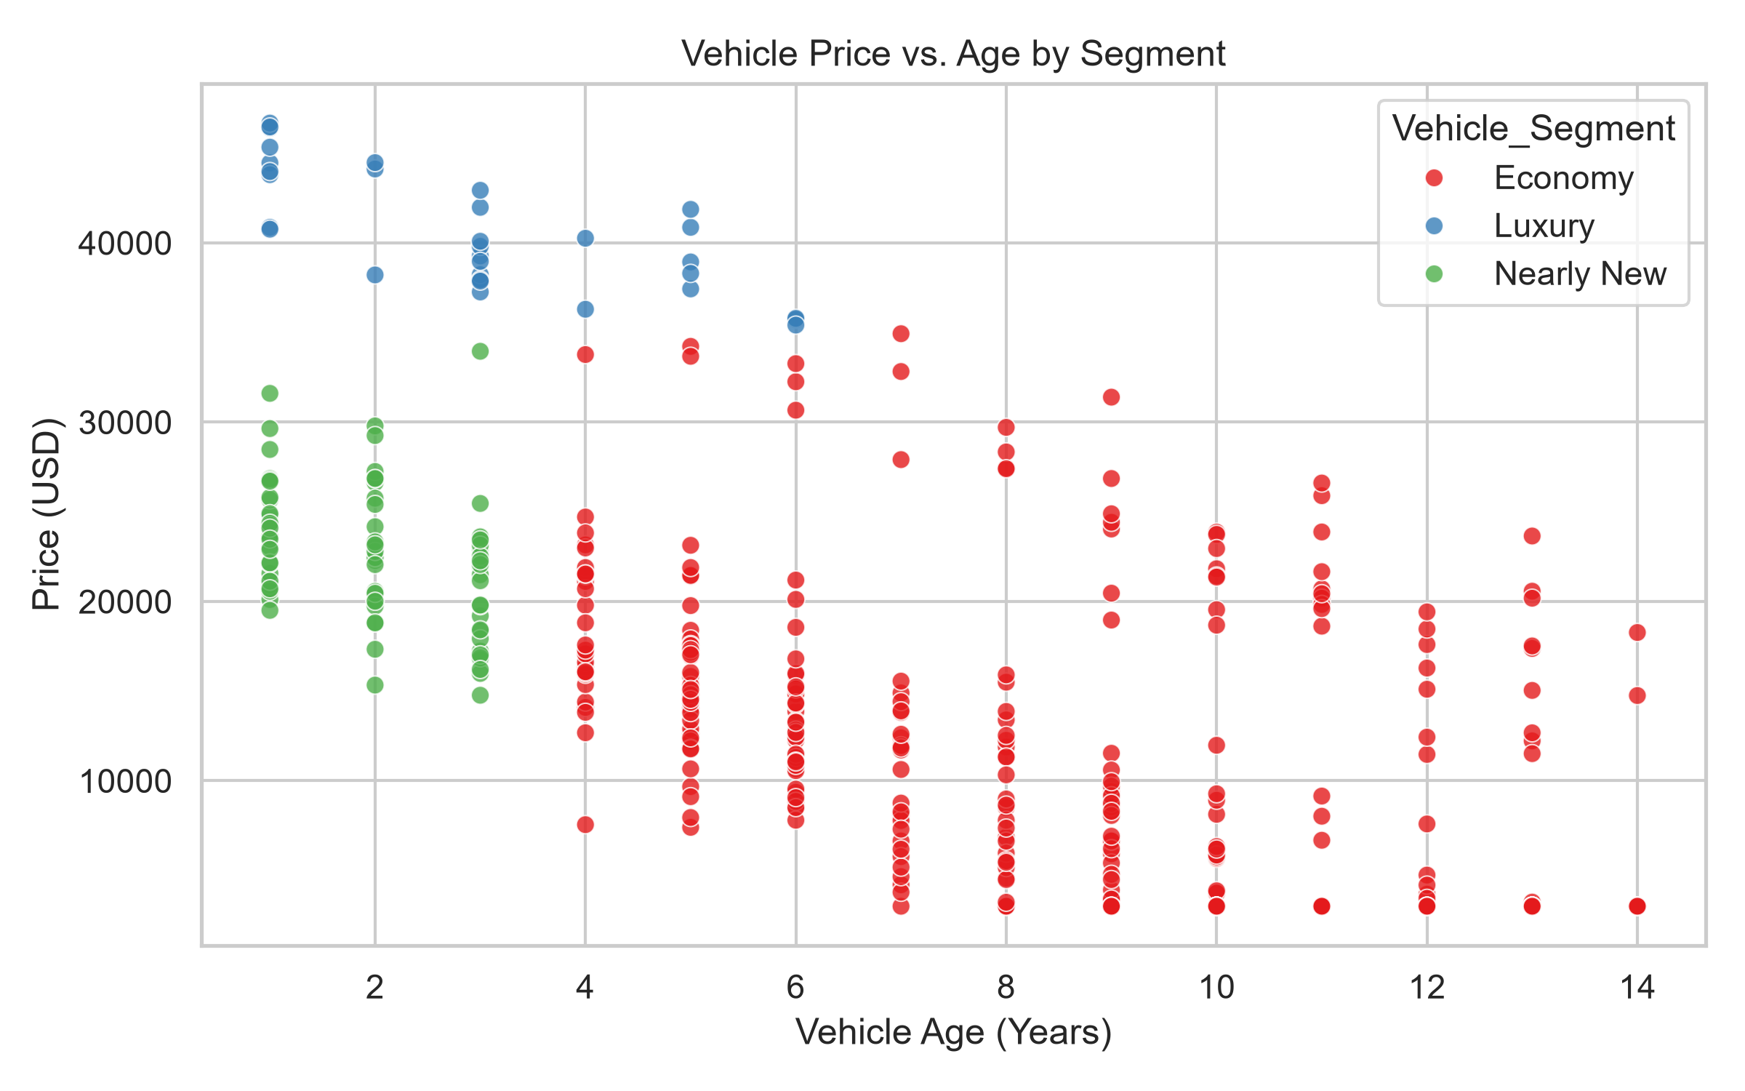
Analysis generated during correlation and feature interaction evaluation.

Figure 2: Annual Depreciation Rate Percentage Across Brands
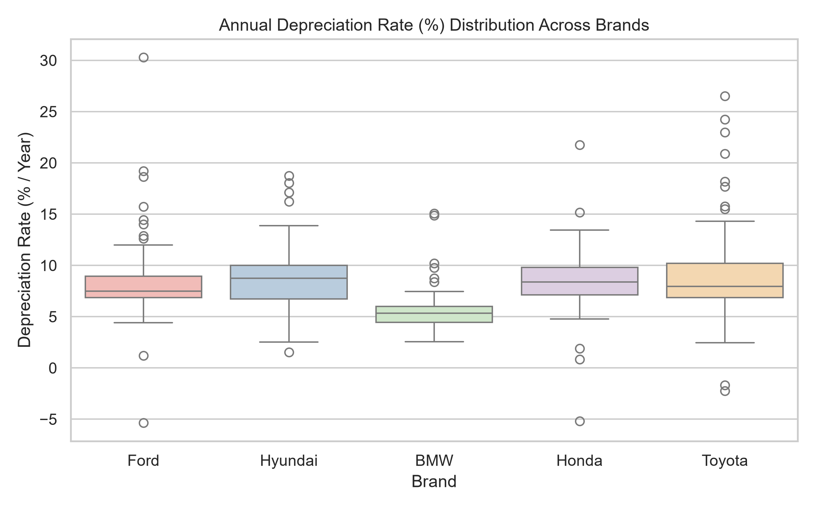
Analysis generated during correlation and feature interaction evaluation.

Figure 3: Usage Intensity vs. Price Per Mile Interaction
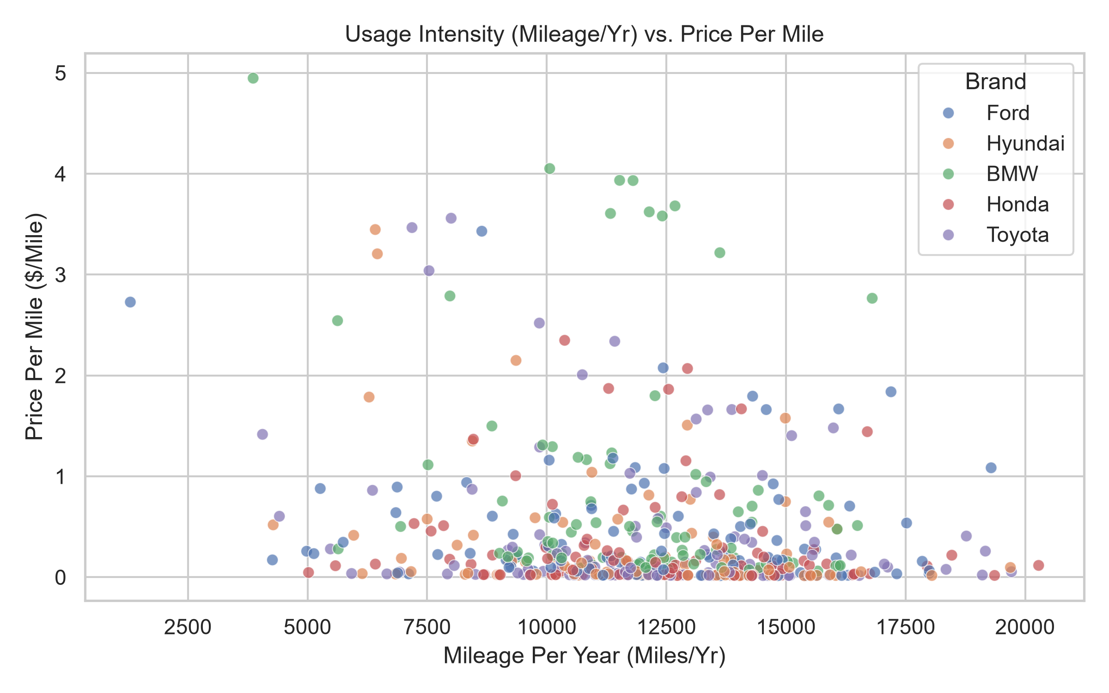
Analysis generated during correlation and feature interaction evaluation.

Figure 4: Correlation Matrix of Raw and Engineered Features
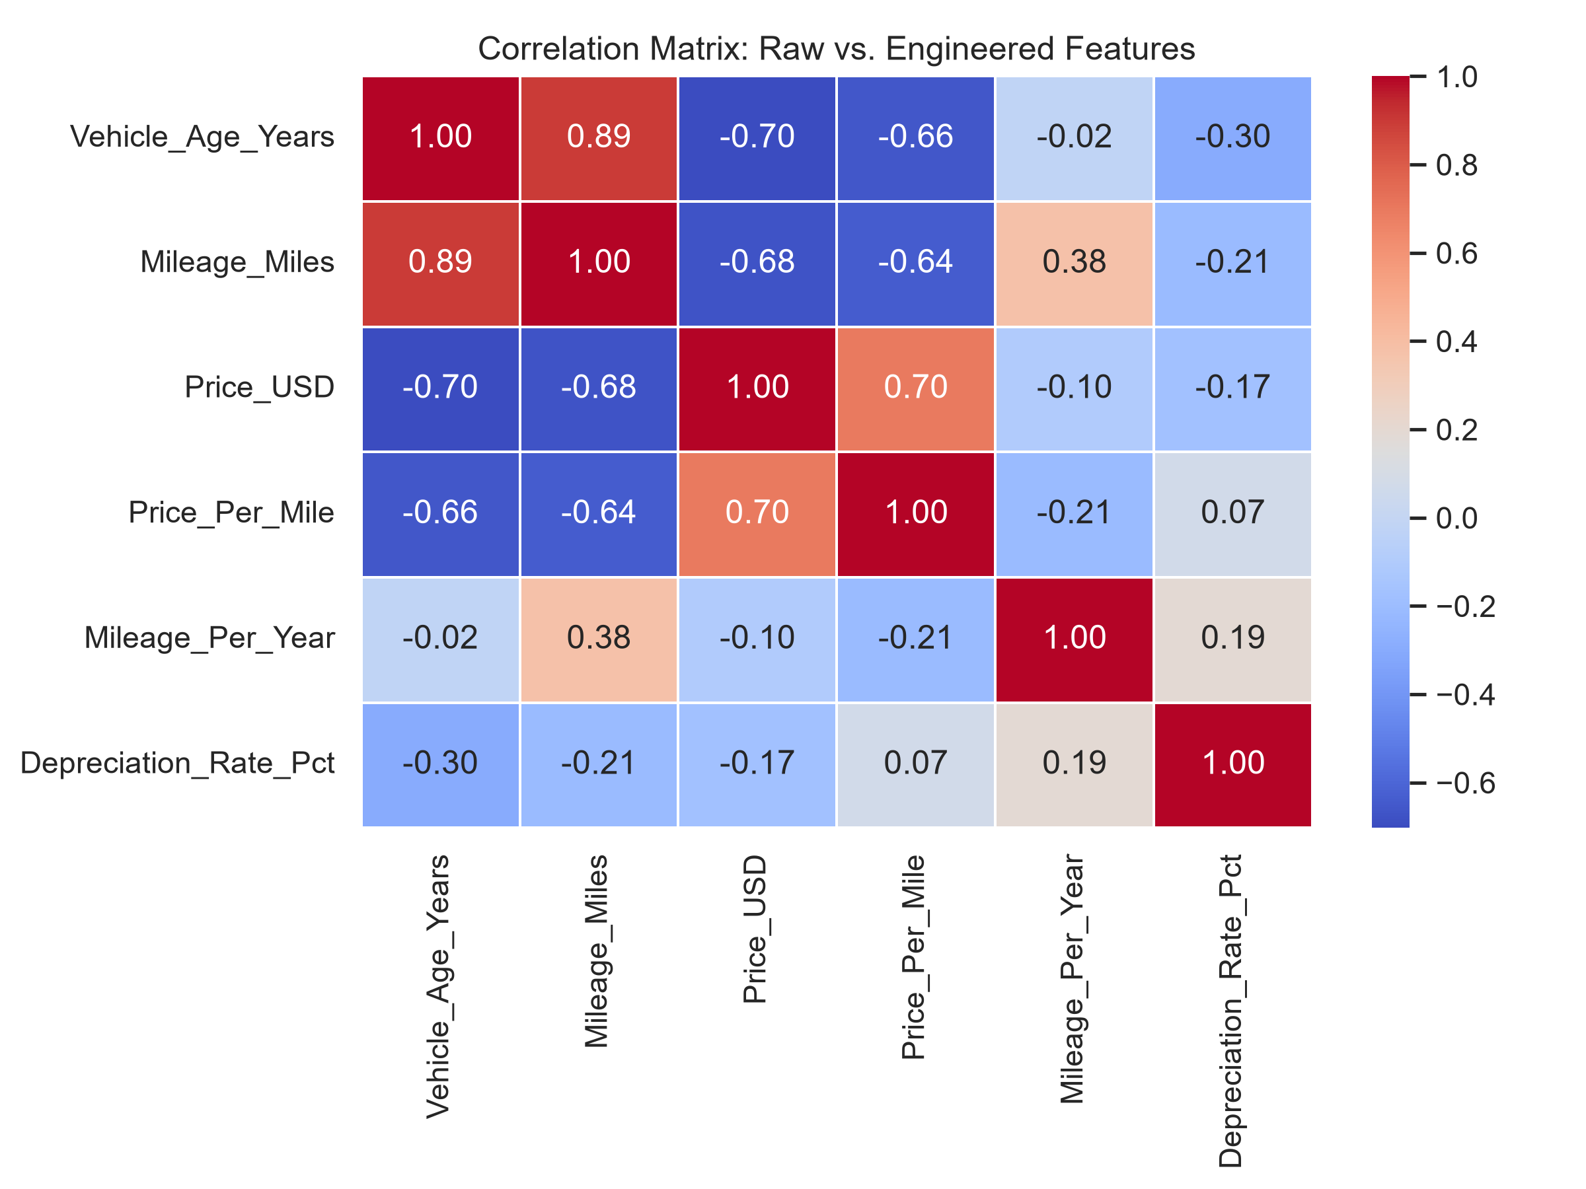
Analysis generated during correlation and feature interaction evaluation.

4. Recommendations for Predictive Modeling
1. Depreciation Rate and Mileage per Year demonstrate stronger linear correlation with resale price than raw mileage alone.
2. One-hot encoded vehicle segments should be utilized in tree-based and linear regression models to reduce price prediction error.

