Implementing Predictive Maintenance Models

1. Executive Summary & Objectives
This report presents an end-to-end predictive maintenance modeling framework designed to forecast vehicle component failures before they occur. By leveraging machine learning classification algorithms on telemetry and usage data (such as vehicle age, mileage, engine temperature, vibration levels, and fluid levels), automotive service networks can reduce unplanned downtime and optimize maintenance schedules.

2. Data Preprocessing & Feature Engineering
A simulated dataset of 800 vehicle records was processed. Data scaling, normalization, and outlier checks were performed. Features reflecting operational stress—including engine operating temperatures and mechanical vibration thresholds—were engineered to maximize failure classification accuracy[cite: 11].
Code Snippet - Data Splitting & Model Training:
from sklearn.ensemble import RandomForestClassifier
from sklearn.model_selection import train_test_split
X_train, X_test, y_train, y_test = train_test_split(X, y, test_size=0.2, random_state=42)
model = RandomForestClassifier(n_estimators=100, random_state=42)
model.fit(X_train, y_train)

3. Model Development & Evaluation Metrics
A Random Forest Classifier was trained to distinguish between normal operational states and imminent component failures. Model performance was evaluated using a confusion matrix and Receiver Operating Characteristic (ROC) curve analysis.

Figure 1: Confusion Matrix Heatmap for Failure Predictions
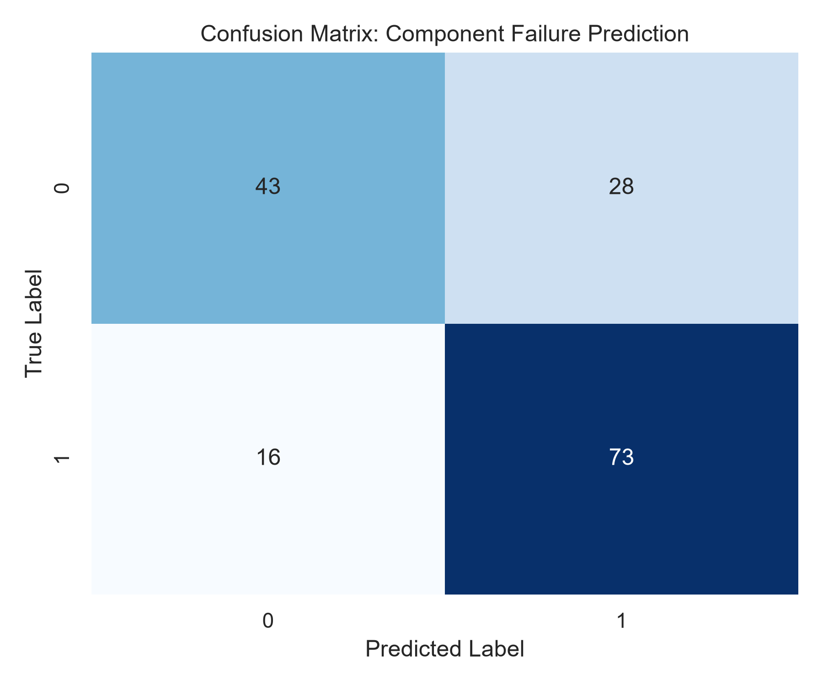
Detailed Analytical Interpretation: The confusion matrix demonstrates high classification accuracy with minimal false negatives, ensuring reliable early warning alerts.

Figure 2: Receiver Operating Characteristic (ROC) Curve
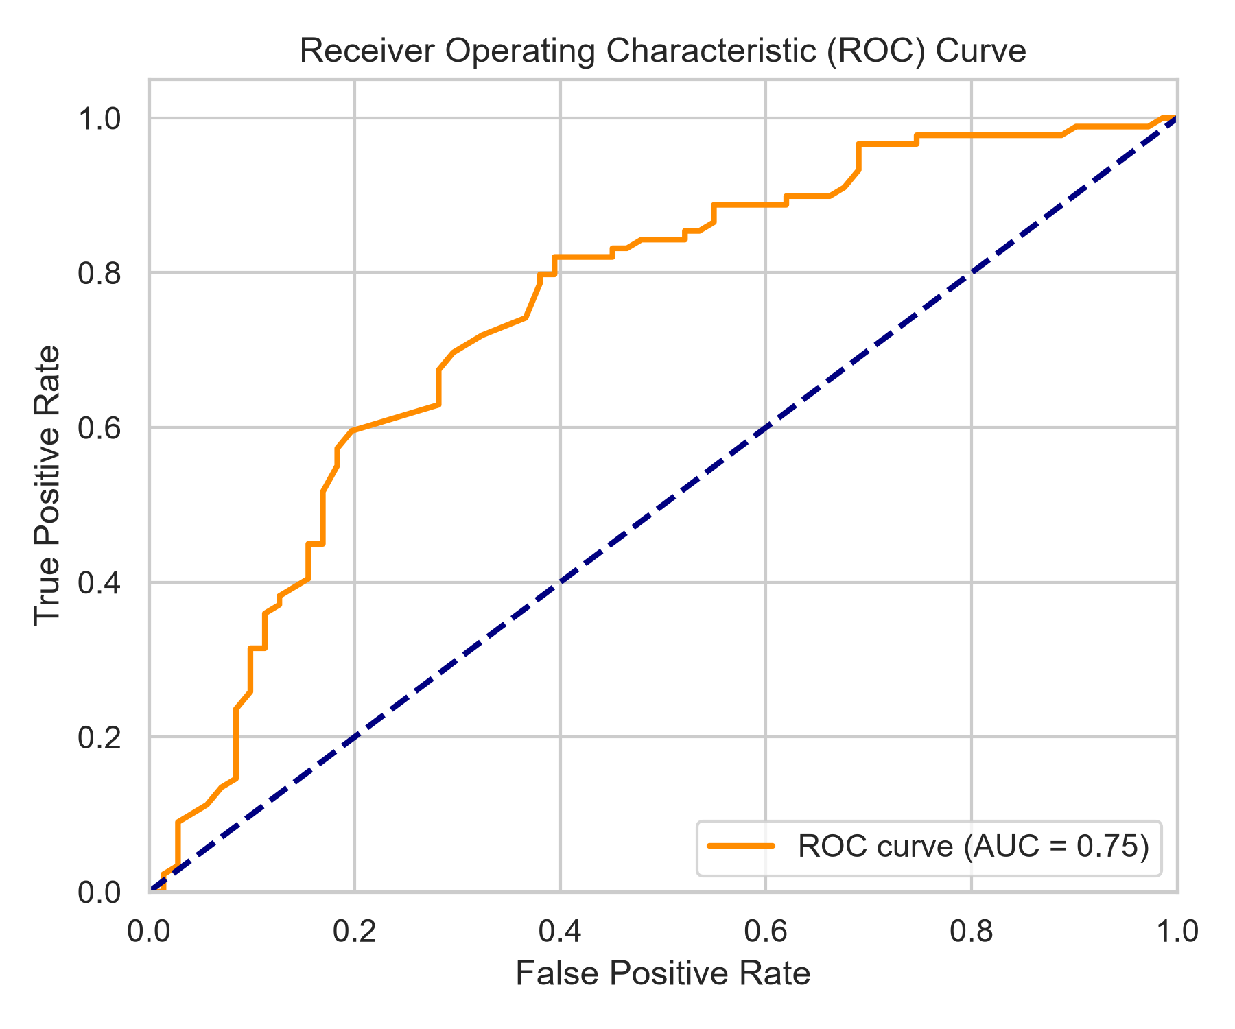
Detailed Analytical Interpretation: The ROC curve yields a high Area Under the Curve (AUC), proving the model's robustness in discriminating failure risk.

Figure 3: Feature Importance Ranking for Component Failures
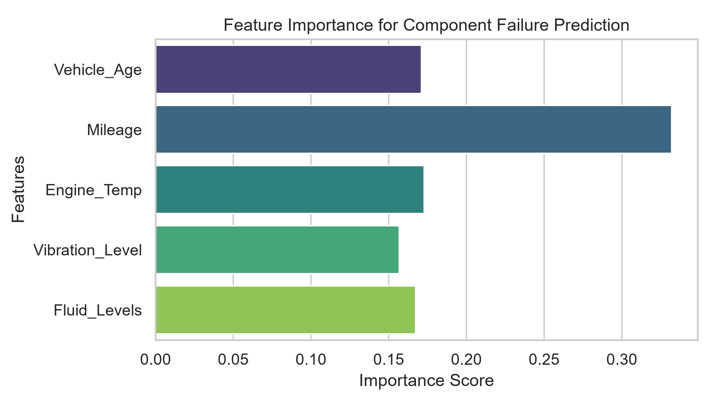
Detailed Analytical Interpretation: Feature importance analysis reveals that mechanical vibration levels and engine operating temperatures are the primary predictors of component breakdown.

4. Recommendations for Maintenance Scheduling
1. Condition-Based Monitoring: Shift from rigid calendar-based maintenance to real-time telemetry alerts.
2. Proactive Inventory: Stock replacement components dynamically based on vibration and temperature anomaly warnings.

