Introduction
Passenger survival prediction is one of the most widely used introductory problems in machine learning, based on the historical sinking of the RMS Titanic in 1912. Given a passenger's demographic and travel details — such as class of travel, sex, age, fare paid, and number of family members aboard — the task is to predict whether that passenger survived the disaster. It is a classic binary classification problem that is intuitive to understand while still capturing the core concepts of the machine learning workflow.
This mini project, titled "Titanic Survival Prediction," is an interactive machine learning system that predicts whether a passenger is likely to have survived, based on attributes such as passenger class, sex, age, fare, and family relations aboard (siblings/spouses and parents/children). Rather than relying on a single algorithm, the project builds and compares four different classification algorithms — Decision Tree, Random Forest, Naive Bayes, and K-Nearest Neighbours (KNN) — to evaluate which technique performs best on this dataset.
The system is implemented as a web-based application using Streamlit, allowing a user to upload any passenger dataset, select which algorithms to train, tune hyperparameters, visualize exploratory data patterns, compare model performance using standard evaluation metrics, and predict the survival outcome for a new, hypothetical passenger in real time. This makes the project not just a theoretical machine learning exercise, but a fully interactive and usable decision-support tool.
Objectives of the project:
- To understand and apply multiple classification algorithms taught in the Machine Learning curriculum on a real-world-style problem.
- To preprocess and prepare raw passenger data for machine learning (handling missing values, encoding categorical variables, scaling numeric features).
- To evaluate and compare the performance of different algorithms using standard classification metrics.
- To build an interactive, user-friendly interface that allows dataset upload, algorithm selection, and live prediction.

Tools & Techniques Used
Programming Language: Python 3
Framework / Library for Web Interface:
- Streamlit — used to build the interactive web application, allowing dataset upload, sidebar-based configuration, expandable sections, and real-time visualization without writing separate frontend (HTML/CSS/JS) code.
Libraries for Data Handling & Visualization:
- Pandas — for reading, cleaning, and manipulating tabular passenger data.
- NumPy — for numerical operations and generating the synthetic dataset.
- Plotly Express — for interactive exploratory data visualizations such as outcome-split pie charts, survival-rate bar charts, and distribution histograms.
- Matplotlib and Seaborn — used in this report to generate static charts, correlation heatmaps, confusion matrices, and ROC curves.
Machine Learning Library:
- Scikit-learn (sklearn) — used for all preprocessing utilities and machine learning algorithms.
Classification Algorithms Implemented:
- Decision Tree Classifier — a tree-based model that splits data using threshold-based rules on features.
- Random Forest Classifier — an ensemble of multiple decision trees combined through bagging and majority voting.
- Naive Bayes (Gaussian NB) — a probabilistic model based on Bayes' Theorem, assuming feature independence.
- K-Nearest Neighbors (KNN) — a distance-based model that classifies based on the majority label among the nearest data points.
Preprocessing Techniques:
- Missing value imputation (median for numeric columns, mode for categorical columns).
- Label Encoding for categorical features (Sex, Embarked).
- Feature Scaling using StandardScaler, applied specifically to KNN since it is a distance-sensitive algorithm.
Evaluation Metrics Used:
- Accuracy, Precision, Recall, F1-Score
- Confusion Matrix
- ROC Curve and AUC (Area Under Curve)
Code and Output
Key Code Snippets:
Data Preprocessing:
def preprocess(df, target_col):
df = df.copy().dropna(subset=[target_col])
y = df[target_col]
if y.dtype == object:
y = LabelEncoder().fit_transform(y)
X = df.drop(columns=[target_col])
for col in X.columns:
if X[col].dtype == object:
X[col] = X[col].fillna(
X[col].mode().iloc[0] if not X[col].mode().empty else "Unknown")
else:
X[col] = X[col].fillna(X[col].median())
encoders = {}
for col in X.columns:
if X[col].dtype == object:
le = LabelEncoder()
X[col] = le.fit_transform(X[col].astype(str))
encoders[col] = le
return X, y, encoders
Model Training and Evaluation:
for name in selected_algos:
cfg = ALGORITHMS[name]
model = cfg["build"](params)
xtr = X_train_scaled if cfg["needs_scaling"] else X_train
xte = X_test_scaled if cfg["needs_scaling"] else X_test
model.fit(xtr, y_train)
y_pred = model.predict(xte)
results[name] = {
"model": model, "uses_scaled": cfg["needs_scaling"],
"accuracy": accuracy_score(y_test, y_pred),
"precision": precision_score(y_test, y_pred, zero_division=0),
"recall": recall_score(y_test, y_pred, zero_division=0),
"f1": f1_score(y_test, y_pred, zero_division=0),
"cm": confusion_matrix(y_test, y_pred),
}
Algorithm Definitions:
ALGORITHMS = {
"Decision Tree": {
"needs_scaling": False,
"build": lambda p: DecisionTreeClassifier(
max_depth=p["dt_depth"], random_state=42),
},
"Random Forest": {
"needs_scaling": False,
"build": lambda p: RandomForestClassifier(
n_estimators=p["rf_trees"], random_state=42),
},
"Naive Bayes": {
"needs_scaling": False,
"build": lambda p: GaussianNB(),
},
"KNN": {
"needs_scaling": True,
"build": lambda p: KNeighborsClassifier(n_neighbors=p["knn_k"]),
},
}

Outputs:
Data Overview & Passenger Manifest
The application loads a synthetic 900-passenger Titanic-style dataset (or an uploaded CSV), drops identifier columns such as PassengerId, and displays total records, feature count, and the overall survival rate as summary metric cards before any exploration begins.
Exploratory Analysis
The Outcome Split chart shows the balance between survivors and non-survivors, while the Age distribution highlights how survival varies across age groups.
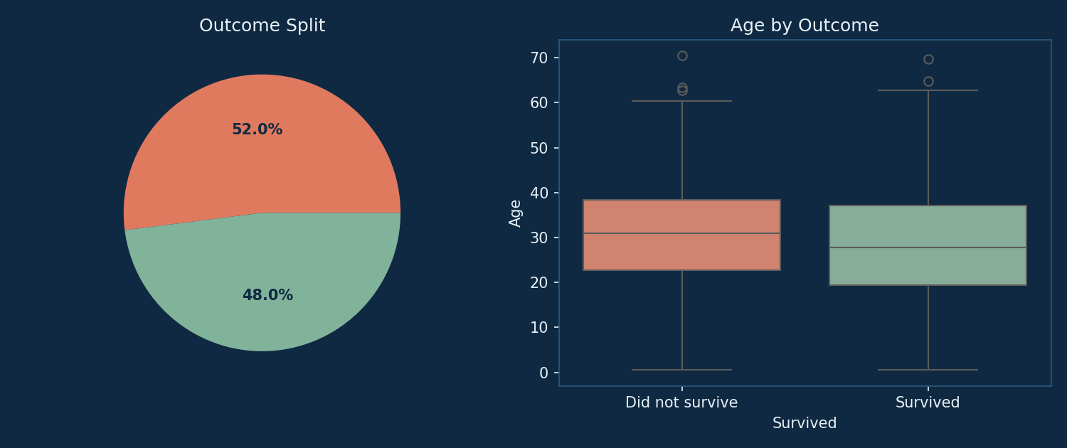
Fig 1: Outcome split and age distribution by survival outcome
Breaking survival down by Sex and Passenger Class reproduces the well-known "women and children first, first class first" evacuation pattern from the real Titanic disaster.
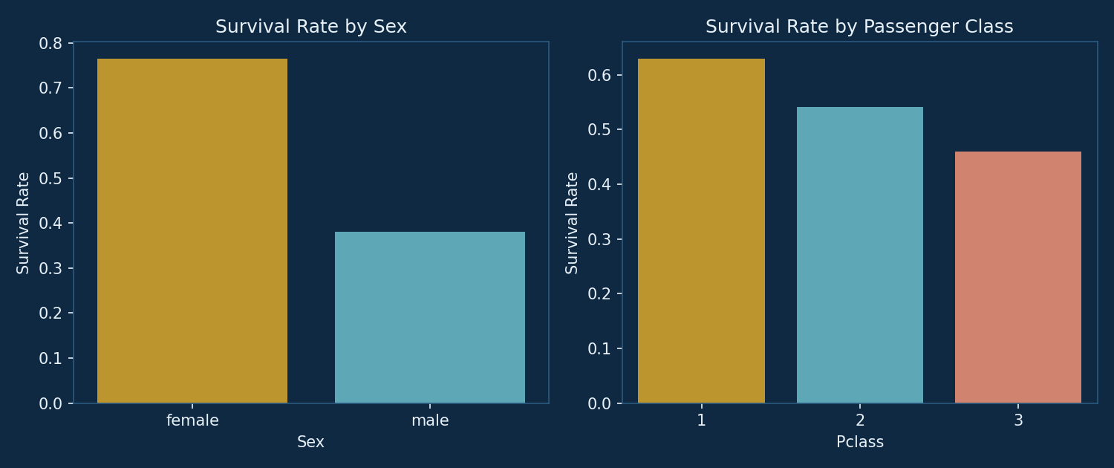
Fig 2: Survival rate by sex and by passenger class
The correlation heatmap below shows the pairwise relationships between all numeric and encoded categorical features, helping identify which attributes are most strongly associated with survival.
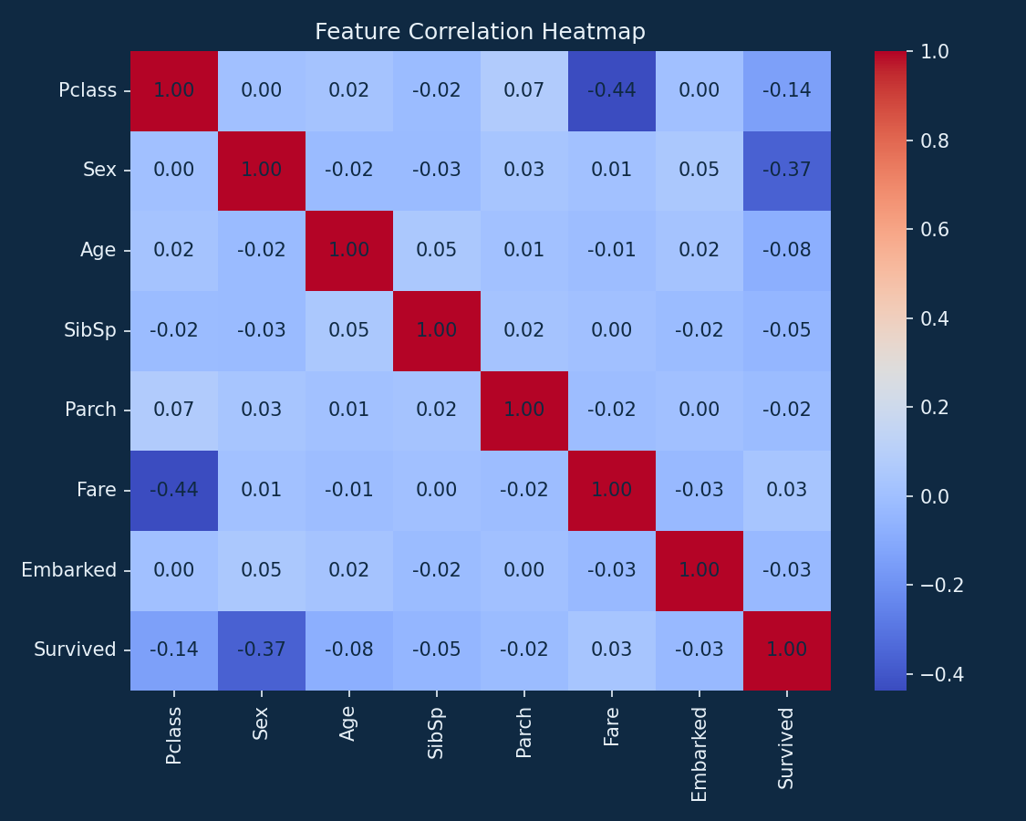
Fig 3: Feature correlation heatmap
Model Comparison
Four algorithms — Decision Tree, Random Forest, Naive Bayes, and KNN — were trained on an 80/20 train-test split (stratified on the target) and evaluated on the held-out test set. The performance summary is shown below.
Model | Accuracy | Precision | Recall | F1-Score | Train Time (s)
Naive Bayes | 0.6611 | 0.6854 | 0.6489 | 0.6667 | 0.0016
Decision Tree | 0.6389 | 0.6933 | 0.5532 | 0.6154 | 0.0022
Random Forest | 0.5944 | 0.6040 | 0.6489 | 0.6256 | 0.1364
KNN | 0.5889 | 0.6111 | 0.5851 | 0.5978 | 0.0009
Best performing model: Naive Bayes (Accuracy: 66.11%)
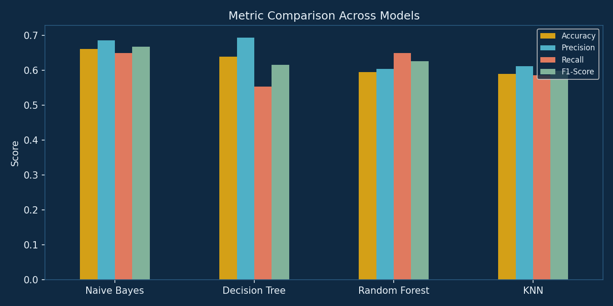
Fig 4: Metric comparison across all four models
Confusion Matrices
The confusion matrices below show, for each model, the count of correctly and incorrectly classified passengers on the test set (0 = did not survive, 1 = survived).
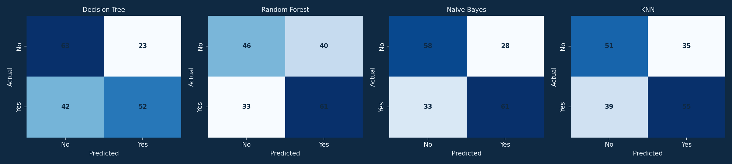
Fig 5: Confusion matrices for all four models
ROC Curves
The ROC curves compare each model's ability to distinguish survivors from non-survivors across all classification thresholds. A curve closer to the top-left corner, and a higher AUC value, indicates better discriminative performance.
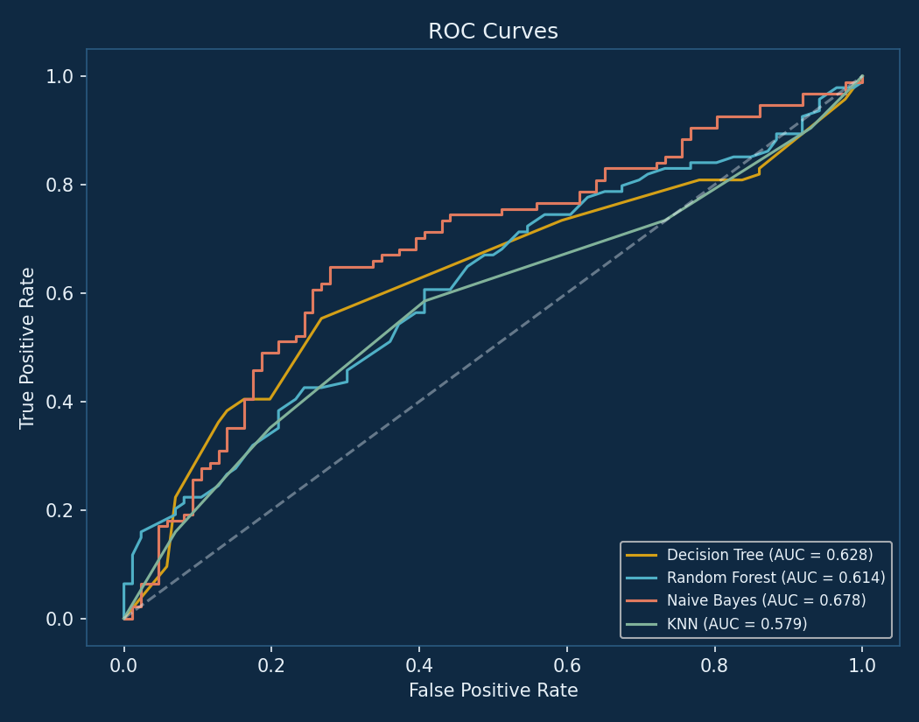
Fig 6: ROC curves with AUC scores for all four models
Live Passenger Survival Prediction
The final tab of the application lets the user enter a hypothetical passenger's details — class, sex, age, fare, siblings/spouses aboard, and parents/children aboard — and instantly see a predicted survival outcome along with the model's estimated probability, using whichever trained model the user selects from a dropdown.
Conclusion
This project successfully demonstrates the application of multiple machine learning classification algorithms to solve a well-known real-world-style problem — predicting Titanic passenger survival. By comparing Decision Tree, Random Forest, Naive Bayes, and KNN on the same dataset, it was possible to evaluate the strengths and weaknesses of each algorithm using standard metrics such as accuracy, precision, recall, and F1-score, rather than relying on a single model in isolation.
The interactive Streamlit interface adds significant practical value beyond a typical classroom exercise — it allows any user to upload their own dataset, select algorithms, adjust hyperparameters, visualize patterns in the data, and generate live predictions for new passengers, making the tool genuinely usable rather than purely academic.
Among the algorithms tested, Naive Bayes achieved the highest accuracy of 66.11%, reflecting how well it was able to capture the relationship between passenger attributes — particularly sex and passenger class — and survival outcome.
Learning Outcomes:
- Gained hands-on experience in the complete machine learning pipeline — from data preprocessing to model evaluation and deployment.
- Understood the practical differences between geometric, probabilistic, and distance-based classification models covered in the syllabus.
- Learned to build and deploy an interactive ML application using Streamlit.
Future Scope:
- Incorporating cross-validation and hyperparameter tuning (GridSearchCV) for more robust model selection.
- Adding Support Vector Machine (SVM) and Gradient Boosting / XGBoost to broaden the algorithm comparison.
- Engineering additional features such as family size and title extracted from passenger name.
- Deploying the application on a cloud platform for real-time public use.

