UNIVERSITY OF DELHI

ATMA RAM SANATAN DHARMA COLLEGE

DS ASSIGNMENT

SUBMITTED BY -
SUYASH PRATAP MALL
( 88051 )

Q. Write a Program to generate the Fibonacci Series using recursion.

ANS-

#include<iostream>
using namespace std;

int fibo(int); // To find fibonacci sequence (recursively)
void fibonaciiSeries(int); // To print fibonacci Series

int fibo(int num ){
if (num==1){
return 1;
}
else if(num==0){
return 0;
}
else{
return fibo(num-1) + fibo(num-2);
}
}
void fibonaciiSeries(int n){
for (int i = 0; i < n; i++){
cout<<fibo(i)<<" ";
}
}

int main(){

int i;
cout<<"Enter the no. of terms want to print(of fibonacci series) : ";
cin>>i;
cout<<"Finonacii Series"<<endl;
fibonaciiSeries(i);
return 0;

}

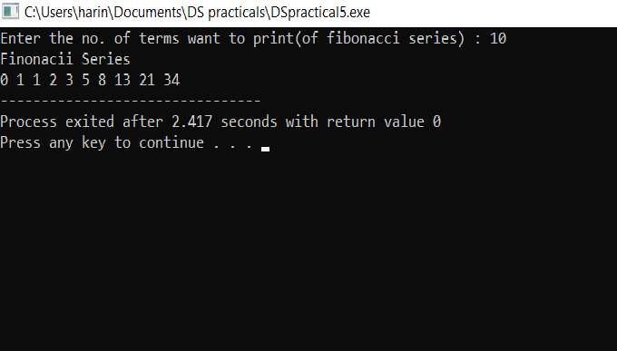
Q. Write a Program to implement Tower of Hanoi using recursion.

ANS-

#include<iostream>
using namespace std;

void towerOfHanoi(int n,char src,char dest,char helper){
if(n<=0){
return;
}
towerOfHanoi(n-1,src,helper,dest);
cout<<"Move from "<<src<<" to "<<dest<<endl;
towerOfHanoi(n-1,helper,dest,src);
}
int main(){
cout<<"Tower Of Hanoi"<<endl;
towerOfHanoi(4,'A','B','C');
return 0;
}

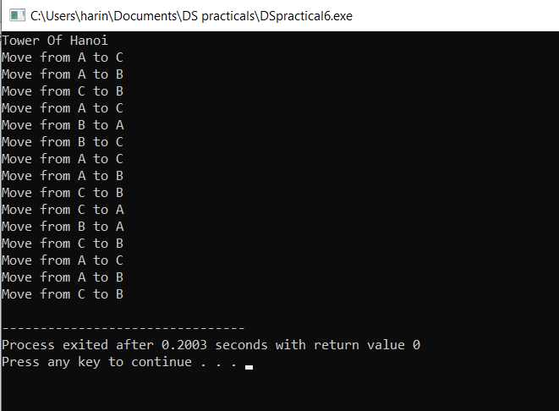

Q. Write a Program to implement binary search using recursion.

ANS -

#include<iostream>
#include<string>
using namespace std;

void displayArray(int* &array , int* &size){
cout<<endl;
cout<<"[ ";
for (int i = 0; i < *size; i++){
cout<<array[i];
if(i!= *size-1){
cout<<" ,";
}
}
cout<<" ]";
cout<<endl;
}
string binarySearch(int arr[] , int key,int start,int end){
if(key<arr[start] && key>arr[end-1]){
return "Sorry, Element isn't present";
}
int mid = (start+end)/2;
if(arr[mid]==key){
return "Element found at position '"+to_string(mid+1)+"'";
}
else if (key>arr[mid])
{
return binarySearch(arr , key,mid+1,end);
}
else{
return binarySearch(arr , key,start,mid-1);
}

}
int main()
{
int arr[] = {1,3,4,5,8,21,34,35,44,56,60,67};
int key;
int *size = new int(12);
int *array = arr;
cout<<"Enter the element to search : ";
cin>>key;
cout<<endl;
cout<<binarySearch(arr ,key ,0,12)<<endl<<endl;
cout<<"Original Array : ";
displayArray(array,size);
return 0;
}
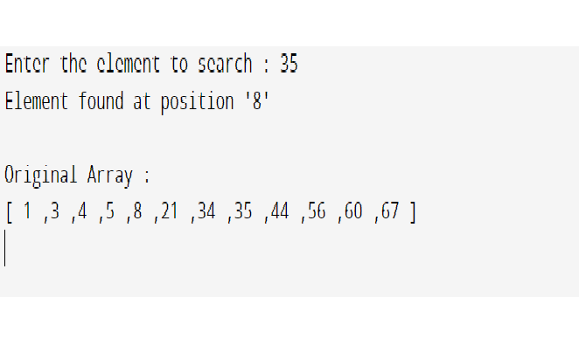

Q. Write a Program to implement Bubble Sort. Find the number of comparisons during each pass and display the intermediate result. Use the observed values to plot a graph to analyse the complexity of algorithm.

ANS-

#include<iostream>
using namespace std;

void swap(int *a, int *b)
{
int temp =*a;
*a=*b;
*b=temp;
}

void bubbleSort(int arr[],int n)
{
int noOfSwaps;
int noOfComparisons;
bool swapped;
for(int i = 0; i<n-1;i++)
{
noOfSwaps=0;
noOfComparisons=0;
for(int j=0;j<n-i-1;j++)
{
noOfComparisons++;
if(arr[j]>arr[j+1])
{
swap(&arr[j],&arr[j+1]);
noOfSwaps++;
}
}
std::cout<<"Array after"<<i+1<<" iteration: \n";
for(int k=0;k<n;k++){
std::cout<<arr[k]<<" ";
}
std::cout<<"\nNo of swaps: "<<noOfSwaps;
std::cout<<"\nNo of comparisons: "<<noOfComparisons<<std::endl<<std::endl;

}
}

void printArray(int arr[],int size)
{
for(int i=0;i<size;i++)
std::cout<<arr[i]<<" ";
std::cout<<"\n";
}

int main()
{
int arr[]={64,34,25,12,22,11};
int n=sizeof(arr)/sizeof(arr[0]);
std::cout<<"Unsorted array:\n";
printArray(arr,n);
cout<<endl;
bubbleSort(arr,n);
std::cout<<"Sorted array:\n";
printArray(arr,n);
return 0;
}

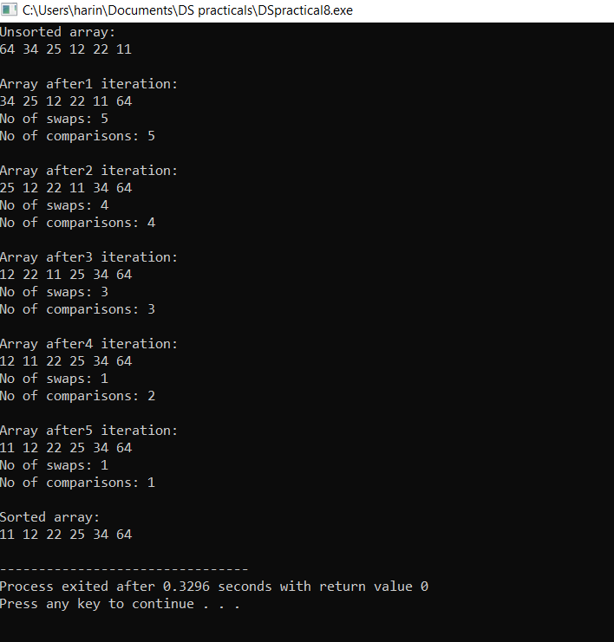

Q. Write a Program to implement Insertion Sort. Find the number of comparisons during each pass and display the intermediate result. Use the observed values to plot a graph to analyse the complexity of algorithm.

ANS-

#include<iostream>
using namespace std;

void displayArray(int* &array , int* &size){
cout<<"\n";
cout<<"[ ";
for (int i = 0; i < *size; i++){
cout<<array[i];
if(i!= *size-1){
cout<<" ,";
}
}
cout<<" ]"<<endl<<endl;
}
void insertionSort(int* &array , int* &size){
int key;
for (int i = 1; i <*size ; i++)
{
key = array[i];
int j = i-1;
int* comparisons = new int(0);
while (key<array[j] && j>=0){
*comparisons+=1;
array[j+1]=array[j];
j--;
}
array[j+1]=key;
cout<<"No. of Iterations : "<<i<<endl;
cout<<"No. of Comparisons : "<<*comparisons<<endl;

}

}
int main(){
int arr[] = {7,38,3,60,76,8,3,10,70,8,19,31};
int *array = arr;
int *length = new int(12);
cout<<endl<<"UNSORTED";
displayArray(array,length);
insertionSort(array,length);
cout<<endl<<"SORTED";
displayArray(array,length);
delete[] array;
delete length;

return 0;
}

