<!DOCTYPE html>

<html>

<head>

<script>

function validateForm() {

var fname = document.myForm.firstname.value;

var lname = document.myForm.lastname.value;

var email = document.myForm.email.value;

var bday = document.myForm.birthday.value;

var gender = document.myForm.gender.value;

if (fname == "") {

alert("Please enter your first name");

document.myForm.firstname.focus();

return false;

}

if (lname == "") {

alert("Please enter your last name");

document.myForm.lastname.focus();

return false;

}

if (email == "") {

alert("Please enter your email");

document.myForm.email.focus();

return false;

}

if (bday == "") {

alert("Please enter your birth date");

document.myForm.birthday.focus();

return false;

}

if (gender == "") {

alert("Please select your gender");

document.myForm.gender.focus();

return false;

}

alert("Thank you for registering!");

return true;

}

</script>

</head>

<body>

<form name="myForm" onsubmit="return validateForm()" method="post">

<h4>REGISTRATION FORM</h4>

<p><font color="red">\*</font> Mandatory Fields</p>

<table>

<tr>

<td>First Name:\*</td>

<td><input type="text" name="firstname"/></td>

</tr>

<tr>

<td>Last Name:\*</td>

<td><input type="text" name="lastname"/></td>

</tr>

<tr>

<td>Email:\*</td>

<td><input type="text" name="email"/></td>

</tr>

<tr>

<td>Date of Birth:\*</td>

<td><input type="date" name="birthday"/></td>

</tr>

<tr>

<td>Your LinkedIn Website:\*</td>

<td><input type="url" name="homepage" value=""/></td>

</tr>

<tr>

<td>Gender:\*</td>

<td>

<select name="gender">

<option value="">Select</option>

<option value="male">Male</option>

<option value="female">Female</option>

</select>

</td>

</tr>

<tr>

<td colspan="2"><input type="submit" name="reg" value="Register"/></td>

</tr>

</table>

</form>

</body>

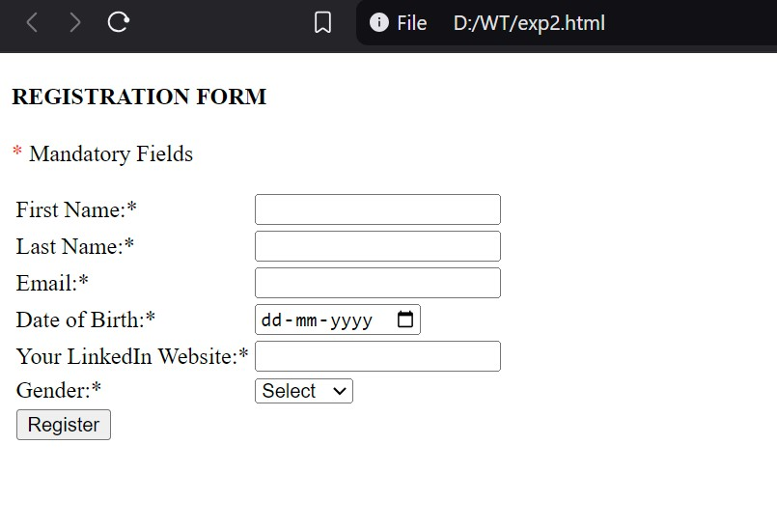</html>