<html>

<head>

<title> Application Form Using HTML </title>

</head>

<form onsubmit="return showSuccessMessage()">

<fieldset>

<legend><h3> PERSONAL INFORMATION </h3></legend>

<img src="https://encrypted-tbn0.gstatic.com/images?q=tbn:ANd9GcQrmvSoqEMvs4E-TIgyfMdztZYEdKav-zok1A&s" alt="Person" style="width:304px;height:228px"; align="right">

First name:

<input type="text" name="firstname" placeholder="Enter First name" required><br><br><br>

Last name:

<input type="text" name="lastname" placeholder=" Enter Last Name" required><br><br>

Gender:

<input type="radio" name="gender" value="male"> Male

<input type="radio" name="gender" value="female"> Female <br><br><br>

Birthday:

<input type="datetime-local" name="bdaytime"><br><br><br>

Country :

<input list="Country" name="Country">

<datalist id="Country">

<option value="India">

<option value="Japan">

<option value="Australia">

<option value="United States">

<option value="United Kingdom">

</datalist>

<br><br>

E-mail:

<input type="email" name="email"><br><br>

Select your favorite color:

<input type="color" name="favcolor" value="#ff0000"><br><br>

Address:

<br/><textarea rows='5' cols='40'></textarea>

</fieldset>

<br><br>

<fieldset>

<legend><h3> EDUCATIONAL DETAILS </h3></legend> Degree :

<select name="degree">

<option value="B.E"> B.E </option>

<option value="M.E">M.E</option>

<option value="PhD"> PhD </option>

</select><br><br>

Certified Courses, any: <textarea rows='5' cols='40'></textarea>

</fieldset>

<br><br>

<fieldset>

<legend><h3> WORK EXPERIENCE </h3></legend>

Knowledge in :

<input type="checkbox" name="HTML" value="HTML"> HTML

<input type="checkbox" name=".NET" value=".NET"> .NET

<input type="checkbox" name="JAVA" value="JAVA"> JAVA

<input type="checkbox" name="PHP" value="PHP"> PHP

<br><br>

Years of Experience :

<input type="number" name="years" min="0" max="50" step="1" value="0">

</fieldset>

<br><br>

<input type="submit" title="Enter the above details and click me" />

</form>

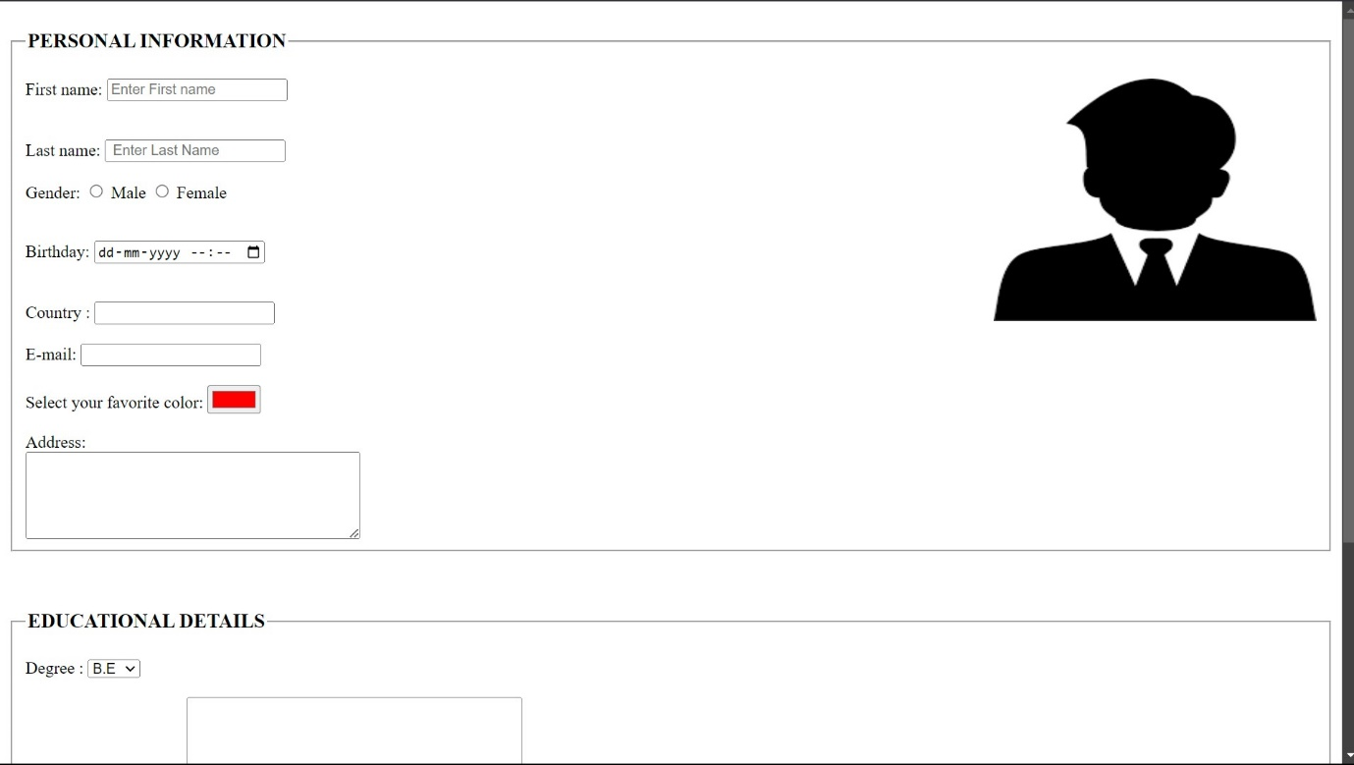<script>

function showSuccessMessage() {

alert("Registration successful!");

return false;

}

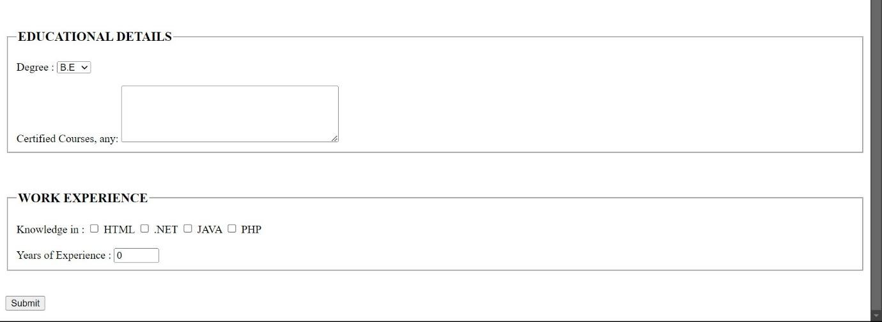 </script>

</body>

</html>