<!DOCTYPE html>

<html>

<head>

<style>

body {

font-family: 'Times New Roman', Times, serif;

}

.flip-card {

background-color: transparent;

width: 300px;

height: 300px;

perspective: 1000px;

}

.flip-card-inner {

position: relative;

width: 100%;

height: 100%;

text-align: center;

transition: transform 0.6s;

transform-style: preserve-3d;

box-shadow: 0 4px 8px 0 rgba(0,0,0,0.2);

}

.flip-card:hover .flip-card-inner {

transform: rotateY(180deg);

}

.flip-card-front, .flip-card-back {

position: absolute;

width: 100%;

height: 100%;

-webkit-backface-visibility: hidden;

backface-visibility: hidden;

}

.flip-card-front {

background-color: #bbbbbb;

color: rgb(46, 7, 7);

}

.flip-card-back {

background-color: #b92929;

color: rgb(255, 255, 255);

transform: rotateY(180deg);

}

</style>

</head>

<body>

<h1>Card Flip with Text</h1>

<h3>Hover over the image below:</h3>

<div class="flip-card">

<div class="flip-card-inner">

<div class="flip-card-front">

<img src="https://img.freepik.com/free-photo/purple-osteospermum-daisy-flower_1373-16.jpg" alt="Avatar" style="width:300px;height:300px;">

</div>

<div class="flip-card-back">

<h1>Shree Ram</h1>

<p>Farmer and Engineer</p>

<p>Welcome!!!!</p>

</div>

</div>

</div>

</body>

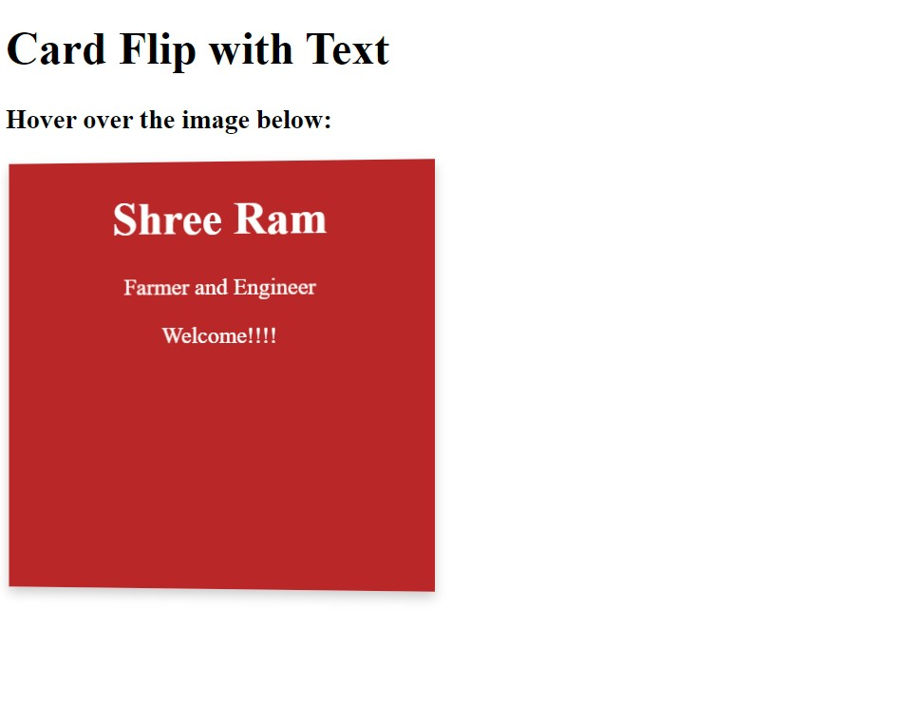</html>