**IT252 Assignment 3**

NAME: SUYASH CHINTAWAR

ROLL NO.: 191IT109

TOPIC: ER DIAGRAM

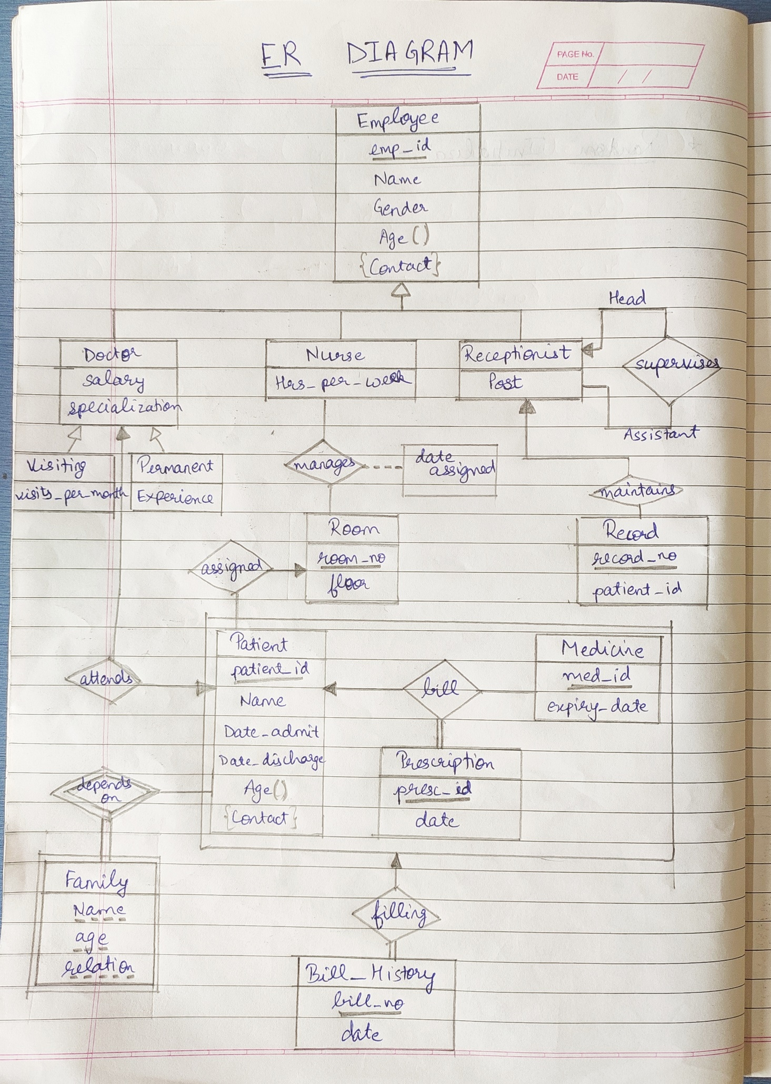**HOSPITAL MANAGEMENT SYSTEM**

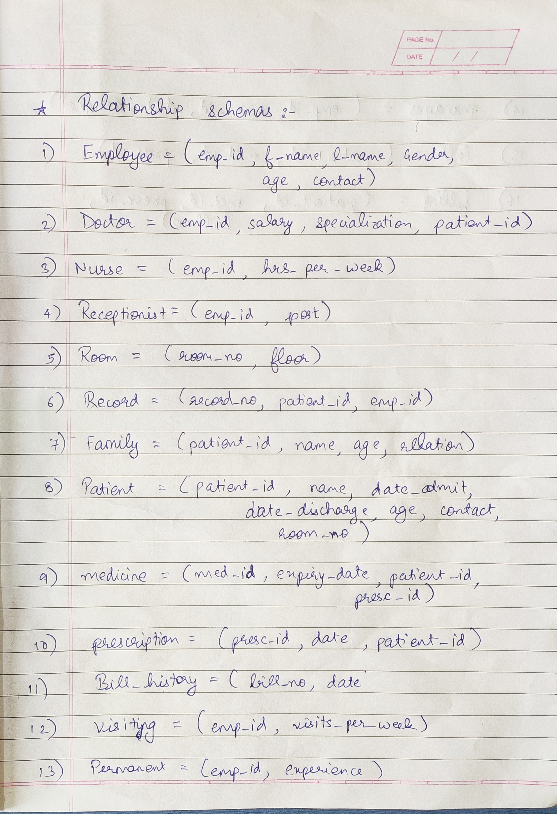

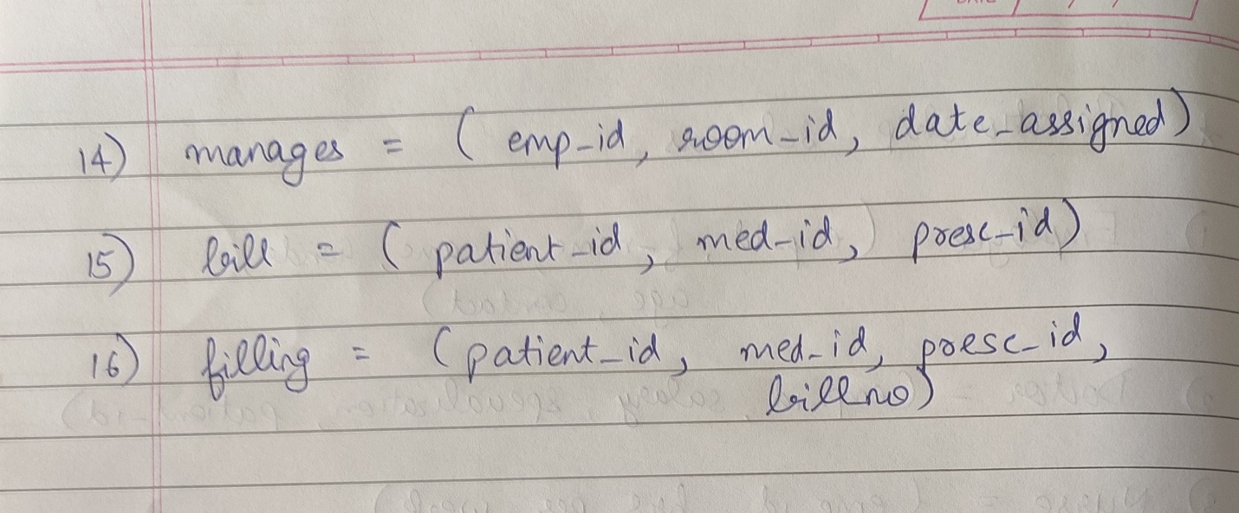

**THANK YOU**