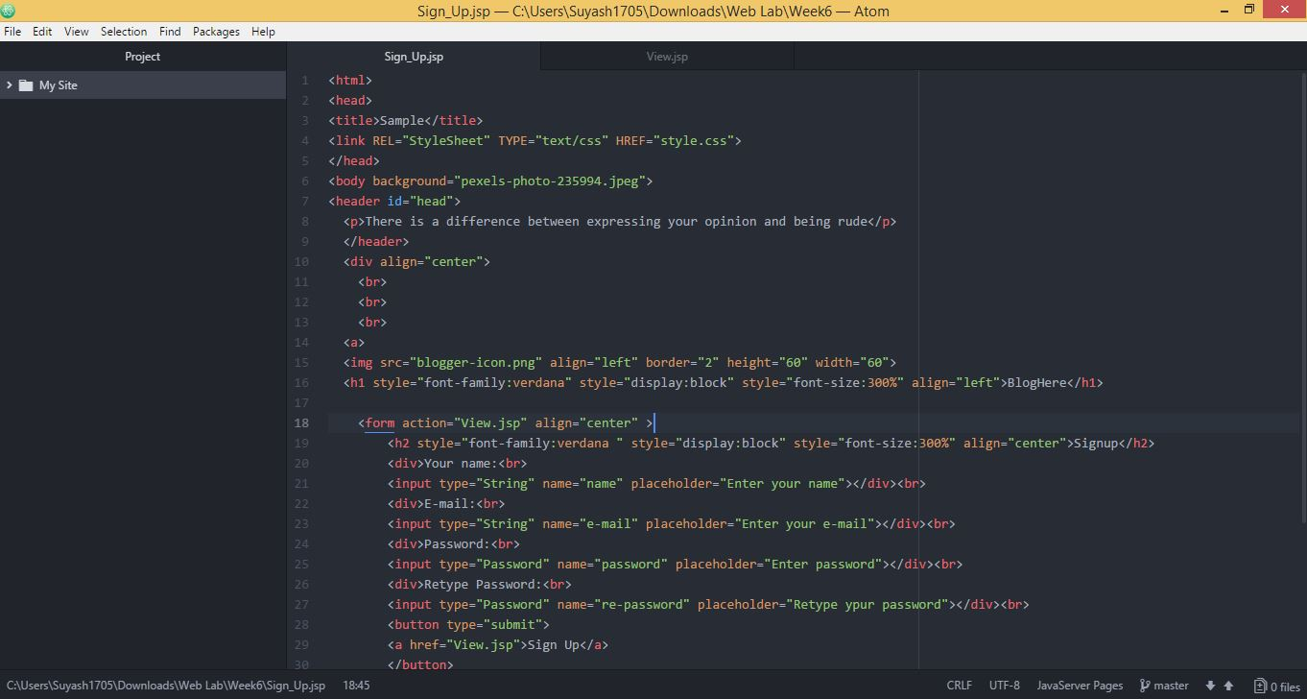

**Source Code**

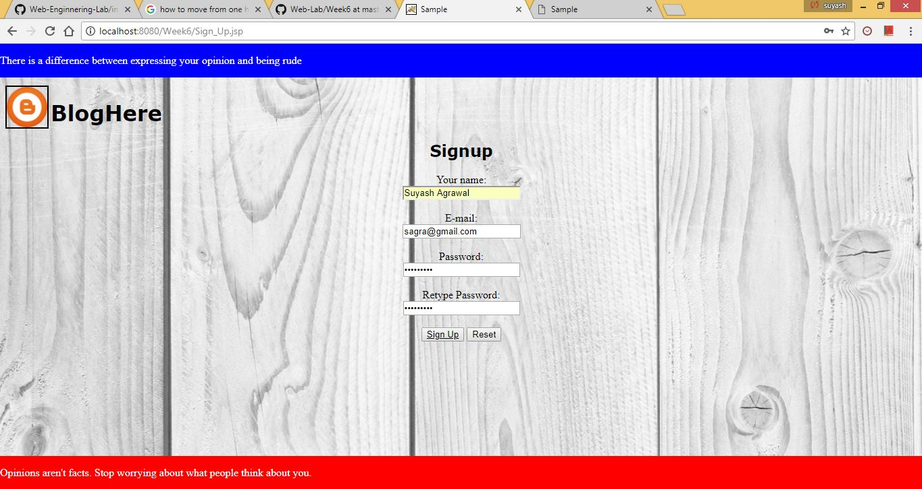

**Web View of Sign Up**

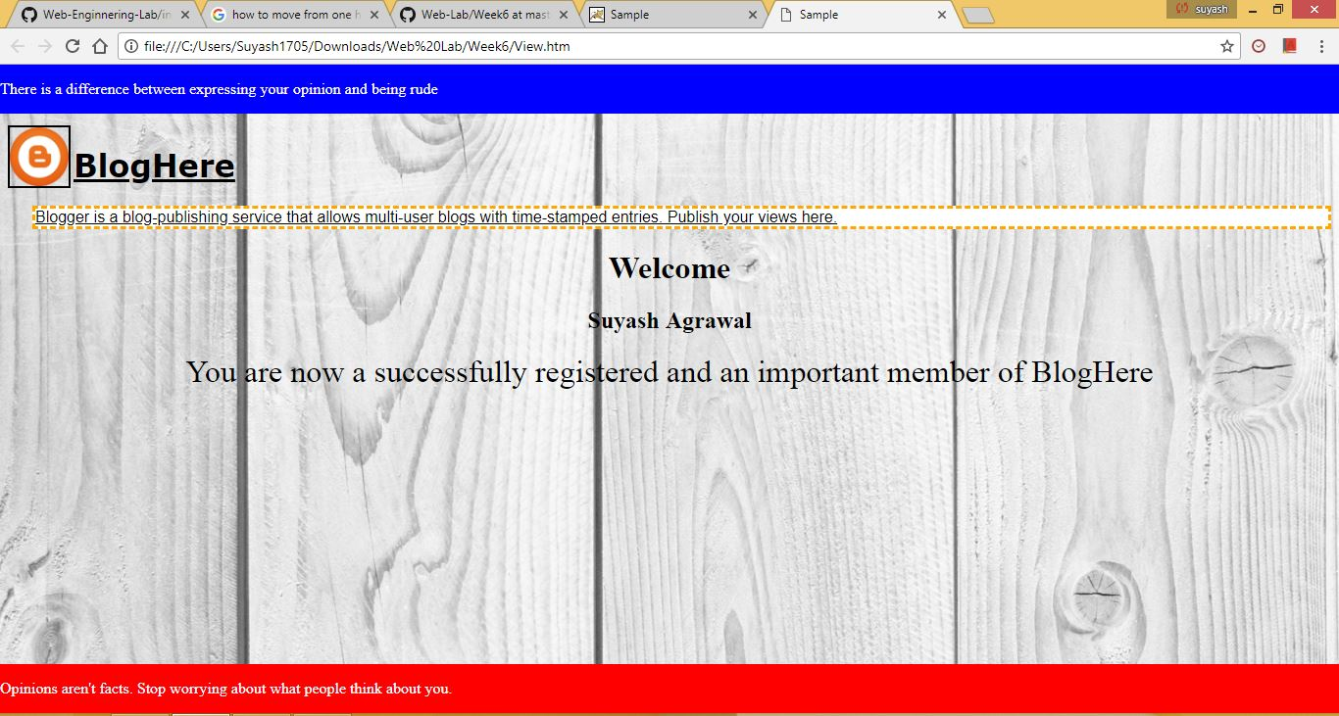

**Web View after JSP**

**JavaServer Pages** (**JSP**) is a technology that helps software developers create dynamically generated web pages based on HTML, XML, or other document types. Released in 1999 by Sun Microsystems,JSP is similar to PHP and ASP, but it uses the Java programming language.

To deploy and run JavaServer Pages, a compatible web server with a servlet container, such as Apache Tomcat or Jetty, is required.