ClubGear
A Campus Club Equipment Booking and Management System

Short Project Report

Student name Suyash Singh
Registration number 25BAI11183
Programme B.Tech CSE, Second Year
Course Java Programming
Repository https://github.com/suyash25bai11183-ui/Java-Project

Introduction

College clubs share equipment — cameras, microphones, projectors, tripods and lighting gear — that is usually tracked in a paper register or a chat group. This causes double bookings, lost items, unnoticed late returns, and damaged equipment being handed out again. ClubGear is a console-based Java application that replaces that register: every club, member and equipment item gets a unique ID, and the system automatically enforces the booking rules that a manual process cannot.

Objectives
    - Track clubs, members and equipment with unique auto-generated IDs
    - Process bookings through a defined life cycle and reject conflicting requests
    - Detect overdue bookings automatically against the current date
    - Record equipment condition on return and manage a maintenance history
    - Persist all data in plain text files with no database
    - Demonstrate core Java: OOP, collections, enums, exceptions, dates and file I/O

Technology stack

Item | Detail
Language | Java 17, compiled with --release 17
Collections | ArrayList , HashMap , HashSet
Dates | java.time.LocalDate , java.time.LocalDateTime
Storage | Five plain CSV text files, no database
Testing | Self-written 55-test suite + 22-case manual test plan
External libraries | None

Functional Modules

The system is built from seven functional modules, each mapped to specific menu options.

# | Module | Capabilities
1 | Club management | Add, view, search clubs; reject duplicate names
2 | Member management | Register members; validate and de-duplicate emails
3 | Equipment management | Add equipment; track quantity, condition, status
4 | Equipment booking | Create bookings; detect date and status conflicts
5 | Booking status management | Approve, cancel, issue, return; detect overdue
6 | Return and maintenance | Record condition, log damage, repair cycle
7 | Reports | Totals, availability, overdue list, usage statistics

Business rules enforced
- Club names must not be duplicated
- Member emails must not be duplicated
- Equipment quantity must be greater than zero
- Damaged or under-maintenance equipment cannot be booked
- A member cannot book the same item for overlapping dates
- Two bookings for the same item cannot overlap
- Return date cannot be earlier than the start date
- Only approved bookings can become active
- Only active (or overdue) bookings can be returned
- Only returned or cancelled bookings release the equipment
- Overdue bookings are detected using the current date
- Invalid menu input must not crash the program

System Architecture

ClubGear follows a three-layer design: presentation (menu and input), domain logic (business rules), and persistence (CSV read/write). Each layer talks only to the layer directly below it.
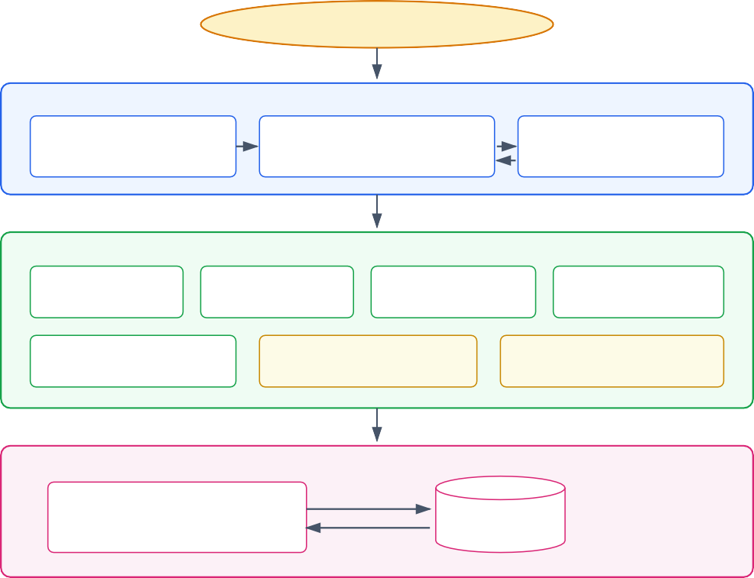
User: Club Coordinator / Club Member

types menu choices
PRESENTATION LAYER
Main.java
entry point, banner, Scanner
ClubGearSystem.java
menu loop + one method per operation
InputValidator.java
safe input + validation
creates and reads objects
DOMAIN / BUSINESS LOGIC LAYER
Club
id, name, coordinator
Member
id, email, course, year
Equipment
qty, condition, status
Booking
dates + overlap rule
MaintenanceRecord
equipment repair history
BookingStatus (enum)
REQUESTED ... OVERDUE
EquipmentStatus (enum)
AVAILABLE ... UNDER_MAINTENANCE
toCsvLine() / fromCsvLine()
PERSISTENCE LAYER

FileStorage.java writeLines() / readLines() missing file returns empty list
clubs.csv bookings.csv
data/*.csv
5 text files
members.csv maintenance.csv
equipment.csv

Figure 1 — Three-layer architecture of ClubGear

Implementation Summary

Class | Responsibility
Main | Entry point; creates the Scanner and starts the system
ClubGearSystem | Menu loop and one method per operation
Club , Member , Equipment | Core data records with CSV conversion
Booking | Booking record, including the date-overlap rule
MaintenanceRecord | One line of repair history per equipment item
BookingStatus ,  EquipmentStatus | Enums controlling valid state transitions
FileStorage | CSV read/write, missing-file handling
InputValidator | Safe, re-prompting keyboard input

Key snippet — clash detection
private Booking findClashingBooking(String equipmentId, LocalDate start, LocalDate end) { for (Booking booking : bookings) {
if (booking.getEquipmentId().equals(equipmentId) && booking.isBlockingEquipment()
&& booking.overlapsWith(start, end)) { return booking;
}
}
return null;
}

Testing

Type | Coverage
Automated ( ValidationTests.java ) | 55 tests: date overlap, status rules, quantity, email validation, CSV round-trips, damaged file lines, file storage
Manual ( TestPlan.md ) | 22 test cases: duplicates, conflicts, approvals, returns, overdue detection, save/load
Total tests : 55 Passed : 55
Failed : 0
RESULT: ALL TESTS PASSED
6. Sample Output
========== BOOKING CONFIRMATION ==========
Booking ID : BKG004
Member : Rahul Nair (MEM003) Equipment : Camera Tripod (EQP004) Club : Photography Club
From : 2026-09-20
Until : 2026-09-22
Status : REQUESTED
==========================================

Error: this equipment is already booked from 2026-09-20 to 2026-09-22 (booking BKG004). Error: this equipment is DAMAGED and cannot be booked right now.
Result. The project compiles cleanly with javac --release 17 -Xlint:all (zero errors, zero warnings) and all 55 automated tests pass.

Conclusion and Future Enhancements

ClubGear meets its objectives: it tracks clubs, members and equipment; it processes bookings through a full life cycle while enforcing twelve business rules; it detects overdue returns automatically; and it persists all data without a database. The project demonstrates practical use of core Java — classes, encapsulation, enums, collections, exception handling, date/time APIs and file I/O — within a scope appropriate for a second-year course project.

Future enhancements
  - Role-based login for coordinators and members
  - Real stock counting instead of one-record-per-asset
  - Email/SMS return reminders and late-return fines
  - Replacing CSV storage with SQLite via JDBC
  - A JavaFX or Swing graphical front end over the existing classes

For full requirements, UML diagrams, design rationale, complete screenshots and the detailed test log, see ClubGear_Project_Report.pdf and the docs/ folder in the repository.

