** ATMA RAM SANTAN DHARMA COLLEGE**

**DELHI UNIVERSITY**

**PRACTICAL FILE**

**ANDROID PROGRAMMING**

**SUBMITTED BY : PIYUSH SOLANKI**

**COLLEGE ROLL NO : 21/18092**

**DEPARTMENT : COMPUTER SCIENCE**

**SEMESTER : IV**

**SUBMITTED TO :**

**MR. LOKESH SRIVASTAVA**

**DEPARTMENT OF COMPUTER SCIENCE**

**INDEX**

|  |  |
| --- | --- |
| **SNO.** | **OBJECTIVE** |
| **1.** | **Create a “Hello World “ application that will display “Hello World” in the middle of the screen in the emulator . Also display “Hello World “ in the middle of the screen in the android phone.** |
|  |  |
| **2.** | **Create an application to display various android activity lifecycle phases.** |
|  |  |
| **3.** | **Create an application with first activity with an editText and send button. On click of send button , make use of explicit intent to send text to second activity and display there in textview.** |
|  |  |
| **4.** | **Create an application with first activity with an editText and send button . On click of send button , make use of implicit intent that uses a SEND ACTION and let user select app from app chooser and navigate to that application.** |
|  |  |
| **5.** | **Create spinner with strings taken from resource folder (res>> value folder) and on changing the spinner value , image will change.** |
|  |  |
| **6.** | **Create a menu with 5 options and selected option should appear in text box in upper case.** |
|  |  |
| **7.** | **Create a radio button group with radio button of all courses in your college and on selecting a particular course , teacher-in-charge of that course should appear at the bottom of the screen.** |
|  |  |
| **8.** | **Create a list of all Courses in your college and on selecting a particular course parent department and the teacher-in-charge of that department should appear at the bottom of the screen.** |
|  |  |
| **9.** | **a) Create an application with three buttons (with different color names) vertically aligned , on selecting a button color of the screen will change.**  **b) Create an application with three buttons horizontally aligned , on selecting a button color of the screen will change.** |
|  |  |
| **10.** | **Create a Login application (check username and password ) . On successful login , pop up the message .(“Welcome Username “)** |
|  |  |
| **11.** | **Create a login application as above , on successful login redirect to another activity with logout button . On click of logout button a dialog appears with OK and CANCEL button . On OK button click go to login activity and on CANCEL stay at same activity.** |
|  |  |
| **12.** | **Create an application to Create , Insert , Update and Delete operation on the database .** |

**OBJECTIVE :**

**Create a “Hello World “ application that will display “Hello World” in the middle of the screen in the emulator . Also display “Hello World “ in the middle of the screen in the android phone.**

**Code :**

**Activity_xml**

<?xml version="1.0" encoding="utf-8"?>  
<androidx.constraintlayout.widget.ConstraintLayout xmlns:android="http://schemas.android.com/apk/res/android"  
 xmlns:app="http://schemas.android.com/apk/res-auto"  
 xmlns:tools="http://schemas.android.com/tools"  
 android:layout_width="match_parent"  
 android:layout_height="match_parent"  
 tools:context=".MainActivity">  
  
 <TextView  
 android:id="@+id/textview"  
 android:layout_width="wrap_content"  
 android:layout_height="wrap_content"  
 android:background="#9C27B0"  
 android:fontFamily="sans-serif-medium"  
 android:text="Hello World!"  
 android:textSize="24sp"  
 android:textStyle="bold"  
 app:autoSizeTextType="uniform"  
 app:layout_constraintBottom_toBottomOf="parent"  
 app:layout_constraintEnd_toEndOf="parent"  
 app:layout_constraintStart_toStartOf="parent"  
 app:layout_constraintTop_toTopOf="parent"  
 app:layout_constraintVertical_bias="0.453" />  
  
</androidx.constraintlayout.widget.ConstraintLayout>

**Main_Activity**

package com.example.practical1;  
  
import androidx.appcompat.app.AppCompatActivity;  
  
import android.os.Bundle;  
  
public class MainActivity extends AppCompatActivity {  
  
 @Override  
 protected void onCreate(Bundle savedInstanceState) {  
 super.onCreate(savedInstanceState);  
 setContentView(R.layout.*activity_main*);  
 }  
}

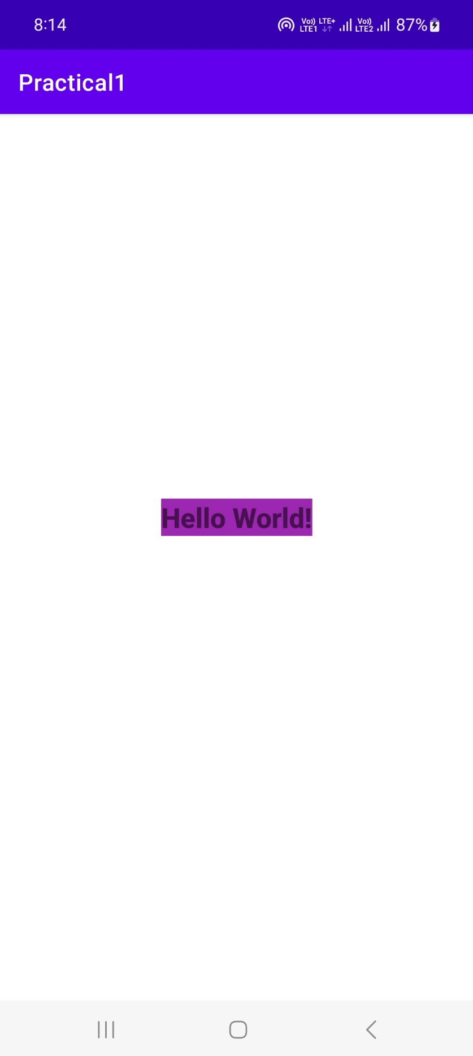

**OBJECTIVE:**

**Create an application to display various android activity lifecycle phases.**

**Code :**

**Activity_xml**

<?xml version="1.0" encoding="utf-8"?>  
<androidx.constraintlayout.widget.ConstraintLayout xmlns:android="http://schemas.android.com/apk/res/android"  
 xmlns:app="http://schemas.android.com/apk/res-auto"  
 xmlns:tools="http://schemas.android.com/tools"  
 android:layout_width="match_parent"  
 android:layout_height="match_parent"  
 tools:context=".MainActivity">  
  
 <TextView  
 android:id="@+id/textview"  
 android:layout_width="wrap_content"  
 android:layout_height="wrap_content"  
 android:text="Android Activity LifeCycle"  
 android:textAppearance="@style/TextAppearance.AppCompat.Display1"  
 android:textColor="#673AB7"  
 android:textStyle="bold"  
 app:layout_constraintBottom_toBottomOf="parent"  
 app:layout_constraintEnd_toEndOf="parent"  
 app:layout_constraintHorizontal_bias="0.458"  
 app:layout_constraintStart_toStartOf="parent"  
 app:layout_constraintTop_toTopOf="parent"  
 app:layout_constraintVertical_bias="0.172" />  
  
</androidx.constraintlayout.widget.ConstraintLayout>

**MainActivity**

package com.example.practical2;  
  
import androidx.appcompat.app.AppCompatActivity;  
  
import android.os.Bundle;  
import android.widget.Toast;  
  
public class MainActivity extends AppCompatActivity {  
  
 @Override  
 protected void onCreate(Bundle savedInstanceState) {  
 super.onCreate(savedInstanceState);  
 setContentView(R.layout.*activity_main*);  
 Toast toast = Toast.*makeText*(getApplicationContext(),"Activity Created",Toast.*LENGTH_SHORT*);  
 toast.show();  
 }  
  
 @Override  
 protected void onResume() {  
 super.onResume();  
 Toast toast = Toast.*makeText*(getApplicationContext(),"Activity Resumed",Toast.*LENGTH_SHORT*);  
 toast.show();  
 }  
  
 @Override  
 protected void onPause(){  
 super.onPause();  
 Toast toast = Toast.*makeText*(getApplicationContext(),"Activity Paused",Toast.*LENGTH_SHORT*);  
 toast.show();  
 }  
  
 @Override  
 protected void onStart(){  
 super.onStart();  
 Toast toast = Toast.*makeText*(getApplicationContext(),"Activity Started",Toast.*LENGTH_SHORT*);  
 toast.show();  
 }  
  
  
 @Override  
 protected void onStop(){  
 super.onStop();  
 Toast toast = Toast.*makeText*(getApplicationContext(),"Activity Stopped",Toast.*LENGTH_SHORT*);  
 toast.show();  
 }  
  
  
 @Override  
 protected void onDestroy(){  
 super.onDestroy();  
 Toast toast = Toast.*makeText*(getApplicationContext(),"Activity Destroyed",Toast.*LENGTH_SHORT*);  
 toast.show();  
 }  
}

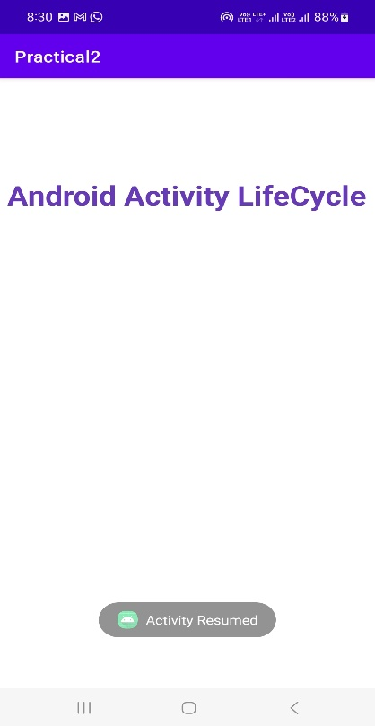 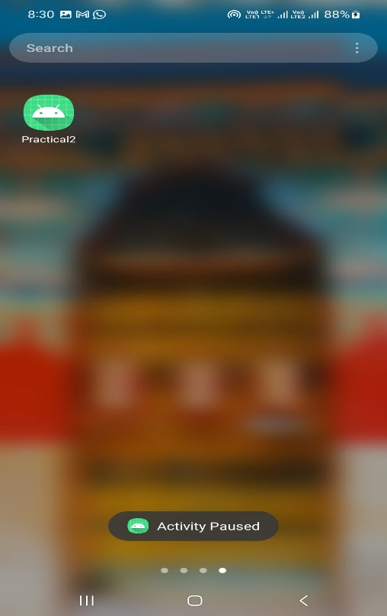

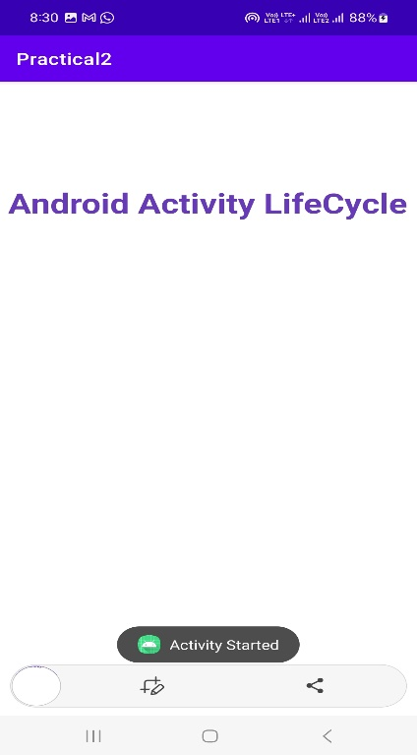 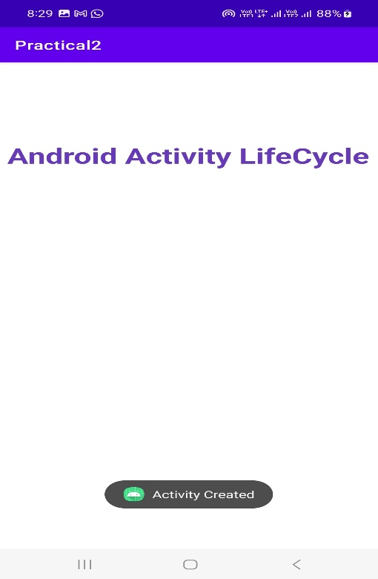

**OBJECTIVE :**

**Create an application with first activity with an editText and send button. On click of send button , make use of explicit intent to send text to second activity and display there in textview.**

**Code:**

**Activity_main.xml**

<?xml version="1.0" encoding="utf-8"?>  
<androidx.constraintlayout.widget.ConstraintLayout xmlns:android="http://schemas.android.com/apk/res/android"  
 xmlns:app="http://schemas.android.com/apk/res-auto"  
 xmlns:tools="http://schemas.android.com/tools"  
 android:layout_width="match_parent"  
 android:layout_height="match_parent"  
 tools:context=".MainActivity">  
  
 <EditText  
 android:id="@+id/editText"  
 android:layout_width="wrap_content"  
 android:layout_height="wrap_content"  
 android:ems="10"  
 android:inputType="textPersonName"  
 app:layout_constraintBottom_toBottomOf="parent"  
 app:layout_constraintEnd_toEndOf="parent"  
 app:layout_constraintHorizontal_bias="0.497"  
 app:layout_constraintStart_toStartOf="parent"  
 app:layout_constraintTop_toTopOf="parent"  
 app:layout_constraintVertical_bias="0.314" />  
  
 <Button  
 android:id="@+id/sendButton"  
 android:layout_width="wrap_content"  
 android:layout_height="wrap_content"  
 android:text="SUBMIT"  
 app:layout_constraintBottom_toBottomOf="parent"  
 app:layout_constraintEnd_toEndOf="parent"  
 app:layout_constraintHorizontal_bias="0.498"  
 app:layout_constraintStart_toStartOf="parent"  
 app:layout_constraintTop_toBottomOf="@+id/editText"  
 app:layout_constraintVertical_bias="0.189" />  
</androidx.constraintlayout.widget.ConstraintLayout>

**Second_activity.xml**

<?xml version="1.0" encoding="utf-8"?>  
<androidx.constraintlayout.widget.ConstraintLayout xmlns:android="http://schemas.android.com/apk/res/android"  
 xmlns:app="http://schemas.android.com/apk/res-auto"  
 xmlns:tools="http://schemas.android.com/tools"  
 android:layout_width="match_parent"  
 android:layout_height="match_parent"  
 tools:context=".Second_Activity">  
  
 <TextView  
 android:id="@+id/textView"  
 android:layout_width="wrap_content"  
 android:layout_height="wrap_content"  
 android:fontFamily="sans-serif-black"  
 android:textAlignment="center"  
 android:textAppearance="@style/TextAppearance.AppCompat.Display3"  
 android:textColor="#4CAF50"  
 android:textSize="60sp"  
 android:textStyle="bold"  
 android:typeface="serif"  
 app:layout_constraintBottom_toBottomOf="parent"  
 app:layout_constraintEnd_toEndOf="parent"  
 app:layout_constraintHorizontal_bias="0.498"  
 app:layout_constraintStart_toStartOf="parent"  
 app:layout_constraintTop_toTopOf="parent"  
 app:layout_constraintVertical_bias="0.258" />  
</androidx.constraintlayout.widget.ConstraintLayout>

**MainActivity.java**

package com.example.practical3;  
  
import androidx.appcompat.app.AppCompatActivity;  
  
import android.content.Intent;  
import android.os.Bundle;  
import android.view.View;  
import android.widget.Button;  
import android.widget.EditText;  
  
public class MainActivity extends AppCompatActivity {  
 private Button btn ;  
 private EditText editText;  
 private String str;  
 @Override  
 protected void onCreate(Bundle savedInstanceState) {  
 super.onCreate(savedInstanceState);  
 setContentView(R.layout.*activity_main*);  
 btn=findViewById(R.id.*sendButton*);  
 editText = findViewById(R.id.*editText*);  
 btn.setOnClickListener(new View.OnClickListener() {  
 @Override  
 public void onClick(View v) {  
 Intent intent = new Intent(MainActivity.this , SecondActivity.class);  
 str = editText.getText().toString();  
 intent.putExtra("value",str);  
 startActivity(intent);  
 finish();  
 }  
 });  
 }  
}

**SecondActivity.java**

package com.example.practical3;  
  
import androidx.appcompat.app.AppCompatActivity;  
  
import android.os.Bundle;  
import android.widget.TextView;  
  
public class SecondActivity extends AppCompatActivity {  
 private TextView textView;  
 private String str;  
 @Override  
 protected void onCreate(Bundle savedInstanceState) {  
 super.onCreate(savedInstanceState);  
 setContentView(R.layout.*activity_second*);  
 textView =findViewById(R.id.*textView*);  
 str= getIntent().getExtras().getString("value");  
 textView.setText(str);  
 }  
}

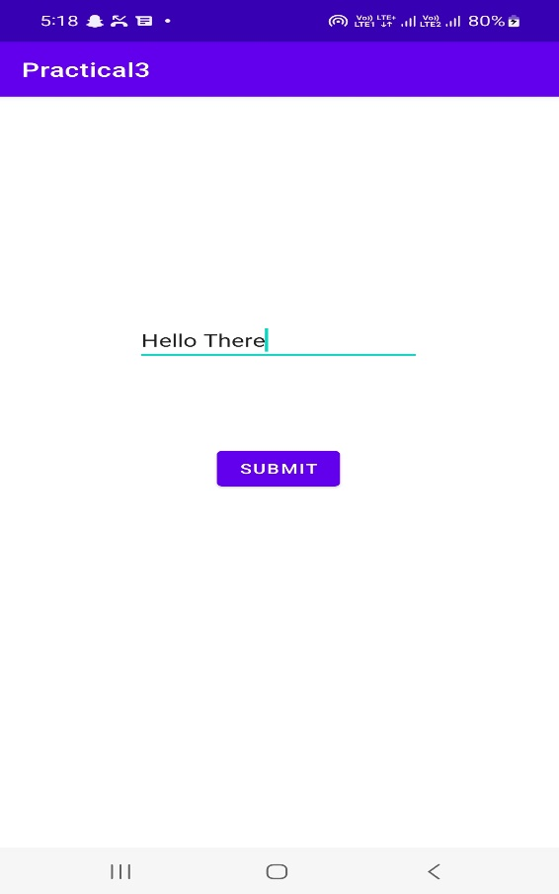

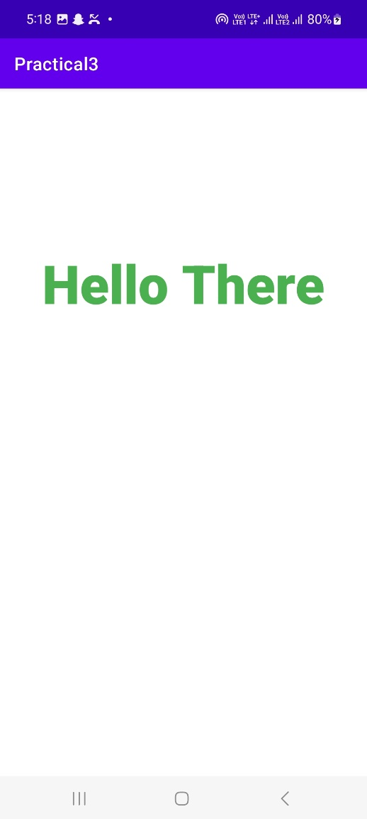

**OBJECTIVE:**

**Create an application with first activity with an editText and send button . On click of send button , make use of implicit intent that uses a SEND ACTION and let user select app from app chooser and navigate to that application.**

**Code:**

**Activity_main.xml**

<?xml version="1.0" encoding="utf-8"?>  
<androidx.constraintlayout.widget.ConstraintLayout xmlns:android="http://schemas.android.com/apk/res/android"  
 xmlns:app="http://schemas.android.com/apk/res-auto"  
 xmlns:tools="http://schemas.android.com/tools"  
 android:layout_width="match_parent"  
 android:layout_height="match_parent"  
 tools:context=".MainActivity">  
  
 <Button  
 android:id="@+id/share"  
 android:layout_width="wrap_content"  
 android:layout_height="wrap_content"  
 android:text="Share Text"  
 app:layout_constraintBottom_toBottomOf="parent"  
 app:layout_constraintEnd_toEndOf="parent"  
 app:layout_constraintHorizontal_bias="0.531"  
 app:layout_constraintStart_toStartOf="parent"  
 app:layout_constraintTop_toTopOf="parent"  
 app:layout_constraintVertical_bias="0.442" />  
</androidx.constraintlayout.widget.ConstraintLayout>

**MainActivity.java**

package com.example.practical4;  
  
import static com.example.practical4.R.id.*share*;  
  
import androidx.appcompat.app.AppCompatActivity;  
  
import android.content.Intent;  
import android.os.Bundle;  
import android.view.View;  
import android.widget.Button;  
  
public class MainActivity extends AppCompatActivity {  
 @Override  
 protected void onCreate(Bundle savedInstanceState) {  
 super.onCreate(savedInstanceState);  
 setContentView(R.layout.*activity_main*);  
 Button btn= findViewById(R.id.*share*);  
 btn.setOnClickListener(new View.OnClickListener() {  
 @Override  
 public void onClick(View v) {  
 Intent intent = new Intent(Intent.*ACTION_SEND*);  
 intent.setType("text/plain");  
 intent.putExtra(Intent.*EXTRA_TEXT*,"Hello There");  
 startActivity(intent.*createChooser*(intent , "Share"));  
 }  
 });  
  
 }  
}

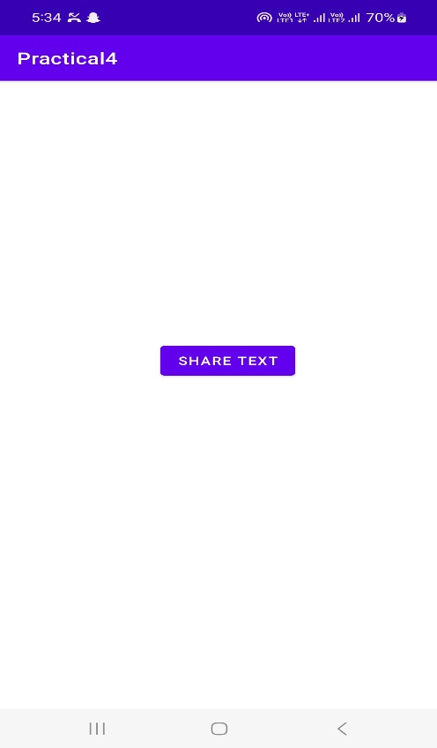 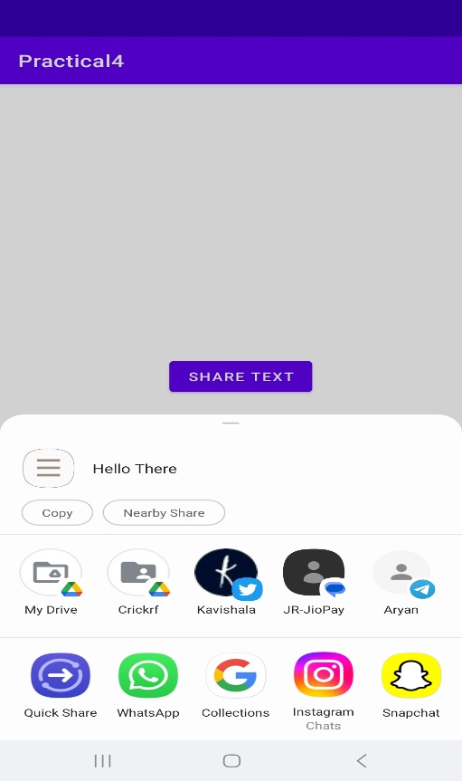

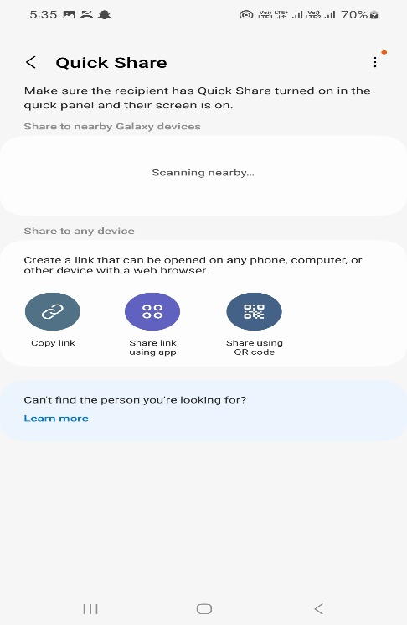

**OBJECTIVE:**

**Create spinner with strings taken from resource folder (res>> value folder) and on changing the spinner value , image will change.**

**Code:**

**Activity_main.xml**

<?xml version="1.0" encoding="utf-8"?>  
<androidx.constraintlayout.widget.ConstraintLayout xmlns:android="http://schemas.android.com/apk/res/android"  
 xmlns:app="http://schemas.android.com/apk/res-auto"  
 xmlns:tools="http://schemas.android.com/tools"  
 android:layout_width="match_parent"  
 android:layout_height="match_parent"  
 tools:context=".MainActivity">  
  
 <Spinner  
 android:id="@+id/spin"  
 android:layout_width="409dp"  
 android:layout_height="wrap_content"  
 android:contentDescription="@string/value0"  
 android:minHeight="48dp"  
 android:spinnerMode="dropdown"  
 app:layout_constraintBottom_toBottomOf="parent"  
 app:layout_constraintEnd_toEndOf="parent"  
 app:layout_constraintHorizontal_bias="1.0"  
 app:layout_constraintStart_toStartOf="parent"  
 app:layout_constraintTop_toTopOf="parent"  
 app:layout_constraintVertical_bias="0.045" />  
  
 <ImageView  
 android:id="@+id/imageview"  
 android:layout_width="410dp"  
 android:layout_height="397dp"  
 app:layout_constraintBottom_toBottomOf="parent"  
 app:layout_constraintEnd_toEndOf="parent"  
 app:layout_constraintHorizontal_bias="0.461"  
 app:layout_constraintStart_toStartOf="parent"  
 app:layout_constraintTop_toBottomOf="@+id/spin"  
 app:layout_constraintVertical_bias="0.283"  
 tools:srcCompat="@color/white" />  
  
</androidx.constraintlayout.widget.ConstraintLayout>

**MainActivity.java**

package com.example.practical5;  
  
import androidx.appcompat.app.AppCompatActivity;  
  
import android.os.Bundle;  
import android.view.View;  
import android.widget.AdapterView;  
import android.widget.ArrayAdapter;  
import android.widget.ImageView;  
import android.widget.Spinner;  
  
public class MainActivity extends AppCompatActivity {  
 private Spinner spinner;  
 private ImageView imageView;  
 @Override  
 protected void onCreate(Bundle savedInstanceState) {  
 super.onCreate(savedInstanceState);  
 setContentView(R.layout.*activity_main*);  
 spinner = findViewById(R.id.*spin*);  
 imageView = findViewById(R.id.*imageview*);  
 String [] birds = {"Select One" , "Flamingo" , "Eagle","Horse" ,"Tiger"};  
 ArrayAdapter<String> adapter = new ArrayAdapter<String>(this, android.R.layout.*simple_spinner_dropdown_item*,birds);  
 spinner.setAdapter(adapter);  
 spinner.setOnItemSelectedListener(new AdapterView.OnItemSelectedListener() {  
 @Override  
 public void onItemSelected(AdapterView<?> parent, View view, int position, long id) {  
 switch (position){  
 case 1:  
 imageView.setImageResource(R.drawable.*flamingo*);  
 break;  
 case 2:  
 imageView.setImageResource(R.drawable.*eagle*);  
 break;  
 case 3:  
 imageView.setImageResource(R.drawable.*horse*);  
 break;  
 case 4:  
 imageView.setImageResource(R.drawable.*tiger*);  
 break;  
 }  
 }  
  
 @Override  
 public void onNothingSelected(AdapterView<?> parent) {  
 }  
 });  
 }  
}

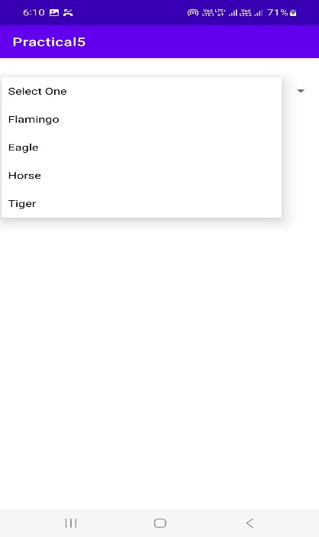 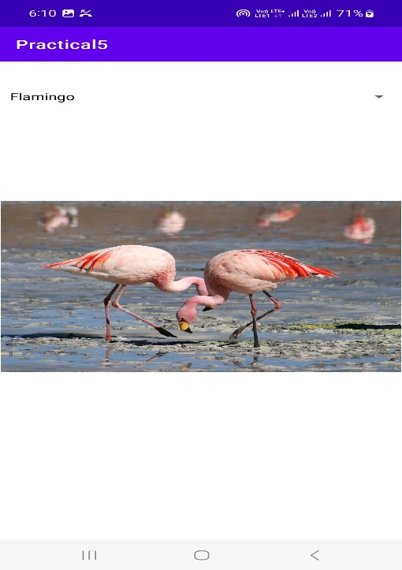

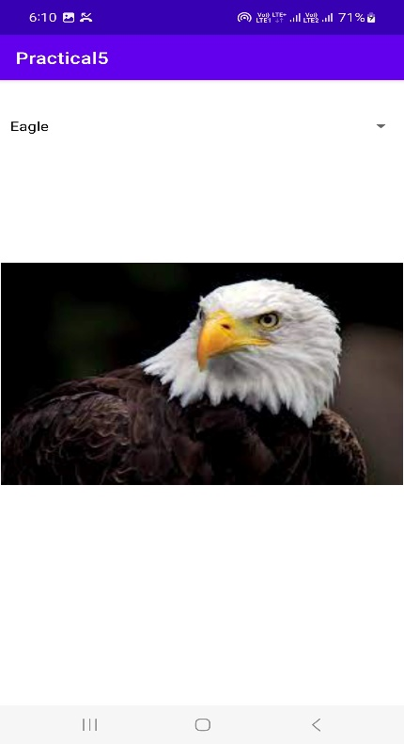 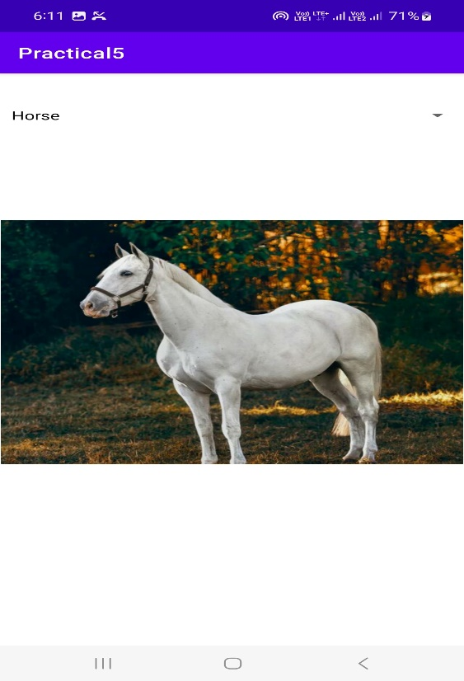

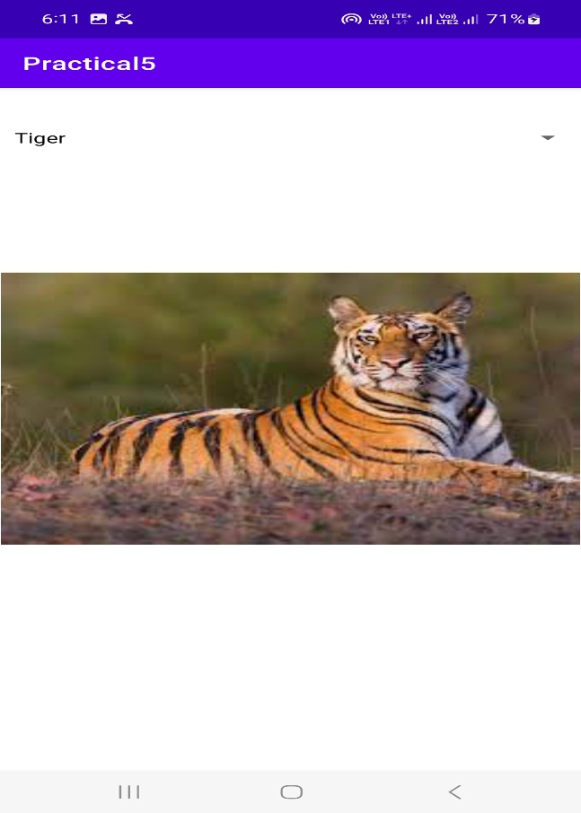

**OBJECTIVE:**

**Create a menu with 5 options and selected option should appear in text box in upper case.**

**Code:**

**Activity_main.xml**

<?xml version="1.0" encoding="utf-8"?>  
<androidx.constraintlayout.widget.ConstraintLayout xmlns:android="http://schemas.android.com/apk/res/android"  
 xmlns:app="http://schemas.android.com/apk/res-auto"  
 xmlns:tools="http://schemas.android.com/tools"  
 android:layout_width="match_parent"  
 android:layout_height="match_parent"  
 tools:context=".MainActivity">  
  
 <RelativeLayout  
 android:layout_width="match_parent"  
 android:layout_height="match_parent"  
 tools:layout_editor_absoluteX="61dp"  
 tools:layout_editor_absoluteY="145dp">  
  
 <EditText  
 android:id="@+id/menuitem"  
 android:layout_width="match_parent"  
 android:layout_height="wrap_content"  
 android:layout_alignParentTop="true"  
 android:layout_alignParentBottom="true"  
 android:layout_marginTop="299dp"  
 android:layout_marginBottom="387dp"  
 android:ems="10"  
 android:gravity="center_horizontal"  
 android:hint="Select an Option from the Item"  
 android:inputType="textPersonName"  
 android:textAlignment="center" />  
 </RelativeLayout>  
</androidx.constraintlayout.widget.ConstraintLayout>

**Main_menu.xml**

<?xml version="1.0" encoding="utf-8"?>  
<menu xmlns:app="http://schemas.android.com/apk/res-auto"  
 xmlns:android="http://schemas.android.com/apk/res/android">  
  
 <item  
 android:id="@+id/settings"  
 android:title="@string/settings" />  
 <item  
 android:id="@+id/backup"  
 android:title="@string/backup" />  
 <item  
 android:id="@+id/reset"  
 android:title="@string/reset" />  
 <item  
 android:id="@+id/about"  
 android:title="@string/about" />  
 <item  
 android:id="@+id/help"  
 android:title="@string/help" />  
</menu>

**Strings.xml**

<resources>  
 <string name="app_name">Practical6</string>  
 <string name="backup">Backup</string>  
 <string name="settings">Settings</string>  
 <string name="reset">Reset</string>  
 <string name="about">About</string>  
 <string name="help">Help</string>  
</resources>

**MainActivity.java**

package com.example.practical6;  
  
import androidx.appcompat.app.AppCompatActivity;  
  
import android.os.Bundle;  
import android.view.Menu;  
import android.view.MenuInflater;  
import android.view.MenuItem;  
import android.widget.EditText;  
  
public class MainActivity extends AppCompatActivity {  
 private EditText editText;  
 @Override  
 protected void onCreate(Bundle savedInstanceState) {  
 super.onCreate(savedInstanceState);  
 setContentView(R.layout.*activity_main*);  
 editText =(EditText) findViewById(R.id.*menuitem*);  
  
 }  
  
 @Override  
 public boolean onCreateOptionsMenu(Menu menu){  
 MenuInflater inflater = getMenuInflater();  
 inflater.inflate(R.menu.*main_menu*, menu);  
 return true;  
 }  
  
 @Override  
 public boolean onOptionsItemSelected(MenuItem item){  
 editText.setText(item.getTitle().toString().toUpperCase());  
 return super.onOptionsItemSelected(item);  
 }  
}

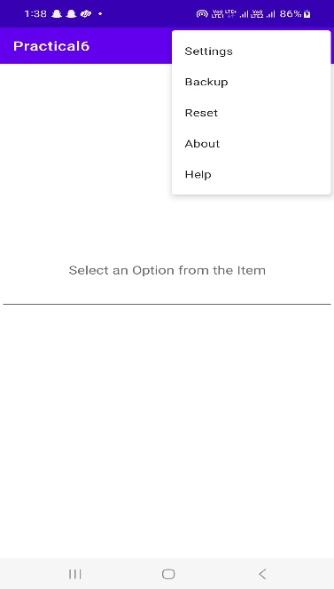 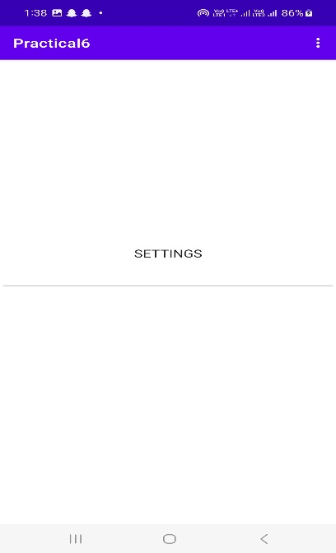 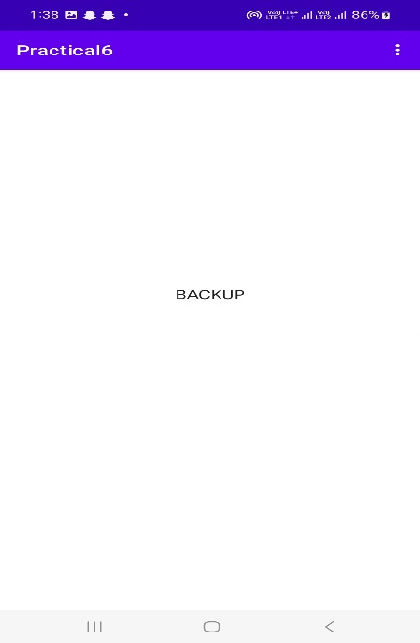

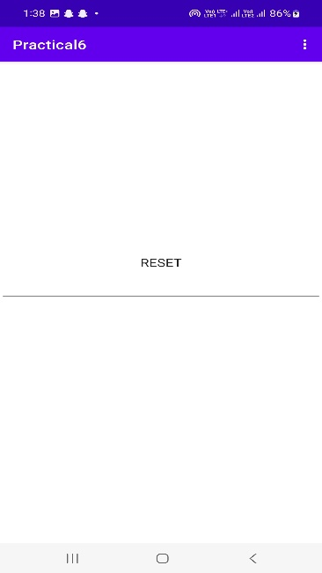 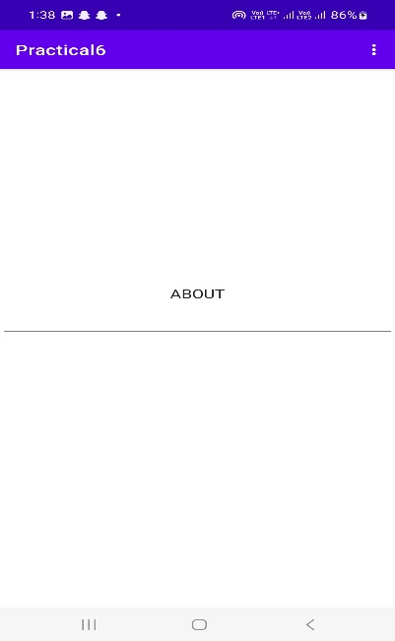 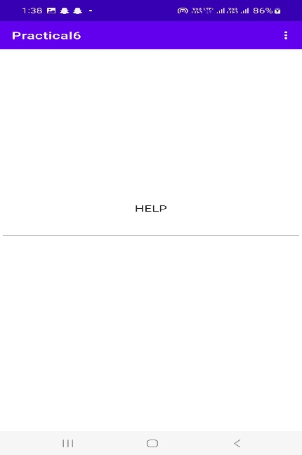

**OBJECTIVE:**

**Create a radio button group with radio button of all courses in your college and on selecting a particular course , teacher-in-charge of that course should appear at the bottom of the screen.**

**Code:**

**Activity_main.xml**

<?xml version="1.0" encoding="utf-8"?>  
<androidx.constraintlayout.widget.ConstraintLayout xmlns:android="http://schemas.android.com/apk/res/android"  
 xmlns:app="http://schemas.android.com/apk/res-auto"  
 xmlns:tools="http://schemas.android.com/tools"  
 android:layout_width="match_parent"  
 android:layout_height="match_parent"  
 tools:context=".MainActivity">  
  
 <RelativeLayout  
 android:layout_width="match_parent"  
 android:layout_height="match_parent"  
 app:layout_constraintBottom_toBottomOf="parent"  
 app:layout_constraintEnd_toEndOf="parent"  
 app:layout_constraintStart_toStartOf="parent"  
 app:layout_constraintTop_toTopOf="parent"  
 app:layout_constraintLeft_toLeftOf="parent"  
 app:layout_constraintRight_toRightOf="parent"  
 >  
  
 <RadioGroup  
 android:id="@+id/courses"  
 android:layout_width="match_parent"  
 android:layout_height="wrap_content"  
 android:layout_centerInParent="true"  
 />  
 </RelativeLayout>  
</androidx.constraintlayout.widget.ConstraintLayout>

**MainActivity.java**

package com.example.practical7;  
  
import androidx.appcompat.app.AppCompatActivity;  
  
import android.os.Bundle;  
import android.widget.RadioButton;  
import android.widget.RadioGroup;  
  
import com.google.android.material.snackbar.Snackbar;  
  
import java.util.HashMap;  
  
public class MainActivity extends AppCompatActivity {  
 private RadioGroup radioGroup;  
 private HashMap<String,String> coursesMap;  
 @Override  
 protected void onCreate(Bundle savedInstanceState) {  
 super.onCreate(savedInstanceState);  
 setContentView(R.layout.*activity_main*);  
 initCourses();  
 }  
  
 private void initCourses(){  
 radioGroup =(RadioGroup)findViewById(R.id.*courses*);  
 if(coursesMap ==null){  
 coursesMap = new HashMap<>();  
 coursesMap.put("BSC(Hons) Computer Science", "Dr.V.S. Dixit");  
 coursesMap.put("BCOM (Hons)","Dr. Manika Jain");  
 coursesMap.put("BA (Hons)","Dr.Arpa Sinha");  
 for (String course: coursesMap.keySet()  
 ) {  
 RadioButton radioButton = new RadioButton(MainActivity.this);  
 radioButton.setText(course);  
 radioGroup.addView(radioButton);  
 }  
  
 radioGroup.setOnCheckedChangeListener(new RadioGroup.OnCheckedChangeListener() {  
 @Override  
 public void onCheckedChanged(RadioGroup group, int checkedId) {  
 int checkedRadioButtonid = radioGroup.getCheckedRadioButtonId();  
 RadioButton rbutton = (RadioButton) findViewById(checkedRadioButtonid);  
  
 Snackbar.*make*(radioGroup,coursesMap.get(rbutton.getText()),Snackbar.*LENGTH_SHORT*).show();  
 }  
 });  
 }  
 }  
}

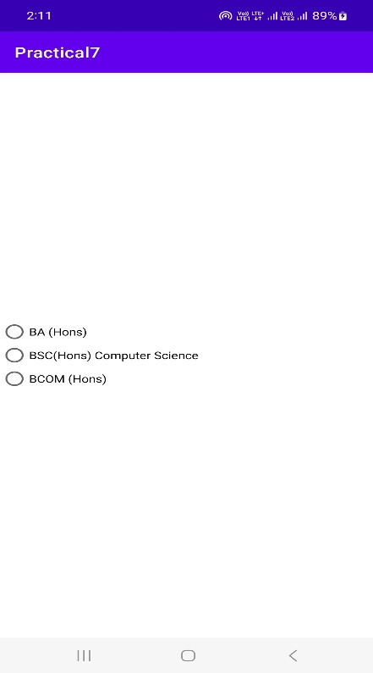 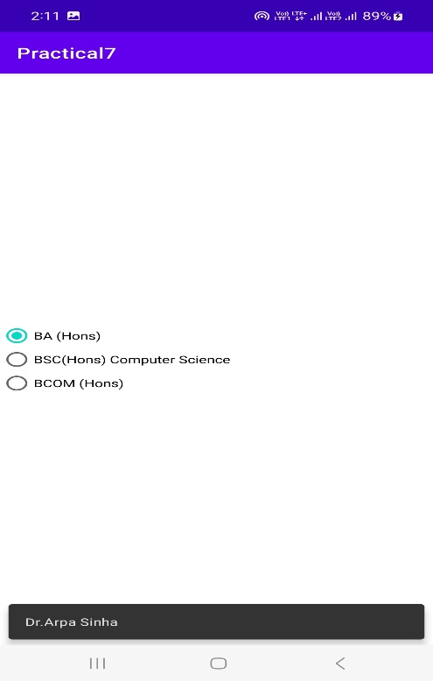

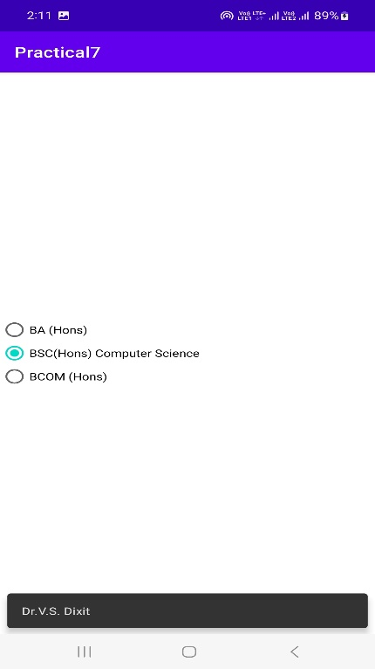 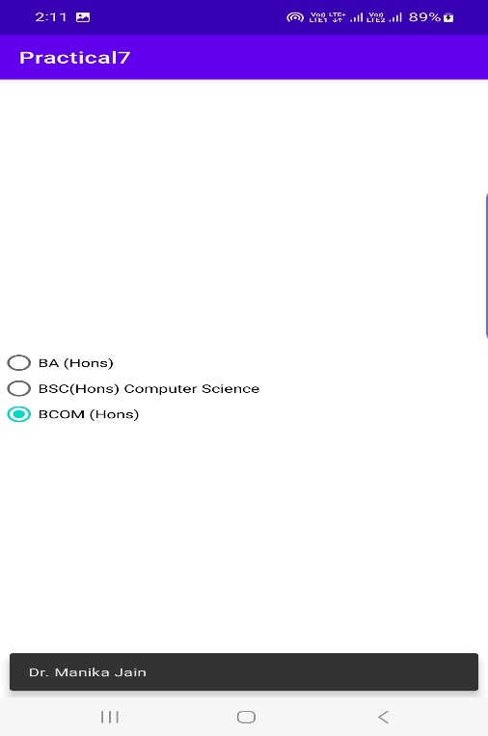

**OBJECTIVE:**

**Create a list of all Courses in your college and on selecting a particular course parent department and the teacher-in-charge of that department should appear at the bottom of the screen.**

**Code:**

**Activity_main.xml**

<?xml version="1.0" encoding="utf-8"?>  
<androidx.constraintlayout.widget.ConstraintLayout xmlns:android="http://schemas.android.com/apk/res/android"  
 xmlns:app="http://schemas.android.com/apk/res-auto"  
 xmlns:tools="http://schemas.android.com/tools"  
 android:layout_width="match_parent"  
 android:layout_height="match_parent"  
 tools:context=".MainActivity">  
  
 <RelativeLayout  
 android:layout_width="match_parent"  
 android:layout_height="match_parent"  
 android:layout_margin="75dp"  
 app:layout_constraintEnd_toEndOf="parent"  
 app:layout_constraintStart_toStartOf="parent"  
 app:layout_constraintRight_toRightOf="parent"  
 app:layout_constraintLeft_toLeftOf="parent"  
 >  
  
 <RadioGroup  
 android:layout_width="match_parent"  
 android:layout_height="wrap_content"  
 android:id ="@+id/courses"  
 android:layout_centerInParent="true">  
  
 </RadioGroup>  
 </RelativeLayout>  
</androidx.constraintlayout.widget.ConstraintLayout>

**MainActivity.java**

package com.example.practical8;  
  
import androidx.appcompat.app.AppCompatActivity;  
  
import android.os.Bundle;  
import android.widget.RadioButton;  
import android.widget.RadioGroup;  
  
import com.google.android.material.snackbar.Snackbar;  
  
import java.util.HashMap;  
  
public class MainActivity extends AppCompatActivity {  
private RadioGroup rgcourses;  
private HashMap<String,String> coursesMap;  
 @Override  
 protected void onCreate(Bundle savedInstanceState) {  
 super.onCreate(savedInstanceState);  
 setContentView(R.layout.*activity_main*);  
 initCourses();  
 }  
  
 private void initCourses(){  
 rgcourses =(RadioGroup) findViewById(R.id.*courses*);  
 if(coursesMap ==null){  
 coursesMap = new HashMap<>();  
 coursesMap.put("BSC(Hons) Computer Science","Dept. of Computer Science - Dr. V.S. Dixit");  
 coursesMap.put("BCOM(Hons)","Dept. of Commerce - Dr. Manika Jain");  
 coursesMap.put("BA(Hons)" , "Dept. of Economics - Dr.Apra Sinha");  
 for(String course : coursesMap.keySet()){  
 RadioButton radioButton = new RadioButton(MainActivity.this);  
 radioButton.setText(course);  
 rgcourses.addView(radioButton);  
 }  
  
 rgcourses.setOnCheckedChangeListener(new RadioGroup.OnCheckedChangeListener() {  
 @Override  
 public void onCheckedChanged(RadioGroup group, int checkedId) {  
 int checkedRadioButtonid = rgcourses.getCheckedRadioButtonId();  
 RadioButton rbutton = (RadioButton) findViewById(checkedRadioButtonid);  
 Snackbar.*make*(rgcourses,coursesMap.get(rbutton.getText()),Snackbar.*LENGTH_SHORT*).show();  
 }  
 });  
 }  
  
 }  
}

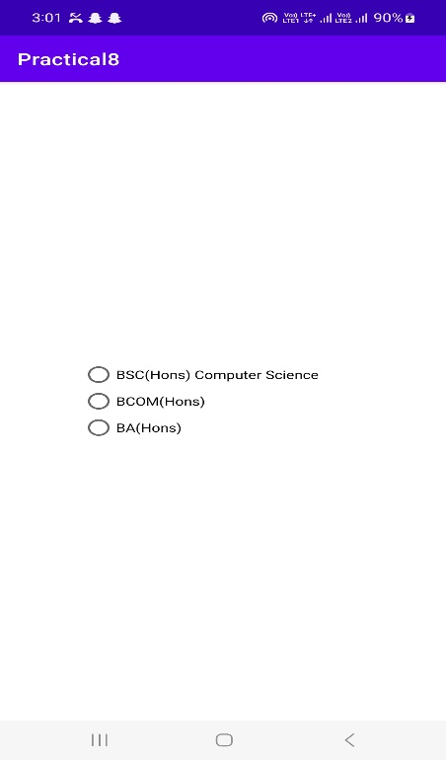 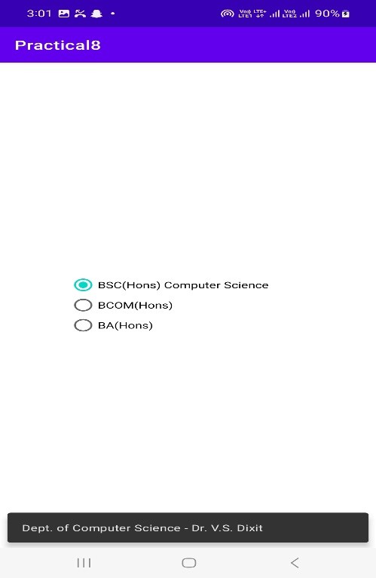

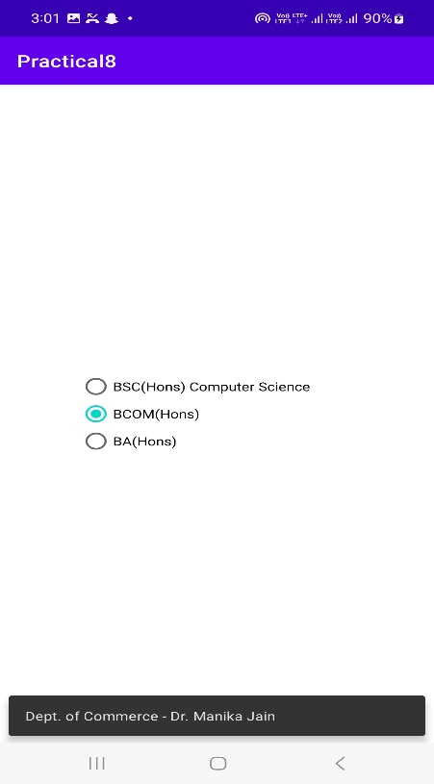 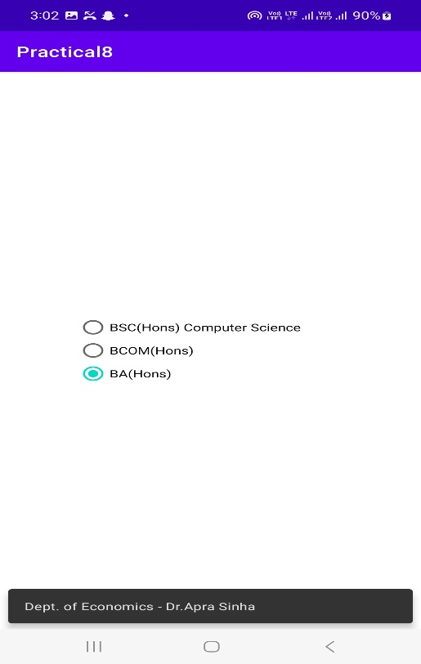

**OBJECTIVE:**

**a) Create an application with three buttons (with different color names) vertically aligned , on selecting a button color of the screen will change.**

**b) Create an application with three buttons horizontally aligned , on selecting a button color of the screen will change.**

**Code:**

1. **Activity_main.xml**
2. <?xml version="1.0" encoding="utf-8"?>  
   <androidx.constraintlayout.widget.ConstraintLayout xmlns:android="http://schemas.android.com/apk/res/android"  
    xmlns:app="http://schemas.android.com/apk/res-auto"  
    xmlns:tools="http://schemas.android.com/tools"  
    android:layout_width="match_parent"  
    android:layout_height="match_parent"  
    android:id ="@+id/layoutSuperParent"  
    tools:context=".MainActivity">  
     
    <LinearLayout  
    android:layout_width="wrap_content"  
    android:layout_height="wrap_content"  
    android:orientation="vertical"  
    app:layout_constraintBottom_toBottomOf="parent"  
    app:layout_constraintLeft_toLeftOf="parent"  
    app:layout_constraintRight_toRightOf="parent"  
    app:layout_constraintTop_toTopOf="parent"  
    >  
    <Button  
    android:layout_width="150dp"  
    android:layout_height="wrap_content"  
    android:id="@+id/btnRed"  
    android:layout_gravity="center"  
    android:backgroundTint="@android:color/holo_red_dark"  
    android:text="RED"/>  
    <Button  
    android:layout_width="150dp"  
    android:layout_height="wrap_content"  
    android:id="@+id/btnBlue"  
    android:layout_gravity="center"  
    android:backgroundTint="@android:color/holo_blue_light"  
    android:text="BLUE"/>  
    <Button  
    android:layout_width="150dp"  
    android:layout_height="wrap_content"  
    android:id="@+id/btnGreen"  
    android:gravity="center"  
    android:backgroundTint="@android:color/holo_green_dark"  
    android:text="GREEN"/>  
    <Button  
    android:layout_width="150dp"  
    android:layout_height="wrap_content"  
    android:id="@+id/btnReset"  
    android:text="Reset"  
    android:gravity="center"/>  
     
    </LinearLayout>  
   </androidx.constraintlayout.widget.ConstraintLayout>

**MainActivity.java**

package com.example.practical9;  
  
import androidx.appcompat.app.AppCompatActivity;  
import androidx.constraintlayout.widget.ConstraintLayout;  
  
import android.graphics.Color;  
import android.os.Bundle;  
import android.view.View;  
import android.widget.Button;  
  
public class MainActivity extends AppCompatActivity implements View.OnClickListener{  
 private Button btnRed;  
 private Button btnBlue;  
 private Button btnGreen;  
 private Button btnReset;  
 private ConstraintLayout layoutSuperParent;  
 @Override  
 protected void onCreate(Bundle savedInstanceState) {  
 super.onCreate(savedInstanceState);  
 setContentView(R.layout.*activity_main*);  
 layoutSuperParent=(ConstraintLayout)findViewById(R.id.*layoutSuperParent*);  
 btnRed=(Button)findViewById(R.id.*btnRed*);  
 btnBlue=(Button)findViewById(R.id.*btnBlue*);  
 btnGreen=(Button)findViewById(R.id.*btnGreen*);  
 btnReset=(Button)findViewById(R.id.*btnReset*);  
 btnRed.setOnClickListener(this);  
 btnBlue.setOnClickListener(this);  
 btnGreen.setOnClickListener(this);  
 btnReset.setOnClickListener(this);  
 }  
  
 @Override  
 public void onClick(View v){  
 switch (v.getId()){  
 case R.id.*btnRed*:  
 layoutSuperParent.setBackgroundColor(Color.*RED*);  
 break;  
 case R.id.*btnBlue*:  
 layoutSuperParent.setBackgroundColor(Color.*BLUE*);  
 break;  
 case R.id.*btnGreen*:  
 layoutSuperParent.setBackgroundColor(Color.*GREEN*);  
 break;  
 case R.id.*btnReset*:  
 layoutSuperParent.setBackgroundColor(Color.*TRANSPARENT*);  
 break;  
 default:  
 break;  
 }  
 }  
}

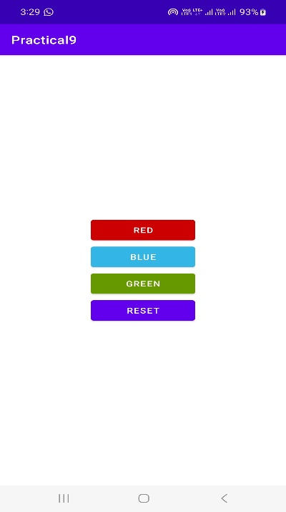 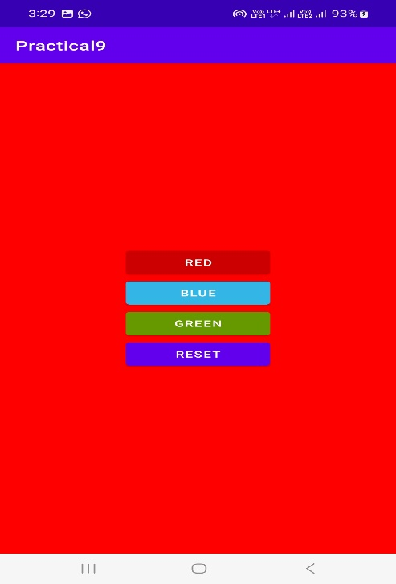

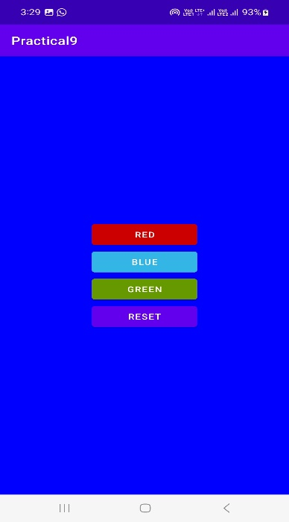 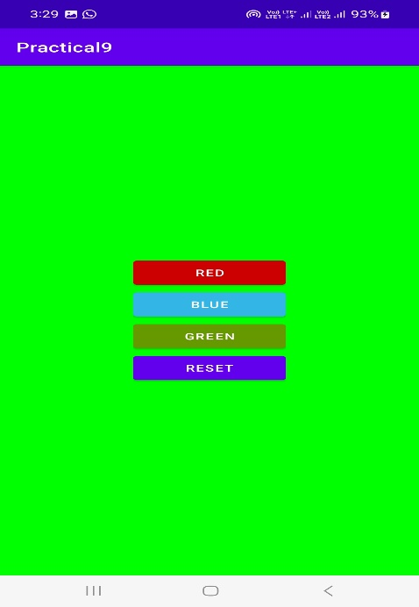

**b)**

**activity_main.xml**

<?xml version="1.0" encoding="utf-8"?>  
<androidx.constraintlayout.widget.ConstraintLayout xmlns:android="http://schemas.android.com/apk/res/android"  
 xmlns:app="http://schemas.android.com/apk/res-auto"  
 xmlns:tools="http://schemas.android.com/tools"  
 android:layout_width="match_parent"  
 android:layout_height="match_parent"  
 android:id ="@+id/layoutSuperParent"  
 tools:context=".MainActivity">  
  
 <LinearLayout  
 android:layout_width="wrap_content"  
 android:layout_height="wrap_content"  
 android:orientation="horizontal"  
 app:layout_constraintBottom_toBottomOf="parent"  
 app:layout_constraintLeft_toLeftOf="parent"  
 app:layout_constraintRight_toRightOf="parent"  
 app:layout_constraintTop_toTopOf="parent"  
 >  
 <Button  
 android:layout_width="150dp"  
 android:layout_height="wrap_content"  
 android:id="@+id/btnRed"  
 android:layout_gravity="center"  
 android:backgroundTint="@android:color/holo_red_dark"  
 android:text="RED"/>  
 <Button  
 android:layout_width="150dp"  
 android:layout_height="wrap_content"  
 android:id="@+id/btnBlue"  
 android:layout_gravity="center"  
 android:backgroundTint="@android:color/holo_blue_light"  
 android:text="BLUE"/>  
 <Button  
 android:layout_width="150dp"  
 android:layout_height="wrap_content"  
 android:id="@+id/btnGreen"  
 android:gravity="center"  
 android:backgroundTint="@android:color/holo_green_dark"  
 android:text="GREEN"/>  
 <Button  
 android:layout_width="150dp"  
 android:layout_height="wrap_content"  
 android:id="@+id/btnReset"  
 android:text="Reset"  
 android:gravity="center"/>  
  
 </LinearLayout>  
</androidx.constraintlayout.widget.ConstraintLayout>

**MainActivity.java**

package com.example.practical9;  
  
import androidx.appcompat.app.AppCompatActivity;  
import androidx.constraintlayout.widget.ConstraintLayout;  
  
import android.graphics.Color;  
import android.os.Bundle;  
import android.view.View;  
import android.widget.Button;  
  
public class MainActivity extends AppCompatActivity implements View.OnClickListener{  
 private Button btnRed;  
 private Button btnBlue;  
 private Button btnGreen;  
 private Button btnReset;  
 private ConstraintLayout layoutSuperParent;  
 @Override  
 protected void onCreate(Bundle savedInstanceState) {  
 super.onCreate(savedInstanceState);  
 setContentView(R.layout.*activity_main*);  
 layoutSuperParent=(ConstraintLayout)findViewById(R.id.*layoutSuperParent*);  
 btnRed=(Button)findViewById(R.id.*btnRed*);  
 btnBlue=(Button)findViewById(R.id.*btnBlue*);  
 btnGreen=(Button)findViewById(R.id.*btnGreen*);  
 btnReset=(Button)findViewById(R.id.*btnReset*);  
 btnRed.setOnClickListener(this);  
 btnBlue.setOnClickListener(this);  
 btnGreen.setOnClickListener(this);  
 btnReset.setOnClickListener(this);  
 }  
  
 @Override  
 public void onClick(View v){  
 switch (v.getId()){  
 case R.id.*btnRed*:  
 layoutSuperParent.setBackgroundColor(Color.*RED*);  
 break;  
 case R.id.*btnBlue*:  
 layoutSuperParent.setBackgroundColor(Color.*BLUE*);  
 break;  
 case R.id.*btnGreen*:  
 layoutSuperParent.setBackgroundColor(Color.*GREEN*);  
 break;  
 case R.id.*btnReset*:  
 layoutSuperParent.setBackgroundColor(Color.*TRANSPARENT*);  
 break;  
 default:  
 break;  
 }  
 }  
}

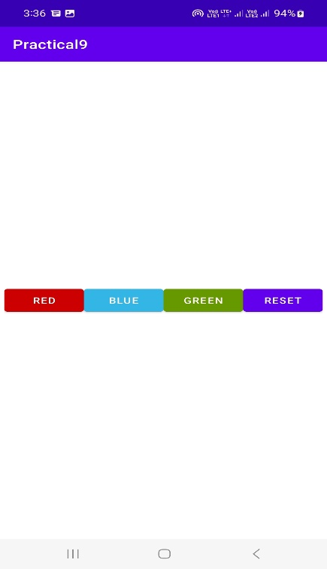 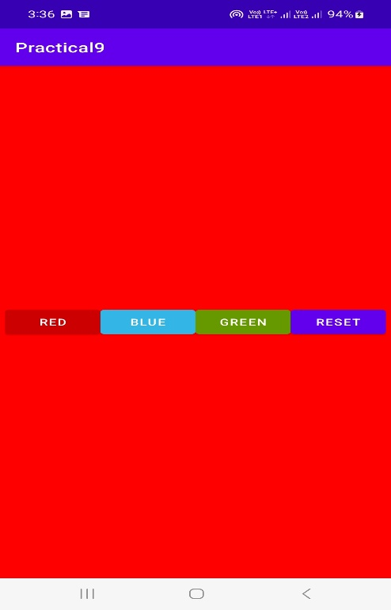

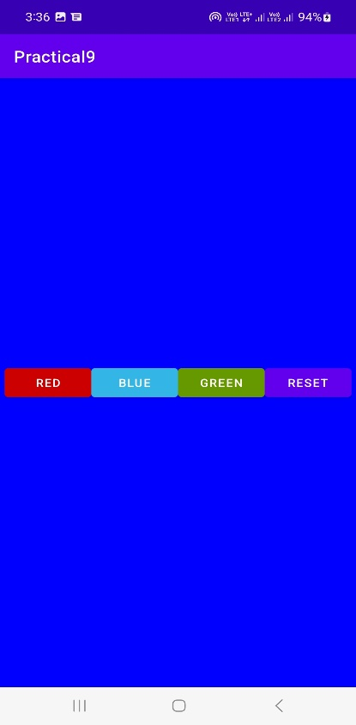 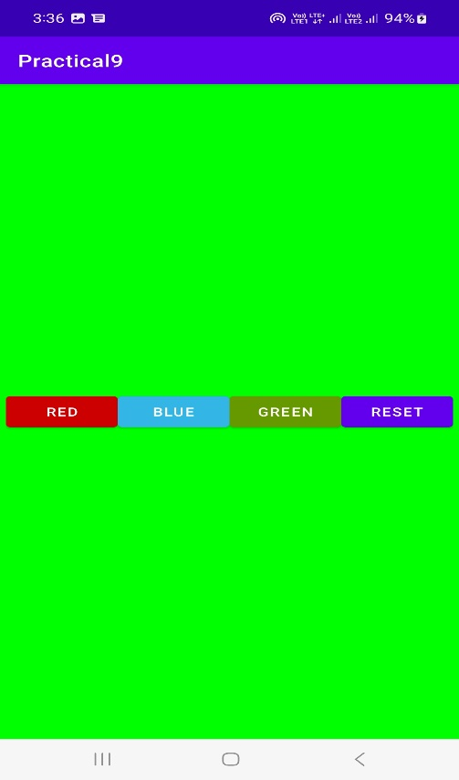

**OBJECTIVE:**

**Create a Login application (check username and password ) . On successful login , pop up the message .(“Welcome Username “)**

**Code:**

**Activity_main.xml**

<?xml version="1.0" encoding="utf-8"?>  
<androidx.constraintlayout.widget.ConstraintLayout xmlns:android="http://schemas.android.com/apk/res/android"  
 xmlns:app="http://schemas.android.com/apk/res-auto"  
 xmlns:tools="http://schemas.android.com/tools"  
 android:layout_width="match_parent"  
 android:layout_height="match_parent"  
 tools:context=".MainActivity">  
 <EditText  
 android:id="@+id/etEmail"  
 android:layout_width="wrap_content"  
 android:layout_height="wrap_content"  
 android:layout_marginTop="240dp"  
 android:autofillHints="false"  
 android:ems="10"  
 android:hint="@string/e_mail_id"  
 android:inputType="textEmailAddress"  
 app:layout_constraintBottom_toTopOf="@id/etPassword"  
 app:layout_constraintEnd_toEndOf="parent"  
 app:layout_constraintStart_toStartOf="parent"  
 app:layout_constraintTop_toTopOf="parent" />  
 <EditText  
 android:id="@+id/etPassword"  
 android:layout_width="wrap_content"  
 android:layout_height="wrap_content"  
 android:layout_marginTop="10dp"  
 android:autofillHints="false"  
 android:ems="10"  
 android:hint="@string/password"  
 android:inputType="textPassword"  
 app:layout_constraintBottom_toTopOf="@id/btnLogin"  
 app:layout_constraintEnd_toEndOf="parent"  
 app:layout_constraintStart_toStartOf="parent"  
 app:layout_constraintTop_toBottomOf="@id/etEmail" />  
 <Button  
 android:id="@+id/btnLogin"  
 android:layout_width="wrap_content"  
 android:layout_height="wrap_content"  
 android:layout_marginTop="30dp"  
 android:text="@string/login"  
 app:layout_constraintBottom_toTopOf="@id/btnRegister"  
 app:layout_constraintEnd_toEndOf="parent"  
 app:layout_constraintStart_toStartOf="parent"  
 app:layout_constraintTop_toBottomOf="@id/etPassword" />  
 <Button  
 android:id="@+id/btnRegister"  
 android:layout_width="wrap_content"  
 android:layout_height="wrap_content"  
 android:layout_marginBottom="250dp"  
 android:text="@string/register"  
 app:layout_constraintBottom_toBottomOf="parent"  
 app:layout_constraintEnd_toEndOf="parent"  
 app:layout_constraintStart_toStartOf="parent"  
 app:layout_constraintTop_toBottomOf="@id/btnLogin" />  
</androidx.constraintlayout.widget.ConstraintLayout>

**Strings.xml**

<resources>  
 <string name="app_name">Practical10</string>  
 <string name="welcome">Welcome</string>  
 <string name="log_out">Log Out</string>  
 <string name="password">Password</string>  
 <string name="e_mail_id">E-mail ID</string>  
 <string name="login">Login</string>  
 <string name="register">Register</string>  
 <string name="cancel">Cancel</string>  
 <string name="ok">Ok</string>  
</resources>

**User.java**

package com.example.practical10;  
import androidx.annotation.NonNull;  
import androidx.room.ColumnInfo;  
import androidx.room.Entity;  
import androidx.room.PrimaryKey;  
  
@Entity  
public class User {  
 @PrimaryKey  
 @NonNull  
 @ColumnInfo(name = "email")  
 public String email;  
 @NonNull  
 @ColumnInfo(name = "password")  
 public String password;  
 public User(@NonNull String email, @NonNull String password) {  
 this.email = email;  
 this.password = password;  
 }  
}

**UserDao.java**

package com.example.practical10;  
  
import androidx.room.Dao;  
import androidx.room.Delete;  
import androidx.room.Insert;  
import androidx.room.Query;  
import java.util.List;  
import  
 com.example.practical10.User;  
@Dao  
public interface UserDao {  
 @Query("SELECT * FROM user")  
 List<User> getAll();  
 @Query("SELECT * FROM user WHERE email LIKE :email LIMIT 1")  
 User findByEmail(String email);  
 @Insert  
 void insert(User user);  
 @Delete  
 void delete(User user);  
}

**UserService.java**

package com.example.practical10;  
  
import android.content.Context;  
  
import androidx.room.Room;  
  
public class UserService {  
 private User user = null;  
 private static UserService *instance* = null;  
 private static UserDatabase *database* = null;  
 public void login(User user) throws IllegalStateException {  
 User u = *database*.userDao().findByEmail(user.email);  
 if (!u.password.equals(user.password))  
 throw new IllegalStateException("Password Mismatch");  
 this.user = user;  
 }  
 public void register(User user) {  
 *database*.userDao().insert(user);  
 this.user = user;  
 }  
 public void logout() {  
 this.user = null;  
 }  
 public User getUser() {  
 return user;  
 }  
 public static UserService getInstance() {  
 if (*instance* == null) {  
 *instance* = new UserService();  
 }  
 return *instance*;  
 }  
 public static void initDatabase(Context ctx) {  
 if (*database* == null) {  
 *database* = Room  
 .*databaseBuilder*(ctx, UserDatabase.class, "login_module")  
 .allowMainThreadQueries()  
 .build();  
 }  
 }  
}

**UserDatabase.java**

package com.example.practical10;  
  
import androidx.room.Database;  
import androidx.room.RoomDatabase;  
  
@Database(entities = {User.class}, version = 1)  
public abstract class UserDatabase extends RoomDatabase {  
 public abstract UserDao userDao();  
}

**MainActivity.java**

package com.example.practical10;  
  
import androidx.appcompat.app.AppCompatActivity;  
  
import android.database.sqlite.SQLiteConstraintException;  
import android.os.Bundle;  
import android.util.Log;  
import android.widget.Button;  
import android.widget.EditText;  
import android.widget.Toast;  
  
public class MainActivity extends AppCompatActivity {  
 private EditText etEmail;  
 private EditText etPassword;  
 private Button btnLogin;  
 private Button btnRegister;  
 private UserService userService;  
 @Override  
 protected void onCreate(Bundle savedInstanceState) {  
 super.onCreate(savedInstanceState);  
 setContentView(R.layout.*activity_main*);  
 userService = UserService.*getInstance*();  
 UserService.*initDatabase*(this);  
 etEmail = (EditText) findViewById(R.id.*etEmail*);  
 etPassword = (EditText) findViewById(R.id.*etPassword*);  
 btnLogin = (Button) findViewById(R.id.*btnLogin*);  
 btnRegister = (Button) findViewById(R.id.*btnRegister*);  
 btnLogin.setOnClickListener(v -> {  
 User user = validateCredentials();  
 if (user != null) {  
 try {  
 userService.login(user);  
 Toast.*makeText*(this, "Welcome " + userService.getUser().email, Toast.*LENGTH_SHORT*).show();  
 } catch (IllegalStateException illegalStateException) {  
 Toast.*makeText*(this, "Invalid Email/ Password", Toast.*LENGTH_SHORT*).show();  
 } catch (Exception e) {  
 Log.*d*("TAG", e.getMessage());  
 Toast.*makeText*(this, "Error", Toast.*LENGTH_SHORT*).show();  
 }  
 }  
 });  
 btnRegister.setOnClickListener(v -> { User user  
 = validateCredentials(); if (user != null) {  
 try {  
 userService.register(user);  
 Toast.*makeText*(this, "Registered", Toast.*LENGTH_SHORT*).show();  
 } catch (SQLiteConstraintException sqLiteConstraintException)  
 {  
 Toast.*makeText*(this, "Email Already Used", Toast.*LENGTH_SHORT*).show();  
 } catch (Exception e) {  
 Toast.*makeText*(this, "Error", Toast.*LENGTH_SHORT*).show();  
 }  
 }  
 });  
 }  
 private User validateCredentials() {  
 String email = etEmail.getText().toString().trim();  
 String password = etPassword.getText().toString().trim();  
 if (email.length() == 0) {  
 etEmail.setError("Enter your e-mail address");  
 return null;  
 }  
 if (password.length() == 0) {  
 etPassword.setError("Enter your password");  
 return null;  
 }  
 return new User(email, password);  
 }  
}

**Output:**

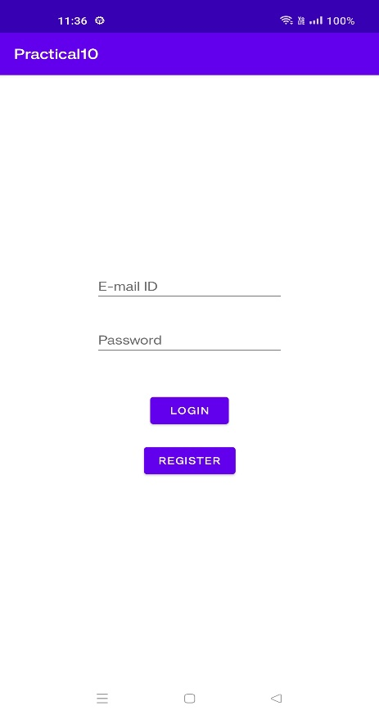

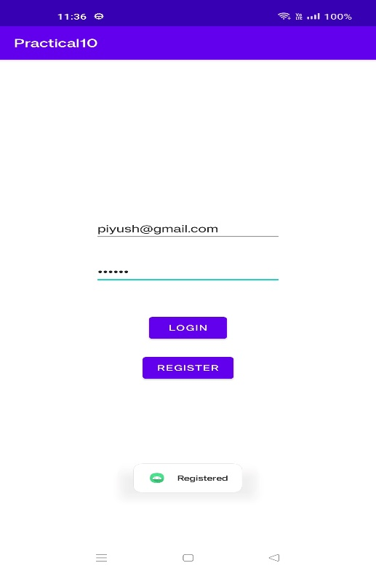

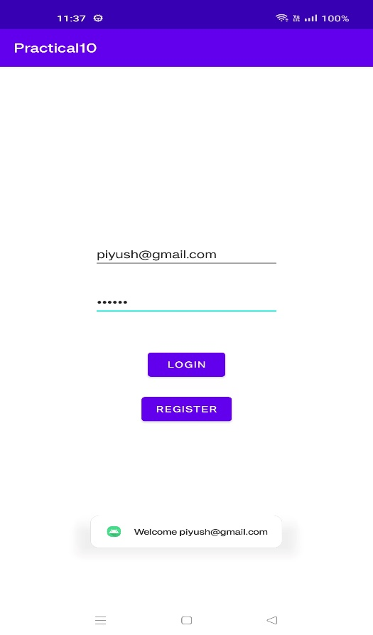

**OBJECTIVE: Create a login application as above , on successful login redirect to another activity with logout button . On click of logout button a dialog appears with OK and CANCEL button . On OK button click go to login activity and on CANCEL stay at same activity.**

**CODE:**

**Android_Manifest.xml**

<?xml version="1.0" encoding="utf-8"?>  
<manifest xmlns:android="http://schemas.android.com/apk/res/android"  
 package="com.example.practical11">  
  
 <application  
 android:allowBackup="true"  
 android:icon="@mipmap/ic_launcher"  
 android:label="@string/app_name"  
 android:roundIcon="@mipmap/ic_launcher_round"  
 android:supportsRtl="true"  
 android:theme="@style/Theme.MaterialComponents"  
 >  
 <activity  
 android:name=".MemberModule"  
 android:exported="true" />  
 <activity android:name=".MainActivity" android:exported="true">  
 <intent-filter>  
 <action android:name="android.intent.action.MAIN" />  
  
 <category android:name="android.intent.category.LAUNCHER" />  
 </intent-filter>  
 </activity>  
  
 </application>  
</manifest>

**Strings.xml**

<resources>  
 <string name="app_name">Practical11</string>  
 <string name="welcome">Welcome</string>  
 <string name="log_out">Log Out</string>  
 <string name="password">Password</string>  
 <string name="e_mail_id">E-mail ID</string>  
 <string name="login">Login</string>  
 <string name="register">Register</string>  
 <string name="cancel">Cancel</string>  
 <string name="ok">Ok</string>  
</resources>

**Activity_Main.xml**

<?xml version="1.0" encoding="utf-8"?>  
<androidx.constraintlayout.widget.ConstraintLayout xmlns:android="http://schemas.android.com/apk/res/android"  
 xmlns:app="http://schemas.android.com/apk/res-auto"  
 xmlns:tools="http://schemas.android.com/tools"  
 android:layout_width="match_parent"  
 android:layout_height="match_parent"  
 tools:context=".MainActivity">  
  
 <EditText  
 android:id="@+id/etEmail"  
 android:layout_width="wrap_content"  
 android:layout_height="wrap_content"  
 android:layout_marginTop="240dp"  
 android:autofillHints="false"  
 android:ems="10"  
 android:hint="@string/e_mail_id"  
 android:inputType="textEmailAddress"  
 app:layout_constraintBottom_toTopOf="@id/etPassword"  
 app:layout_constraintEnd_toEndOf="parent"  
 app:layout_constraintStart_toStartOf="parent"  
 app:layout_constraintTop_toTopOf="parent" />  
 <EditText  
 android:id="@+id/etPassword"  
 android:layout_width="wrap_content"  
 android:layout_height="wrap_content"  
 android:layout_marginTop="10dp"  
 android:autofillHints="false"  
 android:ems="10"  
 android:hint="@string/password"  
 android:inputType="textPassword"  
 app:layout_constraintBottom_toTopOf="@id/btnLogin"  
 app:layout_constraintEnd_toEndOf="parent"  
 app:layout_constraintStart_toStartOf="parent"  
 app:layout_constraintTop_toBottomOf="@id/etEmail" />  
 <Button  
 android:id="@+id/btnLogin"  
 android:layout_width="wrap_content"  
 android:layout_height="wrap_content"  
 android:layout_marginTop="30dp"  
 android:text="@string/login"  
 app:layout_constraintBottom_toTopOf="@id/btnRegister"  
 app:layout_constraintEnd_toEndOf="parent"  
 app:layout_constraintStart_toStartOf="parent"  
 app:layout_constraintTop_toBottomOf="@id/etPassword" />  
 <Button  
 android:id="@+id/btnRegister"  
 android:layout_width="wrap_content"  
 android:layout_height="wrap_content"  
 android:layout_marginBottom="250dp"  
 android:text="@string/register"  
 app:layout_constraintBottom_toBottomOf="parent"  
 app:layout_constraintEnd_toEndOf="parent"  
 app:layout_constraintStart_toStartOf="parent"  
 app:layout_constraintTop_toBottomOf="@id/btnLogin" />  
  
</androidx.constraintlayout.widget.ConstraintLayout>

**MemberModule_activity.xml**

<?xml version="1.0" encoding="utf-8"?>  
<androidx.constraintlayout.widget.ConstraintLayout  
 xmlns:android="http://schemas.android.com/apk/res/android"  
 xmlns:app="http://schemas.android.com/apk/res-auto"  
 xmlns:tools="http://schemas.android.com/tools"  
 android:layout_width="match_parent"  
 android:layout_height="match_parent"  
 tools:context=".MemberModule">  
 <TextView  
 android:id="@+id/tvWelcome"  
 android:layout_width="wrap_content"  
 android:layout_height="wrap_content"  
 android:text="@string/welcome"  
 android:textAppearance="@style/TextAppearance.AppCompat.Display1"  
 app:layout_constraintBottom_toTopOf="@id/tvEmail"  
 app:layout_constraintEnd_toEndOf="parent"  
 app:layout_constraintStart_toStartOf="parent"  
 app:layout_constraintTop_toTopOf="parent" />  
 <TextView  
 android:id="@+id/tvEmail"  
 android:layout_width="wrap_content"  
 android:layout_height="wrap_content"  
 android:text=""  
 app:layout_constraintBottom_toTopOf="@id/btnLogout"  
 app:layout_constraintEnd_toEndOf="parent"  
 app:layout_constraintStart_toStartOf="parent"  
 app:layout_constraintTop_toBottomOf="@id/tvWelcome" />  
 <Button  
 android:id="@+id/btnLogout"  
 android:layout_width="wrap_content"  
 android:layout_height="wrap_content"  
 android:text="@string/log_out"  
 app:layout_constraintBottom_toBottomOf="parent"  
 app:layout_constraintEnd_toEndOf="parent"  
 app:layout_constraintStart_toStartOf="parent"  
 app:layout_constraintTop_toBottomOf="@+id/tvEmail" />  
</androidx.constraintlayout.widget.ConstraintLayout>

**MainActivity.java**

package com.example.practical11;  
import android.content.Intent;  
import android.database.sqlite.SQLiteConstraintException;  
import android.os.Bundle;  
import android.util.Log;  
import android.widget.Button;  
import android.widget.EditText;  
import android.widget.Toast;  
import androidx.appcompat.app.AppCompatActivity;  
  
  
  
public class MainActivity extends AppCompatActivity {  
 private EditText etEmail;  
 private EditText etPassword;  
 private Button btnLogin;  
 private Button btnRegister;  
 private UserService userService;  
 @Override  
 protected void onCreate(Bundle savedInstanceState) {  
 super.onCreate(savedInstanceState);  
 setContentView(R.layout.*activity_main*);  
 userService = UserService.*getInstance*();  
 UserService.*initDatabase*(this);  
 etEmail = (EditText) findViewById(R.id.*etEmail*);  
 etPassword = (EditText) findViewById(R.id.*etPassword*);  
 btnLogin = (Button) findViewById(R.id.*btnLogin*);  
 btnRegister = (Button) findViewById(R.id.*btnRegister*);  
 btnLogin.setOnClickListener(v -> {  
 User user = validateCredentials();  
 if (user != null){  
 try {  
 userService.login(user);  
 Toast.*makeText*(this, "Logged In", Toast.*LENGTH_SHORT*).show();  
 startActivity(new Intent(this, MemberModule.class));  
 } catch (IllegalStateException illegalStateException) { Toast.*makeText*(this,  
 "Invalid E- mail/Password", Toast.*LENGTH_SHORT*).show();  
 } catch (Exception e) {  
 Log.*d*("TAG", e.getMessage());  
 Toast.*makeText*(this, "Error", Toast.*LENGTH_SHORT*).show();}  
 }  
 }); btnRegister.setOnClickListener(v -> { User  
 user = validateCredentials(); if (user !=  
 null) {  
 try {  
 userService.register(user);  
 Toast.*makeText*(this, "Registered", Toast.*LENGTH_SHORT*).show();  
 startActivity(new Intent(this, MemberModule.class));  
 } catch (SQLiteConstraintException sqLiteConstraintException)  
 {  
 Toast.*makeText*(this, "E-mail Already Used",  
 Toast.*LENGTH_SHORT*).show();  
 } catch (Exception e) {  
 Toast.*makeText*(this, "Error", Toast.*LENGTH_SHORT*).show();  
 }  
 }  
 });  
 }  
 private User validateCredentials() {  
 String email = etEmail.getText().toString().trim();  
 String password = etPassword.getText().toString().trim();  
 if (email.length() == 0) {  
 etEmail.setError("Enter your e-mail address");  
 return null;  
 }  
 if (password.length() == 0) {  
 etPassword.setError("Enter your password");  
 return null;  
 }  
 return new User(email, password);  
 }  
}

**MemberModule.java**

package com.example.practical11;  
  
import android.app.AlertDialog;  
import android.os.Bundle;  
import android.widget.TextView;  
import android.widget.Toast;  
import androidx.appcompat.app.AppCompatActivity;  
import com.example.practical11.R;  
import com.example.practical11.UserService;  
  
public class MemberModule extends AppCompatActivity {  
 private User user;  
 private UserService userService;  
 private TextView tvEmail;  
 private TextView btnLogout;  
 @Override  
 protected void onCreate(Bundle savedInstanceState) {  
 super.onCreate(savedInstanceState);  
 setContentView(R.layout.*activity_member_module*);  
 userService = UserService.*getInstance*();  
 user = userService.getUser();  
 tvEmail = (TextView) findViewById(R.id.*tvEmail*);  
 btnLogout = (TextView) findViewById(R.id.*btnLogout*);  
 if (user == null) {  
 super.finish();  
 } else {  
 tvEmail.setText(user.email);  
 }  
 btnLogout.setOnClickListener(v -> {  
 new AlertDialog.Builder(this)  
 .setTitle("Logout")  
 .setMessage("Are you sure you want to log out?")  
 .setPositiveButton(android.R.string.*ok*, (dialog, which) -> logoutUser()).setNegativeButton(android.R.string.*cancel*, null)  
 .setIcon(android.R.drawable.*ic_dialog_alert*)  
 .show();  
 });  
 }  
 private void logoutUser() {  
 userService.logout();  
 Toast.*makeText*(this, "Logged Out", Toast.*LENGTH_SHORT*).show();  
 super.finish();  
 }  
}

**User.java**

package com.example.practical11;  
  
import androidx.annotation.NonNull;  
import androidx.room.ColumnInfo;  
import androidx.room.Entity;  
import androidx.room.PrimaryKey;  
@Entity  
public class User {  
 @PrimaryKey  
 @NonNull  
 @ColumnInfo(name = "email")  
 public String email;  
 @NonNull  
 @ColumnInfo(name = "password")  
 public String password;  
 public User(@NonNull String email, @NonNull String password) {  
 this.email = email;  
 this.password = password;  
 }  
}

**UserDao.java**

package com.example.practical11;  
  
import androidx.room.Dao;  
import androidx.room.Delete;  
import androidx.room.Insert;  
import androidx.room.Query;  
import java.util.List;  
  
@Dao  
public interface UserDao {  
 @Query("SELECT * FROM user")  
 List<User> getAll();  
 @Query("SELECT * FROM user WHERE email LIKE :email LIMIT 1")  
 User findByEmail(String email);  
 @Insert  
 void insert(User user);  
 @Delete  
 void delete(User user);  
}

**UserDatabase.java**

package com.example.practical11;  
  
import androidx.room.RoomDatabase;  
import androidx.room.Database;  
  
@Database(entities = {User.class}, version = 1)  
public abstract class UserDatabase extends RoomDatabase {  
 public abstract UserDao userDao();  
}

**UserService.java**

package com.example.practical11;  
  
import android.content.Context;  
import androidx.room.Room;  
  
public class UserService {  
 private User user = null;  
 private static UserService *instance* = null;  
 private static UserDatabase *database* = null;  
 public void login(User user) throws IllegalStateException {  
 User u = *database*.userDao().findByEmail(user.email);  
 if (!u.password.equals(user.password))  
 throw new IllegalStateException("Password Mismatch");  
 this.user = user;  
 }  
 public void register(User user) {  
 *database*.userDao().insert(user);  
 this.user = user;  
 }  
 public void logout() {  
 this.user = null;  
 }  
 public User getUser() {  
 return user;  
 }  
 public static UserService getInstance() {  
 if (*instance* == null) {  
 *instance* = new UserService();  
 }  
 return *instance*;  
 }  
 public static void initDatabase(Context ctx) {  
 if (*database* == null) {  
 *database* = Room  
 .*databaseBuilder*(ctx, UserDatabase.class, "login_module")  
 .allowMainThreadQueries()  
 .build();  
 }  
 }  
}

**OUTPUT:**

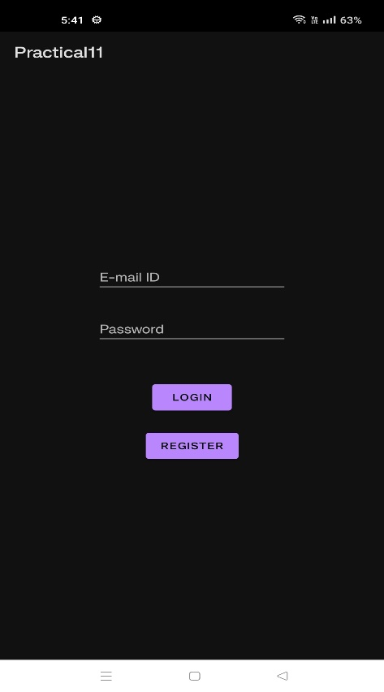 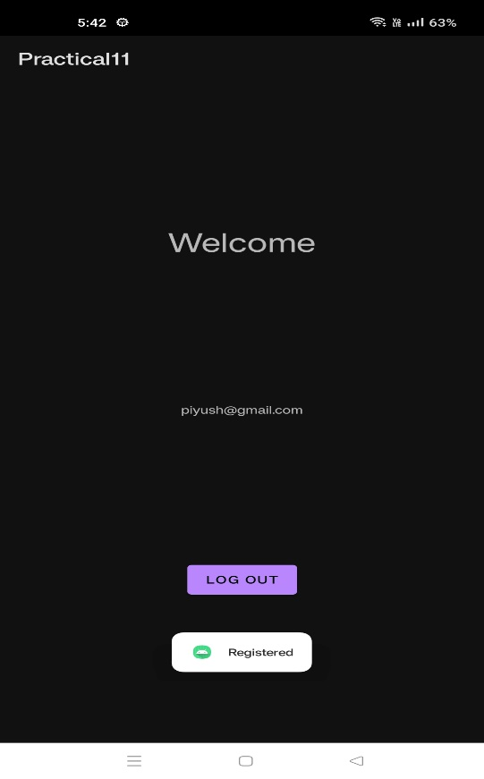

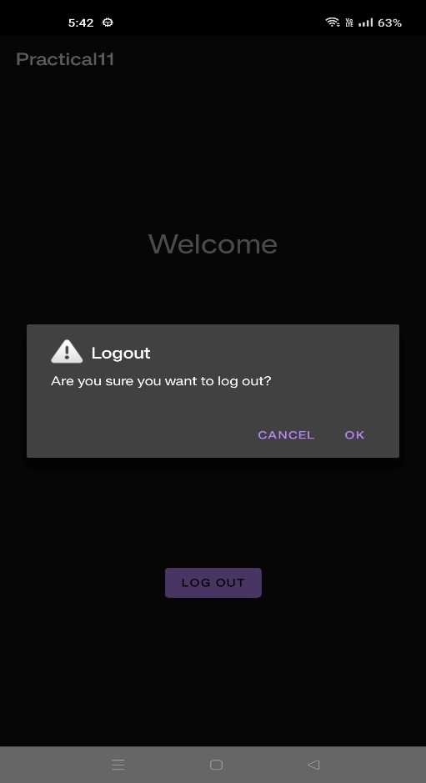 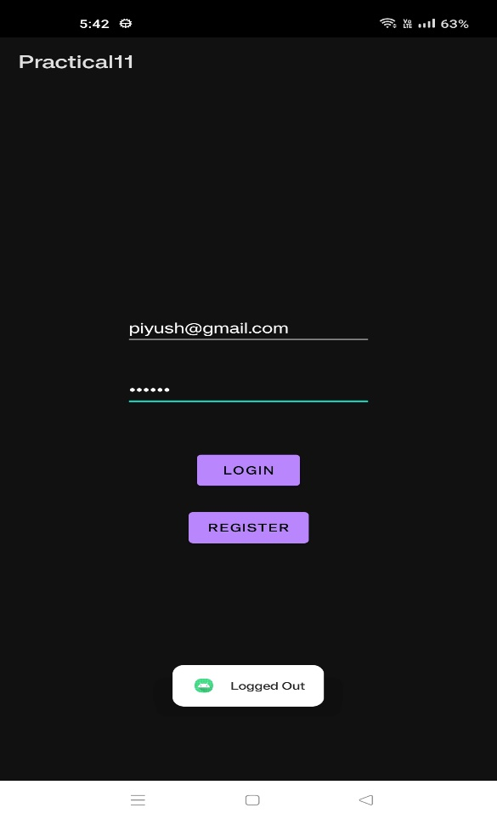

**OBJECTIVE: Create an application to Create , Insert , Update and Delete operation on the database .**

**OUTPUT:**

**Activity_main.xml**

<?xml version="1.0" encoding="utf-8"?>  
<androidx.constraintlayout.widget.ConstraintLayout xmlns:android="http://schemas.android.com/apk/res/android"  
 xmlns:app="http://schemas.android.com/apk/res-auto"  
 xmlns:tools="http://schemas.android.com/tools"  
 android:id="@+id/clRoot"  
 android:layout_width="match_parent"  
 android:layout_height="match_parent"  
 tools:context=".MainActivity">  
 <androidx.swiperefreshlayout.widget.SwipeRefreshLayout  
 android:layout_width="match_parent"  
 android:layout_height="match_parent"  
 android:id="@+id/swipeLayout"  
 app:layout_constraintBottom_toBottomOf="parent"  
 app:layout_constraintLeft_toLeftOf="parent"  
 app:layout_constraintRight_toRightOf="parent"  
 app:layout_constraintTop_toTopOf="parent">  
 <androidx.recyclerview.widget.RecyclerView  
 android:id="@+id/rvTodos"  
 android:layout_width="wrap_content"  
 android:layout_height="wrap_content" />  
 </androidx.swiperefreshlayout.widget.SwipeRefreshLayout>  
 <com.google.android.material.floatingactionbutton.FloatingActionButton  
 android:id="@+id/fabAdd"  
 android:layout_width="wrap_content"  
 android:layout_height="wrap_content"  
 android:layout_gravity="end|bottom"  
 android:layout_margin="16dp"  
 android:src="@drawable/ic_launcher_foreground"  
 app:layout_constraintBottom_toBottomOf="parent"  
 app:layout_constraintEnd_toEndOf="parent" />  
</androidx.constraintlayout.widget.ConstraintLayout>

**Dialog_layout.xml**

<?xml version="1.0" encoding="utf-8"?>  
<LinearLayout xmlns:android="http://schemas.android.com/apk/res/android"  
 android:orientation="vertical"  
 android:paddingHorizontal="20dp"  
 android:layout_width="match_parent"  
 android:layout_height="match_parent">  
 <EditText  
 android:id="@+id/etNewContent"  
 android:inputType="text"  
 android:layout_width="match_parent"  
 android:layout_height="wrap_content"  
 android:hint="Content" />  
</LinearLayout>

**Todo_item.xml**

<?xml version="1.0" encoding="utf-8"?>  
<com.google.android.material.card.MaterialCardView xmlns:android="http://schemas.android.com/apk/res/android"  
 xmlns:app="http://schemas.android.com/apk/res-auto"  
 android:id="@+id/cvParent"  
 android:layout_width="match_parent"  
 android:layout_height="wrap_content"  
 android:layout_marginHorizontal="@dimen/card_margin"  
 android:layout_marginTop="@dimen/card_margin"  
 app:cardCornerRadius="@dimen/cardview_default_radius"  
 app:cardElevation="@dimen/cardview_default_elevation">  
 <RelativeLayout  
 android:layout_width="match_parent"  
 android:layout_height="wrap_content"  
 android:layout_margin="@dimen/default_card_content_margin">  
 <TextView  
 android:id="@+id/tvTodoId"  
 android:layout_width="wrap_content"  
 android:layout_height="wrap_content"  
 android:visibility="invisible" />  
 <TextView  
 android:id="@+id/tvTodoContent"  
 style="@style/TextAppearance.MaterialComponents.Headline6"  
 android:layout_width="wrap_content"  
 android:layout_height="wrap_content"  
 android:text="@string/default_todo_content" />  
 <TextView  
 android:id="@+id/tvTodoAddedAt"  
 android:layout_width="match_parent"  
 android:layout_height="wrap_content"  
 android:layout_below="@id/tvTodoContent"  
 android:layout_marginVertical="5dp"  
 android:text="@string/default_todo_added_at" />  
 <LinearLayout  
 android:layout_width="wrap_content"  
 android:layout_height="wrap_content"  
 android:layout_below="@id/tvTodoAddedAt"  
 android:orientation="horizontal">  
 <Button  
 android:id="@+id/btnTodoAction"  
 style="@style/Widget.MaterialComponents.Button.OutlinedButton"  
 android:layout_width="wrap_content"  
 android:layout_height="wrap_content"  
 android:text="@string/default_todo_action" />  
 <Button  
 android:id="@+id/btnTodoDelete"  
 style="@style/Widget.MaterialComponents.Button.OutlinedButton"  
 android:textColor="@android:color/holo_red_dark"  
 android:layout_marginStart="10dp"  
 android:layout_width="wrap_content"  
 android:layout_height="wrap_content"  
 android:text="@string/default_todo_delete" />  
 </LinearLayout>  
 </RelativeLayout>  
</com.google.android.material.card.MaterialCardView>

**Dimens.xml**

<?xml version="1.0" encoding="utf-8"?>  
<resources>  
 <dimen name="default_card_image_height">150dp</dimen>  
 <dimen name="default_card_content_margin">10dp</dimen>  
 <dimen name="card_margin">25dp</dimen>  
 <dimen name="logo_dim">200dp</dimen>  
</resources>

**Strings.xml**

<resources>  
 <string name="app_name">Practical12</string>  
 <string name="default_todo_added_at">YYYY-MM-DD HH:MM:SS</string>  
 <string name="default_todo_content">Todo</string>  
 <string name="default_todo_action">Mark as Done</string>  
 <string name="default_todo_delete">Delete</string>  
</resources>

**MainActivity.java**

package com.example.practical12;  
  
import android.app.AlertDialog;  
import android.os.Bundle;  
import android.view.LayoutInflater;  
import android.view.View;  
import android.widget.EditText;  
import android.widget.Toast;  
import androidx.appcompat.app.AppCompatActivity;  
import androidx.recyclerview.widget.LinearLayoutManager;  
import androidx.recyclerview.widget.RecyclerView;  
import androidx.swiperefreshlayout.widget.SwipeRefreshLayout;  
  
import com.google.android.material.floatingactionbutton.FloatingActionButton;  
  
public class MainActivity extends AppCompatActivity implements SwipeRefreshLayout.OnRefreshListener {  
private TodoRepository todoRepository;  
private RecyclerView rvTodos;  
private RVAdapter todosAdapter;  
private SwipeRefreshLayout swipeLayout;  
@Override  
protected void onCreate(Bundle savedInstanceState) {  
 super.onCreate(savedInstanceState);  
 setContentView(R.layout.*activity_main*);  
 todoRepository = new TodoRepository(this);  
 todosAdapter = new RVAdapter(this, todoRepository);  
 swipeLayout = (SwipeRefreshLayout) findViewById(R.id.*swipeLayout*);  
 swipeLayout.setOnRefreshListener(this);  
 rvTodos = (RecyclerView) findViewById(R.id.*rvTodos*);  
 rvTodos.setAdapter(todosAdapter);  
 rvTodos.setLayoutManager(new LinearLayoutManager(this));  
 FloatingActionButton fabAdd = (FloatingActionButton) findViewById(R.id  
 .*fabAdd*);  
 fabAdd.setOnClickListener(v -> {View layout = getLayoutInflater().inflate(R.layout.*dialog_layout*,  
 null);  
 EditText etNewContent = (EditText) layout.findViewById(R.id.*etNewContent*);  
 AlertDialog dialog = new AlertDialog.Builder(this)  
 .setView(layout)  
 .setTitle("Add New Todo")  
 .setPositiveButton("Save", (_dialog, which) -> {  
 String content = etNewContent.getText().toString().trim();  
 if (content.length() == 0) {  
 Toast.*makeText*(this, "No Text Entered", Toast.*LENGTH_SHORT*).show();  
 } else {  
 todoRepository.create(content);  
 loadTodos();  
 }  
 })  
 .setNegativeButton("Cancel", (_dialog, which) -> _dialog.dismiss())  
 .create();  
 dialog.show();  
 });  
 loadTodos();  
 }  
@Override  
public void onRefresh() {  
 loadTodos();  
 }  
private void loadTodos() {  
 swipeLayout.setRefreshing(true);  
 todosAdapter.setTodos(todoRepository.getAll());  
 swipeLayout.setRefreshing(false);  
 }  
 }

**RVAdapter.java**

package com.example.practical12;  
  
import android.content.Context;  
import android.util.Log;  
import android.view.LayoutInflater;  
import android.view.View;  
import android.view.ViewGroup;  
import android.widget.Button;  
import android.widget.TextView;  
import android.widget.Toast;  
import androidx.annotation.NonNull;  
import androidx.recyclerview.widget.RecyclerView;  
import com.google.android.material.card.MaterialCardView;  
import java.util.ArrayList;  
  
public class RVAdapter extends RecyclerView.Adapter<RVAdapter.ViewHolder> {  
 private final Context ctx;  
 private final TodoRepository repository;  
 private ArrayList<Todo> todos = new ArrayList<>();  
 public RVAdapter(Context context, TodoRepository repository) {  
 this.ctx = context;  
 this.repository = repository;  
 }  
 @NonNull  
 @Override  
 public ViewHolder onCreateViewHolder(@NonNull ViewGroup parent, int viewType) {  
 View view = LayoutInflater  
 .*from*(parent.getContext())  
 .inflate(R.layout.*todo_item*, parent, false);  
 return new ViewHolder(view);  
 }  
 @Override  
 public void onBindViewHolder(@NonNull ViewHolder holder, int position) {  
 holder.cvParent.setOnClickListener(v ->  
 Log.*d*("DEBUG", todos.get(position).getId() + " Clicked")  
 );  
 holder.tvTodoContent.setText(todos.get(position).getContent());  
 holder.tvTodoAddedAt.setText(todos.get(position).getAddedAt().toString  
 ());  
 if (todos.get(position).isDone()) {  
 holder.btnTodoAction.setText("Mark as Not Done");  
 } else {  
 holder.btnTodoAction.setText("Mark as Done");  
 }  
 holder.btnTodoAction.setOnClickListener(v -> {  
 repository.update(todos.get(position).getId());  
 Toast.*makeText*(ctx, "Todo State Toggled", Toast.*LENGTH_SHORT*).show  
 ();  
 });  
 holder.btnTodoDelete.setOnClickListener(v -> {  
 repository.delete(todos.get(position).getId());  
 Toast.*makeText*(ctx, "Todo Deleted", Toast.*LENGTH_SHORT*).show();  
 });  
 }  
 @Override  
 public int getItemCount() {  
 return todos.size();  
 }  
 public void setTodos(ArrayList<Todo> todos) {  
 this.todos = todos;  
 notifyDataSetChanged();  
 }  
 public static class ViewHolder extends RecyclerView.ViewHolder {  
 private final TextView tvTodoId;  
 private final TextView tvTodoContent;  
 private final TextView tvTodoAddedAt;  
 private final Button btnTodoAction;  
 private final Button btnTodoDelete;  
 private final MaterialCardView cvParent;  
 public ViewHolder(@NonNull View itemView) {  
 super(itemView);  
 tvTodoId = itemView.findViewById(R.id.*tvTodoId*);  
 tvTodoContent = itemView.findViewById(R.id.*tvTodoContent*);  
 tvTodoAddedAt = itemView.findViewById(R.id.*tvTodoAddedAt*);  
 btnTodoAction = itemView.findViewById(R.id.*btnTodoAction*);  
 btnTodoDelete = itemView.findViewById(R.id.*btnTodoDelete*);  
 cvParent = itemView.findViewById(R.id.*cvParent*);  
 }  
 }  
}

**Todo.java**

package com.example.practical12;  
  
import java.time.LocalDateTime;  
import java.util.Date;  
  
public class Todo {  
 private String id;  
 private String content;  
 private LocalDateTime addedAt;  
 private boolean isDone;  
 public Todo(String id, String content, LocalDateTime addedAt, boolean isDone) {  
 this.id = id;  
 this.content = content;  
 this.addedAt = addedAt;  
 this.isDone = isDone;  
 }  
 public String getId() {  
 return id;  
 }  
 public void setId(String id) {  
 this.id = id;  
 }  
 public String getContent() {  
 return content;  
 }  
 public void setContent(String content) {  
 this.content = content;  
 }  
 public LocalDateTime getAddedAt() {  
 return addedAt;  
 }  
 public void setAddedAt(LocalDateTime addedAt) {  
 this.addedAt = addedAt;  
 }  
 public boolean isDone() {  
 return isDone;  
 }  
 public void setDone(boolean done) {  
 isDone = done;  
 }  
  
 @Override  
 public String toString(){return "Todo{" +  
 "id='" + id + '\'' +  
 ", content='" + content + '\'' +  
 ", addedAt=" + addedAt +  
 ", isDone=" + isDone +  
 '}';  
 }  
}

**TodoRepository.java**

package com.example.practical12;  
  
import android.annotation.SuppressLint;  
import android.content.ContentValues;  
import android.content.Context;  
import android.database.Cursor;  
import android.database.sqlite.SQLiteDatabase;  
import android.util.Log;  
import java.time.LocalDateTime;  
import java.util.ArrayList;  
import java.util.UUID;  
  
public class TodoRepository {  
 private SQLiteDatabase db;  
 private DBService dbService;  
 public TodoRepository(Context context) {  
 this.dbService = DBService.*getInstance*(context, "todos", 1);  
 this.db = this.dbService.getWritableDatabase();  
 }  
 @SuppressLint("NewApi")  
 public boolean create(String content) {  
 try {  
 ContentValues contentValues = new ContentValues();  
 contentValues.put("Id", UUID.*randomUUID*().toString());  
 contentValues.put("Content", content);  
 contentValues.put("AddedAt", LocalDateTime.*now*().toString());  
 contentValues.put("IsDone", false);  
 db.insert("todos", null, contentValues);  
 return true;  
 } catch (Exception e) {  
 return false;  
 }  
 }  
 @SuppressLint({"Range", "NewApi"})  
 public ArrayList<Todo> getAll() {  
 ArrayList<Todo> todos = new ArrayList<>();  
 Cursor res = db.rawQuery("SELECT * FROM TODOS", null);  
 res.moveToFirst();  
 while (!res.isAfterLast()) {  
 todos.add(  
 new Todo(  
 res.getString(res.getColumnIndex("Id")),  
 res.getString(res.getColumnIndex("Content")),  
 LocalDateTime.*parse*(res.getString(res.getColumnIndex("AddedAt"))),  
 res.getInt(res.getColumnIndex("IsDone")) > 0));  
 res.moveToNext();  
 }  
 res.close();  
 for (Todo todo: todos) {  
 Log.*d*("TODO", todo.toString());  
 }  
 return todos;  
 }  
 public Todo get(String id) {  
 Cursor res = db.rawQuery("SELECT * FROM TODOS WHERE Id = " + id, null);  
 @SuppressLint({"Range", "NewApi", "LocalSuppress"}) Todo todo = new Todo(  
 res.getString(res.getColumnIndex("Id")),  
 res.getString(res.getColumnIndex("Content")),  
 LocalDateTime.*parse*(res.getString(res.getColumnIndex("AddedAt"))), res.getInt(res.getColumnIndex("IsDone")) > 0  
 );  
 res.close();  
 return todo;  
 }  
 public void update(String id) {  
 db.execSQL("UPDATE TODOS SET IsDone = NOT IsDone WHERE Id = '" + id +  
 "'");  
 }  
 public void delete(String id) {  
 db.execSQL("DELETE FROM TODOS WHERE Id = '" + id + "'");  
 }  
}

**DBService.java**

package com.example.practical12;  
  
import android.content.Context;  
import android.database.sqlite.SQLiteDatabase;  
import android.database.sqlite.SQLiteOpenHelper;  
import androidx.annotation.Nullable;  
public class DBService extends SQLiteOpenHelper {  
 private static DBService *instance* = null;  
 public DBService(@Nullable Context context, @Nullable String name, @Nullable SQLiteDatabase.CursorFactory factory, int version) {  
 super(context, name, factory, version);  
 }  
 @Override  
 public void onCreate(SQLiteDatabase db) {  
 db.execSQL(  
 "CREATE TABLE TODOS ("  
 + "Id INT,"  
 + "Content VARCHAR(255),"  
 + "AddedAt DATETIME,"  
 + "IsDone BOOL"  
 + ");"  
 );  
 }  
 @Override  
 public void onUpgrade(SQLiteDatabase db, int oldVersion, int newVersion) {  
 db.execSQL("DROP TABLE IF EXISTS TODOS;");  
 onCreate(db);  
 }  
 public static DBService getInstance(Context context, String name, int version) {  
 if (*instance* == null) {  
 *instance* = new DBService(context, name, null, version);  
 }  
 return *instance*;  
 }  
}

**Output:**

