1. Time Series Plot



2. Positive and Negative Sentiment Maps

3. Difference (Positive minus Negative) Map

4.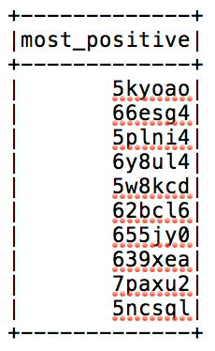 Most positive and most negative submissions (the lists contain the submission_id’s)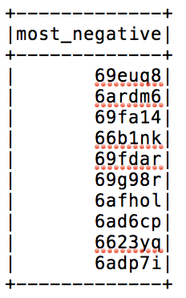



5. Scatter Plots



6. Extra credit plots

7. ROC curve

8. Paragraph

We notice that /r/politics seems to have an exceedingly negative opinion of President Trump from before he was elected to months after he was inaugurated. There is not one state whose Reddit users express more positive than negative sentiment about Trump. By our model, Arkansas has the most positive things to say about Trump, which isn’t surprising. Historically, Arkansas is as red a state as you can get, so our model seems to have gotten something right. On the other end of the spectrum, users from Delaware and Vermont, blue states, have the least positive sentiment in their Reddit comments.