Design and Analysis of Algorithms
Assignment 1 — Divide and Conquer & Asymptotic Notations
Name: ____________________ Group: ____________________
Prepared from the completed project and its measured benchmark data. Benchmark values below are actual outputs from the prepared project, not illustrative values.

1. Introduction
The project implements three Divide-and-Conquer algorithms for integer arrays: MergeSort, QuickSort and QuickSelect. The main goal is to combine algorithm design with practical measurement. The implementation counts comparisons, records execution time and tracks recursion depth, then compares those measurements with the expected asymptotic behaviour.
The design follows the assignment requirements: MergeSort uses one reusable buffer and a 15-element Insertion Sort cutoff; QuickSort uses a random pivot, 3-way partitioning and smaller-side recursion; QuickSelect uses the same partitioning idea but continues only in the part containing k.
2. Objectives
- Implement MergeSort, QuickSort and QuickSelect in Java.
- Use safe recursion and avoid unnecessary memory allocation.
- Measure time, comparisons and maximum recursion depth.
- Test random, sorted and duplicate-heavy inputs for four array sizes.
- Use JUnit 5 for correctness and edge-case testing.
- Export median benchmark results to CSV and analyse the results with plots.
- Use a clean Git workflow with feature branches, meaningful commits and a v1.0 release.
3. Algorithm Design and Complexity
Algorithm | Best | Average | Worst
MergeSort | Θ(n log n) | Θ(n log n) | Θ(n log n)
QuickSort | Θ(n log n) expected | Θ(n log n) expected | O(n²)
QuickSelect | Θ(n) expected | Θ(n) expected | O(n²)
Insertion Sort | Θ(n) | Θ(n²) | Θ(n²)
MergeSort divides the array into two halves and merges them in linear time. A single helper buffer is created at the top level and reused by recursive calls. Subarrays of 15 or fewer elements use Insertion Sort.
QuickSort chooses a random pivot and creates three regions: less than the pivot, equal to the pivot and greater than the pivot. It recursively processes only the smaller side and handles the larger side with a loop. This is intended to keep stack depth around O(log n).
QuickSelect finds the k-th smallest element without sorting the complete array. After partitioning, it continues only on the side that can contain k, so the balanced recurrence has one recursive subproblem.
4. Recurrence Analysis
MergeSort: T(n) = 2T(n/2) + Θ(n). Here a = 2, b = 2 and f(n) = Θ(n). Since n^(log₂2) = n, the balanced Master Theorem case gives Θ(n log n).
QuickSort, using the balanced-split assumption requested in the assignment: T(n) = 2T(n/2) + Θ(n) = Θ(n log n). Random pivoting does not guarantee a balanced split every time, but it makes consistently bad splits unlikely, giving O(n log n) expected running time.
QuickSelect, using the balanced-split assumption: T(n) = T(n/2) + Θ(n) = Θ(n). Only one side is continued, which is why this recurrence differs from QuickSort.
5. Metrics, Inputs and Benchmark
The Metrics class stores comparisons, current and maximum recursion depth, and elapsed time measured with System.nanoTime(). The same Metrics object is passed into an algorithm run, so the measurement state is local to that run.
The benchmark uses n = 1,000, 10,000, 100,000 and 1,000,000. Each size is tested with random integers, an already sorted array and duplicate-heavy values from 0 to 9. Every case is repeated five times and the median time is written to results.csv.
6. Measured Results
Algorithm | Input | n | Median time (ms) | Max depth
MergeSort | random | 1,000,000 | 144.527 | 18
MergeSort | sorted | 1,000,000 | 26.722 | 18
QuickSort | random | 1,000,000 | 151.813 | 12
QuickSort | sorted | 1,000,000 | 76.798 | 12
QuickSort | duplicates | 1,000,000 | 17.218 | 1
QuickSelect | random | 1,000,000 | 16.511 | 0
QuickSelect | sorted | 1,000,000 | 6.496 | 0
QuickSelect | duplicates | 1,000,000 | 12.459 | 0
At n = 1,000,000, MergeSort on random input took 144.527 ms with 19,885,748 comparisons. QuickSort took 151.813 ms with 38,728,672 comparisons, while QuickSelect took 16.511 ms with 5,991,618 comparisons. The measurements show the expected difference between fully sorting an array and selecting one order statistic.
For duplicate-heavy input at n = 1,000,000, QuickSort reached a maximum depth of only 1 because the 3-way partition groups equal values together. On sorted input, QuickSort reached depth 12, which is still far below a linear recursion depth.
7. Plots and Θ Check
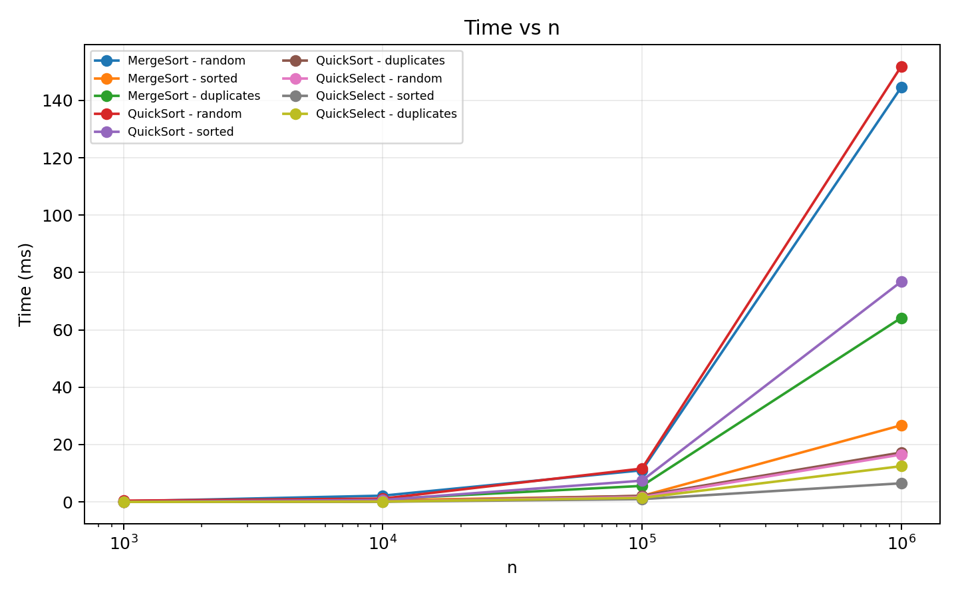
Figure 1. Time vs n for all algorithms and input types.
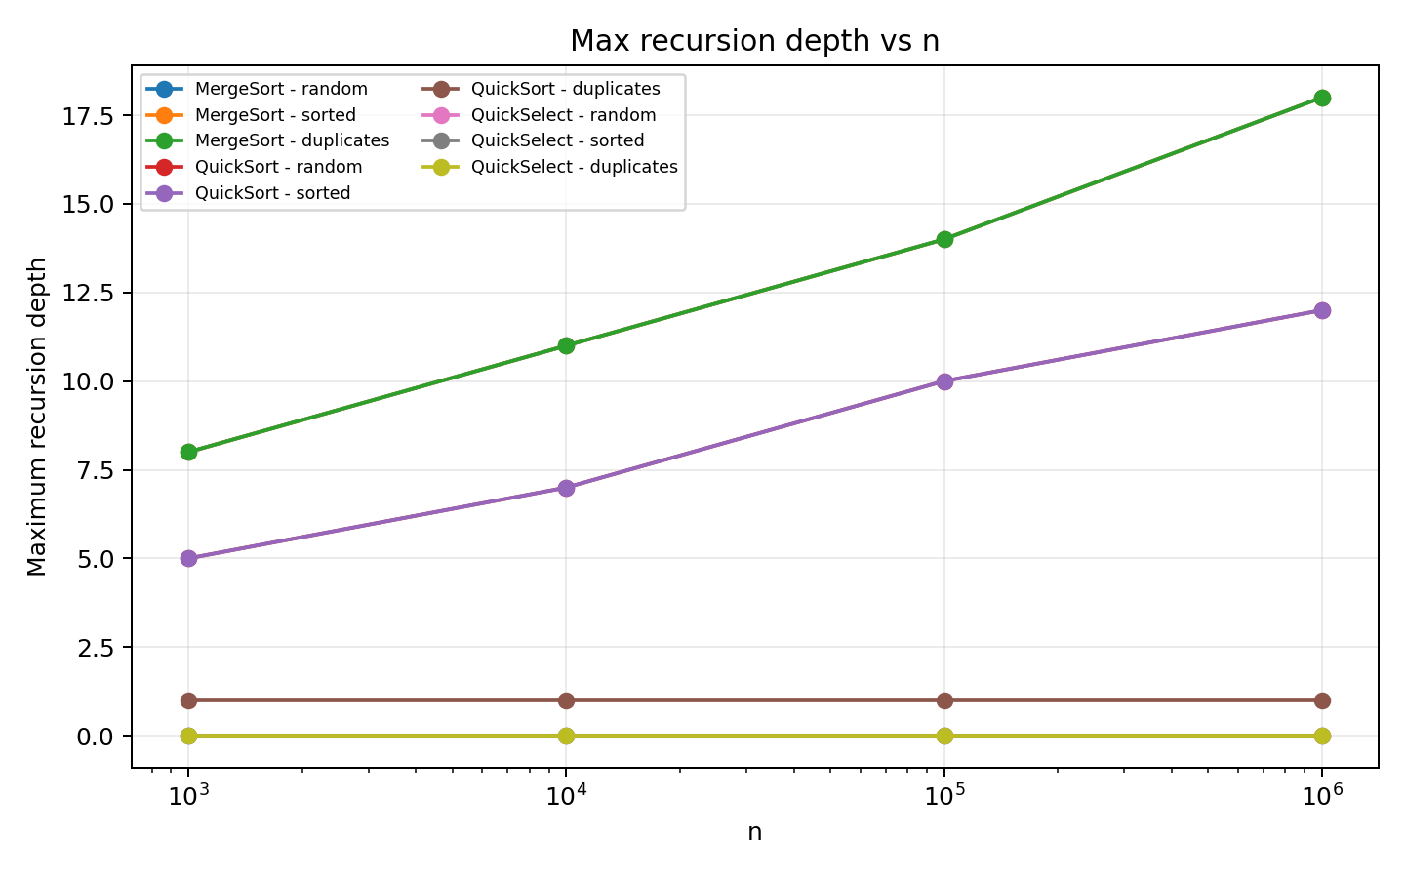
Figure 2. Maximum recursion depth vs n.
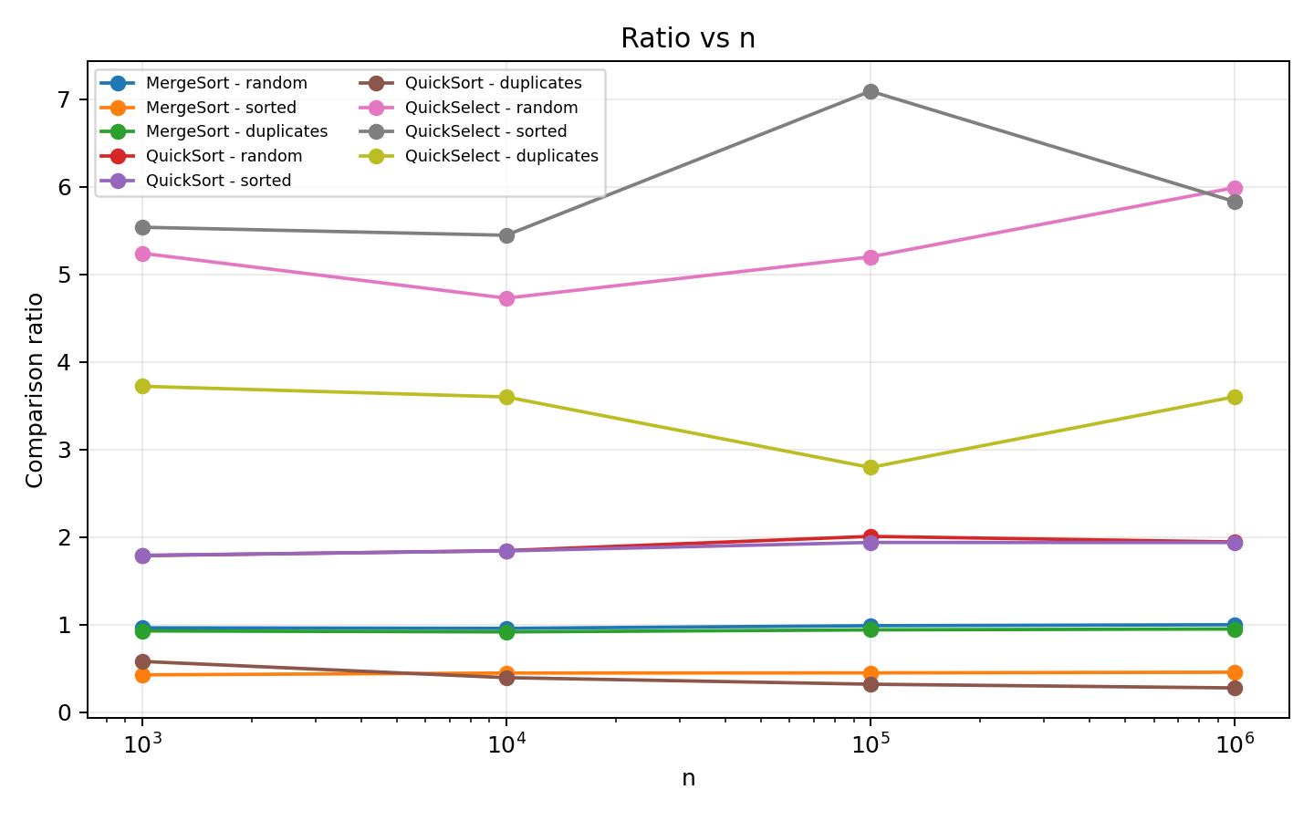
Figure 3. Comparison ratio vs n.
8. Ratio Interpretation
MergeSort / random: ratio values for n = 1,000 to 1,000,000 are 0.963, 0.956, 0.987, 0.998.
MergeSort / sorted: ratio values for n = 1,000 to 1,000,000 are 0.425, 0.446, 0.448, 0.455.
MergeSort / duplicates: ratio values for n = 1,000 to 1,000,000 are 0.927, 0.916, 0.939, 0.949.
QuickSort / random: ratio values for n = 1,000 to 1,000,000 are 1.787, 1.845, 2.007, 1.943.
QuickSort / sorted: ratio values for n = 1,000 to 1,000,000 are 1.791, 1.841, 1.938, 1.937.
QuickSort / duplicates: ratio values for n = 1,000 to 1,000,000 are 0.579, 0.393, 0.318, 0.276.
QuickSelect / random: ratio values for n = 1,000 to 1,000,000 are 5.242, 4.729, 5.200, 5.992.
QuickSelect / sorted: ratio values for n = 1,000 to 1,000,000 are 5.539, 5.447, 7.094, 5.832.
QuickSelect / duplicates: ratio values for n = 1,000 to 1,000,000 are 3.722, 3.600, 2.795, 3.602.
The sorting ratios use comparisons/(n log₂n), while QuickSelect uses comparisons/n. The MergeSort random and duplicate ratios stay in a fairly narrow range as n grows, which supports the expected Θ(n log n) comparison growth. QuickSort random and sorted inputs also stay in a bounded range. QuickSort duplicates show a falling ratio because 3-way partitioning handles the large equal-value region together. QuickSelect ratios stay within a small range compared with n, supporting its expected linear comparison growth.
9. Testing
The project includes JUnit 5 tests for 100 random arrays, edge cases, QuickSelect correctness and the QuickSort depth requirement on a sorted array of 100,000 elements. A separate lightweight correctness runner was also executed in the preparation environment and passed 150 random cases plus edge checks. The official Maven/JUnit test suite is included in the project and should be run with mvn clean test on a machine with Maven available.
10. Project Structure
The source is separated by responsibility: MergeSort.java, QuickSort.java and QuickSelect.java contain the algorithms; Metrics.java stores measurements; Benchmark.java creates the required benchmark and CSV; AlgorithmTest.java contains JUnit tests; plot_results.py creates the three plots; results.csv stores the measured data; plots/ stores the PNG figures; README.md explains how to build and run the project.
This separation keeps the algorithms independent from benchmarking and testing. It also makes individual components easier to understand and defend during the viva.
11. Git and GitHub Workflow
The project contains the assignment-required feature branches: feature/metrics, feature/mergesort, feature/quicksort and feature/select. The work was merged into main with meaningful commits such as feat(metrics): add performance metrics, feat(mergesort): add buffered merge sort with cutoff, feat(quicksort): add random pivot three-way partition and feat(select): add quickselect implementation. The final main branch is ready for the v1.0 tag after the report and generated benchmark files are committed.
The repository is designed to be pushed to a GitHub repository. The .gitignore excludes Maven target files and IDE/OS files so the repository stays clean.
12. Discussion and Conclusion
The benchmark results broadly follow the theoretical behaviour. MergeSort keeps logarithmic recursion depth and its comparison ratio is stable for random and duplicate-heavy inputs. QuickSort also keeps a small recursion depth because only the smaller side is handled recursively. Its duplicate-heavy case benefits strongly from 3-way partitioning. QuickSelect performs fewer comparisons because it does not fully sort the input.
Measured time is not determined by asymptotic complexity alone. JVM warm-up, JIT compilation, garbage collection, CPU cache behaviour and other system activity can change individual timings. For this reason, the median of five runs is used instead of relying on a single measurement.
Overall, the project connects the implementation, theory and experimental parts of the assignment. The final GitHub repository should contain the source, tests, results.csv, plots, report, README and the v1.0 tag.

