**MODULE 3 - TERADATA**

**Q1.**

**Query –**

**select** employeeno,gross,deduction,netpay,csum(netpay,employeeno) **from** salary_164444**;**

**OUTPUT-**

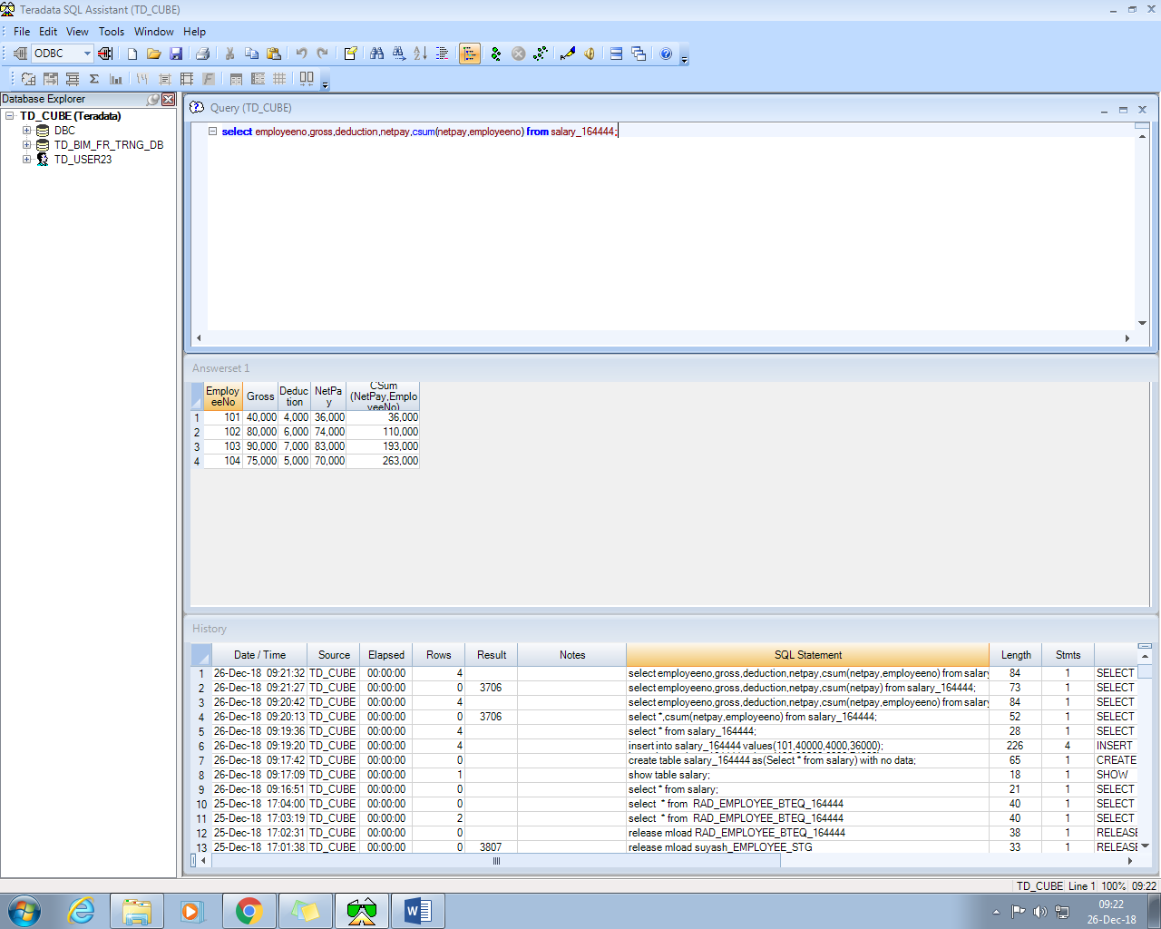

**Q2.**

**Data in table**

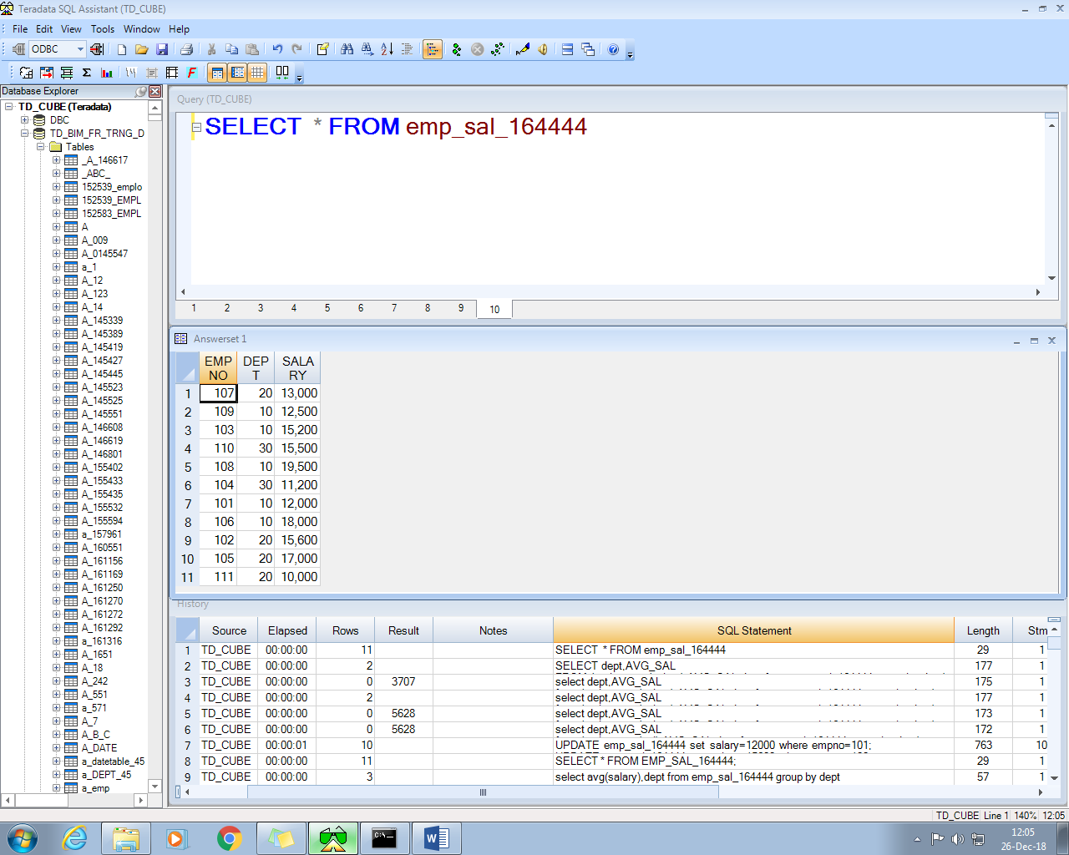

**Query-**

**SELECT** dept,AVG_SAL

**FROM** ( **select** avg(salary) AVG_SAL,dept **from** emp_sal_164444 **group** **by** dept) a,

(**select** avg(salary) AVG_SAL_B **from** emp_sal_164444) b **WHERE** AVG_SAL<AVG_SAL_B

**Output-**

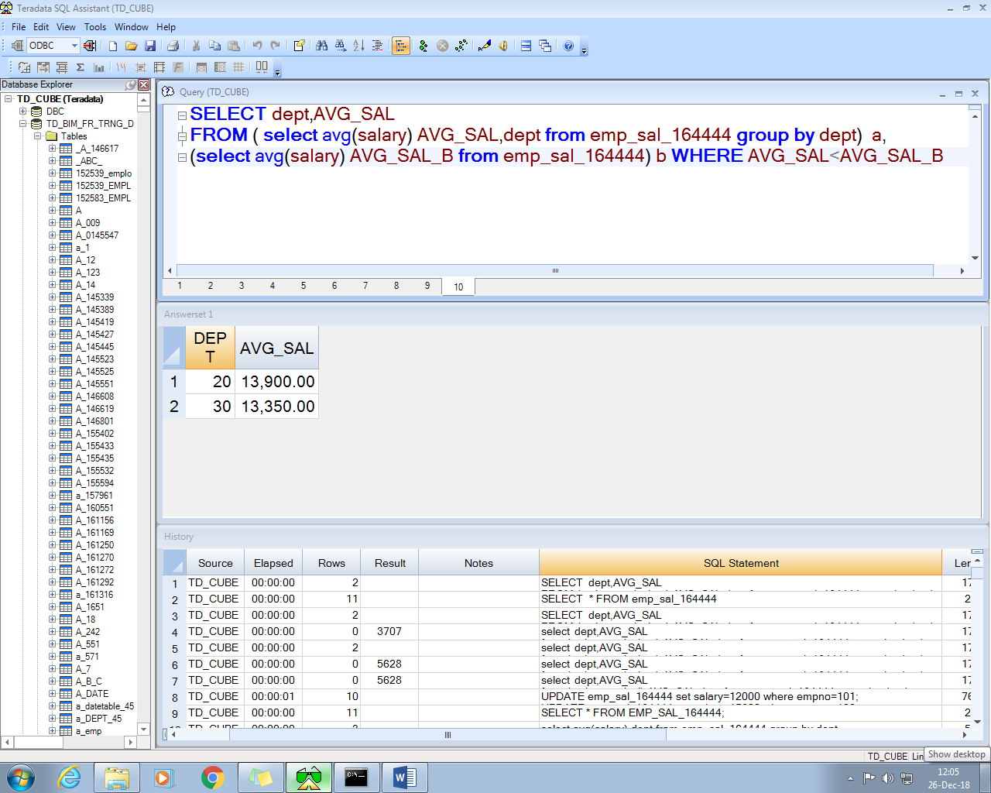

**Q3.**

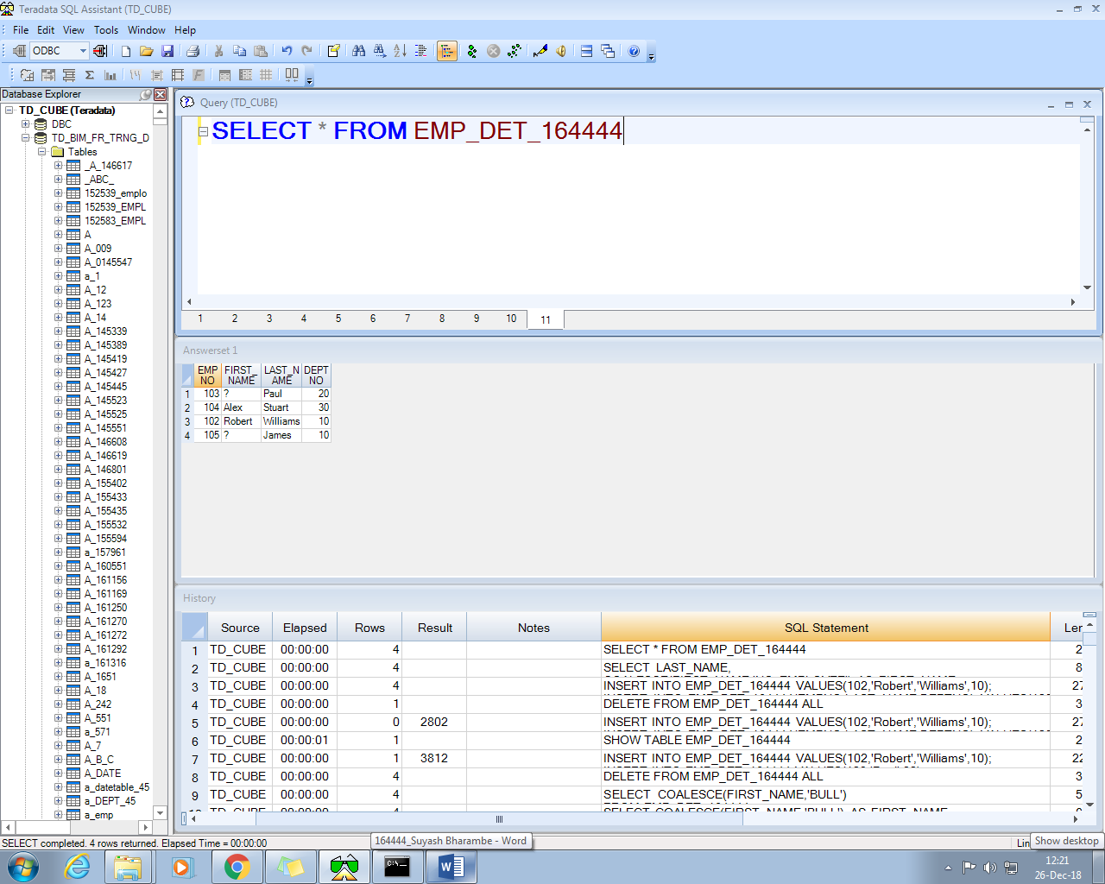

**OUTPUT**

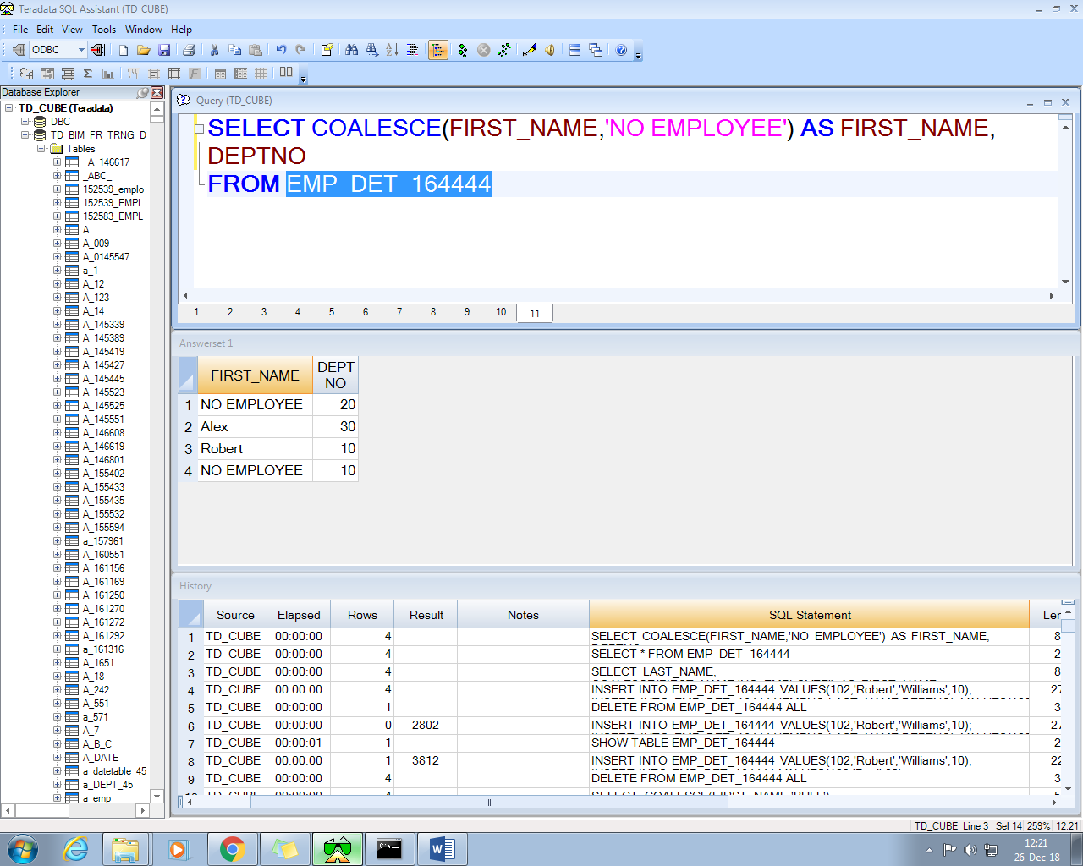

**Q4.**

**1.**

**Query-**

**CREATE** **TABLE** EMP_PH_164444(

EMPNUM integer,

Phone varchar(10))**;**

**Output-**

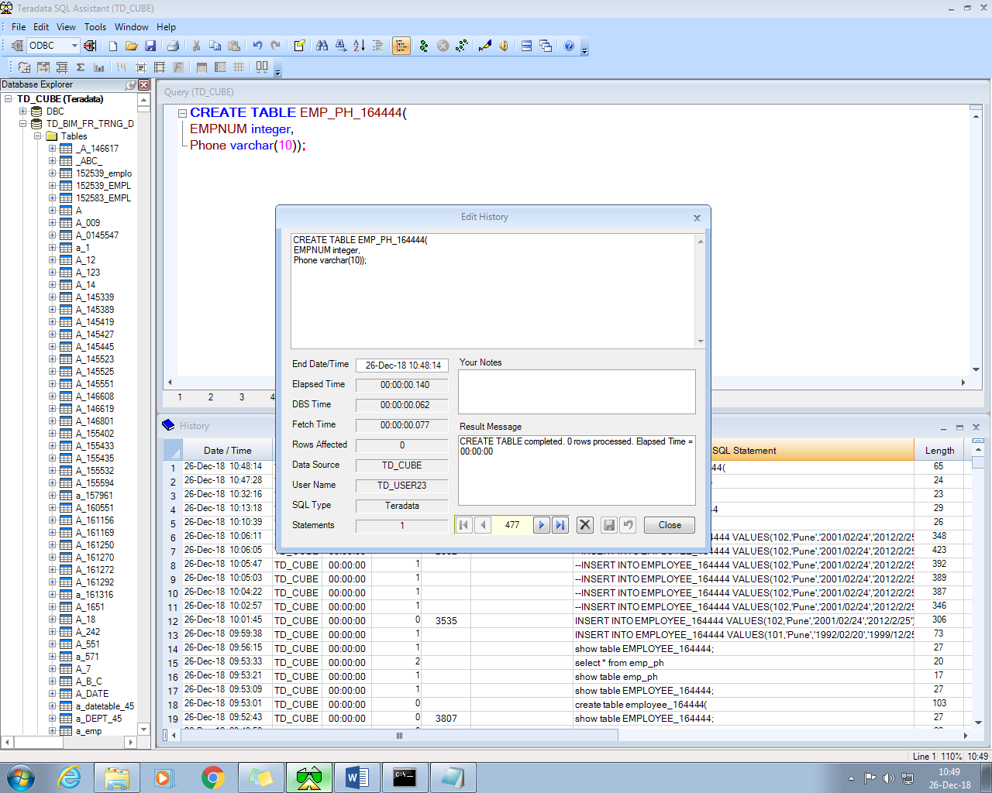

**Data Inserted**

**INSERT** **INTO** EMP_PH_164444 **VALUES**(101,'9545498226')**;**

**INSERT** **INTO** EMP_PH_164444 **VALUES**(102,'9578945602')**;**

**INSERT** **INTO** EMP_PH_164444 **VALUES**(103,'8890214562')**;**

**INSERT** **INTO** EMP_PH_164444 **VALUES**(104,'7845961135')**;**

**2.**

**COMMAND -** C:\teradata>MLOAD < Q_MLOAD.txt

**OUTPUT**

**EMP_PH_UPSERT.txt Content**

102,8805456120

100,7894123520

106,7845142181

104,8975845212

107,9874584254

**Script_file**

.LOGTABLE EMP_PH_LOGTABLE;

LOGON 10.58.0.66/td_user23,td_user23;

.BEGIN IMPORT MLOAD

TABLES EMP_PH_164444

WORKTABLES WT_EMP_PH_164444_1

ERRORTABLES ET_EMP_PH_164444_1 UV_EMP_PH_164444_1;

.LAYOUT LAYOUT_FILE_EMP_PH;

.FIELD In_EmpNo * VARCHAR(10);

.FIELD In_Phone * VARCHAR(30);

.DML LABEL LAYOUT_DML_EMP_PH;

DO INSERT FOR MISSING UPDATE ROWS;

UPDATE EMP_PH_164444 SET PHONE= :In_Phone WHERE EMPNUM= :In_EmpNo;

INSERT EMP_PH_164444 (EMPNUM,PHONE) VALUES (:In_EmpNo,:In_Phone);

.IMPORT INFILE EMP_PH_UPSERT.txt

LAYOUT LAYOUT_FILE_EMP_PH

FORMAT VARTEXT ','

APPLY LAYOUT_DML_EMP_PH;

.END MLOAD;

.LOGOFF;

**BEFORE UPSERT-**

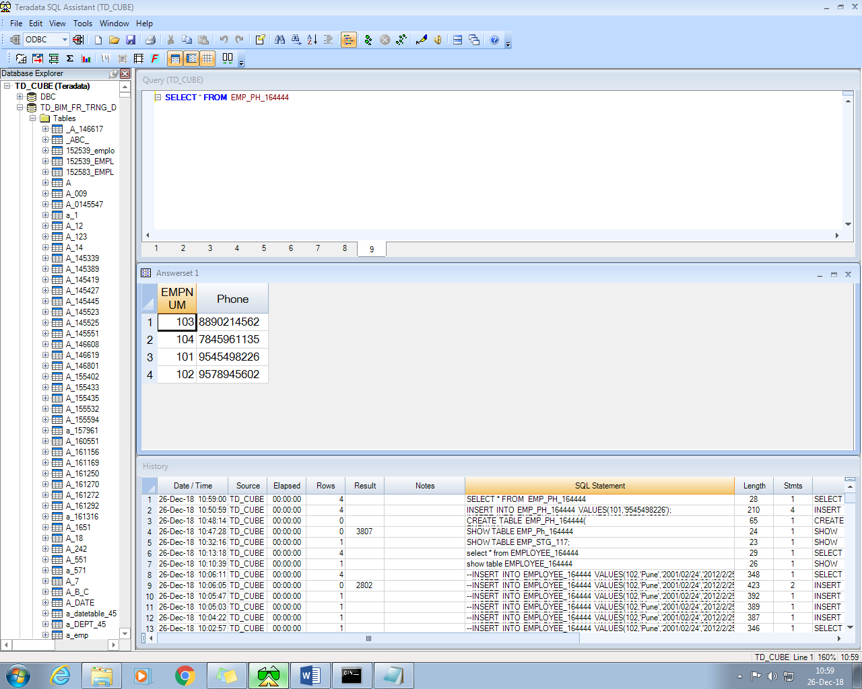

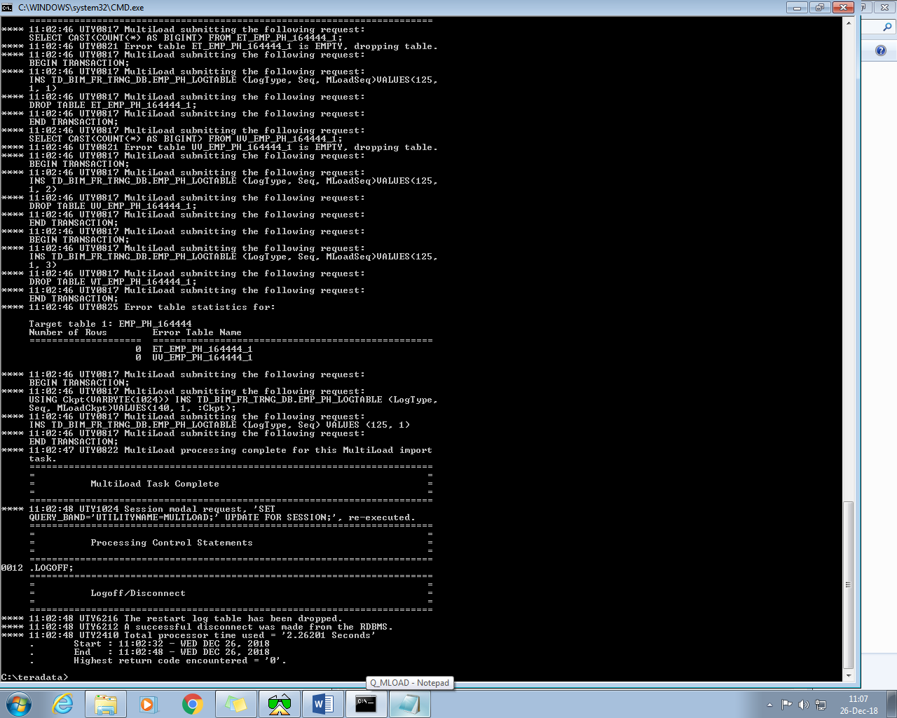

**AFTER UPSERT-**

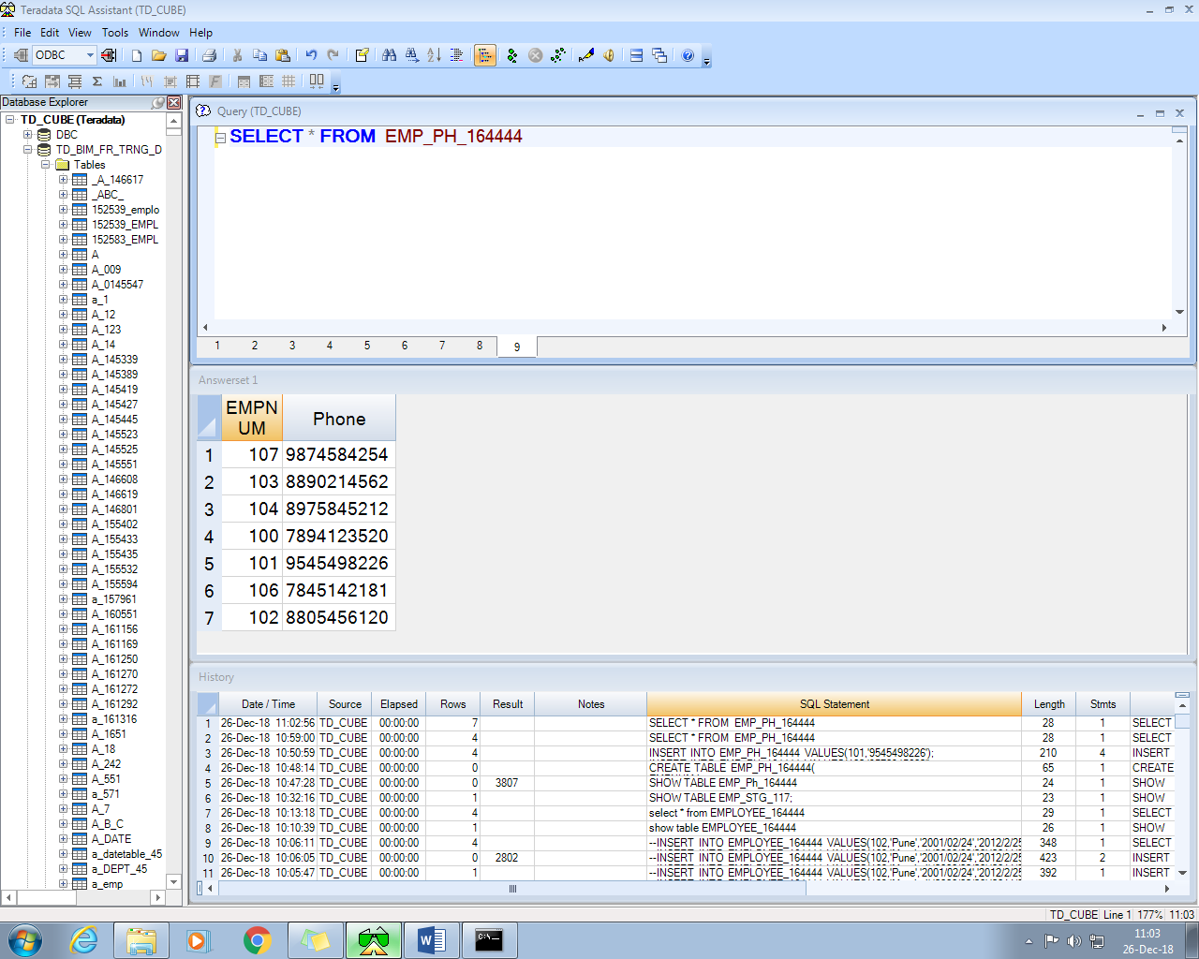

**3.**

**COMMAND -** C:\teradata>MLOAD < Q_MLOAD.txt

**OUTPUT**

**EMP_PH_UPSERT.txt Content**

102,8806091995

112,9545498226

**SCRIPT FILE**

.LOGTABLE EMP_PH_LOGTABLE;

LOGON 10.58.0.66/td_user23,td_user23;

.BEGIN IMPORT MLOAD

TABLES EMP_PH_164444

WORKTABLES WT_EMP_PH_164444_4

ERRORTABLES ET_EMP_PH_164444_4 UV_EMP_PH_164444_4;

.LAYOUT LAYOUT_FILE_EMP_PH;

.FIELD In_EmpNo * VARCHAR(10);

.FIELD In_Phone * VARCHAR(30);

.DML LABEL LAYOUT_DML_EMP_PH;

UPDATE EMP_PH_164444 SET PHONE=:In_Phone WHERE EMPNUM=:In_EmpNo;

.IMPORT INFILE EMP_PH_UPSERT.txt

LAYOUT LAYOUT_FILE_EMP_PH

FORMAT VARTEXT ','

APPLY LAYOUT_DML_EMP_PH;

.END MLOAD;

.LOGOFF;

**BEFORE UPDATE**

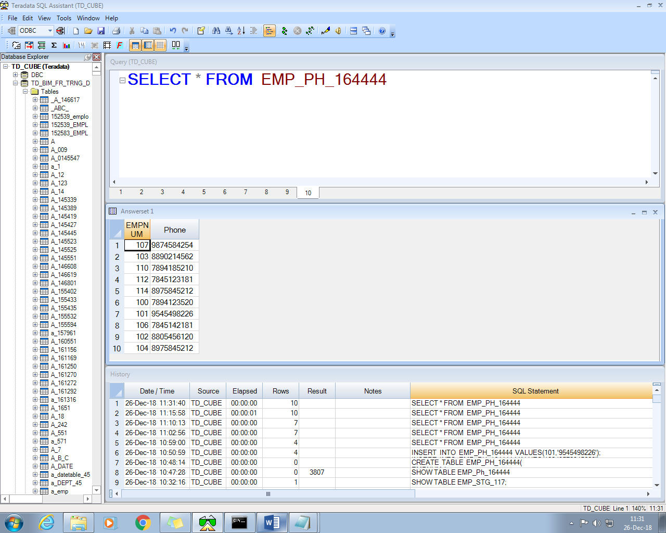

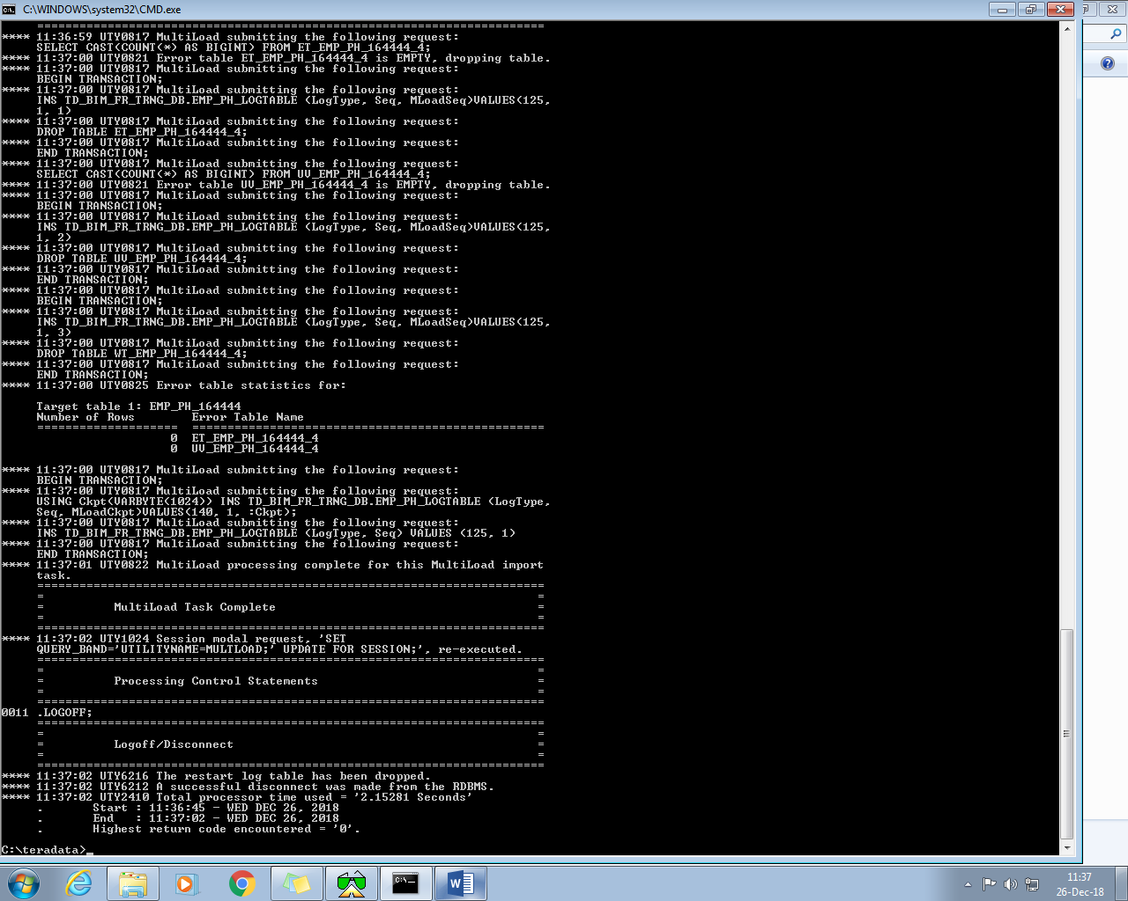

**After Update**

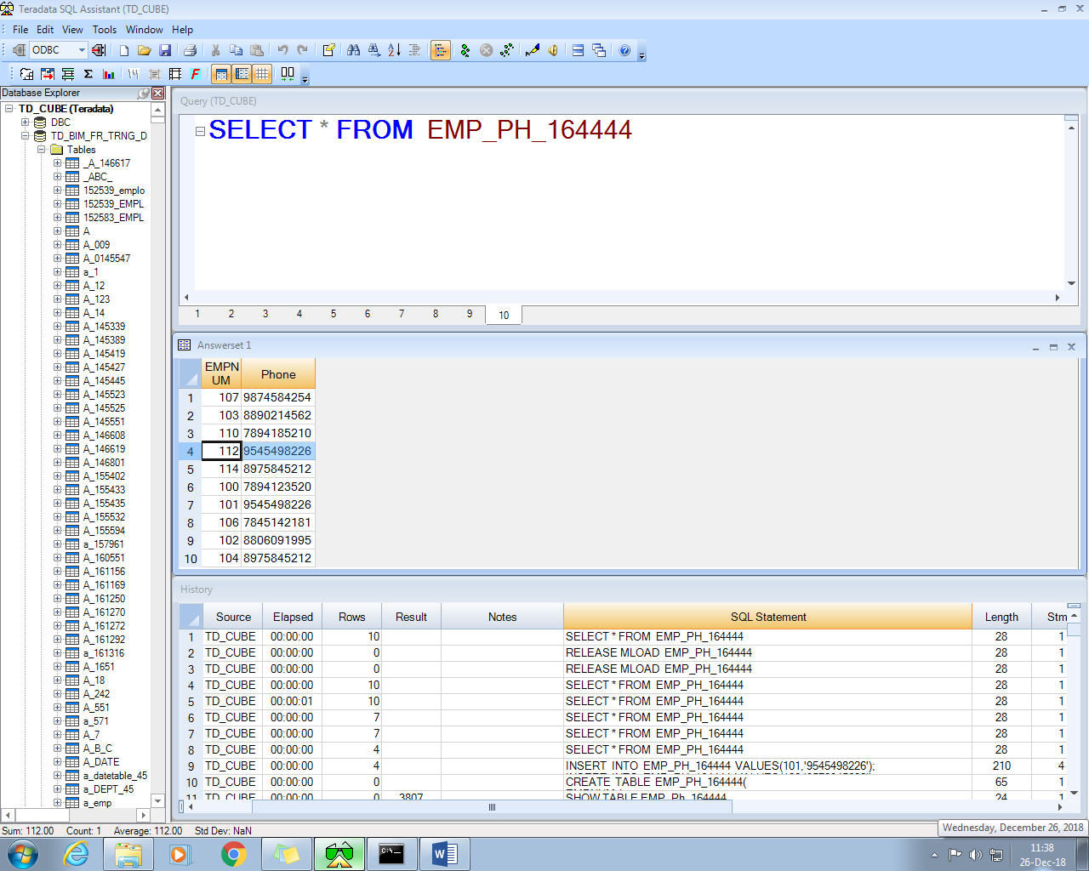

**4.**

**COMMAND -** C:\teradata>MLOAD < Q_MLOAD.txt

**OUTPUT**

**EMP_PH_UPSERT.txt Content**

102,8805456120

110,7894185210

112,7845123181

114,8975845212

107,9874584254

**SCRIPT FILE**

.LOGTABLE EMP_PH_LOGTABLE;

LOGON 10.58.0.66/td_user23,td_user23;

.BEGIN IMPORT MLOAD

TABLES EMP_PH_164444

WORKTABLES WT_EMP_PH_164444_2

ERRORTABLES ET_EMP_PH_164444_2 UV_EMP_PH_164444_2;

.LAYOUT LAYOUT_FILE_EMP_PH;

.FIELD In_EmpNo * VARCHAR(10);

.FIELD In_Phone * VARCHAR(30);

.DML LABEL LAYOUT_DML_EMP_PH;

INSERT EMP_PH_164444(EMPNUM,PHONE) VALUES (:In_EmpNo,:In_Phone);

.IMPORT INFILE EMP_PH_UPSERT.txt

LAYOUT LAYOUT_FILE_EMP_PH

FORMAT VARTEXT ','

APPLY LAYOUT_DML_EMP_PH;

.END MLOAD;

.LOGOFF;

**Before Insert**

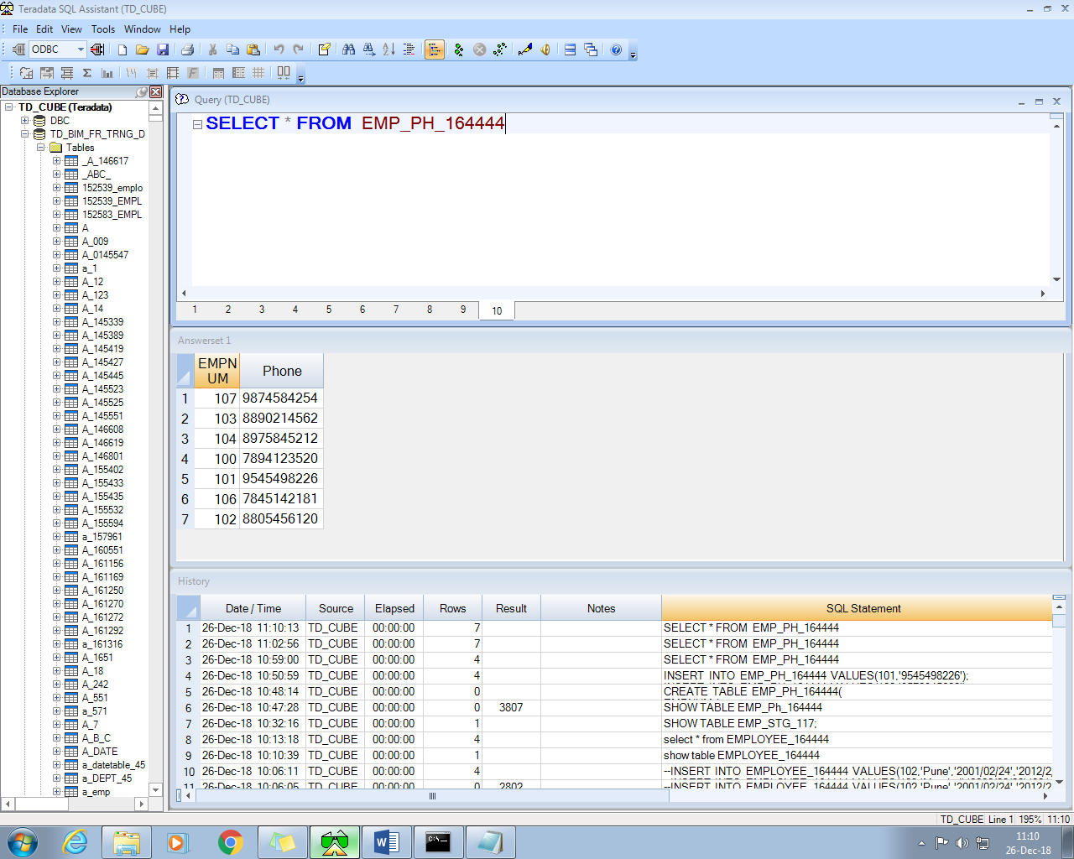

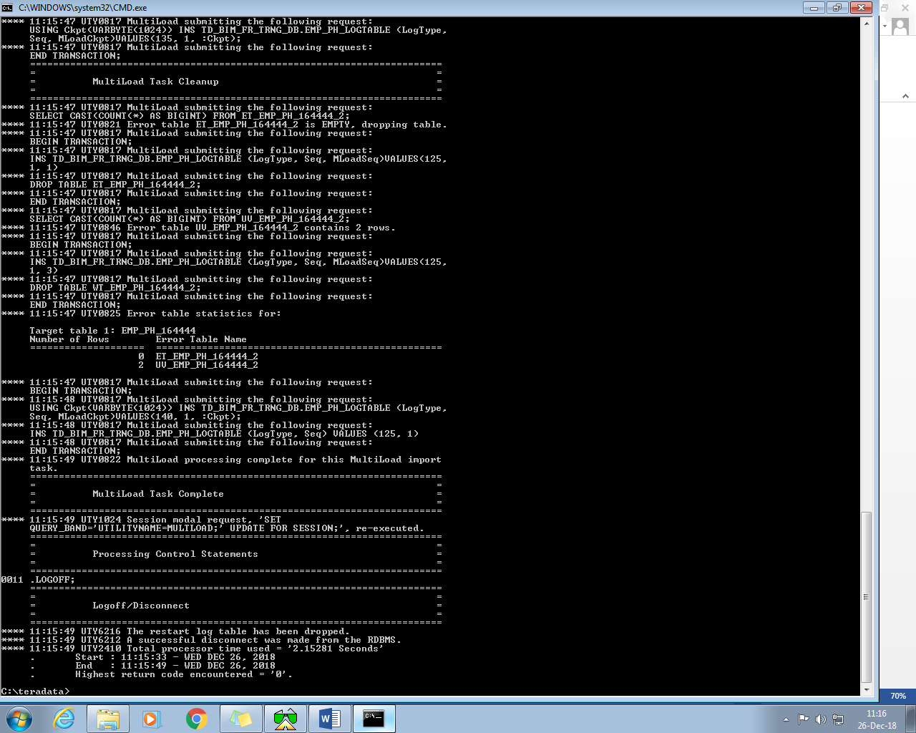

**After Insert**

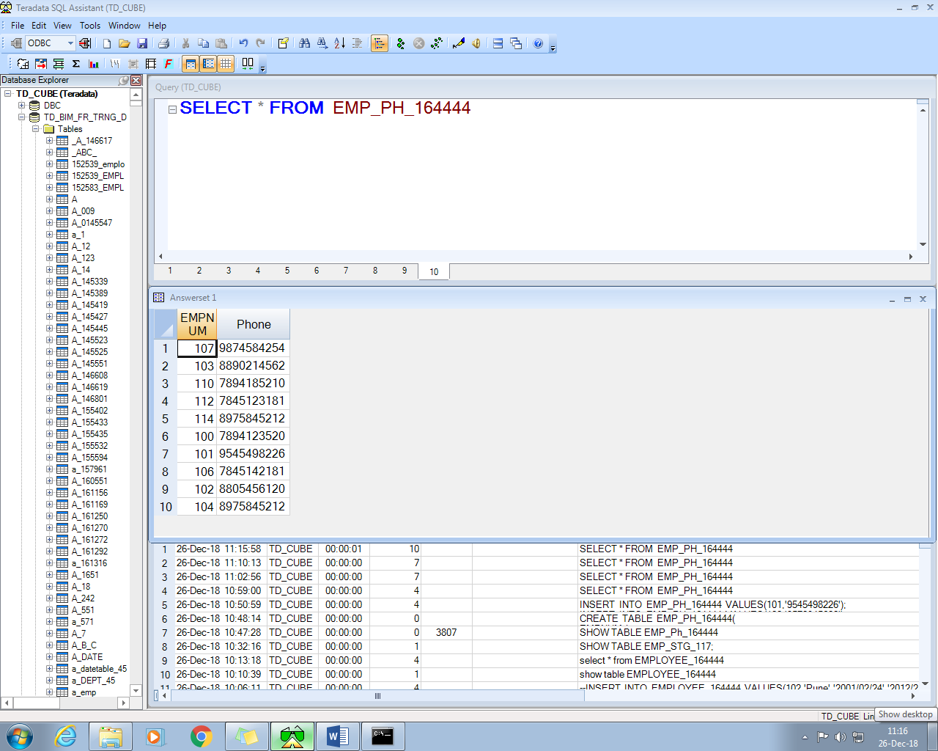

**Q5.**

**1.**

**CREATE** **TABLE** EMPLOYEE_164444(

EMPNO integer,

LOCATION VARCHAR(20),

EFF_DATE DATE,

END_DATE DATE

)**;**

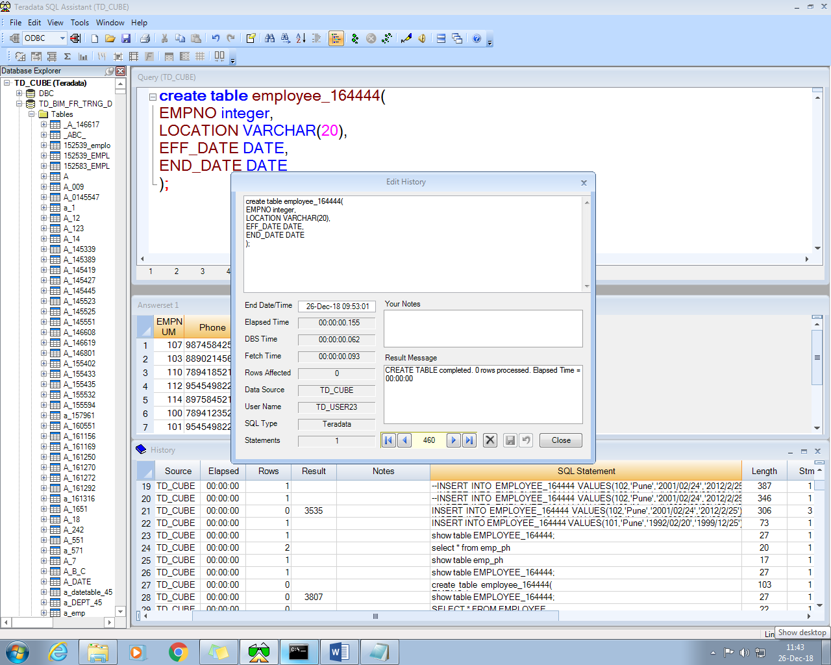

**2.**

**Data Inerted**

**INSERT** **INTO** EMPLOYEE_164444 **VALUES**(101,'Pune','1992/02/20','1999/12/25')**;**

**INSERT** **INTO** EMPLOYEE_164444 **VALUES**(102,'Pune','1996/01/28','1998/01/30')**;**

**INSERT** **INTO** EMPLOYEE_164444 **VALUES**(103,'Mumbai','1998/05/08','2015/12/12')**;**

**INSERT** **INTO** EMPLOYEE_164444 **VALUES**(104,'Bangalore','2010/12/10','2018/12/30')**;**

**3.**

**SCRIPT FILE**

.LOGTABLE EXPORT_LOGTABLE_164444;

.LOGON 10.58.0.66/td_user23,td_user23;

.BEGIN EXPORT SESSIONS 2;

.EXPORT OUTFILE C:\teradata\employee_data.csv

MODE RECORD FORMAT TEXT;

SELECT distinct cast(

cast(

(cast( 'EMPNO' AS CHAR(10))|| ',' ||

cast ('LOCATION' AS CHAR(15)) || ',' ||

Cast('EFF_DATE' AS CHAR(15))|| ',' ||

Cast('END_DATE' AS CHAR(10)))

AS CHAR(150)) AS char(150))

FROM DBC.DBCINFO;

SELECT CAST(EMPNO AS VARCHAR(5))||','||CAST(LOCATION AS VARCHAR(15))||','||

CAST(EFF_DATE AS VARCHAR(15))||','||CAST(END_DATE AS VARCHAR(25)) FROM

EMPLOYEE_164444;

.END EXPORT;

.LOGOFF;

**CMD: C:\teradata>FEXP < Export_To_CSV.txt**

**OUTPUT-**

